PSY 1101 - Chapter 6
Sensation and perception

- Sensation vs. Perception
Sensation: detects areas of light, dark and color on this slide.
- Sensory abilities
Perception: Sensory and perceptual process help us sort out what’s going on in a complex figure.

- Processing
Bottom-up: Sensory receptor relay information to brain; brain interprets information.
Top-Down: Previous expectations affect the detection and analysis of information from the senses. This explains visual illusions.

- How we measure sensation
Psychophysics: Methods that measure the strength of a stimulus and the observer’s sensitivity to it.
- Tells us what senses our body can physically detect;
- How sensory inputs affect us – can we detect them?
- Can we detect the difference between two inputs?

Absolute threshold: the smallest level of energy required by an external stimulus to be detectable by the human senses (vision, hearing, taste, smell and touch); the degree of intensity of a stimulus necessary to correctly detect that stimulus 50% of the time.

Two ways to measure thresholds

** Weber’s Law: For a difference to be perceptible, two stimuli must differ by a constant proportion, rather than by a constant amount

Is there subliminal perception? Two hypotheses:
1. can we detect sensations that are below threshold?
Yes
2. can the sub-liminal stimulus affect behaviour and/or cognition?
Yes, but: there’s a difference between “not sensing” and “not paying attention”.
- Lots of our behavior can be driven by things we can’t or won’t pay attention to. But subliminal perception assumes we are influenced by sensations that we could not perceive, even if we were paying attention to them. So, no: probably not.

Sensation: The detection of environmental stimuli (sounds, objects and smells).
Perception: The experience of detecting those environmental stimuli (how our brains organize and interpret sounds, objects and smells).

- Vision
Organ that transforms light energy into neural signals to represent objects in the environment.
- Shape, size, color, location and movement.

Light Energy
- Hue—the color experienced
- Wavelength—distance from one peak to the other
- Intensity—determined by the wave’s amplitude

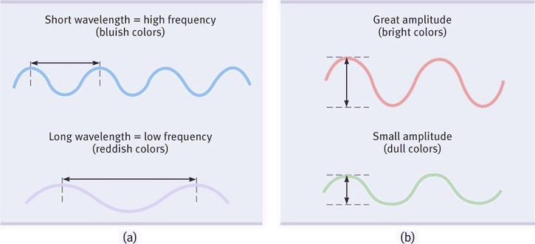

Anatomy of the eye: what happens when light falls on our eye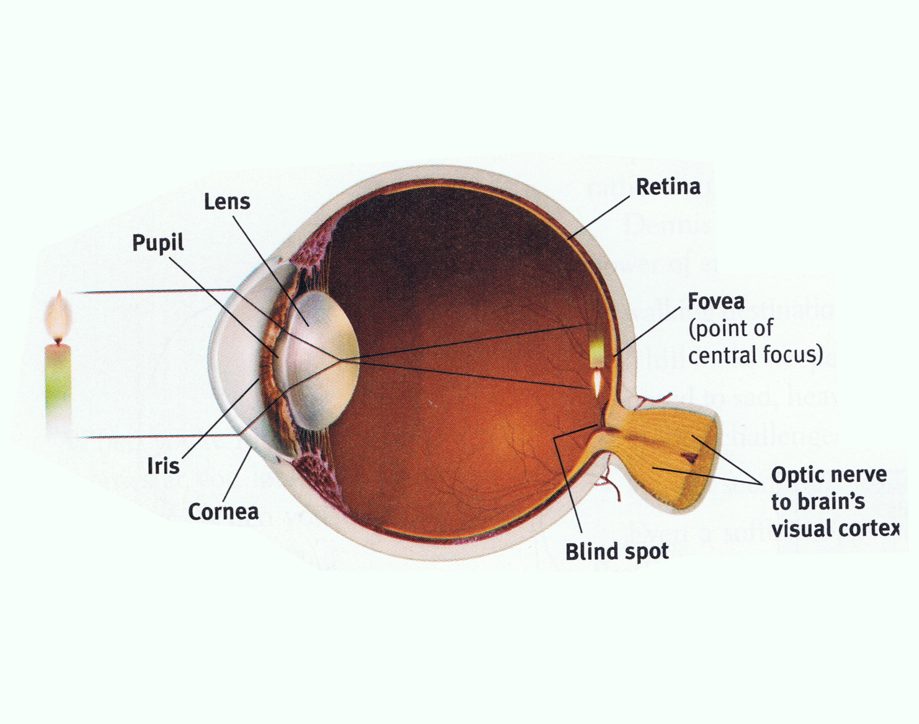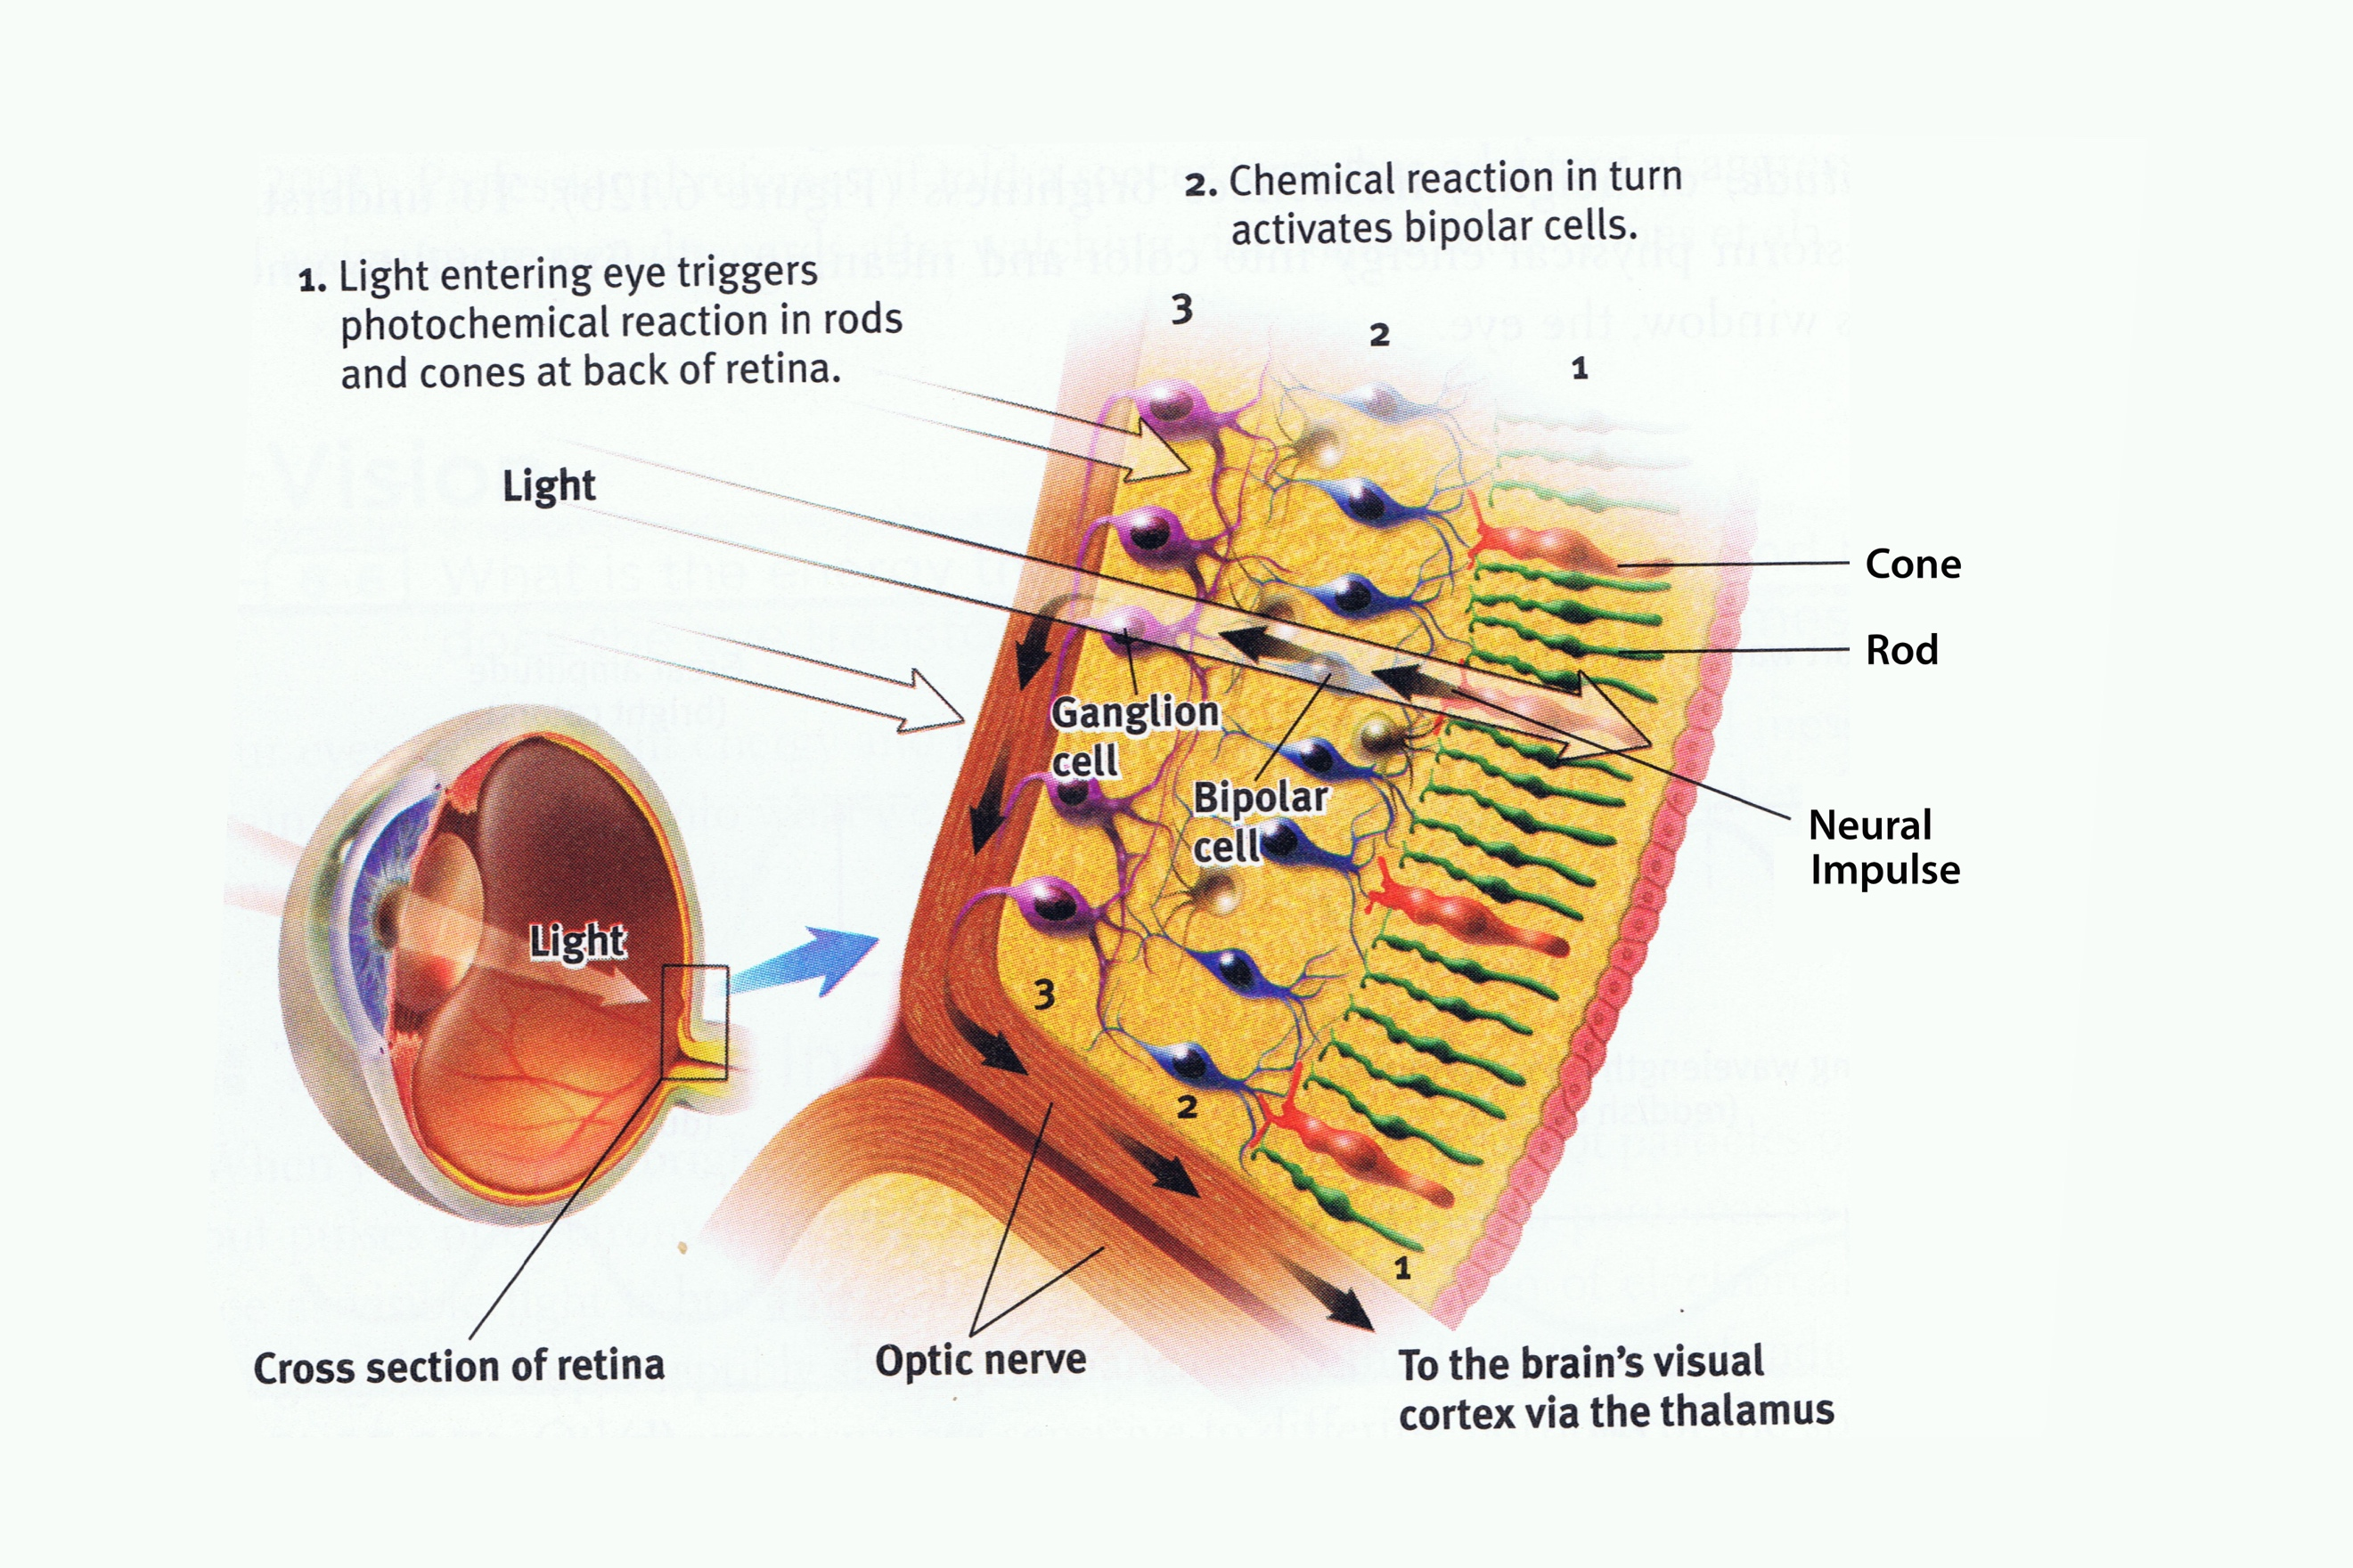
Rods: Functions in dim lights to detect black and white vision (not color).
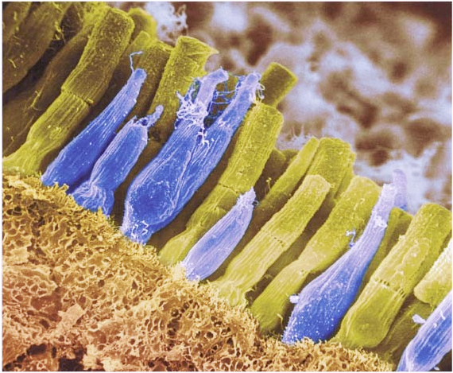
- Peripheral and twilight vision
Cones: located close to the center of the retina (fovea).
- Detects fine detail
Rods tinted yellow
Cones tinted purple

- Enables color perception
  - 3 types of cones

Focus of light on the retina
People with normal vision: nearby and far away objects are focused.
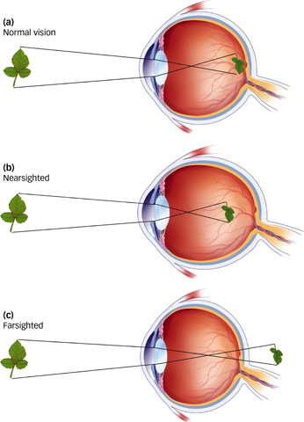
- The lens changes shape to focus near or far objects on the retina.

Focusing Vision
- In people with normal vision, both nearby and faraway objects are focused on the retina at the back of the eye
- In nearsighted people, faraway objects are focused in front of the retina
- In farsighted people, nearby objects are focused beyond the retina

- How we see color
Additive color mixing: seeing light
Adding primary colors of light creates other colors (e.g, Yellow).
- Overlapping colors: white (colors reflected).
Subtractive color mixing: seeing objects
Mixing random amounts of colors to create other colors such as red, blue, and yellow.
- The darker the mixed colors, the closer to black the resulting color.
- Black surfaces reflect no light.

** Trichromatic theory: color vision
- Hermann von Helmholtz proposed the first scientific theory of color vision.
- 3 different cones in retina that are sensitive to different wavelengths of light:
  - Red: Sensitive to long wavelengths.
Colors other than green, red and blue stimulate multiple cones.
- Yellow = red and green

  - Green: Medium wavelengths.
  - Blue: Short wavelengths.

These are the primary colors of light

The trichromatic (three color) theory explains the red-green color blindness; a deficiency in operation of the green or red cones.
‘’ People have blue sensitive cones, but either red or green sensitive cones. As a result, red and green look the same to a person with red-green color blindness.’’
- Red and green cones do not operate perfectly
  - 7-10% males show deficiency
  - Linked to X chromosomes; <1% of females

Opponent-process theory: explain the color afterimage after the initial stimulus is gone.
- 2 sets of colors (red-green and blue-yellow) oppose one another in each pair.
  - Both cannot be stimulated at the same time

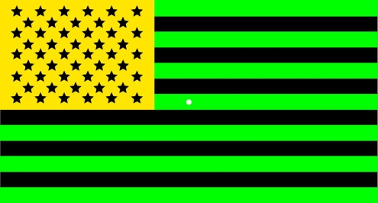
Demonstration of the afterimage: stare at the white dot in the center of the flag for 30 seconds and then look away. You should see an after image of opposing colors: red, blue and white.

Theory suggests that both processes are at work in color vision.
- First step: Cones pick up R,G,B individually
- Second step: Signaling channels can be turned on by green, but off by red on by blue, but off by yellow on by black, but off by white.

Problems with the eye
- Astigmatism: odd shape to parts of eye (cornea, lens) that affects clear vision of shapes: about 30% of people
- Cataracts: clouding of lens, most often related to age
- ”Floaters”: bits of stuff in vitreous humor (eyeball goo) that float around and cause line or spots
  - Can usually be “tuned out” by neural adaptation

Blinking
During a blink, we fill in the existing scene with top-down processing.
- Rate slows during reading
- Increases under arousal
We move our eyes even if we’re focused on a single point so that the retina cells (cones) don’t adapt.

- Visual pathways
- Axons of ganglion cells from the optic nerve
- The retina routes the visual information over optic chiasm, to the visual area of the thalamus.
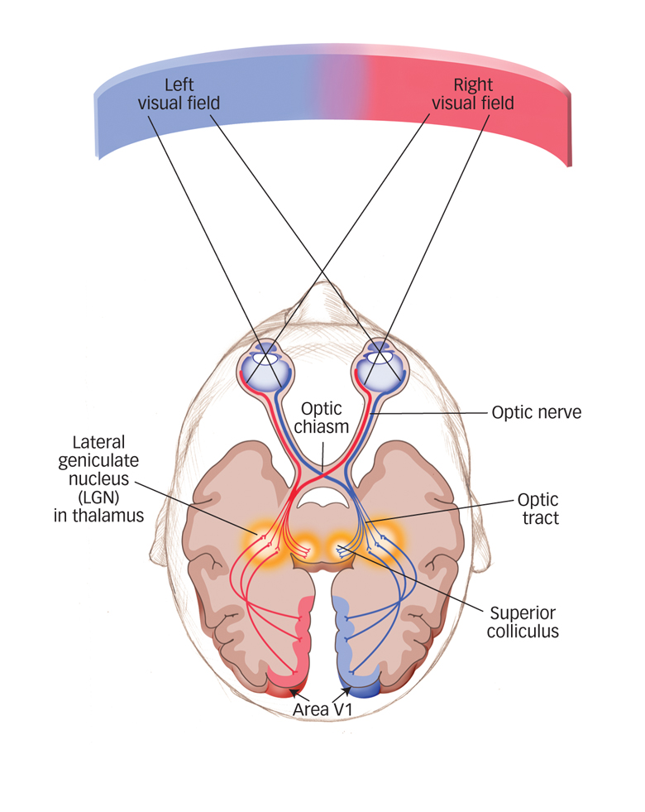
  - Both sides feed same and opposite hemispheres.

→ Info from left visual field travels to right cortex.

→ Info from right visual field travels to left cortex.

Parallel (simultaneous) processing: when info arrives at the eye
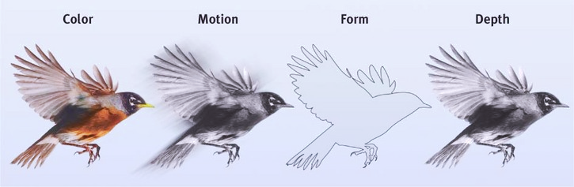
The brain processes:
- color
- movement
- form
- Depth

Feature detection
Looking at different objects such as faces, houses, and chairs activates different supercell areas in the cortex.
- Hubel and Wiesel find feature detecting cells in visual cortex
  - Those cells pass information onto the supercells of the cortex
  - The supercells recognize relevant objects in response to a specific stimulus.

Gestalt: organized whole that is perceived as more than the sum of its parts.
- Form perception: viewing faces and other objects distinctively from their surroundings
- Grouping: Organize stimuli to coherent groups
  - Proximity, Similarity, connectedness, continuity, closure.

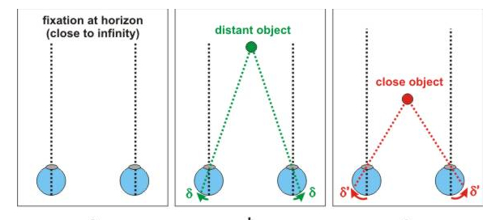
- Perception: depth and distance
- Binocular (depends on 2 eyes)
  - Brain computes difference in the two retinal images to perceive the distance of an object.
  - Consequence: finger sausage illusion
- Monocular (1 eye)
If we assume two or more objects are similar in size, then most people perceive the smaller image as farther away.
  - Relative size, familiar size/height
  - Linear perspective, texture, motion and interposition

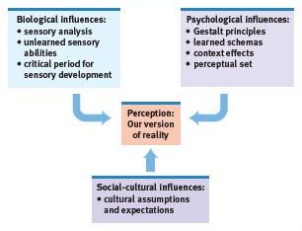
Context effect in perception are…
- Innate and learned
- Fed by sensation, cognition and emotion
- Influenced by culture

- Hearing
Audition: the sense or act of hearing.

Properties of sound waves
- Frequency: Perception of pitch
- Amplitude: Perception of loudness
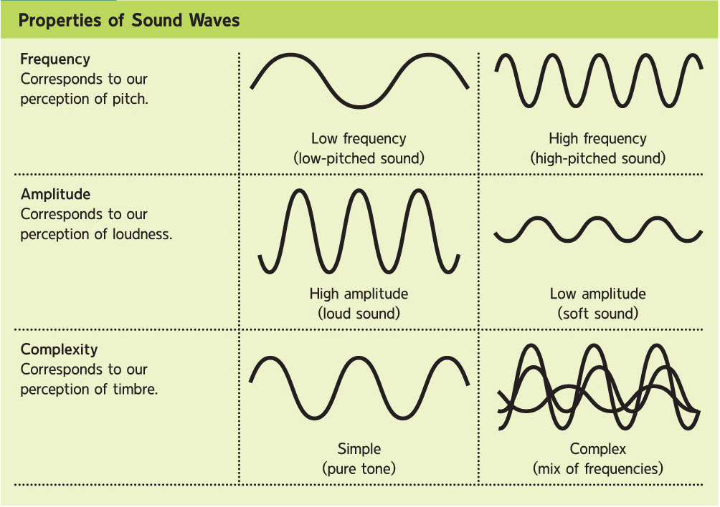
- Complexity: perception of timbre
Sound Waves: Changes in air pressure that unfolds over time.
Oscilloscope: Electronic laboratory instrument that traces a visible wave form.
Amplitude: Intensity or amount of energy of a wave, reflected in the height of the wave; VOLUME.
Decibels (dB): Measurement unit for sound.

Zero Decibels (dB) is based on the absolute threshold for hearing, and every 10 decibels corresponds to a tenfold increase in sound intensity. As a rule, if you cannot talk over a noise, it is potentially harmful, especially with repeated and prolonged exposure.

- The ear
- Outer ear: Sound waves are collected
- Middle ear: Sound waves are amplified
- Inner ear: Sound waves are transduced into coded neural messages

If you follow the path through the anatomy of the ear, this is what happens:
- The pinna funnels sound waves into the auditory canal to vibrate the eardrum at a rate that corresponds to the sound’s frequency.
- In the middle ear, the ossicles pick up the eardrums vibrations, amplify them, and pass them along by vibrating a membrane at the surface of the fluid-filled cochlea in the inner ear.
- Fluid carries the wave energy to the auditory receptors that transduce it into electrochemical activity, exciting the neurons that form the auditory nerve, leading to the brain.
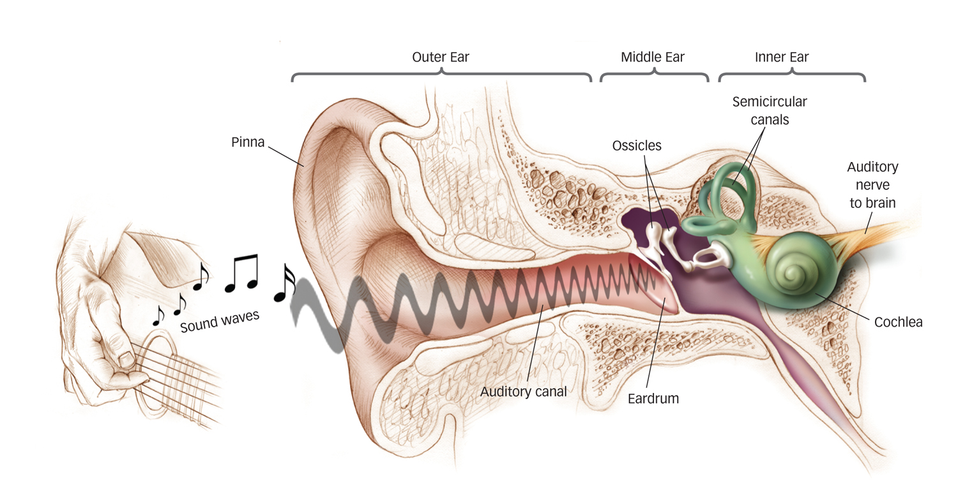
Differences in pitch: three mechanisms
Place theory: frequency of sound based on location (place) on cochlea where neurons fire.
Frequency theory: monitors frequency of neural firing in neurons
- ‘’Volley’’ theory: Neurons alternate firing in volleys so we can hear above 1000 Hz

Localizing sound sources
Ears on either side of the head gives us stereophonic hearing.
Timing method: Direction of sound by which the ear I stimulated first (low freq. sounds)
Volume method: Direction of the sound by which ear is stimulated more vigorously
Hearing: Common problems
- Complete or partial deafness
  - Sometimes congenital
  - Environmental (consistent loud sounds)
  - Ageing process
- Tinnitus (ringing in ears)
  - no objective/external cause
  - Hearing loss/damage to hair cells in cochlea
- Body, Senses, Taste and Smell
Key sensors: Pressure, warmth, cold and pain
- Combinations can result in mixed sensations. E.g: cold + pressure = wetness

- Pain: unpleasant sensory or emotional experience.
Nociceptors
pain receptors
- Temperature
- Pressure
- chemicals
  - Warning for actual or potential tissue damage. That something is wrong.
  - Top-Down/Bottom-Up process; can’t feel pain when nociceptors are active.
    - Playing through pain.
  - Feel pain even if nothing noxious is happening
    - Phantom limb pain.

Bottom-Up processing
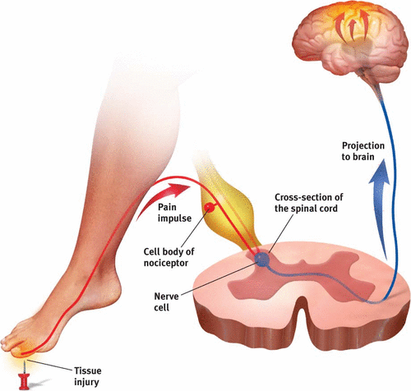
Sensory receptors or nociceptors respond to potentially damaging stimuli. They send a message to the spinal cord, which relays the message to the brain. The brain interprets the signal as pain.

- A-Delta fibers: Fast acting, transmit sharp pain
- C fibers: longer lasting, duller pain
- Nociceptors: pain receptors

Remember that the pain withdrawal reflex, which kicks in when you touch a hot stove, for example, does not involve the brain – it is coordinated by the spinal cord.

Top-Down processing
Wouldn’t it be better to live without this sense? What is the value of having pain?

Feeling pain is a critical signal the body receives to protect itself from harmful objects and environments. Insensitivity to pain usually leads to an early death because the body cannot shield itself.

Gate control theory: The spinal cord contains a neurological gate that blocks pain signals (via larger fibers) and allows pain signals to pass to the brain through small nerve fibers.

Biopsychosocial approach to pain
Biological, psychological and socio-cultural factors contribute to the personal experience of pain. It is much more than the neural messages sent to the brain.

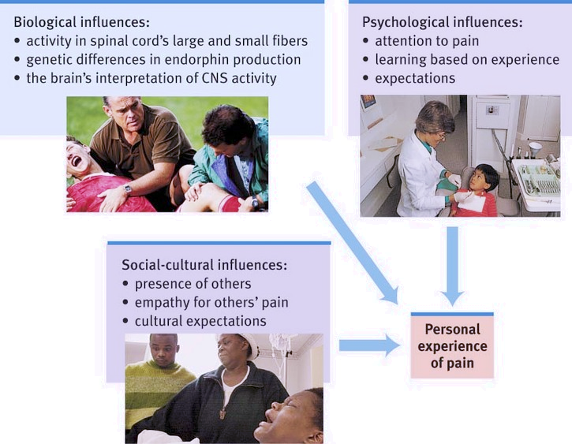

The taste system
Sweet, sour, umami (savoriness), bitter and salty.
- Tastes exist to attract humans to energy and protein-rich foods, that are typically sweet or “umami” and to avert them from potentially toxic or harmful substances that are often bitter or sour. Umami is a recently identified, savory taste that is associated with monosodium glutamate, meats, mushrooms, seaweed and aged cheeses, such as Parmesan.

- 5,000-10,000 taste buds and they each contain 50-100 taste receptor cells.
- All five tastes can be sensed by receptors all over the tongue
  - Taste buds are important, but food doesn’t taste as good when we can’t smell or see or feel that were eating.
    - E.g: loss of hearing = reduced interest in potato chips
    - E.g: loss of smell makes food ‘’taste’’ like sawdust

The smell system
Airborne odor molecules are inhaled through the nose. The olfactory receptor cells in the nasal cavity are stimulated and are converted to neural signals.
- Olfactory neurons are the only neurons that directly link the brain to the outside world.
- Olfactory information travels to the temporal lobe close to the region where the brain receives information about taste. Taste and smell information interact.
- Information about smell also travels to an area in the brain which is connected to memory storage.
The “other” senses: extra-sensory perception (ESP)
- Telepathy: mind-to-mind communication
- Clairvoyance: perceiving remote events
- Precognition: predicting future events

