Basic unit of the Nervous system: The neuron
Anatomy
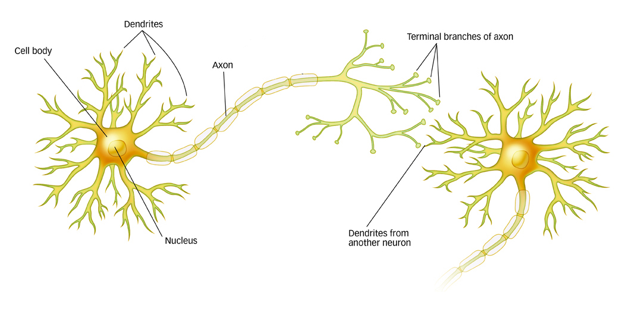
- Cell body (soma): Contains the nucleus and its chromosomes. They are just like any other body cells.
  - Gets fed by O₂ and CO₂
- Nucleus: contains the genetic material in form of chromosomes.
- Axon: Transmits the information from the other neurons. They transmit their information to muscles, other neurons and glands (communications system).
- Dendrites: Receives the information that is submitted by other neurons.
- Myelin: Composed of glial cells, it works as a protective coating/insulant for the axon. It increases the speed of the transmission of information by keeping electrons going the same way to prevent collisions.
  - Computer connexions (1 to 1) vs brain (1 to 10000)
    - Speed comp = 120,000 to 250,000km/h
    - Brain = 3 to 250km/h
    - The reaction time is quicker in smaller nervous systems
  - Multiple Sclerosis (MS): damaged myelin sheath = poor transmission.
  - Myelination: Production of myelin sheath.
- Synapse: Junction between axon and dendrites

- How signal gets transmitted?
Action Potential: Phenomena that stimulates the release of neurotransmitters into synapse by an electrical charge. The charge is gathered by the dendrites/cell body and travels down the axon to the synapse. This action only occurs when the electrical level is at a minimum level (threshold).
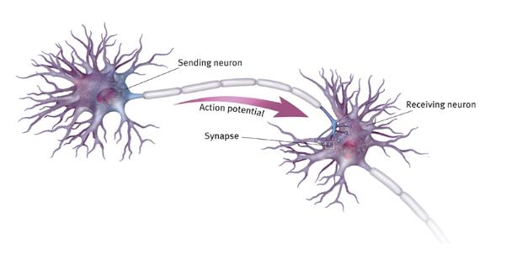
- Action-Potential

- Stimulus is received by the dendrites of nerve cells. This causes the Na⁺ channels to open. This opening is sufficient to drive the potential from -70mV to -55mV.
- Reaching the action threshold, more Na⁺ channels open. The Na⁺ influx (forming a concentration gradient) drives the interior of the cell up to about +30mV. This process is called depolarization.
- The Na⁺ channels close and the K⁺ channels open. The K⁺ channels are much slower to open, and the depolarization has time to be completed.
  - Having both Na⁺ and K⁺ channels open drives the system to neutrality and prevent the action-potential.
- With K⁺ channels open the membrane starts to repolarize back to its rest potential.
- Repolarization overshoots resting potential to -90mV (hyperpolarization).
- Hyperpolarization: assures the signal is going in one direction by preventing stimulus already sent to an axon from triggering another action potential in the opposite direction.
- After hyperpolarization, K⁺ and Na⁺ pumps eventually bring the membrane back to its resting state of -70mV.

- Nerve impulse down axon
- The stimulus creates an action-potential in the cell membrane of the nerve cell. When the action-potential reaches the axon, it proceeds down the transmission line by successive excitation of the axon membrane.
  - Speed is increased by the action of the Myelin sheet.
- Intracellular fluid: positively charged at +40mV, to trigger Na⁺ channels to open, moving the action potential down the axon.
  - K⁺ channels open and the fluid becomes negative again.
- Prevents sodium/potassium gates from opening on the covered part of the axon, and exchanging their ions with the outside environment.
- The gaps between the myelin sheath are known as nodes of Ranvier. These uncovered zones of the axon produce an action-potential to excite a response into the next node. The nerve signal can travel faster by the discrete jumps, rather than the depolarization/polarization along the membrane.

- Na⁺/K⁺ pump restores ion balance
- Na⁺ and K⁺ channels close, having a higher [c] of Na⁺ inside the cell.
- Pump restores resting state charge.
- Refractory period:
- The action-potential reaches +40mV and the membrane channels return to their original state. Neuron can now generate another potential up to 1000 times per second.

- Excitatory Neurotransmitters
- Initiated by one or more chemicals to stimulate a change in the electrical potential of the neuron. The electrical signal moves along the dendrite membrane to the axon and stimulates the release of neurotransmitters from axon terminals.
  - Neurotransmitters chemically transmit message to neighbouring neuron and initiate other action-potential in that neuron.

- Anatomy of the Synapse
- The action potential travels down one neuron’s axon to its terminal buttons.
- The action potential stimulates the release of neurotransmitter from vesicles into the synapse (exocytose).
- Neurotransmitters cross the synaptic gap and bind to receptor sites on the dendrite of the postsynaptic neuron.
- Initiation of a new action potential in the postsynaptic neuron.

** Lock and key: Each neurotransmitter fits a specific site on the postsynaptic neuron as a key fits a lock **

- Axon does not have any physical connection with dendrite; terminal button.
- Terminal buttons contain synaptic vesicles, in which contain the neurotransmitters.
  - Neurotransmitter: brain chemicals that communicate information throughout the brain and body.
    - Excitatory: stimulate the brain. Ex: Dopamine.
    - Inhibitory: calm the brain; can be depleted when excitatory transmitters are overactive. Ex: serotonin.
  - Presynaptic neuron: nerve cell that releases chemical messengers (neurotransmitters) into the synapse, which is the gap at the end of a neuron.
  - Postsynaptic neuron: Nerve cell that receives neurotransmitters.
  - Terminal buttons: small knobs at the end of the axon that release neurotransmitters. It forms the presynaptic neuron.
  - Synaptic gap (cleft): space between the presynaptic neuron and the postsynaptic neuron.
  - Receptor site: Proteins on the surface of each cell that act as little receivers (or ears) that listen to messages of the neurotransmitters as they float in the intercellular fluid (surrounding the cells).

- What happens to Neurotransmitters?
- Reuptake: neurotransmitters are absorbed back into presynaptic neuron.
- Enzyme deactivation: they are broken down by enzymes in the synapse.
- Auto-receptors: they bind to auto receptor sites on the presynaptic neuron.
- Neurotransmitters passively drift out of the synaptic gap.
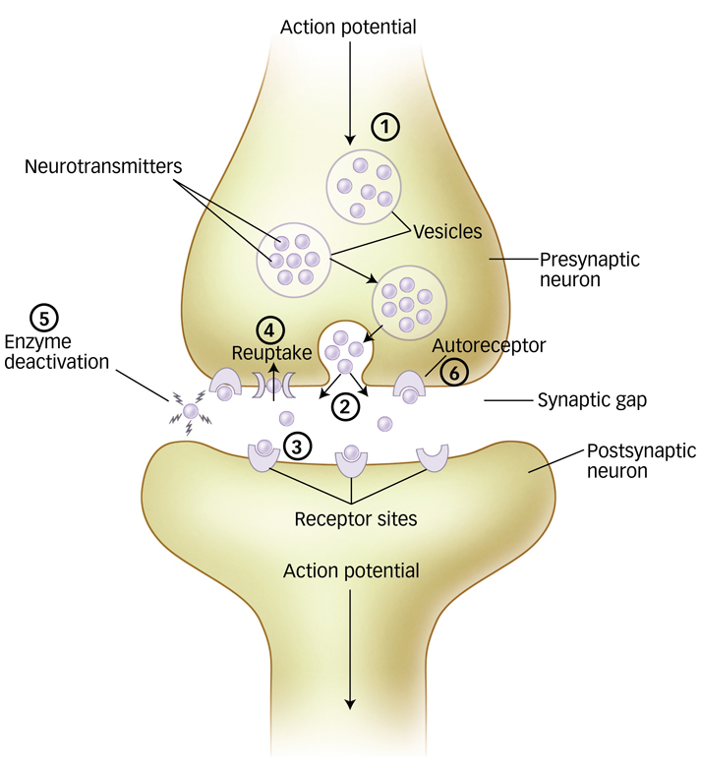
- Types of neurotransmitters
- Acetylcholine (ACh)
- Functions: Enables muscle action, learning and memory
- Malfunctions: With Alzheimer’s, ACh producing neurons deteriorate
- Dopamine
- Functions: Influences movement, learning, attention and emotion
- Malfunctions: High levels linked to schizophrenia, low levels linked to Parkinson’s disease
- Serotonin
- Functions: Affects mood, hunger, sleep arousal
- Malfunctions: Low levels linked to depression
- Effect on a person’s ability to perceive, feel, think, move, act, and react.

- Norepinephrine
- Functions: Helps control alertness and arousal
- Malfunctions: Low levels depress mood
- Endorphins
- Functions: Boosts mood, lessens pain
- Malfunctions: Artificial opiates cause brain to stop producing endorphins

- Drugs and their properties
Drugs can influence the speed and effectiveness of neural transmission by exiting (agonist) or inhibiting (antagonist) the transmission between neurons.
- Opiates vs. Endorphins
- Venom as a ‘’cure’’ for tetanus
- Hallucinogenic drugs

Our body generates its own set of drugs e.g, Endorphins for the ‘’runner’s high’’ or ‘’fight of flight’’. But the capability of the body’s own failure in neural transmission can result in serious medical conditions, such as Parkinson’s disease.
- Parkinson’s Disease: neurodegenerative disease where the production of dopamine in the mid-brain cells die.
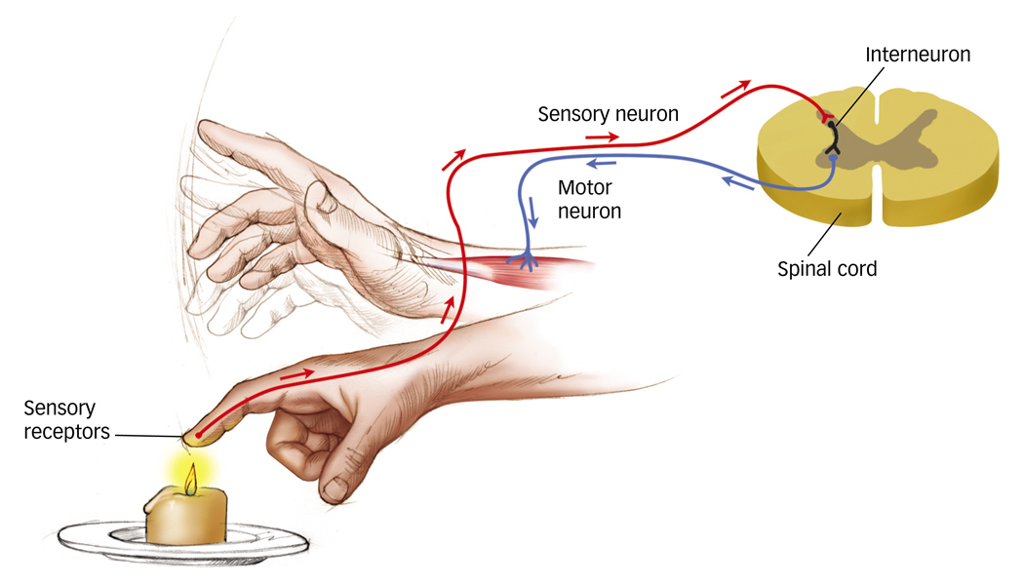
  - Movement is controlled by dopamine.

The nervous system
- Types of neurons
- Sensory: Sends information ‘’up’’ to brain. Receive information from the outside world. (Burn → Spinal cord)
- Motor: Sends information ‘’down’’ from the brain. (Spinal Cord → Muscles to remove hand from flame)
- Interneurons: internal communications. Connect sensory and motor neurons.
Central Nervous System (CNS)
- Brain
Contain interneurons
- Spinal Cord
Peripheral Nervous System (PNS)
Connects the CNS to the organs and muscles of the body.
- Autonomic (ANS): nerves that involuntary (out of conscious control) commands to blood vessels, glands and organs. (Heartbeat, digestion, Blood pressure, respiration, perspiration, etc.)
  - Sympathetic: arouses and raises energy to prepare the body for action in threatening situations. E.g: fight or flight.
  - Parasympathetic: return the body to its normal resting state once the threat has passed. E.g: Rest and digest.
- Somatic: nerves that convey information in and out of the CNS and have control over this system.
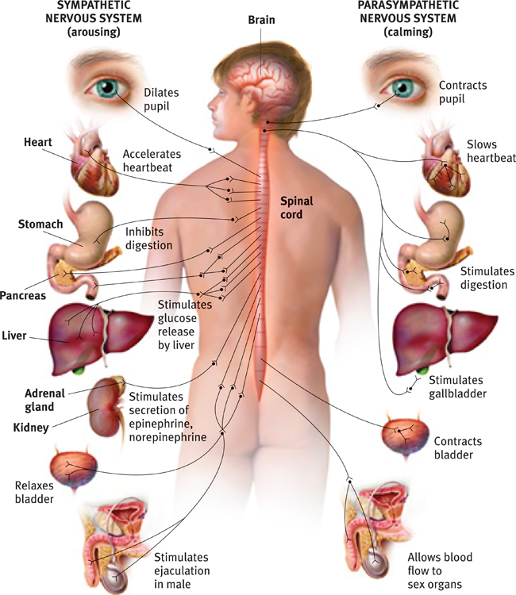
- How the two systems work together?
- The sympathetic nervous system: arouses the body to fight or flee in the face of a threat. It dilates the pupils, accelerates the heartbeat, stimulates glucose release by the liver, stimulates the secretion of epinephrine and norepinephrine and relaxes the bladder and inhibits digestion. It also stimulates ejaculation in the male.

- The parasympathetic nervous system: calms the body once the threat has dissipated and returns it to its resting state. It contracts the pupil, slows the heartbeat, contracts the bladder and allows blood flow to the sex organs. It also stimulates digestion and the gall bladder.

** Goal: To maintain a relatively constant state of arousal; being aware but not on high alert. **

- The brain and Spinal Cord
Medulla
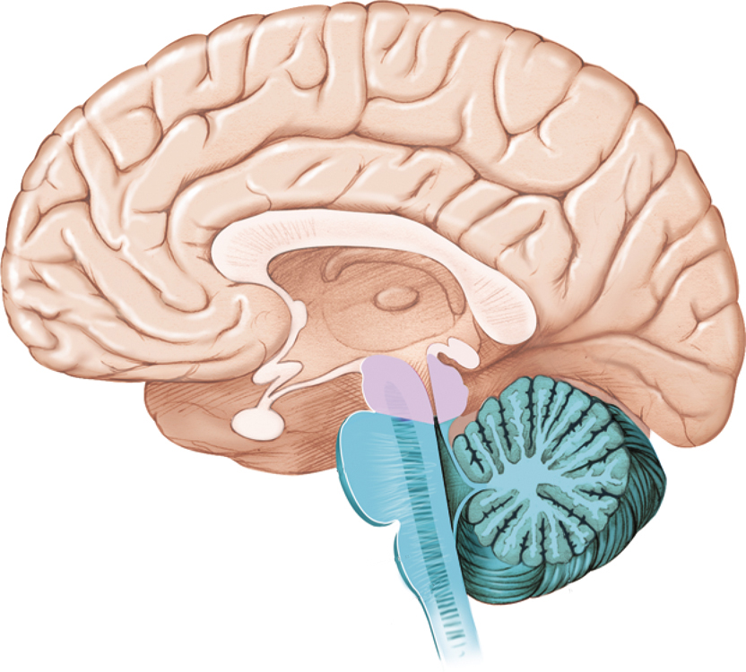
- Spinal Cord
- Brainstem: supports life sustaining bodily functions.
  - Pons (pont de varolle): control/regulate sleep, respiration, swallowing, bladder, hearing, taste, eye movement, facial expression/sensation and posture.
    - Damage? Still breathing and heart function, but vegetative state.
Thalamus
Pons
  - Medulla (middle)
    - Damage? Trouble with basic bodily functions.
- Thalamus: Acts as a relay centre that processes the information before it is sent out the cerebral cortex.
  - E.g: all sensory information travels directly from sensory receptors and travels to a nucleus in the thalamus, and the information is then sent to the appropriate area of the cortex.
Basal Ganglia
cerebellum
R.F
- The Cerebellum (hindbrain): Enables nonverbal learning, coordinates voluntary movements.
  - Damage? Hard to walk/execute voluntary movements. Alcohol affects cerebellum.
- Reticular formation (hindbrain): Regulates sleep, wakefulness and level of arousal.
  - Damage? Permanent coma.
**All hindbrain functions work out of conscious awareness and work regardless of our conscious state **
- Basal Ganglia: Switching centre that directs the intentional movements; receiving input from cerebral cortex and delivering it to motor centers in brainstem.

- Limbic System (UP)
A group of forebrain structures, below the cerebral hemispheres, that are involved in motivation, emotion, learning and memory. Also, includes the Pituitary gland.
- Hypothalamus: Located below the thalamus, it governs the endocrine system.
  - Regulates body temperature
  - Uses light for sleep-wake cycle
  - Houses ‘’reward centre’’
    - Group of neural structures responsible for incentive salience (wanting, desire), pleasure (liking) and positive reinforcement.
    - Primary: for survival of one’s self (sex, food, water, etc.)
- Hippocampus: structure that plays an essential role in the formation of memories about past experiences.
- Amygdala: Almond shaped group of neurons on either tip of the hippocampus.
  - The amygdala directly influences aggression and fear. An animal or human with a damaged amygdala will be quite mellow, remaining calm even when provoked
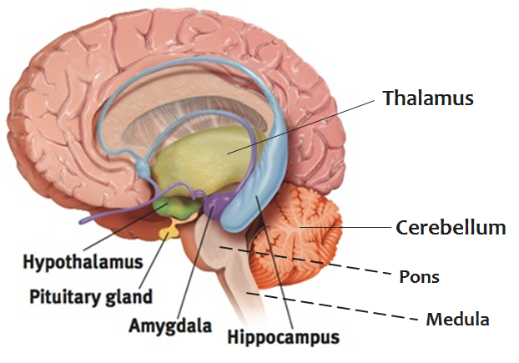
- ** Pituitary gland: Master gland of the endocrine system, it is involved in the stress response. Hypothalamus signals P.G to secrete adrenocorticotropic hormone (ACTH); activation of the SNS.
  - It receives hormone signals from the hypothalamus.
  - Sends hormone signals to other glands to control stress, digestive activities and reproductive activities.

- Cerebral cortex
Interconnected neural cells covering the cerebral hemispheres.
- Larger cortex of mammals offers increased capacities for learning and thinking, making us more adaptable.

** What makes us distinctively human: complex functions of our cerebral cortex **

- Motor cortex: Located at the back of the frontal lobe, different parts of the motor cortex corresponds to different body parts, organized upside down. E.g: top controls movement with toes, bottom controls facial movement.
- Larger areas of the motor cortex are devoted to body parts that require coordinated movement and precise control. E.g: fingers vs. arms.
- Sensory Cortex: Located at the front end of the parietal lobe, it interprets sensations such as touch, temperature and pain in the body.
- If the area is more sensitive, it will have a larger sensory cortex devoted to it. E.g: lips/tongue vs. toes.
- Hemispheres: Divided into 4 lobes.
- Frontal: Planning, judgement, memory, reasoning, abstract thinking.
- Parietal: Sensory information.
- Occipital: Visual information.
- Temporal: Auditory information.

Wernicke’s area: Located in the left temporal lobe of the brain, it plays a significant role in language development (comprehension of speech).

Brain Plasticity: People’s brains change because of experience.
- Children’s brains are much more “plastic” than adult’s brains (plasticity = moldability).
  - will self-repair more easily
  - Can acquire language more readily
  - If language is disrupted in left hemisphere, right hemisphere may compensate.

- Left brain and right brain differences
The two hemispheres are connected by the corpus callosum and are mirror images of each other. General rule for motor and sensory systems:
- Right side of brain (hemisphere) controls left side of body.
- Left hemisphere controls right side of body
There are differences between left and right, but the hemispheres talk constantly over the corpus callosum.
  - One can “take over” functions if the other if one is damaged
  - The “right brain/left brain” dichotomy is not as clear as it is made out in popular literature.

What happens when you ‘’split’’ the brain?
- In split-brain patients, the corpus callosum is severed to stop epileptic seizures.
- Information cannot be relayed from one brain hemisphere to the other.
  - They can verbally identify only objects shown to their right visual field, or in this case, identify an object touched with the right hand.
  - They can identify objects shown to their left visual field by touch (or the left hand), even if they cannot verbally identify them.

