PSY 1101
Course 1 – Introduction

- Roots of Psych? Physiology
Biological branch that studies the functions and parts of living organisms.
- What is psychology?
It is the scientific study of behavior and mental process.
- Scientific: Answering questions objectively based on observable facts, data, and established methods.
- Behavior: Observable actions.
- Mental Process: Thought, feelings, sensations, perception, motivation, dreams, etc.

- Ancient philosophers
- Rene Descartes
  - Dualism: Idea that mind and body are separate entities that interact.
- Plato
  - Nativism: Idea that certain kinds of knowledge are inborn or innate.
- Aristotle
  - Philosophical empiricism: idea that all knowledge is acquired from experience

- Early schools of Psych
- Wilhelm Wundt
- Science of psych: promotes belief that experiments are the methods that should be used to explain mental process.
- Best way to measure mental process?
- Edward Titchener
- Structuralism: complex conscious experiences could be broken into elemental parts or structures.
- Structures of conscious experiences?
Functionalism: How behavior functions to allow people and animals to adapt to their environment
- William James
- Prof + philosopher
- Influential for establishing psych in the U.S
- Charles Darwin
- The naturalist inspired other psychologists to study how animals adapt to their environments.
- Sigmund Freud
- Psychoanalysis Theory (the Unconscious) **: Unconscious mental process shapes behaviors, feelings and thought.
Psych redefined as scientific study of observable behavior – not just introspection. Focus: ignoring introspection/cognitive process.
- Ivan Pavlov
- Discovery of conditioned reflexes.
- John Watson
- Extends approach to human behavior.
- B.F Skinner
- Further experiments on behavior, learning and conditioning.
- Carl Rogers
Human Psych:
- Positive potential of humans assumed
- Emphasis on human-determination, free will and impact of choice
- RXN to Freudian introspection and RXN to behaviorist schools that there is no consciousness
- Abraham Maslow

New schools develop:
- Emphasis on mental process and how they influence behavior

- Cognitive psychology: Scientific study of perception, thought, memory and reasoning process.
  - Analogies on how computers and the human mind process information.
Brain activity
Mental activity

- Perspectives and Practices:
- Nature vs. Nurture
  - Are gender differences biologically predisposed or socially constructed?
  - Is a child’s language skill mostly innate or formed by experience?
  - How are differences in intelligence and personality influenced by heredity and environment?
- Psychology’s current perspectives
  - Perspective: way of viewing subject matter or phenomena.
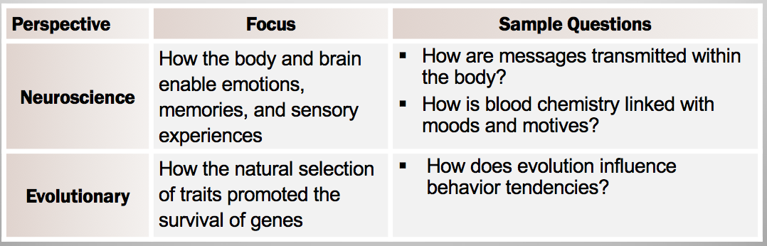
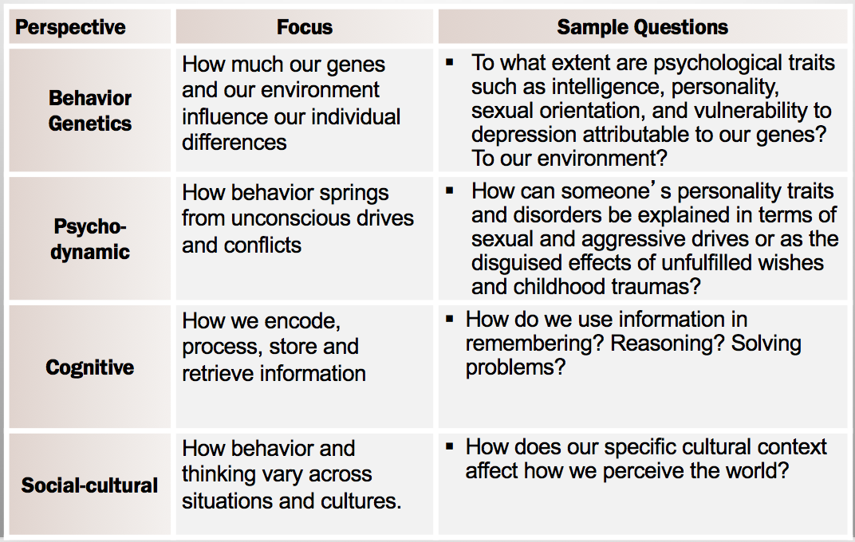

- The scientific attitude and critical thinking
- Whatever setting or subfield, psychologists maintain a scientific attitude
  - Curious, skeptic and humility

- Critical thinking…
- Examines assumptions
Psychologists are open to surprising findings and willing to debunk popular preconceptions.

- Discerns hidden values
- Evaluates evidence
- Assesses conclusions

- The scientific method
The scientific method is a self-correcting process for asking questions and gaining answers.

- DATA COLLECTION
Empirical Evidence: Evidence gained and verified through objective observation, measurement, and experimentation.

 | Descriptive methods are used to observe/describe behavior | Some drawbacks to these methods
Case Study | Examines one individual or social unit in depth in the hope that the findings can be generalized. | The case study may be too narrow to be of general use.
Survey | Asking people to respond in depth to a series of questions or to report on their behavior. | People may not respond accurately to surveys or may be biased.
Naturalistic Observation | Observing and recording behavior as it occurs in its natural setting. | Naturalistic observations may not reveal all the factors that contribute to the observed behavior.

- Comparison?
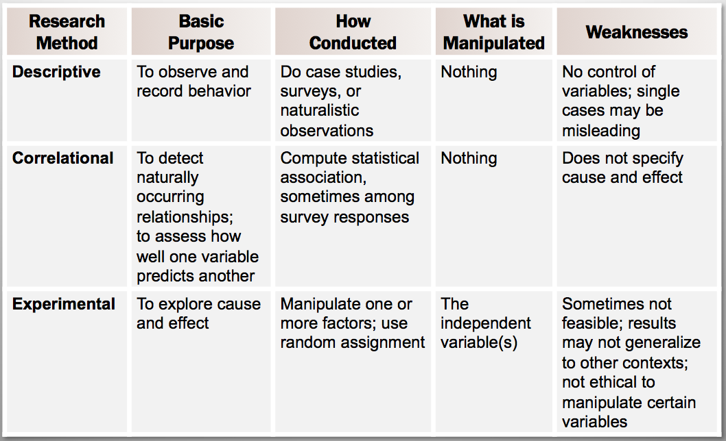

- Research: Correlational Methods (observation)?
- Positive correlations = two factors increase or decrease together
- Negative correlations indicate that when one factor increases, the other decreases.
  - Correlation does not prove causation, so use of experimentation test the hypothesis. 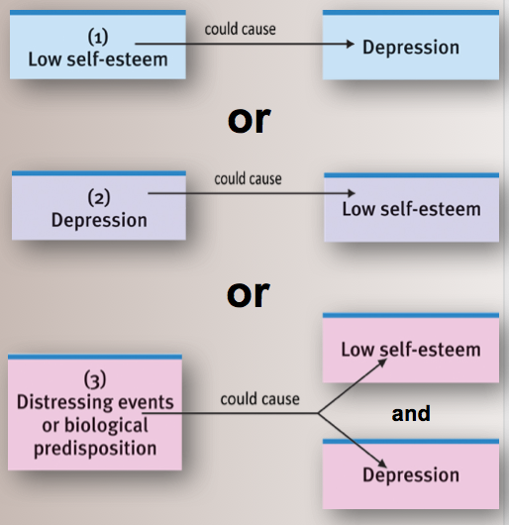
- Research: Experimentation
Experiment: method to test a hypothesis about a cause-and-effect relationship.
- Participants are randomly assigned into experimental and controlled groups, and then are subject to dependent and independent variables.
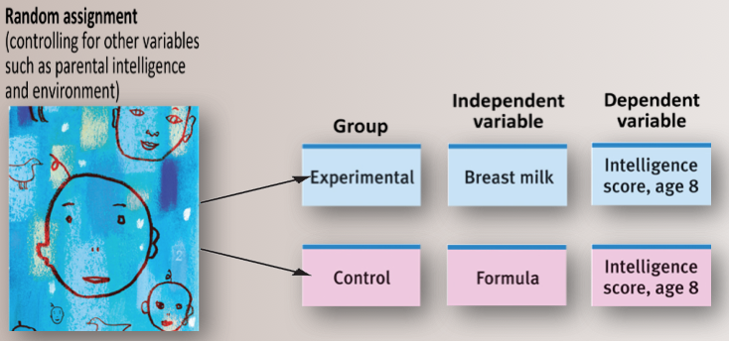
Image: measuring dependent variable (intelligence at age 8) will determine the effect of independent variable (type of milk).

Placebo: Fake independent variable

- SUMMARIZE DATA
- Statistics: math used to organize summarize and interpret data.
- Used for describing data and basis for inferring info from data
- Graph or some other visual form
- Descriptive stats: math used to organize, summarize and describe data.
- Used to put information into a more compact form; summarizing distributions with single score that is typical in some way.
- Can be misleading:
  - Variability: scores are spread out differently (ex: same mean, diff variability)
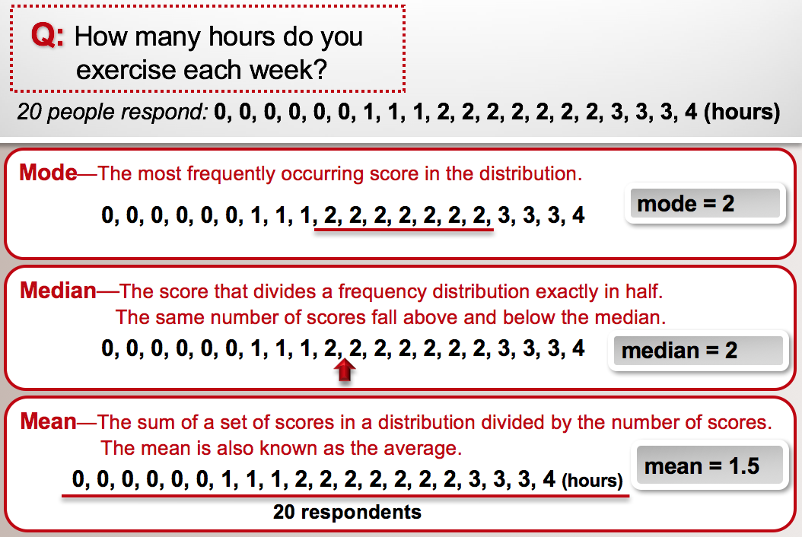

Correlation: Relationship between two stats
Correlation doesn’t tell us which is “cause” and which is “effect” -- just that they are (co)-related.
- Positive correlation: two variables change in the same direction, either increasing or decreasing together.
  - Often directions are shown in scatter dot diagrams = indicates no correlation
- Correlational Coefficient: statistical measurement of two variables (+1.00 to -1.00).
  - Positive correlation: frequent yoga = high energy, vice versa.
  - Negative: frequency of meditation (+) is always accompanied by less smoking (-), vice versa.
- Tell us what might be leading to specific relationships **
- Interferential stats: making inferences about cause of behavior and conclude sample of data.
- Depends on population and sample of the subject under study because can’t afford to measure the full population.
  - The larger the sample = better inference
- Example hypothesis: Watching violent TV positively correlates with aggression in children?
  - Watching violent TV causes aggression
  - Aggression causes children to watch violent TV
  - Variables cause both…
- Determine cause and effect **
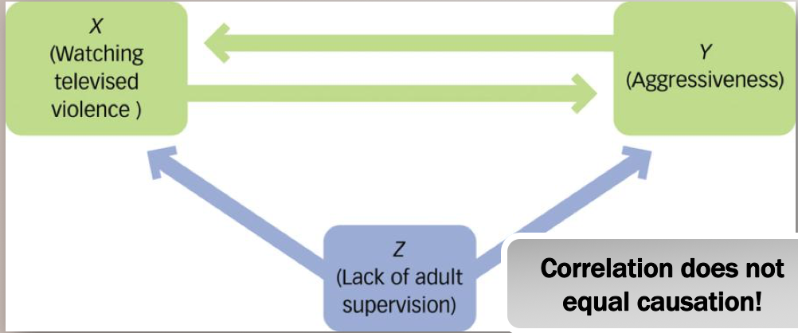

The nature of science: we have a hypothesis, and we’re making a judgment about whether it’s likely to be correct or not.
- We make a judgment based on statistical probabilities, i.e., is this result likely to have occurred by chance alone, or is it a consistent and reliable difference?
  - Type I error: wrongly concluding that study results are significant.
    - Lie detector suspects the person is lying, but is telling the truth.
  - Type II error: Failing to find significant effect that exists.
    - Lie detector indicates suspect is telling the truth when he is lying.
How to avoid errors?
- Representative samples > bias samples.
- Less-variable observations.
- More cases.
- Statistical significance.
- Designing an experiment:
- Experimental and control groups
- Double-blind procedures = avoids bias in dependent variables.
- If required, use placebo.

- BUT we can’t always do experiments….
- Ethical barriers
- Logistical barriers (e.g., money)
- Practicality barriers (e.g., changing the religious beliefs of Chinese population)

Ethics:
  - Informed consent must be given, and participation must be voluntary.
  - Participants may not be coerced into research participation.
  - Deception can be employed only under certain conditions.
  - Personal information about research participants must remain confidential.
  - Information about the study must be provided to participants, who should also be debriefed.

- Both descriptive and experimental techniques necessary for study of behavior

