Name
Student number
Section

Procedure
The procedure is detailed in the CHM 1321 Introductory Organic Chemistry Laboratory Manual 2017. The temperature level of the heating mantle was turned up to about 85 as opposed to the suggested 60-80.

Observations
Simple Distillation
10:50 am Condensation accumulating outside of the condenser
11:09 am Bubbling due to boiling of clear liquid in distilling flask
11:09 am Condensation collecting on thermometer and in distillation head
Fractional Distillation
12:29 am Distillate appears viscous; as if the clear liquid is fractured, like hot air.

Tables
Fractured Distillation Simple Distillation
Temperature (̊C) | Volume of Distillate (mL) |  | Temperature (̊C) | Volume of Distillate (mL)
22.0 | 0 |  | 24.0 | 0
78.1 | 1 |  | 63.6 | 1
78.5 | 2 |  | 66.2 | 2
82.2 | 3 |  | 68.6 | 3
79.2 | 4 |  | 73.6 | 4
83.0 | 5 |  | 76.2 | 5
84.0 | 6 |  | 77.2 | 6
83.5 | 7 |  | 79.2 | 7
83.5 | 8 |  | 79.6 | 8
87.0 | 9 |  | 79.9 | 9
89.0 | 10 |  | 81.3 | 10
90.3 | 11 |  | 78.8 | 11
93.0 | 12 |  | 81.3 | 12
95.5 | 13 |  | 80.6 | 13
104.1 | 14 |  | 82.4 | 14
107.0 | 15 |  | 83.3 | 15
109.1 | 16 |  | 86.7 | 16
111.8 | 17 |  | 89.6 | 17
113.1 | 18 |  | 95.1 | 18
111.5 | 19 |  | 97.8 | 19
112.0 | 20 |  | 101.0 | 20
113.3 | 21 |  | 100.7 | 21
 |  |  | 101.4 | 22
 |  |  | 100.1 | 23
 |  |  | 93.6 | 24

Graphs

Discussion
It is clear from the both completing the procedure and from the results that the substances were successfully separated. As the temperature reached and passed the boiling point of 2-propanol, the volume of distillate increased until most of the 25mL of 2-propanol was distilled.
However, the ideal distillation curve is more gradual when a simple distillation is done and more sharp for fractured. This is because the steepness of the curve indicates the level of efficiency of the component separation. The plateaus of the fractured distillation curve usually occur at the boiling points with a sharp transition between them. In the obtained graph, the plateaus are evident at roughly the proper temperatures (83 and 118 degrees Celsius), but the sharper transition that should contrast with the simple distillation’s gradual increase is not noticeable. The reason for this could be that the heating mantle was turned up too high during the fractured distillation. This would result in a higher temperature in the fractionating column and distillation head, and a higher distillation rate. With a higher distillation rate comes less separation efficiency, because it means fewer vaporization-condensation cycles can occur in the fractionating column. The vapour would contain a smaller portion of the lower boiling component and the contents of the receiving flask would be less pure.

Questions
- When the liquid flows back through the fractionating column, the hot ascending vapours allow it to be vaporized again, but it condenses further up the column. By undergoing multiple vaporization-condensation cycles to occur in the fractionating column, one essentially performs multiple simple distillations simultaneously, with better separation of the lower boiling substance each time.
- A smooth temperature gradient in the fractionating column allows for any of the high boiling component that might have been vaporized to condense and drip down until it gets hot enough to be vaporized again, with a higher proportion of lower boiling component. It makes the separation of components more effective.
- The boiling point of a substance is the temperature at which the vapor pressure of the substance is equal to the ambient pressure. The standard ambient pressure used to determine standard boiling points is 760 torr, so benzene’s vapor pressure at its boiling point is also 760 torr.
- Increasing the atmospheric pressure raises the boiling point of a liquid, because more energy is needed to raise the vapor pressure to match the increased atmospheric pressure.
- Cool water enters the condenser from the bottom so that it’s completely full of water to actively condense. If water came through the top, an improper flow rate would result in the water trickling down one side of the condenser, and only a section of it effectively condense the vapour.
- The 3:1 ratio indicated that the mole fractions of compounds A and B are 0.75 and 0.25 respectively. Applied to Raoult’s law, the vapour pressure can be determined once the mixture reaches its boiling point. When inserted into the equation P_{T} = P_{A}•N_{A} + P_{B}•N_{B} , a total pressure of 300mmHg is attained.

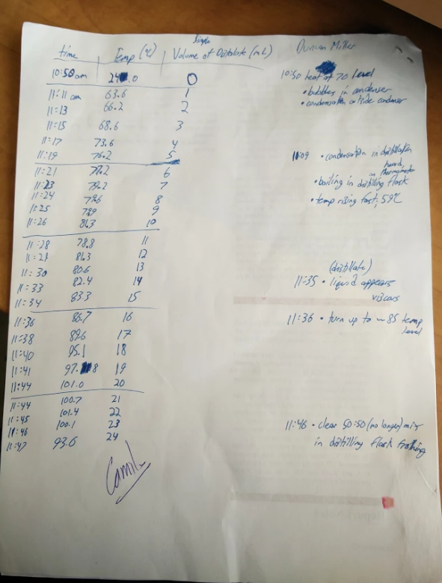
Data Sheets



