Materials, Methods, Results, and Discussion for PCR Amplification and Purification of T7 RNA polymerase

University of Ottawa

Course: BCH3356
Section: AA Lab 4
Team Number: 11
Name: Joel Smith
Student number: 7719828
Date: Tuesday, October 4th, 2016
T.A: Graham Heberlig
Materials and Methods
Two Polymerase Chain Reactions are prepared for the amplification of T7 RNA polymerase. The first, a positive control contains an unknown DNA template (10.0 uL) that was previously prepared by lab technicians at the University of Ottawa. Whereas the second reaction, a negative control is absent of the DNA template. Specific T7 RNA polymerase forward and reverse primers are also used. The forward primer has the following nucleotide sequence: 5’-GTGGTATAAGCTTAT
GAACAACACGATTAACATCGCTAAGAACGACTTCT-3’. While the reverse primer has a nucleotide sequence of 5’-ATTTATGAATTCTTACGCGAACGCGAAGTCCGACTCTAAGA
TG -3’. The preparation of the PCR is extremely important for high quality results and thus when preparing the reaction it is stressed to keep all reagents and reactions on ice and to add the reagents in the following sequence (for the positive control): H₂0 (63.5 uL), 5X Phusion HF buffer(20.0 uL), dNTPs (2.0 uL), T7 RNA forward primer (2.0uL), T7 RNA reverse primer (2.0 uL), unknown DNA template (10.0 uL), Phusion DNA polymerase (NEB)(0.5 ul). For the negative control the same sequence is used to prepare the PCR, however as previously mentioned the DNA template is not added and instead and extra 10.0 uL of H₂O is added. Both reactions are required to have a final volume of 100 uL. The samples are kept on ice until transferred to a thermocycler preset to 4°C. After about 40 minutes in the thermocycler the sample is removed. 2uL is transferred to a separate test tube to be used in the gel electrophoresis. While 98 uL is taken from the unpurified amplicon and combined with 98 uL of your partner’s amplicon, in addition 392 uL of NTI buffer is added to this reaction mixture. The mixture is purified using Clontech Nucleospin Gel and PCR Clean-Up. The exact purification procedure can be found in Appendix E3 in the Molecular Biology Laboratory Manual (pg 152). 2 uL the purified amplicon, 2 uL of the unpurified amplicon, and 2 uL of the negative control are added in three different test tubes. 7uL of H₂O and 1uL of 10X loading buffer are added into each tube. 5uL is loaded onto a 1% agarose gel including a negative control and unpurified amplicon from my partner, for a total of 5 wells. Electrophoresis is carried out at 100V for 1 hour. A picture of the resulting gel is taken using Alphamager mini camera software.
Results
Purified
Unpurified
(Meg)
Negative
Control
(Meg)
2000 bp
1500 bp
3000 bp
5000 bp
7000 bp
10000 bp
Negative
Control
(Joel)
Unpurified
(Joel)
Purified
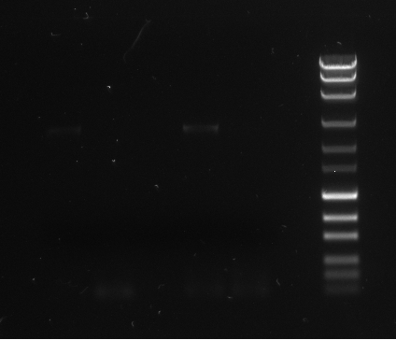
200 bp
300 bp
500 bp
700 bp
1000 bp
1
2
3
4
5
7
6
Figure 1. Gel Electrophoresis results of purified amplicon, unpurified amplicon and negative control (first attempt). 1% agarose gel was cast using 100 mL 1X TAE buffer and 10 uL of SYBR Safe. Purified and unpurified amplicon were prepared using H₂0 (63.5 uL), 5X Phusion HF buffer (20.0 uL), dNTPs (2.0 uL), T7 RNA forward primer (2.0uL), T7 RNA reverse primer (2.0 uL), unknown DNA template (10.0 uL), Phusion DNA polymerase (NEB)(0.5 uL). Purified amplicon had combined products of both mine and my partner’s amplicon (98uL +98 uL) as well as 392 uL of NTI buffer. The reaction was purified using Clontech Nucleospin Gel and PCR Clean-Up. The negative control was prepared using the same reagents, substituting 10 uL of the unknown DNA template for an additional 10 uL of H₂O. 2 uL was transferred from each sample into a new microtube, 7uL of H₂O and 1uL of 10X loading buffer are added to each solution and the solution is mixed thoroughly. 5 uL of each solution is pipetted into wells 1-5. 10 uL of MassRuler Express Forward DNA ladder marker is added to well 7 by our TA. Electrophoresis was ran at 100 V for 1 hour. The gel is analyzed under UV light and this figure was captured by Alphamager mini.
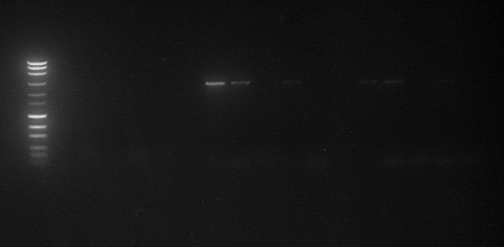
UP1
js
P
N1
N2
UP2
300 bp
200 bp
500 bp
700 bp
1000 bp
1500 bp
2000 bp
3000 bp
5000 bp
7000 bp
10000 bp
18

17
16
15
14
Figure 2. Gel Electrophoresis results of purified amplicon, unpurified amplicon and negative control (second attempt). 1% agarose gel was cast using 100 mL 1X TAE buffer and 10 uL of SYBR Safe. Purified and unpurified amplicon were prepared using H₂0 (63.5 uL), 5X Phusion HF buffer (20.0 uL), dNTPs (2.0 uL), T7 RNA forward primer (2.0uL), T7 RNA reverse primer (2.0 uL), unknown DNA template (10.0 uL), Phusion DNA polymerase (NEB)(0.5 uL). Purified amplicon had combined products of both mine and my partner’s amplicon (98uL +98 uL) as well as 392 uL of NTI buffer. The reaction was purified using Clontech Nucleospin Gel and PCR Clean-Up. The negative control was prepared using the same reagents, substituting 10 uL of the unknown DNA template for an additional 10 uL of H₂O. 2 uL was transferred from each sample into a new microtube, 7uL of H₂O and 1uL of 10X loading buffer are added to each solution and the solution is mixed thoroughly. 5 uL of each solution is pipetted into wells 1-5. 10 uL of MassRuler Express Forward DNA ladder marker is added to well 7 by our TA. Electrophoresis was ran at 100 V for 1 hour. The gel is analyzed under UV light and this figure was captured by Alphamager mini.
Due to insignificant DNA amplification in our first PCR (figure 1), the laboratory was repeated with similar results (figure 2). The same process was used to complete the PCR. Very faint bands can be observed in both figures however the amount of DNA that was optimized is not ideal.

Discussion

The results obtained from this laboratory are not the anticipated desired results. As seen in figure 1 there is a lack of intensity in well 1,2 and 4. Figure 2 shows very similar results to those seen in figure 1 wells 14,15 and 17 are absent of any bands with amplified DNA. Lack of band visibility in (figure 1) can be caused by a lack of SYBR Safe DNA stain that was added to the agarose gel. When the gel was cast there was not a full 10 uL of SYBR Safe available to stain the DNA. All 3 groups who shared the same gel failed to get and satisfactory visible bands. Other possible faults in a poorly visible band can be caused by improper addition of reactants during preparation of the PCR mixture. A lack or excessive amount of a reagent can cause a lack or absence of any product. Another possible error is improper mixture of the PCR solution before it was placed in the thermocycler. Phusion DNA polymerase like Taq DNA polymerase contains high amounts of glycerol and will fall to the bottom of the reaction tube. Without proper mixture of the solution low optimization of the DNA will more than likely occur.

If the PCR was a success, well 1 in figure 1 and well 14 in figure 2 would have a intense band around 2500 bp using the DNA ladder as reference. Due to the fact that the DNA was purified using Clontech Nucleospin Gel and PCR Clean-Up, these bands should be more intense than those of the unpurified dna that are found in wells 2 and 4 in figure 1 and 15 and 17 in figure 2. While wells 3 and 5 in figure 1 and 16 and 18 in figure 2 are negative controls and should not contain any bands due to the absence of the unknown DNA template.

