Chapter 10: Regulating Business
Spectrum of regulation
- Self-regulation: regulation imposed by corp. or industry and not by gov’t or market forces
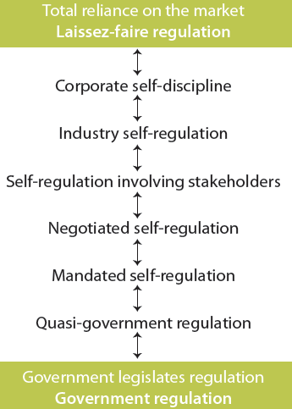
- Gov’t regulation: gov’t extensively regulates industry or some aspect of business operations
Market regulation
- No need for government-imposed laws or regulations
- Corporation influenced by market forces
- Laissez-faire approach
- Government does not interfere with business
- Consumers can force companies to behave in particular ways
by refusing to purchase goods or services or through boycotts
Self-regulation
- Laissez-faire market regulation
- Corporate self-discipline regulation: Mission, values statement, codes of conduct or ethics
- Industry self-regulation: Voluntary codes
- Self-regulation involving stakeholders
- Negotiated self-regulation
  - Some outside body voluntarily negotiates regulatory standard (ex: NGO, gov’t agency)
- Mandated self-regulation: Gov’t prefers industry regulate itself, grants this under legislation
- Quasi-government regulation
  - Rather than regulate industry directly through gov’t departments, some regulation is delegated to government agencies that operate at arm’s length from government
Scope of government
- Scope of government-business relationships. Government
  - Is architect of economic growth
  - Prescribes rules businesses must follow
  - Is a major purchaser of goods and services produced by businesses
  - Is a major promoter and subsidizer of businesses
  - Is supplier of debt capital to businesses (tax expenditures + credits, chosen instrument)
  - Is a rescuer of failed businesses, Is the protector of business and producer interests
  - Is the owner of business enterprise
  - Is partner with business in some endeavors (mixed enterprise, PPP)
  - Directly manages (through regulation) large areas of private business activity
  - Is the protector of various societal interests against business exploitation
Legislation CSR
- Legal system can be used to protect stakeholders (e.g., investors, consumers, employees)
- Attempts made to legislate CSR in US, UK and Canada but with only limited success
Lobbying: All attempts to influence directly or indirectly any government activity, includes any attempt to influence legislators, their staff members, public administrators, and members of regulatory agencies
Business lobbying
- Business lobbying attempts to influence:
  - The making or amending of legislation and regulations
  - The making or changing of government policies or programs
  - Gov’t decisions in awarding of grants, contracts, contributions, or similar benefits
  - Governments appointments to boards, commissions, and any other public office
Types of business lobbyists
- Business interest groups or associations: influence government through lobbying
- Consultants who specialize in government-business relations: tell bus. how to influence gov’t
- “In-house” lobbying capability through gov’t relations:
Business lobbying: benefits
- Business must lobby to offset the influence of other groups
- Opinions or perspectives must be made known to gov’ts if informed decisions are to be made about public policies affecting business
Business lobbying: criticisms
- Practices were unethical (e.g., bribes, gifts, improper political contributions, blackmail)
- Business lobby too powerful and presents a view that is too one-sided
- Business has unequal access to government, business is overrep’d + consumers underrep’d
- Cost of business lobbying can be passed on to consumers through prices paid for g and s
Corporate public affairs departments:
- Management function responsible for monitoring and interpreting gov’tal environment of corp. or industry and for managing responses necessary to protect interests of corp./industry
- Role expanded to include community relations, media relations, environmental monitoring, issues management, lobbying, and public relations
Corporate agenda: real or imagined alleged domination of public policy or gov’t programs by corporations or business orgs in their own best interests
- The corporate agenda might include:

  - Reduction of gov’t involvement
  - Deregulation of business + industry

  - Reduced corporate taxation
  - Enactment of free trade agreements and support for globalization
Corporate welfare: any action by municipal, provincial, or federal gov’ts that give specific corp. or entire industry benefit not offered to others
- Industries appear increasingly willing to advocate for and accept government assistance
Impact of changing government involvement
- Deregulation: reduction of gov’t influence or impact over economy allowing for freer and more efficient marketplace
  - Pro: more competitive business environment = productivity, more efficiency, lower P
  - Con: reduced environmental quality standards, greater financial uncertainty, market control by monopolies
- Privatization: strengthening of the market at the expense of the state
- Common themes of privatization
  - Provision of public service by the private sector
  - Degrees of privatization (i.e. complete or partial)
  - Techniques or forms of privatization (i.e. divestiture, contracting out)
  - Terms are used that have overlapping meanings (i.e. contracting out service delivery)
Ethical implications in business-government relationship
- Appropriateness of government involvement and interference in business operations
- Matter of accessibility to government
- Favouritism to some corporations regarding loans, grants, or protecting
- Endorsement of political candidates or parties can be perceived as expecting future favours
- Lack of transparency in relationship (that is, influence) between government and business
Ethics in government
- Relation between business + gov’t involve ethical behavior of politicians and public admins
  - Governments have developed codes and conflicts of interest guidelines
  - Business codes and guidelines often include clauses identifying appropriate behavior when dealing with government
- Morality of operating some government-owned business corporations
Chapter 11: Ownership and Governance of the Corporation
Role of the owner stakeholder
- Owners, also referred to as investors or shareholders, are key stakeholders in a capitalist system as they provide a major portion of capital to finance corporations
- Governing system: processes, structures, & relationships through which decisions are made
Ownership of Canadian business

- Investors
- Entrepreneurs
- Employees and managers
- Customers or consumers
- Producers
- Mutual funds
- Pension funds
- Union sponsored investment funds
- Corporate ownership
- Private equity firms
- Venture capital company
- Not-for-profit organization ownership
- Government ownership

Investors: individuals who personally hold equity interests for investment purposes and who are not involved in the corporation as entrepreneurs or managers
Mutual fund: pool of money from many individual investors that is invested on their behalf, usually in a specific kind of investment, does not include right to vote as a shareholder
Labor-supported investment funds (LSIFs): funds that provide venture capital primarily to private corporations to create employment
Private equity firms: manage large pools of money acquired from wealthy individuals or families and big institutions such as pension + mutual funds, not listed/traded on stock exchange
Venture capital company: type of private equity firm that usually acquires part ownership of business enterprises for which they provide financial and management assistance
Issues of ownership
- Widely held versus concentration ownership
- Minority versus majority shareholders
  - Increase in # of takeovers where rights of minority holders were being overlooked
  - Majority of minority shareholders must approve takeover/management proposal
- Dual-class stock: more than one type of share or stock with different voting rights and dividend payments is issued by single corporation
  - Non-voting shares: common shares without voting privileges
  - Restricted shares: involve some limit on voting, sometimes called uncommon shares
Passive versus active shareholders
- Passive shareholders: do not attempt to influence affairs of corp. when have legal right to
- Active shareholders: participate in governance of firm to full extent allowed by law
Pros and cons of employee ownership
- Pros:

  - Increases morale
  - Increases company loyalty

  - Motivates employee = productivity
  - Sometimes can save failing firms

- Cons:
  - Jobs and often savings and pensions depend on fate of firm
  - Employees rarely have majority ownership and control of corporation
  - Management may still not relinquish control to employees
Issues of accountability
- Accountability of non-public corp. and accountability of government-owned corps.
Protecting owners and investors
- Shareholder democracy: exercise of power by owners to ensure they are treated fairly and enjoy equally the privileges and duties of ownership
- Governments (e.g., US Sarbanes-Oxley Act, 2002)
  - Public company accounting oversight board

  - Auditor independence
  - Corporate responsibility

  - Enhanced financial disclosures
  - Corporate + criminal fraud accountability
  - White-collar crime penalty enhancements
- Self-regulatory agencies and organizations (e.g., stock exchanges)
- Industry associations (e.g., Investment dealers’ association)
- Individual and institutional activists (e.g., small investor protection association)
Responsible investing: screening investments in corps. or mutual and pension funds for their response to social or ethical responsibilities as well as their financial or economic performance
- Several mutual funds have been established that have socially responsible objectives
- These funds are categorized into two types: do-gooder (invests in corp. with good social + environ. records), with positive screens, or objectionable (obj. corp.), with negative screens
- Use positive screens and negative screens (e.g., alcohol, tobacco, weapons, nuclear power)
Stakeholders monitoring responsible investment
- Social Investment Organization – SIO (Canada)

- Jantzi Social Index – JSI (Canada)
- Domini 400 Social Index (US)
- Dow Jones Sustainability Indexes (US)
- FTSE4Good Index Series (UK)

Corporate governance: processes, structures, and relationships through which shareholders, as represented by board of directors, oversee activities of the corporation
Rights of shareholders

- Secure ownership registration
- Capability to transfer ownership

- Access to relevant corporate info
- Participate/vote at shareholder meetings

- Election + removal of board members
- Share in profits of the corporation

- Knowledge of extraord. transactions or decisions

- Disclosure of dual-class shares
- Capability to exercise ownership rights

- Rules and regulations to ensure transparent functioning of capital markets
- Ability to consult other shareholders relating to their rights
Responsibilities of the board
- Board of directors: elected by shareholders to govern or oversee corp. affairs, monitor + evaluate corp.’s activities/performance, power: select, value, fire CEO + top management
- Fiduciary duties: obligations of directors to shareholders prescribed by laws or regulations
- Board’s written mandate must include board’s satisfaction with integrity of CEO and other execs and that they are creating a culture of integrity (Canadian stock exchanges)
- Board must apply high ethical standards + take acct interests of stakeholders (OECD, 2004)
Board membership
- Independent (or unrelated) director: director who is free from any interest and any business or other relationship which could, or could reasonably be perceived to, materially interfere with director’s ability to act in best interests of the corporation
Board structure
- Board of committee examples: audit; finance; HR; pension; compensation; nominating; governance; strategic planning
- Audit committee is required to have independent members
- Most experts recommend separation between role of board chair and the CEO
Disclosure and transparency
- Disclosure requirements for Canadian public companies (national instrument 58-201)
  - Disclose whether board has adopted written code
  - Describe steps board takes to encourage & promote culture of ethical business conduct
  - Disclosures of executives’ compensation
- Audit committee: members of board oversee internal and external accounting auditing function to ensure that financial statements accurately and appropriately represent condition of corporation and that regulated disclosures are made
Evaluating board and director performance
- Reluctance as process may exposes weakness in governance process and be embarrassing and collegial relationship among board members may be disrupted
- Criteria for evaluating board performance:

  - Legal
  - Strategic and social
  - Financial
  - Business
  - HR
  - Governance

Legal: protects shareholder interest, ensures compliance with regulation + financial reporting Strategic and social: participates in strategic decisions such as acquisitions and capital incr.
Financial: reviews and approves annual capital and operating budgets, evaluates risk
Business: approves investment guidelines, evaluates corp. performance
HR: selects, evaluates and monitors CEO performance, determines exec compensation
Governance: selects board, evaluate member performance, ensure committee appropriateness
Criticism of corporate governance reform
- Audit fees have increased
- Management attention diverted away from operation of business
- Additional costs have made North American business less competitive in global market
- Changes may not make a difference to firm performance or in protection of shareholders
- Approach should be principles-based, not rule-based
Rebalancing power in the corporation
- CEOs have been too powerful
- New balance of power emerging among management, board, professional services (lawyer, auditor)
- Directors now playing bigger role in strategic decision making and ethical responsibilities

- Auditors more cautious
- Legal counsel representing everyone

- Some shareholders more active in pressuring boards
Corporate governance and performance
- Some research suggests that good corporate governance affects firm performance
- Effective boards:
  - Are accountable and independent
  - Have experienced, knowledgeable and effective directors with highest level of integrity

  - Have clear roles and responsibilities
  - Engage with stakeholders

OECD principles of corporate governance
- Rights of stakeholders are to be respected
- Effective redress for stakeholders when rights violated
- Stakeholders should have access to info
- Stakeholders should be allowed to blow whistle on illegal or unethical practices to board
Ownership, governance, and CSR
- Directors are encouraged to ask five questions about corporation’s ethics management:
  - What is strategy to manage ethics?
  - Who is responsible for ethics in company?
  - Are people in our firm equipped to recognize and resolve moral dilemmas?
  - Are people in firm provided with safe opportunity to discuss ethical issues of concern?
  - Do we reward or punish ethical integrity and moral courage if it has negative impact on bottom line?
- Schacter argues that four factors have to come together for board to pay attention to CSR

  - Globalization
  - Loss of trust
  - Civil society activism
  - Investor interest in CSR

Chapter 12: Ethics Responsibility in the Workplace and the Marketplace
Issues associated with key stakeholders
- There are four stakeholders to be discussed:

  - Employee
  - Consumers
  - Competitors
  - Suppliers

Employee in the workplace
- Work conditions: Safety, working hours, work-life balance, wellness program, etc.
- Workforce reduction: Notice, severance, etc.
- Privacy: Health and drug testing, monitoring, etc.
- Unions: Anti-union tactics, change in work rules, etc.
- Fair compensation: Pay based on performance, pay equity, pension plans, etc.
- Employee loyalty and duties:
  - Complying with contracts, work quality, respect for property and use of resources, etc.
- Diversity management: Freedom from discrimination, harassment, employment equity, etc.
- Right to due process: Promo and dismissal policies, access to employment files
- Employee participation: Freedom of speech and whistle blowing, right to join union, etc.
- Right to work: Fairness in interviews, non-discriminatory, etc.
- Work ethic:
  - Set of values which holds that work is important to members of society; is a purposeful activity; that some gain (e.g., money) is involved, and that through work, a person contributes to society and becomes better individual
- Contemporary implications on the work ethics:
  - Workplace stress, fringe benefits changing, compensation based on performance, work balance, moonlighting, job insecurity, labor skills shortage
- Employee loyalty: commitment by employees to organization they work for
  - Employers can also demonstrate loyalty to employees
  - Measuring loyalty can be difficult
  - Loyalty can go to one’s self or one’s job, rather than corporation
- Managing employment diversity
- Discrimination: preferential (or < preferential) treatment on bases not directly related to qualification of the job or job performance, prejudice against certain people
  - Categories: race, gender, nationality, age (young and old), disability, marital status, physical appearance, sexual orientation, and health
- Legislation to address discrimination: Employment equity act; Canadian human rights act
- Employment equity: fair and equal treatments of employees
- Diversity management
  - Voluntary initiative beyond what is required by law to eliminate discrimination
- Workplace privacy
  - Privacy of personal info is regulated by federal gov’ts Personal Info Protection and Electronic Documents Act (PIPEDA) and other provincial legislation
- Employees and CSR
  - Employee engagement: emotional and intellectual commitment of an individual or group to an organization that supports building and sustaining business performance
Consumer and consumption
- Consumer sovereignty
  - Consumers dictate goods and services to be provided

  - Elements of democracy are present
  - Consumers make own choices

  - Economic system operates more efficiently when consumers determine production
- Consumers and marketplace: concerns: high info costs, misleading ad, unsafe goods
- Consumerism: social movement seeking to protect and augment rights and powers of buyers in relation to sellers
- Consumer rights
  - To choose, be heard, educate, redress, to be informed, to safety, to healthy environment
- Issue: but is the customer always right?
- Consumers and CSR
- Issue: but are socially conscious consumers willing to pay for ethical products?
Competitors and competition
- Competition and ethics and responsibilities
- Competition is necessary for an effective market economy and benefits consumer
- But can lead to questionable practices: industrial spying, espionage, sabotage, eavesdropping, hiring competitor’s key employees
- Causes: cutthroat global economy, aggressive competitive tactics, and shorter product cycle
- Concentration of corporate power: concern over collaboration and higher profitability
- Government influence to encourage competition
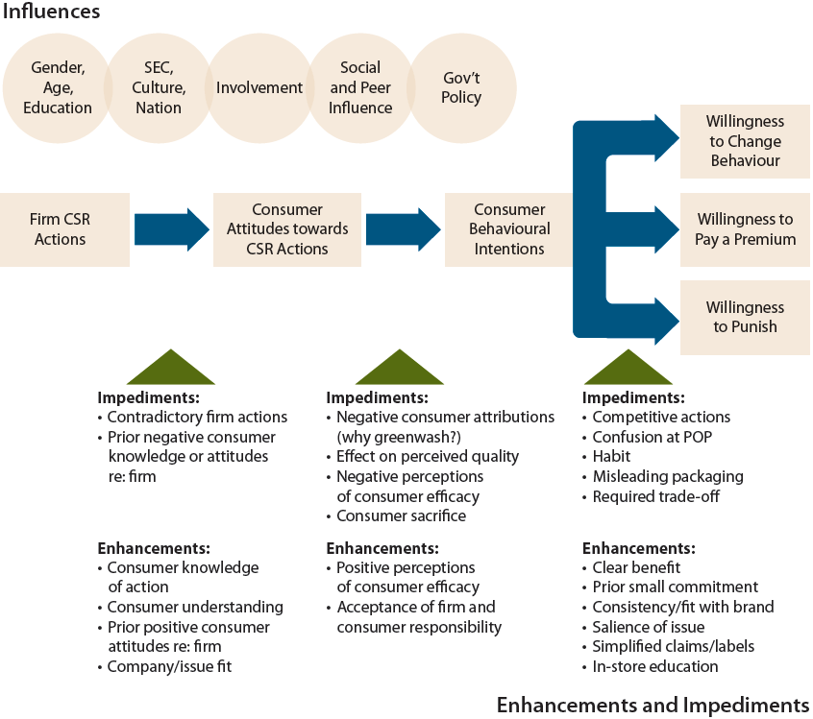
  - Canadian competition act: conspiracy, bid-rigging, predatory pricing, review of mergers, abuse of dominant position
- Factors determining
competitive behavior
  - Entrepreneurship; dereg.
and privatization; tech;
decline of natural monop;
global trends in trade;
mergers/takeovers
Model of socially conscious
consumerism

Suppliers and the supply chain
- Business-to-business: commercial
activity where one corp. sells goods or services to another corp. rather than to consumers
- Buyers recognizing suppliers committed to consider social + environmental responsibilities
- Supply chain regulated by Can. comp act to prevent suppliers not taking adv. of consumers
  - Exclusive dealing, tied selling and market restrictions

  - Price discrimination
  - Price maintenance

  - Refusal to deal
Supply chain
- Supply chain:
  - Route product travels from procurement of raw materials, transformation into intermediate goods and then final products, and delivery to consumers through distribution system to its ultimate disposal by consumer
- Extended producer responsibility
  - “Environmental policy approach in which producer’s responsibility, physical and/or financial, for product is extended to post-consumer stage of a product’s life cycle”
- Sustainability purchasing
  - “Acquisition of goods and services (‘products’) in a way that gives preference to suppliers that generate positive social and environmental outcomes. It integrates sustainability considerations into product selection so that impacts on society and environment are minimized throughout full life cycle of product”
- Fair trade
  - Term to identify prods involved with sustainability buy; focuses on start of product chain
Chapter 14: Environment and Business Responsibilities
Business, its stakeholders, and natural environment
- Environmental issues confront virtually all aspects of corp., from input of resources to manufacturing process, from workplace conditions to way products are packaged and sold
- Common: any resource used as though it belongs to all
Defining environmental ethic and sustainable development
- Environmental ethic:
  - Set of values or principles that govern corporation’s practices relating to environment
- Sustainable development:
  - Development ensuring that use of resources and impact on environment today does not damage prospects for use of resources or environment by future generations
- Business sustainable development:
  - “Adopting business strategies and activities that meet needs of enterprise and its stakeholders today while protecting, sustaining, and enhancing human and natural resources that will be needed in future”
Environmental concerns in business and society

- Acid rain
- Air pollution
- Ecosystems
- Energy production and consumption
- Nature and wildfire
- Ozone
- Pollution
- Waste management
- Water quality
- Climate change/global warming

Government’s influence

- Government departments and agencies (state = national, assess = assessment)
  - Environment Canada
  - Can. council of ministers of environ.
  - State roundtable of environ. + econ.
  - Can. environ.al assess act agency

- Regulation: Can. environ.al protection act, Can. environ.al assessment act, Kyoto protocol
Environmental NGO influence
- Environmental non-governmental orgs (ENGOs): hold shared values or attitudes about challenges meeting natural environ. + advocate for changes to improve condition of environ.
- Such groups (e.g., Greenpeace) influence corps. through protests, blockades, boycotts, and annual shareholder meetings
Factors leading ENGOs to target firms

- Firm is source of environmental impact
- Extent of consequences of firm’s actions
- Dense relations among firm’s ENGOs
- Larger the firm
- Greater influence of firm
- Previous interactions with ENGO
- Closeness of firm to consumers
- Firm’s brands are well known

Market-driven environmentalism
- Standard environmentalist
  - Gov’t regulation occurs when is a necessary remedy for market’s failure to provide environmental amenities
- Market environmentalist
  - Economic incentives created by market more effective at protecting environ. than gov’t intervention
- Environmentalism affected by market factors: economic growth, free trade, property rights
- Emissions trading:
  - System whereby corps. set targets for greenhouse gas reduction; if one corp. cannot meet target, it buys carbon credits from those that have met their targets (or “cap and trade”)
- Offsets (emission reduction credits):
  - Credits purchased from other corp. or orgs to ease greenhouse gases released in environ.
Managing responses to environmental concerns
- Token response (e.g., ‘greenwashing’ where firm does not seriously address environmental issues but merely says it does)
- Compliance with laws and regulations
- Comprehensive environmental management (gaining competitive advantage)
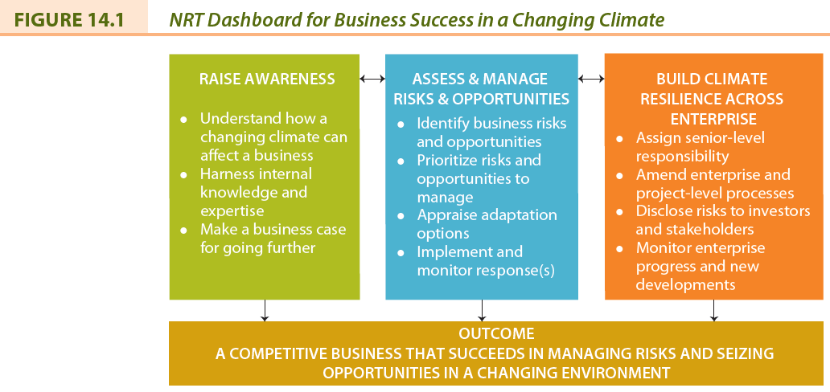
- Sustainable development

“Greening” of business functions

- Financial management (e.g., disclosure)
- Marketing (e.g., green marketing)

- HR (environ.ly friendly workplace)
- Operation (reduce, recycle, conserve etc)

Measuring and reporting on environmental sustainability

- Type and amount of materials used
- Source of energy and efficiency of use
- Source and quality of water
- Impact on biodiversity
- Reduction of emissions, effluents, and waste
- Product design that minimizes impact
- Compliance with environmental laws
- Use of efficient transportation

- Coalition or environmentally responsible economies (CERES)
- International organization for standardization ISO 14000
- International institute for sustainable development (IISD)
- Canadian sustainability indicators network (CSIN)
- Environmental and sustainable development indicators initiatives (ESDI)
Dissenting views on environment
- According to some business journalists (dif. = difficult):

  - Concept dif. to define + understand
  - Implies capitalism is unsustainable

  - Means stopping or constraining economic development

  - Lacks understanding of markets
  - Executives are being misled

Environment: Corporate opportunities

- Reputations likely enhanced
- Customers attracted
- Investors attracted
- Costs reduced through recycling/conservation
- More competent staff attracted
- Better integration with local community
- New technologies or expertise developed
- More efficient ways of producing products found

Environment: Corporate threats

- Corporate image may deteriorate
- Revenues may suffer if customers are lost
- Investors may decide not to invest
- Material and production costs may increase
- Financial penalties increasing
- Insurance premiums can increase
- Potential alienation from local community
- Government may enact stricter legislation

Chapter 15: Globalization and Business Regulations
Global business responsibilities
- Not a new phenomenon: goods have been traded between regions since ancient times
- Corps. now seen as more efficient than gov’ts in distributing G&S needed by citizens
- Today, new view toward trade and market systems is referred to as globalization
Defining globalization (sov. = sovereignty)
- Globalization: process of decr. constraint on interactions among nations and peoples of world
- Economic globalization: integration of fragmented markets into global economy
- Political globalization: process by which world power relation change, loss of sov. by states
- Social or cultural globalization: emergence of worldwide cultural system
UN global compact
- Human rights:
  - 1. Respect internationally proclaimed human rights
  - 2. Not be complicit in human rights abuses
- Labor standards
  - 3. Uphold right to collective bargaining
  - 4. Eliminate all forms of forced and compulsory labor
  - 5. Effective abolition of child labor
  - 6. Eliminate employment discrimination
- Environment
  - 7. Precautionary approach to environmental challenges
  - 8. Promote greater environmental responsibility
  - 9. Use environmentally friendly technologies
- Anti-corruption
  - 10. Avoid corruption (e.g., extortion and bribery)
Globalization and implications for business

- Damage to environment
- Support for oppressive regimes

- Criticism of marketing practices (tobacco, pharmaceutical, baby formula, etc.)

- Arms trade
- Treatment of employees (sweatshops)

- Treatment of indigenous peoples
- Corruption and bribery

- Genetic modification of plants and animals
Debate over globalization: supporters (globalists)
- Trade leads to more efficient production of better goods and services
- Better opportunities for employment and higher incomes
- Standards of living has increased
- Transfer of capital, technology, intellectual property, skilled labor
Debate over globalization: opponents (anti-globalists)

- Benefits received by only a few
- Creates unemployment
- Increased poverty and inequality
- Causes periodic financial crises
- Destroys local environment
- Destroys cultures
- Violates human rights
- Questionable payments made
- Disrespect of intellectual property

Internal non-governmental organizations (INGO’s)
- INGOs are groups that hold shared values and attitudes about issues relating to globalization and advocate for changes to improve conditions in developing countries
- INGOs put pressure on corporations and governments
- INGOs are also referred to as transnational non-government actors (TNGOs) or transnational social movement organization (TSMOs)
Institutions of globalization
- Supranational institution: international org that transcends national boundaries where member states share in decision making on particular issues pertaining to members
- World Bank: provides financial and technological assistance to developing countries
- International monetary fund (IMF): fosters financial stability, international trade, employment, and reduction to poverty
- International labor organization (ILO): UN agency that seeks to promote social justice and internationally recognized human and labor rights
- World trade organization: coordinates agreements reducing trade barriers
Globalization and Canadian business and society (Edu = education, comp = competition)

- Pressure to forge international links
- More direct investment abroad

- Must meet challenges of global restructuring (R&D, Edu, comp policy, cost of capital, etc.)
- Attract more investment in natural resource plants

International code of ethics for Canadian business principles
- Community participation and environmental protection

- Human rights
- Employee rights and health and safety

- Business conduct (bribery + compliance with law)
Standards of conduct and accountability for global business

- Political factors
- Socio-cultural objectives and standards
- Disclosure of info
- Competition
- Financing
- Employment and HR
- Science and tech
- Corrupt practices
- Environmental protection
- Stakeholder consideration
- Corporate governance

Global standards of conduct (MN = multinational)

- Caux Round Table: “Caux Principles”
- OECD “Guidelines for MN Enterprises”

- “Principles for Global Corporate Responsibility” (Interfaith organizations)

- UN Global Conduct
- Global Reporting Initiative (GRI)

Special challenges of global business – corruption
- Corruption: abuse of entrusted power for private gain (e.g., bribery)
  - Bribery: making questionable payments, bribes, to gov’t officials to influence decision
  - Three types of bribery assessed included:
    - 1. Bribery of high-ranking politicians or political parties
    - 2. Bribery of low-level public officials to ‘speed things up’
    - 3. Use of personal or familiar relationships to win public contracts
Special challenges of global business – human rights
- Human rights: fundamental rights and freedoms to which all individuals, groups, and societies are entitles (e.g., sweatshops)

  - Child labor
  - Forced labor
  - Discrimination
  - Environment
  - Working conditions

Acceptance of global capitalism (not = should not)
- Bottom of pyramid: corp.= not ignore, as consumers, world’s pop living in poverty (4 billion)
- Fair trade: trading partnership which aims to sustainable development for excluded and disadvantaged producers (e.g., Fairtrade Foundation, Oxfam, and Tradecraft)
- Microfinance: provision of financial products such as micro-credit or micro-insurance to people living in poverty (e.g., Grameen Bank in Bangladesh)
Chapter 16: Sustainability Strategy
Sustainability strategy: plan that views economic, ethical, social and environmental responsibilities more intensively and integrates CSR into all facets of corp.’s operations
  - Also referred to as a CSR strategy

- Amoral sustainability strategy
- Compliance-based sustainability strategy
- Emerging sustainability strategy
- Comprehensive sustainability strategy

Main characteristics of sustainability strategies

- Awareness
- Stakeholder focus
- Management/staff involvement
- Board involvement
- Ethics program
- CSR program
- Reporting
Strategic management
- Strategic management: process through which corp. establishes mission + objective, analyzes environ. + resource capabilities in order to formulate strategy, creates organizational systems + process needed to implement strategy, devises mechanisms for evaluating performance
Sustainability strategy and purpose
- Vision: statement of what corp. wants to become, where it wants to be some date in future
- Mission: enduring statement that specifies in broad, even philosophical, terms the organization’s “reason for being” and what distinguishes it from similar organizations
- Values: basic assumption about which ideals are considered desirable or worth striving for
Sustainability strategy and formulation
- Assessment of external environment in which corporation operates
  - Understand when and how this environment influences corporation
- Assessment of internal resources and capabilities (opp. = opportunities)
  - Allow corp. to determine ability to take adv. of opp. in environ + overcome any threats
- Establishment of objectives: the ends corp. seeks to achieve through existence + operations
- CSR strategy options and selection
  - Beliefs: basic assumption about world in which individual operates and how it works
  - Corporate culture: complex set of values, beliefs, assumptions, symbols that define way in which an organization conducts its business
Sustainability strategy implementation
- Sustainability implementation includes:

  - Designing corporation’s structure
  - Allocating resources

  - Develop info + decision-making process
  - Managing HR, incl. such areas as reward system, approaches to leadership, and staffing
Sustainability strategy evaluation
- Important to have continuous monitoring and reviewing of strategic management process
- Become important to incorporate social policies into strategic management process:

  - Business legitimacy depends on it
  - Gov’t can legislate compliance reg.
  - Business’s success and continued existence are interrelated with social policies
Achieving sustainability strategy
- CSR model should become corporate social integration model approach, which would integrate social perspective with business strategy
  - CSR should be an opportunity, innovation, and competitive advantage
Prevailing justifications for CSR

- Moral obligation
- Sustainability
- Licence to operate
- Reputation

Corporate social integration model approach
- CSR should identify points of intersection between business and society, then create corporate social agenda, and integrate inside-out and outside-in linkages
  - Inside-out linkages: rep corp.’s + and – influence on society through its operations
  - Outside-in linkages: represent society’s positive and negative influences on corporation
Three types of social issues
- Generic: do not significantly affect corporation but are important to society
- Value chain: significantly affected by corporation as it carries out business
- Social dimensions of competitive context: factors in external environment that significantly affect underlying drivers of competitiveness where the company operates

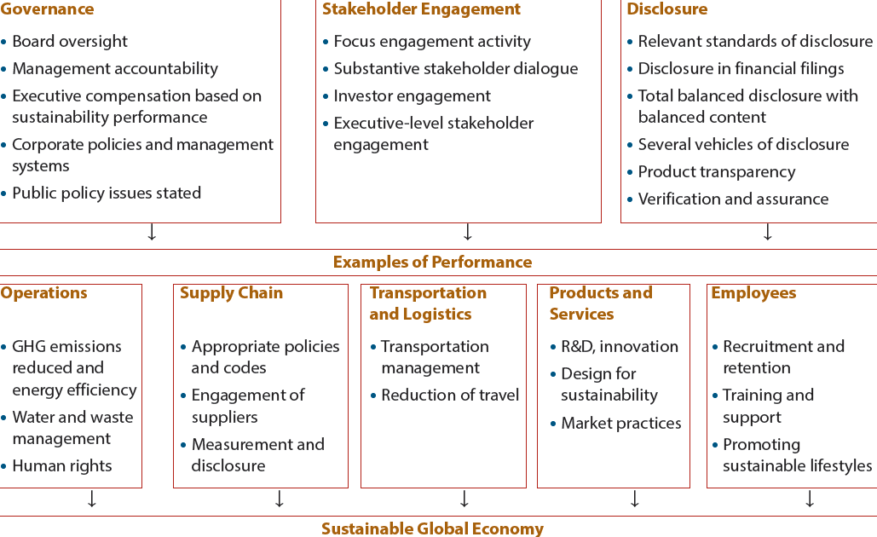
Ceres Roadmap for sustainability

Business programs and sustainability
- Business schools are responding to increasing awareness of ethics of business and CSR
- Response takes various forms and business education programs are feeling the impact
Argument for teaching ethics
- Many immoral or unethical events taking place
- Business environment is changing radically and students must be made aware of this
- Provide students with some tools or techniques for analyzing ethical issues
- Ethics courses legitimize consideration of ethical components as integral part of managerial decision making
Arguments against teaching ethics
- Business ethics are not a major problem
- There is little likelihood that it can alter ethical behavior of students
- There are few qualified teachers of ethics in business and management departments
- Many business problems involve ethical considerations that are not resolvable
- Separate ethics course suggests that ethics are considered “separate” in decision making

