CHAPTER 2

History of the Internet
- Developed for secure military communications
- Evolved from Advanced Research Projects Agency Network (ARPANET)
- Funded by the U.S. government in the 1960s
- Enabled computers at leading universities and research organizations to communicate with each other

The Web vs. the Internet
The web is part of the Internet, distinguished by common communication protocols
Navigation links
1989: Web invented by Tim Berners-Lee.
1993: Mosaic browser released.
1994: Netscape Navigator marked beginning of the web’s major growth.
1997: Internet access was global.

Internet is a bunch of websites, and websites all together make up the wed

Internet Communications
Forms of Internet-based communication include:
- Email
- Instant messaging
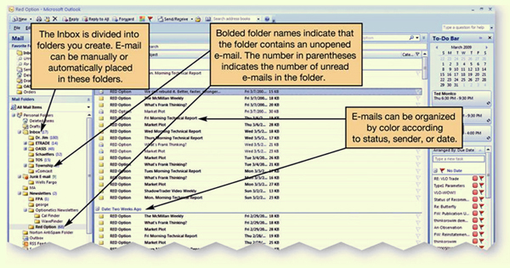
- Group communication
- Social networking
- Web logs and video logs
- Wikis
- Podcasts
Webcasts

Email
- Electronic mail
- Asynchronous communication

Types of email accounts
  - Client-based (requires client email software)
  - Web-based (does not require software)
Not private
Can be printed or forwarded
Can be monitored by employers
Email Etiquette
- Be concise and to the point
- Use spell-check
- Avoid texting abbreviations
- Include meaningful subject line
- Use smilies (emoticons) sparingly to convey emotion
- Include signature line with contact information
- Do not type in all capital letters, which is interpreted as shouting.

Instant Messaging
- Instant messaging (IM) uses real-time text-based conversations, similar to chat rooms.
- Users set up a list of contacts, often called a buddy list.
- Contacts must be online to participate.
- IM software detects the presence of members who are online.
- Examples include:
AOL Instant Messenger

Group Communication
There are many ways you can interact with a wide variety of people online.
- Chat rooms
- Newsgroups
- Blogs and vlogs
- Wikis
- Podcasts and webcasts
- Social networks

Chat Rooms and Newsgroups
- Chat rooms
  - Real-time, text-based conversations
  - Can focus on specific topics of interests or be general interest
  - Username can allow anonymous interaction
- Newsgroups
  - Online discussion forums
  - Members post and reply to messages
  - Create or respond to “threads”

Netiquette
- Introducing yourself when entering a chat room
- Specifically address the person to whom you are talking
- Refrain from swearing, name-calling, and using explicit or prejudiced language
- Do not post the same text repeatedly with the intent to disrupt the chat, a behaviour called flooding.

Web 2.0
- Web interactions among people, software, and data
- Social web where the user is also a participant
- New applications that combine the functions of multiple applications

Social Networks
- Used to communicate and share information among immediate friends, and meet and connect with others through common interests, experiences, and friends

- Examples:
  - MySpace.com
  - Facebook.com
- Members communicate by voice, chat, IM, and videoconference.
Growth has been explosive.

Blogs and Vlogs
- Personal journals posted on the Web
- Weblogs (blogs):
  - Primarily text-based
  - Simple to create, read and manage
  - Entries listed on a single page, with most recent entry at the top
  - Searchable
- Video blogs (vlogs): Digital video clips playable on media player software

Wikis
- Wikis: Websites that allow anyone to edit/change their content
  - Provide a source for collaborative writing
  - Eliminate exchanging emails
  - Track revisions
Podcasts
- Podcasts: Compressed audio or video files distributed on the internet
- Really Simple Syndication (RSS) technology allows constant updates for subscribers
- Podcasts are all over the Web.
  - Need aggregator software to gather podcasts
  - Need media player software to play them
Simple to create

Webcasts
- Webcasts: Broadcasts of audio or video content over the internet
  - Often live
  - Delivered to your computer
  - Use streaming media

Twitter
- Social networking and micro-blogging service that enables you to exchange short text messages in real time with your friends or “followers”
- Twitter messages, called tweets, are limited to 140 characters.
Businesses are using Twitter to respond to customer queries, or to broadcast new services or products.

Web Entertainment
- Multimedia is anything that involves one or more forms of media in addition to text.
  - All kinds of multimedia are available on the Web and involve forms of media and text.
    - Graphics
    - Audio
    - Video
  - Streaming audio and video can deliver on-demand pictures and sounds. Sites like CNN.com offer clips from their broadcasts.
- Games
  - Multiplayer online games
  - Interact with other players

E-Commerce
E-commerce grows in importance every day, with billions of dollars worth of transactions.
- In business-to-consumer (B2C) transactions, such as amazon.com, the end buyer purchases goods or services over the Internet.
- In business-to-business (B2B) transactions, businesses sell to one another.
- In consumer-to-consumer (C2C) transactions, like ebay.com, consumers sell to one another.

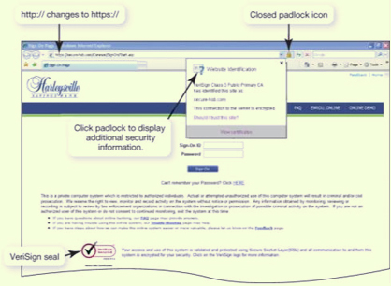
Secure Websites
- Online transactions can be safer than traditional retail shopping.
  - VeriSign is a company that certifies that online transactions are secure. Businesses hire security companies such as VeriSign to certify that their online transactions are secure. Thus, if a website displays the VeriSign seal, you can usually trust that the information you submit to the site is protected.
  - Another indication that a website is secure is the appearance of a small icon of a closed padlock (IE) or key (Netscape) on the status bar at the bottom of the screen.
Additionally, the beginning of the URL changes from http:// to https://, the s standing for “secure.”

Online Shopping Guidelines
To shop safely online, follow these guidelines:
- Shopping at well-known, reputable sites helps ensure a safe shopping experience. If you are not familiar with a site, check it out with the Better Business Bureau, and also make sure that the company has a phone number and street address before ordering from it.
- Avoid making online transactions when using public computers.
- Pay by credit card, not debit card. Debit cards do not have the same level of protection as credit cards under U.S. federal consumer credit card protection laws. Use a card with a small limit, or consider using a pre-paid credit card.
- Check and print out the return policy. You may need it when filing a complaint to prove what the policy showed at the time of your order. Websites can be changed easily and rapidly and can also be shut down overnight.

Web Browsers
- A Web browser is software installed on your computer system that allows you to locate, view and navigate the Web.
- Graphical
- Enable web navigation
- Popular browsers:
  - Microsoft Internet Explorer
  - Mozilla Firefox
  - Apple Safari
  - Google Chrome

Browser Features
- Quick tabs show thumbnail images of all open web pages in open tabs.
- With tabbed browsing, web pages are loaded in “tabs” within the same browser window. Rather than having to switch between web pages on several open windows, you can flip between the tabs in one window.
- The browser also includes a built-in search box in which you can designate your preferred default search engine. Tools for printing, page formatting and security settings are allocated to a special toolbar.

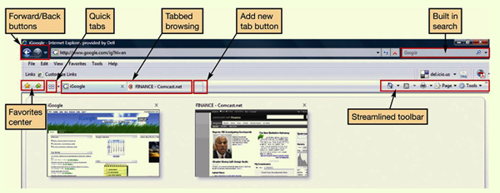

URLs
- A URL is a website’s address. It is composed of several parts that help identify the Web document it stands for.
  - Uniform Resource Locator
  - Unique Web site address
- The first part of the URL indicates the set of rules (or the protocol) used to retrieve the specified document. HTTP is most common. Another popular protocol is FTP.
- The protocol is generally followed by a colon, two forward slashes, www (indicating World Wide Web), and then the domain name. The domain name is also referred to as the host name. At times, a forward slash and additional text follow the domain name. The information after the slash indicates a particular file or path (or subdirectory) within the website.

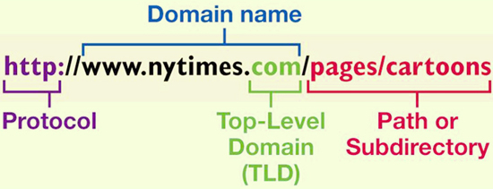
Top-Level Domains

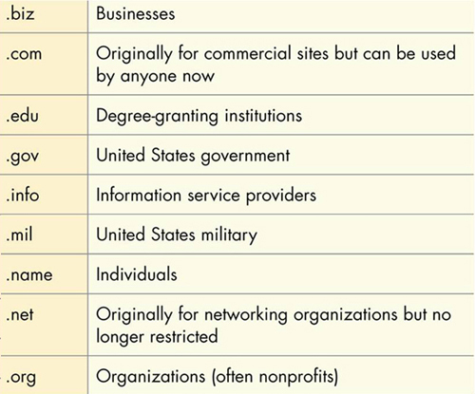

Hyperlinks
- Once you’ve reached a website, you can jump from one web page to another within the website or to another website altogether by clicking on specially coded text called hyperlinks.
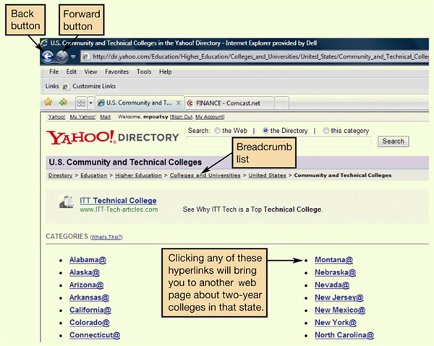
- When programming HTML, the web page author can code any word or image to be a hyperlink.
- Generally, text that operates as a hyperlink appears in a different color (often blue) and/or is underlined. Sometimes images also act as hyperlinks.
- When you pass your cursor over a hyperlink, the pointer turns from an arrow into a hand. To retrace your steps, some sites also provide a breadcrumb list — a list of pages within a website that you have visited that usually appears at the top of a page.
Favorites and Bookmarks
- Allow you to return to web pages
  - IE and Safari = Favorites
  - Firefox and Chrome = Bookmarks
- Stay up to date
  - Live bookmarks (Firefox)
- Organize and share
Social bookmarking sites: Websites such as del.icio.us and digg.com provide proprietary toolbars and tagging tools that incorporate into your Web browser and allow you to tag and organize websites using your own keywords.
**FAVORITES UNDER A YELLOW STAR

Search Engines
- User types word or phrase into search box.
- Spider or web crawler program scans web pages.
- Results are indexed and sent to the client.
- Different engines produce different hit lists.
- Multimedia search functionality is also available.

Improve Search Results
- Place quotation marks around phrases
- Search within a specific web site
- Enter wild card symbols
- Use the advanced search form

What Can You Borrow from the Web?
- Avoid
  - Plagiarism: Representing someone else’s ideas or words as your own
  - Copyright violation: Using another person’s material for your own economic gain
- Properly credit information you quote or paraphrase
- Obtain written permission from copyright holder

Evaluating Websites
Evaluating the content of a website is important. Before you believe what the site says or take action based on the information presented, several questions need to be answered.
- Who is the author of the article or website sponsor?
- Is the site biased?
- Is the information current?
- Toward what audience is the site geared?
- Are links available?
The same information should exist on at least three different web sites.

Internet Clients and Servers
- The Internet is a client/server network.
- Thus, a computer connected to the Internet acts in one of two ways:
  - Client computer
    - Users connected to the internet
    - Requests data and web pages
  - Server computer
    - Stores web pages and data
    - Returns the requested data to the client
- Internet backbone IP addresses are the means by which all computers connected to the Internet identify each other.

Connecting to the Internet
- To take advantage of the resources the Internet offers, you need a means to connect your computer to it. Home users have several connection options.
- Originally, the only means to connect to the Internet was with a dial-up connection. With dial-up connections, you connect to the Internet using a standard telephone line.
- However, other connection options, collectively called broadband connections, offer faster means to connect to the Internet. Broadband connections include:
  - DSL
  - Cable
  - Fiber-optic service
  - Satellite
CDFS

Broadband Connections

Cable Internet
  - Uses coaxial cable and a cable modem
  - Fast connection speed
  - Speed depends on number of users
  - Not available in all areas

Digital Subscriber Line (DSL)
  - Uses telephone lines
  - Faster than dial-up
  - Does not tie up phone line.
  - Requires special DSL modem
  - Not available in all areas

Satellite
  - Uses satellite dish and coaxial cable
  - Slower than cable or DSL
  - Expensive

DSL MODEM CABLE MODEM
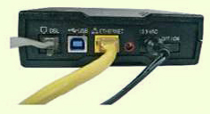
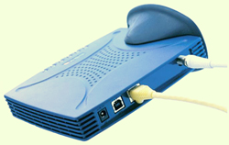

Wireless Access
- Increases mobility and productivity
- Requires a Wi-Fi hotspot
- If device is not wireless-ready, wireless adaptors are available.
- Aircards provide wireless access through mobile devices when a Wi-Fi hotspot is not available.

Dial-Up Connections
- Use standard telephone line
- Tie up phone line
- Require a modem to convert analogue and digital signals
- Slowest connection speed (56 Kbps)
- Lowest cost
Modern computers have internal modems built into the system unit.

Comparing Internet Connection Options
DSL
  - Average download speed of 1.5 Mbps
  - Maximum download speed of 7 Mbps
  - Lets you access the internet and talk on the same phone line simultaneously
  - Speed drops as you get farther from the phone company's central office
  - Not available on every phone line
Cable
  - Average download speed of 5 Mbps
  - Maximum download speed of 30 Mbps
  - Speeds are not dependent on distance from central office
  - Line is shared with others in the neighborhood
  - Speeds may vary due to peak/non-peak usage
  - Might require professional installation if cable is not already present
Fibre optic
  - Average download speed of 20 Mbps
  - Maximum download speed of 50 Mbps
  - Increased speed
  - Service not shared or dependent on distance from central office
  - High cost, but becoming lower as the technology continues to be deployed
  - Not available in all areas

Future of the Internet
- Large scale networking (LSN)
  - Research and development of cutting-edge networking and wireless technologies
- Internet2
  - Project sponsored by universities, government, and industry to develop new internet technologies
  - Internet2 backbone supports transmission speeds of up to 8.8 gigabits per second.
- Internet entrenched in daily life
- Web-based services for personal and professional interactions
Internet-enabled appliances and systems

CHAPTER 3

Software
- The term software refers to a set of instructions that tells the computer what to do. These instruction sets, also called programs, provide the means for us to interact with and use the computer.
- Your computer uses two basic types of software:
  - System software
  - Application software

System Software vs. Application Software
System Software |  | Application Software
- Coordinates instructions between software and hardware  - Includes:  - Operating system  - Utility programs |  | - Programs used to complete tasks  - Includes:  - Productivity software  - Specialty software  - Entertainment software  - Educational and reference software  - Personal software

Application Software
Here you see the various types of application software available. In this module, we look at all of these types in detail, starting with productivity software.

PMEB

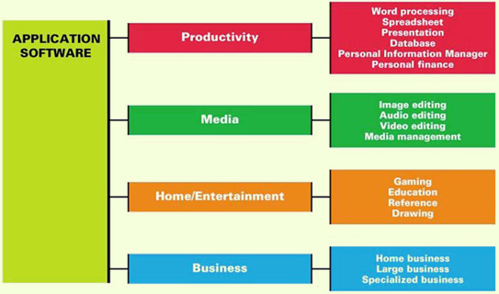

Productivity Software
- Programs that enable you to perform various tasks generally required in home, school and business
- This category includes:
  - Word-processing programs
  - Spreadsheet programs
  - Presentation programs
  - Database programs
  - Personal Information Manager (PIM) programs

Word-Processing Software
- Used to create and edit documents
- Features include:
  - Quick and easy editing
  - Formatting options
  - Graphics
  - Templates
  - Wizards
- Examples:
  - Corel WordPerfect
  - Microsoft Word
  - OpenOffice Write

(section headings is subtitles, and drop cap is the capital letter and the first letter of the story and two column text for articles, etc)

Spreadsheet Software
- Used to perform calculations and numerical analyses
- Features include:
  - Worksheets with cells
  - Values, formulas and functions
  - Automatic recalculation
- The basic element in a spreadsheet program is the worksheet, columns and rows of which form boxes called cells. There are several types of data you can enter into a cell:
  - Labels are descriptive text that identifies the components of the worksheet.
  - Values are numeric data entered either directly or as a result of a calculation.
  - Formulas are equations that you build yourself.
  - Functions are formulas that are preprogrammed into the spreadsheet software.
- The primary benefit of spreadsheet software is its ability to recalculate all functions and formulas in the spreadsheet automatically when assumptions are changed.
- Examples:
  - Microsoft Excel
  - OpenOffice Calc

Presentation Software
- Used to create slide shows.
- Features include:
  - Templates and layouts
  - Animations
  - Transitions
- Can use animation effects to control how and when text and other objects enter and exit each slide. Similarly, slide transitions add different effects as you move from one slide to the next during the presentation.
- Examples:
  - Microsoft PowerPoint
  - OpenOffice Impress
  - Zoho Show

Database Software
- Used as a complex electronic filing system.
- Features include:
  - Ability to group, sort and retrieve data and generate reports
  - Organized into fields, records and tables
- Examples:
  - Microsoft Access
  - Oracle
  - MySQL

Field = column (going downwards) and record = row (side to side)

Note-Taking Software
- Microsoft OneNote
  - Allows students who have Tablet PCs to write their notes directly onto the tablet, using it as an electronic notebook
  - Can be used with a notebook or desktop computer, typing the information onto the sheets, and then the pieces of text can be easily moved around the page
Has co-authoring and version tracking capabilities

Personal Information Manager (PIM) Software
- Used to replace the management tools found on a traditional desk, such as a calendar, address book, notepad and to-do list
- Features include:
  - Calendar, address book, notepad, to-do list
  - Some contain email management features
- Examples:
  - Microsoft Outlook
  - Lotus Organizer

Productivity Software Tools
Whether you are working on a word-processing document, spreadsheet, database or slide presentation, there are several tools you can use to increase your efficiency:
- Wizards are step-by-step guides that walk you through the necessary steps to complete a complicated task. At each step, the wizard asks you questions. Based on your responses, the wizard helps you complete that portion of the task.
- Templates are predesigned forms included with software.
- Macros are small programs that group a series of commands to run as a single command. Macros are best used to automate a routine task or a complex series of commands that must be run frequently.

Integrated Software Applications vs. Software Suites
Integrated Software Application |  | Software Suite
- Single program that incorporates many software programs  - Complex features are not included  - Less expensive  - Example: Microsoft Works |  | - Collection of stand-alone software programs packaged together  - Share common menus and toolbars  - Integrate well  - Developers: Microsoft, Corel, and Lotus

Personal Financial Software
- Used for tax preparation and financial planning.
- Tax-preparation software enables you to prepare your taxes on your own rather than hiring a professional. Each program offers a complete set of tax forms and instructions as well as expert advice on how to complete each form.
  - Examples include: Intuit’s TurboTax and H&R Block’s TaxCut
- Financial planning software helps you manage your daily finances. These programs include electronic checkbook registers and automatic bill payment tools. With these features, you can print checks from your computer or pay your regular monthly payments with automatically scheduled online payments or printed checks.
  - Examples include:
    - Intuit’s Quicken and Microsoft Money
    - Web-based programs: Mint.com and Wesabe.com

Media Software for Home
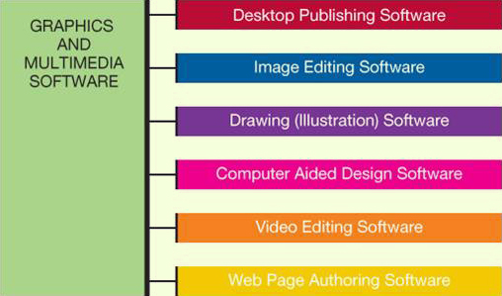

Digital Image-Editing Software
- Used to edit photographs and other images
  - Remove red-eye
  - Modify contrast
  - Fix scratches
- Examples:
  - Adobe Photoshop
  - Corel PaintShop Pro
  - Google Picasa
Digital Audio Software
- Used to edit audio files in formats such as MP3, WAV, WMA, and AIFF
- Most popular is MP3: Compresses audio file size
- Hundreds of applications allow you to rip, play, and organize MP3s
- Features include recording, editing, adding special effects, and format conversion

Digital Video-Editing Software
- Used to create and edit Windows Media Player, Apple QuickTime, or RealPlayer video files
- Examples:
  - Adobe Premiere Pro
  - Microsoft Live Movie Maker
  - Apple iMovie HD
- Buy the application that supports your file format
Many portable devices play MP4 format.

Media Management Software
- Software to organize media files
  - Sort, filter and search by artist, album or category
- Examples:
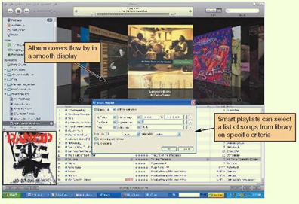
  - Windows Media Player
  - Nullsoft Winamp
  - Apple iTunes
- Manage tracks and generate playlists
Burn songs to CDs and print liner notes
Apple iTunes

Online Photo Management
- Web-based sites allow easy management and sharing of digital photos
- Allow creation of photo albums
- Offer professional printing services
- Examples:
  - Flickr.com
  - Snapfish.com
  - Kodak.com
  - Shutterfly.com
Software Fun for Home
Computer games require appropriate:
- Processing power
- Memory (RAM)
- Hard disk capacity
- Sound card
- Video card
- Speakers
- Monitor
- CD or DVD drive
- Specialized controllers

Game Rating System
- The Entertainment Software Rating Board (ESRB) provides:
  - Rating symbols
    - Everyone (E)
    - Teens (T)
    - Mature (M)
    - Adult Only (AO)
Content descriptors

Educational and Reference Software
Educational Software
- Provides instruction or training
Types include:
  - K-12 education
  - Skill development
  - Test preparation
  - Brain training
  - Simulations
  - Online courses

Drawing Software
- Used to create and edit
  - Two-dimensional drawings
  - Technical diagrams
  - Animations
  - Geometric shapes
- Examples:
  - Adobe Illustrator
  - Microsoft Visio

Business Software for Home and Office
- Programs for home business
  - Accounting software
  - Desktop publishing software
  - Webpage authoring software

Accounting Software
- Helps small-business owners efficiently manage their finances
- Provides tools for tracking accounts receivable and accounts payable
- Includes templates for invoices, statements, and financial reports
- Examples:
  - Intuit QuickBooks
  - Peachtree by Sage

Desktop Publishing (DTP) Software
- Used to arrange text and graphics for publications
Features include:
  - Text formatting
  - File importing
  - Graphics tools
  - Web publishing
- Examples:
  - QuarkXPress
  - Adobe InDesign

Web Page Authoring Software
- Used to create a Web page
- Knowledge of HTML is not necessary.
- Features include:
  - Wizards and templates
  - Reference materials
  - Interactive content
- Examples:
  - Microsoft Expression Web
  - Adobe Dreamweaver
Office applications can save a document as a Web page.

Large-Business Software
- Used across a variety of industries
- Includes:
  - Business and marketing plan software
  - Project management software
  - Customer relationship management (CRM) software
  - Enterprise resource planning (ERP) systems
  - Ecommerce solutions

Mapping Software
- Provides nationwide street maps and directions
- Supplies geographic data for decision making
- Available versions:
  - Online
  - PC
  - Smartphone
  - GPS devices

Specialized Business Software
- Vertical market software: Tailored to the needs of a particular industry
- Examples:
  - Estimating software
  - Property management software
  - Scheduling and dispatching software
  - Proprietary software can be custom developed for a company.

Computer-Aided Design (CAD) Software
- Used to create 3-D automated designs, technical drawings and model visualizations
- Industrial use includes:
  - Architecture
  - Automotive
  - Aerospace
  - Medical engineering industries
Example: Autodesk’s AutoCAD

Getting Help with Software
- Types of help:
  - For general help or information about the product, many websites offer frequently asked questions (FAQs), which include answers to the most common questions.
  - Some programs also offer online help and support. Sometimes, online help also allows you to chat with a member of an online support team.
  - Some applications are context-sensitive and offer help based on the task you’re doing or ScreenTips to explain where your cursor is resting.
  - In Microsoft Office applications, on the far top-right of the screen, you’ll find a question mark icon. This takes you to the main Help interface. Integrated help means that the documentation is built directly into the program. You type a question, search for a term, or browse the help topics.
  - There is a Help menu on the menu bar of most applications where you can choose to search an index or content outline to find out the nature of almost any feature.
There are also many online sites, such as Malektips.com, that provide a vast array of multimedia help files and tutorials.

Software Licenses
- You buy a license, not the software itself.
- Check license for:
  - Ultimate owner of software
  - Number of installations allowed per license
  - Per computer, per user, or per family (Apple)?
  - Warranties
- Multiuser licenses available
  - Per-seat
  - Concurrent
Acquiring Software
Software can be purchased **************************
  - Through retail stores
  - Online
  - By mail order
- Virtually every new computer comes with some form of application software installed, although the applications depend on the hardware manufacturer and the computer model. You can usually count on your computer having some form of productivity software preinstalled.

- Web-based application software:
  - Hosted on a website
  - Requires no installation on your computer
- Discounted software
- Custom-developed software

Freeware and Shareware
- Freeware is any copyrighted software you can use for free.
- Some software developers offer beta versions of their software free of charge. Beta versions are still under development. By distributing free beta versions, developers hope to have users report errors or bugs they find in the program. This helps them correct any errors before they launch the software on the market at retail prices.
- Software that allows users to test software (run it for a limited time free of charge) is referred to as shareware. Shareware is not freeware. If you use the software after the initial trial period is over, you will be breaking the software license agreement.
Open source software is free to use on the condition that any changes you make to improve the source code also must be distributed for free.

Software Versions
- Numbers are used to represent major and minor upgrades.
  - Major upgrade: Version 2.0
  - Minor upgrade: Version 2.1
- Years (Microsoft Office 2010) and letters (WordPerfect Office X3) are also used.
When an upgrade is released, consider if it is cost-effective to purchase it.

System Requirements
- Minimum standards for the operating system, processor, RAM, and hard drive capacity
- Specifications for video card, monitor, CD drive, and other peripherals
- Need sufficient storage, memory capacity, and processing capabilities

Installing/Uninstalling Software
- Installing software from CD or DVD
  - Installation wizard
  - Choose full or custom installation
- Downloading software from the web
  - Unzip files
  - Launch setup program
- Uninstalling software
Software uninstall utility
Chapter 4: Using System Software: The Operating System, Utility Programs, and File Management

System Software: The OS
The operating system (OS) is the main program that:
  - controls how your computer system functions and manages the computer’s:
    - hardware
    - processor
    - memory
    - peripheral devices
  - provides means for software to work with the CPU
  - is responsible for management, scheduling and interaction of tasks
  - provides user interface such as the desktop, icons, and menus

System Software: Utilities
System software also includes utility programs. These are programs that perform computer housekeeping tasks.
- Backup
- Security
- Diagnostic
- Recovery

Operating System Categories
- Operating systems can be classified into four categories.
  - Real-time (RTOS): Embedded systems
    - Example: Found in measurement instruments
  - Multiuser: Network operating system
    - Example: Microsoft Windows Server OS
  - Single-user, multitask
    - Example: Apple Mac OS
  - Single-user, single-task
Example: MS-DOS

Real-Time Operating Systems
- Machinery that performs a repetitive series of specific tasks in an exact amount of time requires a real-time operating system.
- This type of operating system is a program with a specific purpose.
- Uses include:
  - Automobiles
  - Printers
  - VoIP phones
  - Medical devices
  - Appliances
  - Robotic equipment

Multiuser Operating Systems AKA network operating systems
- Enables more than one user to access the computer system at one time by efficiently juggling all the requests from multiple users.
- A network operating system is installed on the server and manages all user requests, ensuring that they do not interfere with each other.
- Systems include:
  - Linux
  - UNIX
  - Windows Server 2008
  - Mac OS X
  - IBM i
  - z/OS

UNIX
- UNIX is a multiuser, multitask operating system.
- Used primarily with mainframes as a network operating system
- Also often found on PCs
- Vendors can modify the code.
  - Hewlett-Packard HP/UX
  - Sun Solaris
  - IBM AIX

Mainframes and Supercomputers
- Other computers utilizing multiuser operating systems
  - Mainframes
    - Handle requests from hundreds or thousands of users simultaneously
  - Supercomputers
Used by scientists and engineers
Smartphones
- Do more than let the user make and answer phone calls
- Have productivity features, in addition to features found on personal media players and cameras, and the ability to connect to the web
- Examples:
  - BlackBerry devices
  - Apple iPhone
  - Google Android
  - Palm Pre

Desktop and Notebook Operating Systems
- The combination of operating system and processor is referred to as a computer’s platform. For example:
  - Microsoft Windows OS/Intel and AMD processors
  - Apple Macintosh OS/Motorola, IBM, and Intel processors
  - Application software is platform specific.

Microsoft Windows
- Multiuser, multitasking OS
- Windows 7 is the newest version.
- Features:
  - Increased functionality
  - User-friendliness
  - Improved internet capabilities
  - Enhanced privacy and security

Mac OS
- First commercially available OS with point-and-click technology (GUI)
- Excellent in:
  - graphics display
  - processing capabilities
  - system reliability
  - file backup utilities
- However, there are fewer software applications available for the Mac platform than for the Windows platform.
Macs tend to be more expensive than Windows-based PCs.

Linux
- Open source operating system
- Based on UNIX
- Stable system
- May be downloaded free from the internet
- Can be tweaked to meet any OS needs
- Runs on PCs, netbooks, iPods, and gaming systems

What the OS Does
- Provides a user interface
- Manages the CPU
- Manages memory and storage
- Manages hardware and peripheral devices
- Coordinates application software with the CPU

The User Interface
- Enables you to interact with the computer
- Types of interfaces:
  - Command-driven interface: meaning that the user had to type very specific commands to get the computer to load a program. The commands were not always easy to understand; therefore the interface proved to be too complicated for the average user.

  - Menu-driven interface: the user chooses a command from menus displayed on the screen. Menu-driven interfaces eliminated the need to know every command because you could select most of the commonly used commands from a menu. However, they were still not easy enough for most people to use.

  - Graphical user interface (GUI): displays graphics and uses the point-and-click technology of the mouse and cursor, making operating systems much more user friendly.

Processor Management
- Controls the timing of events the processor works on:
  - Multitasking
  - Interrupts
  - Interrupt handler
  - Interrupt table
  - Stack

OS Architecture
- Systems with more than 4 GB of RAM feature a 64-bit version of Windows (Windows Vista or Windows 7).
- If you purchase a 64-bit system, you will need to make sure that all your hardware and software programs are updated to work well with the 64-bit version of your OS.
Previous versions of Windows used 32-bit systems.

Random Access Memory (RAM)
- RAM has limited capacity.
- Running multiple programs at one time requires more RAM.
- Most editions of Windows 7 require more than 1 GB of RAM for the OS alone.
The translucent Aero user interface requires at least 2 GB of RAM and a video card with at least 256 MB of RAM.

Virtual Memory
- Instructions and data are stored on the hard drive when RAM is full.
  - Swap file
  - Paging
  - Thrashing
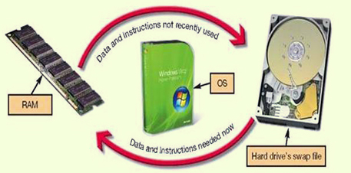

Hardware and Peripheral _Device Management
- Device drivers
  - Each device attached to your computer comes with a special program, called a device driver, that facilitates the communication between the device and the OS.
  - The device driver translates the specialized commands of the device to commands that the OS can understand, and vice versa. Thus, devices will not function without the proper device driver because the OS would not know how to communicate with them.
- Plug and Play
  - Today, most devices come with the driver preinstalled in Windows. Devices whose drivers are included in Windows are called Plug and Play (PnP).
Plug and Play is not a driver. Instead, it is a software and hardware standard designed to facilitate the installation of a new piece of hardware in computers by including in the OS the driver the device needs to run. Plug and Play enables users to plug their new device into a port on the system, turn on the system, and immediately use the device. The OS automatically recognizes the device and its driver.

Software Application Coordination
- For software programs to work with a CPU, they must contain code that the CPU recognizes. Rather than having the same blocks of code for similar procedures in each software application, the OS includes the blocks of code that software applications need. These blocks of code are called application programming interfaces (APIs).
- To create programs that can communicate with the operating system, software programmers need only refer to the API code blocks in their individual application programs rather than including the entire code in the application itself. Not only do APIs avoid redundancies in software code, but they also make it easier for software developers to respond to changes in the OS.
Microsoft DirectX, for example, is a group of multimedia APIs built into the Windows operating system that improves graphics and sounds when you’re playing games or watching video on your PC.

Starting the Computer
- For a computer to go from a dead stop to ready-for-use, a start-up process is required. This is often referred to as booting up the computer, or the boot process.
- The boot process consists of four basic steps:
  - The basic input/output system (BIOS) is activated by powering on the CPU.
  - The BIOS checks that all attached devices are in place (called a power-on self-test, or POST).
  - The operating system is loaded into RAM.
  - Configuration and customization settings are checked.
- Once the boot process has completed these steps, the computer is ready to accept commands and data.
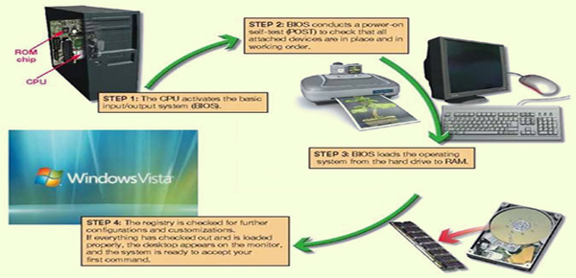

Handling Errors in the _Boot Process
- Errors during the boot process are often very simple to correct. It is helpful to be aware of the most common problems.
- Sometimes Windows does not boot properly and you end up with a screen with the words Safe Mode in the corners.
  - Safe mode is a special diagnostic mode designed for troubleshooting errors.
  - While in Safe Mode, only the essential devices of the system (such as the mouse, keyboard and monitor) function.
  - If, after you boot, you end up in Safe Mode, try rebooting the machine before doing anything else.
  - If you still end up in Safe Mode and if you have recently installed new software or a new hardware device, try uninstalling it.

The Desktop
- The desktop is the first interaction you have with the OS and the first image you see on your monitor. As its name implies, your computer’s desktop puts at your fingertips all of the elements necessary for a productive work session that typically are found on or near the top of a traditional desk, such as files and folders.
- The Recycle Bin is a location for deleted files and folders from the C: drive only.
- A gadget is an easy-to-use miniprogram that gives you information at a glance or quick access to frequently used tools including weather information, calendar items, calculators, games, photo albums, and system tools.
The Taskbar displays open and favorite applications for easy access.

Mac vs. Windows
- Similar functionality
- Streamlined user interface
- Window-like work areas on the desktop
-Widgets (MAC) vs. Gadgets (WINDOWS)

Windows
The standard window in Windows has consistent features. Once a user is familiar with the setup of these features, he or she will be immediately familiar with the windows in any Windows-based software. How many of the features can you name?
- Title bar
- Menu bar
- Toolbar
- Windows view options
- Status bar
- Scrollbars
- Sizing buttons

Viewing Windows
- Side-by-side
- Stacked
- Cascading
- Flip 3D
- Snap
- Aero Shake
- InstanceEndEditable

InstanceBeginEditable name="footNotes" InstanceEndEditable

File Management
- The operating system provides an organizational structure for the computer’s contents.
- The OS allows you to organize the contents of your computer in a hierarchical structure of directories that includes:
  - Drives
    - Folders
      - Subfolders
        - Files
Windows 7 introduces the concept of libraries, which are collections that gather files from different locations and display them as if they were all saved in a single folder, regardless of where they are physically stored.

Viewing and Sorting Files and Folders
- Many views available:
  - Large Icon view
  - Extra Large Icon view
  - Tiles view
  - Details view
  - List view
  - Small and Medium Icon views

Filename Extensions
- Following the filename and after the dot (.) comes an extension, or file type. This extension identifies what family of files the file belongs to or which application should be used to read the file.
  - Examples: if the bioreport file is a Word 2003 document, it has a .doc extension and is named bioreport.doc. If the file is created in Word 2007 or 2010, the file extension is .docx and is named bioreport.docx.
All Word, Excel, and PowerPoint files created in the 2007 and 2010 version have an “x” at the end of the traditional three-letter extension.

Extension | Type of Document | Application
.doc | Word-processing document | Microsoft Word 2003
.docx | Word-processing document | Microsoft Word 2007 and 2010
.wpd | Word-processing document | Corel WordPerfect
.xlsx | Spreadsheet | Microsoft Excel 2007 and 2010
.accdb | Database | Microsoft Access 2007 and 2010
.pptx | PowerPoint presentation | Microsoft PowerPoint 2007 presentation
.pdf | Portable Document Format | Adobe Acrobat or Adobe Reader
.rtf | Text (Rich Text Format) | Any program that can read text documents
.txt | Text | Any program that can read text documents
.htm or .html | Hyper Text Markup Language for a Web page | Any program that can read HTML
.jpg | Joint Photographic Experts Group (JPEG) image | Most programs capable of displaying images
.gif | Graphic Interchange Format (GIF) image | Most programs capable of displaying images
.bmp | Bitmap image | Windows
.zip | Compressed file | WinZip

Naming Files
- Filename: Name assigned plus filename extension.
  - Examples: “bioreport” may be the name you assign to a report you have completed for biology.
    - If it was created in Works, it would be named bioreport.wks.
    - If it was created in Word 2007 or 2010, it would be named bioreport.docx.
- File and folder name length is up to 255 characters.
- Characters not legal in Windows filenames: “ / \ * ? < > | :
- Character not legal in Mac filenames: :
Mac file names are case sensitive and do not need file extensions.

File Path
- You can tell the location of a file by its file path. The file path starts with the drive in which the file is located and includes all folders, subfolders (if any), the filename and the extension.
  - For example, if you were saving a picture of Emily Brontë for a term paper for an English Comp course, the file path might be C:\My Documents\Spring 2009\English Comp\Term Paper\Illustrations\EBronte.jpg.
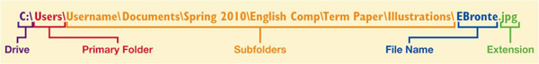

Working with Files
- File management actions:
  - Open: Open a file by clicking the file in its storage location. The operating system then determines which application needs to be loaded to open the requested file and opens the file within the correct application automatically.
  - Copy: When you copy a file, a duplicate file is created and the original file remains in its original location.
  - Move: When you move a file, the original file is deleted from its original location.
  - Rename
  - Delete
- The Recycle Bin is a folder on the desktop in Windows where files deleted from the hard drive reside until you permanently purge them from your system. Files in the Recycle Bin can be easily restored to their original location.
- Mac systems have something similar to the Recycle Bin, called Trash.
Files deleted from other drives, such as a floppy drive, DVD, flash drive, or network drive, do not go to the Recycle Bin, but are deleted from the system immediately.

Utility Programs
Utility programs are small applications that perform special functions.
- Some utility programs (such as disk defragmenter utilities) manage system resources.
- Some (such as screen savers) help make your time and work on the computer more pleasant.
Others (such as file compression utilities) improve efficiency.

Display Utilities
- Right clicking on an open area of the desktop opens the Display Properties dialog box. This dialog box can also be accessed from the Control Panel using the Display icon.
- From here, you can change the appearance of:
  - Desktop
  - Background
  - Screen savers
  - Window colours

Add or Remove Programs
- When you install a new program, the program runs a wizard that walks you through the installation process. If a wizard does not initialize automatically, however, you should go to the Add or Remove Programs folder in the Control Panel. This prompts the OS to look for the setup program of the new software and starts the installation wizard.
- Most programs include support files that are not located in the main program folder. By selecting the Add or Remove Programs icon in the Control Panel and choosing a particular program, you delete the main program file and all supporting files as well.
Programs should NOT simply be deleted.

File Compression Utilities
- A file compression utility is a program that takes out redundancies in a file to reduce the file size.
- File compression is helpful because it makes a large file more compact, making it easier and faster to send over the Internet, upload to a Web page, or save onto a disk.
- Windows has built-in compression (or zip) file support.
- There are also several stand-alone freeware and shareware programs, such as:
  - WinZip (for Windows)
  - StuffIt (for Windows or Mac)
- Most compression programs look for repeated patterns of letters and replace them with a shorter placeholder.

System Maintenance Utilities
- A set of maintenance utilities is built into Windows primarily for system efficiency.
- Disk Cleanup
  - Rremoves unnecessary files from your hard drive.
  - Choose the files to be deleted:
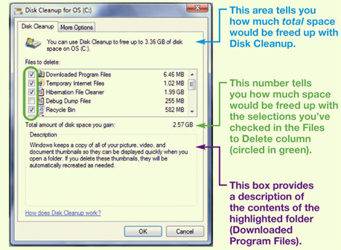
    - Downloaded program files
    - Temporary internet files
    - Offline web pages
    - Recycle Bin

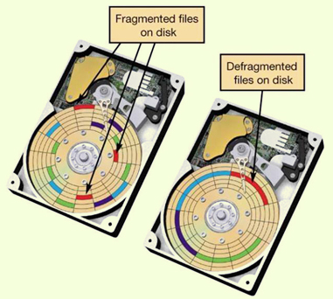
- Disk defragmenter utilities regroup related pieces of files together on the hard disk, allowing the OS to work more efficiently. Using the Windows Disk Defragmenter Analyzer feature, users should check their hard drive several times a year.

- Error checking, once known as ScanDisk, checks for lost files and fragments as well as physical errors on your hard drive. Sometimes error checking can recover the lost data, but more often, it deletes files that are taking up space unnecessarily.
If a program on your system stops working, you can use the Windows Task Manager utility to check on the program or to exit the nonresponding program.

System Restore
Windows has a utility called System Restore that lets you restore your system settings back to a specific date when everything was working properly.

System Backup
- Backup
  - Creates a copy of a hard drive to another storage device, such as a CD or an external hard drive.
- Task Scheduler
Schedule tasks to run automatically at predetermined times, with no interaction necessary on your part.

Accessibility Utilities
- Windows Vista and 7 have created an Ease of Access Center, a centralized location for assistive technology and tools that adjust accessibility settings.
- Centralized location for assistive technology:
  - High contrast
  - Magnifier
  - On-screen keyboard
  - Windows speech recognition

CHAPTER 5

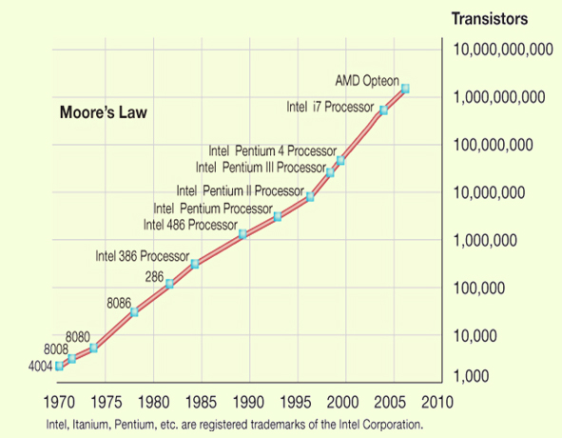
To Buy or to Upgrade?
- A rule of thumb often cited in the computer industry, called Moore’s Law, describes the pace at which CPUs improve.
- When deciding whether to upgrade or buy new, consider:
  - Moore’s Law
  - Cost of upgrading vs. buying
  - Time to install software and files
  - Needs and wants
- Determine your ideal computer system
- Assess existing computer’s subsystems
  - CPU
  - RAM
  - Storage devices
  - Video
  - Audio
-Consider training needs

Desktop or Notebook
Desktop |  | Notebook
- Hard to move around  - Less expensive  - Harder to steal  - Easier to expand and upgrade  - Difficult to transport  - Larger monitors |  | - Portable  - More expensive  - Easily stolen  - Difficult to upgrade  - Easy external expansion  - Prone to damage  - Smaller displays

How Does the CPU Work?
- The CPU or processor is the “brains” of the computer. It processes instructions, performs calculations, manages the flow of information through the computer system, and is responsible for processing the data you input into information.
- The CPU is located on the motherboard.
- The CPU is composed of two units: the control unit and the arithmetic logic unit (ALU).
  - The control unit coordinates the activities of all the other computer components.
  - The ALU is responsible for performing arithmetic calculations and makes logic and comparison decisions, such as comparing items to determine if one is greater than, less than, equal to, or not equal to another.

- Every time the CPU performs a program instruction, it goes through the same series of steps, called a machine cycle:

- Fetches the required piece of data or instruction from RAM.
- Decodes the instruction into something the computer can understand.
- It then executes the instruction.
- Last, it stores the result to RAM before fetching the next instruction
FDES

Differentiating CPUs **********
- Processing power:
  - Core: A complete processing section from a CPU embedded into the same physical chip
  - Clock speed: How quickly the processor works
  - Cache: The amount of immediate access memory the CPU has
  - Front side bus: Connects the processor to system memory

Evaluating the CPU
- Identify your current CPU
- Determine whether it is meeting your needs
- Go to Task Manager to review CPU usage
- Consider how quickly data moves to or from the CPU

Evaluating RAM
- Random access memory (RAM) is your computer’s temporary storage space.
- Memory modules (or memory cards), the small circuit boards that hold a series of RAM chips, fit into special slots on the motherboard.
  - Most memory modules in today’s systems are called dual inline memory modules (DIMMs).
- Several types of RAM are available.
  - DDR2
  - DDR3
  - SRAM
  - DRAM
  - SDRAM

How Much RAM Do You Need?
- Physical memory vs. kernel memory
  - The amount of RAM actually sitting on memory modules in your computer is your computer’s physical memory.
  - The memory that your (OS) operating system uses is referred to as kernel memory.
Application | RAM Recommended
Windows 7 | 2,000 MB (or 2 GB)
Microsoft Office Professional 2010 | 512 MB
Internet Explorer 8 | 512 MB
iTunes | 512 MB to 1,000 MB (1 GB)
Adobe Photoshop Elements | 1,000 MB (1 GB)
Total RAM required to run all programs simultaneously | 4,536 MB to 5,024 MB (or 4.5 GB to 5.0 GB)
- To determine how much RAM your computer needs, look at the memory requirements for each program and add them up.
- RAM is needed for system software, productivity software, and entertainment and graphics programs.

Adding RAM
- Adding RAM can have a big positive effect on system performance.
- Things to consider:
  - Type of RAM module
  - Amount of RAM
    - Maximum limit
    - Number of slots
    - Operating system

Storage
- RAM is a form of temporary storage – anything residing in RAM is not permanently saved. Therefore, it’s critical to have the means to store data and software applications permanently.
- Several storage options exist, including:
  - Hard drive
  - USB flash drive
  - Optical drive
  - External hard drive
  - When you turn off your computer, the data stored to these devices is saved. These devices are therefore referred to as nonvolatile storage devices.

The Hard Drive
- Storage capacity is up to 2 terabytes (TB).
- Access time is measured in milliseconds.
- Data transfer rate is measured in megabits or megabytes per second.

How a Hard Disk Works
- A hard disk drive is composed of several coated platters stacked on a spindle.
- When data is saved to a hard disk, a pattern of magnetized spots is created on the iron oxide coating each platter.
  - Each of these spots represents a 1.
  - The spa
  - ces not spotted represent a 0.
  - These 0s and 1s are bits (or binary digits), the smallest pieces of data that computers can understand.
- Sitting between each platter are special arms that contain read/write heads. The read/write heads move from the outer edge of the spinning platters to the center to read and write the magnetic data to and from the hard disk.
- When data stored on the hard disk is retrieved (or read), your computer translates these patterns of magnetized spots into the data you have saved.
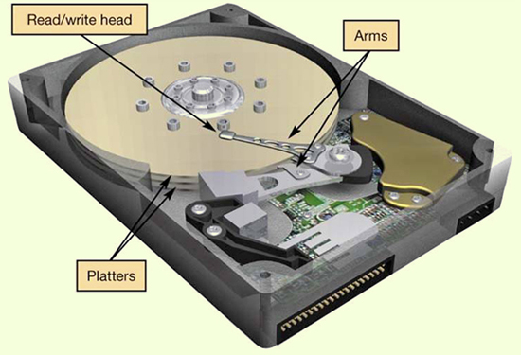

Evaluating Storage
- Identify your hard drive’s total capacity
- Determine your storage capacity needs
- Consider data transfer rates
  - Internal
  - External

Optical Storage
- Optical media: Store data as tiny pits burned into a disc by a laser
  - Prerecorded
    - CD-ROM, DVD-ROM, BD-ROM
  - Recordable
    - CD-R, DVD-R, BD-R
  - Rewritable
    - CD-RW, DVD-RW, BD-RE
Consider replacing CD/DVD drive with BD burner

Evaluating Video
- How video is displayed depends on two components:
  - video card (adapter)
  - monitor
- It’s important that your system have the correct monitor and video card to meet your needs.
- If you use your computer system to display files that have complex graphics, such as videos on DVD or from your camcorder, or if you play graphics-rich games with a lot of fast action, you may want to consider upgrading your video subsystem.

Video Cards
- A video card (or video adapter) is an expansion card installed inside your system unit to translate binary data into the images you view on your monitor.
- Modern video cards include ports allowing you to connect to different video equipment as well as their own RAM, called video memory.

- Video cards also come with their own processors. Calls to the CPU for graphics processing are redirected to the processor on the video card, significantly speeding up graphics processing.

- The video card also controls the number of colors your monitor can display. The number of bits the video card uses to represent each pixel on the monitor (referred to as the bit depth) determines the color quality of the image displayed. The more bits, the better the color detail of the image.
  - A 4-bit video card displays 16 colors, the minimum number of colors your system works with (referred to as Standard VGA).
  - Most video cards today are 24-bit cards, displaying over 16 million colors. This mode is called true color mode (SVGA)

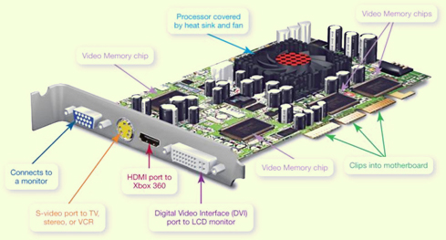

Graphics Processing Unit (GPU)
- Performs the same work as a CPU
- Specialized to handle:
  - 3D graphics
  - Image and video processing
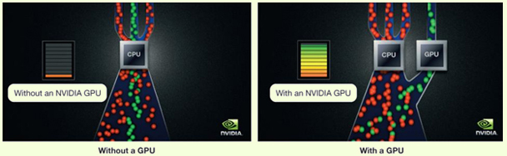
- CPUs perform better with a GPU handling graphics computation.

Evaluating Video Card
- Identify the amount of video memory on your video card
- Determine your video needs
- Consider how many monitors you want to use

Evaluating Audio
- Sound cards attach to the motherboard and enable your computer to produce sounds.
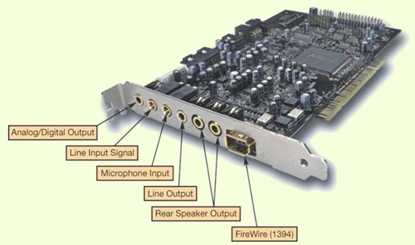
  - Attach to motherboard
  - Process digital data into sounds
  - 3D sound cards
  - Surround sound
  - Allow you to connect audio devices

Evaluating System Reliability
Before you buy a new system thinking yours is unreliable, make sure the problem is not one you can fix. Proper upkeep and maintenance may postpone an expensive system upgrade or replacement.
- Performance:
  - Is slow
  - Freezes
  - Crashes
- Upkeep and maintenance:
  - System tools
  - Control Panel
  - Update software
Upkeep and Maintenance
There are several procedures you can follow to ensure that your system performs reliably:
- Clean out your Startup folder. Some programs install themselves into your Startup folder and are automatically run each time the computer reboots. This unnecessary load causes extra stress on RAM. Make sure you delete only those programs you know for sure are unnecessary.
- Clear out unnecessary files. Temporary Internet files can accumulate quickly on your hard drive. Running the Disk Cleanup utility is a quick and easy way to ensure these files dont take up hard drive space. Likewise, delete unnecessary files from your hard drive regularly.
- Run spyware and adware programs. These can detect and remove various pests and should be used in addition to your regular antivirus package.
- Run the Disk Defragmenter utility on your hard drive. When your hard drive becomes fragmented, its storage capacity is negatively affected. When you defrag your hard drive, files are reorganized, making the hard drive work more efficiently.

Update Software and Hardware Drivers
- Software
  - Having the latest version of software products makes your system much more reliable.
  - You should upgrade or update your operating system, browser software and application software as often as new patches (or fixes) are reported for resolving errors. Sometimes these errors are performance related; sometimes they’re tied to maintaining better security for your system.
  - You can configure Windows to automatically check for downloads and install any available updates for itself and for Internet Explorer. In addition, products such as McAfee’s Oil Change enable you to sort through numerous websites and quickly find the bug fixes for most application software.
- Hardware
  - Download updated drivers.

The Last Resort
When all else fails, you have two options:
- Upgrade your operating system to the latest version. There are substantial increases in reliability with each major release of a new operating system. However, upgrading the operating system may require hardware upgrades, such as additional RAM, an updated graphics processor, and even a larger hard drive. The Microsoft Windows 7 Upgrade Advisor will perform a scan of your system to determine what upgrades might be required before converting to Windows 7. Be sure to examine the recommended (not just required) specifications of the new operating system.
- Reinstall the operating system. To do so, you'll need to back up all of your data files before the installation and be prepared to reinstall your software after the installation. Make sure you have all of the original discs for the software installed on your system, along with the product keys, serial numbers, or other activation codes so that you can reinstall the software.

The Final Decision
- When a decision about upgrading versus replacing your computer is required, you have to ask yourself how you use your computer system?
  - How might you use it if it were more capable?
  - Can your existing system do what you want it to? If not, can you purchase the parts and install them to achieve the desired capability?
Add up the cost of the parts, figure in the value of the headaches and labor required to install those parts, and compare the total to the cost of a new machine that will do the same tasks and more. You should then arrive at a point where the decision is easy.

CHAPTER 6

Networking Fundamentals
- Computer network: Two or more connected computers
- Node: Any device connected to a network
- Benefits of computer networking
Facilitates resource sharing
    - High-speed internet connections
    - Peripheral devices such as printers
    - Files
- Disadvantages of computer networking
Network administration
    - Installing new computers and devices
    - Monitoring the network’s performance
    - Updating and installing new software
    - Configuring network security

Network Architectures
- Architecture: Design of the network
- Peer-to-peer network
  - Local administration
  - Each node can communicate directly with every other node.
- Client/server
  - Central administration
  - Clients: Used to accomplish tasks
  - Server: Administers network functions

Networks Based on Distance
- LAN: Local area network
- HAN: Home area network
- WAN: Wide area network
- MAN: Metropolitan area network

Network Components
- Transmission media
  - Wireless networks connect nodes with radio waves.
  - Wired networks use cables to connect nodes.
    - Twisted-pair cable
    - Coaxial cable
    - Fibre-optic cable
Data Transfer
- Data transfer rate
  - Bandwidth= the bit-rate of available or consumed information capacity
  - Speed of data transmission

- Throughput
  - Actual speed of data transfer achieved
  - Always less than or equal to the data transfer rate

Network Adapters
- Devices connected to, or installed in, network nodes
- Enable nodes to communicate with each other and access the network

Wireless Signals
- Might have decreased throughput:
  - Interference from magnetic and electrical sources
  - Interference with other wireless networks
  - Building materials and metal
  - Distance from networking equipment
  - Coded signals

Network Navigation Devices
Control the flow of data through a network
- Data sent in bundles called packets
- Routers
  - Transfer packets between two or more networks
- Switches
- Send packets to intended nodes on same network

Networking Software
- Home networks
  - P2P supporting operating system
  - Windows
  - OS X
  - Linux
- Client/server networks
  - Network operating system (NOS) software
  - Windows Server 2008 R2
  - SUSE Linux Enterprise Server

Home Ethernet Networks
- Use Ethernet protocol as standard for network communication
- Wireless 802.11
- Wired 802.3

Routers and network adapters
  - Translate electronic data into radio waves
  - Broadcast radio waves to other nodes
  - Receive signals from other nodes

Throughput Speeds
- Can be measured using utilities like Net Meter
- Wired connections provide best throughput.
- Wi-Gig will be faster than current wired or wireless standards
- Will not be available for several years

Network Cabling
- Unshielded twisted-pair (UTP) cable
  - Most popular cable for Ethernet networks
  - Composed of four pairs of wires that are twisted around each other to reduce electrical interference
- RJ-45 connectors: used on cable ends
- Cat 6 cable: best UTP for home networks
- Signal degrades after 100 m (328 ft).

Home Ethernet Network Equipment
- Router (broadband router)
  - Includes integrated switches
  - Most have wireless capability
  - Can contain broadband modem
- Wireless devices need wireless network interface cards (NICs).
- Network-ready devices can connect directly to router.

NAS Devices
- Network attached storage (NAS) devices
  - Store and manage data
- Home network server
  - More sophisticated NAS device
Performs only a limited set of functions performed on client/server networks

Digital Entertainment Devices
- Connect to network to access and share digital content
- Use gaming devices to play multiplayer games with players all over the world
- Network-ready TVs and home theater systems
- Blu-ray players
- DVRs

Specialized Devices
- Internet appliances
  - Used to access internet
  - Apple iPad
  - Digital picture frames
  - Security monitoring cameras

Securing Wireless Networks
- Piggybacking
  - Connecting to a wireless network other than your own without permission of the user
  - Can be unintentional
- Most wireless adapters are set up to access the strongest wireless signal detected.
- Hackers can intercept packets of information broadcast on a wireless network.

- Precautions to secure a wireless network:
  - Change your network name (SSID)
  - Disable SSID broadcast
  - Change the default password on your router
  - Turn on security protocols
  - Implement media access control
  - Limit your signal range
  - Apply firmware upgrades

Configuring a Home Network
- Windows 7 automates setting up networks.
- Before running the automated wizards:
  - Make sure there are network adapters on each node
  - For any wired connections, plug all the cables into the router, nodes, and so on
  - Make sure your broadband modem is connected to your router and that the modem is connected to the internet

- Turn on your equipment in the following order (allowing the modem and the router about one minute each to power up and configure):
  - Broadband modem
  - Router
  - All computers and peripherals (printers, scanners, etc.)
- Access Network and Sharing Centre from within Control Panels
- Turn Network Discovery on
- Turn File and Printer Sharing on
- Turn Public Folder Sharing on
- Use Set up a New Connection Wizard
- Use Connect to the Internet Wizard
- Use Set Up a Wireless Router Wizard

Connecting Macs Wirelessly
- Set up router security (as in Windows)
- Logging onto network requires SSID and passphrase
- Choose network, enter password, and join
- Networks with SSID broadcast turned off will not appear as an available network.
- Click "Other" and enter the network name and password

Wireless Node Configuration
- Hook up devices like DVRs or gaming consoles
  - Wired connection
    - Plug cable into device and router
  - Wireless connection
    - Follow steps in device’s setup menu
    - SSID name and security passphrase required if network is secured

Test Internet Connection Speed
Internet sites allow you to test speed of downloading and uploading files.
- Speedtest.net
- Broadband.gov
- Run test at several different times during the day over the course of a week

Troubleshooting Network Problems
- Throughput decreases as device moves farther away from router
- To increase throughput:
  - Move the router within the room or to another room
  - Move the device closer to the router
  - Amplify your wireless signal by adding a wireless range extender

