How can we recognize acids and bases?
- We need to be able to recognize acids/bases based on their chemical formula:
  - CO2H2 = Acid? Base? Neutral?
- There are three types of acids:
  - Oxoacids = H_{x}EO_{y}
  - Carboxylic acids = RCO₂H
  - Other acids: HX
Recognizing acids - Oxoacids
- Oxoacids: contain an inner atom bonded to a variable number of oxygen atoms and acidic OH group
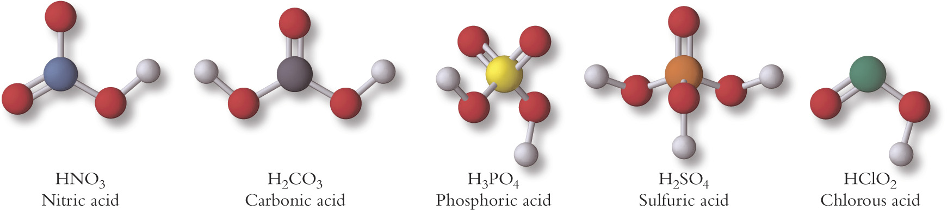
- A reminder:
  - Monoprotic acids: only capable of donating one proton
    - HCl, HI, HS-, HPO4-, HSO4
  - Polyprotic acids: capable of donating two or more protons
    - H2CO3, H3PO4, ,H2PO4-, H2SO4, H2S
  - Monoprotic bases: only capable of accepting one proton
    - Cl-, HPO4-, HSO4
  - Polyprotic bases: capable of accepting two or more protons
    - SO42-, CO32-, PO43-
  - Amphiprotic: molecules or ions which can behave either way (either an acid or a base)
- Rules for naming oxoacids:
  - An oxoacid that forms from a polyatomic anion having an ending in –ate has a name ending in –ic:
    - NO3- = nitrate HNO3 = nitric acid
  - An acid that forms from a polyatomic anion having an ending in –ite has a name ending in –ous:
    - NO2- = nitrite HNO2 = nitrous acid
- A table of common weak oxoacids:
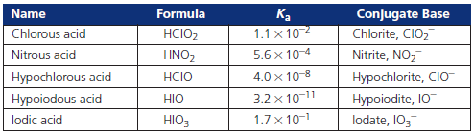

Carboxylic acids:
- Carboxylic acids: have a general formula RCO₂H
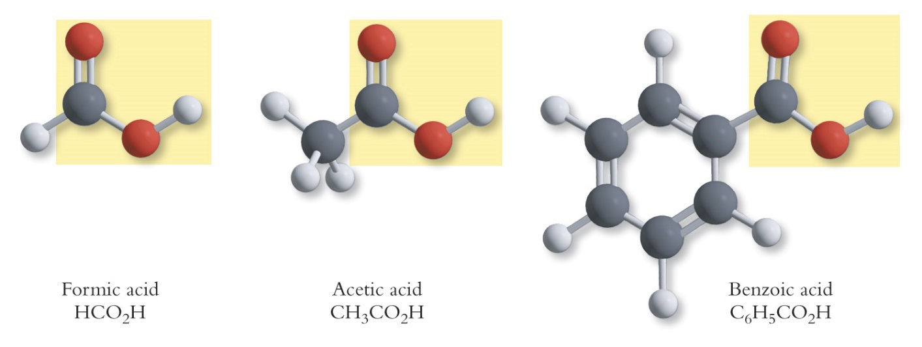
- Note: all carboxylic acids are weak acids:
  - CH3CO2H (aq) + H2O (l) → CH3CO2- (aq) + H3O+ (aq)
Other acids:
- Those acids that do not fall into the previous two categories are lumped together and named “other acids”
- These acids have no clear structure or pattern:
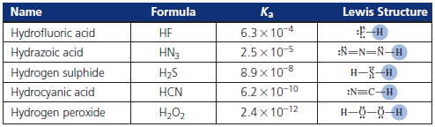
Recognizing bases – amine bases:
- Amines: Compounds whose molecules can be viewed as ammonia with one or more N-H bonds replaced by N-C bonds:
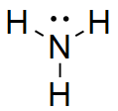
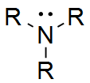
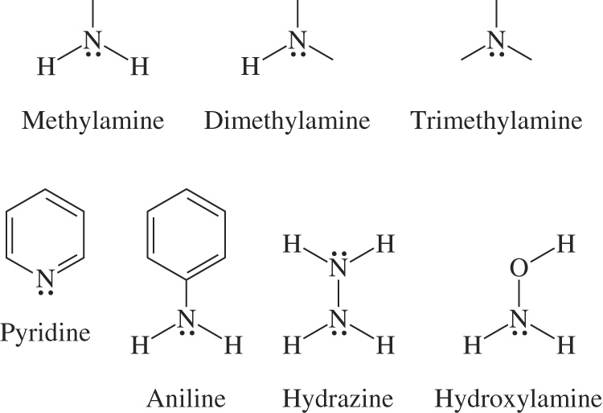
- Common amine bases

- Note: water is a weak base

- Below is a table of common organic bases:
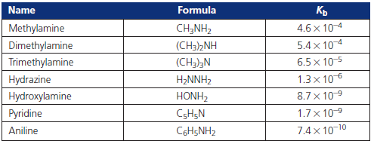
Acidic and basic salts:
- Not all chemical compounds are acid or bases, but these compounds can display acid-base properties
- Salts of weak acids:
  - Consider the addition of NaF to a pure solution of water:
    - NaF (s) → Na+ (aq) + F- (aq)
  - The anions and cations may contain acid-base properties:
    - F- (aq) + H2O (l) ⇆ HF (aq) + OH- (aq)
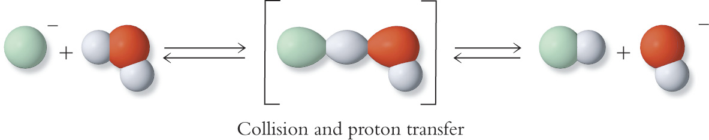
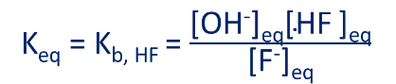
- How is the proton transfer reaction below linked to what else is going on in solution?
  - F- (aq) + H2O (l) ⇆ HF (aq) + OH- (aq) Kb, HF
  - HF (aq) + H2O (l) ⇆ H3O+ (aq) + F- (aq) Ka, HF
- If we cancel the species, we will get:
  - 2H2O (l) ⇆ H3O+(aq) + OH- (aq) Recall: Kw = [H3O+][OH-]
- If we multiply the Ka and Kb, we will obtain the Kw:
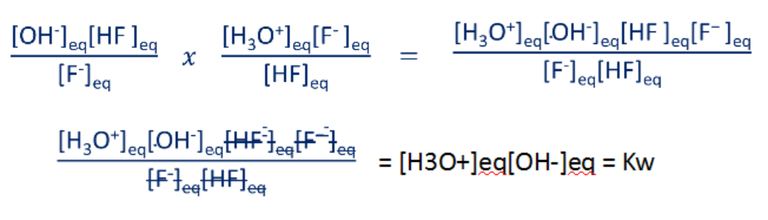
- Therefore: Ka x Kb = Kw ➜ pKa + pKb = 14
- Salts of weak acids are basic in aqueous solutions:
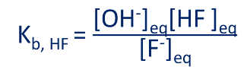
- Salts of weak bases are acidic in aqueous solution:
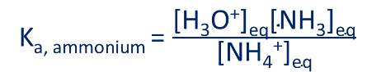
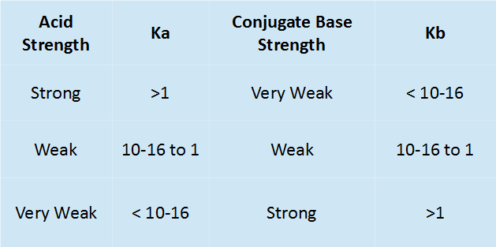
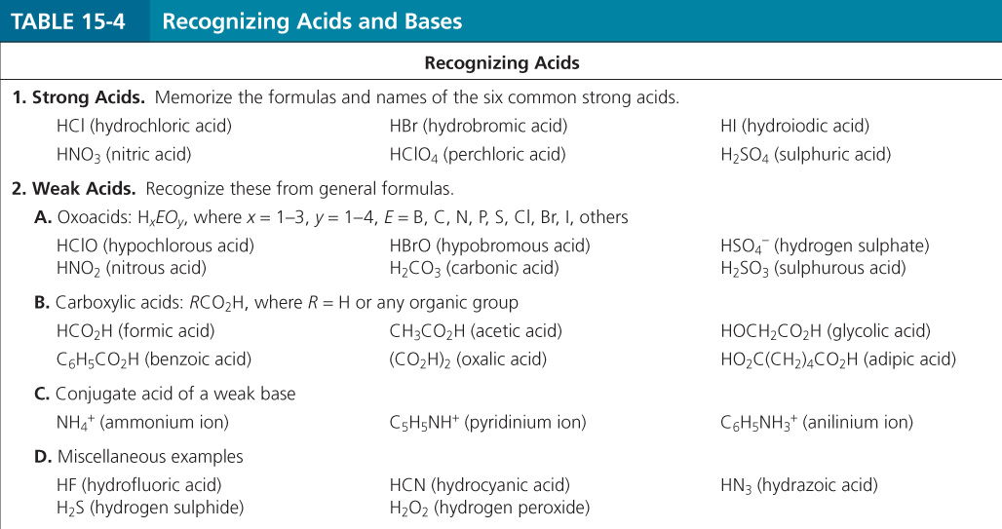
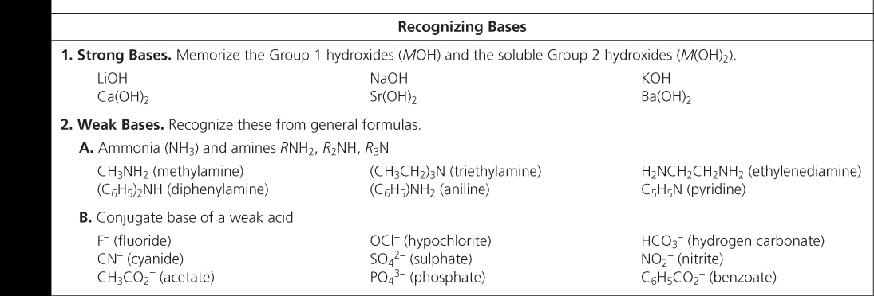
Factors affecting acid strength – charge effect:
- The charge on a molecule can have a significant impact on the acidity of a molecule:
  - Remember: opposite charges attract, like charges repel
- Key point of charge effect: how easily/difficult it is to donate/accept hydrogen
- Strong acids:
  - HX (aq) + H2O (l) H3O+ (aq) + X- (aq)
- Strong bases:
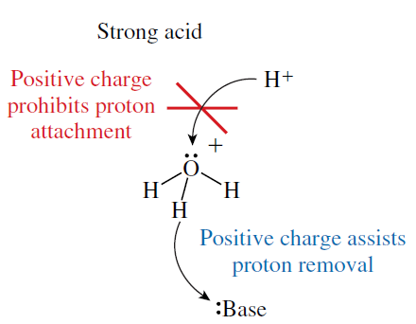
  - X- (aq) + H2O (l) HX (aq) + OH- (aq)
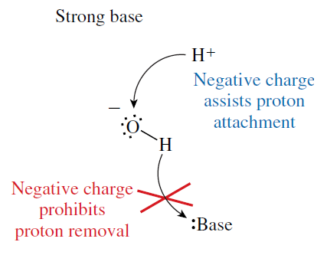
- weak acids/bases:
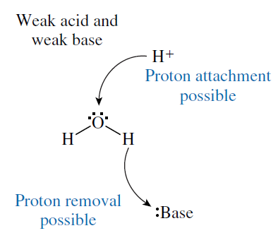
  - HX (aq) + H2O (l) H3O+ (aq) + X- (aq)
  - X- (aq) + H2O (l) HX (aq) + OH- (aq)
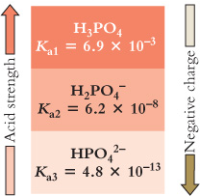
- The greater the negative charge on the acid, the greater the decrease in acid strength

Factors affecting acid strength - Structural factors:
- The strength of an oxoacid or carboxylic acid increases as electron density is withdrawn from the O-H bond:


