Know and identify the main classes of macromolecules, recognize their general structures, and interpret these in relation to their cellular location and their roles in cells

Main Class of Macromolecules | General Structure | Cellular Location | Role in the Cell
Carbohydrates | Made from 3 elements: Oxygen, carbon and hydrogen | Found on the outer surface of all eukaryotic cell membranes and are attached to mostly the membrane proteins and sometime phospholipids | starches and sugars that bodies use for energy
Lipids | - They are large molecules assembled from smaller molecules by dehydration reactions.  - A fat is constructed from two kinds of smaller molecules: glycerol and fatty acids. | Lipid molecules are found in cell membranes in phospholipids due to them being amphipathic molecules | Help the body store the energy it needs in the form of fats and oil
Proteins | A protein consist of one or more polypeptides folded and coiled into a specific conformation | Ribosomes | Protein Functions included structural support, storage, transport, cellular signaling, movement, and defense against foreign substances. Most Important, protein enzymes function as catalysts in cells
Nucleic Acids | Nucleic acids are polymers made of nucleotide monomers. Each nucleotide consists of three parts: a nitrogenous base, a pentose sugar, and a phosphate group. | Nucleus | Code for the structure and function of the body's proteins. Also forms RNA
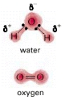
Importance of water in biology:
- accounts for about 70% of a cell's weight
- most intracellular reactions occur in an aqueous environment
- Life centres on the properties of water
- there is an unequal distribution of electrons in a water molecule
- this results in positive and negative areas
- Positive areas such as Hydrogen gets attracted to the opposite which is negative such as oxygen, this results in the bond referred as “hydrogen bond”
- hydrogen bonds are being continually broken and formed
- because of hydrogen bonding water is liquid at room temperature
- molecules carrying plus or minus charges (ions) likewise interact favorably with water
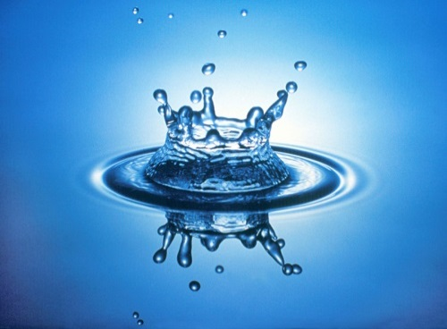
- Because of a favorable interaction between water molecules and ions, ionic bonds are greatly weakened by water; thus many salts (including NaCl) are highly soluble in water
Properties of Water:
- Water is a dipolar molecule
- Water molecules form hydrogen bonds
- Water is the universal solvent
- Water has a high surface tension
- Ice floats on water
- Water is adhesive and cohesive
- Important thermal properties

What are the types of chemical bonds present in cellular macromolecules and how are they relevant to cell biology:

Covalent Bonds In a covalent bond, electrons are being shared between the 2 atoms
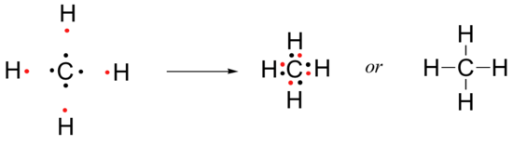

Polar Bonds Pair of electrons are found closer to 1 of the atoms, therefore the electrons are NOT shared equally. This is due to electronegativity (electronegativity is a measure of how strongly an atom pulls the electrons to itself; how strongly it attracts electrons)
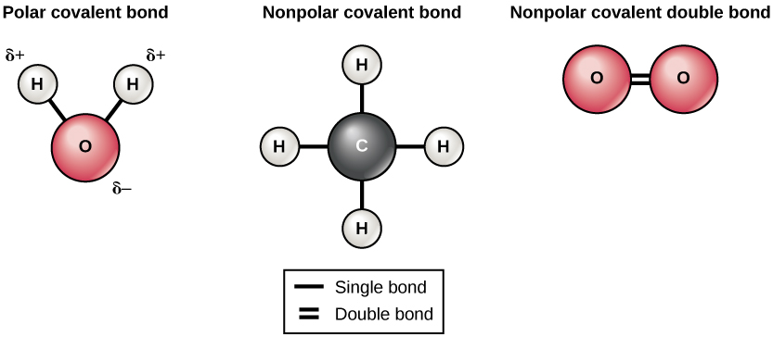

Ionic Bonds Interaction between 2 ions, 1 ion loses an electron and becomes positively charged, the other atom gains an electron and becomes negatively charged. Positive and negatives attract to each other so both ions form an association because of their opposite charges

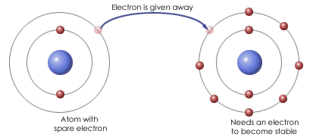

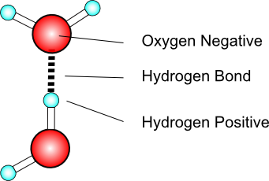
Hydrogen Bond only implies to polar molecules such as water. Hydrogen bond is a weak association, a weak interaction between hydrogen and an oxygen or nitrogen that is not covalently bonded to hydrogen. (Hydrogen of a water molecule is interacting with oxygen on another water molecule) This occurs because of the polarity of the water molecule, both have opposite charges therefore they attract each other and create this weak bond

Hydrogen bonding occurs in DNA and cellulose. The hydrogen bonding that occurs in cellulose is what gives the plant it’s very rigid structure

Van Der Waals Interactions very weak interactions within or between molecules. They have to do with the fact that electrons are constantly orbiting the atomic nucleus, they are in constant motion. At any moment in time, more of them might be found on one end of the molecule, making that end of the molecule temporarily negative and the opposite end temporarily positive. As they create bonds, they attract to opposite charges therefore will form an association but in a moment it will be gone because the electrons will move again. Therefore, Van der Waals interactions are constantly forming a constantly breaking. BUT because they’re always some there, they’re together very powerful
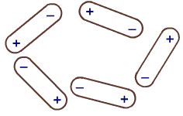
All these bonds are critical to forming biological molecules. Hydrogen, and Van der Waals interaction is especially important to holding the shape of the molecule and the shape of the molecule is critical to its function.

