Lymphatic System

Plays a Role: A vital supporting role for both your cardiovascular and immune systems
Lymphatic System:
- Returns fluid that has leaked out from the vascular system back into the blood
- Consists of 3 Parts:
1.) Network of lymphatic vessels
2.) Lymph: Fluid in vessels
3.) Lymph nodes: Cleanses lymph
Lymphoid Organs and Tissues: Provide structural basis of immune system by housing phagocytic cells and lymphocytes.
The story of Lymph: As blood exchanges nutrients, gases and wastes between the blood and the interstitial fluid. The hydrostatic and colloid osmotic pressure at the capillary beds forces fluid out of the blood. This fluid remains in the tissue space as interstitial fluid. This leaked fluid must be returned to the blood because it contains plasma proteins that are necessary for the cardiovascular blood volume. Since it’s the lymphatic vessels job they take in the excess protein interstitial fluid and it is now called Lymph
How lymph travels:
1.) Lymphatic Capillaries
2.) Afferent Lymphatic Vessel
3.) Lymph Node
4.) Efferent Lymphatic Vessel
5.) Lymphatic Trunk
6.) Collecting Duct
7.) Subclavian Vein

Lymphatic Capillaries:
- Begin as blind-ended tubes that weave between tissue cells and blood capillaries in loose connective tissues; the smallest vessels
- Absent from bones, teeth and bone marrow
- Responsible for carrying large molecules and particles like: Proteins, Cell Debris, Pathogens, and Cancer Cells.
- More Permeable than blood capillaries because
- 1.) There endothelial cells are loosely joined which allows them to overlap in a flap like easily opened way which we know as minivalves
- 2.) Collagen filaments anchor the endothelial cells to the surrounding structures so that and increase in the interstitial fluid will open the minivalves
- Pressure Changes: Increase in pressure in the interstitial fluid will cause the minivalves to open & If there in an increase in pressure in the lymphatic capillaries it will then cause the minivalves to close.
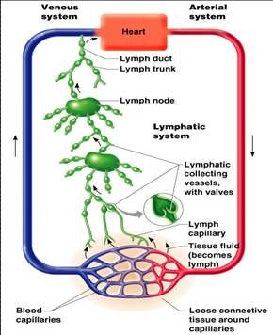
- Specialized Capillaries: We have these lymphatic capillaries that transport absorbed fat from the small intestine into the blood stream: Lacteals.This know milky fluid fatty lymph will be called chyle which will drain into the blood.
Lymphatic Vessels
- Common pattern of : Collecting Vessels Trunks Ducts
- Lymphatic capillaries will drain into larger vessels
- 1.) Collecting Vessels:
- As shown on the right will merge from the capillaries.
- They contain the same 3 tunics as blood vessels but there walls are thinner with more internal valves
- Anastomose more frequently than blood vessels.
- Collecting vessels of the skin will travel with the superficial veins and the deep vessels will travel with the arteries.
2.) Lymphatic Trunks:
- The largest collecting vessels will unite to form the lymphatic trunks
- These will drain in fairly large areas of the body.
- Important names of the trunks where they drain lymph are:
1.) Paired Lumbar
2.) Paired Bronchomediastinal
3.) Paired Subclavian
4.) Paired Jugular Trunks
5.) Single Intestinal trunk

3.) Lymphatic Ducts:
- Right Lymphatic Duct that drains from the right upper limb and right side of the head and thorax
- Thoracic Duct Drains from the entire lower body, left upper extremity and left side of the head and thorax.
- Each of these ducts empties into venous circulation at junction of internal jugular and subclavian veins on its own side of the body which then feed into the superior vena cava.
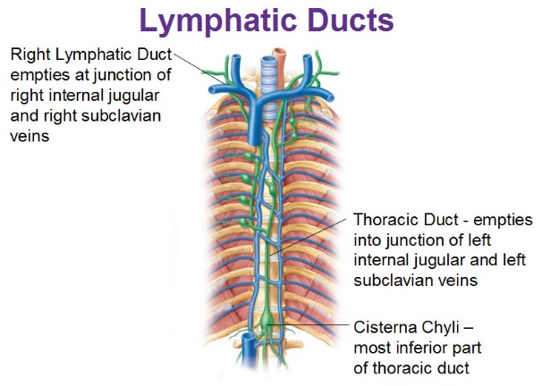

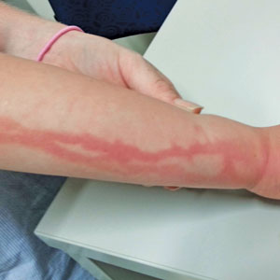
Lymphangitis: Where the vaso vasora of the larger lymphatic vessels becomes congested with blood because the lymphatic vessels are inflamed. As a result the vessels appear as painful red lines under the skin.

Lymph Transport:
- There is no pump in this system so it uses the same mechanisms as you would see in the venous system with low-pressure circulation. Here are some examples:
- 1.) Milking action of skeletal muscles
- 2.) Valves that prevent backflow of lymph
- 3.) Pressure changes of the thorax during inhaling and exhale
- 4.) Pulsations of nearby arteries
- 5.) contractions of smooth muscles in the walls of these vessels
- 6.) Physical activity: increase venous return and cardiac output.
Lymphedema:
- Severe localized edema causes by anything that prevents normal return of lymph to blood
- So this happens when we have tumors blocking the lymphatics or removal of lymphatics during cancer surgery.
- Lymphedema may improve if some lymphatic pathways remain and enlarge.
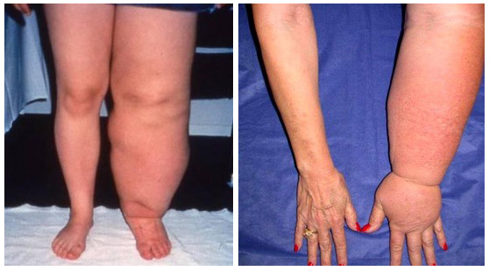uhuh global warming.

To summarize, the lymphatic vessels:
- Returns excess tissue fluid to the bloodstream
- Return leaked proteins to the blood
- Carried absorbed fat from the intestines to the blood (lacteals)
The blocked lymphatic vessels in Mr. Thomas’s left leg no longer return excess tissue fluid or proteins to the bloodstream. The lack of fluid return from the tissues into the blood will result in a higher interstitial fluid hydrostatic pressure. This is an inward pressure, and will tend to help limit the edema. However, the lack of proteins being returned from the interstitial fluid to the blood will result in a higher interstitial fluid osmotic pressure, which will tend to pull more fluid into the tissue.
Immune System aspect of the Lymphatic System:
Lymphoid Cells:
- 2 types of lymphatic cells:
- 1.) Immune Cells (in the lymphoid tissue)
- 2.) Supporting Cells (in the lymphoid tissue structures )
- 1.)Immune System Cells are your Lymphocytes which the protect the body from antigens ( anything they perceive as foreign and provokes and immune response)
- Lymphocytes: Cells of the adaptive immune system (not the innate immune system)
- T cells: Manage the immune response and some also attack and destroy infected cells
- B Cells: Produce plasma cells and secrete antibodies. Humoral Immunity. The antibodies will mark the antigen for destruction
- Macrophage: Big eater, phagocytizing foreign particles and help activate T cells
- Dendritic Cells: Capture antigens; deliver them to lymph nodes; help activate T cells. Antigen presenting cells to the T cells.
- 2.) Supporting Lymphoid Cells:
- Act as a scaffolding for immune cells (T cells, Macrophages and B cells).
- Reticular cells form a scaffolding with the reticular fibers called a stroma in lymphoid organs.
- * Keep in mind you will see this in all organs the immune system cells embedded with the stroma of the reticular fibers. Constantly will show up in this chapter.
Lymphoid Tissue:
- Houses and provides proliferation sites for lymphocytes. Once your body has detected the presence of a foreign organism some cells will recognize them and destroy them and the send signals to the rest of the immune system. This signal is a note to your immune system to keep making more of these immune cells AKA proliferation of B and T cells.
- Offers surveillance vantage points for lymphocytes and macrophages as they filter through lymph.
- Largely composed of reticular connective tissue and type of loose connective tissue(supplied with blood)
- Macrophages live on the reticular fibers
- Spaces between the fibers offer a place for lymphocytes to occupy when they return from patrolling body.
- You will not find reticular CT on the Thymus
- The purpose of this is to monitor. The lymphocytes will cycle between the circulatory vessels, lymphoid tissue and loose connective tissues of the body to ensure that they reach all infected or damaged sites quickly.
2 types of Lymphoid Tissue:
1. Diffuse Lymphoid Tissue:
- Loose Arrangement of lymphoid cells and some reticular cells; You will see this virtually in all body organs; find lining the digestive tract lamina propia .
2. Lymphoid Follicles (Lymph Nodules):
- Solid, spherical, more organized, consisting of tightly packed lymphoid cells and reticular fibers.
- Contains a Germinal Centers where proliferating B cells predominate in case a bad guy comes and will hyper proliferate when it does. Found in Lymph Nodes. These centers will enlarge dramatically when the B cells are dividing rapidly and producing plasma cells.
- They may be patches of these in the GI tract and appendix known as Peyer Patches.

Lymphoid Organs:
2 Functional Categories of lymphoid organs
Primary Lymphoid Organs: Areas where T cells and B cells mature; red bone marrow and thymus. B cells mature in red bone marrow but the T cells mature in the thymus.
Secondary Lymphoid Organs: Where the mature lymphocytes first encounter their antigen and become activated. Nodes, Spleen, MALT (Mucosa-associates lymphoid tissue) and Diffuse lymphoid tissue.
Lymph Nodes (Secondary Lymphoid Structure):
- Most important secondary lymphoid organs
- They don’t secrete anything they just get inflamed. When someone says your glands are swollen they really mean you lymph nodes are swollen.
- Cluster along the lymphatic vessels
- Not normally visible because they are embedded deep in Connective Tissue
- You will find the ones closer to the surface in the inguinal, axillary and cervical regions of the body. Found in the vertebral column and mesentery groove (intestine)

2 Main Functions of Lymph Nodes
1.) Cleansing the Lymph: They act as filters
- Macrophages remove and destroy microorganisms and debris that enter the lymph
- Prevent unwanted substances from being delivered into the blood
2.) Immune System Activation:
- Offer a place for lymphocytes to become activated and mount an attack against antigens. Activates the entire immune system.
Structure of a Lymph Node
- It is structured in a particular way for its defensive function
- They vary in shape and size, most are small (1 inch ) bean shaped structure; surrounded by an external fibrous capsule.
- The outer capsule connective tissue fibers branch inwards as trabeculae that divide the node into compartments
- Discrete and encapsulated with collections of diffuse lymphoid tissue and follicles. *
2 Distinct Histologically Regions of the Node:
1.) Cortex
- Outer surface of the organ
- Densely Packed Follicles with Germinal Centers that are heavy with dividing B cells
- Deeper part of the cortex has T cells performing their surveillance role
- Abundant numbers of dendritic cells that are closely associates with both T and B cells .They play a role in activating both lymphocytes.
2.) Medulla
- Medullary cords (elongated) extend inward from cortex and contain B cells, T cells and Plasma Cells
- Lymph Sinuses are found throughout node
  - Large Lymphatic capillaries spanned by crisscrossing reticular fibers
  - Numerous Macrophages reside in these reticular fibers and phagocytize foreign matter in the lymph
Circulation in the Lymph Nodes
Afferent Lymphatic vessels- Lymph enters the lymph node through here.
Subcapsular Sinus- Lymph then moves from the afferent into the large, baglike sinus into a number of smaller sinuses that cut through the cortex and enter the medulla.
Lymph then enters medullary sinuses and then exits on the indented region on the concave side called the Hilium
Efferent Lymphatic vessels- Carries away the lymph
*There are fewer efferent vessels draining the node that afferent vessels feeding it, so the flow of lymph through the node stagnated somewhat, allowing time for the lymphocytes and macrophages to carry out their protective functions. * Like how the capillary bed slows down to allow diffusion to take place.
Homeostatic Imbalance:
Buboes (swollen glands): Inflamed, swollen, tender to touch and filled with pus. Lymph nodes that result when nodes are overwhelmed by what they are trying to destroy. Germinal centers are triggered even more producing and activating more. Enlargement occurs.
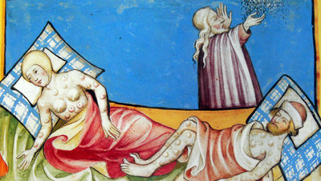
- Bubonic Plague was named after chief clinical feature of this disease. Picture is above.
Cancer and Lymph Nodes: Nodes are secondary cancer sites if metastasizing cancer cells become trapped in a node. Theses cancer-infiltrated lymph nodes are usually swollen but not painful.
Spleen (Secondary Lymphoid Organ):
- The largest lymphoid organ, Blood-Rich Organ, located on the left side of the abdominal cavity just below the stomach. Blood Reservoir.
- Removes blood borne pathogens and aged red blood cells, responsible for lymphocyte proliferation and surveillance.
- Served by the splenic artery and vein
- Cleanses the body of aged RBC’s and platelets, WBC’s, macrophages remove debris
- Recycles breakdown products from the RBC’s for late reuse (iron which will be used in hemoglobin)
- Stores blood platelets – If you clot too much they will remove your spleen because they store a lot of platelets. You are not getting rid of the source just the storage.
- Monocytes for release into blood when needed
- May be site for fetal RBC production

Structure of the Spleen:
- White Pulp
  - Site where IMMUNE FUNCTION occurs this is why you will find mainly lymphocytes on reticular fibers
  - Found around Central Arteries, “ islands of white in a sea of red pulp”
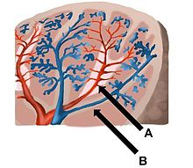
- Red Pulp (most of it)
  - Site where old blood cells and blood borne pathogens are destroyed
  - It is red because huge number of thin walled veins that give it this appearance.
  - Huge number of RBC’s and the macrophages that come in and destroy them
  - It is all splenic tissue that is not white pulp.
  - Composed of splenic cords (reticular tissue) that separates blood-filled splenic sinusoids (Venous Sinuses) walls are very thin and contain huge spaces for proteins and cells to go through.
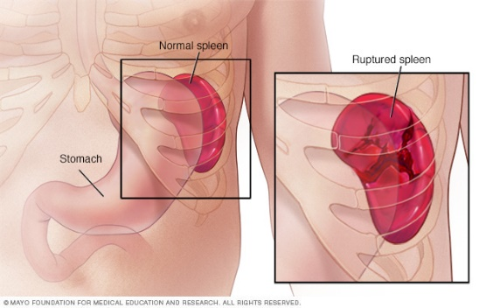
Homeostatic Imbalance:
- The spleen has a thin capsule and since it contains lots of blood if it is ruptured if can cause internal bleeding into the peritoneal cavity
- Splenectomy: They would surgically remove the ruptured spleen before they knew that it can regenerate on itself to prevent hemorrhage or shock
- The liver and bone marrow will take over the spleens functions if it is removed
- Children under 12 there spleen will regenerate
MALT-Mucosa-Associated lymphoid tissue
- Protects the pathogens from trying to enter the body; Patches or reticular tissue with immune cells dotted throughout it. Located in areas open to the external environment.
- Found in the mucosa of the respiratory tract, genitourinary organs, and digestive tract; largest collections of MALT found in
  - Tonsils
  - Peyer’s Patches
  - Appendix
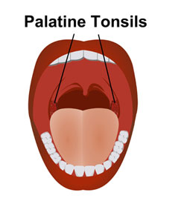
Tonsils:
- Simplest lymphoid organs; ring of lymphatic tissue around the pharynx; appear as swelling of mucosa; just with lymphocytes and macrophages living on it
- Palatine Tonsils: Located at either side of the posterior end of the oral cavity; Largest tonsils and one of the most infected
- Lingual Tonsils: Lumpy Collection of Lymphoid follicles at the base of the tongue
- Pharyngeal Tonsil: Also called Adenoids. In the posterior walls of the nasopharynx
- Tubal Tonsils: surround openings of the auditory tubes into the pharynx
Tonsils Continued…
- Because we have tonsils in the openings of all these areas ( nasopharynx, auditory tubes, back of tongue and oral cavity) we are able to gather and remove pathogens in food or air.
- Contains follicles of germinal centers surrounded by lymphocytes always proliferating that’s why they sometimes get swollen.
- They are not fully encapsulated
- Overlying epithelium invaginates forming tonsillar crypts
- Bacteria or particulate matter enters crypts, where they are trapped and destroyed.
  - Risky to lure bacteria into tissues, but allows immune cells to become activated and build memory cells against these potential pathogens.
Peyer’s patches: Clusters of lymphoid follicles in wall of distal portion of small intestine.
- Also called aggregated lymphoid nodules
- Structurally similar to tonsils
- Location aids in functions:
1.) Destroy bacteria, preventing them from breaching intestinal wall
2.) Generate “Memory” lymphocytes.
Appendix: Offshoot of first part of large intestine; tonsils of your GI tract.
- Contains a large number of lymphoid follicles
- Location aids in functions (like Peyer’s patches)
- 1.) Destroys bacteria, preventing them from breaching the intestinal wall
- 2.) Generate “Memory” lymphocytes
Thymus (Primary Lymphoid Cell):
- Bilobed lymphoid organ that if found in the inferior neck; extends to the mediastinum and partially overlies the heart
- T cells are schooled; they learn what belongs to you and what is foreign.
- Functions as lymphoid organ where T cells mature; mostly active when you are young and stops growing during adolescence; then gradually atrophies (shrivel up)
- Still produces immunocompetent cells, though more slowly.
- If this doesn’t work your will get autoimmune diseases; MS, Diabetes, Locus. Without it we will turn against ourselves.
3 Main Differences of the Thymus:
1.) Has no follicles because it lacks B cells
2.) Does not directly fight antigens
3.) Functions strictly in T lymphocyte maturation.
4.) Contains blood thymus barrier: keeps immature T lymphocytes isolated from any antigens to prevent premature activation
5.) Stroma is made up of epithelial cells, not reticular fibers; provides an environment where T lymphocytes become immunocompetent

