Geography 2010A

Quebec, Ontario, New Brunswick, Nova Scotia July 1st, 1867
Quebec City 1608
Manitoba, N.W.T. July 15th, 1970
B.C. July 20th, 1871
P.E.I July 1st, 1873
Yukon June 13th, 1898
Saskatchewan, Alberta September 1st, 1905
Newfoundland March 31st, 1949
Nunavut April 1st, 1999

The 4 Faultlines within Canada

Centralist/Decentralist – Demography favours Ontario and Quebec because the majority of Canadians reside in these areas. People in other regions have perceived the federal government as favouring these 2 provinces. No federal political party can form a majority government without strong support from these 2 regions.
- based on Canada’s vast size, linking the country has always been a challenge
- railway was built to B.C., voting times shifted

Anglophone/Francophone – There is a political and cultural struggle in Quebec to maintain French as a viable language in a principally English-speaking continent. The proportion of French-speaking Canadians has declined. Within Quebec itself, an internal faultline exists between separatists and federalists.

Aboriginal/Non-Aboriginal – Many aboriginal communities remain dependent on the federal government. Poverty, unemployment, and social issues are common in these communities. Modern land claim agreements have led to self-government on reserves. Nunavut was created in 1999 as a separate territory that is predominantly populated by Inuit people.

Newcomers/Old-Timers – Canada is a country of immigrants and this can sometimes lead to cultural friction among the different ethnic groups. Many new immigrants are concentrated in major cities; this gives them a network of family and friends who speak their language and restaurants that serve their desired food. However, it could create a sense of isolation from other Canadians.

The 6 Regions of Canada
Atlantic Canada, Quebec, Ontario, Western Canada, B.C., Territorial North

Defined as this because:
1. They are manageable sections.
2. They are identifiable by a set of physical features
3. Breakdown is on a provincial basis (making it easy to study statistics and census data).
4. These regions are commonly used by the media.

The Core/Periphery Model (Heartland/Hinterland)

- describes interactions amongst regions and is evident in Canada.
- based on a theory that capitalist economics results in regionally uneven development.
- both parts are dependant on each other but the core (industrial heartland) dominates the economic relationship with its periphery (resource hinterland).
- Southern Ontario & Quebec are considered to be the core, the rest is the periphery
- B.C. and Western Canada are considered to be upward transitional regions.
- Atlantic Canada is a downward transitional region.
- The territorial North is a resource frontier.

Core
- receives raw materials from the periphery
- manufacturing is a common industry
- geographically small
- diverse economy
- urban and densely populated
- home to corporate headquarters.

Periphery
– purchase finished goods from the core
- resource based economy
- geographically large
- rural and sparsely populated

Theories
Regional Exploitation Theory
- wealthy core exploits the natural wealth of the periphery leaving it impoverished
Modernization Theory *Canada*
- core invests in the periphery and helps it to develop

Sub-cores – Vancouver/Victoria, Edmonton/Calgary, Halifax

The Staples Thesis
The regional economic history of Canada was linked to the discovery, utilization, and export of staple resources in Canada’s vast frontier. It was expected that eventually, economic diversification would take place, making peripheral regions less reliant on primary resources. Harold Innis proposed this thesis in the early 1930s.

Progression of Canada’s Staples

1. Fish (east)
This was the earliest staple product.
2. Furs (east > west)
3. Timber (east > west)
Cut trees and move to next area
4. Agriculture (Ontario > west)
5. Oil (west)

Economic Linkages for Growth

Backward linkage: Supplies for the staple industry (e.g. saws and tools for the forest industry).
Forward linkage: Local processing before export
(e.g. squaring the timber before shipment)
Final demand linkage: Service needs of the worker and families (stores, schools, etc.)

The National Policy (1879)
- the implementation of tariffs and restrictions on foreign goods
- discouraged Canadians from purchasing cheaper goods from the U.S.
- favoured further economic and manufacturing growth in Ontario and Quebec since this is where transportation costs were minimized
- negative impact on the west because they had to purchase expensive goods from Canada’s core but they were selling staple goods to the U.S. at low prices

The Canada – U.S. Free Trade Agreement (1988)
- helped peripheries by providing cheaper products to purchase and also providing a larger market for staple products.
- many companies began integrating major plants and feeder factories in one general location (U.S. and Canadian manufacturing core)
- superseded by NAFTA (1994) when Mexico joined the agreement

The Thickening Canada – U.S. Border
- ongoing concern since Sept. 11, 2001.
- heightened security measures a border crossings have led to a decline in tourism and increased costs for the manufacturing assembly plants
- U.S. federal government favours a North America security perimeter that includes a common position on immigration, military, and trade policies in order to thwart terrorist attacks.

Physical Geography

Geology

Igneous – molten rock that emerged onto the Earth’s surface and cooled. It is hard, resists erosion, and often contains minerals

Sedimentary – Layered rock composed of materials that have been affected by wind and weathering. These rocks are usually flat and horizontal. Sediments are cemented together by pressure and generally do not contain mineral content. Fossil fuels are sometimes found in this rock type.

Metamorphic – Pre-existing rocks that change by the process of extreme heat and pressure. They sometimes contain minerals. Limestone is a sedimentary rock, the metamorphic rock of limestone is marble.

Major Geologic Elements of Canada

Canadian Shield - it is composed of ancient igneous, resistant rock.
- extends form NWT through the northern prairie provinces, northern Ontario, Northern Quebec, and Labrador
Platform Rock - underlays the interior plans of the continent
- stretches from NWT to Texas
- mainly sedimentary and contain pockets of oil and natural gas
Folded Mountains - folding is caused by the movement of tectonic plates.
- can cause sedimentary rock to change into metamorphic
- 3 major mountainous regions in Canada
Appalachian Mountains - found in Quebec and Atlantic Canada
- old, relatively low, well eroded, covered with vegetation
Innuitian Mountains - found in northern Nunavut
- jagged, somewhat eroded, mostly inaccessible
Cordillera – major ranges include rocky mountains and coast mountains
- Canada’s youngest mountains, tall, jagged, permanently snowcapped

Physiogeographic Regions
- large area of the earths crust with common characteristics
- extends over a large area with similar topographic features
- landforms have been shaped by a common set of geologic processes

Canadian Shield
- over half the country’s land mass
- rock-like surface consists of mainly rugged land
- wealth of mineral resources
- subject to glacial erosion and deposition during the last ice advance
Cordillera
- complex region of mountains, plateaus, and valleys
- north-south alignment extends from Yukon to southern B.C.
- Rocky mountains are best known and tallest of the ranges
Interior Plains
- once covered by shallow inland seas where sediments formed rock
- deep, wide river valleys are a unique feature of this region
Hudson Bay Lowlands
- many bogs and contains muskeg (poorly drained soil).
- Permafrost is widespread
Arctic Archipelago
- complex area of costal plains, plateaus, and mountains lying north of the Arctic Circle
- northern part is permanently covered in snow/ice, southern part is tundra
- continuous permafrost making tree growth impossible
Appalachian Uplands
- rugged rocky environment (Newfoundland) & old rounded mountains (New Brunswick)
Great Lakes – St. Lawrence Lowlands
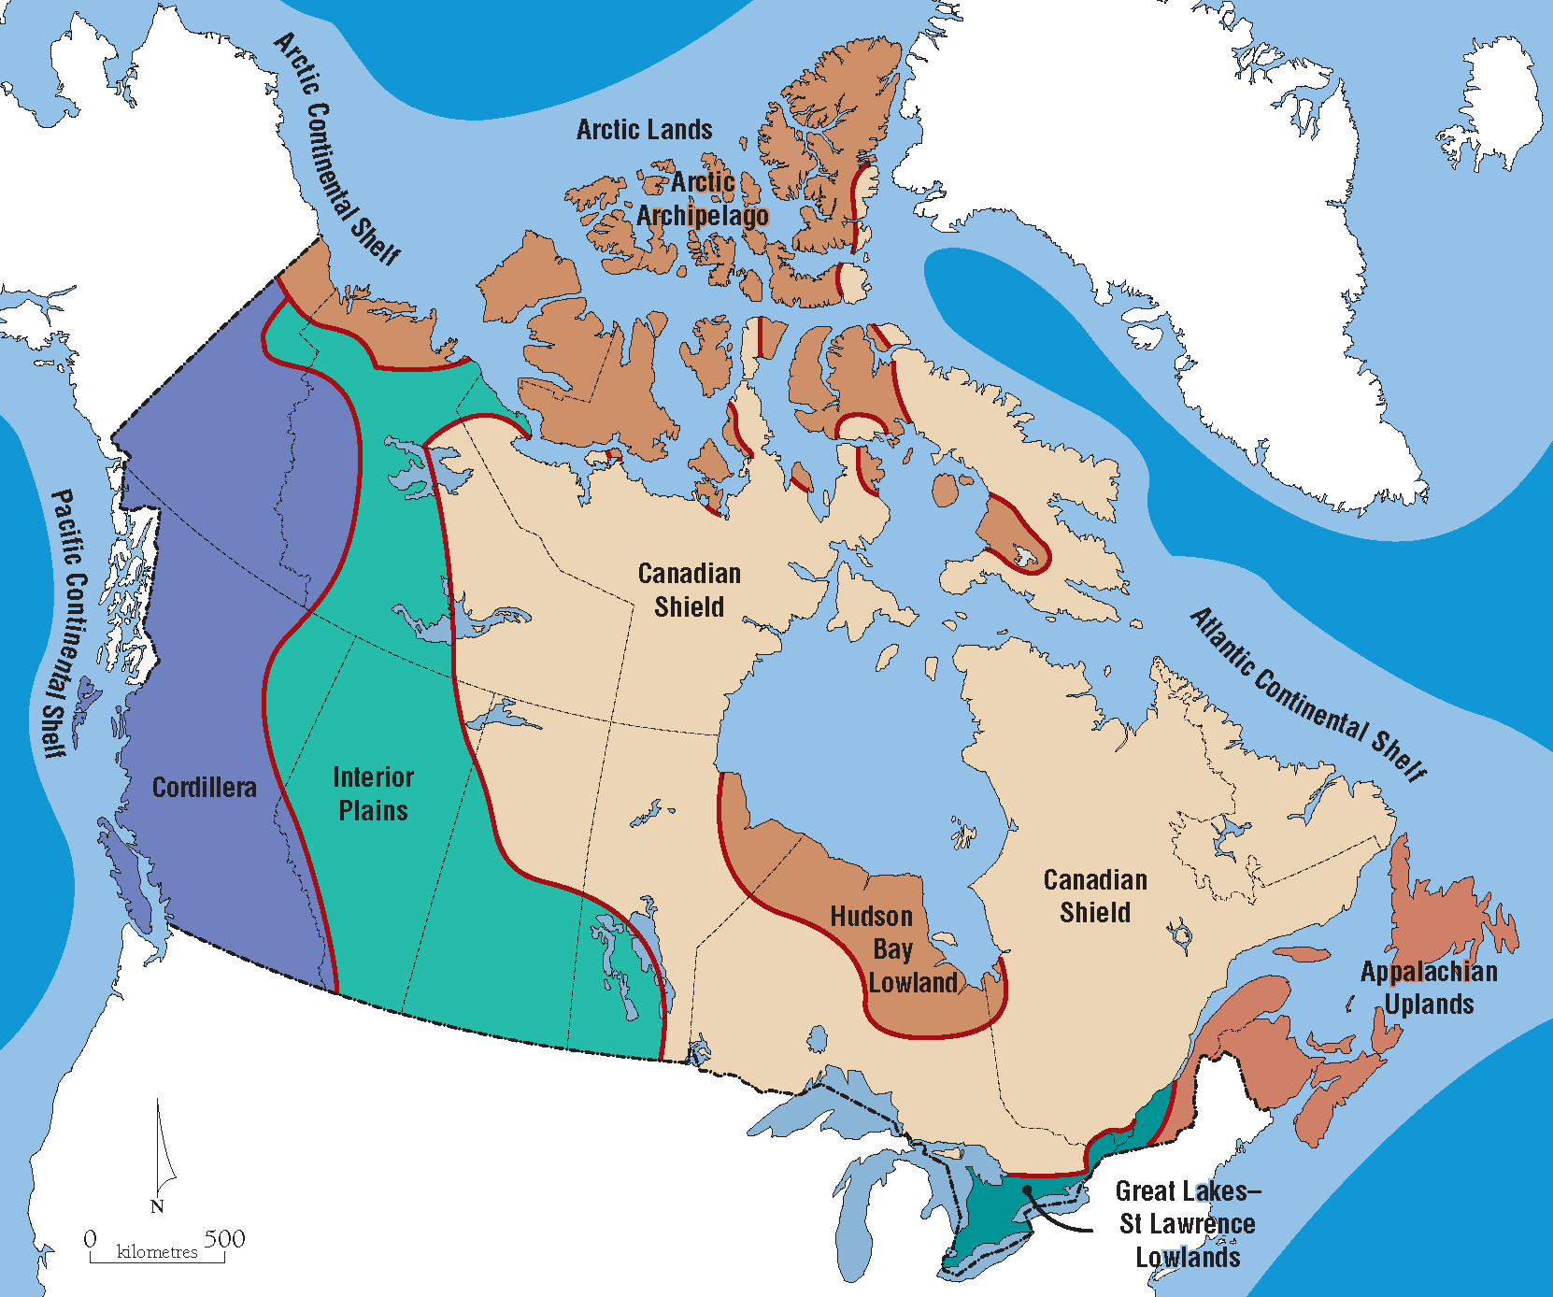
- generally flat with rolling hills
- very fertile soil, well suited for agriculture

Glaciation
- major shaping force in Canada
- all of Canada (except northern Yukon) covered by ice 18000 years ago

Continental Glaciers
– thick sheets of ice that cover entire continents
- only exist on Greenland and Antarctica today, up to 3km thick
Alpine Glaciers
- Glaciers found in mountainous regions
- Can develop when slopes accumulate with snow that compacts into ice over long periods of time

Climate
- average weather conditions for a specific place over a long period of time
- two major components: temperature and precipitation
Weather - current state of the atmosphere

7 Major Climatic Controls
- Latitude - at lower latitudes, more solar radiation impacts the surface
- Altitude - higher elevations experience cooler temperatures
- Proximity to Bodies of Water - water keeps nearby lands warmer in autumn and cooler in spring
- Ocean Currents - currents transport warm or cold water depending on the source of the current.
- Variations in Topography - Cold air is dense and tends to sink into valleys
- Prevailing Wind - Some wind systems cause rapid temperature changes
- Locations of Pressure Systems - relates to the position of warm/cold fronts

Canada has 7 major Climatic Zones:
- Pacific, Cordillera, Prairies, Great Lakes - St. Lawrence, Atlantic, Subarctic, Arctic

Vegetation

Forest - Deciduous forests are composed of trees that lose their leaves each winter
- Coniferous forests are composed of evergreen trees (~50% of country)

Grassland - found in relatively dry areas; quality of grass varies with moisture
- only found in the prairie provinces

Tundra - Small plants surviving in harsh climates; reproduce by runners
- found in arctic and alpine areas
- shallow root systems due to permafrost
- leaves are waxy to reduce moisture loss
Permafrost - forms where the mean annual soil temperature is below 0C
- discontinuous permafrost may form on northerly aspects
- continuous permafrost boundary roughly follows the tree line
- tree line is moving northward at approximately 2km/year
- melting can cause roads and railways to buckle, buildings to fracture
- utilities and pipelines must be built aboveground, many buildings on stilts

Soil

Cryosolic Soil - north of the tree line; dominant soil in the territories
- found where permafrost is common

Podzolic Soil - found in cool, moist climates; light grey in colour
- coniferous vegetation is common
- leaching is evident (moisture easily percolates downward through the soil)

Luvisolic Soil - found in humid continental climates
- deciduous vegetation is common
- more organic content is evident, trees drop leaves creating a layer
- warm summers lead to quick decomposition of organic material

Chernozemic Soil - found in dry climates (prairies)
- grassland is common, soil is very dark & high in organic content
- leaching is evident but not as much as in Podzolic Soil

Palliser’s Triangle
- semi-arid area in western Canada, named in mid 1800s unsuitable for agriculture
- since then, wheat growing and cattle grazing have become common land uses
- farmers often require government subsidies to aid in surviving through drought

Drainage Basins - every river has a drainage basin
- can also be defined for lakes
- Canada has 4: Pacific, Atlantic, Arctic, Hudson Bay
Divides - a high ridge of land, form the boundaries of drainage basins
Continental Divide - located along the spine of the rocky mountains, on the B.C. - Alberta border; separates which ocean the water will eventually drain into

Columbia Ice Field - home to 8 major alpine glaciers, straddles the continental divide in Jasper National Park, one of the last remaining ice sheets in Canada.
Historical Geography of Canada

3 Influential events that shaped Canada’s History
- arrival of the first people in North America
- colonization of North America by England and France
- influx of people from eastern europe

First People
- hunters from the Old World (Eastern Hemisphere) arrived about 40000 years ago
- crossed the Bering Land Bridge that connects Siberia to Alaska; was exposed with lower sea levels
- as ice retreated 15000 years ago, descendants of the hunters pushed farther south
- travelled along an ice-free corridor along the Rocky mountain foothills
- these people known as Paleo-Indians

Paleo-Indians - descendants of Old World Hunters
- commonly hunted mammoths with pointed spears
- as mammoths became extinct, diet shifted to buffalo, caribou, fish, and plants

Indians - the revised diet allowed them to stay in a specific geographic region
- this marked the beginning of more social units that lead to become North American Indian tribes
- trade among groups began about 10000 years ago, from this point people were referred to as Indians

Thule/Inuit - the Laurentide Ice Sheet began retreating from Arctic Canada 5000 years ago
- After this, Arctic sea hunters advanced eastward hunting walrus, seal, etc.
- Settled in what is now Nunavut about 1000 years ago, ancestors to the Inuit

Europeans first explorers considered the New World terra nullius (empty land)
- first contact between Europeans and Natives occurred from late 1400s thru 1600s
- 500,000 Native population before first contact, quickly dropped by 80% as a result of conflict and disease brought on by Europeans
- second people of Canada were French or British
- France Settled Quebec City in 1608
- the area became known as New France and had a population of 60,000 before the arrival of the British in the mid 1700s

British Immigration
- after the British Conquest of New France in 1759 (Plains of Abraham) British immigrants began to move to the area
First Wave - British Loyalists supported Britain during the American War of Independence (1775-1783). Many settled in Nova Scotia & Southern Ontario
Second Wave - early 1800s, one million people from the British Isles to British NA
- resulted in deteriorating economy in Britain
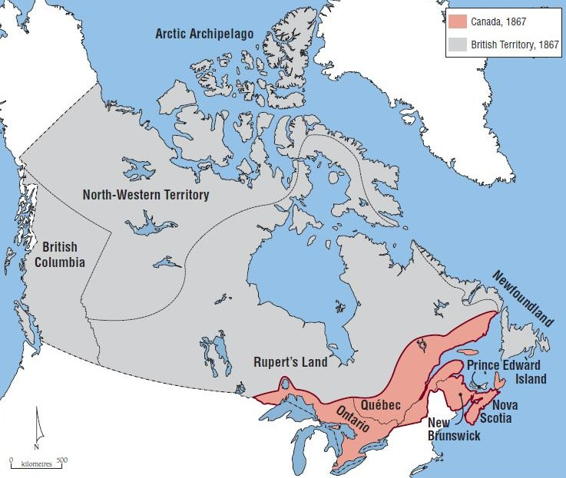
Canada at Confederation
- Population of 3 million in 1867
- 80% lived in the Great Lakes - St. Lawrence Lowlands, 20% Atlantic Canada
- 60% of Europeans were Anglophones
- Red River area, Metis were the dominant population
- in 1870, Ottawa obtained the land of HBC
- encouraging settlement here was important to diminish the threat of American settlers
- transport of grain would supply freight for the newly build CP Railway

Third People of Canada
-Clifford Sifton (Minister of the Interior) was assigned to settle Western Canada
- immigrants ere attracted from eastern Europe, Russia, Scandinavia, and Ukraine
- majority arrived 1895-1915, coming from cold grasslands similar to the prairies
- majority of these immigrants lived in homesteads

Territorial Evolution of Canada
- began with the B.N.A. Act July 1, 1867
- after confederation, changes to internal boundaries were frequent. Most notable the dispute between Quebec and Labrador boundaries
- settled by British government in 1927, awarding Labrador all the land draining into the Atlantic Ocean. Quebec has not formally accepted this ruling
National Energy Program (1980-1984)
- energy prices rose dramatically through the 1970s
- mid-70s, oil producing provinces and Ottawa agreed to match the domestic oil price to the world price, resulting in huge oil revenues for Alberta
- in 1979, Ottawa refused to match the domestic price with the world price
- created by Pierre Trudeau liberal government
- Ottawa formed the NEP in 1980 to ensure low cost of oil for Ontario and Quebec & increase federal share of revenue from oil industry taxes
- As a result of decreased oil revenue to Alberta, there is much distrust with liberal governments that is still quite evident today

Equalization Payments
- the sharing of federal tax revenue amongst the provinces/territories
- goal is to ensure a relatively equal standard of living for all Canadians
- Have: BC, AB, SK, NL
- Have not: ON, QC, MB, NB, NS, PEI, Territories

Residential Schools (1892-1996)
- goal was assimilation of Aboriginal children, forcing them to speak either French or English
- operated by Christian churches
- deemed a colossal failure and in 2008 the federal government publicly apologized for harm caused

Status Indians: People registered as Indians under the Indian Act of 1985. They are entitled to certain rights from the federal government.

Non-Status Indians: People of Indian ancestry who are not registered as Indians and have no rights under the Indian Act.

Treaty Indians: Members of a band who have signed a treaty.

Métis: People of mixed biological or cultural heritage, usually French-Indian or English-Indian. Originally, the term was narrowly applied to French-Indian people who settled in the Red River Area.

Inuit: Descendants of the Thule people (who migrated into Canada’s Arctic from Alaska 1000 years ago)

Immigration
- historically used as an instrument of British colonial power
- after British conquest of New France, Britain offset the francophone population by encouraging large scale British immigration
- immigrants of other backgrounds were needed due to a shortage of workers
- these immigrants were often marginalized

Red River Rebellion (1869)
- clash between Ottawa and the Metis, led by Louis Riel
- western land survey system ignored existing Metis landholdings, posing a threat to the hunting economy
- The rebellion began when Louis Riel placed his foot on a land surveyors chain and told them to leave. The Metis took control of the HBC headquarters and formed a provisional government tat began to negotiate with Ottawa under entry into confederation.
- Resulted in Manitoba, 1870; English/French government; dual school system

The Northwest Rebellion (1885)
- another clash between Ottawa and Metis, again led by Louis Riel
- this time Ottawa ignored their demands
- Metis/Riel ambushed a Northwest Mounted Police Contingent killing 8 men
- Canadian army responded via railway and wore down the Metis forces
- Riel and 8 Indian leaders were hanged.

Doukhobors
- fled persecution in Russia after refusing to enlist in the army
- communalists, who wanted little to do with the government
- granted blocks of land and freedom from military service
- Doukhobors refused to swear allegiance to King of England
- 1905, Minister of the Interior, Frank Oliver, enforced Dominion Lands Act
- this allowed Ottawa to cancel the Doukhobors’ rights to land

Key Terms

Arete - jagged side of a mountain between 2 alpine glaciers

Aspect - direction facing

Cirque - rounded alpine glacier

Regionalism - the division of a large area into different parts

Region - a distinctive area of the Earth’s surface with distinguishing human or natural characteristics that set it apart from other areas.

Faultline - not a physical line, instead a division of differences between 2 different areas wether geographical, cultural, etc.
- economic, social, and political ‘cracks’ that divide regions and threaten to destabilize Canada’s integrity as a nation

Krumholz - plant that grows in a sideways formation because harsh winds desiccate the upper part of the plant.

Uniform - named after a characteristic where all locations in the region have Region similarities in that characteristic (eg. Vegetation region grassland, desert, etc.)

Functional - Interactions among different areas within the region
Region (ie. urban part of region and the periphery; Transportation Network)

Cultural - These areas are based on a sense of belonging. There is a bond Region between people and the region. Arises from shared historical experiences, similar values, etc. Eg. Francophones in Quebec

Physical - the study of the Earth’s natural features
Geography

Weathering – the breakdown of rock

Erosion – the movement of broken materials

Xerophyte - a plant that has adapted to low amounts of water

Textbook Highlights

Ch.1 Faultlines; core periphery model
7 physiographic regions, climate factors (controls), drainage basins, vignette 2.9 types of precipitation

National energy program, the first peoples, vignette 3.6 & 3.7

