Student Name: Nathan Napper

Student Number: 8663298

Partner’s Name and Student #: Mustafa Al-Saeed 8649313

Demonstrator's Name: Daniel Nascimento

PLEASE NOTE: If ANY of the above information is UNCLEAR or not provided, your grade will NOT be recorded!!

Lab Day (T/W/Th/F): Wednesday

Lab Week (even/odd): Even

Lab time (10:00, 2:30, 6:30): 10:00am

Laboratory Report Form

Experiment 4.

Chemical Kinetics

Checklist:
- Raw Data Sheet written in pen, signed by TA and attached
- Report Form typed and attached

Student’s Initials: NN

Experiment 4: Chemical Kinetics

INTRODUCTION:

Reaction Rate:

The rate at which a reaction occurs can remarkably vary from almost instantaneous reactions to immensely slow reactions that occur over many years. The speed at which a reaction is completed is directly proportionate to the rate of the reaction. The mechanisms by which the reactions occur and various influences that control reaction rates is the commonly known as the study of chemical kinetics. This experiment investigates how the concentration of a reactant is related to the rate of a chemical reaction, more specifically, the how the order of a reaction impacts the overall rate.

The reaction rate is of a chemical species is directly proportional to the reactant concentration raised to a power. Continually, the power indicates the order of the reactant, and the sum of all the exponents is known as the overall order for that particular reaction.

Rate can be expressed as:
[1]
Rate = k[A]^{x}[B]^{y}

In equation [1], there is a constant k, which is the rate constant for the reaction. Every reaction has a different rate constant and the k value is dependant of the order of the reaction.

Graphically, the rate of a chemical reaction can be determined when concentration is plotted as a function of time. The instantaneous rate can be found at any point on the function by calculating the slope of the tangent.

Order:

When referring to equation [1], the exponents x and y express the orders of [A] and [B] respectively. The sum of x and y is the overall or total order of the reaction. The order of a reaction is not related to the stoichiometric coefficients as it can only be calculated experimentally. The order can be an integer, a fraction or even an inverse.

There are various methods for calculating the order of a reaction. The method utilized in this experiment encompasses the absorbance, which is related to the colour of the solution, and the time over which the reaction occurs.

Concept of the Experiment:

In this experiment chromium (III) ions are added to a solution containing ethylene dinitrilo tetraacetate (EDTA) at room temperature. A purple solution forms from the original grey-green solution. The purple colour is a characteristic of the chromium (III)-EDTA complex, which forms from many slow steps. The first is the first-order chromium (III) and concentration of the inversely proportional hydrogen ion. In truth, the purple colour observed is a mixture of several intermediates. The complex will have the highest absorbance at a wavelength of 545nm. Variations in the results yielded is due to changes in pH and wavelength.

Due to the fact that the complex is made up of several intermediates, the experiment will be performed across a pH range of 4 to 5 to ensure the dominant colour of the complex is purple.

The rate of this reaction can expressed as:
Rate = k[Cr(III)][H⁺]
[2]

For simplicity EDTA is no included in the rate expression as its concentration is relatively high (0.1M), therefore, the change in concentration of EDTA is negligible. The change concentration over time of the complex will be measured using a spectrophotometer.

Spectrophotometry:

Spectrophotometry is the interaction of electromagnetic radiation with matter. More specifically the measurement of transmittance or absorbance as a function of wavelength.

Percent transmittance the ratio of the intensity of the light that passes through a particular medium (I), to the intensity of light before it passes through the medium, multiplied by 100%. The equation is expressed as follows:

%T = (I/I_{o})*100%
[3]

Percent transmittance is linear when illustrated graphically, whereas absorption is exponential, more explicitly logarithmic. Absorption is modeled after the equation:
[4]
A = -log(T) = -log(I/I_{o})

Spectrophotometry can be applied to determine the concentration of many solutions, including dilute solutions, as long as there is enough of the absorbable wavelength for that particular substance. Many substances will absorb the maximum amount light at a specific wavelength. In this experiment, the maximum absorbance of the chromium (III)-EDTA substance occurs at a wavelength of 545nm. The relationship between absorbance and concentration is known as the Beer-Lambert Law and is expressed as:
[5]
A = εbc
In this equation, A represents the amount of light absorbed, ε characterizes the molar absorptivity coefficient, b represents the path length of the light and finally, c is the concentration of the solution. For this experiment we are using the same cuvette and similar substances, therefore the path length (b) and the molar absorptivity coefficient are both constant. We can then conclude that absorption is directly proportional to concentration.

The absorbance at an infant time (A∞) can be determined by heating the EDTA-chromium (III) solution at 100ºC for roughly ten minutes. This will ensure that all the chromium (III) is fully reacted to form the chromium (III)-ETDA complex. The amount of remaining chromium at any time during the reaction can be determined by the equation:

A_{Cr(III)} = A∞ - A_{t}
[6]

Thus at time zero, we only have chromium (III) in the solution and at time infinity there would be no chromium (III) as it would have all reacted in solution.

Determination of the Rate:

If A_{Cr(III)} is plotted as a function of time a family of rate curves will appear, which can be used to find the partial order for the chromium (III) ion. The instantaneous rate can be found by finding the slope of the tangent line on one of these plots. As long as the chromium (III) ion is changing and the hydrogen ion (pH) is constant we can observe a pseudo first-order kinetics.

According to equation [2] the rate of the reaction is dependent on both the concentrations of the chromium (III) ion and the hydrogen ion. It is impossible to observe any change in the rate when we change both variables. In order to observe the effect [Cr(III)] on the rate we can keep the pH ([H⁺]) constant. This will allow us to determine the partial order of chromium (III). If it is found that the order is one, the reaction is demonstrating a pseudo first-order reaction.

If [H⁺] is held constant, then in equation [2] the rate is proportional to both k and [Cr(III)]^{x}. Since k is constant we can use logarithmic laws to rearrange the equation:
[7]
Log Rate = xlog [Cr(III)] + log k

Since [Cr(III)] is represented by A_{Cr(III)}, pseudo first-order kinetics can be observed graphically by plotting the logarithm of A_{Cr(III)} as a function of time. If the plot reveals a linear correlation, we can conclude that this is pseudo first-order behaviour. The rate of change of the concentration of chromium (III) over time is simply the instantaneous rate displayed in equation [2]. The rate of change of the absorbance of chromium (III) also yields the instantaneous rate, since the absorbance is representing the concentration. Since the instantaneous rate is known, we can graph the logarithm of the rate as a function of the logarithm of the concentration of chromium (III) or the logarithm of A_{Cr(III)}. The slope of this function will represent the partial order with respect to the chromium (III) ion.

Dr. R. Venkateswaran, “What in the World ISN’T Chemistry?”, General Chemistry Laboratory Manual, 2016, Experiment 4. p(44-48).
Germer, Thomas A., Tsai, Benjamin K. & Zwinkels Joanne C., “Spectrophotometry”, Chapter 1.1, Elsevier Inc., 1-4 (2014).

PROCEDURE:
As described in the General Chemistry Laboratory Manual: Dr. R. Venkateswaran, “What in the World ISN’T Chemistry?”, General Chemistry Laboratory Manual, 2016, Experiment 4. p(49-52).
NOTE: Due to time constraints, for trial three the reaction was only 26 minutes as opposed to 42 minutes.

DATA and OBSERVATIONS:
Data Tables:
Table 1: Percent Transmittance of EDTA Containing at Particular Time Intervals
Minimum Wavelength (nm) | pH of EDTA | Volume of EDTA (mL) | Percent Transmittance after 40 minutes (%) | Percent Transmittance after 42 minutes (%) | Absorbance after 40 minutes (AU) | Absorbance after 42 minutes (AU)
574.900 | 4.000 | 10.000 | 56.507 | 0.884 | 0.24789 | 2.0536
574.900 | 4.500 | 10.000 | 69.868 | 1.662 | 0.15572 | 1.7793
574.900 | 5.000 | 10.000 | 44.360 | 2.884 | 0.35301 | 1.5400

Table 2: Numerous calculations related to percent transmittance over a specific time interval for the chromium(III)-EDTA complex containing an EDTA solution with a pH of 4.

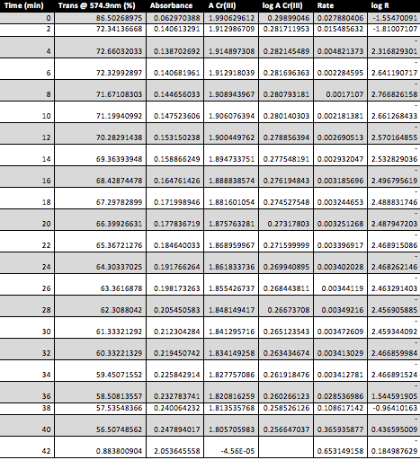

Table 3: Numerous calculations related to percent transmittance over a specific time interval for the chromium(III)-EDTA complex containing an EDTA solution with a pH of 4.5.
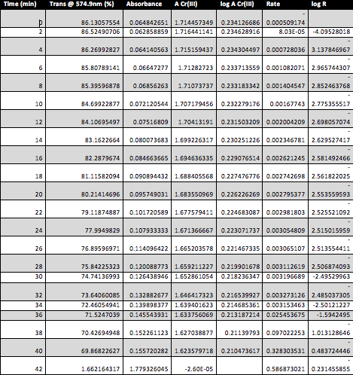

Table 4: Numerous calculations related to percent transmittance over a specific time interval for the chromium(III)-EDTA complex containing an EDTA solution with a pH of 5.

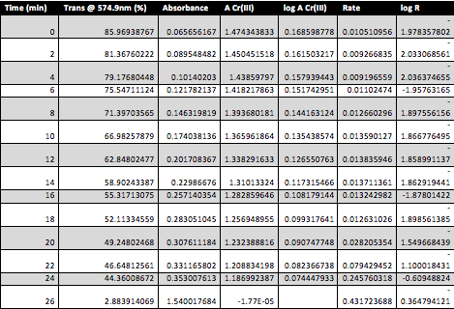

Graph 1: The remaining amount of unreacted chromium(III) as a function of time for all pH values.
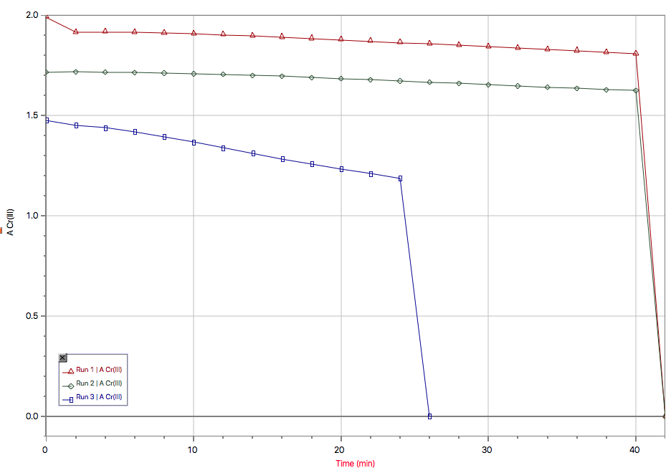

Graph 2: The log of the remaining amount of unreacted chromium(III) as a function of time for all pH values.

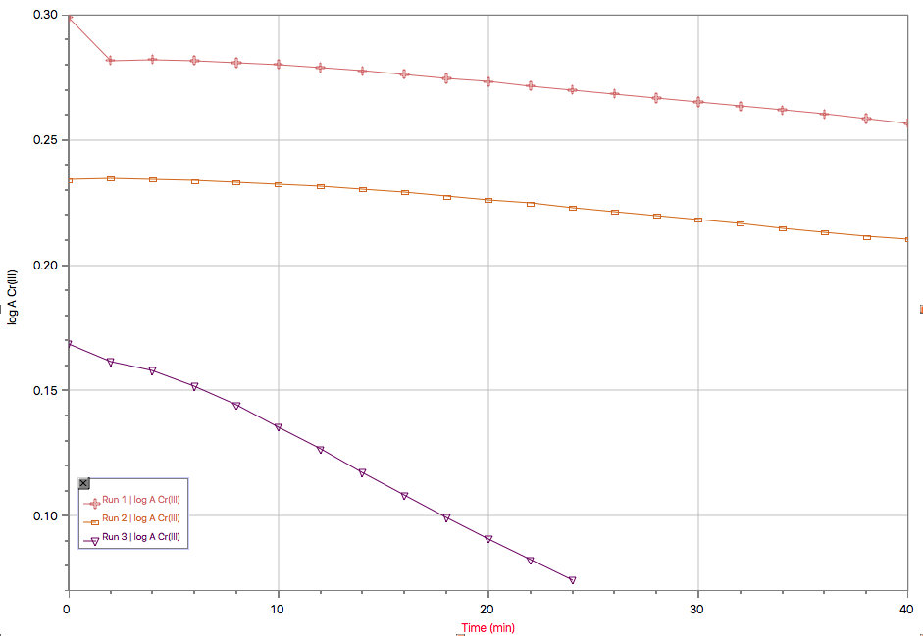

Graph 3: The log of the Rate as a function of the log of the remaining amount of unreacted chromium(III) for the EDTA solution with a pH of 4.

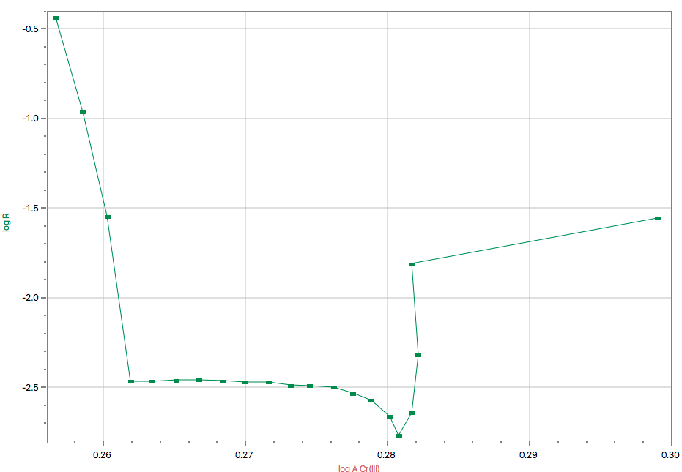

Graph 4: The log of the Rate as a function of the log of the remaining amount of unreacted chromium(III) for the EDTA solution with a pH of 4.5.

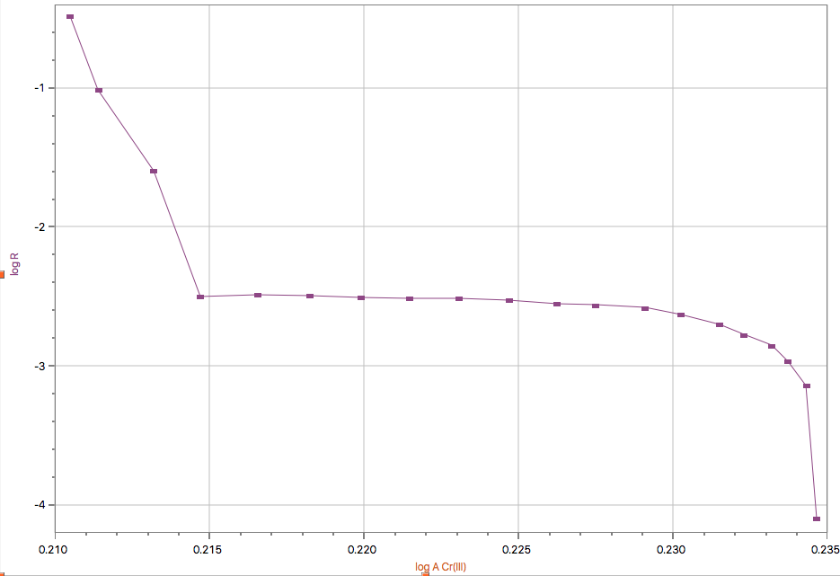

Graph 5: The log of the Rate as a function of the log of the remaining amount of unreacted chromium(III) for the EDTA solution with a pH of 5.

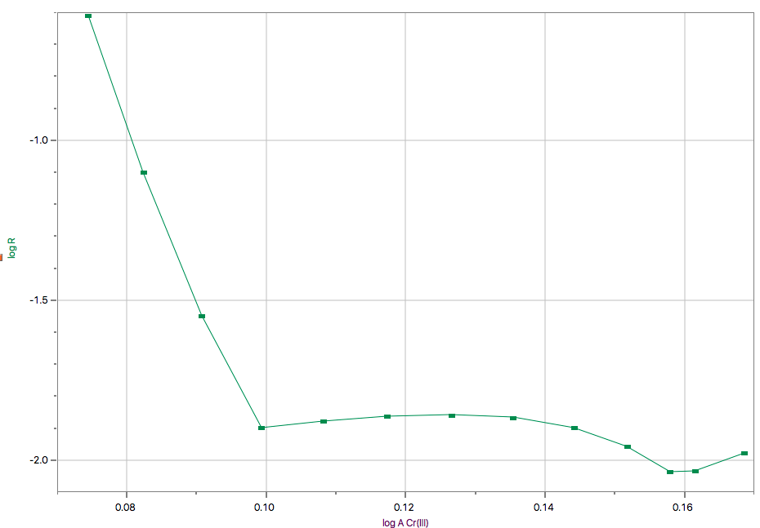

Sample Calculations:

- Determining the absorption given percent transmittance:
Trial 1 at 8 minutes

A = -log T = -log (%T/100)
A = -log (71.67108303%/100%)
A = 0.144656033UA

- Calculating the amount of unreacted chromium (III):
Trial 1 at 8 minutes
NOTE: A∞ was determined experimentally, having a value of 2.053645558UA

A_{Cr(III)} = A∞-A_{t}
A_{Cr(III)} = A∞-A₈
A_{Cr(III)} = 2.053645558UA - 0.144656033UA
A_{Cr(III)} = 1.908943967UA

- Calculating log A_{Cr(III)}:
Trial 1 at 8 minutes

log A_{Cr(III)} = log (1.908943967UA)
log A_{Cr(III)} = 0.280793181UA

- Determining the log of the Rate:
Trial 1 at 8 minutes

Rate = -d/dx(A_{Cr(III)})
log R = log (-d/dx(A_{Cr(III)}))
log R = 2.766826158

- Calculating the order of the reaction:

log rate = x log [Cr(III)] + log k
y = m x + b
Therefore x = m
x = (log rate – log k)/(log [Cr(III)])
Since we don’t know the k value and it is too difficult to determine the slope of the graph then we can assume that the partial order of the chromium ion is 1.

Discussion:

There is great potential for error to occur in this particular lab. Some may be experimental, while others may be inherited by the method. An example of an experimental error would be forgetting to wipe the cuvette before inserting it into the SpecroVis. This will case more light to be absorbed due as the grease and sweat from our fingers, distorting the expected results. This would cause a negative radiating effect on all calculations that rely on the percent transmittance, such as absorption. Continually, an inherited error may have occurred if the all the chromium (III) did not fully react in the hot water to form the chromium (III)-EDTA complex. This would have caused the A_{Cr(III)} value to be less, therefore leading to less accurate results in the equations that follow.

Over the first 40 minutes when A_{Cr(III)} was plotted as a function of time, for all pH values, the graph was linear. This is expected as in this specific lab absorption is directly proportional to time due to the fact that in equation [2] k is a constant and [H⁺] is also held constant as the pH remains the same, yielding a linear function. When log A_{Cr(III)} was plotted as a function of time, the pH solutions of 4 and 4.5 displayed almost identical linear slopes, whereas the solution with a pH of 5 had an exponentially decreasing linear slope. This may have occurred due to the fact that as pH increases, the percent transmittance decreases, therefore causing the absorbance to increase. When tables two, three and four are compared one can see that the percent transmittance for the fourth table decreases more exponentially than in tables two and three. This indicates that the solution is changing to the darker colour at a much faster rate, allowing less light to transmit though the cuvette. However, this did not occur, therefore an inherited error must have occurred. Also, due to time constraints, the third trial was almost half the time as trial one and two, possible also affecting the results obtained. Continually, graphs three, four and five all display a similar function. The slope of these graphs is too difficult to calculate and due to the fact that this experiment deals with pseudo first-order reactions, the assumption can be made that the partial order of chromium(III) is one. Overall, as the pH values increase, the amount of unreacted chromium(III) remaining decreases. Additionally, the log A Cr(III) values decrease as pH increases and finally.

Conclusion:

The results displayed that after numerus calculations that the partial order of chromium (III) is one.

Raw Data:


