- Chapter 15: Personal selling and Sales Promotion

- Personal selling – Interpersonal influence process involving a seller’s promotional presentation conducted on a person-to-person basis with the buyer
  - Salespeople are problem solvers who focus on satisfying customers’ needs before, during, and after the sale
- 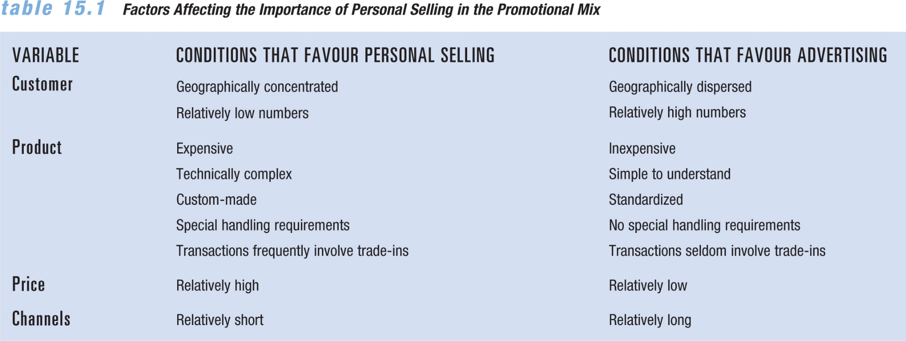
- Over the Counter Selling: Personal selling conducted in retail and some wholesale locations in which customers come to the seller’s place of business
  - Ex. Best Buy
    - CARE Mantra: C contact with the customer. A asking questions about customer needs. R recommendations to the customer. E encourage the customers for their wise purchase.
- Field Sales: Sales presentations made at prospective customers’ locations on a face-to-face basis, Expensive form of selling, particularly because of travel expenses. In routine cases, the salesperson processes regular customers’ orders. In more complex cases, the salesperson prepares for weeks, makes presentations, and follows up
  - Network marketing – Personal selling that relies on lists of family members and friends of the salesperson, who organizes a gathering of potential customers for a demonstration of products Ex. Avon

Telemarketing: Selling process conducted by phone severs both saves and service purposes and serves two markets business to business and business to customer.
  - Outbound telemarketing – Sales method in which sales personnel place phone calls to prospects and try to conclude the sale over the phone Ex. Autodialing, Predictive dialing, random dial.

=> Draw back is that most consumers do not like being bothered by businesses. However telemarketing is still used because it is cheap.
  - Inbound telemarketing – Sales method in which prospects call a seller to obtain information, make reservations, and purchase goods and services
- Inside Selling: Selling by phone, mail, and electronic commerce, Turn opportunities into actual sales, Support technicians and purchasers with current solutions
- 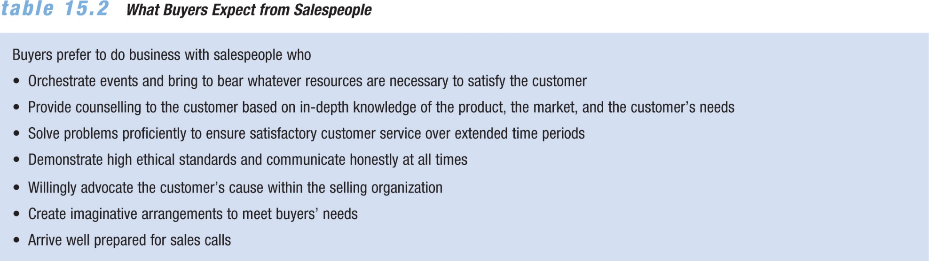

- Consultative Selling: Meeting customer needs by listening to them, understanding their problems, paying attention to details, and following through after the sale used in combination with relationship selling to create customer loyalty.
  - Cross selling – Offering multiple goods or services to the same customer
- Team Selling: A salesperson joins with specialists from other functional areas of the firm to complete the selling process

Benefit: Customer feels better when served by a group
  - Virtual sales teams – A network of strategic partners, suppliers, and others who are qualified and willing to recommend a firm’s goods or services
- Order Processing: Selling, mostly at the wholesale and retail levels, that involves identifying customer needs, pointing them out to customers, and completing orders.
- * Most important part of selling positions. Motivate purchasers to feature products, increase shelf space and improve product location in store.

- Creative Selling: Personal Selling in which a considerable degree of analytical decision making on the buyer’s part results in the need for skillful proposals of solutions for the customer’s needs.
  - Used to create buzz and develop new business with new products or new customers.
- Missionary Selling: Indirect selling method in which salespeople promote goodwill for the firm by educating customers and providing technical or operational assistance
- Ex. a cosmetics company salesperson may call on retailers to check on special promotions and overall product movement
  - Sales Incentives may be used such as trips, free product etc.
- 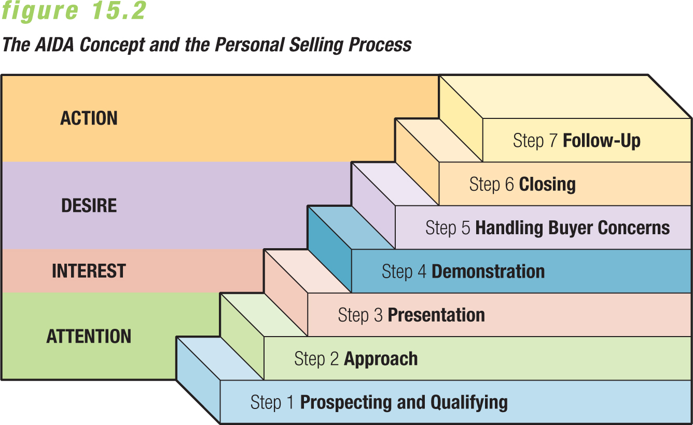
- STEP 1:Prospecting – Identifying potential customers
  - Time-consuming and involves many sources
- Qualifying – Determining that the prospect really is a potential customer
  - Not all prospects are qualified to make purchase decisions
- **Prospects may fail to become customers for several reasons:
  - 1. They do not really see a need.
  - 2. They cannot afford to make a purchase.
  - 3. They do not have the authority to make a decision.
  - 4. They may be unwilling to consider making a purchase.
- STEP 2:Approach – Initial contact with prospective customer
  - Use precall planning research to learn about the industry, the customer, his or her needs, and how your products might best meet these needs
- STEP 3:Presentation- Conveying the marketing message to the customer, should be well organized, clear and concise and include efficient use to tech.
  - “features-benefits” framework focuses on the good or service in terms that are meaningful to
the buyer
  - Cold calling – Contacting a prospect without
a prior appointment
- STEP 4: Demonstration- Buyer has a chance to try a product or see how it works. Multimedia interactive demonstrations are becoming more common.
  - Ex. Videos or letting customer try product first hand
- STEP 5: Handling Objections - Expressions of resistance by the prospect, may take the form of stalling or indecisiveness
  - Use objections as an opportunity to reassure the buyer or offer more suitable alternatives
- **Objections relate to one of only five issues or concerns that a prospect might have.
  - PRODUCT: Is this the right product for me?
  - PRICE: Can I buy it for less elsewhere?
  - SOURCE: Are you the right salesperson, or is your company the right company?
  - TIME: Why should I buy it now?
  - NEED: Do I really need this product?
- STEP 6: Closing - Point at which the salesperson asks the prospect for an order. “ABC” Always Be Closing. Possible strategies:
  - Addressing the prospect’s major concern about a purchase and then offering a convincing argument
  - Posing choices for the prospect in which either alternative represents a sale
  - Advising the buyer that a product is about to be discontinued or will go up in price soon
  - Remaining silent so the buyer can make a decision on his or her own
  - Offering an extra inducement designed to motivate a favorable buyer response
- Step 7: Follow Up - Post-sale activities that often determine whether a person will become a repeat customer by reinforcing the purchase decision.
  - Ensures that customer service needs are met and strengthens the bond salespeople build through relationship selling.

- Managing the Sales Effort: Sales managers handle overall direction and control of the personal selling effort requires sales and management skills.
- Recruitment and Selection – One of the greatest challenges. A company invests time and money in the selection process and hiring mistakes can damage relationships with customers and overall performance, and are costly to correct
  - Successful sales careers offer: Opportunity for advancement, Potential for high earnings, Personal satisfaction, Job security, Independence and variety.
- Training - Primary methods are on-the-job training, individual instruction, how-to classes, and external seminars. Ongoing training is important for experienced salespeople. CSP (Canadian Prof. Sales Association)
- Organization - May be based on geography, products, types of customers, or some combination of these factors.
  - National accounts organization – Assigning senior sales personnel or sales teams to major accounts in each market to strengthen relationships with the biggest customers
- 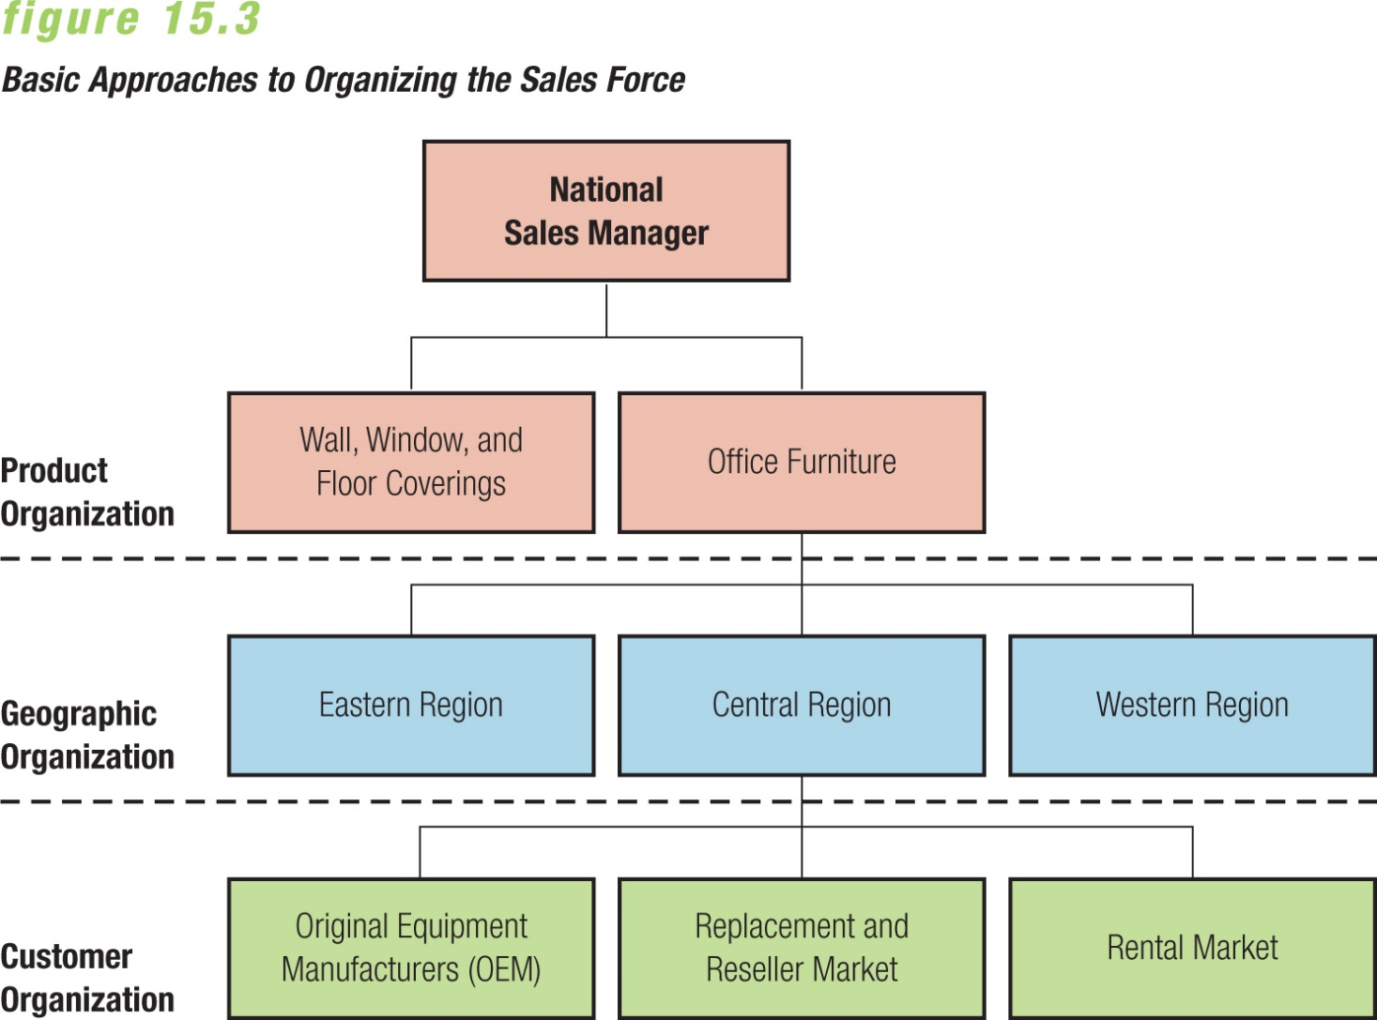
- Supervision - Span of control: Number of sales representatives who report to first-level sales managers.
  - Optimal span of control is affected by: Complexity of work activities, Ability of the individual sales manager, Degree of interdependence among individual salespeople, Extent of training each salesperson receives.
- Motivation - Motivational tools include information sharing, recognition, bonuses, incentives, and benefits. Knowing what motivated people.
  - Expectancy theory – Motivation depends on an individual’s expectations of his or her ability to perform a job and how that performance relates to attaining a desired reward
- Compensation – Commission: Compensation tied directly to the sales or profits the salesperson achieves
- Salary: Fixed payment made periodically to an employee
- Evaluation and Control - Managers must set standards and choose the best methods for measuring sales performance. Should identify areas of strength and weakness and serve as motivation for improved performance
  - Sales quotas – Specified sales or profit targets that the firm expects salespeople to achieve *Often tied to compensation system

- Ethical Issues in Sales:
  - Long-term success requires a strong code of ethics
  - Honesty and ethical behaviour is encouraged when:
    - Employees understand what is expected of them
    - Open communication is encouraged
    - Managers lead by example

- Sales Promotion:
  - Marketing activities other than personal selling, advertising, and publicity that enhance consumer purchasing and dealer effectiveness
  - Integrated into overall marketing plan
  - Promotions are likely to stress price advantages, giveaways, or special offers
  - Goal is speeding the sales process and increasing sales volume
  - Produces best results when combined with other marketing activities, such as advertising
  - Cannot overcome poor brand images, product deficiencies, or poor training for salespeople
- Consumer Oriented Sales Promotion: Encourage repurchases by rewarding current users. Boost sales of complementary products and increases impulse purchases.
  - Coupons – Offer a discount on the purchase price of goods or services
  - Refunds or rebates – Cash given back to consumers who send in proof of purchase for one or more products
  - Sampling – Free distribution of a product to obtain future sales

Higher response rate, good for new or unusual products but expensive for firm.
  - Bonus pack – Specially packaged item that gives the purchaser a larger quantity at the regular price ex. Two for 1, 20% more inside
  - Premiums – Items given free or at reduced cost with purchases of other products ex. Toy in happy meal
  - Contest – Sales promotion technique that requires entrants to complete a task for the chance to win a prize
  - Sweepstakes – Sales promotion technique in which prize winners are selected by chance

- Specialty Advertising: Sales promotion technique that places the advertiser’s name, address, and advertising message on useful articles that are then distributed to target consumers

- Trade Promotion: Sales promotion that appeals to marketing intermediaries rather than to consumers
  - Trade allowances – Special financial incentives offered to wholesalers and retailers that purchase or promote specific products
    - May give a discount on goods or include off-invoice allowances
  - Point-of-purchase (POP) advertising – Display or other promotion located near the site of the actual buying decision
  - Trade shows – Product exhibition organized by industry trade associations to showcase goods and services
    - Vendors who serve the industries display and demonstrate their products for attendees
  - Dealer incentives and contests reward retailers who increase sales
  - Push money – Cash reward paid to retail salespeople for every unit of a product they sell
  - Specialized training helps salespeople explain features, competitive advantages, and other information to consumers

