- Chapter 4: Digital Marketing and Social Media Living in the Connected World

- E-business: The wide range of business activities that take place via Internet applications, such as email and virtual shopping carts.
  - E-business can be divided into five broad categories:
    - E-tailing, or virtual storefronts on the websites
    - Business-to-business transactions
    - Electronic Data Interchanges (EDI), the business-to-business exchange of data
    - Email, IM, blogs, podcasts, vlogs, and other Web-enabled communication tools—as media for reaching customers
    - Web contacts that allow the gathering and use of demographic, product, and other information

- Digital Marketing: The strategic process of creating, distributing, promoting, and pricing goods and services to a target market over the Internet or through digital tools
  - Benefits include:
    - Global reach—The ability to reach anyone connected to the Internet anywhere in the world
    - Personalization—Creating products to meet customer specifications
    - Interactive marketing—Buyer–seller communications through such channels as the Internet and interactive kiosks
    - Right-time marketing—The ability to provide a product at the exact time needed
    - Integrated marketing—Coordination of all promotional activities to produce a unified, customer-focused promotional message
- 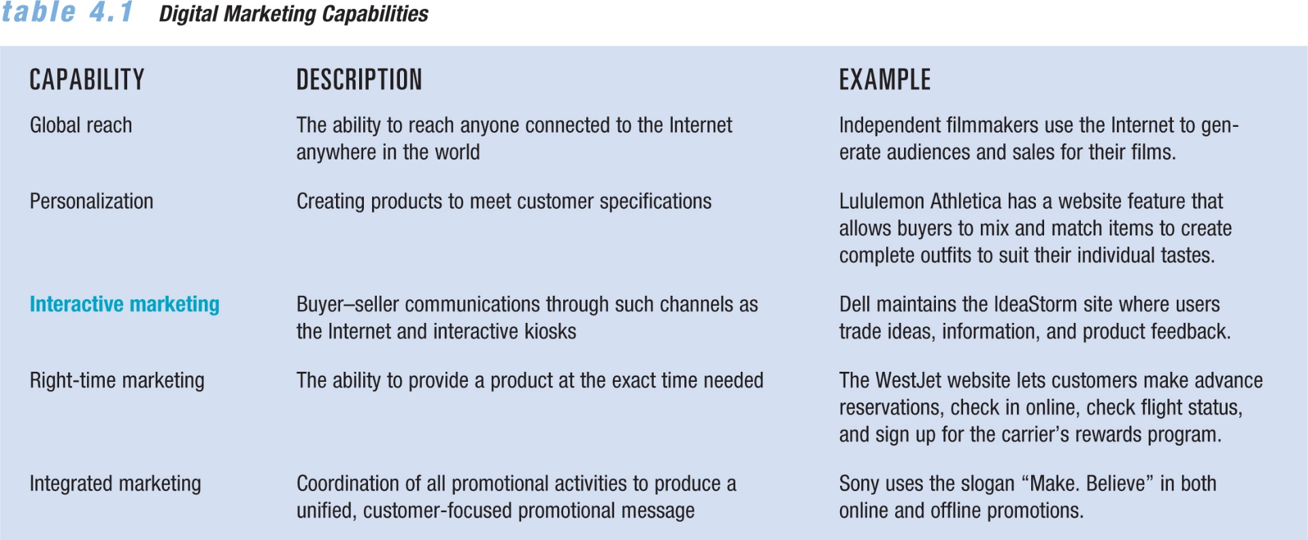
- Worldwide Internet usage has reached over 2.45 billion while more than 78% of the North American population have access to the Internet

- Business-to-consumer digital marketing (B2C): selling directly to consumers over the Internet
  - Convenience and more secure credit card transactions have caused rapid growth in online retail sales (e-tailing)
  - Interactive marketing involves buyer-seller communications in which the customer controls the amount and type of information received from a marketer through such channels as the Internet and virtual reality kiosks
  - Electronic storefronts are company websites that offer items for sale to consumers
  - These items are placed in an electronic shopping cart or shopping bag

Benefits:
  - Competitive pricing: The comparison of features and prices across sites is facilitated
    - Bots (shopbot) are search programs that check hundreds of sites, gather and assemble information, and bring it back to the sender
  - Access and convenience: Facilitates ordering of goods and services from around the world at any hour of the day or night
    - Customers are required to select a user name and password for security
    - Emails are used to confirm orders, to aid the delivery process
  - Personalized service: Customer satisfaction is greatly affected by the marketer’s ability to offer service tailored to many customers

- The typical Internet user is now likely to be between 18 and 64 years of age, 78% of Canadians shop online
- A broader range of Internet users now purchase items online, more men shop online than women
- Early online sellers focused on products that consumers were familiar with such as books and music

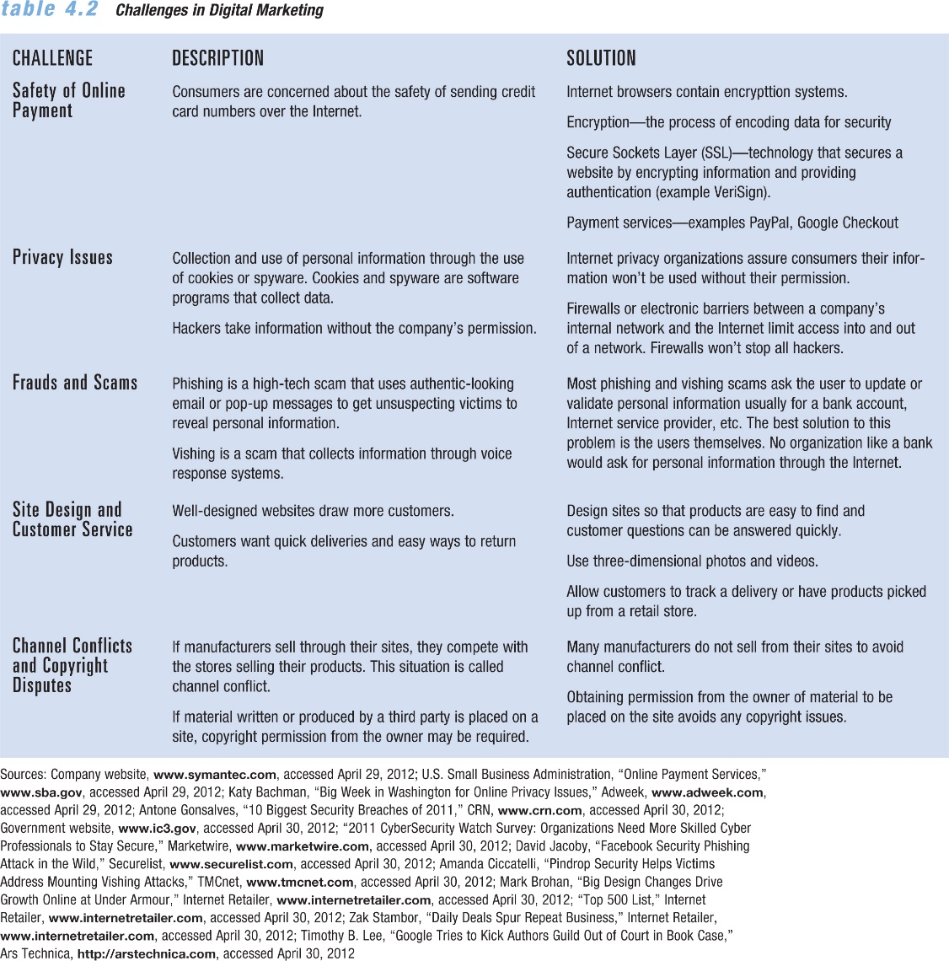
- The Internet has four main functions:
  - Digital business
  - Entertainment
  - Information
  - Communication
- Many firms use Internet forums, newsgroups, electronic bulletin boards, and social networks to communicate
- Blogs: short for web logs, are web pages that serve as publicly accessible journals for individuals or organizations may also incorporate a wiki, which is a Web page that any readers can edit and change
- Podcasts: audio or video recordings that are posted to a website and downloaded to a digital device that can play the file

- Promotions on the web
  - Banner ads are typically small, strip messages placed in high-visibility areas of frequently visited websites
  - Pop-up ads are separate windows that appear with an advertising message
  - Preroll video ads are marketing messages that play before an online video
  - Widgets are tiny applications that Internet users can copy and add to their own pages to play music, video, or slide shows
  - Search marketing is an arrangement by which a firm pays a search engine—such as Google—a fee to make sure that the firm’s listing appears toward the top of the search results
- Effective E-business Web Presence will:
  - Broaden customer bases
  - Provide immediate access to current catalogues
  - Accept and process orders
  - Offer personalized customer service

Successful Site Development:
  - Establish goals
    - What is the company’s goal for the website?
    - Objectives for the website also determine the scope of the project
    - Key decisions include whether to create and maintain a site in-house or to contract with outside designers
    - A domain name should reflect the company and its products and be easy to remember
  - Implementation and interest
    - Relevant to users
    - Easy to access and understand
    - Updated regularly
    - Written or displayed in a compelling way
    - List with major search engines to draw visitors to the site
  - Pricing and maintenance
    - Development
    - Placing the site on a web server
    - Maintaining and updating the site
    - Promoting the site
  - Assessing site effectiveness
    - Profitability is easy to measure in companies that generate revenues directly from online product orders, advertising, or subscription sales
    - Web-to-store shoppers are consumers who use the Internet as a tool to aid their purchases made at stores
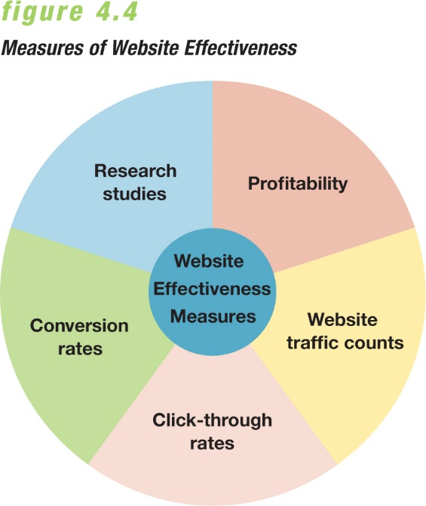
    - Revenue is not the major objective of most websites—companies are looking for brand awareness and brand loyalty
    - Advertisers typically measure the success of their ads in terms of click-through rates—the percentage of people presented with a banner ad who click on it
    - Click-through rates are currently declining, because in earlier days viewers were clicking on just about anything online
    - A conversion rate—a measure of the percentage of visitors to a website who make a purchase—of 3 to 5 percent is considered average
    - Engagement measures how much time users spend on sites, rather than how many pages of a site they view

- Social Media: different forms of electronic communication through which users can create online communities to exchange: information, ideas, messages, and other content such as videos or music.

  - Social media platform: It is a type of software or technology that allows users to build, integrate, or facilitate a community, interaction among users, and user-generated content
  - Social media tool: It enables users to communicate with each other online
- 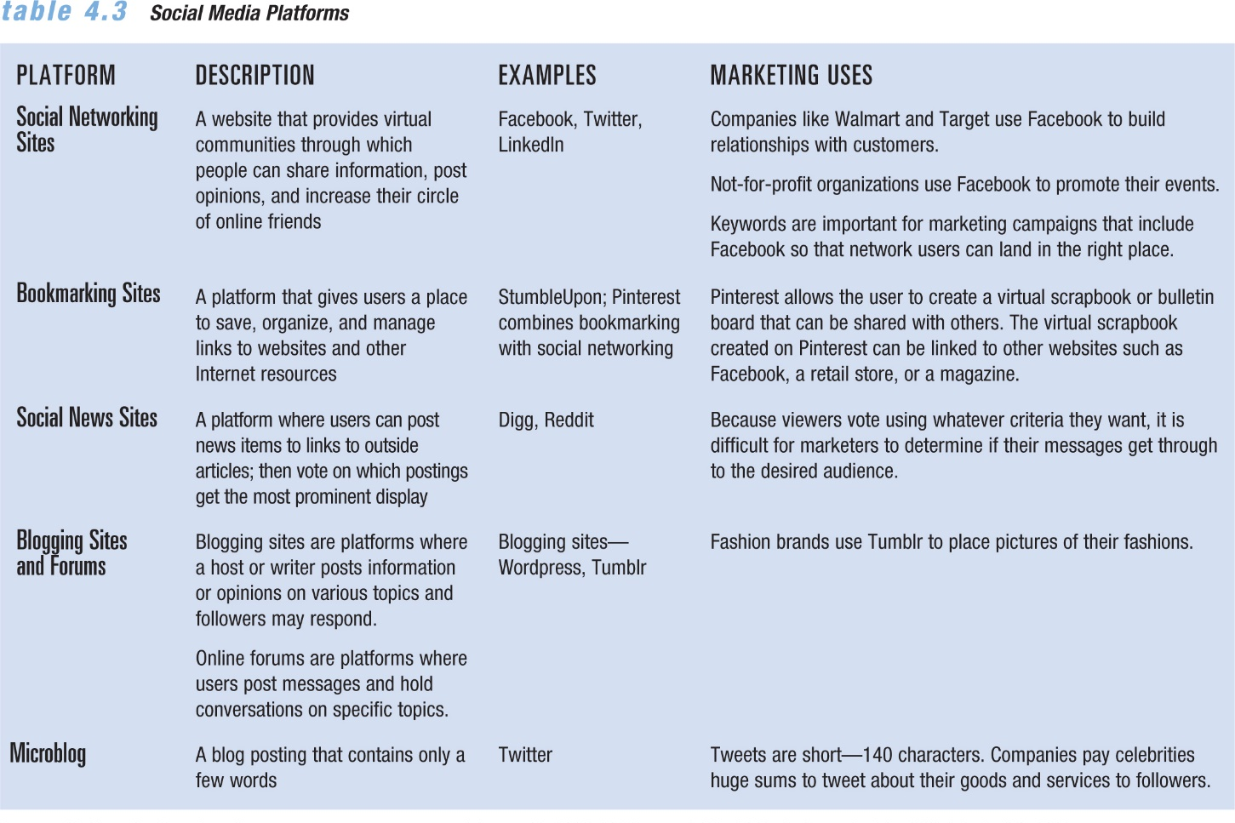
- Social Media Tools:
  - Media sharing services like YouTube and Flickr allow people to upload and share media such as photos and video
  - Blogging allows people to communicate in greater detail than microblogging does
  - Microblogging offers short bursts of news
  - Apps, short for applications, are paid or free software downloads that link users to a wide range of goods and services, media and text content, etc.
  - QR codes, short for “quick response,” are two-dimensional bar codes that can be read by some mobile phones with cameras
- Social media is a tool for marketers to:
  - Build relationships with customers
  - Strengthen brands
  - Launch new products
  - Enter new markets
  - Boost sales

- Social Media Marketing (SMM): Uses social media portals to create a positive influence on consumers or business customers toward an organization’s: Brand, Goods and services, Public image, Website
- helps develop a conversation with potential customers—resulting in a purchase, subscription to an email newsletter, and so forth. Not-for-profit organizations use it to expand their reach of campaigns
- Essential Features Include:
  - It creates a buzz
  - It creates ways for customers or fans to engage in conversations with each other and the organization
  - It allows customers to promote the firm’s messages themselves

- Consumers use social media to:
  - To learn about new goods and services
  - To conduct research and share information
  - To make final purchase decisions

- Social media Marketing Plan: Formal document that outlines a firms SMM and includes an executive summary, a brief overview, analysis of competition and body of the plan.
  - Set Goals
    - clear and flexible
  - Target Audience
    - Demographics
    - What the group needs or wants
    - Which of the firm’s products/social media will meet the needs and wants of particular groups of people
  - Develop Strategies
    - Which social media platforms to use
    - Which social media tools to use
    - Who will participate in the conversion on behalf of the company
    - How to make it easy for customers to participate
  - Produce Content
    - Have a strong brand focus
    - Focus on the audience rather than the organization
    - Use targeted keywords
    - Provide relevant information
    - Have shareworthy text and images
    - Include invitations to generate content
    - Include promotions that offer discounts, gifts, or other special deals in exchange for participation
  - Implement Plan
    - Marketers need to create a timeline for rollout onto each social media platform
    - Content should not be scheduled more than a week in advance
  - Monitor and Measure
    - social media monitoring is to track, measure, and evaluate a firm’s social media marketing initiatives
    - social media analytics tools help marketers track, measure, and interpret data related to SMM initiatives
    - return on investment (ROI) of their social media marketing initiatives, using:
      - Reach: The percentage of people in a target market who are exposed to the marketing effort at least once
      - Frequency: The number of times an individual is exposed to the marketing material during the campaign
- Two major distinctions between traditional marketing and SMM:
  - Traditional marketing seeks to control the content and message received by an audience; SMM actively solicits the audience’s participation in the message
  - Successful SMM efforts require the audience’s trust
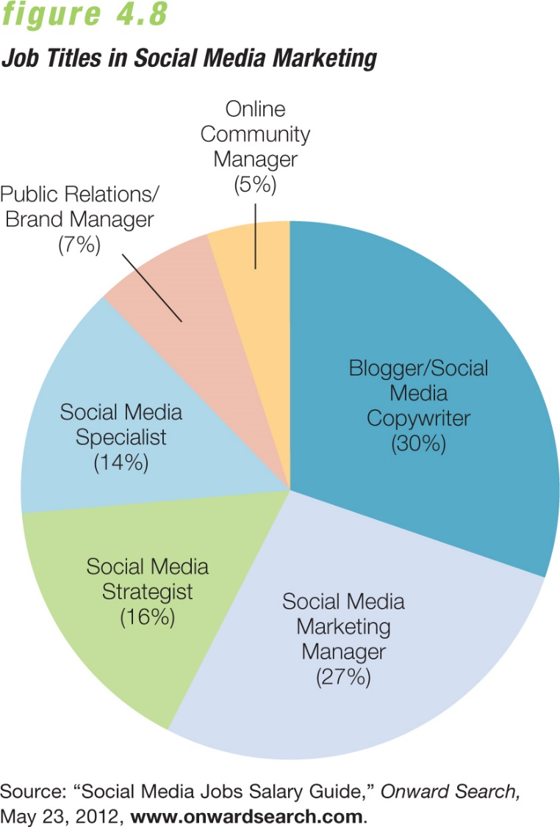
- Ethics in SMM:
  - Workplace ethics
  - Be honest
  - Respect privacy
  - Be accountable

