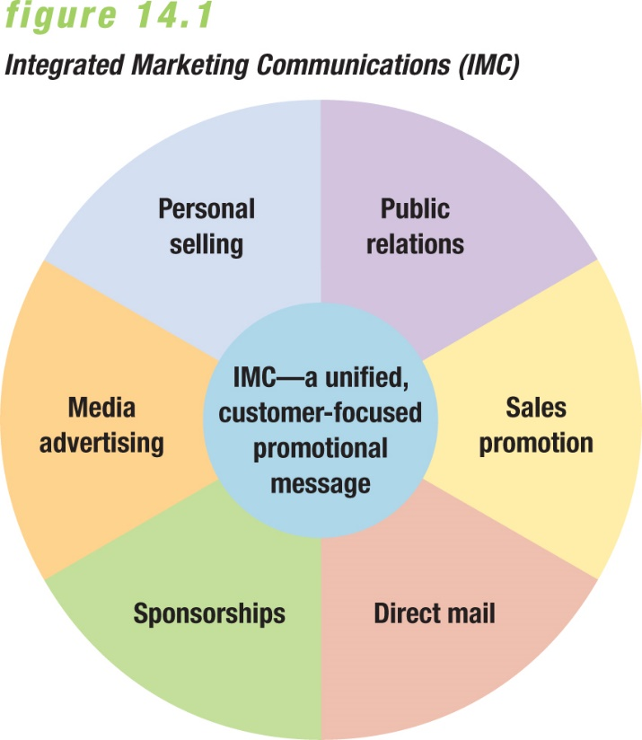
- Promotion and the Marketing Mix:
- •Promotion is the communication link between buyers and sellers, the function of informing, persuading, and influencing a consumer’s purchase decision.

- •Marketing communications are messages that deal with the buyer-seller relationships. Messages must make the greatest impact without overdoing it and causing consumers to completely tune them out.

- Integrated Marketing Communications (IMC), coordinates all promotional activities to produce a unified, customer-focused message. Beginning with their wants or needs and then works backward to the product.
  - Success depends on identifying the members of an audience and what they want so they don’t send the wrong message.
  - Successful implementation of IMC requires consistent, coordinated promotional effort at every stage of customer contact (Teamwork)
  - Role of database in effective IMC programs, the Internet allows companies to gather information faster and organize it easily

- The Communication Process: the sender acts as the source in the communication system in trying to convey (encode) a message to a receiver, who decodes and responds to the communication (feedback).
  - It gains the receiver’s attention.
  - It achieves understanding by both receiver and sender.
  - It stimulates the receiver’s needs and suggests an appropriate method of satisfying them.

- AIDA concept: Attention-Interest-Desire-Action, the steps consumers take in reaching a purchase decision.
  - the promotional message must gain attention.
  - seeks to arouse interest in the product
  - produces desire to purchase product
  - leads to the action of buying product now and in the future.
- 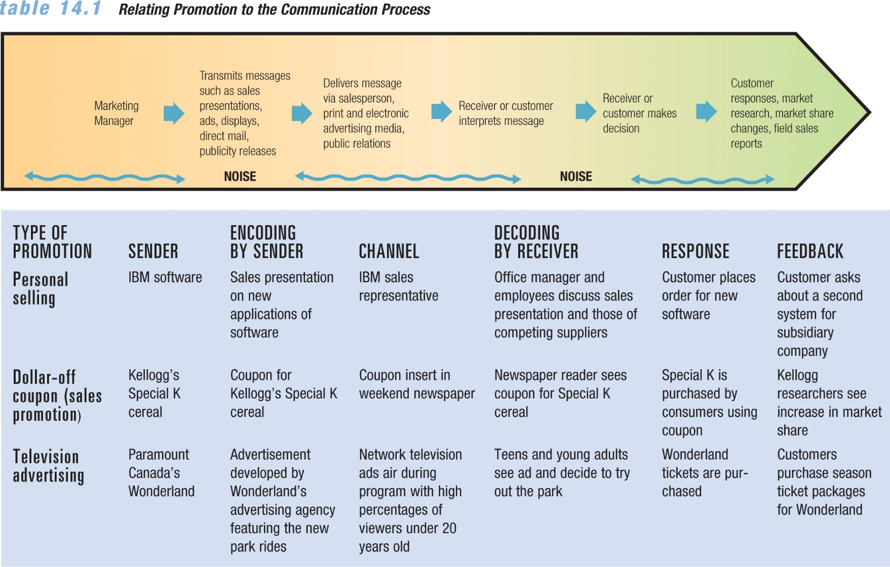
- 1. Sender: Business sending promotional messages.
- 2. Encoding: Translate message into understandable terms
- 3. Channel: Transmits the message through a communication channel
- 4.Decoding: Receiver of the message must interpret its meaning
- 5.Response: Customers response positively or negatively to message
- 6. Feedback: How the receiver responds to the message, allows markets to judge effectiveness or make changes.

- ** Noise: anything that interferes with or interrupts the message—physical problems like bad radio or TV reception, or conceptual problems such as poor appeals or use of inappropriate media.

- Promotional mix — Subset of the marketing mix in which marketers attempt to achieve the optimal blending of the elements of personal and nonpersonal selling to achieve promotional objectives
  - Personal selling refers to a seller’s promotional presentation conducted on a person-to-person basis with a buyer. Oldest form.
    - face-to-face, over the phone, videoconferencing, via computer links.
  - Nonpersonal selling includes advertising, product placement, sales promotion, direct marketing, public relations, and guerilla marketing.
    - Advertising and sales promotion are more important forms.
- Advertising :Any paid, nonpersonal communication through various media about a business firm, not-for-profit organization, product, or idea by a sponsor identified in a message
- Product placement: Form of nonpersonal selling in which the marketer pays a motion picture or television program owner a fee to display his or her product prominently in the film or show
- Sales promotion: Marketing activities other than personal selling, advertising, guerrilla marketing, and public relations that stimulate consumer purchasing and dealer effectiveness
- Direct marketing: Direct communications, other than personal sales contacts, between buyer and seller, designed to generate sales, information requests, or store or website visits
- Public relations: Firm’s communications and
relationships with its various publics
- Publicity: Nonpersonal stimulation of demand through unpaid placement of news in published medium or a favourable presentation of it on the radio or television
- Guerrilla marketing: Unconventional, innovative, and low-cost marketing techniques designed to get consumers’ attention in unusual ways
  - Buzz marketing: directed at young consumers, spreading the word of a product using ambassadors.
  - Viral marketing: voluntarily forwarded info spread by consumers.
- 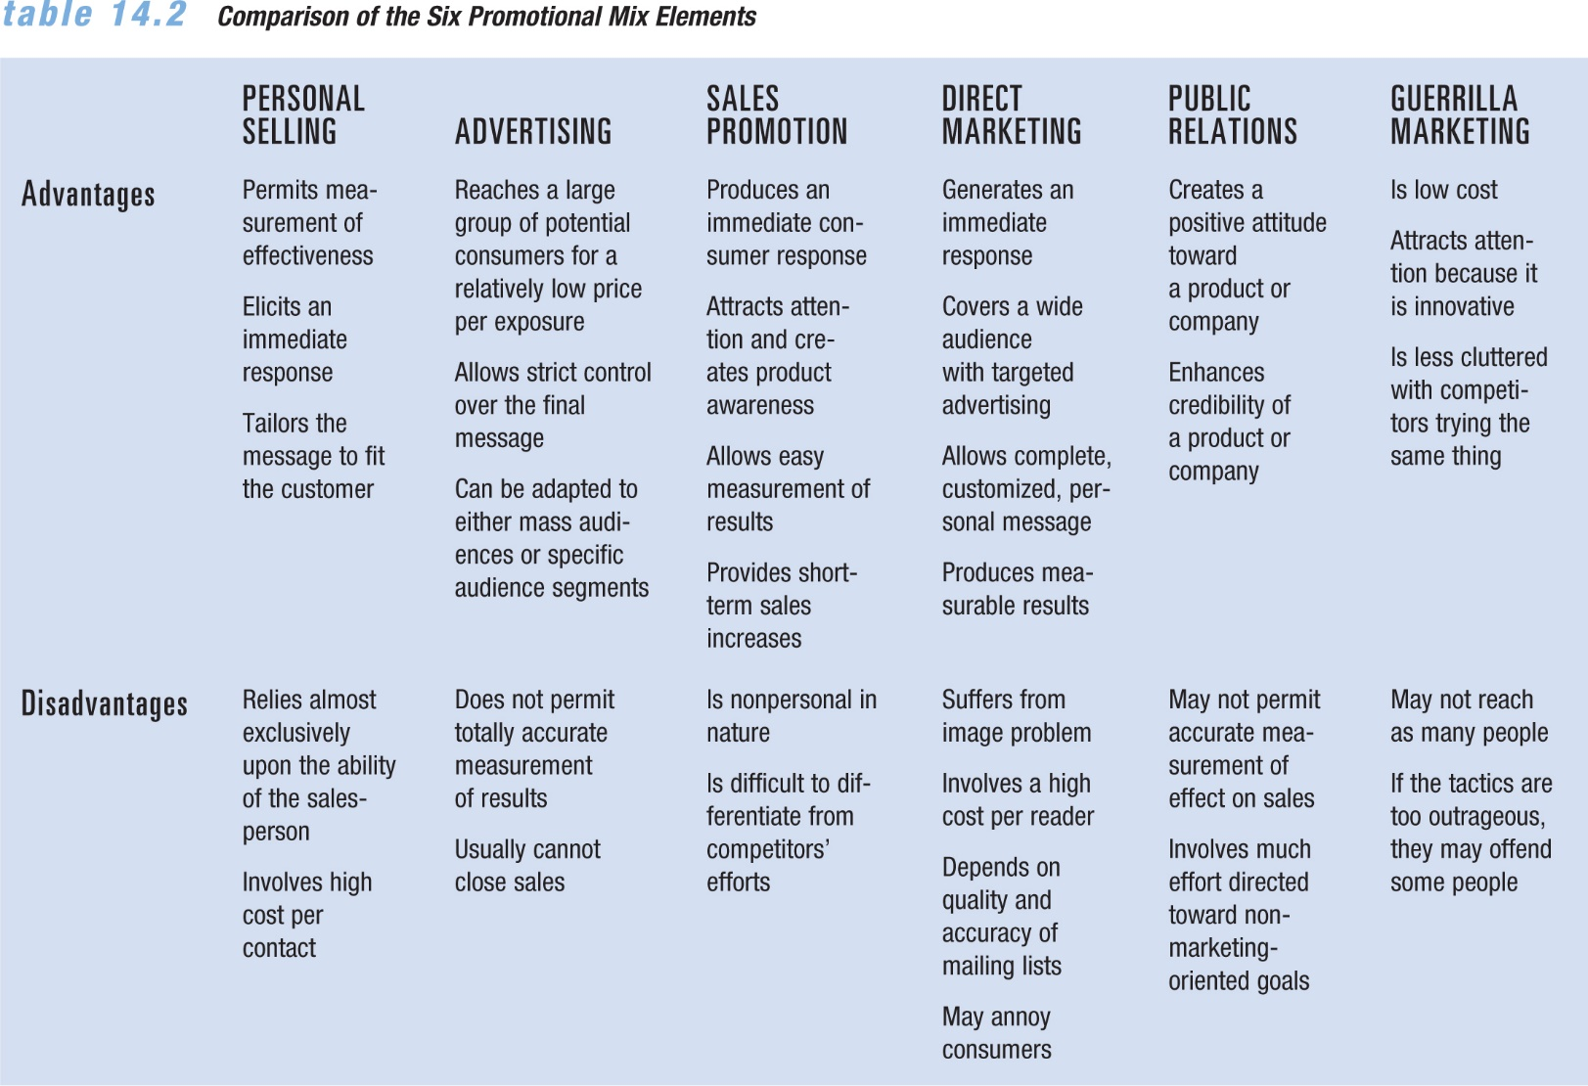
- Sponsorships: Relationship in which an organization provides funds or in-kind resources to an event or activity in exchange for a direct association with that event or activity

- Type of Advertising:
  - Product advertising is nonpersonal selling of a particular good or service, the type people picture when they think of promotions.
  - Institutional advertising promotes a concept, an idea, a philosophy, or the goodwill of an industry, company, organization, person, geographical location, or government agency. Linked to PR.
- Objectives of Advertising:
  - Informative advertising seeks to develop initial demand for a good, service, organization, person, place, idea, or cause. Used in promoting new market entry to announce availability.
  - Persuasive advertising is designed to increase demand for an existing good, service, organization, person, place, idea, or cause, it’s a competitive method used in the growth and early maturity.
  - Reminder advertising strives to reinforce previous promotional activity by keeping the name of the good, service, organization, person, place, idea, or cause in the minds of the public in later maturity and decline stage of lifecycle.
- Reasons for using ads:
  - To enhance consumer perceptions of quality in a good or service
  - To increase customer loyalty
  - To encourage repeat purchases
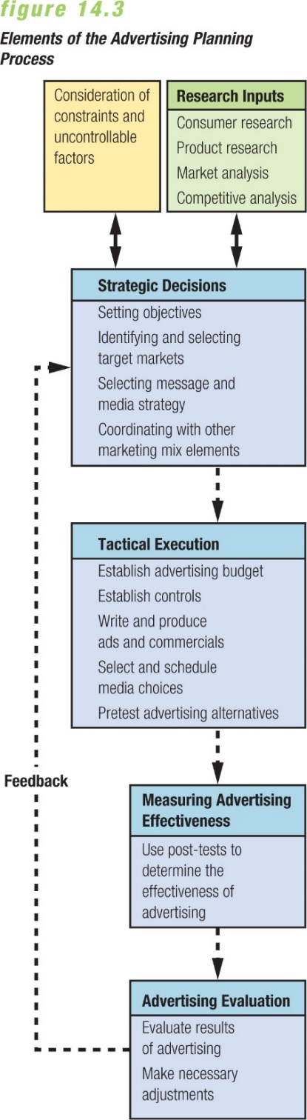
  - To protect themselves during a price war
  - To show their superiority in order to raise prices without losing market share
- Advertising Strategies:
  - Comparative advertising: promotional strategy that emphasizes ad messages with direct or indirect comparisons to dominant brands in the industry.
  - Celebrity testimonials: well-known individuals who endorse or promote a particular product or service.
  - Retail advertising: includes all ads by retail stores that sell products directly to the consuming public.
    - Cooperative advertising: Strategy in which a retailer shares advertising costs with a manufacturer or wholesaler
  - Interactive advertising: two-way promotional messages sent through communication channels that encourage recipients to take an active part in the promotional effort.
  - Cross promotion: when marketing partners
- share the cost of a promotional campaign that meets their mutual needs—an important benefit in an environment of rising costs
- ex. co-marketing and co-branding are forms of cross-promotion

- *Positioning strategy aims at creating a desired image in the consumer’s mind and distinguishing the product from those of competitors.

- Advertising campaign — Series of different but related ads that use a single theme and appear in different media within a specified time period

- Advertising Appeals: Tone of an ad ex. Fear, humor, or sexual appeal
- All ads should:
  - Gain attention and interest
  - Inform and/or persuade
  - Eventually lead to a purchase or other desired action
- Four major elements of a print ad:
  - Headline—should grab interest and attention, along with illustrations
  - Illustrations—photographs, drawing, artwork
  - Body copy—informs, persuades, and stimulates buying action
  - Signature—names the sponsoring organization, may include company name and logo as well as address, phone, web address, slogan, trademark, or product photo
- (Television, Radio, Newspaper, Magazines, Direct Mail, Outdoor advertising (billboards), Interactive Media (keyword ads, augmented reality).

- Media scheduling refers to setting the timing and sequence for a series of advertisements. These decisions can be affected by several factors:
  - Sales patterns—seasonal ups and downs over the year
  - Repurchase cycles—products with shorter cycles will need ongoing media schedules throughout the year
  - Competitors’ activities—avoiding advertising during heavy campaigns for competing products
- Reach – the number of people viewing an ad
- Frequency – the number of times an ad is viewed
- Gross point rating = frequency x reach

- Public Relations: the firm’s communications and relationships with its various publics—customers, employees, shareholders, suppliers, government agencies, and society at large.
  - Nonmarketing public relations refers to a company’s messages about general management issues, involving decisions that affect any of its publics.
  - Marketing public relations (MPR) refers to narrowly focused PR activities that directly support marketing goals, involving the firm’s relationships with consumers or other groups.
- ** Also responsible for promoting the firm.

- Ethics and Promotional Strategies:
  - Children greatly influence purchasing decisions of their parents, by promoting goods and services directly to children, firms can sell not only to them but to the rest of the household, too
  - Another issue is product messages in media programs without full disclosure of the marketing relationship to audiences
  - Another ethical issue surrounding advertising online is the use of cookies, small text files automatically downloaded to a user’s computer whenever a site is visited, often without the user’s knowledge.
- Deceptive advertising refers to exaggerated claims of a product’s superiority, vague statements about it that may not be literally true, Advertising Standards Canada regulated this.
- **Several public relations issues open organizations to criticism—such as promoting the tobacco industry; defending unsafe products

- Promotional Mix Effectiveness

1.Nature of the market
    - Market’s target audience, type of customer

2.Nature of the product
    - Highly standardized products usually depend less on personal selling
    - Consumer product sellers rely more on advertising than business products

3. Stages in the product life cycle
    - Personal selling in introductory stage
    - Advertising in growth and maturity stages
    - Differentiation when competitors enter the market

4. Price
    - Advertising for low-unit-value products

5. Funds available for promotion
    - Size of the budget influences promotional mix

- Methods for creating a promotional Strategy:
  - The percentage-of-sales method is based on sales either from some past period (such as the previous year) or forecast for a future period (the current year); though it is simple, it does not support the achievement of basic promotional objectives
  - The fixed-sum-per-unit method allocates a predetermined amount to each sales or production unit; high-end consumer durable manufactures use this budgeting method
  - The meeting competition method matches competitors’ outlays, either in absolute amounts or relative to the firm’s market shares
  - The task-objective method develops a promotional budget based on a sound evaluation of the firm’s promotional objectives; the method has two steps: define realistic and quantifiable communication goals for the promotional mix and determine the amount and type of promotional activity required for each objective

- Direct sales results test measure the effectiveness of promotion; this approach reveals the specific impact on sales revenue for each dollar of promotional spending
- Indirect evaluation helps researchers concentrate on quantifiable indicators of effectiveness, such as recall and readership.

- Media research: Assesses how well particular medium delivers message, where and when to place the message, and the size of the audience
- **Advertisers typically pay a fee based on the cost to deliver the message to viewers, listeners, or readers: the cost per thousand impressions (CPM)
- Message research: Tests consumer reactions to an advertisement’s creative message through pretesting and post-testing
  - Pretesting — Assessing an advertisement’s likely effectiveness before it is completed (focus groups, blind product tests)
  - Post-testing — Assessing advertisement’s effectiveness after it has appeared (Inquiry tests, recall tests)
    - Split runs — Allow advertisers to test the relative effectiveness of two ads

- Hits—user requests for a file

Impressions—number of times a viewer sees an ad
- Click-through rates—number of times users click on an ad to get information
- View-through rates—responses to ads over time

- Cost per impression is a measurement technique that relates the cost of an ad to every thousand people who view it
- Cost per response (or click-throughs) is a direct marketing technique that relates the cost of an ad to the number of people who click it

