- Pricing Concepts and Strategies

- Price is the exchange value of a good or service
- 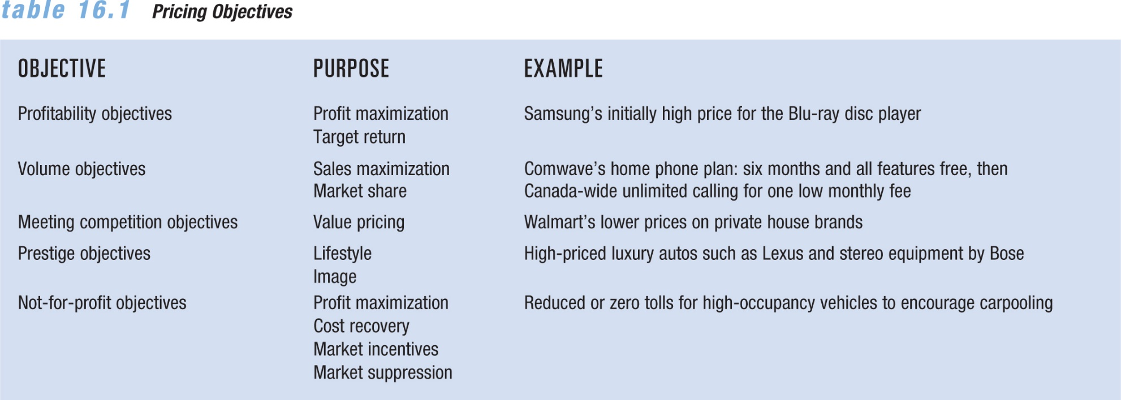
- Ex. Oil prices became higher so oil competitors started to manufacture oil at a lower price by using sands and other expensive processing methods, so the owners of real own in the middle east were forced to lower their prices.

- Not-for-profit organizations set prices high to cover expenses and to cover unforeseen needs and expenses.

- Economic theory
  - that firms will behave rationally
  - that this rational behavior will result in an effort to maximize gains and minimize losses.

- Some marketers estimate profits:
  - looking at historical sales data
  - using elaborate calculations based on predicted future sales.
- *balance between desired profits and the customer’s perception of a product’s value will be successful.

- Basic profit and revenue formula:
  - Profit= Revenue – Expense
  - Total Revenue = Price x Quantity Sold

- Marginal analysis – Method of analyzing the relationship among costs, sales price, and increased sales volume
- Profit maximization – Point at which the additional revenue gained by increasing the price of a product equals the increase in total costs
- Target-return objective – Short-run or long-run pricing objectives of achieving a specified return on either sales or investment

- Volume Objectives: Belief that increased sales volume is more important in the long run than immediate profits
  - Can maximize sales through pricing and nonprice factors such as service and quality
- Ex.Procter & Gamble (P&G) decided to roll back its price increases to improve its market share.
- Market-share objective – The goal of controlling a specified minimum share of the market for a firm’s good or service

- Profit Impact of Market Studies (PIMS) project – Discovered a strong positive relationship between market share and product quality and a firm’s return on investment
  - Firms with market share more than 40 percent have average return on investment of 32 percent
  - Firms with large shares accumulate greater operating experience and lower overall costs relative to competitors with smaller market shares
- Ex. Best Buy loyalty program are a means of retaining customers and protecting their market share

- Meeting Competition Budgets:
  - Firms sometimes set prices to match established industry price leaders
  - Shifts marketing mix to focus on nonprice variables-focusing on product strategies, promotional decisions, and distribution
- Value Pricing: Pricing strategy emphasizing benefits derived from a product in comparison to the price and quality levels of competing offerings
  - Works best for relatively low-priced goods and services
  - Challenge is convincing customers that low-priced brands offer quality comparable to that of a higher-priced product
- Ex. Loblaws discount store, nofrills lowest-price food stores in their markets.

- Prestige Objectives: Establishing a relatively high price to develop and maintain an image of quality and exclusiveness that appeals to status-conscious consumers ex. Louis Vuitton

- Pricing Objectives for Non-for profit Organizations
  - Profit maximization: Maximizing return on an event ex. $1000-a-plate political fundraiser is a classic example.
  - Cost recovery: attempt to recover only the actual cost of operating the unit. Ex. toll roads
  - Market incentives: lower-than-average pricing policy or offer a free service to encourage increased usage of the good or service.
  - Market suppression: High prices help discourage consumption ex. Illustrations include tobacco and alcohol taxes (the so-called sin taxes), parking fines, tolls, and gasoline excise taxes.

- Methods for Determining Price
  - Prices are traditionally determined in two basic ways:
    - Supply and demand- higher demand higher cost
    - Cost-oriented analyses-
  - Customary prices – Traditional retail prices that customers expect to pay for certain goods and services
  - Demand – The amounts of a firm’s product that consumers will purchase at different prices during a specified time period
  - Supply – The amounts of a good or service that will be offered for sale at different prices during a specified period
- Four Market Structures: Fig. 16.2
  - Pure competition – A market structure with so many buyers and sellers that no single participant can significantly influence price
  - Monopolistic competition – large number of buyers and sellers, - differentiated products, some control over prices most retailers
  - Oligopoly – Relatively few sellers; each has large influence on price (cell phone providers)
  - Monopoly – Only one seller of a product exists and for which there are no close substitutes ( where every company wants to be but laws exist to prevent it.

- Variable costs – Change with the level of production
  - Raw materials and labor costs
- Fixed costs – Remain stable at any production level within a certain range
  - Lease payments or insurance costs, manager salaries

- Average total costs – Costs calculated by dividing the sum of the variable and fixed costs by the number of units produced
- Marginal cost – Change in total cost that results from producing an additional unit of output
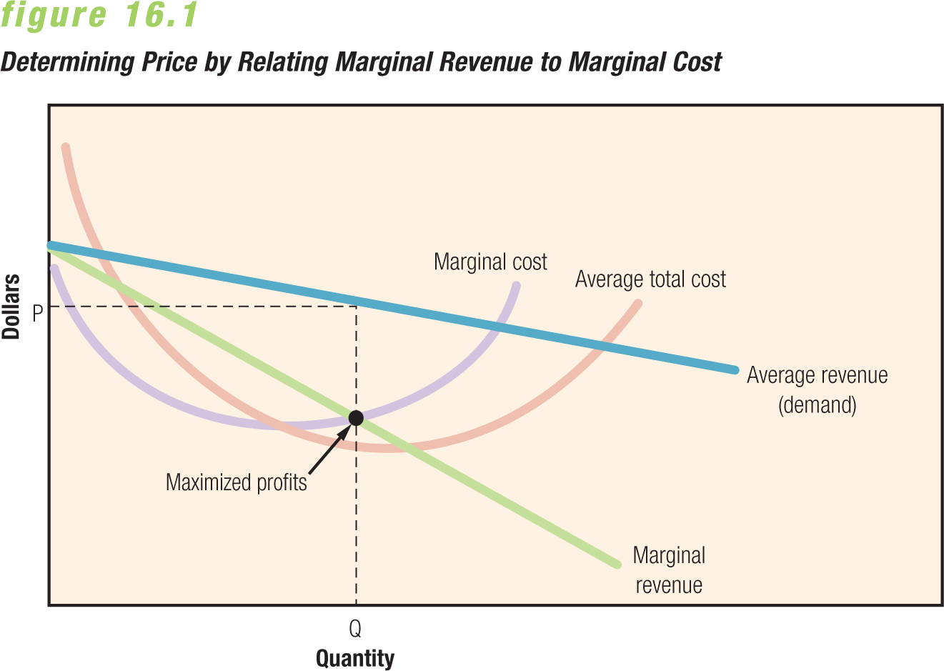
- -Negative slope the higher the cost the lower the demand.

- -Marginal revenue curve, your first customers will pay high cost as you gain customers prices will drop

- **Every manufacturing factory has a manufacturing max
- Marginal cost and average cost is what happens when they hit manufacturing max so then costs for company increase due to variable costs ie. Opening new factory or making hours longer paying additional electricity.

- Some companies start at making 0 profit to attract more customers the more customers you attract the less your production costs are and you slowly start to make profit.
  - When marginal revenue crosses marginal costs this is where maximized profit occurs.
  - Although the firm can earn a profit at several different prices, the price at which it earns maximum profits is $22.
  - At a price of $24, $66 in profits are earned—$4 less than the $70 profit at the $22 price.
  - If a price of $20 is set to attract additional sales, the marginal costs of the extra sales ($7) are greater than the marginal revenues received ($6), and total profits decline.
- Elasticity – Measure of responsiveness of purchasers and suppliers to a change in price
- Elasticity of demand – Percentage change in the quantity of a good or service demanded divided by the percentage change in its price
- Elasticity of supply – Percentage change in the quantity of a good or service supplied divided by the percentage change in its price

- ***Quantity/ price = if it is over 1 it is elastic if it is under 1 it is inelastic
- As a company you want inelastic demand
- Determinants of Elasticity
  - Availability of substitutes or complements
    - Role as a complement to another product
  - Number of business transactions conducted online
    - Online is more elastic because of its convenience and the ability to shop around and compare
  - Whether product is perceived as a necessity or luxury
    - if a product is a necessity it is less elastic because people will pay whatever because they need it.
    - Luxury goods are inelastic because there price makes them valuable and people will pay for the name.
  - Portion of a person’s budget spent on an item
    - Persons budget more elastic items because it is a large part of their income
  - Demand shows less elasticity in the short run than in the long run

Elasticity has a strong influence on revenue
  - Price cuts will increase revenues for products with elastic demand
  - Price increases will increase revenue for products with inelastic demand
- **It takes awhile for people to realize that price in unfairly rising, you can get
- away with it at first for a while if increase is small and slow.

- Problems with price theory:
  - Many firms do not attempt to maximize profits
  - Demand curves are difficult to estimate

- Cost-plus pricing – Uses a base-cost figure per unit and adds a markup to cover unassigned costs and to provide a profit
  - Allows businesses with low costs to set prices lower than those of competitors’ and still make a profit
- Ex. Newspaper company has 45 cent markup to cover other expensesand earn reasonable return.
- Full-cost pricing – Uses all relevant variable costs in setting a product’s price and allocates those fixed costs not directly attributed to the production of the priced item
  - No consideration of competition or demand for the item
  - Any method for allocating overhead is arbitrary and may be unrealistic
- Ex. if job order 515 in a printing plant amounts to 0.000127 percent of the plant’s total output, then 0.000127 percent of the firm’s overhead expenses are charged to that job. This approach allows the marketer to recover all costs plus the amount added as a profit margin.
- Incremental-cost pricing – Attempts to use only costs directly attributable to a specific output in setting prices
  - What I charge customers solely on variable costs
- =>If firm is contracted for an additional 5000 units, the lowest possible price would be $9/unit under full-cost pricing, Under incremental-cost pricing, prices above $5/unit are permitted:

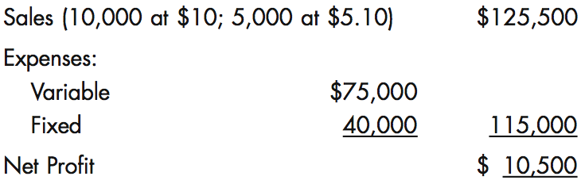

- Break-Even Analysis: Pricing technique used to determine the number of products that must be sold at a specified price to generate enough revenue to cover total cost

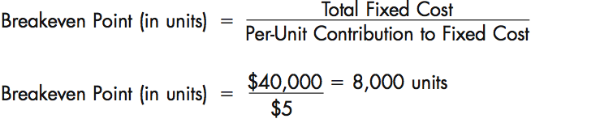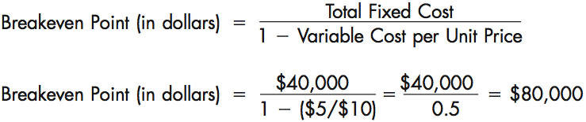
  - Easily understood by marketers and nonmarketers
  - Assumes that costs can be divided into fixed and variable categories
  - Assumes that per-unit variable costs do not change at different levels of operation
  - Cost-based model that does not consider demand

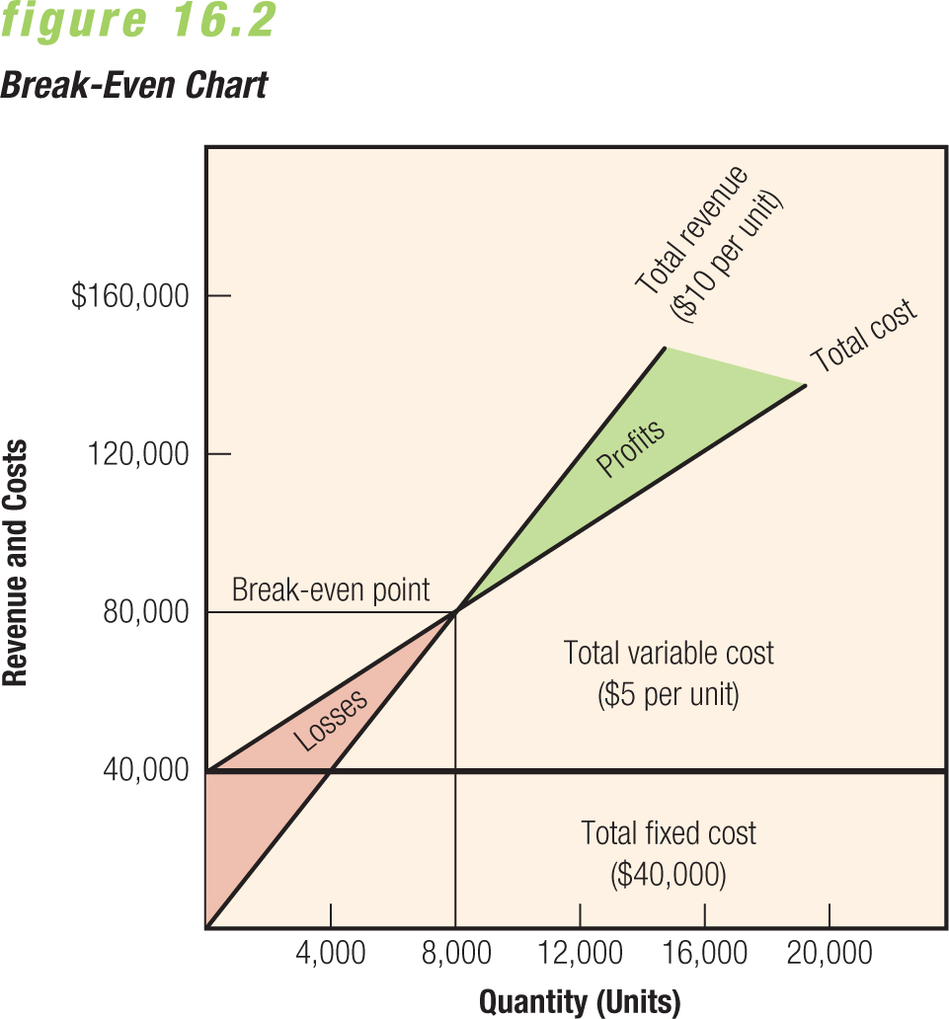
- Both fixed and variable segments, and total fixed cost is represented by a horizontal line. Average variable cost is assumed to be constant per unit as it was in the example for incremental pricing.
  - The breakeven point is the point at which total revenue equals total cost.

  - Sometimes breakeven is reached by reducing costs.

- Once revenues have reached enough to cover all fixed costs, any additional sales will generate per-unit profits equal to the difference between the products selling price and the variable cost of each unit.
- Target Returns: Most managers include a desired profit in their break even analysis by adding the desired dollar return to the total fixed costs.
- 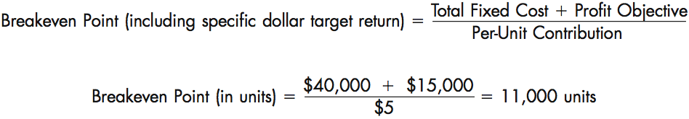

- Yield management: Pricing strategy that allows marketers to vary prices based on such factors as demand, even though the cost of providing those goods or services remains the same
  - Ex: airfares, lodging, and auto rentals
  - All inclusive resorts in the summer, they lower prices significantly to attract customers and gain 100% profit
- Price skimming — Pricing strategy involving the use of a high price relative to competitive offerings
  - Commonly used as a market entry price for distinctive goods or services with little or no initial competition
  - Sometimes used throughout the life of the product, as with luxury goods
  - Permits marketers to control demand but also attracts competitors
    - Start at top prices with high profits as competition starts todo the same you slowly lower prices to compete and stay on top.
- =>Successive price declines may expand the firm’s market size and meet challenges posed by new competitors.
- Ex.10 percent of the market may buy Product X at $10.00, and another 20 percent could be added to its customer base at a price of $8.75.

- Penetration pricing: (opposite of price skimming) Use of a relatively low-entry price compared with competitive offerings, based on the theory that this initial low price will help market acceptance, used throughout lifecycle.
  - Price level may increase to match competitors, once the product has recognition in the market
  - Sometimes called market-minus pricing
- =>Works best for goods and services that have:
  - Highly elastic demand
  - Low production and marketing costs
  - A high likelihood of attracting strong competitors

- Everyday Low Pricing (EDLP)
  - Strategy devoted to continuous low prices as opposed to relying on short-term, price-cutting tactics
  - Used by retailers selling to consumers and by manufacturers in dealing with channel members
  - Some retailers, such as grocery stores, oppose EDLP strategies
    - Prefer high-low strategies that set profitable regular prices to offset losses from frequent specials and promotions
- Ex. Wal-Mart achieves EDLP by negotiating better prices with suppliers and cutting own costs. Dollar stores also do this, Lowe’s does price match &-10%
- Disadvantages:
  - Easy for competitors to match
  - Unless demand is elastic, reduces revenue throughout industry
  - May generate image of questionable quality

- Competitive Pricing Strategy:Designed to de-emphasize price as a competitive variable by pricing a good or service at the general level of comparable offerings
  - Ex:Home Depot and Lowe’s both promise to meet and beat competitors’ prices
- =>Opening price point: Setting an opening price below that of the competition, usually on a high-quality private-label item
  - Prices can drop when competitors continually match each other
  - Forces firms to compete based on nonprice variable in the marketing mix

- Price Quotations
- Sticker/List price – Established price normally quoted to potential buyers
  - Reductions from list price
    - Market price – Price a consumer or marketing intermediary actually pays for a product after subtracting any discounts, allowances, or rebates from the list price

Ex. Cars have a list price but that price can vary depending on add ons and features included.
- Reductions from List Price:
  - Cash discount – Price reduction offered to a consumer, business user, or marketing intermediary in return for prompt payment of a bill 2%/10days Ex. Car dealership
    - negative cash discount: customers are charged interest on late payments.
  - Trade discount – Payment to a channel member or buyer for performing marketing functions Ex. Business to Business
  - Quantity discount – Price reduction granted for a large-volume purchase
    - Cumulative quantity discount – Price discount determined by amounts of purchases over stated time periods (once you’ve ordered 100 cases, the price per case will go down after)
    - Noncumulative quantity discount – Price reduction granted on a one-time-only basis
  - Allowance – Specified deduction from list price, including a trade-in or promotional allowance
    - Trade-in – Credit allowance given for a used item when a customer purchases a new item
    - Promotional allowance – Reduces prices as part of an attempt to integrate promotional strategies within distribution channels
    - Minimum advertised pricing (MAP) – A manufacturer pays a retailer not to advertise a product below a certain price
  - Rebate – Refund of a portion of the purchase price, usually granted by the product’s manufacturer

- Geographic Considerations:
  - Strongly influences a firm’s ability to deliver orders in a cost-effective manner at the right time and place
  - Can also affect the marketer’s ability to receive additional inventory quickly in response to demand fluctuations
  - Three ways to handle transportation costs:
    - buyer pays, seller pays, or both share costs
- FOB Pricing:

FOB (free on board) plant or origin: price does not include shipping charges; title and responsibility pass to buyer once seller makes shipment
- FOB destination (uniform delivered pricing): pricing included shipping charges. The seller pays the freight charges, and retains title and responsibility until the shipment is received by the buyer
- * Sometimes called postage-stamp pricing because it is structured like mail service.
  - Firm quotes the same price, including transportation expenses, to all buyers
  - Includes transportation charge averaged over all customers
  - Nearby customers pay disproportionate freight charges, so-called phantom freight (the amount by which the average transportation charge exceeds the actual cost of shipping)
- Zone Pricing: Modified uniform delivered pricing system that divides the overall market into different zones and establishes a single price within each zone
  - Ex: Canada Post parcel rate
- Base-Point Pricing: Price of a product includes the list price at the factory plus freight charges from the basing-point city nearest the buyer
  - The basing point specifies a location from which freight charges are calculated, Few buyers would accept a basing-point system today.
- Ex. a seller might quote a customer a price of $1000 per ton for a shipment of steel from Montreal, but designate the basing point as Hamilton, Ontario. So customer pays for the steel plus a charge equal to the freight that would have resulted had the shipment been made from Hamilton.

- Psychological Pricing: Pricing policy based on the belief that certain prices or price ranges make a good or service more appealing than others to buyers, Includes prestige pricing.
  - Odd pricing – Setting prices at odd numbers just under round numbers
  - Unit pricing – Prices stated in terms of some recognized unit of measurement or a standard numerical count (g,ml,ect.)
- Ex. some consumers would feel better paying $400.00 for their shoes, rather than $399.99./When you buy a printer you don’t realize that ink is a major cost after the fact because they don’t advertise that.

- Price Flexibility: Pricing policy permitting variable prices for goods and services
  - One-price policies suit mass-selling marketing programs
  - Variable pricing is more likely to be applied in marketing programs based on individual bargaining
- *customers may be upset should they learn that others have gotten a lower price for the same product.

- Product-Line Pricing: Practice of setting a limited number of prices for a selection of merchandise and marketing different product lines at each of these price levels
  - Helps retailers differentiate product lines
  - Allows customers to focus on desired prices ranges
  - Retailers may have difficulty making price changes on individual items as necessary
- Ex. a clothier might offer three lines of men’s suits—one priced at $400, a second at $600, and the most expensive at $1200.

- Promotional Pricing: Pricing policy in which a lower-than-normal price is used as a temporary ingredient in a firm’s marketing strategy
  - Must be managed carefully because customers may come to expect these promotions and wait for them
- Ex. Buy one get the second pair 50% off.
  - Loss leader – Product offered to consumers at less than cost to attract them to stores in the hope that they will buy other merchandise at regular prices Ex. House label brands
  - Leader pricing – Variant of loss-leader pricing in which marketers offer prices slightly above cost to avoid violating minimum-markup regulations and earn a minimal return on promotional sales Ex. Higher pricing set on cosmetics and toiletries to offset the difference
- Price-Quality Relationship:
  - Price affects consumer perception of quality
  - Customers often associate prestige with high prices
  - Many consumers are willing to pay more for ecofriendly products
  - Consumers have maximum and minimum price limits

- Competitive bidding – Inviting potential suppliers to quote prices on proposed purchases or contracts
  - Detailed specifications of products often used
  - Sometimes negotiated contracts are used with preferred suppliers rather than competitive bidding for lowest cost suppliers.

- Pricing in Global Markets:
  - Prices must support the company’s broader goals
  - Global pricing objectives:
    - Profitability – If company is a price leader
    - Volume – Expose foreign markets to competition when trade barriers are lowered
    - Meeting competition – Important in Europe where common currency has led to price convergence
    - Prestige – Valid when products are associated with intangible benefits, such as high quality, exclusiveness, or attractive design
    - Price stability – Important for producers of commodities who are more susceptible to fluctuating prices than producers of value-oriented products
- Global Pricing Strategies:
  - Standard worldwide pricing – Can succeed if foreign marketing costs remain low or if their prices reflect average unit costs
  - Dual pricing – Distinguishing prices for domestic and export sales

Ex. Macdonals in Russia still 1$ but they only make 30$ a month so it is a luxury there.
  - Market-differentiated pricing – Setting prices according to local market conditions

- Transference Pricing Dilemma:
  - Transfer price – The price for moving goods between profit centres
  - Profit centres – Any part of the organization to which revenue and controllable costs can be assigned
- *Governments monitor transfer pricing because it can be used by companies to avoid paying taxes on profits
- Ex of pricing manipulation: each DVD unit costs $25 to build, the manufacturer charges its subsidiary $75. the distributor sells the DVD players to retailers for $125 each.
- This arrangement gives the manufacturer a $50 profit on each machine, on which it pays taxes only in South Korea. Meanwhile, the Canadian subsidiary writes off $50 for advertising and shipping costs, leaving it with no profits—and no tax liability.

- Online Pricing: Search programs that compare prices on products called bots force online marketers to keep prices low, Brand image and customer service may outweigh price for certain purchases.

- Cannibalization: Loss of sales of an existing product due to competition from a new product in the same line
  - Some companies price the same products differently online; this practice runs the risk of cannibalization

- Bundle Pricing:Offering two or more complementary products and selling them for a single price
  - Prevalent in the telecommunications industry
  - Consumers may resist the practice of bundling claiming they are being forced to pay for products they don’t want
- Ex: Cable television industry, which resists selling channels individually

- Pricing and the Law:
  - Federal, provincial and territorial, and municipal laws all influence pricing decisions
  - Tariffs levied on imported goods and services can help firms protect local markets
    - Countries impose them to protect domestic suppliers

NAFTA = low tarrifs between mexico, us and Canada. Canada has negotiated trade agreements in other global markets: the European Union (2013) and Korea (2015).
  - Government regulation also imposes costs that affect prices
  - Some companies use regulatory cost recovery as a source of additional revenue
  - A historically illegal practice – ticket scalping – has moved online to legal websites (stub hub)

- The Competition Act: tries to balance the interests of businesses and consumers; it tries to foster a fair competitive environment to protect businesses from each other and to protect consumers from unfair business practices. Such as:
  - Price discrimination: enforces same customer same price theory, however does not account for senior discount for example.
  - Price fixing: way to avoid price wars, is all companies raise price together customers will be forced to pay premium for necessities. Risky because one company can suddenly lower prices and steal market share
  - Bid rigging:
  - Predatory pricing: lowering pricing to squeeze competition out.
  - False or misleading price representations:

