- Retailers, Wholesalers and Direct Marketers

- Retailing: Activities involved in selling merchandise to ultimate consumers
  - Retailers—both large and small—create time, place, and ownership utility
  - Retailers act as both customers and marketers in their channels

- Evolution of Retailing:
  - The general store – first type of retail institution
  - Rise of supermarkets in the early 1930s, discount stores in the 1950s, convenience stores in the 1960s, and off-price retailers in the 1980s and 1990s
- Wheel of retailing – Hypothesis that each new type of retailer gains a competitive foothold by offering lower prices than current suppliers charge; the result of reducing or eliminating services

- Retailing Strategy:
- 1) Select a target Market
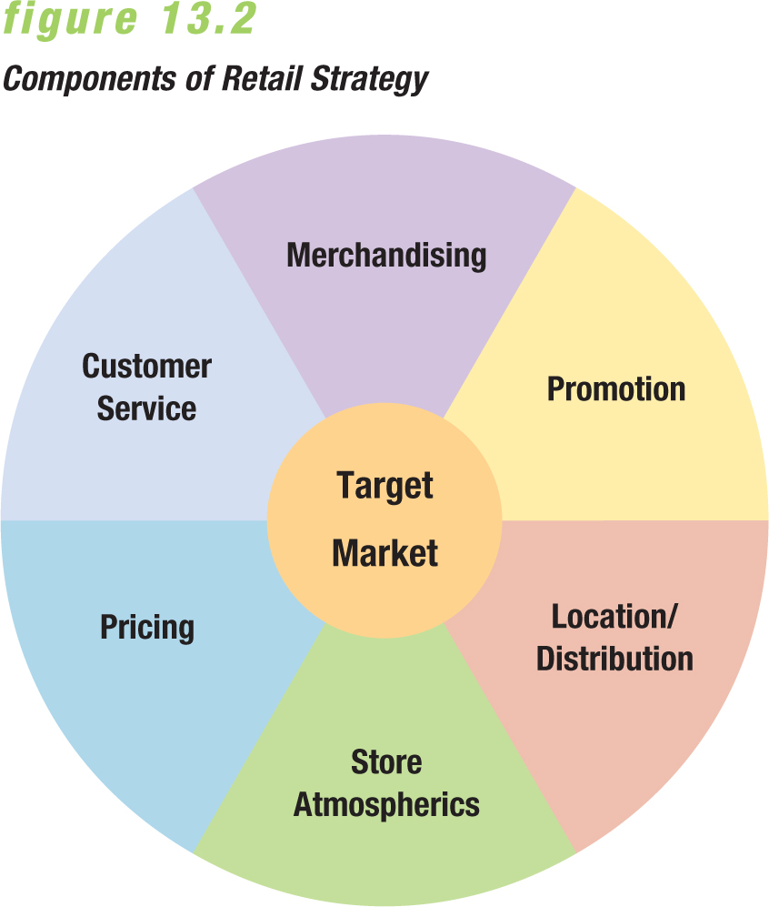
- 2) Develop a retailing mix to satisfy the chosen market

- *Like manufacturers and wholesalers, a retailer develops a marketing strategy based on the firm’s goals and strategic plans. The organization monitors environmental influences and assesses its own strengths and weaknesses in identifying marketing opportunities and constraints.

- Selecting a Target Market Things to consider:
  - Size
  - Profit potential of Market
  - Level of competition
- Ex. Walmart draws customers away from traditional department stores with trendy but affordable lines of clothing.
- =>Retailers pore over demographic, geographic, and psychographic profiles to segment markets. In the end, most retailers identify their target markets by certain demographics.

- Merchandising Strategy: Guides retailer’s decisions on the items it will offer.
  - Needs and preferences of its target market
  - Competitive environment influencing choices
  - Overall profitability of each product line and category

- Category Management: evaluates performance according to each product category. Laundry detergent, skin-care products, and paper goods, for example, are each viewed as individual profit centres, and different category managers supervise each group.
  - Seeks to improve retailer’s product performance through coordinated buying, merchandising, and pricing
  - Category management evaluates performance according to each product category
  - Categories that underperform may be dropped even if they are strong brands

- The Battle for Shelf Space
  - Proliferation of new products and variations on existing ones have increased the competition for shelf space.
  - Stock-keep unit (SKU) offering within a product line such as a specific size of liquid detergent.
- =>Large-scale retailers are increasingly taking on the role of channel captain within many distribution networks. Some have assumed traditional wholesaling functions, while others dictate product design and specifications to manufacturers. The result is a shift in power from the manufacturers of top-selling brands to the retailer that makes them available to customers.
  - Major retailers increasingly make demands from manufacturers such as pricing and promotional concessions in exchange for shelf space
  - Slotting allowance: Nonrefundable fees grocery retailers receive from manufacturers to secure shelf space for new products (as much as $40,000 per item)
    - Other fees include failure fees (imposed if a new product does not meet sales projections), annual renewal fees (a “pay to stay” inducement for retailers to continue carrying brands), trade allowances, discounts on high-volume purchases, survey fees for research done by the retailers, and even fees to allow salespeople to present new items.

- Customer-Service Strategies
  - Heightened customer service is one possible retailing strategy
  - The goal is to attract and retain target customers to increase sales and profits
  - Some services that retailers could provide:
    - Enhanced comfort through lounges, complimentary coffee, convenient restrooms
    - Child-care services for customers
    - Virtual assistance programs

- Pricing Strategy: Prices reflect a retailer’s marketing objectives and policies, they affect consumer perceptions.
  - Ex. Hermes Customers expect to find such expensive merchandise as leather handbags priced at $3275 while customers of Giant Tiger or Winners expect totally different merchandise and prices, and to see new items each time they visit.

- Markup: Amount a retailer adds to the cost of a product to determine selling price, it is influenced by:
  - Inventory turnover rate
  - Services by the retailer
- => Markup’s influence the retailers image among potential clients and customers, its ability to attract shoppers. If markup is to high it may drive customers away but low markup may not generate enough income to cover costs and turn a profit.
- Mark down: Amount by which a retailer reduces the original selling price of a product.

- Location/ Distribution Strategy
  - Type of merchandise
  - Retailer’s financial resources
  - Characteristics of the target market
  - Site availability
- =>Good Life Fitness has approximately 50 of its more than 300 Canadian outlets in Real Canadian Superstore locations. These stores offer high traffic and ample parking, and attract women aged 35 to 50 with high household incomes. Real Canadian Superstore strengthened its position as a one-stop-shop for customers.

- Planned shopping centre: Group retail stores planner, coordinated, and marketed as a unit. There are 5 main types:
  - Neighborhood shopping center: 5-15 stores (serves 5000–50 000 people)
  - Community shopping centre:10–30 stores (serve 20 000 to 100 000 people)
  - Regional shopping centre: some major anchor stores and as many as 200 smaller stores (serves 250 000 people or more)
  - Power centre: usually located near a regional centre, and brings together many stand-alone specialty retailers, such as Costco, Michaels, Pier 1, Rona, etc.
  - Lifestyle centre: seeks to offer a combination of shopping, movie theatres, stages for concerts and live entertainment, decorative fountains and park benches in greenways, and restaurants and bistros in an attractive outdoor environment. Promotional Strategy

- Promotional Strategy:
  - Promotion informs customers about locations, merchandise selections, hours of operation, and prices
  - Helps retailers attract shoppers and build customer loyalty
  - National chains purchase advertising in print and broadcast media

- Salespeople play an important role
  - Selling up: Persuading customers to buy higher priced items than originally intended
  - Suggestion selling: Broadening a customers original purchase by adding related items, special promotions or seasonal products.
- => Poor service can influence costumers attitude about a retailer.

- Atmospherics: combinations of physical characteristics and amenities that contribute to a stores image.
  - Atmospherics includes: exterior and interior décor
    - Exterior should help identify the retailer and attract target market shoppers ex. Red triangle maple leaf Canadian tire
    - Interior should complement retailer’s image, respond to customers’ interests, and induce shoppers to buy.
- Types of Retailer
  - Shopping Effort Expended by Customers
    - Convenience Retailers, Shopping Stores, Specialty Outlets
  - Services provided for Customers
    - Self-Service, Self-Selection, Limited Service, Full Service
  - Product Lines
    - Specialty Retailer, Limited Line Retailer, General Merchandise, Retailer
  - Location of Retail Transactions
    - Retail Stores, Nonstore and Internet Retailing
  - Form of Ownership
    - Corporate Chain, Independent Retailer.

Chain Stores: Groups of retail outlets that operate under central ownership and management and handle the same product lines
  - Volume purchases allow chains to pay lower prices than their rivals must pay

- Convenience retailers- Focus marketing appeals on:
  - Accessible locations
  - Extended store hours
  - Rapid checkout service
  - Adequate parking facilities
    - Examples: Gas stations and dry cleaners

Shopping stores: Offer potential customers the chance to compare pricing, assortment, and quality levels
  - Ex. Furniture stores, clothing outlets
- Specialty retailers: Combine carefully defined product lines, services, and reputations in attempts to persuade consumers to expend considerable effort to shop at their stores
  - Handle only part of a single product line that it stocks in considerable depth or variety
  - Ex. Michaels, fish markets, shoe stores and bakeries
- Classifications include three retail types:
  - Self-service
  - Self-selection
  - Full-service retailers
- Limited-line stores: Offer a large assortment of products within one product line or a few related lines
  - Example: IKEA
- Category killer – Offers huge selections and low prices in single product lines
  - Example: Best Buy
- Variety stores – Offer an extensive range and assortment of low-price merchandise
  - Stores that carry a wide variety of product lines, stocking all of them in some depth
  - Declining in popularity, account for less than 1% of sales.
    - Ex. Giant Tiger
- Department stores – A series of limited-line and specialty stores under one roof
  - Faced intense competition from discount stores, Internet retailers, and hypermarkets
  - Fought back by eliminating poorly performing lines, improving appearance
    - Ex. The Bay
- Mass Merchandisers: Stock a wider line of items than a department store but usually without the same depth of assortment within each line
  - Discount houses: Charge low prices and offer fewer services
  - Off- price retailers: Stock only designer labels or well-known brand-name clothing at prices equal to or below regular wholesale prices and then pass the cost savings along to buyers ex. winners
  - Hypermarkets: Giant one-stop shopping facilities that offer wide selections of grocery and general merchandise products at discount prices
    - Hypermarkets typically fill up 200 000 or more square feet of selling space, about a third larger than most, carry more food items but have not does well in north America only in Europe.
  - Supercenters: Large store, usually smaller than a hypermarket, that combines groceries with discount store merchandise
- =>Most retail transactions occur in stores
- =>Nonstore retailing is used for generating orders for both consumer and B2B marketers

- Retail convergence – Situation in which similar merchandise is available from multiple retail outlets, resulting in the blurring of distinctions between type of retailer and merchandise offered
  - A few years ago, a customer looking for a fashionable coffeepot might have headed straight for Williams-Sonoma now she can get one at Canadian Tire.
- Scrambled merchandising – Retailing practice of combining dissimilar product lines to boost sales volume
  - Drug Mart stores, not only fill prescriptions but also offer cameras, cards, magazines, small appliances, home decor accessories, and even fresh and prepared foods.

- Wholesaler – Channel intermediary that takes title to goods it handles and distributes these goods to retailers, other distributors, or B2B customers

- Wholesaling intermediary – Comprehensive term that describes wholesalers as well as agents and brokers
  - Time utility – Making products available for sale when consumers want to purchase them
  - Place utility – Helping deliver goods and services for purchase at convenient locations
  - Ownership (or possession) utility – Involves smooth exchange of title to the products from producers or intermediaries to final purchasers
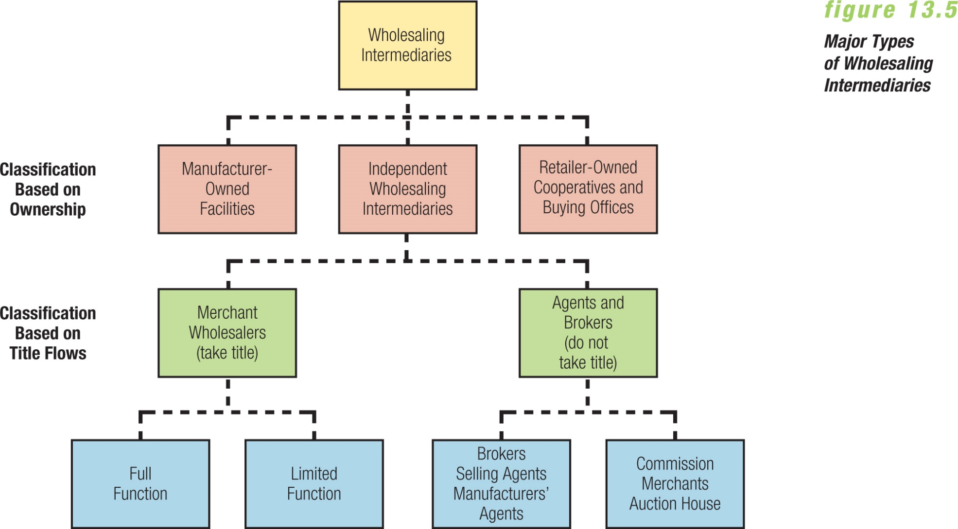
- 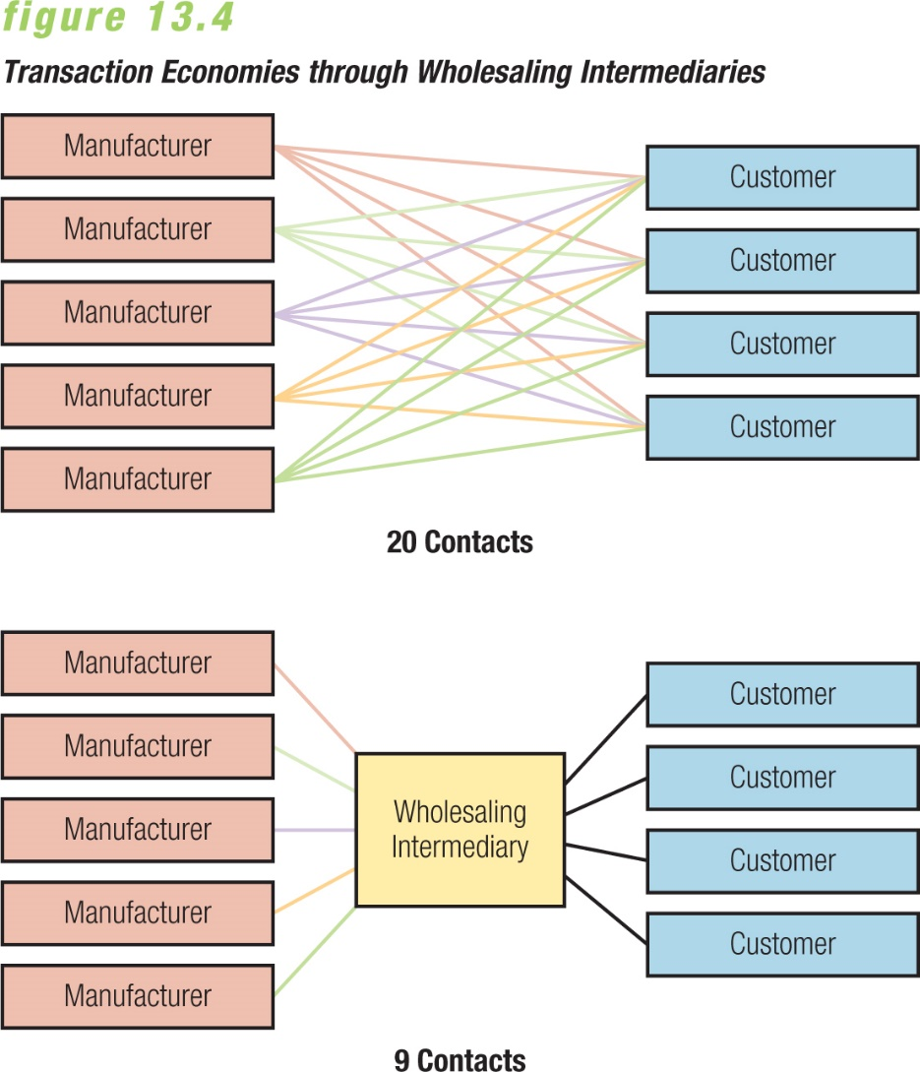
- Direct marketing: Direct communication other than personal sales contact, between buyer and seller, designed to generate sales, information requests or store website visits
  - Ex. best buy vending machines in airprots or Telemarketing
- Direct Mail: Letters, Catalogues, forms they send msgs quickly and can narrow target market, high response rate.

- Direct Selling: Manufacturers sell directly to consumers Ex. Avon, Tupperwar

- Direct-Response Retail: Order merch. By mail or telephone

- Internet Retailing: Sellin online, ex Canadian ties, Costco.

- Automatic Merchandising: vending machines.
  - Approximately 5000 North American vending machine operators sell more than $6 billion in convenience goods annually.

