Product and Services Strategies

The Marketing Mix: Blending of 4 strategy elements (product, distribution, promotion, and price) to fit the needs and preferences of a specific target market.
  - Other variables of the marketing mix—distribution channels, promotional plans, and pricing decisions—must accommodate the product strategy selected.
  - Marketers develop strategies to promote both tangible goods and intangible services.
    - Any strategy begins with investigation, analysis, and selection of a particular target market.
    - It continues with the creation of a marketing mix designed to satisfy that segment.
  - Strategies to promote goods are often quite different from those designed to promote services.

- Product: Bundle of physical, service, and symbolic attributes designed to satisfy customer’s wants and needs.
  - Marketers now recognize that people buy want satisfaction rather than objects.
  - Marketers think of a product as a compilation of package design and labeling, brand name, price, availability, warranty, reputation, image, and customer-service activities.
- Consumer (B2C) product — Product destined for use by ultimate consumers
- Business (B2B) product — Product that contributes directly or indirectly to the output of other products for resale

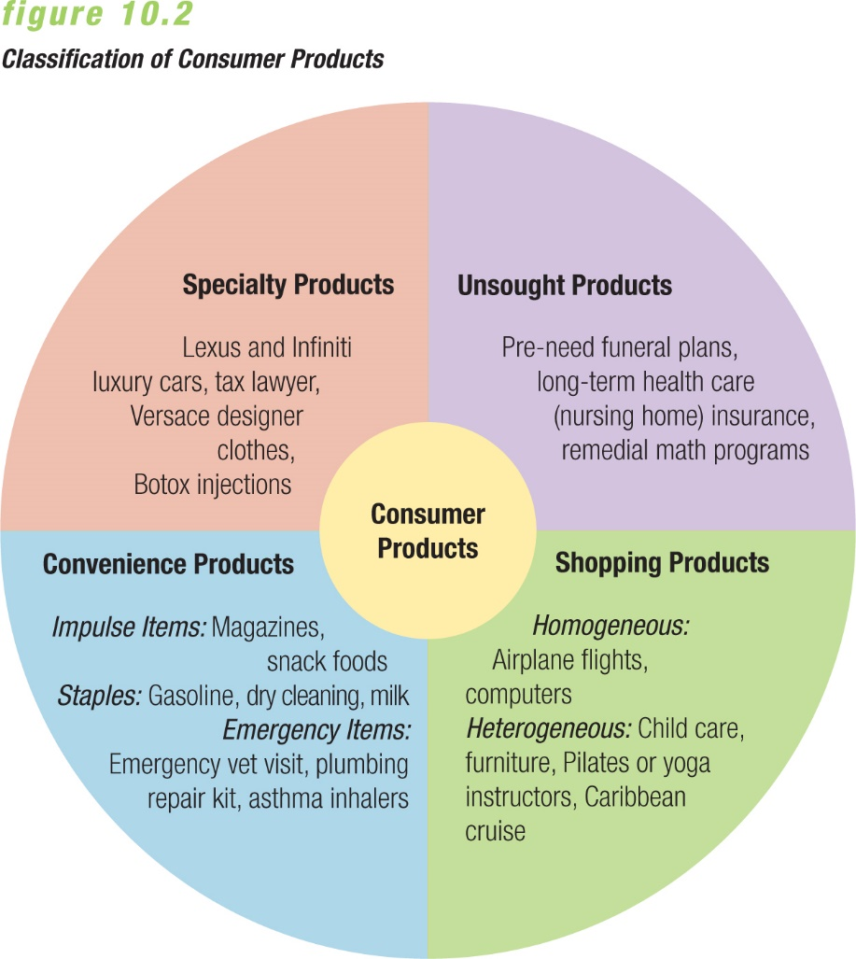
- Types of consumer products:
- One distinction in classifying products focuses on the buyer’s perception of a need for the product as well as his or her buying behavior.
  - Variation in buying behavior is key to distinguish categories.
- A common classification divides consumer goods and services into three groups:
- Convenience products are goods and services that consumers want to purchase frequently, immediately, and with minimal effort.
- =>Marketers further subdivide the convenience category into impulse items, staples, or emergency items.
  - Impulse goods and services are purchased on the spur of the moment; some are now available on certain websites.
  - Staples are bought constantly to replenish and maintain a ready inventory, with many competitors offering these products.
  - Emergency goods and services are bought in response to unexpected and urgent needs, and can be considered an “emergency” depending on the purchaser’s viewpoint.
- Because consumers devote little effort to these purchase decisions, marketers try to make these exchanges as convenient as possible.
  - Store location can boost a product’s visibility.
  - Location within a store, and on a shelf, also makes a difference.
  - Slotting allowances, or slotting fees, are often charged to large firms in exchange for a guaranteed display of their merchandise in the most visible spots on store shelves.
  - The practice of slotting fees has been investigated and it was found that the fees can vary widely.

- Shopping products are purchased only after the consumer compares competing offerings on such characteristics as price, quality, style, and colour.
- Shopping products differ from convenience products in several ways:
  - They’re generally more expensive.
  - The purchaser lacks complete information prior to the buying trip, and gathers it in the process.
  - They often carry warranties and after-sale service terms.
  - A store’s name and reputation have considerable influence on consumer buying behaviour.
  - The personal selling efforts of salespeople provide important promotional support.
- Some shopping products are viewed as homogeneous:
  - To consumers, one brand often seems much like another.
  - Marketers try to differentiate homogeneous products from competing products in terms price and value, quality, appeal, or uniqueness.
- Other shopping products seem heterogeneous:
  - To consumers, basic differences seem to stand out.
  - Differences in features separate competing heterogeneous shopping products in the minds of consumers.
  - Perceptions of style, color, and fit can all affect consumer choices.

- Specialty products offer unique characteristics that cause buyers to prize those particular brands.
  - They carry high prices and many represent well-known brands.
  - Purchasers of specialty goods and services know just what they want—and they are willing to pay for it.
    - Buyers begin shopping with complete information and refuse to accept substitutes.
    - Because consumers are willing to exert the effort to obtain specialty products, producers can promote them through few retail locations.
    - Some firms intentionally limit the range of retailers that will carry their product.
    - Both highly personalized service and image advertising help to promote specialty items.
    - Some specialty products are sold for less through a firm’s company-owned discount outlets or in designated discount areas of their retail stores.

- Unsought products are marketed to consumers who may not yet recognize any need for them. Ex. Pet health insurance.
- Relatively few products fall into this category.

- The Goods-Services Continuum: This spectrum helps marketers visualize the differences and similarities between goods and services.
  - It also clarifies which purchases can be a mixture of both.
    - Example of a pure good would be a car
    - Example of a pure service would be a hair salon
    - Example of a mixture is a restaurant, you pay for the service of the staff and the product of the meal.
- Goods: Tangible products that customers can see hear, smell, taste, or touch.
- Services: Intangible tasks that satisfy the needs of consumer and business users
- =>Most service providers can’t transport or store their products, but instead customers simultaneously buy and consume them.
  - Services are intangible—customers are asked to buy a promise.
  - Services are inseparable from service providers—consumer perception of a service provider becomes their perception of the service itself.
  - Services are perishable—they’re created and consumed at the time of purchase, so providers cannot maintain inventories.
  - Companies cannot easily standardize services—though this is changing as firms attempt to promise certain qualities, amenities, or results.
  - Buyers are part of the development and distribution of services—interactions between buyer and seller are often required at the production and distribution stages.
  - Service standard shows wide variation—the quality and standards can vary greatly among service providers in the same industry.
  - Importance of the service sector
    - We would all live very different lives without service firms to fill many daily needs—the service sector makes a huge contribution to the Canadian economy in terms of both products and jobs.
    - The service sector now makes up roughly 75 percent of the Canadian economy as it continues to shift from a goods-oriented to a service-oriented economy.
    - Services play a crucial role in the international competitiveness of Canadian firms.
  - Reasons for growth in services:
    - Consumer desire for speed and convenience
    - Technological advances that allow firms to fulfill this demand
    - Bigger consumer demand for certain services, including those involving wireless communications, data backup and storage, financial consulting, insurance, even meal preparation
  - Most service firms emphasize marketing for two reasons:
    - The growth potential of service transactions represents a vast marketing opportunity.
    - Increased competition is forcing traditional service industries to differentiate themselves, and providing superior service is one way to develop long-term relationships.
- Classifying consumer services:
  - Like tangible goods, services are also classified based on convenience, shopping, and specialty categories.
  - But several factors are unique to classifying services, and service firms may sell to business markets, consumer markets, or both.
  - Marketers can ask five questions to classify services:
    - What is the nature of the service?
    - What type of relationship does the firm have with its customers?
    - How much flexibility is there for customization and judgment on the part of the provider?
    - Do demand and supply for the service fluctuate?
    - How is the service delivered?
- 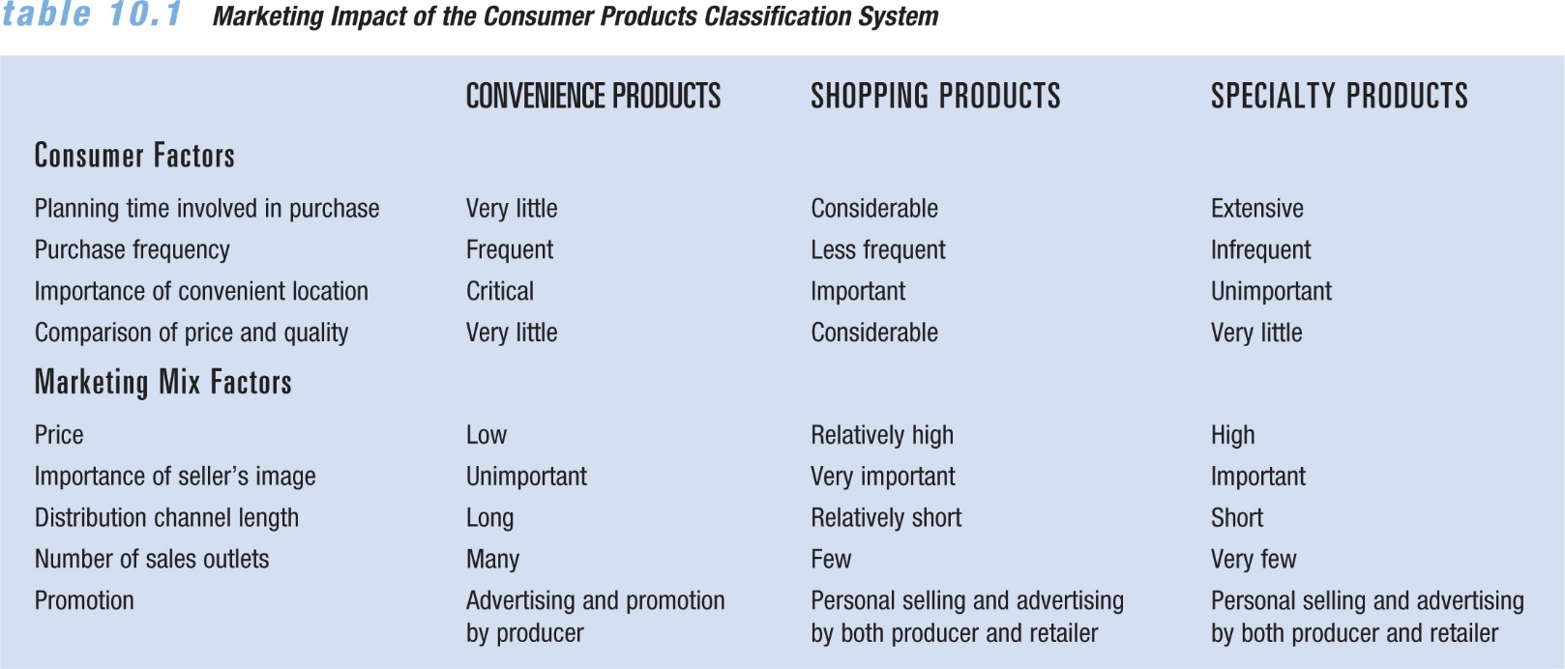
- Applying the consumer products classification system:
  - The three-way classification system (convenience, shopping, or specialty) guides firms in developing a marketing strategy.
  - Buying behaviour patterns differ for the three types of purchases.
  - The classification system poses a few problems:
    - Not all goods and services fit within one of the three categories; some share characteristics of more than one category.
    - Products might be more accurately classified on a continuum, depending on effort spent by consumers—at one end they casually pick up items, at the other end they search extensively for specific products.
    - Consumers differ in their buying patterns, but goods and services are classified based on purchase patterns of the majority of buyers.

- Classification of Business products: Categories emphasize product use rather than consumer busying behavior.
  - Types of business products:
    - Business buyers are professional customers.
    - Their jobs require rational, cost-effective purchase decisions.
    - The classification system for business products focuses on use rather than buying behaviour.
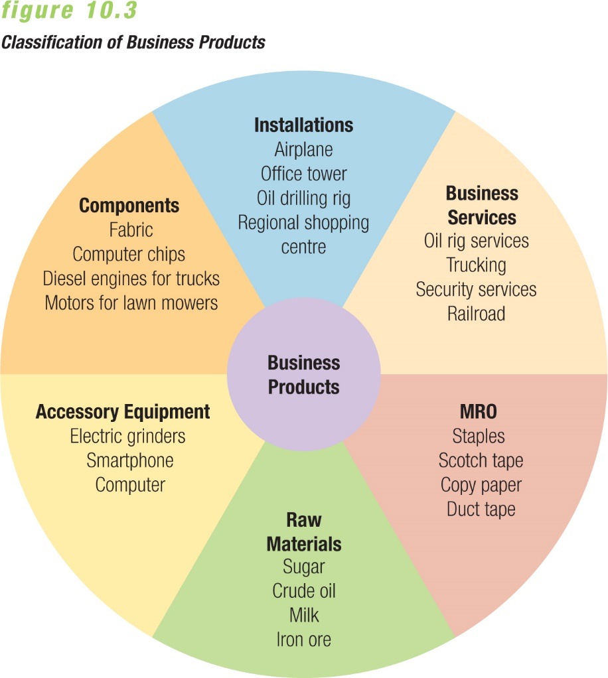
  - Installations are the specialty products of the business market; this classification includes major capital investments.
  - Accessory equipment refers to capital items that cost less and last for shorter periods than installations.
  - Component parts and materials are finished business products of one producer that become part of the final products of another producer.
  - Raw materials resemble component parts and materials in that they become part of the buyers’ final products.
  - Supplies are regular expenses that a firm incurs in its daily operations, and are not part of a final product.
    - Supplies are called MRO items because they fall into three categories: maintenance items, repair items, operating supplies
  - Business services include intangible products that firms buy to facilitate their production and operating processes.
- 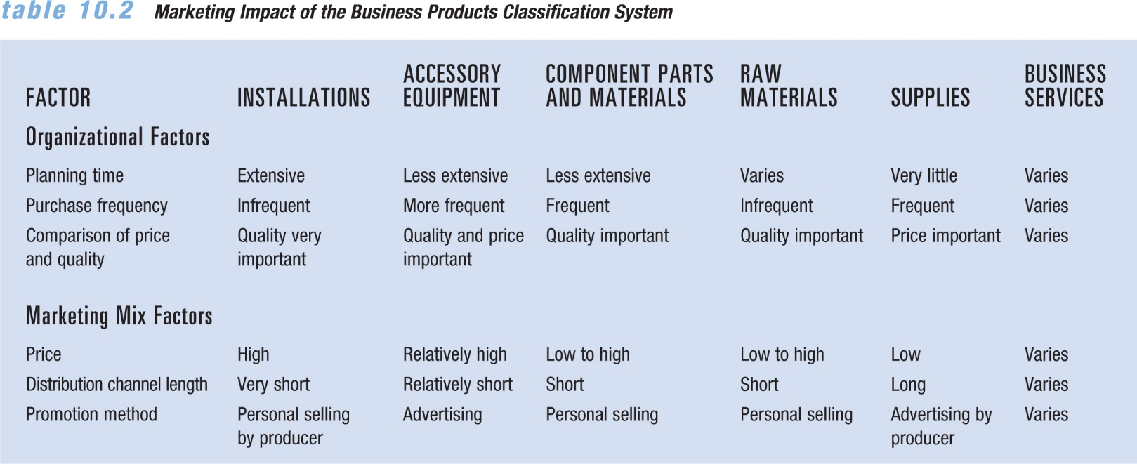
- Quality as a product strategy:
  - Poor quality discovered in a newly purchased item can leave an impression that will lead customers to make different decisions in the future.
  - Poor service quality can also leave bad impressions with consumers.
  - In both ways, quality is the key component to a firm’s success.
  - Total quality management:
    - Total quality management (TQM) expects all of a firm’s employees to continually improve products and work processes with the goal of achieving customer satisfaction and world-class performance.
    - Managers are expected to communicate the goals of total quality to all staff.
    - Many companies solicit reviews or feedback from customers in order to improve their goods and services.
- Worldwide quality programs:
  - The movement toward quality began in the 1920s as an attempt to improve the manufacturing process.
  - During the 1980s the quality revolution picked up speed in North American corporations, at a time when large firms had lost market share to Japanese competitors.
  - Excellence Canada provides advice on quality, organizational assessments, offers education programs, and presents Canada’s awards for excellence.
  - The Malcolm Baldrige National Quality Award is the highest national recognition for quality that a U.S. company can receive.

ISO 9001:2008 standards
    - The quality movement has become strong in European countries, particularly as the EU has adopted strict standards for manufacturing.
    - ISO 9001:2008 standards define international criteria for quality management and quality assurance.
    - They were developed by the International Organization for Standardization (ISO) in Switzerland to ensure consistent quality among products manufactured and sold in the EU.
    - Many European companies require suppliers to have ISO certification as a condition of doing business with them.
    - The Canadian member body of ISO is the Standards Council of Canada.
- Benchmarking is used to set standards in order to achieve superior performance that results in a competitive advantage.
  - Many quality-conscious firms rely on benchmarking to set performance standards.
  - It does this in three ways:
    - Identifying manufacturing or business processes that need improvement
    - Comparing internal processes to those of industry leaders
    - Making changes for quality improvement
  - Analyses required by the benchmarking process:
    - Internal—analyzing the firm’s own activities to determine strengths and weaknesses, and to provide a baseline for comparison
    - External—gathering information to find out why the benchmark partner is perceived as the industry’s best, to provide an objective basis for making improvements
    - A comparison of the results of the analysis provides an objective basis for making improvements

- Quality of services:
  - The buyer’s perception of the quality of a service is usually determined during the service encounter—the point at which the customer and service provider interact.
  - Sales associates, cashiers, and customer service reps have a powerful impact on a customer’s decision to return or not.
  - As the customer talks about an experience during the service encounter, a powerful message is sent about the product.
  - Service quality refers to the expected or perceived value of a service, having a huge effect on the competitiveness of a firm.
  - Service quality is determined by five variables:
    - Tangibles—physical evidence
    - Reliability—consistency of performance and dependability
    - Responsiveness—the willingness and readiness of employees to provide service
    - Assurances—the confidence communicated by the service provider
    - Empathy—the service provider’s efforts to understand the customer’s needs and then individualize the service
  - If a gap exists between the level of service customers expect and the level they think they’ve received, it can be favorable or unfavorable.

- Development of product lines
  - A product line is a series of related products.
  - Few firms market only one product today.
- Motivations for marketing full product lines include:
  - Desire to grow
    - Firms may limit their growth potential by concentrating on a single product, even if they started that way.
    - It’s unlikely that growth will result from selling only one product, so many firms expand their product offerings.
  - Enhancing the company’s position in the market
    - A company with a line of products often makes itself more important to both consumers and marketing intermediaries than a firm with only one product.
    - Business buyers often expect a firm that manufactures a particular product to offer related items as well.
    - The service involved with the variety of products that a firm sells (such as return policies or special programs) can enhance its position in the market.
  - Optimal use of company resources
    - By spreading the costs of operations over a series of products, a firm may reduce the average production and marketing costs for each product.
  - Exploiting the stages of the product life cycle

- The product mix is an assortment of product lines and individual product offerings that the company sells.
  - The right blend of product lines and products allows a firm to maximize sales opportunities within the limitations of its resources.
- Marketers typically measure product mixes according to width, length, and depth.
  - Product mix width: the number of product lines a firm offers
  - Product mix length: the number of different products a firm sells
  - Product mix depth: variations in each product that the firm markets in its mix.
- To evaluate a firm’s product mix, marketers look at the effectiveness of all three elements.

- Product mix decisions:
  - Establishing and managing the product mix has become increasingly important in the world of marketing.
  - Adding depth, length, and width to product mixes requires careful thinking and planning, or the firm ends up with too many products, including some poor sellers.
    - If a firm has ignored a consumer segment, it might increase its depth by offering a new variation.
    - If a firm wants to achieve economies in sales and distribution, it may increase its width by adding a complementary line.
    - If a firm wants to gain equal contributions from all products, it may lengthen or shorten its mix.
    - If it wants to further expand, it may purchase lines from other companies or acquire entire companies through mergers or acquisitions.
  - Line extensions
    - A line extension adds individual offerings that appeal to different market segments while remaining closely related to the existing product line.
    - A firm may assess its current product mix in order to determine the feasibility of a line extension.
  - The marketing environment also plays a role in a marketer’s evaluation of a firm’s product mix.
  - Careful evaluation of product mix can help in making decisions about brand management and new-product introductions.

- The product life cycle
  - Products pass through stages as they age, and this progression is referred to as the product life cycle.
  - Successful products pass through four basic stages: introduction, growth, maturity, and decline.
  - The concept applies to products or product categories (watches, digital cameras) within an industry, not to individual brands (Timex watch, Canon digital camera).
  - There is no set time frame for a life cycle stage—some products pass rapidly through certain stages, others move more slowly.
- The stages of the product life cycle:
  - Introductory stage—Product is launched.
    - Firm works to stimulate demand for the new market entry.
    - It could be a totally new product or an innovative offering bringing new technical features to an existing category.
  - Growth stage—Sales rise, firm begins to make profit, competitors enter.
    - Sales volume rises rapidly.
    - New customers make purchases and early buyers make repurchases.
  - Maturity stage—Sales reach a plateau, many competitors attempt to differentiate products.
    - Sales of a product category continue to grow during the early part of this stage, but eventually sales reach a plateau as the backlog of potential customers dwindles.
    - By this time, many competitors are in the market.
  - Decline stage—Sales fall dramatically, most firms drop the item from their product lines.
    - Innovations or shifts in consumer preferences bring about an absolute decline in industry sales.

- Product life cycles differ from fad cycles.
  - Fashions refer to currently popular products that tend to follow recurring life cycles.
  - Fads are products with abbreviated life cycles, those that experience a brief popularity and then quickly fade.
  - Fads tend to be short-lived, but some do manage to hold onto residual markets among certain segments.
- Both fashions and fads profoundly influence marketing strategies across industries.

- Extending the product life cycle:
  - Firms usually want to extend product life cycles for as long as possible.
  - Product life cycles can stretch indefinitely as a result of certain marketing decisions.
- Increasing frequency of use:
  - The focus is on getting current users to purchase more often.
- Increasing the number of users:
  - The focus is on attracting new customers who previously have not used the product.
- Finding new uses:
  - The focus is on searching for other ways that a product can be used.
- Changing package sizes, labels, or product quality:
  - The focus is on introducing physical changes to the look or content of a firm’s offering.

- Product deletion decisions:
  - Marketers must sometimes prune product lines and eliminate marginal products.
  - This is done to avoid wasting a firm’s resources in the promotion of unpromising items.
  - This decision is typically faced during the late maturity and early decline stages of the product life cycle.
  - Periodic reviews of weak products can justify eliminating or retaining them.
  - A firm may continue to carry an unprofitable item in order to provide a complete line for its customers.
  - Shortages of raw materials sometimes prompt companies to discontinue production and marketing of previously profitable items.
  - A firm may even drop a profitable item that no longer fits the product line or the direction taken by the firm.

