- Chapter 9: Market Segmentation, Targeting, and Positioning

- Market: composed of people with sufficient purchasing power, authority, and willingness to buy. Many markets include consumers with different lifestyles, backgrounds, and income levels.

- Consumer products are bought by ultimate consumers for their personal use (smartphones, grocery products, beauty products).

- Business products are goods and services purchased for use either directly or indirectly in the production of other goods and services for resale (rubber for tires, cotton for cloth).

- Market segmentation is the division of the total market into smaller, relatively homogeneous groups, practiced by both profit-oriented and not-for-profit organizations.
  - In today’s business world there are too many variables in consumer needs, preferences, and purchase power to attract all consumers with a single marketing mix.
  - Meeting the needs of different market segments can be obtained through several options:
    - Change the product itself
    - Identify the factors that affect purchase decisions and then group consumers according to the presence or absence of these factors
    - Adjust marketing strategies to meet the needs of each group
- •Savvy marketers look toward segments that show growth (such as the aging baby boomer population).

- The four basic requirements for effective segmentation:

1)First, market segments must present measurable purchasing power and size.

2)Second, market segments must be served and reached effectively through promotion.

3)Third, segments must be large enough to give them good profit potential need to be identified.

4)Fourth, segments that match a firm’s marketing capabilities must be identified (and at times limited to only a certain niche rather than spreading into too many small markets).

- Geographic segmentation divides an overall market into homogeneous groups based on location. (Population,job growth/income, migration pattern)
  - Core Regions: Many major brands get 40 to 80 percent of their sales from certain areas
  - Census metropolitan area (CMA) refers to a geographic area surrounding an urban core with a population of at least 100 000.
  - Census agglomeration (MSA) is the same as a CMA but with a population of over 10 000.
- => Geographic Information Systems (GIS) assembles, stores, manipulates, and displays data by location

- Demographic segmentation defines consumer groups according to their personal traits such as gender, age, income, occupation, education, sexual orientation, household size, and stage in family life cycle.
  - It’s the most common method of market segmentation.
  - This approach is also called socioeconomic segmentation.
  - The primary source of demographic data in Canada is Statistics Canada.
  - While demographic data is helpful, it can also lead to stereotyping which can alienate or totally miss a potential market.
- *Gender is the most obvious variable but can be tricky as lines continue to blur, however most marketing is directed towards women.

- Age Segmentation
- School-age children, and even those younger, have great influence over family purchases, particularly regarding food, and recent trends toward child obesity have led to more products that stress nutrition.
- Tweens (preteens) and teens are a rapidly growing market. This group influences purchases of food, clothing and technology.
- Generation X, those born 1966-1981, tend to be well-educated, optimistic, and technologically savvy, defining themselves less by careers than previous generations.
- Baby boomers, those born 1947-1965, are a huge group, influenced by early television and the Vietnam War. This group tends to focus on careers; they value health and quality of life.
- Seniors, those over age 65, tend to have high discretionary incomes and rates of home ownership, are healthier, living longer, are more active, and often have more money to spend than previous generations.

  - The cohort effect is a sociological concept referring to the way members of a generation are influenced and bound together by significant events occurring during their key formative years (roughly age 17 to 22).
  - These events help define core values of the group that eventually shape consumer preferences and behaviour.
  - Seniors were defined by the Great Depression and WWII; baby boomers by the Vietnam War and the civil rights movement; those who were roughly age 17 to 22 on September 11, 2001, have now been defined as the Video Game Generation.
  - In order to reach them, marketers need to understand basic characteristics of various age groups as they respond to life-defining events.
  - Common age categories include school-age children, tweens and teens, generation X, baby boomers, and seniors.

- Segmenting by ethnic group:
- •According to Statistics Canada, Canada’s ethnic makeup is constantly changing.
- •The three largest groups are Chinese, South Asians, and Blacks.
- •Chinese Canadians mostly live in Vancouver and Toronto; prefer promotional material in their own language.
- •South-Asian Canadians are the largest cultural group in Ontario.
- •Black Canadians come from Africa or the Caribbean.
- •Other ethnic groups include the Hispanic/Latino group.

- Segmenting by family life cycle stages:
- •Family life cycle is the process of family formation and dissolution.
- •Primary determinant of many consumer purchases.
- •As people move from one stage to another, their preferences and buying habits change ie. single, newly married, young parents, empty nesters, or retired.
- •Trends seen in family life cycles include “boomerangs” (grown children returning to live with parents) and grandparents who care for grandchildren regularly.

- Segmenting by household type
- •The average number of people per household has fallen to 2.5 people recently.
- •This is due in part to lower fertility rates, postponed marriages, frequent divorces, and the ability and desire to live alone.
- •Today’s households are widely diverse regarding relationships among members, marital status or lack of it, children or no children, same-sex households both with or without children, and people living alone.

- Segmenting by income and expenditure patterns:
- •Income is a common basis for segmentation, since the term “market” refers to people with purchasing power.
- •Marketers often target geographic areas known for the high incomes of their residents.
- •Engel’s laws, established over 100 years ago, consist of three statements regarding impact of household income on consumer spending behaviour.
  - First, the percentage of expenditures for food drops.
  - Second, the percentage spent on housing, household operations, and clothing remains constant.
  - Third, the percentage spent on other items—such as education and recreation—increases.
- •Researchers believe Engel’s laws are still valid today with a few exceptions (expenditures for household goods, clothing, and medical or personal care).

- =>These laws can help marketers target markets at all income levels; for instance, regardless of economic environment, consumers still buy luxury goods and services because they’re offered at varying price levels.

- Psychographic segmentation
- Psychographic segmentation divides a population into groups that have similar psychological characteristics, values, and lifestyles.
- •Lifestyle refers to a person’s mode of living or daily operations.
- •Psychographic profiles are created through extensive surveys that ask consumers to agree or disagree with a collection of AIO statements (describing activities, interests, and opinions).
- •Many businesses turn to psychographic research to learn what consumers want and need.

- VALS
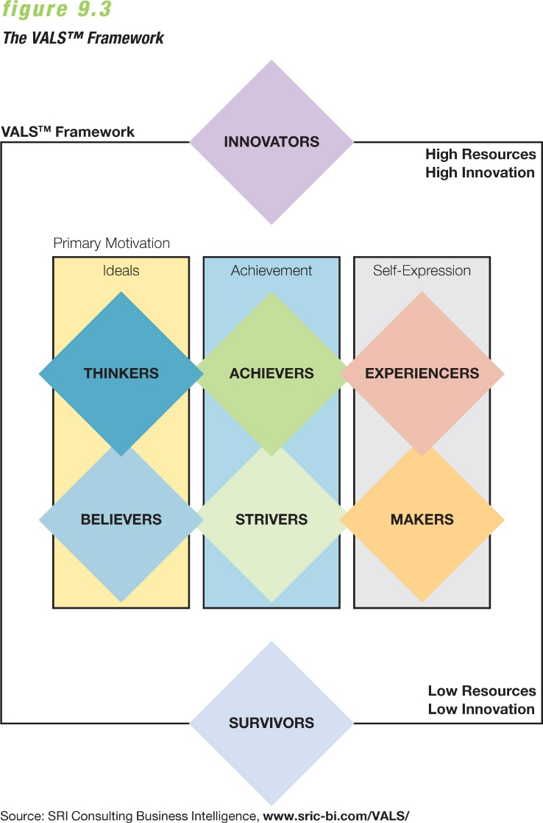
- •VALS (values and lifestyle), created by SRI International, is a psychographic segmentation system that categorizes consumers based on social values.
- •SRI Consulting Business Intelligence (SRIC-BI), a spin-off of SRI, revised the system that links buying behaviour with two concepts: resources and innovation.
- •It divides consumers into eight psychographic categories with profiles for each: innovators, survivors, thinkers, believers, achievers, strivers, experiencers, and makers (see chart for details).
- •The resource dimension weighs income, education, self-confidence, health, eagerness to buy, and energy level.
- •The innovation dimension divides consumers into three groups: principle-oriented consumers who live by ideals or morals; achievement-oriented consumers who are influenced by symbols of success; and action-oriented consumers who seek activity, variety, and adventure.
- •SRI has created other systems, estimating each VALS type in certain foreign nations.
- •A similar tool, Canada’s Social Value Tribes, groups people according to political views, religious affiliations, and social attitudes.

- Psychographic segmentation of global markets:
- Similar to JapanVALS, a list of six psychographic consumer segments said to exist in 35 nations was created by research firm RoperASW:
- •Strivers, the largest segment, value professional and material goals (most common in developed Asia and Russia; slightly more likely to be male than female).
- •Devouts value duty and tradition (most common in Africa, the Middle East, and developing Asia; more female than male).
- •Altruists emphasize social issues and societal well-being (most common in Latin America and Russia, with a significant number of Chinese young adults; slightly more female than male).
- •Intimates value family and personal relationships (most common in North America and Western Europe, equally male and female).
- •Fun seekers focus on personal enjoyment and pleasurable experiences (most common in developed Asia, more male than female).
- •Creatives, the smallest segment, seek education, technology, and knowledge (most common in Latin America and Western Europe, also in some Chinese young adults, equally male and female).

- Using psychographic segmentation:
- •Psychographic segmentation is not meant to be an exact science.
- •Its profile systems can paint pictures of the overall psychological motivation of consumers, producing rich and detailed descriptions of potential target markets.
- •Identifying which psychographic segments are most prevalent in certain markets helps marketers plan and promote more effectively.
- •Psychographic studies are good supplements to segmentation by demographic or geographic variables, as they refine the broad picture and depict more elaborate lifestyle profiles.

- Product-related segmentation:
- •Product-related segmentation involves dividing a consumer population into homogeneous groups based on their relationship to the product.
- •These divisions can be based on several elements:
- •The benefits that people seek when they buy a product
- •Usage rates for a product
- •Consumers’ brand loyalty toward a product

- Segmenting by benefits sought:
- •The “benefits sought” approach focuses on the attributes that people seek in a good or service and the benefits they expect to receive.
- •Consumers are grouped into segments based on what they want a product to do for them.
- •This can extend beyond the product’s purpose to the experience they have, the way it makes them feel, or what they believe it does.
- •Two people may buy the same product for very different reasons.

- Segmenting by usage rates:
- •The “usage rates” approach focuses on the amounts of a product that people buy and use.
- •Markets are often divided into heavy-user, moderate-user, and light-user segments.
  - The 80/20 principle says that a big part of a product’s revenues—roughly 80 percent—can come from a small, loyal group of people—20 percent of all customers.
  - Also called Praedo’s Law, it holds that relatively few users account for much consumption, even if the percentages aren’t exact.
- •Marketers may set goals to target heavy, moderate, or light users, as well as nonusers.
- =>Usage rates can be linked to other methods such as demographic and psychographic segmentation.

- Segmenting by brand loyalty:
- •The “brand loyalty” approach focuses on how strongly and how loyal consumers feel toward a product.
- •Firms may offer frequent-purchase programs or attempt to develop brand loyalty over time through consumers’ stages of life.
- •Consumers can become loyal to seemingly similar brands for very different reasons.

- The market segmentation process:
  - There are two methods:
    - A management-driven segmentation
    - A market-driven method segmentation
- Stage 1: Develop a relevant profile for each segment.
  - Identifying promising segments, then understanding the customers in each one
- Stage 2: Forecast market potential.
  - Using market segmentation and market opportunity analysis to produce a forecast of market potential within each segment
- Stage 3: Forecast probable market share.
  - Analyzing competitors’ positions in targeted segments
- Stage 4: Select specific market segments.
  - Using the accumulated analysis and forecasts to weigh the potential for reaching company goals and to justify committing resources to developing one or more segments

- Strategies for reaching target markets:

- Undifferentiated marketing
  - In undifferentiated marketing, also called mass marketing, a firm produces only one product or product line and promotes it to all customers with a single marketing mix.
- Differentiated marketing
  - In differentiated marketing, a firm promotes numerous products with differing marketing mixes designed to satisfy smaller segments.
- Concentrated marketing
  - In concentrated marketing, or niche marketing, a firm focuses its efforts on satisfying only one market segment.
- Micromarketing
  - In micromarketing, a firm targets potential customers at a very basic level (such as by postal code, specific occupation, or lifestyle).

- The basic determinants of a market-specific strategy are:

- Company resources—a firm with limited resources may have to choose a concentrated strategy
- Product homogeneity—a firm selling items perceived by consumers as relatively homogeneous may benefit from an undifferentiated strategy
- Stage in the product life cycle—a firm whose product changes over time may shift from undifferentiated to narrower strategies
- Competitor’s strategies—A firm may see obstacles to undifferentiated marketing if the competition cultivates many smaller markets
- *No strategy is a single best choice for all situations

- Positioning:
- •Positioning seeks to put a product in a certain place in the minds of prospective buyers.
- •It is used to distinguish a firm’s offerings from those of competitors and to create promotions that communicate this desired placement.
- •Positioning a product may be based on the following categories:
  - Attributes, Price/quality, Competitors, Application, Product user, Product class
- •Reasons for positioning a product:
  - To emphasize a product’s unique advantages
  - To differentiate it from competitors’ options
- •A positioning map is a tool that graphically illustrates consumers’ perceptions of competing products within an industry by presenting two characteristics (such as price and quality) to show differing views of a product, service, or retailer.

- Repositioning:
- •Repositioning refers to changing the position a product holds in the minds of prospective buyers relative to the positions of competing products.
- •Changes in the competitive environment may force marketers to reposition their products.

