Introduction to Pharmacology
- Pharmacology: The study of drugs and their interactions with living systems
-study of the physical and chemical properties of drugs
-their biochemical properties of drugs
-their biochemical and physiologic effects
-knowledge of the history, sources and uses of drugs
-drug absorption, distribution, metabolism, and excretion
-limited to info that is clinically relevant

Pharmacology is very multidisciplinary
-studies the physical/chemical properties of drugs (Chemistry)
-studies the effects of drugs on a body’s organ systems (Physiology, Anatomy)
-studies the molecular composition of a drug and the body’s effect on drug structure (Biochemistry)
-studies the effects of a drug on human behaviours (Psychology)

Clinical Pharmacology: the study of drugs in humans, in patients as well as in healthy volunteers( during new drug development)

pharmacology is very multidisiplinary (chemistry, physiology, anatomy, psychology, biochemistry) *get from slides

- Drug names
-we study the generic name
1)Chemical name
2)Generic Name
3)Trade/brand name

- Pharmacology informs all aspects of clinical drug use
-How drugs produce therapeutic and adverse effects
-reasons for giving a particular drug to a particular pt
-Rationale for selection of dosage, route, and schedule of administration
-strategies to promote beneficial drug effects
-strategies to minimize undesired effects
-provide drug-related pt education

- Properties of an Ideal Drug
The Ideal drug does not exist
- Effectiveness: elicits response(s) for which it is given
- Safety: minimal harmful effects (ideally none)
- Selectivity: elicits only response for which drug given

- Reversibility: action subsides appropriately
- Predictability: know how pt will respond
- Ease of administration
- Freedom from drug/drug interactions (DDis)
- Low cost
- Chemical Stability: stored or in solution
- Simple generic name: for effective communication

- Individual Variation in Drug Response
-No 2 pt’s will respond identically tom same drug regimen
-most tailor drug therapy to individual
->drug/drug interactions
->physiologic variables (age, gender, weight)
->pathologic variables (especially diminished liver/kidney functionreduced elimination)
->Genetic factors alter drug metabolism unique drug reactions

- Factors Determine Drug Response
Prescribed dose Administered dose Concentration at sites of action Intensity of responses

-errors can happen between these; influencing the final response
-ie: medication errors and patient adherence
-administer to conc. Pharmacokinetics; sources of ind. Variation
***look in note***

Pharmacology In Nursing Practice
- Nursing responsibilities regarding drugs
-The 5 rights of drug administration
1) Drug
2) Patient
3) Dose
4) Route
5) Time
6) Documentation; important for drug/drug interactions, liability etc.

The 5 rights; Very important but not enough
-much more is required to achieve therapeutic objective; maximum benefit/ minimum harm
-important events take place after medication administered
-your responsibility does not end after the drug has been administered
-a broad base of pharmacologic knowledge is needed to fully achieve the therapeutic objective

- Why Should nursing students learn about drugs?
-You must understand:
1) the pt and the disorder
2) what medications are appropriate
3) what drugs are contraindicated (Cant give drug to pt. because some risk- due to
interactions or state of pt, ie pregnant)
- examples: birth control and antibiotics (bc dosage cant be verified), pregnancy; drugs can cause birth defects, children often bc dont have mature systems
4) probable interactions between drug and pt

- Checks and Balances in Drug Administration; last line of defense
-Because the nurse actually administers drugs, they are the last person to check medications before they are given
-Nurses are the pt’s last line of defense against medication errors

- Application of Pharmacology in Patient Care
- Pre-administration Assessment
- Dosage and Administration
- Evaluating and promoting therapeutic effects
- Minimizing adverse drug reactions (ADR’s)
- Minimize drug/drug interactions (DDis)
- Making PRN decisions
- Managing toxicity

Pharmacokinetics
- The principles of ADME; what the body does to the drug
Adsorption
-how drug gets into blood?
Distribution
-how does it get transported?
Metabolism(biotransformation)
-how is it broken down?
Excretion
-how does it leave?
- Pharmacokinetics; a drugs movement throughout the body
-Pharmakon (greek for drug/poison) + kinesis (motion).
-Determines ability of drug to act and duration of action .
Four Phases “AD ME”
1) Adsorption
-movement of drug from site of administration into blood
-may require crossage of membranes (to enter blood from site of administration or to leave vascular system and enter site of action)
2) Distribution
-moving drug from blood into organ/cells
3) Metabolism (Biotransformation)
-enzymatically mediated alteration of drug structure, typically to make it more polar
4) Excretion
-movement of drugs and metabolites out of body

Knowledge of pharmacokinetics helps choose most effective route, dosage and schedule that:
- Achieve concentrations high enough to elicit desired response
- Avoid concentrations that are too high to cause toxicity

- 1) Adsorption: Routes of administration
-Movement of a drug into the bloodstream is dependent upon the route of administration

Route | Barriers to Adsorption | Adsorption Pattern | Advantages | Disadvantages
Parenteral (away from digestive system)
Intravenous (IV) | None | Instantaneous | -Rapid onset  -Precise control  -Large fluid volumes OK  -Irritant drugs OK | -irreversible  -Expensive  -Inconvenient  -Difficult  -Potential for Injury  -fluid overload, infection risks  -Embolism possible  -drug must be H20 soluble
Intramuscular (IM) | Capillary wall (easy to pass) | -Rapid with H20 soluble drugs  -otherwise slow | -Poorly soluble drugs OK  -Depot preparations can be used | First 6 of IV
Subcutaneous (SubQ) | II | II | II | II
Enteral (into digestive system)
Oral (PO) | Epithelial lining of GI tract + capillary wall | Slow, Variable | -Easy  -Convenient  -Inexpensive  -Ideal for self-Rx  -Potentially reversible | -Variability  -Stomach Inactivation  -Nausea and vomiting potential  -conscious and cooperative pt needed

- 2)Distribution
-Distribution of a drug after adsorption into bloodstream is not necessarily uniform. Certain barriers can affect drug distribution
- The Blood-Brain Barrier
-tight junctions in the walls of CNS capillaries prevent drugs from leaving the blood and reaching the brain. Absent in other capillary systems
-only drugs that are: can cross the BBB
a) lipid soluble or
b) have a transport system
Distribution: Placental Blood Transfer
- The membranes of the placenta, which separate the maternal circulation from the fetal circulation, do NOT constitute an absolute barrier to the passage of drugs
- Drugs that have the ability to cross the placenta can sometimes cause serious harm
- Some compounds can cause birth defects, ranging from low birth weight to mental retardation to gross malformations,
- eg. Cigarette constituents, heroin, thalidominde (drug given for morning sickness)
Distribution: Protein Binding (Albumin)
- Drugs bind reversibly with various blood proteins, most importantly; Albumin
- Albumin is a large molecule (molecular weight of 69,000 – most durgs are <500) and always remains within the blood stream
- Drugs bound to Albumin cannot reach their sites of action; drugs are given at a higher dose if they bind to albumin to make sure they reach site of action

- 3) Drug Metabolism
-Therapeutic consequences of drug metabolism
- Liver
- Convert pharmacologically active compounds to inactive forms
- Activate prodrugs ie. Pharmacologically inactive -> active forms (eg the anticancer drug tamoxifen)!! (drug)
- Increase therapeutic action of some drugs (eg. Codeine morphine)
- Decrease toxicity, usually
  - Sometimes can increase toxicity. Eg. Conversion of acetaminophen (drug) into a hepatotoxic substance. Significant in overdose

  - Kidney
    - Accelerate kidney excretion of lipid-soluble drugs, by converting them into water-soluble compounds

Metabolism: Special Considerations
- Age
  - Infants (immature liver) and elderly (reduced liver/kidney function) need drug dosage (or choice) adjustments
- Nutritional Status
  - Drug-metabolism requires a number of co-factors
  - May be absent in malnourished pt compromised drug metabolism
- First-pass effect
  - Rapid hepatic inactivation of an oral drug
  - Drug adsorbed from GI tract, carried directly to liver; when drug reaches liver for 1st time, its going to be inactivated, amount available can be decreased dramatically
  - Therapeutic effects lost
  - Drugs with strong first-pass effect must be administered parenterally (IV/IM/SQ)
  - For Iv injections, it can reach site of action before liver, so there is no first-pass effect
  - Increase dose to help solve issue
- Drug-metabolizing enzymes in liver
  - Hepatic microsomal enzymes (cytochrome p450/CYP450 system)
  - Most important: CYP1, CYP2, and CYP3
  - Each has multiple drug-specific isoenzymes (ie. CYP1A2, CYP2D6, CYP3A4)
  - Responsible for about 75% of all drug metabolism (3A4 is most prevalent)

A drug may be:
- Enzyme Substrate: metabolized by an isoenzyme
- Enzyme Inducer: increase rates of metabolism of a substrate drug
- Enzyme Inhibitor: decrease rates of metabolism of a substrate drug
- Some drugs are designed to take advantage of this (pro-drugs that are activated by CYP450 metabolism (ie. Phenytoin )!! (drug example)
-give prodrug orally, when it reaches site of action its activated, its not if you give it IV
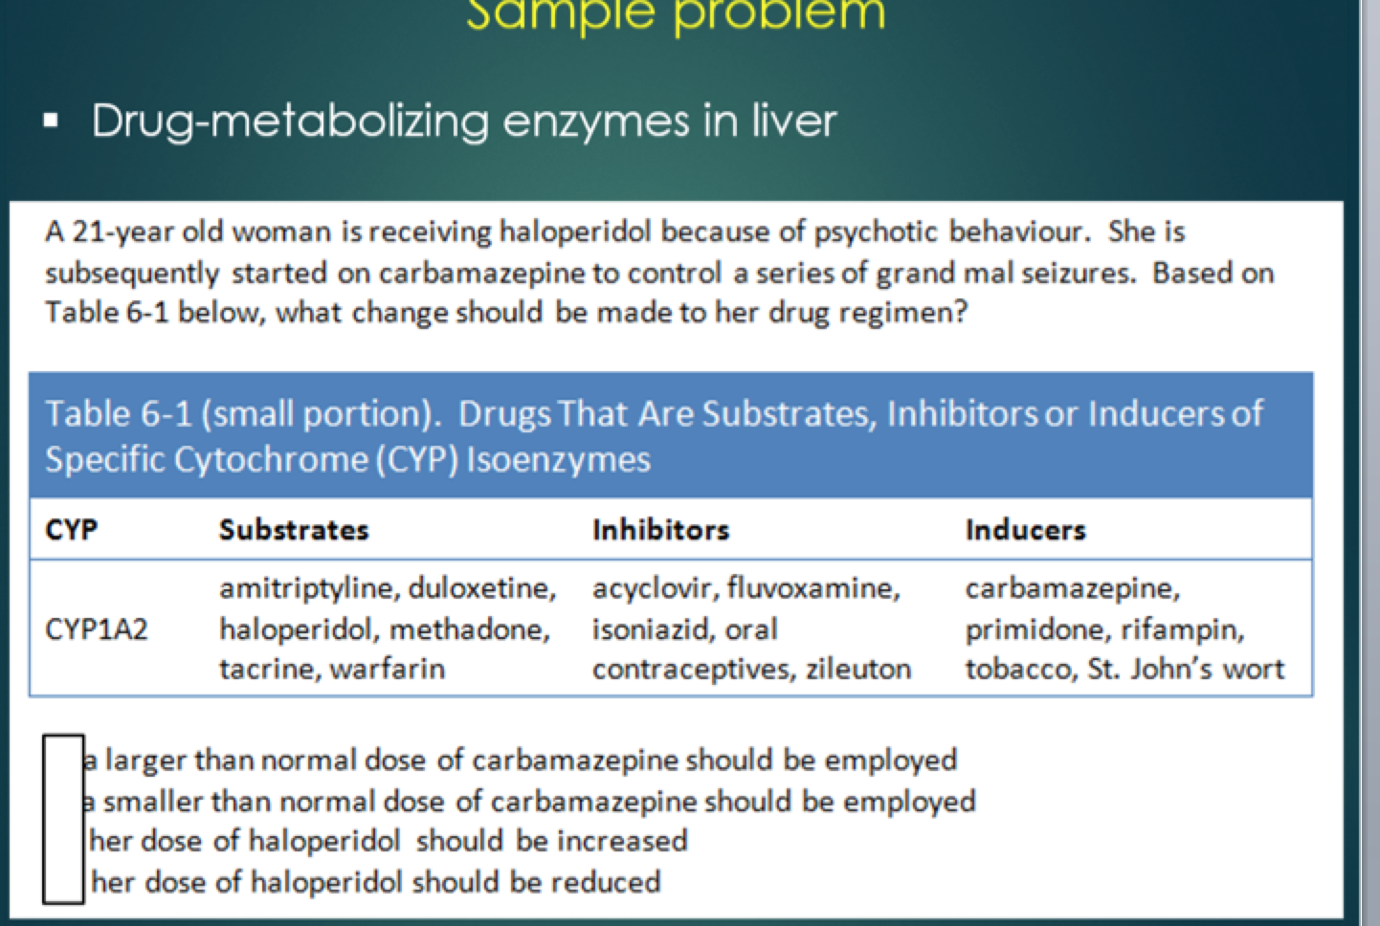answer: C
- 4)Drug Excretion
- Bile: secreted by liver into small intestine and then leaves body in the feces
    - If liver failure occurs, both the duration and intensity of drug responses may increase

  - Urine: Kidney is major organ of drug excretion
    - If renal failure occurs, both the duration and intensity of drug responses may increase
  - Breast milk: breast-feeding can expose the nursing infant to drugs
  - Exhaled air: Lungs major route for volatile anesthetics
  - Sweat and Saliva and hair: minor;

- Time Course of Drug Reponses
-Plasma Drug levels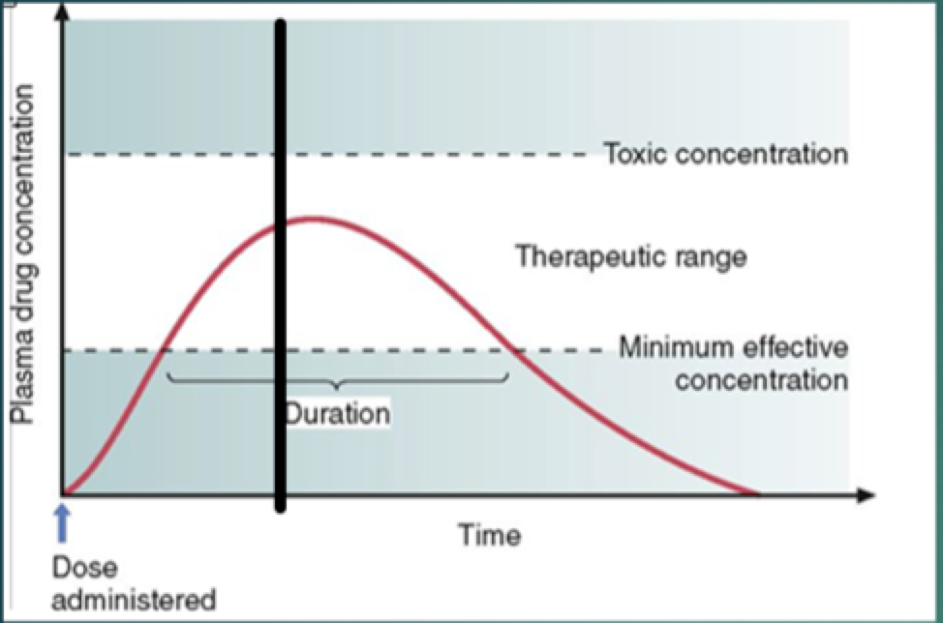
(know what graphs for diffent types of drugs would look like, ie IV drugs dont have period of absorption, just starts at distribution
-IM and subcutanous, shorter period of absoprtion than oral)

-Minimum effective Concentration (MEC): plasma drug level below which therapeutic effects will not occur
-Therapeutic range of a drug lies between the MEC and the toxic concentration
-Drugs with a wide therapeutic range are relatively easy to use safely
-Drugs with a narrow therapeutic range (ie. Digoxin) require careful monitoring
-used for heart failure, drugs with narrow range can be used /are usu. Used in hospital setting

- Time Course of drug responses
- Drug half-life
- Time required for the amount of drug in the body to decline by 50%
- Drugs with a short half-life must be administered more frequently than drugs with a long half-life
- When drug administration is discontinued most of the drug will be eliminated over 5 half lives (he says 4 or 5, because at time of 5th theres like none)

- Repeated dosing and drug accumulation
- Drugs often need repeated doses (chronic administration)
- Results In drug accumulation
- Plateau when amount of drug eliminated (metabolized/excreted) equals the amount administered
- For a consistent dose/interval this will be about four-five half lives
- Loading dose: large initial dose used to achieve immediate therapeutic effect when time to plateau is too lone
- Maintenance dose: smaller doses given after loading dose to maintain drug conc. In the therapeutic range (equivalent to amount of drug lost since last administration)

- Pharmacodynamics: what drug does to the body
(vs. pharmacokinetics; what body does to the drug)

Dose-Response Relationship: relationship between dosage and intensity of the response produced
Determines:
-minimum amount of drug
-maximum response
-how much to increase dosage to produce desired increase in response

- Measures of what a drug does to the body: Efficacy vs. Potency
Maximal efficacy: largest effect drug can produce
Potency: amount of drug needed to produce a given effect

-Meperidine has greater efficacy than pentazocine: more pain relief
-Morphine more potent than meperidine: can be used in lower dose
-for moderate pain relief (below green line) meperidine also has greater potency than
pentazocine: lower dose same pain relief

-potency of a drug implies nothing about its maximal efficacy!
-drugs potency much less clinically relevant than its efficacy

Drug-Receptor Interactions
Receptors activated by binding with ligands
- Endogenous compounds: naturally occurring within body (nt, hormones)
- Drugs: not normally found in body but if introduced will affect receptors
-Receptor: huge protein molecule, 100x larger than ligands

-NT norepinephrine (NE), NE binds to receptors on heart
-rate and force of cardiac contractions increase
-cardiac output increases

-when a drug binds to a receptor, it either mimics or blocks the actions of endogenous regulatory molecules
-Drug will either increase or decrease the rate of the physiologic activity normally controlled by the receptor

Receptors: Selectivity of Drug Action
- The more selective a drug is (ie. Only interacting with its target receptor and few, if any others) the less side effects it will have
- The body employs many different kinds of receptors, each regulating just a few physiologic processes
- How can a drug interact with just one receptor type?
-receptor/drug= lock/key
-only exact key can fit a particular lock; only drugs with proper size, shape, and physical properties can bind to a particular receptor

Types of Receptor Interactions
-when a drug binds to a receptor, it can do one of three things:
1) Agonist
-mimics action of endogenous regulatory molecules
-acts to turn on receptor and do desired effect
-ie: norethindrone in oral contraceptives, acts by turning on receptors for
progesterone
2)Antagonist
-blocks receptor action
-ie. Antihistamines suppress allergy symptoms by binding to receptors for
histamine, released by the body in response to allergens
3)Partial agonist
-both mimic and block at the same time and produce response of intermediate
intensity
-ie. Pentazocine provides pain relief but not pleasurable effects sought by
heroin addicts

-Inverse agonist (emerging now, opposite effect of agonist, ie. Induced pain instead of
relieves it)

Patient Variability in Drug Response
-Initial dose: average effect dose (ED50); an approximation
-subsequent doses are fine tuned, based on pt responses

ED50 and LD50
The ED50: the dose that is required to produce a defined therapeutic response in 50% of the population. -The ED50 can be considered a “standard” or “average” dose and, as such, is frequently the dose selected for initial treatment.
The LD50: average lethal dose, ie the dose that is lethal to 50% of the animals treated.
-Not that clinically relevant

Therapeutic Index of a drug
The therapeutic index: the ratio of a drug's LD50 to its ED50.
TI= LD50/ED50
is a measure of a drug's safety
> A large (or high) therapeutic index indicates that a drug is relatively safe. Conversely, a small (or low) therapeutic index indicates that a drug is relatively unsafe.

- Drug- Drug Interactions
-interactions can occur whenever a patient takes two or more drugs. Some interactions are both intended and desired, as when we combine drugs to treat hypertension. In contrast, some interactions are both unintended and undesired, as when we precipitate malignant hyperthermia in a patient receiving halothane and succinylcholine. Some adverse interactions are well known, and hence generally avoidable. Many others are yet to be documented.
Drug interactions occur because patients frequently take more than one drug. They may take multiple drugs to treat a single disorder. They may have multiple disorders that require treatment with different drugs. They may take over-the-counter drugs in addition to prescription medicines. And they may take caffeine, nicotine, alcohol, and other drugs that have nothing to do with illness
Drug-Drug interaction consequences

Increased Therapeutic Effects.
eg When administered alone, ampicillin undergoes rapid inactivation by bacterial enzymes. Sulbactam inhibits those enzymes, and thereby prolongs and intensifies ampicillin's therapeutic effects.
Reduced Therapeutic Effects.
eg Albuterol is taken by people with asthma to dilate the bronchi. Propranolol, a drug for cardiovascular disorders, can act in the lung to block the effects of albuterol. Hence, if propranolol and albuterol are taken together, propranolol can reduce albuterol's therapeutic effects.
Increased Adverse Effects.
eg Warfarin is an anticoagulant used to suppress formation of blood clots. If the dosage is too high, the patient is at risk of spontaneous bleeding. Like warfarin, aspirin also suppresses clotting. As a result, if aspirin and warfarin are taken concurrently, the risk of spontaneous bleeding is significantly increased.
Reduced Adverse Effects.
eg When administered in excessive dosage, morphine can produce coma and profound respiratory depression; death can result. Naloxone, a drug that blocks morphine's actions, can completely reverse all symptoms of toxicity

Basic Mechanisms of Drug-Drug Interactions
1) Direct Chemical or physical Interactions
2) pharmacokinetic Interactions
Altered Absorption:
Drug absorption may be enhanced or reduced by drug interactions:
- By elevating gastric pH, antacids can decrease or increase the absorption of certain drugs.
- *Laxatives accelerate passage of other drugs through the intestine, reducing adsorption
- Drugs that depress peristalsis (eg morphine) prolong drug transit time in the intestine, thereby increasing the time for absorption.
Altered Distribution:
- Competition for protein binding causes plasma levels of free drug to rise
- alteration of extracellular pH.(ie, sodium bicarbonate is given for aspirin toxicity since it increases pH outside cells, causing aspirin to move from intracellular sites into the interstitial fluid and plasma.)
Altered metabolism
- certain medications induce or inhibit cytochrome P450 (CYP) enzymes that metabolize other drugs
- inhibition: fluvoxamine inhibits metabolism: increased clozapine levels
- induction: Omeprazole induces/accelerates metabolism: decreased clozapine levels
Altered Renal Excretion:
- Drugs can alter renal excretion. By doing so, one drug can alter the renal excretion of another

DDIs: Altered Metabolism
- Certain medications induce or inhibit cytochrome P450 (CYP) enzymes that metabolize other drugs
- Drug -> metabolite // Drug X Metabolite 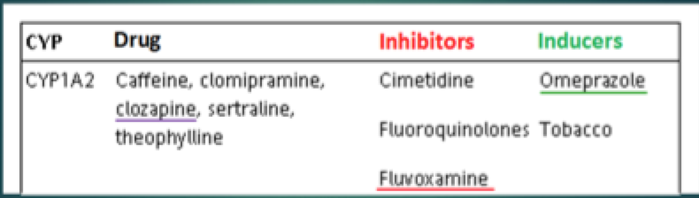
- Inhibition:
  - Fluvoxamine inhibits metabolism: increases clozapine levels
- Induction:
  - Omeprazole induces/accelerates metabolism: decreases clozapine levels

Minimizing Adverse Drug-Drug Interactions
- Use as few drugs as possible
- Thorough drug history (ie. Ilict drugs, OTC, alcohol/caffeine, natural health products)
- Adjust dosage when inducer/inhibitor of metabolism added/deleted
- Adjust timing of administration to minimize interference with adsorption
- Monitor for early signs of toxicity when combinations of toxic agents cannot be avoided
- Be especially vigilant when pt taking drug with narrow therapeutic range
Food-Drug Interactions
- Foods can decrease or increase drug absorption
  - Antibiotic effect of tetracycline is reduced by milk products because insoluble complex formed with calcium
  - High-calorie meal doubles absorption of Saquinavir, anti-HIV/AIDS drug
- Grapefruit- but not other citrus fruits, can significantly inhibit metabolism of certain drugs, raising their blood levels
  - eg. Co-administration of grapefruit juice produced at a 40.6% increase in blood levels of nifedipine (calcium channel blocker used for HTN)
  - Furanocoumarines(ie Bergamotttun) and flavonoids(ie. Naringin) are responsible for the effects
Impact of Food on Drug Toxicity
- Interaction between monoamine oxidase (MAO inhibitors) (Antidepressants) and certain foods (ie. Aged cheeses and meats, chianti wine) or medications (ie. Pseudoephedrine, meperidine) can cause blood pressure to rise to a life-threatening level
  - To avoid disaster, pts taking MAO inhibitors must be given a list of foods/drugs to strictly avoid
- Theophyline (asthma med) + caffeine excessive CNS excitation
- Potassium-sparing diuretics (ie. Spironolactone + K+) containing salt substitutes dangerously high K+ levels

Drug-Supplement Interactions
- Dietary supplements (herbal medicines and other non-traditional remedies) are used widely, creating potential for interactions with conventional drugs
- Of greatest concern are interactions that reduce beneficial responses to conventional drugs and interactions that increase toxicity
- Eg.St Johns Wart (herbal antidepressant) can decrease effectiveness of Digoxin
- Unfortunately, reliable info about drug-dietary supplements is largely lacking

Chapter 7: Adverse Drug Reactions and Medication Errors

Adverse Drug Reactions (ADRs)
- Noxious, unintended effect at normal drug doses
- Affect all body systems, mild (ie drowsiness, itching, rash) -> severe/potentially fatal (ie. Depression, neutropenia, hepatocellular injury, cardiac dysrhythmias, anaphylaxis, and hemorrhage)
- Risk Factors:
  - Elderly/Very young
  - Severe illness
  - Multiple drugs
- Facts and Figures:
  - Incidence rising “dramatically” –in Canada 80,000/year visit emergency departments because of ADRS
  - US: hospitalized pts: ~ 1,735,00 have a serious ADR, ~53,800 die
  - Many of these incidences preventable

ADRs- Definitions
- Allergic Reaction (<10%):
- An immune-system response after prior sensitization from an initial exposure
- Re- exposure triggers allergic response
- Intensity: mild itch severe rash anaphylaxis (life-threatening bronchospasm, laryngeal edema, and precipitous drop in BP)
- Intensity is Independent of dosage
  - Dose the elicits strong reaction in one patient may elicit much more mild reaction in another
- Sensitivity can change over time: mild early intense later
- Most serious allergic reaction cause by one drug family: Penicilins
- Idiosyncratic Effect:
- An uncommon drug response from a genetic predisposition
  - Ie. G6PD deficiency severe hemolytic anemia with aspirin or sufonaminde antibiotics
- Paradoxical Effect:
- Opposite of intended/expected response
- Iatrogenic Disease:
- Produced by a health professional and/or by drugs
- Carcinogens:
- Ability of certain medications/chemicals to cause cancers
- Only a few therapeutic agents are carcinogenic
- Several anticancer drugs most carcinogenic
- Teratogens:
- Drugs that induce birth defects
  - Ie. Isotretinoin (for acne) Thalidomide (some severe skin diseases; formerly-morning sickness in pregnancy)

Ways to minimize ADRS
- Pharmaceutical industry produces safest medicines possible
- Prescriber selects least harmful
- Both nurse and pt/family know major ADRs a drug can produce
  - Nurse evaluates pts for ADRs and educates pts
  - Pts/families watch for signs of ADRS/seek attention
- Function of target organ monitored, ie liver (look for jaundice, liver function tests), kidneys (urinalysis and serum creatinine) and bone marrow (periodic blood cell counts)
- Individualizing therapy: balance potential risks vs. benefits
- Be aware the pts with chronic disorders require long-term drug Rx, (Ie HTN, epilepsy, heart disease, depression) are especially vulnerably to ADRs

Medication Errors
- Every year medication errors injure at least 150,000 Canadians and kill ~700. Among hospitalized pts, treatment of drug-related injuries costs about .35 billion a year
- Definition: any preventable event that may cause or lead to inappropriate medication use or pt harm, while the medication is in the control of the healthcare professional, patient or consumer.

Who Makes Medication Errors (Hospital)
- The order moves down the line:
  - Physician/nurse practitioner writes prescription
  - Clerk transcribes, pharmacy clerk enters order
  - Pharmacy technician prepares drug
  - Pharmacist checks it
  - Rn checks order again and administers drug
- Each are in position to make eeor and to catch others errors
- Since last in sequence, RN is pt’s last line of defence against mistakes-& last person with opportunity to make one
- RNs only one whose actions not routinely checked by anyone else

Causes of Medication Errors
-Human Factors, communication mistakes, and drug name confusion account for 90% of all errors

Chapter 12: Basic Principles of Neuropharmacology

Drugs Alter processes controlled by the nervous system
- Nervous system: a complex collection of nerves and specialized cells that transmit signals between different parts of the body
  - CNS
- brain and spinal cord
-coordinates the actions of all parts of body, including PNS
  - PNS
-components of NS outside brain and spinal cord
Neurons regulate Physiologic Processes
- Conduction of nerve impulse (Action potential) along axon
- Release of neurotransmitter molecules from axon terminal
- Synaptic transmission: info carried across gap between neuron and postsynaptic cell
- Binding of these NT molecules to receptors on postsynaptic cell
- Series of events in postsynaptic cell, leading to a change in it’s behaviour (ie. Increased heart rate)

Drugs Affect Synaptic Transmission
Drugs can affect:
- NT synthesis
-increase/decrease
- NT storage
-interfere with storage-> reduce nt amount
- Receptor binding
-act directly at receptors: activate receptor (agonist) block NT (antagonist)
- Termination of NT action
i) blocking reuptake
ii)inhibiting degradation
Selectivity of Drug Action
- There are hundreds of different receptors and dozens of different neurotransmitters in the body
- For a given synapse there may be more than one NT and more than one receptor
- Drugs designed to be very selective
  - Specific for only one type of receptor
  - Affect action of only one NT
  - Can either activate receptor (agonist) or block it (antagonist)
- Selectivity is very desirable in drug
  - A selective drug is able to alter a disease process while leaving other physiologic processes largely unaffected

Chapter 13: Physiology of the PNS
CNS vs PNS components (psns, sns) -> get a diagram
-rest and digest (Ach) vs flight or fight (epine, norepine)

Peripheral Nervous System
Parasympathetic nervous system (rest and digest)
- Slow heart rate
- Increase gastric secretions
- Bladder and bowel emptying
- Focus eye for near vision
- Constrict pupil
- Contracting bronchial smooth muscle
- Cholinergic is predominant endogenous ligand
Sympathetic nervous system (fight or flight)
- Regulate cardiovascular system: ie maintains blood flow to brain, redistributes blood flow during exercise, vasoconstriction during blood loss
- Regulating body temp: blood flow skin, sweat glands, piloerection
- Implementing the fight or flight response: increase HR and BP, blood: skin/viscera muscles, dilate bronchi (to increase 02), dilate pupils, stored energy glucose +fatty acids
- Epinephrine, norepinephrine, dopamine are dominant endogenous ligands

PNS: Innervation and control
PSNS vs SNS; 3 possibilities
- Oppose (ie. Heart)
- only one (ie blood vessels)
- compliment (ie. Erection (psns) and ejaculation (sns)

Typically a feedback loop, (ie baroreceptor reflex)
- baroreceptor sensors monitor BP changes
  - CNS (spinal cord/brain): intergration
- Signals relayed by ANS to effector organs
  - Heart: increase rate if BP to low, vice-versa
  - BV: constrict if BP to low, vice-versa

PNS: Receptors and Neurotransmitters
Receptor NT
Cholinergic Acetylcholine
Adrenegic epinephrine, norepinephrine, dopamine

Cholinergic Receptors in the PNS
-3 cholingeric receptor subtypes: nicotinicN, nicotinicM, muscarinic
NT Ach can bind to all 3
-note distribution of these 3 receptor types
-1st one is located throughout ANS
-2nd one is located at neuromuscular junction
-3rd one is located- eye, heart, lung, bladder, gi tract, sweat glands, sex organs, BVs

Cholinergic Receptors/Drug Selectivity
- Drug companies have synthesized thousands of drug analogues of Ach (goal: selectivity)
- Drugs may acts as ligands (agonists, antagonists, partial agonists) or act to alter endogenous Ach levels

Categories of Cholinergic Drugs
category | effect | chapter
Muscarinic agonists | Mimic Ach at muscarinic receptors | 14
Muscarinic antagonists | Block Ach II | 14
Neuromuscular blocking agents | Block Ach at nicotinicM receptors | 16
Cholinesterase inhibitors (ChE) | Increase effect of ACH at all receptors | 15

Adrenergic Receptors in the PNS
- 5 adrenergic receptor subtypes: a1,a2,b1,b2 and dopamine
- different receptors are found on different organs
- chart is DNM chart; highlights that subtype Beta2 is located in bronchi; and response to receptor activation is dilation/ located in uterus and response to receptor activation is relaxation
Adrenergic Receptors in the PNS
-although NT Ach activates all 3 subtypes of cholinergic receptors, the 2 adrenergic NT – epinephrine, norepinephrine and dopamine are more selective:

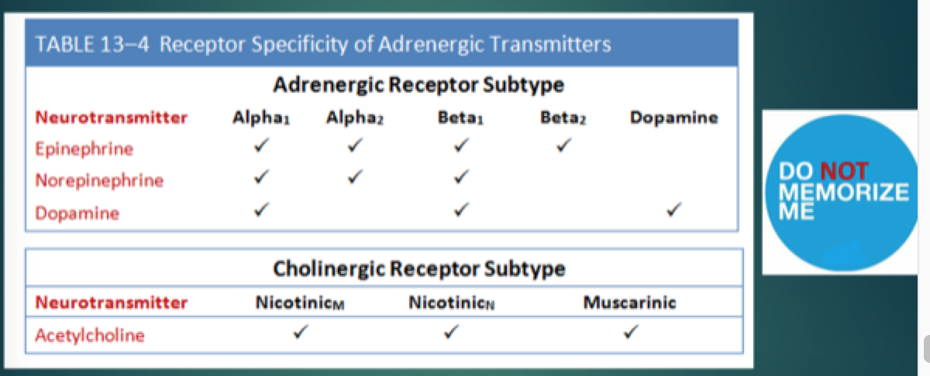

-ligands dont neccesarily bind to same receptors (what the chart shows)
-ach binds to all

Adrenergic Receptors/ Drug selectivity
- drug companies have synthesized thousands of analogues of E, NE and DA, as agonists, antagonists and partial agonists (goal: selectivity)

Chapter 14: Muscarinic Agonists and Antagonists

Muscarinic Agonists
- Mimic actions of Ach. Clinical uses:
  - Bethanechol (improves urine flow, ie.post-op)
  - Pilocarpine (for dry mouth, ie. Sjogren’s syndrome- autoimmune disease of salivary glands)

- Adverse effects:
  - Increase saliva, decrease HR/BP, bronchoconstriction (wheeze)
- In toxicology:
  - Certain mushrooms, overdose of muscarin (or derivatives that function as muscarinic agonists)

  - Risk of CV collapse/resp paralysis, over stimulation of SNS
  - Rx: Atropine (muscarinic antagonist)

table on slide 78 (eye, heart, lung, bladder, gi tract, etc – didn’t fill it in)

Muscarinic Antagonists
- Act against endogenous Ach. Also know as “anticholinergics”
- Clinical uses:
  - Atropine (pre-anesthetic, eye exams, bradycardia, diarrhea)
  - Oxybutynin, tolterodine (overactive bladder OAB)
  - Ipratropium (Asthma)
  - Scopolamine (motion sickness CNS)
- Adverse effects(table 13-2):
  - Dry mouth, blurred vision, urinary retention, constipation, increase HR
- In toxicology:
  - Belladonna Leaves (atropine is active ingredient)
  - Adverse effects in OD “ red as a beet, dry as a bone, mad as a hatter (delirium/hallucinations) death (resp. depression)
  - Rx: Charcoal lavage (absorbs poison in intestine), Physostigmine –cholinesterase (ChE) inhibitor that boosts Ach

Chapter 15: Cholinesterase (ChE) Inhibitors
Degradation of Acetylcholine Blocked
- Ach----ChE choline + acetic acid
- Boosts acetylcholine: same effect as muscarinic agonists
- Inhibitors can be reversible/irreversible

- Clinical Uses

  - Reversible Inhibitors(neostigmine, physostigmine, edrophonium):
    - Myasthenoa gravis
    - Alzhemiers disease (?)
    - Reverse neuromuscular blockade post-op
    - Rx anticholinergic OD (not TCAs) {Physostigmine- crosses BBB}
- Irreversible inhibitors: echothiophate (glaucoma sole clinical use)
- Toxicity: malathion(insecticide)/Sarin (Nerve gas)
- Adverse effects and toxicity:
  - Same as muscarinic agonists
  - Safety alert: in high doses: death by resp paralysis, CV collapse
  - Rx: Atropine, mechanical ventilation

Myasthenia Gravis
- Signs and Symptoms
  - Muscle weakness
  - Fatigue
  - Horizontal smile
  - Difficulty breathing
- Pathophysiology
  - Autoimmune attack on skeletal muscle nicotinicM Ach receptors
  - 70-90% reduction of receptors at neuromuscular junction
- Rx
  - Reversible ChE inhibitor (ie. Neostigmine) not a cure: lifelong treatment needed. Critical need to stay within therapeutic range
- 1. Myasthenic Crisis
  - inadequate ChE inhibitor
  - muscle weak, decreased respiration
  - Rx: Neostigmine
- 2. Cholinergic Crisis
  - excess ChE inhibitor
  - muscles weak, decrease respiration
  - increased saliva, decreased HR/BP, wheeze
  - Rx: Atropine
- Edrophonium (ultra-short acting ChE inhibitor) reduces risk of 1, increases risk of 2
  - Controversial to use

Chapter 16: Neuromuscular Blocking Agents

Clinical Use
- Displace Ach from skeletal muscle nicotinicM receptors
- Non depolarizing –bind/Ach cant contract muscle
- Depolarizing –muscle contracts, then paralyzed

Pharmacological effects:
  - Muscle relaxation (ie. Paralysis)
  - Cant cross BBB, no effect on consciousness/pain perception
    - Stressful/horrific without anesthesia
Therapeutic uses:
- Endotracheal intubation (for ie. Mechanical ventilation)
- Electroconvulsive therapy

Adverse Affects
- Non depolarizing (pancuronium, etc):
  - Resp arrest
  - Hypotension
- Depolarizing (Succinylcholine):
  - Prolonged apnea if genetically unable to metabolize
  - Malignant hyperthermia (1/25,000) T less or equal to 43 degrees, muscle rigidity
    - Also with all inhal. Anesthetics
    - Rx IV Dantrolene (skeletal muscle relaxant(
    - Cf neuroleptic malignant syndrome (NMS) from antipsychotic drugs
- Postop muscle pain
- Hyperkalemia: increased blood potassium death (cardiac arrest)

Chapters 17: Adrenergic Agonists
Aka ‘sympathomimetics’
Mechanisms of Adrenergic receptor activation
Mechanism of stimulation | examples
A)Direct Mechanism
Receptor activation through direct binding | Dopamine  Isoproterenol  Epinephrine  Ephedrine
B) Indirect Mechanisms
Promotion of NE release | Amphetamine  Ephedrine
Inhibition of NE reuptake | Cocaine  Tricyclic antidepressants
Inhibition of MAO | MAO Inhibitors (antidepressants)

Catecholamines and Noncatecholamines
Catecholamines
- Cant be used orally: Liver/intestinal enzymes metabolize extensively
- Rapid metabolism: short duration of action
  - Continuous IV infusion only
- Very polar: cannot cross BBB
  - Minimal CNS effects
Noncatecholamines
- Can be used orally; liver/intestinal enzymes don’t metabolize
- Slow metabolism: long duration of action
- Less polar: can cross BBB
  - CNS effects seen: excitement, nervousness

Adrenergic Receptors/Drug Specifity
- 5 Adrenergic receptor subtypes: a1,a2,b1,b2, and dopamine
- different receptor subtypes are found on different organs
  - ie dopamine-kidney
  - beta1-heart/kidney
  - beta2-arterioles(hear, lung, muscle), bronchi, uterus, liver, muscle
  - alpha1-eye,veins, sex organs, bladder, arterioles(skin, membranes)
  - alpha2-presynaptic nerve terminals

- Variable receptor specificity/activation from different adrenergic receptor agonist drugs
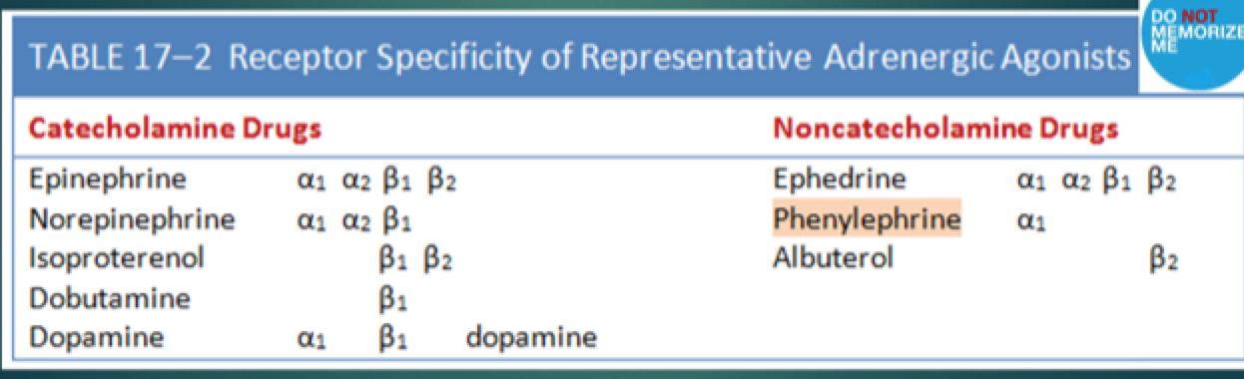
- Receptor specificity relative- not absolute. Depends on dose

- Clinical consequences of alpha1 Activation
Therapeutic uses:
->2 main therapeutic uses: vasoconstriction and mydriasis(pupillary dilation)
- Hemostasis
- Nasal congestion
- Adjunct to local anesthesia
- Counteract hypotension
- Facilitate exe exams/surgery
  - Increase pupil size
Adverse effects: all result directly/indirectly from vasoconstriction
- HTN (elevation of bp)
- Local tissue necrosis (extracasation)
- Bradycardia (reflex slowing of the heart, increased bpd triggers baroreceptor reflex, cause hr to decline)

Safety alert: all alpha1 atonists used intravenously are high-alert medications: medication error hypertensive crisis

- Clinical Consequences of Alpha2 Activation
- Direct alpha2 PNS activation: no clinical consequences
- CNS: alpha2 activation reduces sympathetic outflow to heart and also has analgesic effects
- Therapeutic uses: HTN, pain relief
- By activating CNS a2 receptors, we can produce 2 useful effects
  - 1) reduction of sympathetic outflow to the heart and BV
  - 2) relief of severe pain

- Clinical Consequences of Beta1 Activation
- All due to activating b1 receptors In heart:
  - Increased HR
  - Increased force of contraction
  - Increased cardiac output
- therapeutic uses:
  - heart failure
  - shock (decreased BP/tissue perfusion)
  - AV block (arrhythmia)- until pacemaker implanted
  - Cardiac arrest/asystole (IV/intracardiac epi)
- Adverse effects:
  - Altered heart rate or rhythm (overstimulation of beta1 receptors can cause: tachycardia and dysrhythmias
  - Angina Pectoris
  - Movie-pulp fiction guy dies of “cardiac arrest/resp depression” actuallynaloxone

- Clinical consequences of B2 activation
- Therapeutic uses: limited to the lungs and the uterus.
  - Asthma
    - Since drugs that promote b2 receptors promote bronchodilation they can be used to relieve/prevent asthma attacks
    - Drugs that selective for beta2 receptors are preferred to less selective agents, esp. for pts who also suffer from angina
    - use selective B2-angina pts!!!
- Relax uterine smooth muscle: delay preterm labour
- Adverse effects
  - Hyperglycemia (Increased blood glucose) (glycogengluscose)
  - tremor (B2 receptors in skeletal muscle activated)

- Clinical consequences of DA activation
- Therapeutic use:
  - Dilates renal BV improves renal perfusion and can thereby reduce the risk of renal failure
    - Manage shock by reducing risk of renal failure

Anaphylactic Shock
- severe allergic reaction: bronchoconstriction glottal edema, decreased BP (vasodilation)
- Bee sting, peanuts/shellfish, drugs
- 600 deaths/year (Canada)
  - venom(8%), food(2%), drug (90%, Penicillin)
- Rx with IM Epinephrine
  - Involves activation of multiple adrenergic receptors:
    - B1: increases cardiac output
    - B2: counteract bronchoconstriction
    - A1: vasoconstriction increases BP, supresses glottal edema
- Rx: epinephrine auto injector (Epipen)
  - Don’t leave home without it
  - Seek medical attention after use

Ch 18: Adrenergic Antagonists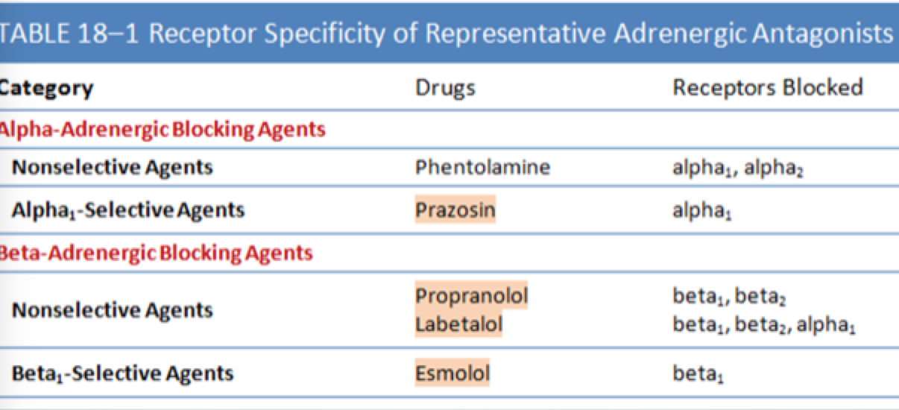

- Clinical consequences of Alpha Blockade
Therapeutic uses:
- essential hypertension by vasodilating arterioles and veins
- hypertension from overdose of an alpha-agonist
- BPH(benign prostatic hyperplasia)
  - Dysuria, urgency, increased frequency urination, hesitance
  - Rx reduces contraction of bladder muscles
- Pheochromocytoma (adrenal tumor secretes increases NE/E)
- Raynaoud’s Syndrome (Toe/finger vasospasm)
- ADHA
- PTSD/ nightmares

Adverse Effects:
- Orthostatic hypotension
  - blood pools on standing -> decreased BP
- Reflex tachycardia
  - response to vasodilation and decreased BP
- Nasal congestion
  - from vasodilation in nasal mucosa
- Ejaculation inhibition (impotence)

- Safety alert: all alpha1 antagonists used intravenously are high-alert medications: medication errors devastating effect

- Clinical Consequences of Beta Blockade

Therapeutic Uses: (from blocking B1 receptors in heart)
decreases HR/Force of contraction/AV node conduction
- Angina pectoris
  - Cardiac work reduced
- Hypertension
- Cardiac Dysrhythmias
- Myocardial Infarction (MI)
  - Decreased pain/size/mortality/re-infraction
- Heart failure
  - Had been contraindicated
- Hyperthyroidism
- Migraine prophylaxis
  - Unknown mechanism
- Pheochromocytoma
- Glaucoma

Adverse Effects (seen from blocking either B1 or B2 receptors)
Adverse effects of B1 blockade
- Bradycardia
- Cardiac output decreased
- Precipitation of heart failure (but also used to Rx!!!)
- Atrio-ventricular heart block
- Rebound cardiac excitation if drug abruptly stopped
- Bradycardia in neonate

Adverse effects of B2 blockade
- Bronchoconstriction
  - Contraindicated with asthma
- Hypoglycemia
  - Inhibit glycogenglucose. Diabetics!!!
- Resp. distress/hypoglycemia in neonate

->beta blockers can also cause clinical depression

Chapter 19: Indirect-acting Antiadrenergics
-2 kinds, both act presynaptically:
- In the CNS:
  - Ie: central acting alpha2 agonists
  - Agonist on presynaptic alpha-2 receptors
  - Negative feedback: decreased NE in CNS decreases activation of PNS adrenergic receptors
- In the PNS
  - Ie: adrenergic neuron-blocking agents
  - Cause decreased norepinephrine (NE) synthesis and release

-Equivalent of direct acting postsynaptic adrenergic receptor blockers

Centrally Acting Antiadrenergics (CNS)
- Clonidine
- Stimulates a2 receptors leading to reduced NE release postsynaptically
- Effect: decrease HR/CO, vasodilation-> decreased BP
- Indications: hypertension, pain, ADD
- Investigational uses: opiod withdrawal, smoking cessation, tourettes syndrome
- Adverse effects: CNS depression, rebound HTN if suddenly discontinue, embryotoxic,abusable (euphoria, hallucinations)
- Guanabenz and Guanfacine
- Same pharmacology
- Indications: Hypertension, ADHD
- Methyldopa
- Same pharmacology
- Indication: Hypertension (preferred Rx in pregnancy)
- Adverse effects: haemolytic anemia, hepatotoxic

