BPS2110 – Introduction to Biopharmaceutical Science

Biopharmaceutics: The study of the properties of “therapeutic substances” and their dosages/bioactivity relationships.

Therapeutic Substances:

Prescription Drugs
- “Small molecule” (generally with molecular weight of < 500 – anything > 500 has difficulty crossing the blood-brain barrier)
- Peptides/proteins (amide bonds are easily broken down by peptases meaning they have a shorter biological half life and require more frequent dosages)
- Vaccines (and conjugates)
Natural Health Products (NHPs)
- Vitamins
- Plant extracts
Diagnostics
- Radioisotopes and dies, Probes

Pharmaceutical Sciences: A group of “interdisciplinary” areas of study involved in the design and synthesis, mode of action (know every metabolite), delivery, and use of drugs.

The Pharmaceutical Industry

Purpose: Supplying materials and techniques that deliver (or promise to deliver) the things that people desire most – good health!

Cure vs. Prevention and Life Expectancy:

Average lifespan in early 1900’s = 50 years, in 2015 = 80+ years.
Why?? Higher standard of living.
  - Better food (and food supply)
    - Ex. Pasteurized milk (unpasteurized = risk of TB), Safe water
  - Work place infrastructure & education
    - Workers educated to stay safer, safer environments, basic safety is general knowledge
  - Vaccines (prevention)
  - Drugs (cures)
    - Antibacterial, antihypertensive (BP)
  - Diagnostics (and improved medical procedures)
    - Able to treat serious conditions earlier

The “irony” is that healthcare spending by government does not correlate well with “wellness”

Global Pharmaceutical Industry:

The top four drug companies (2012):
- Pfizer
(USA) $70.7 Billion 137,000 Employees
- Johnson + Johnson
(USA) $63.7 Billion 119,000 Employees
- Hoffman-LaRoche
(Switzerland) $43.9 Billion 98,200 Employees
- Novartis
(Switzerland) $41.5 Billion 98,200 Employees

The others:
- GlaxoSmithKline
(UK) $40 Billion 103,000 Employees
- Merck-Frost
(USA) $24 Billion 74,300 Employees
- Boehinger Ingelheim
(Germany) $17 Billion 43,000 Employees
- Takeda Pharma
(Japan) $16 Billion 15,000 Employees

The Most Prescribed Drugs (USA, 2012):
- Hydrocodone
  - 131.2 million prescriptions
  - Synthetic opioid from codeine (painkiller)
- Generic Zocor
  - 94 million prescriptions
  - Hypolipidemic drug (lowers cholesterol)
- Lisinopril
  - 87 million prescriptions
  - ACE Inhibitor (lowers BP to stop hypertension)
- Generic Synthroid
  - 70 million prescriptions
  - synthetic thyroid hormone (regulates basal metabolic rate)
- Generic Norvasc
  - 57 million prescriptions
  - calcium channel blocker – called the “next generation beta blocker”
  - For people with really high BP
  - Hypertension often treated with ACE inhibitor, beta blocker & diuretic
- Generic Prilosee
  - 54 million prescriptions
  - treats gastro esophageal reflux disease (GERD)
- Azithromycin (z-pak)
  - 56.2 million prescriptions (Pfizer)
  - antibiotic taken for 5 days, stays in system for weeks (easier than asking someone to take pills for weeks – less drug resistance)
- Amoxicillin
  - 52.3 million prescriptions
  - antibiotic
- Generic Glucophage
  - 48 million prescriptions
  - First line of treatment for type II diabetes (can’t absorb glucose)
- Hydrochlorothiazide
  - 48 million prescriptions
  - controls BP

*Fact: Most antibiotics are used in agriculture (livestock, fish farming)

Top Selling (Grossing) Drugs

USA, 2010:
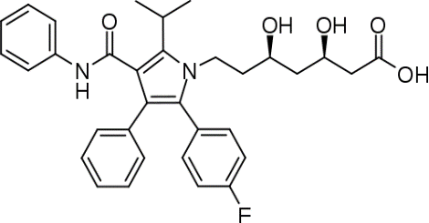
- Lipitor
  - $7.2 Billion
  - Cholesterol lowering drug
  - Alkane chain is the “business end”, it mimics natural substrate to block the pathway in which cholesterol is formed
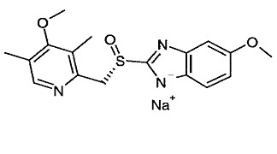
- Nexium
  - $6.3 Billion
  - Proton pump inhibitor (treats esophageal reflux (GERD))
  - Non-charged molecule is not water soluble, so they make the anion to make it hydrophilic
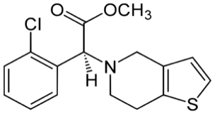
  - Forms dimers which do the work (for this reason, lots of patent issues surrounding it)
- Plavix
  - $6.1 Billion
  - Blood thinners (treat blood clots)
- Advair
  - $4.7 Billion
  - Treat asthma
  - Two drugs in one: the first opens airways initially, the second (steroids) stop swelling in the bronchioles.
- Ability
  - $4.6 Billion
  - Antipsychotic

Compare stats in 2012:
- Humira
  - $9.8 Billion
  - anti-inflammatory
- Enbrel
  - $8.4 Billion
  - Psoriasis, rheumatoid arthritis
- Advair
  - $8.0 Billion
  - Asthma
- Remicade
  - Chimeric (chemo therapy) monoclonal antibody (MAB) against TNF alpha (tumor necrosis factor)
- Rituxan
  - Chimeric MAB to treat B-cell diffusion (tissue rejection)

*Notice the change in order:
- Newer drugs to treat complex autoimmune conditions (this is a recent change)

Compare stats in 2006:
- Lipitor – $14.4 Billion
- Advair – $6.1 Billion
- Plavix – $6.1 Billion
- Nexium – $5.2 Billion

50. Ability – $1.9 Billion

The Canadian Pharmaceutical Industry

Represents only 3% of the world pharmaceutical sales (2010) (Still make the Global top 10 list)
“Canadian Pharma” consists of:
- Research and Development (R+D) companies = 78% of total sales
- Generic Drug companies = 22% of total sales
R+D companies are usually multinational
- Develop new drugs (this requires a lot of $$)
- Average cost is around $700 million per drug
Generic companies manufacture drugs after the patents expire (approx. 20 years)

Drug Costs vs. Healthcare Costs
Year | $ on Drugs | $ on Healthcare | % of Drugs Available
2000 | $15.1 Billion | $98 Billion | 15.3 %
2005 | $23.3 Billion | $141 Billion | 16.5 %
2010 | $30.1 Billion | $192.8 Billion | 16.0 %

We Don’t have more drugs even though we spend increasingly more money on healthcare

Theories:
- First world nations are much wealthier and can just afford to pay more
- Older and less healthy population
- We utilize more and more healthcare each year

Drug Development

Combined Effort from:
- Biochemists
- Molecular Biologists
- Physiologists
- Analytical Chemists (quality control and formulation)
- Toxicologists
- Organic Chemists
- Pharmacologists
- Biostatisticians
- Chemical Engineers (control exotherm of reactions – can be dangerous on large scale)
- Legal Experts (patents, intellectual property (IP))

Process of Drug Development

- Typical timeline = 8-18 years
  - From identification of a potential “drug” to development of a “lead structures” to approved for sales by FDA or Health Canada
- Four phases:
- Preclinical Research and Development – (3-8 years)
- Clinical Trials – (4-8 years)
- New Drug Application (NDA) Review – (1-2 years)
- Post market surveillance – (on going)

A closer look at these phases:

- Preclinical Research and Development
*Entire preclinical research and development (R&D) phase takes a long time (3-8) years
  - Understanding the nature of the disease or condition that you want to treat (drug companies don’t want to find the one-time cure as that is not profitable)
  - Where do you “intervene” in the process of the disease to treat it?
    - Need full understanding of the disease mechanism
    - Consider HIV
      - Initial Infection
      - Replication – HIV Protase target, Reverse transcriptase inhibitors
      - Virus Release (budding) – neuramidase inhibitors (Tamiflu)
  - Have to identify a “lead” structure or compound
    - Where do you look?
    - Three common strategies
      - Rational Design (uncommon)
      - Accidental discovery (*most common) – Ex. Viagra
      - Nature
  - Development of a bioassay to determine how effective a drug candidate is.
- HTS (high throughput screening) ideally
- ~1000 compounds in a library
  - 1 compound tested in 3 days, therefore 5000 days = 13.7 years
  - Chemical synthesis
    - Improve characteristics
      - Efficiency
      - Efficacy
      - Solubility

Efficiency vs. Efficacy
Drug inhibitory enzyme dose response curve
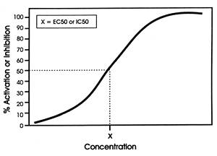
X = IC₅₀ value (half curve) = amount required to inhibit 50%

IC₅₀ in μM range = efficacious

IC₅₀ in M range = not efficacious

Efficiency: the way to maximize the effect.
Efficacy: the “power” required (amount of drug/concentration) to do that.
  - Testing Toxicity and Activity in appropriate models
    - In vitro
      - Cells, cell lines, tissue
    - In vivo
      - Animals (animal type depends on condition being studied)
      - Costs associated with animal tests arises from having to keep them all alive (food, housing, vets, etc.)
      - In vivo could be short term or long term studies

- Clinical trials (3 main phases)
  - Phase 1:
- 20 healthy individuals
- determines safety only (based on toxicity studies in previous stage)
- 1-2 months’ total
  - Phase II:
- Small, highly controlled group of patients who have the condition you want to treat with your drug
- 50 individuals
- Assess both efficacy and efficiency
- 3 months to 1-year total
  - Phase III:
- Large and diverse group of individuals that represent the “type” of person who would use the drug
- Efficacy and safety of the drug tested
- 3-8 years’ total

- New Drug Application Review & Regulatory Agency Approval
- Serious effort that requires the company (making the drug) to convince Health Canada (FDA in USA) that the IND (Investigational New Drug) Application is complete and covers all the requirements:
  - Manufactured well using GMP (good manufacturing procedure)
  - Knowledge of metabolic and pharmokinetics
      - Absorption, distribution, metabolism, excretion. (ADME)
  - SAFETY (or lack of any toxicity and serious side effects) and efficacy as shown in the clinical trials

Considering 1000 compounds entering Phase I clinical trials
      - ~600 pass onto phase II – (2/3 total)
      - ~400 make it through to phase III — (2/3 from phase II)
      - only ~50 may pass through phase III trials
    - ~5% make it to through clinical trials

Estimated Costs:
- Preclinical R&D = ~$5-10 million
- Phase I Clinical = ~$15-20 million
- Phase II Clinical = ~$90-100 million
- Phase III Clinical = ~$400-500 million
- Regulatory approval (NDA) = ~$5-10 million
TOTAL = ~$650-700 million

Big Question: how to manage cost and success rate (save money)?
- “Weed out” as many of the poor candidates before clinical trials as possible
- Apply ADME
- Use Lipinski’s rules for “Drug like” molecules – Rule of 5’s (RO%)
- No more than 5 H-bond donors (N-H, O-H, etc.)
- No more than 10 H-bond acceptors (N, O)
- Molecular mass less than 500 Daltons
- Octanol-H₂O partition coefficient (Log P) (how the molecule partitions itself between octanol and water)
- Look for obvious toxicity issues
- Use computer screening (in silico)

Last step in Drug Development:
- Post Marketing Surveillance
- Problem: large genetic diversity in large population makes it impossible to test all of the “adverse” effects.
- Drugs that treat life threating conditions can have more severe side effects that are tolerated
- Treating lifestyle situations (cancer, HIV), only minor side effects tolerated
- Have to list all side effects (SE’s)

How does Pharma “decide” what disease to treat?
- Filling a need (problem):
- E.g. HIV
  - 1980-2000 spent time studying the disease
  - then develop new drugs (nucleoside reverse transcriptase inhibitors, prolease inhibitors)
- React to opportunity:
- New developments in understanding of condition
- E.g. cyclooxygenases and inflammation (COX inhibitors)

How do we discover a drug candidate?

3 months
Active molecule “Hit”
Target Identification
3-4 months
6 months – 2 years
HTS
“Hit” lead
CANDIDATE DRUG
Lead Optimization projects
(trying to improve pharmacokinetics)

2 years
6-9 months

Common Drug Biological Mechanisms (sale of drugs 2005)
- Enzyme Inhibitors 38%
- Receptor Antagonists 24%
- Receptor Agonists 12%
- Ion Channel Modulator 8%
These four categories = 80% of all drugs made in 2005

Bioassays

- Once a target is established a need to identify other components that interact
  - Most targets are enzymes (easier to work with)
- Bioassays based upon either
  - Cells (whole)
  - Isolated enzymes
- A solution is HTS (high throughput screening)
  - Allows us to work with “libraries” or groups of compounds (100 10000) at once

Types of Libraries:
- Combinational Libraries (chemical)
  - Generate these using synthetic organic chemistry
  - Drawback = structural diversity is limited (constrained by structural patterns chemists think are essential and therefore miss the random structure that works)
  - A typical example: (2 component)
    - Amine and carboxylic acid amide bond
    - If we have 10 amines and 10 carboxylic acids, we get 100 different amides
  - PROS:
    - Generate many compounds
  - CONS:
    - No real diversity – all compounds have similar structure
    - Separation can be a problem
    - The diversity issue can be overcome by using natural product based libraries
- Natural Product-Based Libraries
  - Use extracts that contain many different compounds
  - PROS:
    - Highly structurally diverse library
    - Likely “bio-variable”
      - A sub category of absorption and is the amount of drug that reaches systemic circulation
  - CONS:
    - Complex mixture
      - Difficult to separate into different compounds

Diversity in Natural Product Libraries:

Plant Sources:
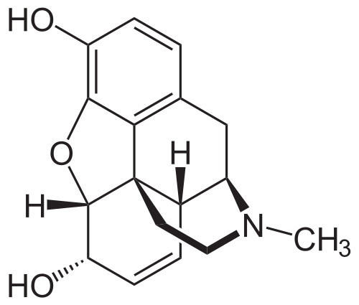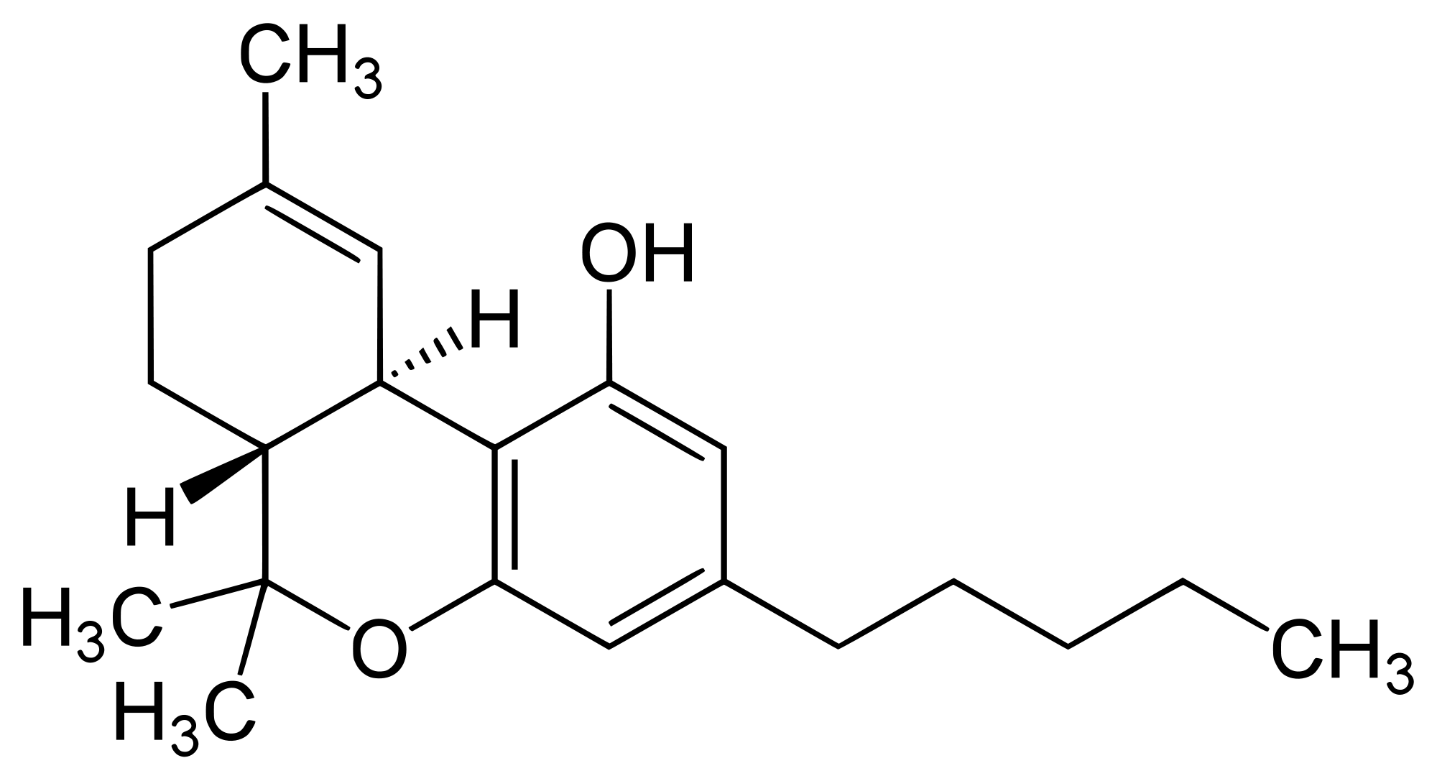
Morphine THC
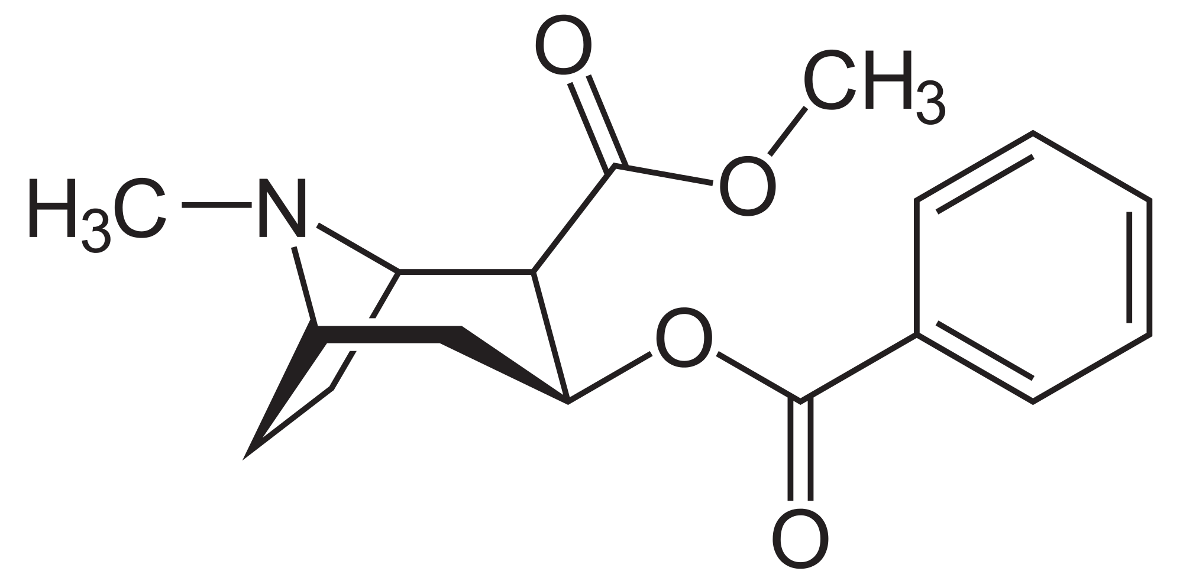 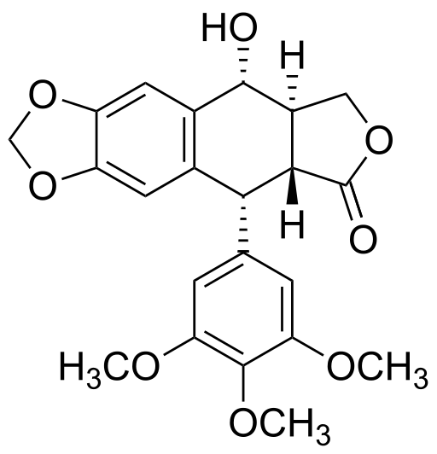
Cocaine Podophyllotoxin (anticancer)

Microorganisms:
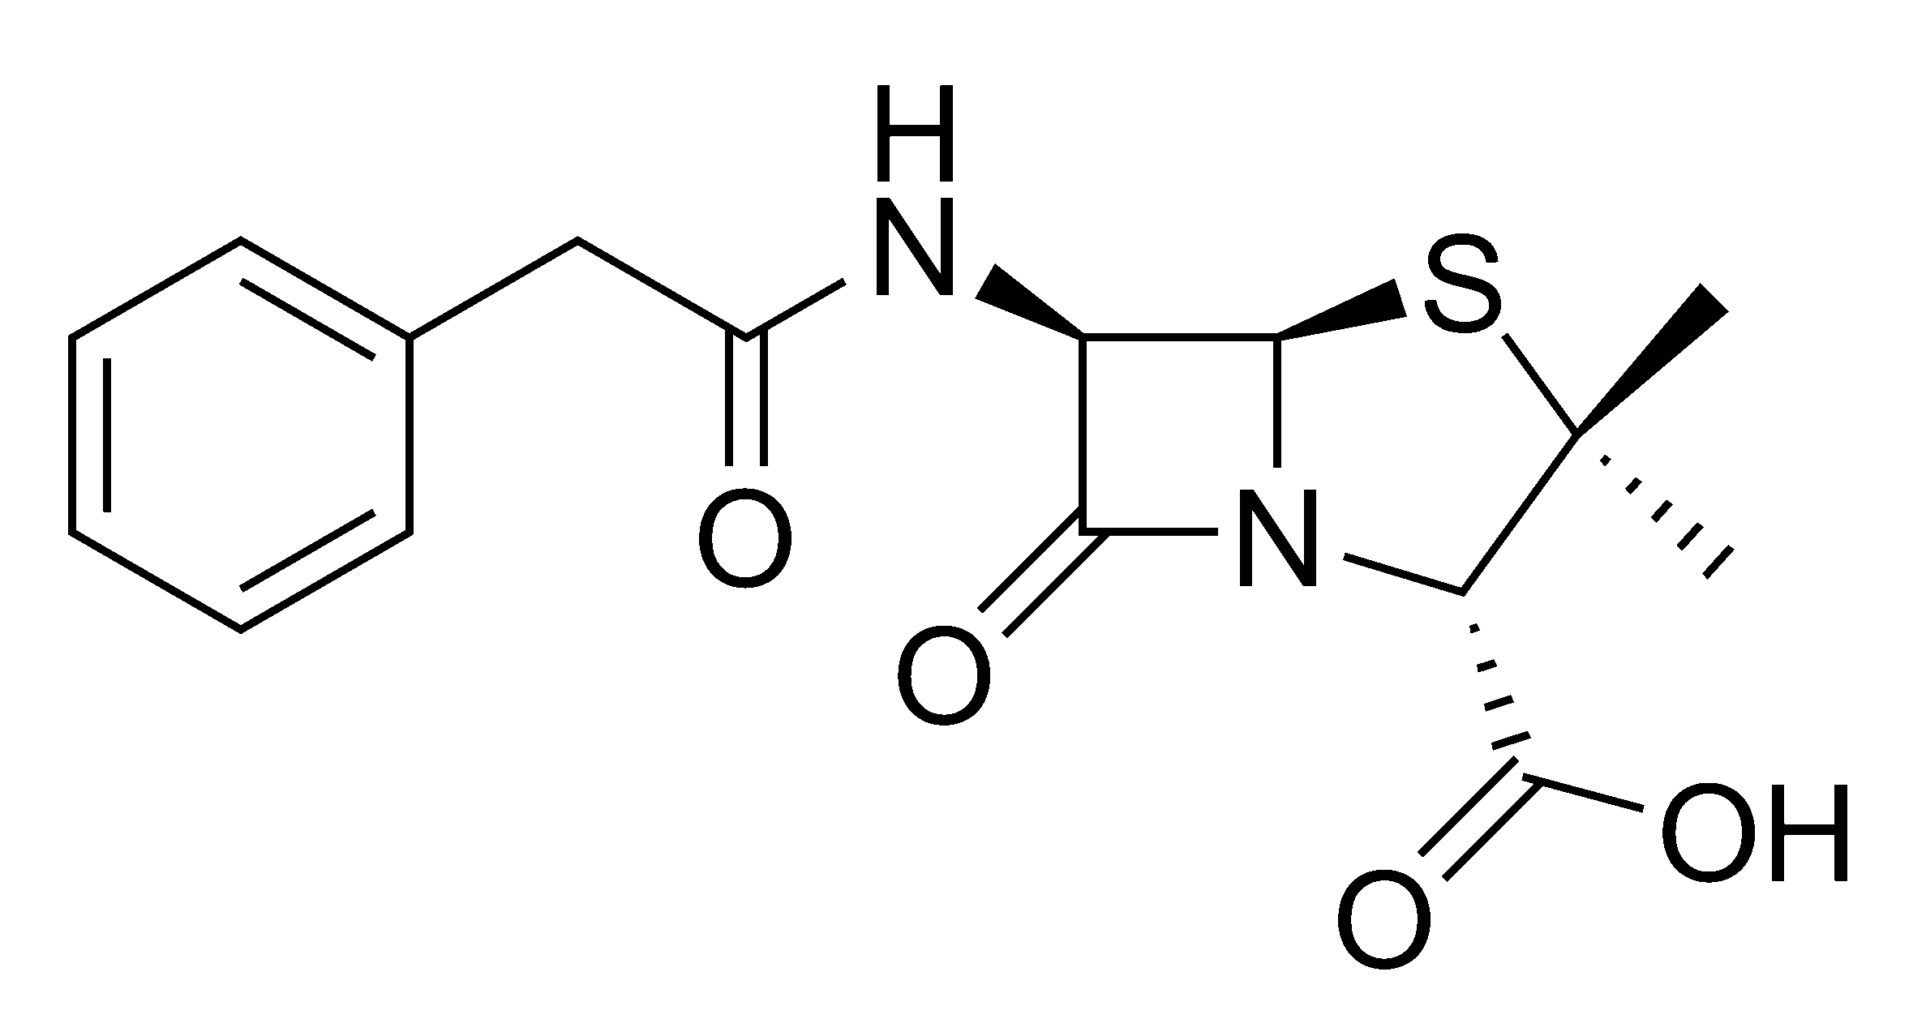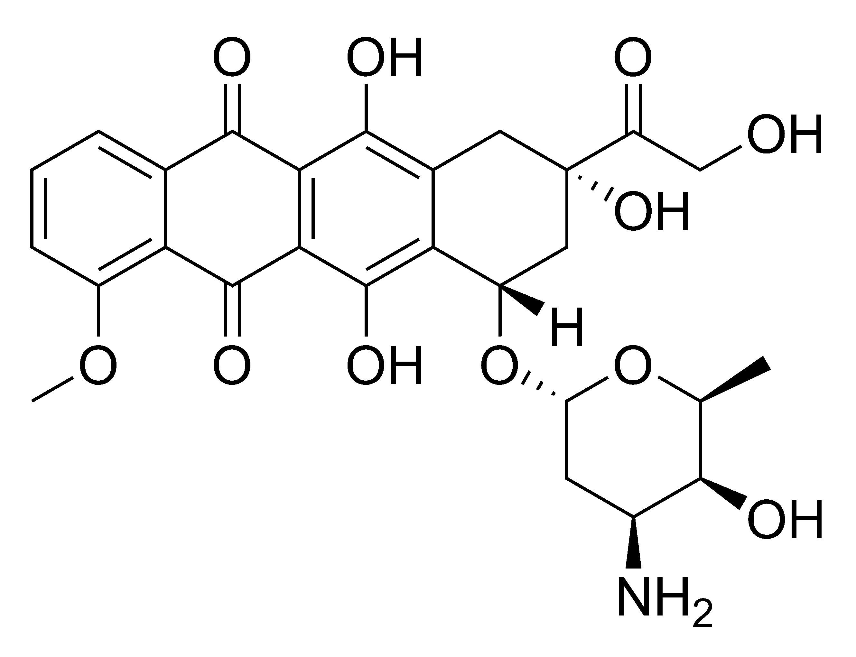
Penicillin g Adriamycin (anticancer)

High Throughput Screening (HTS)

“An industrialized process which brings together validated, tractable targets and chemical diversity to rapidly identify novel lead compounds for early phase drug discovery”
- Allows for screening of a series of compounds
- 50-70% of new drugs originate from an HTS
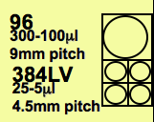
Microtitre Plates – the HTS test tube
- 125 x 1536 well plates
- 500 x 384 well plates
- 2000 x 96 well plates

SPA (Scintillation Proximity Assay)
- First true homogeneous HTS technology
- When a hit occurs (molecule binds to bead), the light turns on
- Allows throughput of ~30K compounds/day in 384 format
- Easy to automate, no significant volume of aqueous waste
- But:
  - Radioactive (safety headaches)
  - Long read times (>30min/plate)
  - Susceptible to quench artefacts
  - Not applicable to all targets

FLIPR (Flourescent Imaging Plate Reader)
- A high throughput fluorimeter
- Real-time simultaneous imaging of 96- & 384- well plates
- Used for HTS Ca²⁺ flux assays and ion channel screening
- How it works:
  - Cells loaded with fluorescent dye sensitive to Ca²⁺ (fluo-3)
  - CCD camera images base of microtitre plate
  - Addition of receptor agonist stimulates Ca²⁺ release, resulting in fluorescence increase
  - Whole plate is read simultaneously, allowing kinetic analysis
- Functional’ screen (i.e.whole cell) – greater relevance than simpler screening methods
- Throughput is 1000x greater than cuvette-based fluorimeter assay

A Clever Example of HTS:
- Solid phase library to bind a lectin
- The library contained a single compound on each bead and contained 1300 unique disaccharide and trisaccharide structures
- Result:
  - Only 25 beads stained blue.
  - 13 of these contained the same core disaccharide acylated with different hydrophobic groups.
  - Of the remaining 12 beads, all the carbohydrate structures were unique and two of these bound the lectin with higher affinity than the native substrate.

Ethnopharmacology
- The study of the use of plant-derived materials in traditional societies for the purpose of maintaining and improving health
- 80% of the world population uses plant materials to treat health problems
- combining random screening of natural product libraries and Ethnopharmacology is a clever strategy
  - e.g. 50% of “new” anticancer drugs come from natural products
- A great example is malaria treatment:
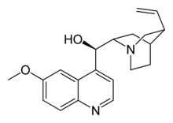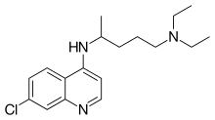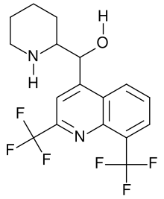

Quinine Chloroquine Mefloquine
- Chinrona tree - 1934-1943 - ~1970
- very first anti-malarial - resistance developed - [Vietnam war]
- parasite developed resistance - [US-Pacific WWII]

- All structures very similar, changes are very slight
- Why fast resistance developed?
  - Malaria serious issue during time of war (when USA was in malaria-ridden places)
  - Wars = need for new drugs
  - Often med-chem and drug development is based upon political/war needs
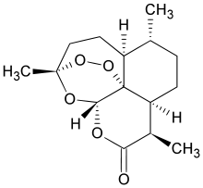
Today we have:
Artimisinin
- Comes from
artemensia annua
(Chinese traditional
medicine)

The Story of Statin Drugs

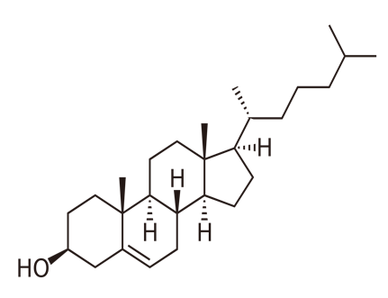
- Excellent example of drug discovery process
- Based upon a complete understanding of cholesterol biosynthetic pathway (biosynthesis)
Cholesterol
Sources include:
- Meats, lard, butter
- Not found in veggies or plant products

How do we use Cholesterol?
- Cell membrane (brain & spinal chord)

Negative Effects
- Arterial plaque (some of this can be controlled by diet)
Cholesterol (C₂₇H₄₆O)

Biosynthesis of Cholesterol
* Mevalonate is the key.

IPP AND DMAP ARE KEY BUILDING BLOCKS FOR CHOLESTEROL.
Mechanism:

* All of this had to be understood before a drug could be made.

The big question is:
How do you inhibit HMG-CoA reductase? (and ultimately reduce/hinder cholesterol biosynthesis to lower blood cholesterol levels)
Answer:
Find a substrate that “looks” like HMG-CoA and binds to the HMG-CoA reductase active site.

Inhibitors of HMG-CoA Reductase

Mevastatin:
- isolated from penicillium mold by Akino Endo (JPN) in the 1970’s
- He identified it as a potent HMG-CoA reductase inhibitor
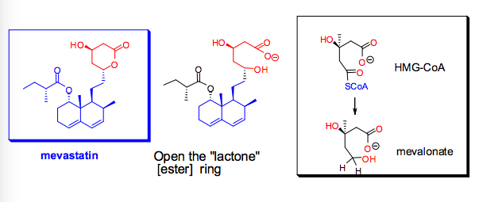
- When the “lactone” [ester] ring of Mevastatin is opened, the structure is called Mevalonate and it highly resembles HMG-CoA

- But Mevastatin was not developed due to toxicity issues

Merck-Frost takes a chance:
- Asked the question – are there other micro-organism or fungal metabolites that inhibit HMG-CoA reductase but do not have the toxicity of Mevastatin?
  - Answer = Oyster Mushroom
Other naturally occurring HMG-CoA reductase inhibitors:

Mevastatin Lovastatin Pravastatin Simvastatin
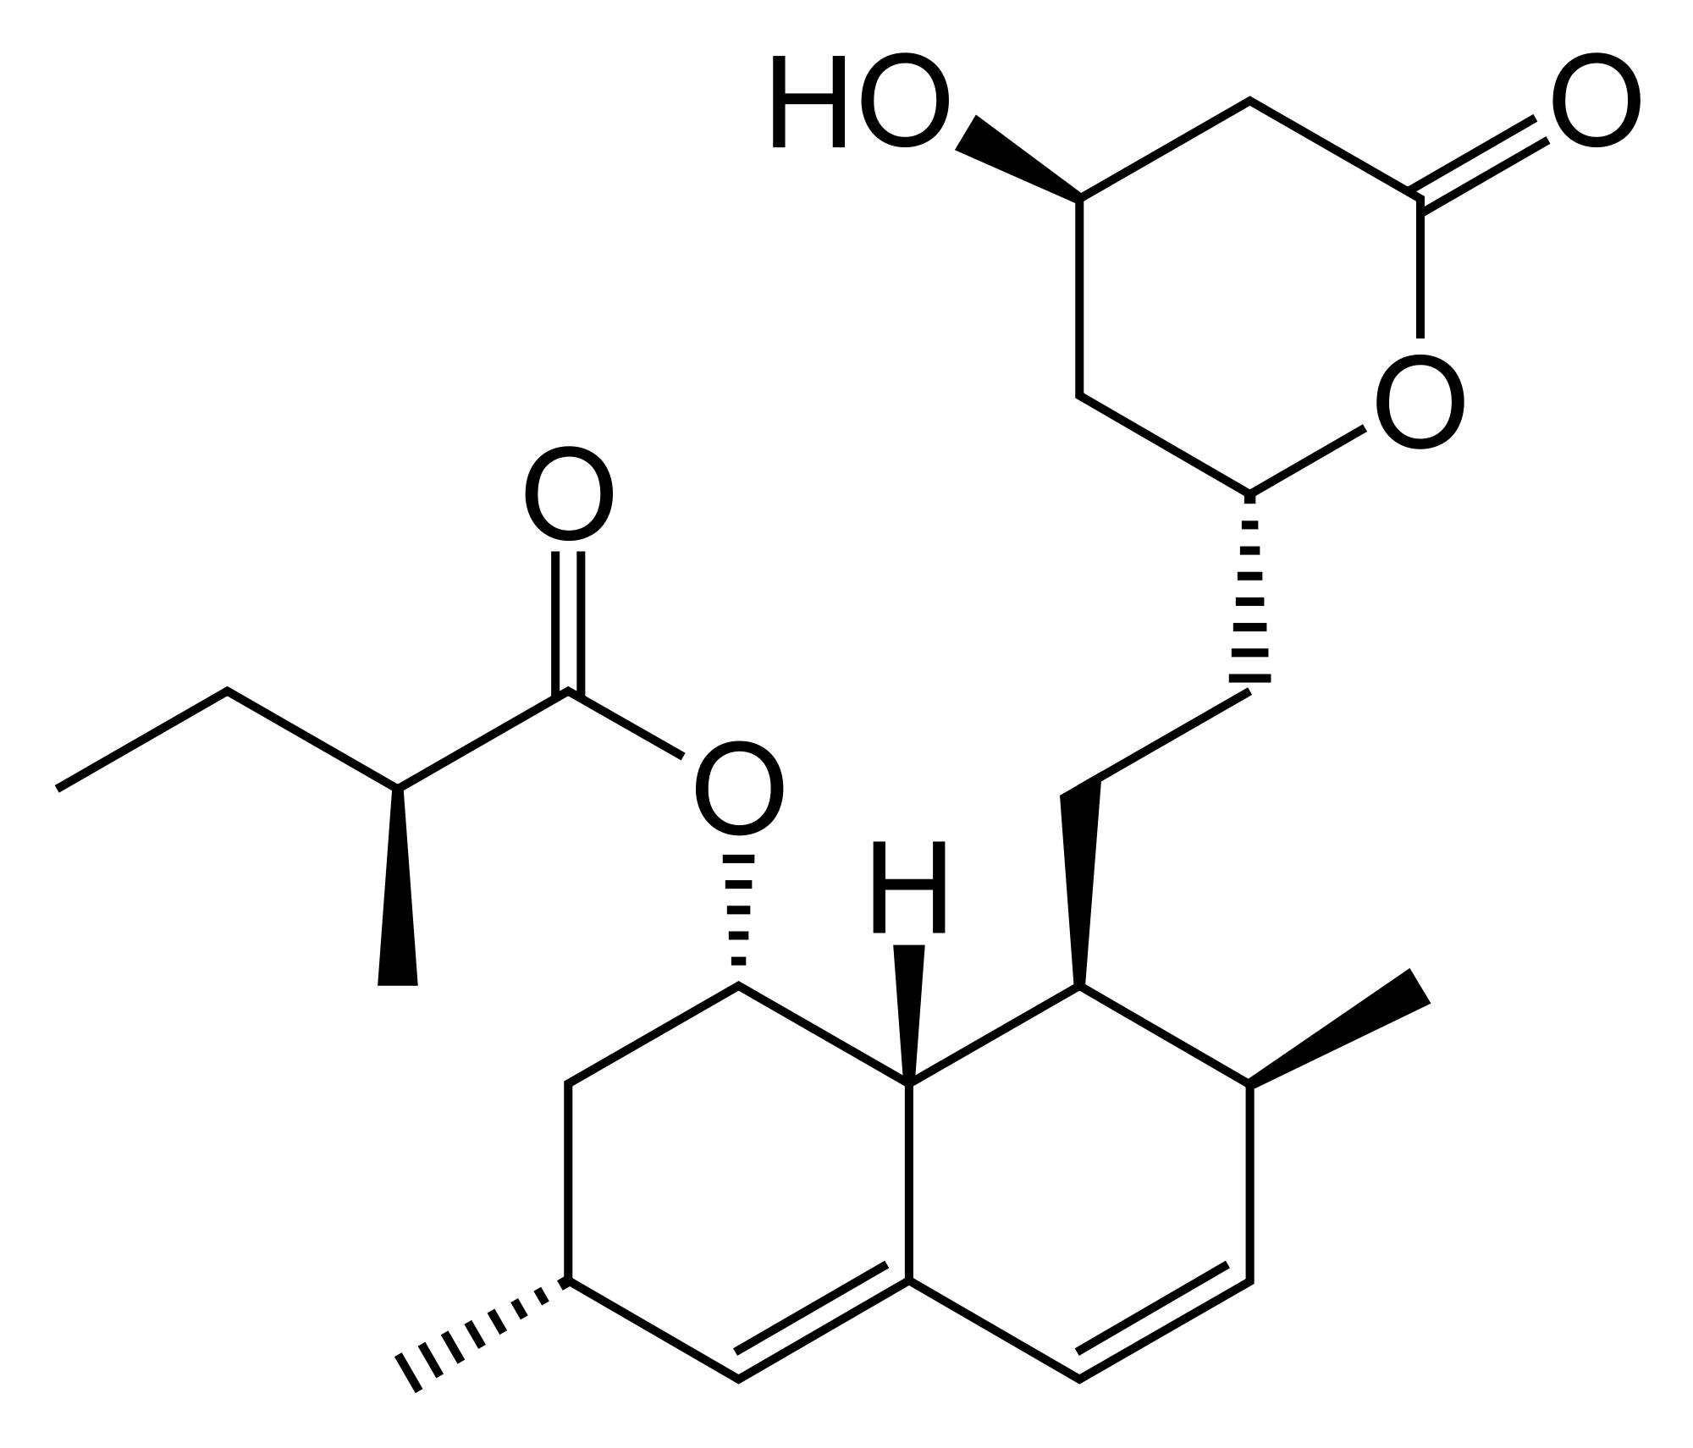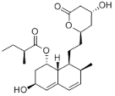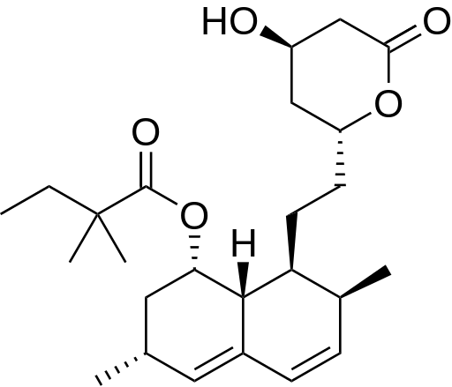

Serious side effects Oyster Mushroom (only difference = OH) Zocor ®
Mevacor ® (only difference = 2 CH₃) (only difference = CH₃) semi-synthetic

Proposals:
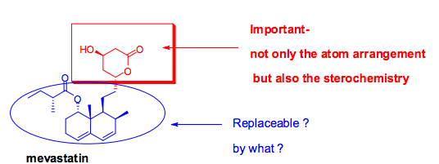
- Make a synthetic vatiation of Mevastatin
  - What part of Mevastatin is crucial? (pharmacore)
  - What part can be replaced? And by what?
- Need imaginative/knowledgeable medicinal chemists

First Approach: Keep the chemistry relatively simple.
- Properties of replaceable substituent:
  - rather large size – hydrophobic
  - Aromatic ring – flat (no stereochemistry issues
- Substituents can be added to:
  - adjust hydrophobic/hydrophilic [Polarity]
  - Increase bio-availability, metabolic stability

The Results: (synthetic statins)
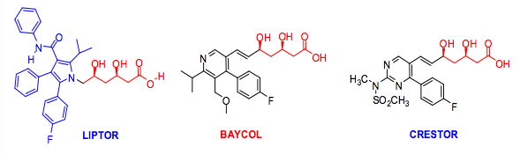

Similarities – all have aromatic ring with fluorine substituent.
Similarities to HMG-CoA – all have same opened lactone ring seen on mevalonate.
Lipitor, etc.

- Lipitor – a member of the “statin” family of drugs – the best seling drug in history
  - Total sales since 1996 > $125 Billion
  - Patent ended ~2011
- Other “important” statins:
  - Mevacor, Crestor, Zocor, Pravachol, Baycol

Epidemiology studies:
- Zocor: ~4500 patients with high cholesterol levels and heart disease
After 5 years: 35% lowering of cholesterol and 42% decrease in deaths from heart attack.
- There are many epidemiology studies due to the widespread use of Statins
  - Some show “good” relationships – one suggested 50% reduction in colorectal cancer
  - Some show “bad” relationships – one showed higher risk of diabetes

Side Effects:
- Most are “tolerable”
- Except rhabdomylolysis [skeletal muscle wasting > kidney failure]
  - Relatively rare: 250,000 patients studied over a long period of time
    - 1 person in 25,000
    - For Baycol (1 person in ~2,500). Withdrawn from market in 2001.

Building a Better Aspirin

- How the discovery of cyclooxygenase-2 enzyme led to development of new Anti-inflammatory drugs
  - From Willow Bark to Aspirin to Ibuprofen (Advil, Motrin) to Vioxx and Celebrex

The early Aspirin Story:
- Willow bark has been used for thousands of years to make a tea as a treatment for pain, fevers and inflammation
- In about 1830:
  - the active ingredient called salicin was first isolated
- By about 1860:
  - it was realized that the salicin could be converted into salicylic acid and that this resulted in a more effective treatment – but had many side effects
- In the 1960’s:
  - Felix Hoffmann (Baeyer, Germany) made the acetyl derivate which was effective and well tolerated – sold under the name Aspirin ®
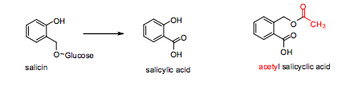
Aspirin – the wonder drug (ASA):
- Many positive effects:
  - Relieves pain (Analgesic); Reduces fever (antipyretic); Relieves inflammation; Reduces blood clotting
- Negative effect:
  - Causes gastric lesions

Use in Canada:
- Each person = 120 ASA tablets a year at 325 mg/tablet = 40g/p/y
- Assume 33 mill. Canadians = 1,320,000,000g = 1,320 tons of ASA annually

Acetyl salicylic acid [ASA] synthesis:
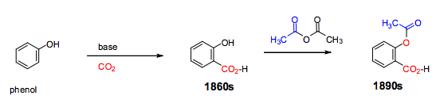

Understanding the mechanism of action of ASA:
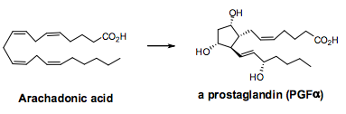
- 1960’s to 1980’s – It was shown that ASA inhibits the formation of prostaglandins from arachidonic acid
    - Prostaglandins – many structure variations mediate different biological processes
    - Arachidonic Acid – a poly-unsaturated fatty acid

Cyclo-oxygenase enzyme:
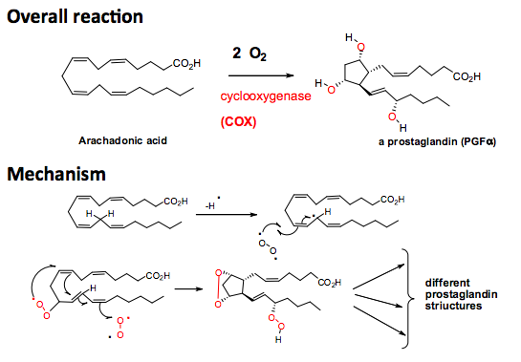
Overall Reaction:

Mechanism:

New anti-inflammatory drugs from 1970 on:
- Compounds that inhibit COX
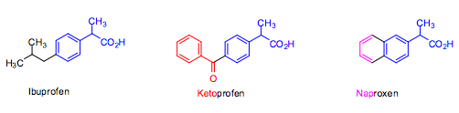
  - Non steroidal anti inflammatory drugs
- Often more potent anti-inflammatory drugs than aspirin (more potent COX inhibitors)
  - But, do not reduce fevers and are not cardio-protective!!
- Major side effect: Gastric lesions and stomach bleeding

Major Breakthrough:
- Academic researchers in the mid to late 1980s discovered that there are two cyclo-oxygenase enzymes that are closely related!!
- Both inhibit prostaglandin formation
  - COX-2 inhibits prostaglandin formation associated with inflammation
  - COX-1 mediates formation of prostaglandins associated with important body functions including renewal of the stomach and esophagus lining
- Opportunity:
  - Molecules that selectively inhibit COX-2 vs. COX-1 should relieve inflammation but not be gastro-toxic

The search for COX-2 selective compounds:
- First– develop a bio-assay that can determine the inhibition of both COX-1 and COX-2 by various compounds
- Once available – test known anti-inflammatory compounds
- Results:
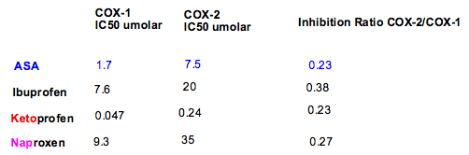 ratios are similar
IC50: Concentration tat inhibits 50% of the activity of a substance (enzyme)

The First COX-2 selective compound:

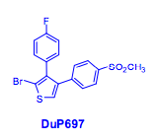
DuP679 (lead structure)

Optimizing lead structure (DuP679):
- Race to be first: Pfizer (USA – Merck Frost (Montreal)
- Medicinal chemists synthesized hundreds of compounds with variations on the DuP679 structure

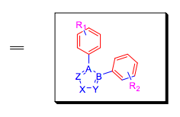
Probable structure requirements:
- Central 5-membered heterocyclic ring; likely aromatic
- Two aromatic rings ortho to each other; likely benzene rings but other 5- or 6-membered aromatic rings also plausible.
- Suitable substituents on the aromatic rings.
- Possible additional substituents on the central 5-membered ring
- Can the central ring be a six membered ring?

Process:
- Develop a synthetic method to prepare the compounds
- Evaluate each and provide feedback to generate more structures

The Synthetic Chemistry Challenge:

- How many plausible structures are there??
Different central rings
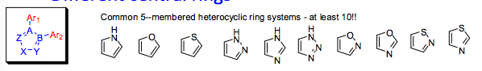
Different Ar1 and Ar2 in different positions
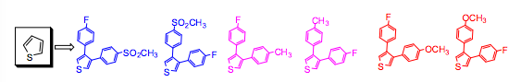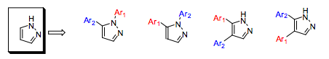

First estimate: 10x3x33 = 1000
- Does not take into account the possible di- and tri- substitution on the aromatic rings
- Does not count changing:
  - CH₃ to C₂H₅… to C₆H₁₁
  - Branching in the chain
  - Making rings
Final tally: Millions – billions of possible structures!!!

Compounds synthesized: Merck created Vioxx & Pfizer created Celebrex.
Marketing of Celebrex and Vioxx:
- Both were approved in 1999/2000 in Canada and the US. (very quick approval ~7 years)
- Heralded as miracle drugs – excellent treatment for inflammation but not likely to cause stomach lesions
- Key applications:
  - Arthritis – long term
  - Accident & sport injuries – short term
- Sales: within one or two years = several billion $

Problems with Vioxx (and NSAIDs):
- Sept. 30, 2004 Merck announces withdrawal of Vioxx from the market.
  - A study concerning the use of Vioxx for the prevention of colon cancers showed that long term use of Vioxx increased the risk of heart attack or stroke by a factor of 2.
- Other clinical data and post marketing surveillance also indicated significant concerns for Vioxx, other COX-2 selective inhibitors and long term use of other NSAIDs (nonsteroidal anti-inflammatory drugs)

Complicated situation:
- After a review of all available data in 20055, both the US FDA and Health Canada approved/recommended the re-introduction of Vioxx
  - Why?
    - Benefits outweighed the risks for some patients
    - The cardiovascular risk for Vioxx seemed no worse than those for Ibuprofen
  - Recommended further studies for all NSAIDs to fully understand the risk/benefit profiles
- Merck has not re-introduced Vioxx – fear of litigation?
- Pfizer stopped advertising and strongly marketing Celebrex after withdrawal of Vioxx, but resumed again three or four years later

Vioxx vs Celebrex:
- Key difference:
  - Vioxx is a much stronger inhibitor of COX-2 than Celebrex
- Speculation:
  - COX-2 does more than simply mediate inflammation!!
  - Is it also present in heart tissue?
  - Does COX-2 serve unknown other cardio-protective functions?
    - It is involved in the production of prostacyclin – a potent vasodilator, and also inhibits platelet aggregation

Natural Products (Secondary Metabolites) as sources of New Drugs

- Terrestrial plants (and to a lesser extent, sea organisms) continue to be a key source of novel drugs
- Surveys have been carried out to show where drugs since the 1960s have originated:
  - 60% of all new antibiotics have a natural product origin
  - 50% of all approved anti-cancer drugs have a natural product origin or are natural product derived
  - Most central nervous system drugs have a synthetic chemistry origin but are based on the naturally occurring alkaloids with CNS Activity
Plant Secondary Metabolites:
(Secondary metabolites – organic compounds that are not directly involved in the normal growth, development, or reproduction of an organism.)
- Purpose of these compounds?
  - Perform key functions necessary for survival of the organism – like animal hormones
  - Ensure propagation – pollination, dispersal of seeds
  - Protection/defense against insects and herbivores
- Phytochemical redundancy and plant defense mechanism
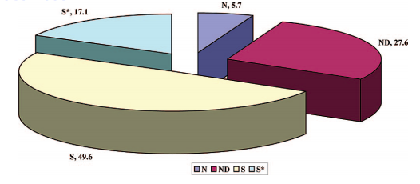
  - Plants make a number of similar compounds to prevent animals and insects from becoming resistant

Origin of new drugs 1983-2008:
N = natural product
ND = natural product derived
S* = synthetic but based on natural product pharmacophore
S = synthetic

Hypotheses for Discovery:

Focused screening:
- by learning from Healers (shamans) ethopharmacology
- via studying available literature describing the use of plants for medicinal purposes – Traditional Chinese medicine
- by focusing on plants belonging to families that are known to have certain types of bio-active compounds

Learning from Healers:
      - Typical “common” health problem
        - Infections
        - Stomach and intestinal ailments
        - Pain
        - Mental/ nervous issues
        - Reproductive issues
      - Healer consensus
      - Bio-assay guided isolation

Random Screening:
- Screening of organisms that have previously not been investigated
- Rare plants from areas not preciously accessed – often give new and unusual compounds
- Micro-organisms growing in areas not previously accessible or growing under unusual conditions
  - Ocean floor at various depths, near toxic dumps, near hot springs or volcanoes

Random (rational) approach:
- Suppose you are searching for an anti-fungal compound.
- Where would you collect plants that might generate anti-fungal compounds?
- New anti-biotic compounds would likely be synthesized by micro-organisms that compete against each other
- Insecticides are likely to be produced by plants that grow in areas with many insects
- Plants may produce compounds toxic to mammals to defend themselves against herbivores (or also bitter compounds)

Natural Product as sources of new drugs:
- Plants
  - Often sources of anti-cancer, anti-fungal, anti-oxidants
  - Also mood altering drugs
  - Most of the alkaloid derived drugs have a plant origin
- Microorganisms
  - Often a source of antibiotics and anti-cancer compounds
- Oceans
  - Typically, many compounds have antibiotic and anti-cancer activity
  - Compounds which incorporate Cl and Br

Recent Publications:
- Journal of the American Chemical Society - “Isolation and First Total Synthesis of PM050489 and PM60184, Two New Marine Anticancer Compounds” (2013)
  - Shows remarkable potential:
    - Show antimitotic properties in human tumor cell lines at sub-nanomolar concentrations and display a distinct inhibition mechanism on microtubules
    - The development of an efficient synthetic procedure has solved the supply problem and, following pharmaceutical development, has allowed PM060184 to start clinical studies as a promising new drug for cancer treatment.
- Pharmaceutical Biology – “New drugs and Biodiversity Conservation” (2009)
  - Estimated 250,000 plant species world wide
  - Approx. 50% occur in the tropical forests which currently cover only 7% of land surface compared to 16% in 1950
  - A relatively modest proportion of the plants have been investigated for their secondary metabolites which may have medicinal potential

The Inherent Advantages of Natural Products:
- Produced by biological systems, so:
  - More likely to be bio-active and bio-available
  - Are produced as single stereoisomers

Racemic Drugs

Isomers:
Enantiomers [non superimposable mirror images] have different biological properties.
Diastereomers [different compounds, same molecular formula] have different biological properties.
- Number of isomers 2^{n} where n represents the number of chiral centers of the molecule
- 8 Isomers: 4 pairs of Diastereomers

Racemic mixtures:
- In a racemic mixture there are equal amount amounts of each enantiomer
- Racemic mixtures of drugs are easier to synthesize (no separation)
- Usually one enantiomer is more active than the other. Second isomer could:
  - Have no biological activity
  - Have other biological activity
  - Be toxic
Chiral vs. Racemic Drugs
- Up to about 1990 most drugs which had chiral centers were marketed as racemates
  - 50/50 mix of isomer that carried activity, and isomer which is essentially inactive
- Reason: Cost!! (much cheaper)
- Consequence: Had to take 2x amount of drug for same effect.
  - Best scenario: the “other” isomer is harmless
  - Other scenarios: the “other” isomer has:
          - Different biological effects
          - Toxicity
Current Regulatory Practice:
- Ideally all chiral drugs should be sold as a single enantiomer
- Allowance is made if it is shown conclusively that the second isomer is harmless OR the drug can only be prepared as a racemate using currently available technology
- That enxymes in the patient convert one into the other – racemize the pure isomer

Biological racemization of drugs:

The most “famous” example – thalidomide
- Only one isomer causes terogenicity (growth retardation, etc.)
- Unfortunately, if the “harmless isomer” is given, it is racemized in the body to make a 50:50 mixture

Ibuprofen (Motrin, Advil)
- A ‘core’ medicine in the World Health Organization’s WHO Model of Essential Medicines, which is a list of minimum medical needs for a basic healthcare system
- Anti-inflammatory drug
- Sold as a racemate
  - (S) isomer is the active one
  - An enzyme in the body is able to convert the (R) isomer into the (S) isomer

Salbutamol:
- Causes dilation of the bronchial smooth muscle
- Used in puffer
- On market currently as a racemate
  - (R) is active enantiomer responsible for the pharmacologic activity
  - (S) is “other” that slows metabolism of it and the (R) isomer

Bio-assay guided isolation of isomers:
- Say a plant extract is shown to have the desired activity
- Extracts are typically prepared by grinding the plant sample, either fresh or dried, with 95% ethanol
  - Other organic solvents used are ethyl acetate and dichloromethane
  - Water is sometimes used
- Extracts have many, often 30-100 or more component compounds
  - what is the active component?
- Use a standard operating procedure
  - Bioassay guided isolation to determine which is the active component

Structure Variety in Natural Products

Antimalarials:

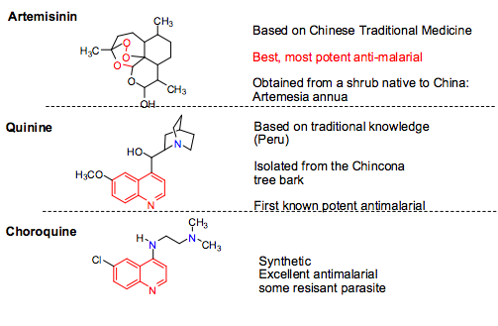

Penicillins: 1928 1942
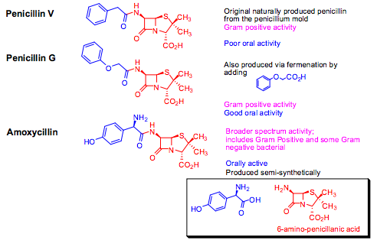
CNS active Alkaloids:
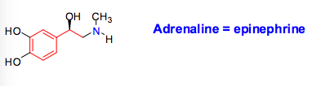
- Common structure requirements for CNS active compounds:
  - Basic nitrogen atom joined to aromatic ring via a saturated two carbon unit
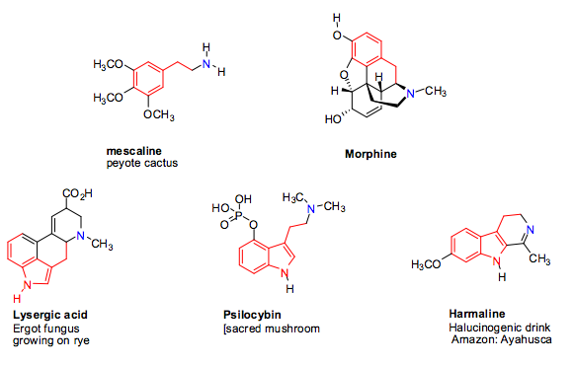

Natural CNS Active compounds:

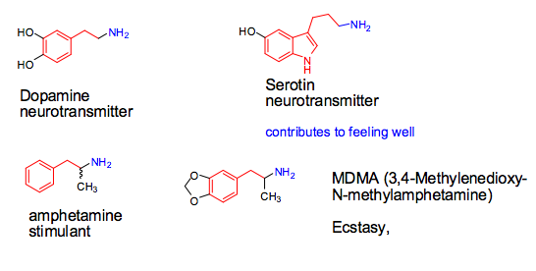

Neurotransmitters and “street drugs”:

- Dopamine, serotonin, and amphetamines

Metabolism

Metabolism – The complex of physical and chemical processes occurring within a living cell or organism that are necessary for the maintenance of life. In metabolism some substances are broken down to yield energy for vital processes while other substances, necessary for life, are synthesized.

- Mainly by liver enzymes belonging to the cytochrome P-450 family
- Almost a dozen variations have been identified in humans
  - The most important one, CYP3A4, is involved in the metabolism of approximately half the drugs that are used today
  - CYP2C19 is next in importance

The CYP-family of enzymes:
- These enzymes accept compounds with widely different shapes and sizes (not common for enzymes – usually very specific)
- Introduce oxygen into the molecule using molecular oxygen

Mechanism:
- Introduction of an OH group at a saturated carbon (sp3 hybridized) atom

Mechanism -1:
- Abstraction of H atom, preferred from a relatively weak H bond, thereby forming a relatively stable carbon centered radical
- Reaction with molecular oxygen to form a hydroperoxy radical
- Abstraction of a H atom from another molecule giving a hydroperoxide
- Reduction of the hydroperoxide to an alcohol.
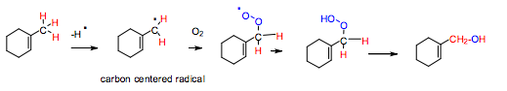
- A key part of the active site I the cytochrome enzymes is the iron center (Fe+2)
- Reaction with oxygen to form an Fe-hydroperoxy radical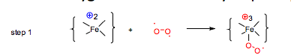
- Abstraction of a relatively weak C-H bond from the substrate to form Fe-hydro-peroxide and a carbon centered radical
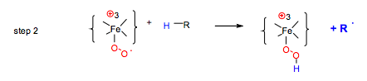
Chemistry: C-H bond dissociation energies:
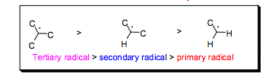
- Bond strenths:
  - Primary C-H bond ~ 98 Kcal/mol
  - Secondary C-H bond ~ 95 Kcal/mol
  - Tertiary C-H bond ~ 91 Kcal/mol
- Allylic and benxzylic radicals are as or more stable than tertiary radicals due to resonance stabilization
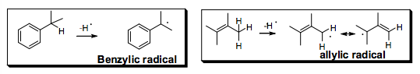

Dimethylation of R₂N(CH₃) and R-O-CH₃:
Why are they favourable?
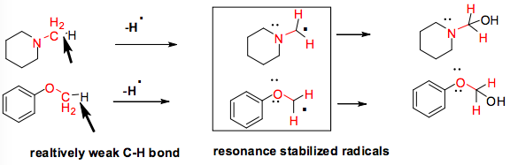

Introduction of OH groups into aromatic rings:
- Mechanism involves formation of an epoxide followed by rearrangement
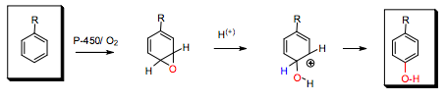

Why a different mechanism in aliphatic systems?
- Aromatic and alkene C-H bond strength is much higher than aliphatic C-H bond strength
- In other words: aromatic and alkene radicals are much less stable than alkyl or allyl radicals
- Result: abstraction of a hydrogen from an aromatic ring or attached to a double bond is difficult for the enzyme

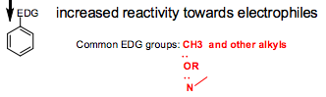
Effect of substituents on aromatic hydroxylation:
- If aromatic ring acts as nucleophile:

  - A substituent on the ring that is electron donating (EDG) will increase reactivity
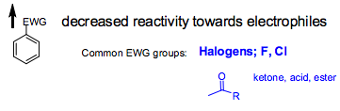
  - A substituent that is electron withdrawing (EWG) will decreases reactivity

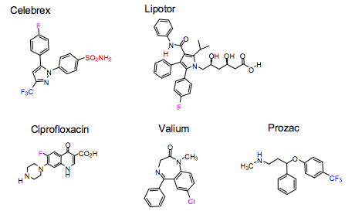
EWG reduce rate of metabolism in drugs:
- In many drugs with aromatic rings EWG substituents are introduced in order to slow down their rate of metabolism and increase their half-life in the body (Other effect of F of Cl: increase lipophilicity)

Metabolism at aromatic rings other than benzene:
- Electron poor aromatic rings tend to be metabolically more stable than a benzene ring

Drug-Drug Interactions:
- Many drug-drug interactions are due to metabolism issues
- Need to be aware of the
  - Metabolism (enzyme involved
  - The degree of Inhibition
  - Therapeutic Index [TI] of the drug

Therapeutic Index [TI]:
- Toxic Dosage for 50% of patients / Therapeutic dosage for 50% of patients
  - TD50/ED50
- Ideally a large number – low toxicity relative to effective dosage
- If less than 5 it gives narrow window and small margin of error for safety
- Digoxin, for coronary heart disease has a rather small TI
- Acetominiphen (Tylenol) has a large TI, a relatively safe drug
- Many cancer drugs have rather small TI’s

Liver Metabolism:
- Avoiding liver enzyme metabolism – also called “first pass metabolism”
- Oral administration: drugs are absorbed through the gut, do to the liver
  - Oxidative metabolisms occur mainly in the liver and gut
  - To avoid this, have the drug go into the blood stream before it can be metabolized by liver enzymes

Methods of administration:
- Oral – most common, reasonable compliance
- Intravenous injection – typical of many anti-cancer drugs, often problems with formulations
- Intramuscular injection – most vaccines, acid sensitive penicillin
- Sublingual (under tongue) – angia drugs – nitoglycerin
- Inhalation – asthma drug – salbutamol “puffer”
- Transdermal – hormones, nicotine patch
- Rectal suppositories – aspirin

PHYSIOCHEMICAL CONSIDERATIONS

Biopharmaceutics: The study of the physicochemical properties of the drug and the drug product, in vitro, and its impact on the bioavailability of the drug, in vivo, to produce a desired therapeutic effect. It is the science of preparing, using, and administering drugs to living organisms.
- Utilizes fundamental knowledge of various scientific fields including: chemistry, physiology, physics, statistics, engineering, mathematics, microbiology, enzymology, and cell biology.
- Requires:
  - Physiochemical considerations
  - Physiological considerations

DRUG PROPERTIES:

- Most drugs on the market are organic molecules that behave like weak acids/bases in aqueous solution:
- Acid: a proton donor
- Base: a proton acceptor

- Ionization and pKa:
Key implication:
- Drugs are partially ionized
- Their ionized and un-ionized forms coexist in solution, which would affect the drug’s:
  - Solubility
  - Pharmacokinetics (absorption, distribution, elimination)
  - drug-receptor interaction
Acid/base strength:
Strong acids/bases ionize completely (dissociate)
Weak acids/bases ionize partially (dissociate)
- Allows for prediction of drug absorption
- Because drugs are weak acids/bases, they are partially ionized
- For simplicity:
- K_{a} is the acid ionizaition constant.
  - When K_{a} is very large: strong acid
  - When K_{a} is very small: weak acid
- We define:
  - pK_{a} = - log K_{a}
  - pH = - log [H^{+]}
Ionization and absorption:
- Unionized drugs absorbed much more readily than ionized form
- Have charges on the cell membrane (can attach or repel)
- hydrophilic
Partition coefficient:
- Drug partitions between aqueous environment of intestine and lipophilic environment of cell membrane
Oral drugs:
- As the drug passes through the intestine the environmental pH changes, so the ionization of the drug changes
- First metabolism (major site of drug absorption) occurs in the small intestine where the pH is approx. 6.5
Henderson-Hasselbach:
- Since the degree of a drug’s ionization depends on the pH of the solution, the relationship between pKa and pH could be represented as follows:
ACID: BASE:

- Solubility:
- Solubility = max concentration of a substance that may be completely dissolved in a specific solvent at a specific temperature and pressure
- Generally expressed in mass (g) of solute per volume of solvent
- Determines the appropriateness to be used as a medical agent
- Guides the formulation, administration, and absorption of a drug substance.
- Could be improved via chemical manipulations of:
  - The drug substance (e.g. into salt or ester forms)
  - The solvent (e.g. pH variation)
Aqueous solubility:
- Critical for therapeutic efficacy
- Necessary for entrance into systemic circulation
- Ionized salt more soluble than unionized salt
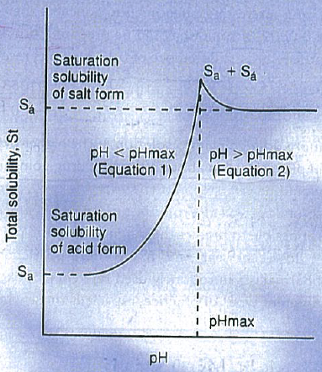
Solubility and pH:
- The solubility of a weak acid or base is often pH dependent
- The total quantity of a weak acid in solution at a specific pH is the sum of the concentrations of both the free acid and the salt forms
- As the pH of the solution increases, the quantity of drug in a solution increases
- When pH is increased, the concentration of the product will be decreased, resulting in a shift in the equilibrium so that the ionized form will increase meaning the concentration of the drug in solution will increase (look at graph)
  - As pH is increased, more ionized form
  - It will increase to pH max (point of saturation)
  - It can then
- The total quantity of drugs that can be maintained in solution at a specific pH
  - Below the pH max:
  - Above the pH max:
- Where:
  - S_{T}: Total solubility of the drug
  - pH_{max}: pH level where S_{T} is saturated with respect to both salt + acid forms of drug.
  - K_{a}: acid ionization equilibrium constant
  - S_{a}: Saturation solubility of the free acid form
  - S”_{a}: Saturation solubility of the salt form

- Hydrophilicity and Hydrophobicity:
- Hydrophobic/lipophilic property of a drug is its relative tendency to partition between hydrophilic and lipophilic media
Partition coefficient:
- It is expressed by the partition coefficient, log P:
  - The equilibrium ratio of a pure substance’s concentrations when distributed in 2 partially immiscible solvents in contact
where:
  - P: partition coefficient
  - C₁/C_{U}: concentration of drug in upper solvent
  - C₂/C_{L}: concentration of drug in lower solvent
- The octanol-water partition coefficient is commonly used in formulation development
Surface active agents:
- Molecules or ions that possess both hydrophilic and lipophilic groups
- They are called: ampiphiles
- They tend to be absorbed at interfaces (i.e. between water and air/oil)
- Surfacants (surface active agents) improve the solubility of the drug substance by:
  - Promoting drug wetting
  - Forming micelles
  - Decreasing surface tension of hydrophobic drug particles with the dissolution medium
- Surfactants may act as detergent:
  - The ability to remove particles from a surface.

- Chirality:
- Property of a molecule to have 2 optical isomers (stereoisomers) that are non-superimposable structures that are mirror images of each other – also called enantiomers
- Enantiomers can be distinguished by experiment because they have different ability to rotate a beam of plane-polarized light:
  - To the clockwise direction as a dextrorotatory (+)-enantiomer
  - To the clockwise direction as a levorotatory (-)-enantiomer
  - A mixture of equal portions (50/50) combo = racemic mixture (racemates)
Stereoisomers have:
Similar
- Physiochemical properties
- Passive diffusion ability across gastrointestinal membrane
Different
- Drug absorption process when mediated by carrier molecules
- Interactions with excipients and receptors (behave differently)
Issue:
- Many enantioselective drugs are usually marketed as racemates, although their therapeutic benefits are only attributed to one enantiomer
Racemate Example: Thalidomide
- Marketed in 1957 in Germany and 1959 in Canada (and 46 other countries)
- It was indicated for:
  - Sedation and inducing sleep
  - Alleviated morning sickness associated with pregnancy
- Could cross the placenta and affect the fetus
- Was marketed as a racemic mixture of the (+)(S)-thalidomide and (-)(R)-thalidomide
Teratogenic action Sedative action
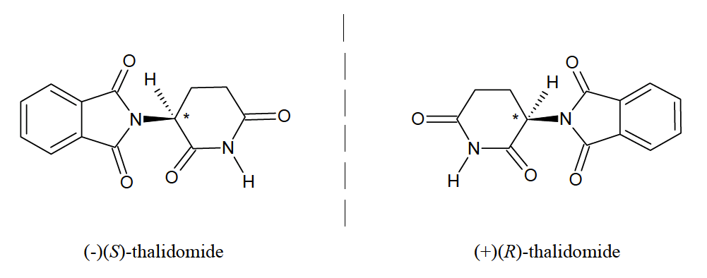
- Teratogenic = negative effects – caused the fetus to be under developed (arms and legs)

DRUG ABSORPTION AND TRANSPORT:

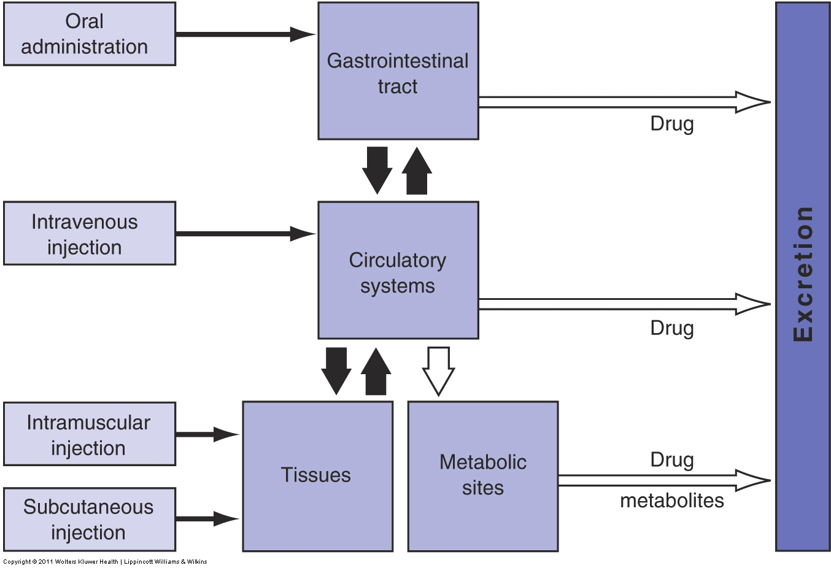

Cell membrane:
Components:
- A lipid bilayer ~ 5nm thick – composed of 2 opposing layers:
  - Hydrocarbon tails facing one another - oily bilayer core
  - NPolar heads – facing the water solution
- Acts as a barrier to the surrounding of the cell.
- Embedded with proteins that play various roles:
  - Identification of the cell
  - Anchoring one cell to another
  - Initiation of intracellular responses
  - Transport of molecules across the membrane (play role of drug transport)
Entry of molecules through cell membrane:
- Lipid domains – predominant
  - Permeation of lipophilic molecules
- Water-filled pores:
  - Made up of proteins
  - Transport of hydrophilic molecules
- However – many drugs are acids/bases: they form ions in aqueous solution (e.g. intestinal fluid)
pH partition hypothesis:
- Drugs are absorbed from the gastrointestinal tract by passive diffusion, depending on the fraction of non-dissociated drug at the pH of the intestines
  - Nonionized drugs – pass quickly through membranes
  - Ionized drugs – too polar to pass easily
- Problems:
  - In many cases, ionized and unionized drugs equally transported across lipophilic membrane
  - Permeation of ionized > unionized (e.g. sulfathiazole)
  - Metabolism of the drug in the gastrointestinal membrane
  - Enterohepatic loop circulatory effects (liver bile duct intestine liver)
    - Not simple diffusion – facilitative/active transport (pumped back where it comes from)

Transport (passage):
- Of solute molecules and ions across the bi-layer membrane is by:
  - Simple diffusion
  - Facilitative transport
  - Active transport
- Simple diffusion
  - No transport protein, no saturation, along [ ] gradient, not energy dependent
- Facilitative transport:
  - Transport protein, saturation, along [ ] gradient, not energy dependent
- Active transport:
  - Transport protein, saturation, against [ ] gradient, energy dependent
- Transport proteins allow for selective transport into cells (preventing unwanted compounds to enter cell) and to pump out compounds
- Possible sources of energy of active transport:
    - Light
    - oxidation reaction
    - ATP hydrolysis (primary source for transport)
    - Co-transport of another solute

Drug transporters:
  - Primary role: to transport endogenous substances across the cell membrane
  - Facilitated movement of molecules (e.g. drugs across the cell membrane)
  - Human genome contains > 700 known transporter genes
  - Human proteome: 4-5% are transporters
- Transporters superfamilies:
  - Adenosine Triphosphate (ATP) -Binding Cassette (ABC) family
  - Solute Carrier (SLC) family
- Classifications:
  - Per transport direction
    - Efflux: pump substrates out of cell (e.g. P-gp)
    - Influx: transfer substrate into cell (e.g. PepT1)
  - Per pharmacokinetics:
    - Absorptive transporter: transfer substrate towards the systemic circulation
    - Secretory transporter: transport substances from the systemic circulation
  - Per energetics:
    - Active transporters – requiring energy: Primary and secondary
    - Passive transporters – no energy: Facilitative

Types of Transport Mechanism – Transporters:

Primary Active Transport:
- Moves molecules against concentration gradient using energy from hydrolysis of ATP
- example: P-Glycoprotein (P-gp)

Secondary Active Transport:
- Can move molecules against concentration gradient using co-transport of another substance (e.g. an ion) either:
  - Symport – same direction of transport
  - Antiport – opposite direction of transport
- Uses energy from the hydrolysis of ATP and the ion gradient
- Example: Ogliopeptide transporter (PepT1)

Facilitative Transport:
- Non-energy dependent (with concentration gradient), transporter mediated mechanism
- Example: Equilibrated nucleoside transporters

Drug Transporters locations:
- Mostly in tissue with barrier functions (e.g. intestine, kidney, liver, and brain)
- Cells at the border of these barriers are polarized

Example Question: MRP1 can pump drugs such as sequinavir, an HIV protease inhibitor, out of cells. However, MRP1 expression in enterocytes in the intestine is restricted to the basolateral membrane. How would you classify MRP1 according to the transport direction and pharmacokinetically?
Apical – faces inward to the lumen, Basolateral – faces away from lumen
Answer: Efflux and absorptive

Membrane Transporters Structure:
- Various configurations (topologies) across membrane
- They span the lipid bi-layer at least once and usually several times
- They form a transmembrane channel lined with hydrophilic amino acid side chains
- Channels allow molecules to be transported across the lipid bi-layer without dissolving in it.
- Transporter configuration relates to its physiologic function (tells us a lot about what type of molecules they pump out/in etc.)
- Allows for the design of useful molecules to enhance absorption and targeted delivery.

Adenosine Triphosphate (ATP)-Binding Cassette (ABC) family
- The largest transporter gene family
- Configuration of ABC transporters:
  - Two ATP- binding domains – located intracellularly
    - Exception: BCRP (Breast cancer resistance protein) – only one ATP-binding domain
  - Twelve membrane-spanning alpha-helice
- Multidrug resistance protein (MRP)
- P-glycoprotein (P-gp), and
- BCRP

BCRP pumps drug out, we want to get drug in.
- Want to block efflux (not for too long as to avoid toxicity)
- To block efflux: target ATP binding sites

BCRP: Placenta, brain, lungs, intestines.
- Functions as a xenobiotic transporter, which contributes to multidrug resistance. It serves as a cellular defence mechanism in a response to mitoxantrone and anthracycline exposure. It also transports organic anions, steroids (cholesterol, estradiol, progesterone, testosterone), and certain chlorophyll metabolites.

MRP1: Lungs, intestine, kidneys.
- Transports glucuronides and sulfate-conjugate steroid hormones and bile salts. It also transports drugs and other hydrophobic compounds in presence of glutathione.

P-gp: Many tissues (especially those with barrier functions such as liver, blood-brain barrier, placenta, kidney, Intestine)
- Efflux pump for xenobiotic compounds with broad substrate specificity. Which is responsible for decreased drug accumulation in multidrug -resistant cells and often mediates the development of resistance to anticancer drugs.

Importance of ABC transporters:
- Substrate interactions:
  - Sugars, amino acids, metal ions, peptides, proteins, hydrophobic compounds & metabolites.
- Medical condition (ABC dysfunction):
  - Cystic fibrosis, neurological disease, retinal degeneration, cholesterol, bile transport defects, anemia.
- Play important role in multidrug resistance (e.g. in cancer treatment)
- Influence the pharmacokinetic behaviour of many drugs.
- Determines the therapeutic outcome

Example question:
In chemotherapy of cancer, it is typically observed that the gene expression
IC50 = 50 % inhibition.
Increase in

Solute Carrier (SLC) Family Transporters
- Transport many exogenous and endogenous substances:
  - Amino acids
  - Glucose
  - Ogliopeptides
  - Antibiotics
  - Nonsteroidal anti-inflammatory drugs
  - Antitumor and anti-HIV drugs
- Configuration of SLC transporters:
  - Do not carry ATP-binding sites or ATPase domain
  - Primarily involved in secondary active transport mechanism
  - Significant involvement in drug-drug interaction
- Most transport substrates with another ion:
    - For example: PepT1
  - Steps:
    - Na⁺/H⁺ exchanger generate a lower Ph
    - Substrates are taken into cell by PepT1
    - Coupled with influx of protons
      - The driving force

hPepT1: Intestines and kidneys.
- Proton coupled uptake of ogliopeptides of 2-4 amino acids, beta-lactam antibiotics.

Multidrug Resistance Transporters
- Chemotherapy fails primarily due to resistance of the tumours to the drugs
- Resistance to chemotherapy is caused by multi-drug resistance (MDR) transporters.
- The best characterized MDR is the P-glycoprotein (P-gp)
- P-gp’s physiological role is to protect the cell against xenobiotics and endogenous metabolites.

Pharmaceutical Strategies of Targeting Drug Transporters

Modification of transporter’s expression:
  - Inhibiting efflux transporters expression (drug for treatment allowed in instead of pumped out)
    - P-gp can be inhibited by the following drugs:
      - Verapamil, Nifedimine, Taxotere
  - Up-regulation influx transporters expression

Pro-drug formulation:
  - Pro-drugs – the chemical modification of a drug aimed at the enhancement of solubility and permeability
  - This strategy can be applied to water-insoluble (hydrophobic) drugs and hydrophilic drugs.

Hydrophobic:
    - Strategy: use of amino acid derivatives to increase solubility. (will be converted back to parent drug by intestinal enzymes)
Hydrophilic:
    - Strategy: use of ester form of parent drug to increase hydrophobicity and diffusion. (will be converted back to parent drug by esterases within the body)
    - Design the drug as a substrate of specific transporters:
      - Usually peptide transporters
      - Preferable if transporter is located apical and basolateral
Schematic representation of the prodrug strategy to increase intestinal drug absorption
Example:
- Dipivefrin is a prodrug of epinephrine:
  - Esterification of epinephrine with pivalic acid: produce dipivefrin – enhancement of the lipophilicity (penetration into eye 17x that of epinephrine)
  - Once in chamber – enzymatic hydrolysis of dipiverin in the eye re-produces epinephrine.
  - Epinephrine induces pharmacological activities

To know before using pro-drug strategies:
- Know more about catalytic cleavage:
  - The effect of the cleavage on the drug
  - How successful will it be (%) – needs to be successful enough that it is effective.
  - What will happen after detached?
- Know more of the linker:
  - What’s the nature of the linker? Is it toxic?
- Know about the substrate:
  - How does it interact with the drug?
- Know about the fate of the drug

PASSIVE DIFFUSION:

- The passage of drug molecules through a membrane that does not actively participate in the process:
  - By random molecular motion
  - Driven by the concentration gradient
- Involves most drugs
- Hydrophilic compounds cross the membrane by filtration, through water-filled pores in the membrane
- When driven by the concentration gradient:
  - The rate of diffusion of a drug across the membrane depends on:
    - The drug’s concentration
    - The drug’s affinity with the lipid bilayer
  - Passive diffusion is described by Fick’s first law:
    - The rate of diffusion across a membrane is proportional to the difference in drug concentrations on both sides of the membrane

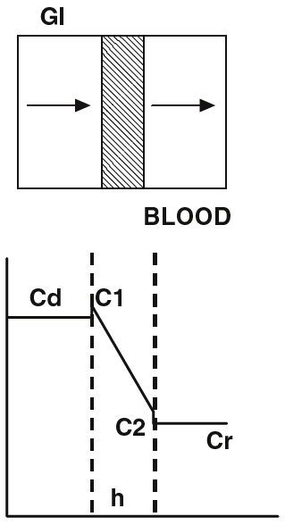
Fick’s First Law of Diffusion:

  - GI – gastrointestinal tract
  - Cd – donor compartment (the lumen) – High concentration of drug molecules
  - C1-C2 – cell membrane (thickness = h)
  - Cr – systemic circulation – Sink condition
- Sink condition: drug enters systemic circulation which has infinitely more liquid, therefore the concentration of the drug is infinitely lower and essentially equal to zero.
- Since Cd is so much greater than Cr (sink condition) it is insignificant and therefore plays no role in the equation.

Equations:
J: Flux (amount of material flowing through a unit cross section)
D: Diffusion coefficient

Partition coefficient:

Substitution:

Since Cd >>> Cr Permeability coefficient:

THUS:

FACTORS AFFECTING DRUG ABSORPTION:

- Solubility
- Permeability (ability to cross membrane)
- Dissolution (prosses in which a solute forms a solution in a solvent)
- Gastric emptying time (stomach empties after a certain amount of time)
- Surface area of drug
- Intestinal motility (constant movement in intestines)
- Characteristics of GI fluids (affected by food, drink, other drugs, etc.)
- Food
- Age

Key Principle:
For a drug to be absorbed, it must first be dissolved in the fluid at the absorption site.

Key Dilemmas:
  - The un-ionized (hydrophobic) form is absorbed more readily across a biological membrane/tissue than its ionized form
  - Hydrophobic compounds are not readily soluble in the gastric fluid
- Want a drug to be hydrophobic so it can cross the membrane, but also soluble (hydrophilic) so it can be absorbed

Dissolution:
- The process by which a drug particle dissolves
- From dissolution to absorption:
  - Drug molecules on the surface enter the solution
  - Creation of a saturated layer: diffusion layer
  - Drug molecules in the diffusion layer leave and enter the dissolving fluid
  - Drug molecules make contact with the membrane
  - Absorption takes place
- The diffusion layer continues to be replenished
Strategies for increasing dissolution:
- Drug Particles
  - Increasing surface area
  - Reducing the drug particle size
  - Increasing solubility of the drug
- Solvent
  - Decreasing the viscosity
  - Change the pH
- Other parameters
  - Increasing the intensity of agitation of the solvent
  - Increasing temperature (not of body)

Gastric emptying time:
Too long gastric emptying time = too long to reach intestines = too long to absorb = too long to act
Too fast gastric emptying time = drug particles may miss their absorption sites
- A drug could stay in the:
  - Stomach: 2-4 hours
  - Small intestine 4-10 hours
- Gastric emptying time most rapid with a fasting stomach but becomes slower as food content increases
- Certain drugs enhance the emptying time (e.g. laxatives)

Surface area:
- Smallest particles = fastest absorption
- It is increased when drug particles are broken up:
  - Micronized powder - ≤ 5 μm
- Different particle sizes for the same drug but from different manufacturers may lead to different therapeutic responses. Example phenytoin:
  - Prompt Phenytoin Sodium Capsule
    - ≈ 85% in 30 minutes
  - Extended Phenytoin Sodium Capsule
    - ≈ 15 - 35% in 30 minutes
- Small intestine has largest effective surface area for drug absorption due to folds of mucosa, villi, and microvilli (most drug transporters are expressed)
- The stomach and large intestine have no villi and microvilli (less drug transporter expressions)

Intestinal motility:
- Propulsion:
  - Determines the intestinal transit time of drugs, which is important for:
    - Slow release dosage forms
    - Enteric coated drugs = coated (with polymer film that dissolves at pH around 7 – intestine pH) so that it doesn’t dissolve until the intestine (protected from stomach acids) – this method is used when we know that the medical ingredient will be affected by the acid Aspirin.
    - Slowly dissolving drugs
    - Carrier-mediated absorption
- Mixing:
  - Increase dissolution rate via:
    - Drug molecule contacts with endothelial surface area for absorption

Characteristics of GI fluids:
- GI pH:
  - Affects drug ionization
  - Depends on patient health
  - Patient age
  - Type of diet
  - Results differ according to diet
- Drug effect:
  - Anticholinergic drugs & H2 -blockers:
    - Increase gastric pH
    - Significantly decrease bioavailability of some drugs

Food:
- High fat food may:
  - Stimulate bile salt secretion
  - Increases drug solubility and dissolution
  - Increases bioavailability for certain drugs with low solubility
- High protein food may:
  - Increase gastric pH
    - Decrease dissolution of weak basic drugs
    - Decrease bioavailability
- High calorie food may:
  - Decrease gastric emptying rate
  - Delay rate of absorption
  - Delays the onset of therapeutic drugs
    - Decrease dissolution of weak basic drugs
    - Decrease bioavailability
- Food components may compete for drug transporters:
  - Grapefruit juice:
  - Inhibits efflux pump (P-gp) and increases bioavailability of P-gp substrates.
- Food components may form complexes with drugs:
  - Decrease drug absorption & bioavailability.
    - Example: Tetracycline forms a complex with calcium in milk and impedes its absorption

Age:
- In the elderly – the following are decreased:
  - Gastric acidity
  - Number of absorptive cells (common to elderly and newborns – in newborn organs not fully developed)
  - Intestinal blood flow
  - Rate of gastric emptying
  - Intestinal motility

PHARMACOKINETICS & BIOAVAILABILITY

Pharmacokinetics: The study of how a drug reaches its target, and what happens to it during that journey. It elucidates the time course of drug concentration in the blood and tissues.

ADME (Absorption, Distribution, Metabolism, Excretion)
- Absorption phase
  - The process through which drug proceeds from the site of administration into the systemic circulation in which drug level can be measured.
- Disposition phase – everything that happens after absorption
  - Distribution through body (systemic circulation)
  - Metabolism begins in the intestine, then in the kidney
  - Excretion

Distribution:
- Not all of the drug that enters the bloodstream is involved in therapeutic activity
  - Could be bound to blood proteins
    - Considered inactive but may serve as reservoir
(a reservoir is a place from which you can draw things from – because it is not metabolized/excreted, the drug will stay in circulation until it is unbound eventually, resulting in the drug acting longer in the body – the ratio of bound drug becoming unbound is not included in formulation calculations so these calculations are based on concentration required to be in circulation)
      - High percent (sometimes >99%) bound, therefore the required concentration of drug in the bloodstream is normally much, much less than the amount of drug in the tablet. (ex. 100mg – 99mg bound, 1mg has therapeutic effect)

    - Shielded from metabolism and excretion
  - Transferred into the fluid bathing the tissues
    - Considered active as it’ll interact with the intended target faster
    - May accumulate in cells according to their permeability and chemical & physical affinities
    - Will be subject to metabolism and excretion

Elimination: irreversible process.

Metabolism:
- A biotransformation through which a xenobiotic or endobiotic compound is enzymatically transformed into a generally more polar, water-soluble, and excretable metabolite.
  - major process by which foreign substances, including drugs are eliminated from the body.
- Why does it become more polar and water-soluble? It is preparing it for excretion (making it more easily carried by blood)

- During metabolism, a drug may be biotransformed into a pharmacological form that is: active, inactive, or both
- Prodrug – administered drug that is “inactive” while its metabolite is “active”
- Four principle chemical reactions are involved in the metabolism of drugs:
  - Oxidation, Reduction, Hydrolysis, Conjugation

Factors that influence metabolism:
- Species differences
  - Extremely difficult to extrapolate from one species to another (e.g. Mice to humans)
- Interindividual variations
  - Genetic factors: cytochrome p-450 (CYP) mutations – vary depending on ethnic group, environments, etc.
    - CYP most important metabolic enzymes located mainly in liver (in intestine also)
- Age
  - Ability to metabolize drugs is low in neonates and the elderly
    - Liver blood flow is reduced by aging at about 1% per year
- Diet
  - Production of polycyclic hydrocarbons by the charcoal broiling of beef affects theophylline: enhances its hepatic metabolism, shortens its plasma half-life
  - Large quantities of grapefruit juice (at least 1 quart daily) taken with some HMG-CoA reductase inhibitors (statins) such as Lipitor may increase plasma levels of the drug and increase patient risk of myopathy
- Other drugs
  - Pesticides, alcohol, nicotine
- Disease state

Elimination:
- Excretion terminates the activity and presence of drugs and their metabolites in the body.
- Elimination includes metabolism & excretion
- Excretion takes place through various routes:
  - Kidney – via urine – the main organ of elimination
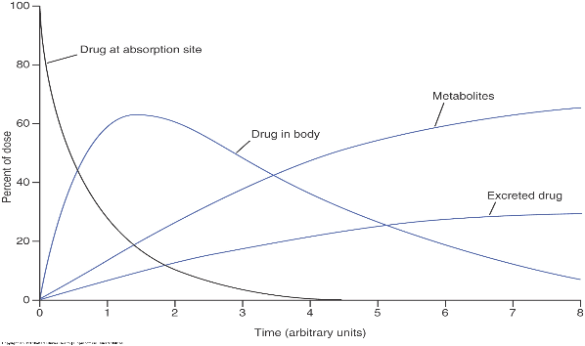
  - Anus – via feces
  - GI tract – via bile
  - Lungs – via expired breath
  - Sweat glands – via saliva & milk
- Drugs may enter the breast milk and be transferred to nursing infants:
  - Theophylline, Penicillin, Reserpine, Codeine, Meperidine, Barbiturates, Diltiazem, Thiazide diuretics

Fig. 4 – Time course of drug in the body.
- Drug at absorption site = rate limiting step
- Accumulation of drug in body, formulation of metabolites (from liver), and drug excretion all happen almost simultaneously
Question: How to determine the drug concentration at the active site of action following absorption?
Answer: Compartmental analysis
Compartmental Models:
- Key assumption:
  - The human body may be represented by one or more compartments in which a drug resides in a dynamic state for a short time
  - Concentration of the drug is uniform throughout each compartment

One-compartment model:
- The simplest pharmacokinetic model
- Depicts the body as a single compartment
- A drug can be introduced in the compartment via:
  - Rapid intravenous administration
  - Gradually e.g. oral administration
- The drug distributes to tissues and reaches equilibrium
- The drug is eliminated from the compartment at a certain rate
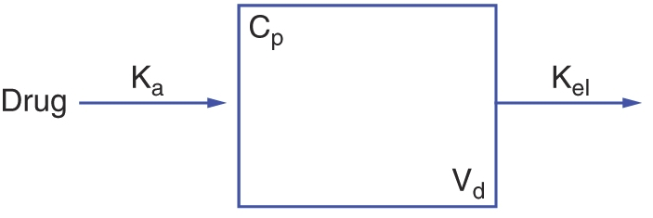

K_{a}: Absorption rate constant
K_{el}: Elimination rate constant
C_{p}: Drug concentration in plasma
V_{d}: Volume of the compartment or distribution

Concentration of drug at time t:

Where:
C: Concentration of the drug at time t
C₀: Concentration of the drug at time zero, when all the drug administered has been absorbed and none has left the body
k_{el}: First-order rate of elimination constant
t: Time

Half-Life (t_{1/2})
- Time required for a drug’s blood concentration to decrease by half
- Indication of rate/extent of metabolism and/or excretion
- Useful in determining the most appropriate dosage regimen
Exception: If the administered drug is a prodrug the half-life will not truly be an indication of the metabolism of the drug because the drug is being created following metabolism
- Half-life is important to reduce possibilities of risks (want drug to be in body for minimum amount of time possible that still provides desired effect)
- Blood-protein binding could extend the half-life

Formula: or

Clearance (Cl_{b}):
- The sum of all body clearance by liver (hepatic) or kidneys (renal)
- Clearence via the vile and faeces is not significant
Expressed as:

Where: V_{d}: Volume of distribution
K_{el}: Rate of elimination of the drug from the body

Drug Bioavailability:
- Rate and extent to which a drug is absorbed and becomes available at the site of action.
- Portrayed by a concentration time curve of the administered drug in a specific tissue system

- We want to know: if you take the drug what is the highest concentration that the drug is able to reach in your body? Why? Toxicity.
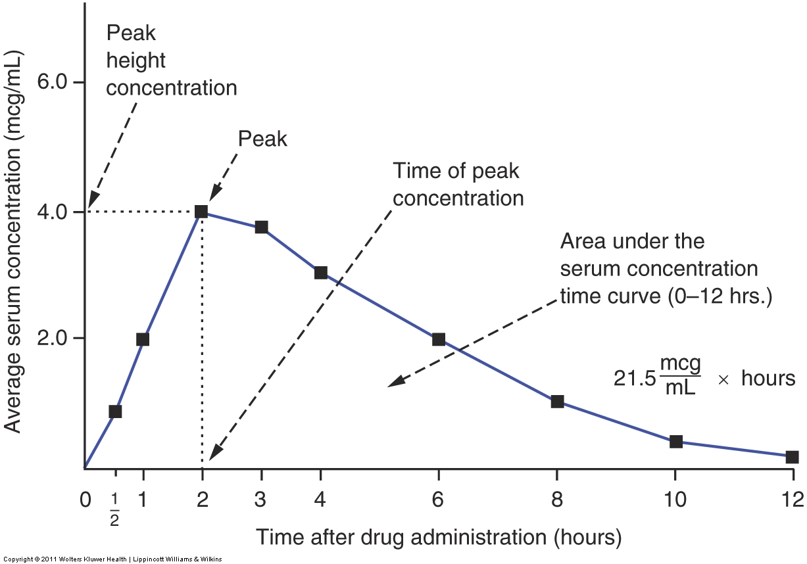
Key Bioavailability parameters:
- C_{m}: Peak height concentration
  - Want to know if peak concentration is toxic
    - On graph – slope of zero (Rates of absorption and elimination are equal)
      - Before C_{m} = absorption
      - After C_{m} = elimination
  - Used to compare different formulations of drugs
- T_{max}: Time of the peak concentration
  - Reflects the rate of absorption
  - Determines the time needed for MEC to be reached
        - MEC – minimum effective concentration
          - If peak is below MEC – drug has no effect
        - MTC – minimum toxic concentration
      - Depending on whether a rapid onset of action is required
- AUC: area under the blood concentration-time curve
    - Represents the total amount of drug absorbed into the blood following the administration of a single dose of a drug.
    - Determines extent of absorption
    - Drugs with different C_{m} can still have similar AUC
    - The bioavailability (F) of an orally administered drug is:

Bioavailability data used to determine:
- The amount of drug absorbed and the rate at which the drug was absorbed
- The duration of the drug’s presence in the biologic fluid or tissue correlated with the patient’s response
- The relationship between drug blood levels and clinical efficacy and toxicity
- To compare different dosage forms of a drug

Desired effect of the Dose of a Drug:
- Effective dose of a drug may be different for different patients
- In normal distribution (bell curve) sample:
- The dose that would produce the desired effect in most individuals is considered the drug’s usual adult dose (starting dose)
  - Middle of bell curve

Oral Administration – Solid Dosage Form

Dosage Forms:
- Drug substances may be formulated into multiple dosage forms
- A key consideration in selecting the dosage form is whether it is intended for local or systemic effects
  - Local vs. Systemic
    - With respect to the site of administration
    - Any drug that must enter the bloodstream first – systemic
    - Any drug that does not have to enter bloodstream first (directly on site of action) – local
- Different dosage forms generally result in different:
  - Absorption rates
  - times of onset
- These differences in absorption between dosage forms are a result of:
  - formulation
  - route of administration

Path of an oral dosage tablet:
- Stomach
  - Acid + enzymes
- Small intestine
  - Food products + enzymes + dissolution
- Liver
  - Entero-hepatic loop + first-pass effect
- Blood
  - Protein binding
- Site of therapeutic action (Small fraction of dose taken)

Ingredients & Preparation:
- All pharmaceutical dosage forms generally contain:
  - Medicinal ingredient and Non-medicinal ingredients
- Most ingredients occur in the solid state as:
  - Amorphous powders
  - Crystals
    - Powder: intimate mixture (homogeneous) of dry, finely divided drugs and/or chemicals that may be intended for internal or external use
- Before their use, solid materials’ (both medicinal and non-medicinal) physical & chemical characteristics are first determined:
  - Morphology
  - Purity
  - Solubility
  - Flowability (how it will flow in a mixer/tablet press)
  - Stability
  - Particle size
  - Uniformity (homogeneous)
  - Compatibility with other components (i.e. non-medicinal ingredients do not effect medicinal)
- Solid materials are subjected to various treatments to enable:
  - Efficient production of the finished dosage form
  - Optimum therapeutic efficacy
Medicinal & non-medicinal ingredients powders are:
  - blended to produce:
    - Tablets + Capsules
  - Suspended (not dissolved/not in solution) in liquid vehicles to prepare:
    - Liquid dosage forms
  - Incorporated in semi-solid bases to make:
    - Ointments + Creams
  - Agglomerated into granules
    - Granules are powders that have been agglomerated into larger particles

Powders
- Particles of pharmaceutical powders vary in size:
1 µm (or less) – 10 mm
- Particle sizes influence important factors:
  - Dissolution rate
    - Dissolution is the action of particles forming solution (solubility is the maximum amount that goes into solution)
    - Longer process for larger particle sizes
    - Shorter process for smaller particles
      - Micronization improves dissolution rate
  - Suspendability
    - Particles not in solution – why liquid drugs need to be shaken
    - Fine dispersion requires particle size of 0.5 – 10 µm
    - Larger particle sizes may prevent suspendability
    - Why suspension instead of in solution?
      - Due to solubility issues
      - To mask the taste of the drug
      - To avoid toxicity issues with co-solvents
  - Uniform distribution
    - For the drug substance in the powder mixture or solid dosage form
    - To ensure dose-to-dose content uniformity
    - United States Pharmacopeia provides a margin of error (around 5-10%)
  - Penetrability
    - For particles to be inhaled required size of 1 – 5 µm
  - Lack of grittiness
    - Want creams, ointments, etc. to be smooth
    - Required size of 50 – 100 µm

Granules
Generally prepared by:
- Wet methods:
  - Moisten the powder, pass through a screen of desired mesh size, dry by air/heat
- Dry methods:
  - Powder passed through a roll compactor, passed through granulating machine for desired particle size
Advantages of granules vs powders:
- Better flowing properties
- Reduced surface area:
  - More stable to humidity, less likely to cake/harden
- More easily wetted by liquids
  - Preferred for products to be constituted into solutions/suspensions (Certain antibiotic drugs)
- Powders are high maintenance in production – float in air in pharmaceutical companies and can cross-contaminate drugs
Effervescent Granulated Salts:
- Goal: to mask undesirable taste of medicinal agent
- Granules generally containing a dry mixture of:
  - Medicinal ingredient
  - Sodium bicarbonate
  - Citric acid
  - Tartaric acid
- When added to water:
  - The acids & the base react
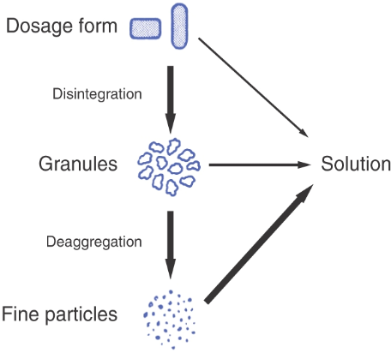
  - Liberation of carbon dioxide
    - Effervescence

Tablets
- Key consideration:
  - Exposure of the drug substance to the dissolution process may involve a few steps.

Types of tablets:
- Compressed tablets
- Film-coated tablets
  - Compressed tablets with a thin polymer coating layered into the tablet as a thin film
- Enteric-coated tablets
  - Delayed release
  - Enteric coating generally dissolves in a higher pH range (e.g. after moving into the small intestine)
  - Protects drug at acidic pH range (stomach)
- Buccal (stays in mouth – absorbs through cheek to bloodstream) and Sublingual tablets (under the tongue
  - Don’t go through GI tract
    - avoiding first pass metabolism
    - Good for pH sensitive products (protects from gastric juices)
- Chewable tablets
  - Children
  - Adults who have difficulty swallowing
  - Must be chewed and should not be swallowed whole

Tablet qualities:
  - Accurate & uniform weight (all tablets same concentration within range)
  - Homogeneity
  - Absence of incompatibilities
  - Stability and hardness
  - Ease of disintegration
  - Reasonable size and shape
  - Pleasing appearance
  - Ease of manufacturing
  - Economy of production

Non-Medicinal ingredients:
  - Dilutents
    - Increase bulk
  - Binders
    - Hold powders together
  - Disintegrants
    - Aid in breaking up the tablet
  - Lubricants
    - Improve powder flow properties
    - Decrease adhesion and friction
    - Facilitate tablet ejection
  - Glidants
    - Improve flow properties
  - Colouring
  - Flavouring

Quality Standards and Compendial Requirements
- Weight
  - USP weight variation test: 10 tablets weighed individually and average calculated
- Content uniformity
  - Ten tablets are assayed
  - Content of medicinal ingredient in each tablet calculated
    - 85% - 115% Standard deviation: <6%
  - Homogeneous drug distribution expected
- Thickness
- Hardness & Friability
  - Hard enough to resist breaking during normal handling
    - Need to stay intact to ensure proper dosage
  - Soft enough to disintegrate properly
- Disintegration
  - Six tablets are assayed
  - Tubes lowered & raised in immersion fluid at 29 – 30 cycles per minutes at 37 deg. Celsius. (normal body temperature)
  - Disintegration must be achieve according to the compendium requirement
- Dissolution
  - Intestinal motility is mimicked in the lab when testing dissolution
  - An indication of bioavailability
    - drug particles must be in solution for absorption to occur
  - Allows for in vitro selection of formulation
  - In the dissolution fluid at 37 deg. Celsius (body temp)
  - Batch-to-batch consistency is vital

Tablet Advantages:
- Accurate dosage/minimum variability
- Patient acceptance
- Absence of alcohol
- Concentration variability
- Elegance
- Convenience (light and compact)
- Tamper resistant
- Low cost (Liquid – need antiseptic environment, anti-microbial and also administration costs)
- Easiest/cheapest to package and ship
- Production identification is simple
- Ease of administration
- Special release profiles possible
- Suited for large-scale production
- Best overall properties of all oral dosage forms

Tablet Disadvantages:
- Swallowing
- Difficult to extemporaneously prepare (outside of pharmaceutical lab – cannot prepare inside pharmacy)
- Some drugs resist compression
- Poorly wetting drugs, slow-dissolving drugs, intermediate to large dosages
- Bitter taste/bad odor
- Oxygen/moisture-sensitive require coating

Fick’s First Law of Diffusion
The rate of diffusion across a membrane is proportional to the difference in drug concentrations on both sides of the membrane.

  - GI – gastrointestinal tract
  - Cd – donor compartment (the lumen) – High concentration of drug molecules
  - C1-C2 – cell membrane (thickness = h)
  - Cr – systemic circulation – Sink condition

Sink condition: drug enters systemic circulation which has infinitely more liquid, therefore the concentration of the drug is infinitely lower

J: Flux (amount of material flowing through a unit cross section)
D: Diffusion coefficient

Diffusion coefficient: proportionality constant between the molar flux due to molecular diffusion and the gradient in the concentration of the species (or the driving force for diffusion).

Partition coefficient:

Substitution: to

Since Cd is so much greater than Cr (sink condition) it is insignificant and therefore plays no role in the equation.
Permeability coefficient:

Permeability coefficient: a coefficient associated with simple diffusion through a membrane that is proportional to the partition coefficient and the diffusion coefficient and inversely proportional to the membrane thickness.
THUS:

Pro-drug Formulation:

- Pro-drugs: the chemical modification of a drug aimed at the enhancement of solubility and permeability
- this strategy can be applied to water-insoluble (hydrophobic) drugs and hydrophilic drugs.

Process:
- Drug cannot pass through membrane – either not in solution (hydrophobic) or not permeable (hydrophilic)
- Addition of a linker and transporter substrate (amino acid derivative or ester form)
- Drug with transporter substrate can pass through bilayer via transporter (by secondary transport)
- Catalytic cleavage occurs to separate drug an transporter substrate
- Drug produces desired effects

Hydrophobic:
  - Strategy: use of amino acid derivatives to increase solubility. (will be converted back to parent drug by intestinal enzymes)
Hydrophilic:
  - Strategy: use of ester form of parent drug to increase hydrophobicity and diffusion. (will be converted back to parent drug by esterases within the body)

Tip:
- Design the drug as a substrate of specific transporters:
  - Usually peptide transporters
  - Preferable if transporter is located apical and basolateral

Example: Dipivefrin is a prodrug of epinephrine.
  - Esterification of epinephrine with pivalic acid
  - produce dipivefrin – has enhanced lipophilicity (penetration into eye 17x that of epinephrine)
  - Once in chamber – enzymatic hydrolysis of dipivefrin in the eye re-produces epinephrine.
  - Epinephrine induces pharmacological effects

know before using pro-drug strategy:
  - Know more about catalytic cleavage:
    - The effect of the cleavage on the drug
    - How successful will it be (%) – needs to be successful enough that it is effective.
    - What will happen after detached?
  - Know more of the linker:
    - What’s the nature of the linker? Is it toxic?
  - Know about the substrate:
    - How does it interact with the drug?
  - Know about the fate of the drug

Distribution:
- Not all the drug that enters the bloodstream is involved in therapeutic activity
  - Could be bound to blood proteins
    - Considered inactive but may serve as reservoir
(a reservoir is a place from which you can draw things from – because it is not metabolized/excreted, the drug will stay in circulation until it is unbound eventually, resulting in the drug acting longer in the body – the ratio of bound drug becoming unbound is not included in formulation calculations so these calculations are based on concentration required to be in circulation)
      - High percent (sometimes >99%) bound, therefore the required concentration of drug in the bloodstream is normally much, much less than the amount of drug in the tablet. (ex. 100mg – 99mg bound, 1mg has therapeutic effect)
    - Shielded from metabolism and excretion
  - Transferred into the fluid bathing the tissues
    - Considered active as it’ll interact with the intended target faster
    - May accumulate in cells per their permeability and chemical & physical affinities
    - Will be subject to metabolism and excretion

- Describe the inter-relationship of the concepts of absorption and drug disposition
- Explain the characteristics of metabolism, the chemical reactions involved, and key factors involved
- Explain the compartmental model and corresponding key assumptions
- Differentiate between powders & granules
- Explain how the powder’s particle size influences the dosage form.
- Compare and contrast advantages and disadvantages of the various types of tablet dosage forms.
- List categories of non-medicinal ingredients, with examples, which are employed in the manufacture of compressed tablets.
- State & explain quality standards and USP compendial requirements for tablets.
- Define and differentiate weight variation from content uniformity.
- Explain the fate of orally taken drugs

