BPS2110 – Introduction to Biopharmaceutical Science

Biopharmaceutics: The study of the properties of “therapeutic substances” and their dosages/bioactivity relationships.

Therapeutic Substances:

Prescription Drugs
- “Small molecule” (generally with molecular weight of < 500 – anything > 500 has difficulty crossing the blood-brain barrier)
- Peptides/proteins (amide bonds are easily broken down by peptases meaning they have a shorter biological half life and require more frequent dosages)
- Vaccines (and conjugates)
Natural Health Products (NHPs)
- Vitamins
- Plant extracts
Diagnostics
- Radioisotopes and dies, Probes

Pharmaceutical Sciences: A group of “interdisciplinary” areas of study involved in the design and synthesis, mode of action (know every metabolite), delivery, and use of drugs.

The Pharmaceutical Industry

Purpose: Supplying materials and techniques that deliver (or promise to deliver) the things that people desire most – good health!

Cure vs. Prevention and Life Expectancy:

Average lifespan in early 1900’s = 50 years, in 2015 = 80+ years.
Why?? Higher standard of living.
  - Better food (and food supply)
    - Ex. Pasteurized milk (unpasteurized = risk of TB), Safe water
  - Work place infrastructure & education
    - Workers educated to stay safer, safer environments, basic safety is general knowledge
  - Vaccines (prevention)
  - Drugs (cures)
    - Antibacterial, antihypertensive (BP)
  - Diagnostics (and improved medical procedures)
    - Able to treat serious conditions earlier

The “irony” is that healthcare spending by government does not correlate well with “wellness”

Global Pharmaceutical Industry:

The top four drug companies (2012):
- Pfizer
(USA) $70.7 Billion 137,000 Employees
- Johnson + Johnson
(USA) $63.7 Billion 119,000 Employees
- Hoffman-LaRoche
(Switzerland) $43.9 Billion 98,200 Employees
- Novartis
(Switzerland) $41.5 Billion 98,200 Employees

The others:
- GlaxoSmithKline
(UK) $40 Billion 103,000 Employees
- Merck-Frost
(USA) $24 Billion 74,300 Employees
- Boehinger Ingelheim
(Germany) $17 Billion 43,000 Employees
- Takeda Pharma
(Japan) $16 Billion 15,000 Employees

The Most Prescribed Drugs (USA, 2012):
- Hydrocodone
  - 131.2 million prescriptions
  - Synthetic opioid from codeine (painkiller)
- Generic Zocor
  - 94 million prescriptions
  - Hypolipidemic drug (lowers cholesterol)
- Lisinopril
  - 87 million prescriptions
  - ACE Inhibitor (lowers BP to stop hypertension)
- Generic Synthroid
  - 70 million prescriptions
  - synthetic thyroid hormone (regulates basal metabolic rate)
- Generic Norvasc
  - 57 million prescriptions
  - calcium channel blocker – called the “next generation beta blocker”
  - For people with really high BP
  - Hypertension often treated with ACE inhibitor, beta blocker & diuretic
- Generic Prilosee
  - 54 million prescriptions
  - treats gastro esophageal reflux disease (GERD)
- Azithromycin (z-pak)
  - 56.2 million prescriptions (Pfizer)
  - antibiotic taken for 5 days, stays in system for weeks (easier than asking someone to take pills for weeks – less drug resistance)
- Amoxicillin
  - 52.3 million prescriptions
  - antibiotic
- Generic Glucophage
  - 48 million prescriptions
  - First line of treatment for type II diabetes (can’t absorb glucose)
- Hydrochlorothiazide
  - 48 million prescriptions
  - controls BP

*Fact: Most antibiotics are used in agriculture (livestock, fish farming)

Top Selling (Grossing) Drugs

USA, 2010:
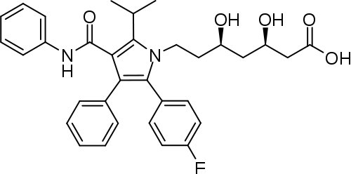
- Lipitor
  - $7.2 Billion
  - Cholesterol lowering drug
  - Alkane chain is the “business end”, it mimics natural substrate to block the pathway in which cholesterol is formed
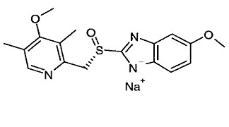
- Nexium
  - $6.3 Billion
  - Proton pump inhibitor (treats esophageal reflux (GERD))
  - Non-charged molecule is not water soluble, so they make the anion to make it hydrophilic
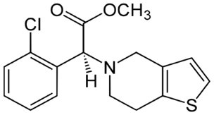
  - Forms dimers which do the work (for this reason, lots of patent issues surrounding it)
- Plavix
  - $6.1 Billion
  - Blood thinners (treat blood clots)
- Advair
  - $4.7 Billion
  - Treat asthma
  - Two drugs in one: the first opens airways initially, the second (steroids) stop swelling in the bronchioles.
- Ability
  - $4.6 Billion
  - Antipsychotic

Compare stats in 2012:
- Humira
  - $9.8 Billion
  - anti-inflammatory
- Enbrel
  - $8.4 Billion
  - Psoriasis, rheumatoid arthritis
- Advair
  - $8.0 Billion
  - Asthma
- Remicade
  - Chimeric (chemo therapy) monoclonal antibody (MAB) against TNF alpha (tumor necrosis factor)
- Rituxan
  - Chimeric MAB to treat B-cell diffusion (tissue rejection)

*Notice the change in order:
- Newer drugs to treat complex autoimmune conditions (this is a recent change)

Compare stats in 2006:
- Lipitor – $14.4 Billion
- Advair – $6.1 Billion
- Plavix – $6.1 Billion
- Nexium – $5.2 Billion

50. Ability – $1.9 Billion

The Canadian Pharmaceutical Industry

Represents only 3% of the world pharmaceutical sales (2010) (Still make the Global top 10 list)
“Canadian Pharma” consists of:
- Research and Development (R+D) companies = 78% of total sales
- Generic Drug companies = 22% of total sales
R+D companies are usually multinational
- Develop new drugs (this requires a lot of $$)
- Average cost is around $700 million per drug
Generic companies manufacture drugs after the patents expire (approx. 20 years)

Drug Costs vs. Healthcare Costs
Year | $ on Drugs | $ on Healthcare | % of Drugs Available
2000 | $15.1 Billion | $98 Billion | 15.3 %
2005 | $23.3 Billion | $141 Billion | 16.5 %
2010 | $30.1 Billion | $192.8 Billion | 16.0 %

We Don’t have more drugs even though we spend increasingly more money on healthcare

Theories:
- First world nations are much wealthier and can just afford to pay more
- Older and less healthy population
- We utilize more and more healthcare each year

Drug Development

Combined Effort from:
- Biochemists
- Molecular Biologists
- Physiologists
- Analytical Chemists (quality control and formulation)
- Toxicologists
- Organic Chemists
- Pharmacologists
- Biostatisticians
- Chemical Engineers (control exotherm of reactions – can be dangerous on large scale)
- Legal Experts (patents, intellectual property (IP))

Process of Drug Development

- Typical timeline = 8-18 years
  - From identification of a potential “drug” to development of a “lead structures” to approved for sales by FDA or Health Canada
- Four phases:
- Preclinical Research and Development – (3-8 years)
- Clinical Trials – (4-8 years)
- New Drug Application (NDA) Review – (1-2 years)
- Post market surveillance – (on going)

A closer look at these phases:

- Preclinical Research and Development
*Entire preclinical research and development (R&D) phase takes a long time (3-8) years
  - Understanding the nature of the disease or condition that you want to treat (drug companies don’t want to find the one-time cure as that is not profitable)
  - Where do you “intervene” in the process of the disease to treat it?
    - Need full understanding of the disease mechanism
    - Consider HIV
      - Initial Infection
      - Replication – HIV Protase target, Reverse transcriptase inhibitors
      - Virus Release (budding) – neuramidase inhibitors (Tamiflu)
  - Have to identify a “lead” structure or compound
    - Where do you look?
    - Three common strategies
      - Rational Design (uncommon)
      - Accidental discovery (*most common) – Ex. Viagra
      - Nature
  - Development of a bioassay to determine how effective a drug candidate is.
- HTS (high throughput screening) ideally
- ~1000 compounds in a library
  - 1 compound tested in 3 days, therefore 5000 days = 13.7 years
  - Chemical synthesis
    - Improve characteristics
      - Efficiency
      - Efficacy
      - Solubility

Efficiency vs. Efficacy
Drug inhibitory enzyme dose response curve
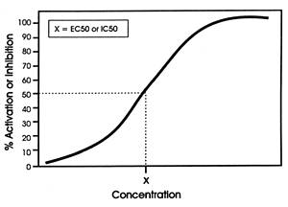
X = IC₅₀ value (half curve) = amount required to inhibit 50%

IC₅₀ in μM range = efficacious

IC₅₀ in M range = not efficacious

Efficiency: the way to maximize the effect.
Efficacy: the “power” required (amount of drug/concentration) to do that.
  - Testing Toxicity and Activity in appropriate models
    - In vitro
      - Cells, cell lines, tissue
    - In vivo
      - Animals (animal type depends on condition being studied)
      - Costs associated with animal tests arises from having to keep them all alive (food, housing, vets, etc.)
      - In vivo could be short term or long term studies

- Clinical trials (3 main phases)
  - Phase 1:
- 20 healthy individuals
- determines safety only (based on toxicity studies in previous stage)
- 1-2 months’ total
  - Phase II:
- Small, highly controlled group of patients who have the condition you want to treat with your drug
- 50 individuals
- Assess both efficacy and efficiency
- 3 months to 1-year total
  - Phase III:
- Large and diverse group of individuals that represent the “type” of person who would use the drug
- Efficacy and safety of the drug tested
- 3-8 years’ total

- New Drug Application Review & Regulatory Agency Approval
- Serious effort that requires the company (making the drug) to convince Health Canada (FDA in USA) that the IND (Investigational New Drug) Application is complete and covers all the requirements:
  - Manufactured well using GMP (good manufacturing procedure)
  - Knowledge of metabolic and pharmokinetics
      - Absorption, distribution, metabolism, excretion. (ADME)
  - SAFETY (or lack of any toxicity and serious side effects) and efficacy as shown in the clinical trials

Considering 1000 compounds entering Phase I clinical trials
      - ~600 pass onto phase II – (2/3 total)
      - ~400 make it through to phase III — (2/3 from phase II)
      - only ~50 may pass through phase III trials
    - ~5% make it to through clinical trials

Estimated Costs:
- Preclinical R&D = ~$5-10 million
- Phase I Clinical = ~$15-20 million
- Phase II Clinical = ~$90-100 million
- Phase III Clinical = ~$400-500 million
- Regulatory approval (NDA) = ~$5-10 million
TOTAL = ~$650-700 million

Big Question: how to manage cost and success rate (save money)?
- “Weed out” as many of the poor candidates before clinical trials as possible
- Apply ADME
- Use Lipinski’s rules for “Drug like” molecules – Rule of 5’s (RO%)
- No more than 5 H-bond donors (N-H, O-H, etc.)
- No more than 10 H-bond acceptors (N, O)
- Molecular mass less than 500 Daltons
- Octanol-H₂O partition coefficient (Log P) (how the molecule partitions itself between octanol and water)
- Look for obvious toxicity issues
- Use computer screening (in silico)

Last step in Drug Development:
- Post Marketing Surveillance
- Problem: large genetic diversity in large population makes it impossible to test all of the “adverse” effects.
- Drugs that treat life threating conditions can have more severe side effects that are tolerated
- Treating lifestyle situations (cancer, HIV), only minor side effects tolerated
- Have to list all side effects (SE’s)

How does Pharma “decide” what disease to treat?
- Filling a need (problem):
- E.g. HIV
  - 1980-2000 spent time studying the disease
  - then develop new drugs (nucleoside reverse transcriptase inhibitors, prolease inhibitors)
- React to opportunity:
- New developments in understanding of condition
- E.g. cyclooxygenases and inflammation (COX inhibitors)

How do we discover a drug candidate?

3 months
Active molecule “Hit”
Target Identification
3-4 months
6 months – 2 years
HTS
“Hit” lead
CANDIDATE DRUG
Lead Optimization projects
(trying to improve pharmacokinetics)

2 years
6-9 months

Common Drug Biological Mechanisms (sale of drugs 2005)
- Enzyme Inhibitors 38%
- Receptor Antagonists 24%
- Receptor Agonists 12%
- Ion Channel Modulator 8%
These four categories = 80% of all drugs made in 2005

Bioassays

- Once a target is established a need to identify other components that interact
  - Most targets are enzymes (easier to work with)
- Bioassays based upon either
  - Cells (whole)
  - Isolated enzymes
- A solution is HTS (high throughput screening)
  - Allows us to work with “libraries” or groups of compounds (100 10000) at once

Types of Libraries:
- Combinational Libraries (chemical)
  - Generate these using synthetic organic chemistry
  - Drawback = structural diversity is limited (constrained by structural patterns chemists think are essential and therefore miss the random structure that works)
  - A typical example: (2 component)
    - Amine and carboxylic acid amide bond
    - If we have 10 amines and 10 carboxylic acids, we get 100 different amides
  - PROS:
    - Generate many compounds
  - CONS:
    - No real diversity – all compounds have similar structure
    - Separation can be a problem
    - The diversity issue can be overcome by using natural product based libraries
- Natural Product-Based Libraries
  - Use extracts that contain many different compounds
  - PROS:
    - Highly structurally diverse library
    - Likely “bio-variable”
      - A sub category of absorption and is the amount of drug that reaches systemic circulation
  - CONS:
    - Complex mixture
      - Difficult to separate into different compounds

Diversity in Natural Product Libraries:

Plant Sources:
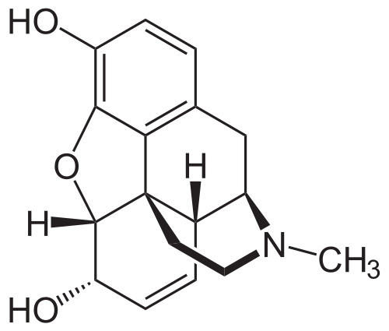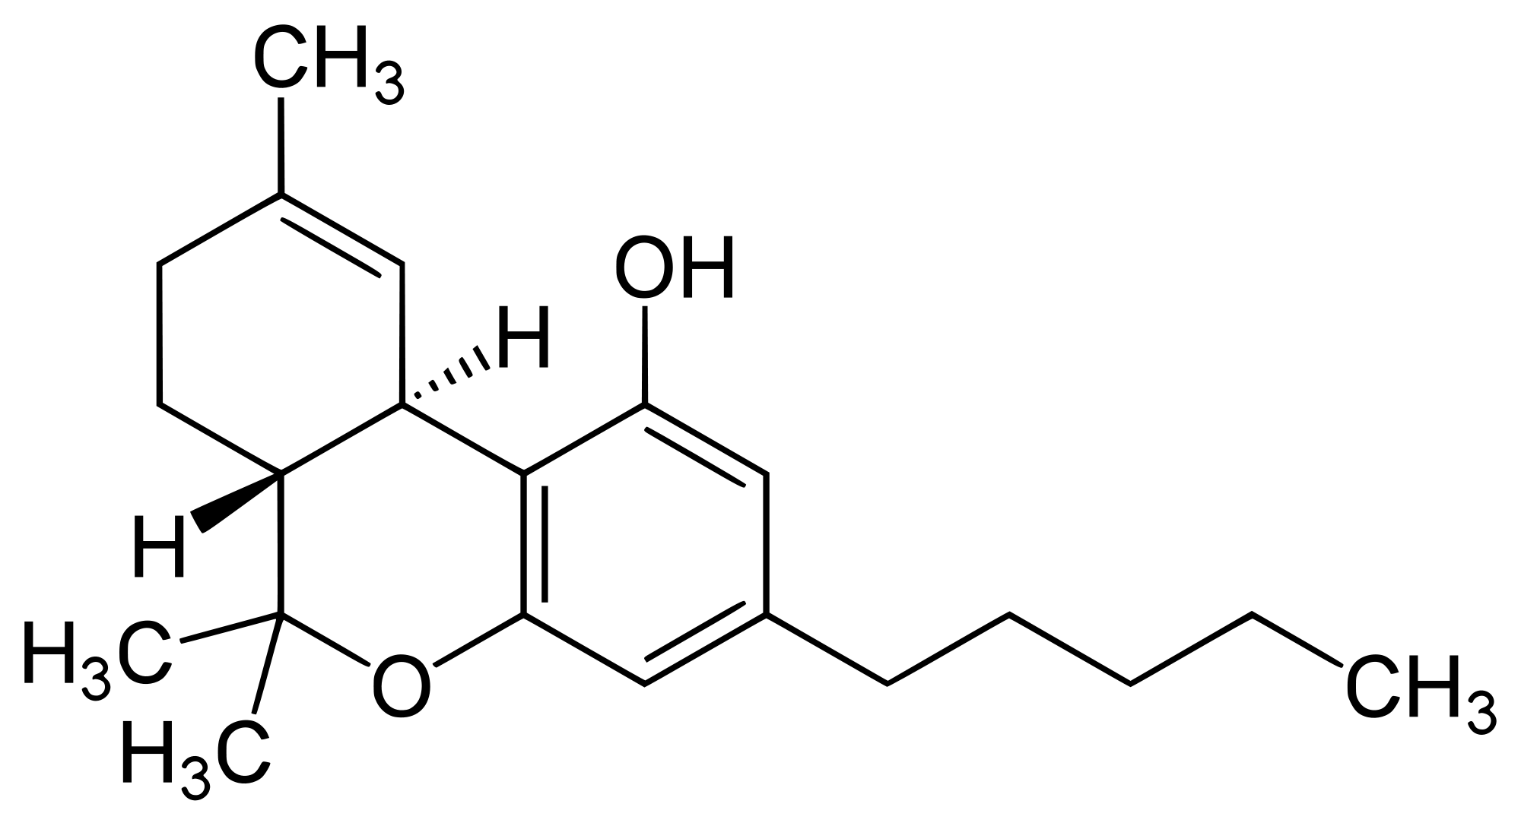
Morphine THC
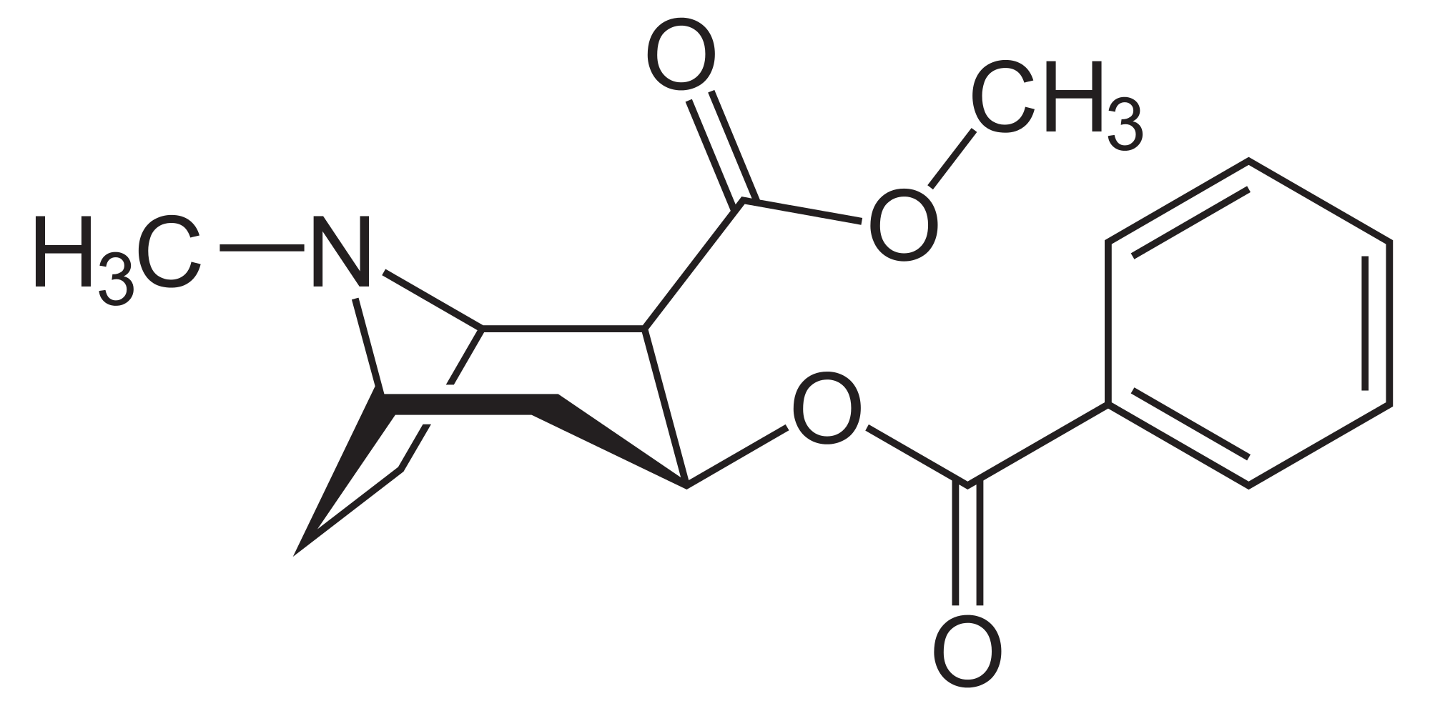 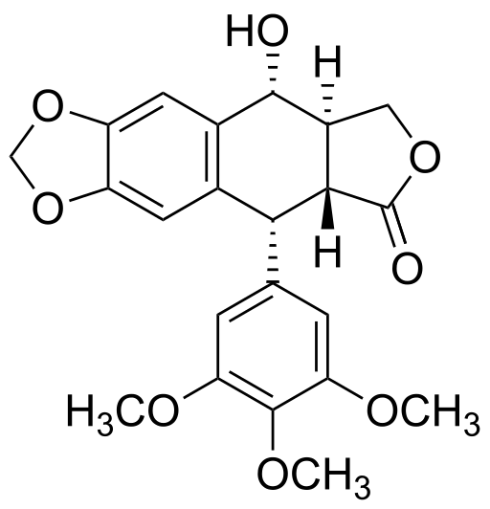
Cocaine Podophyllotoxin (anticancer)

Microorganisms:
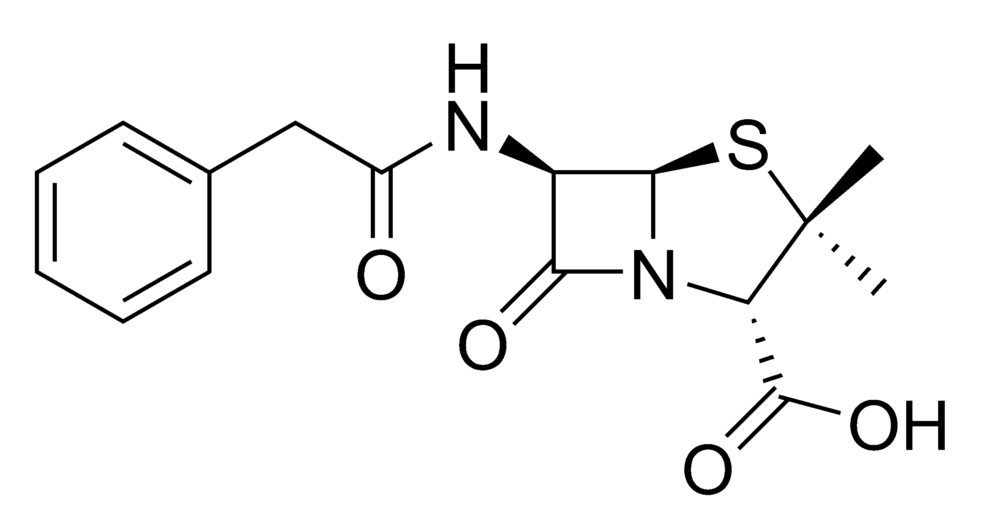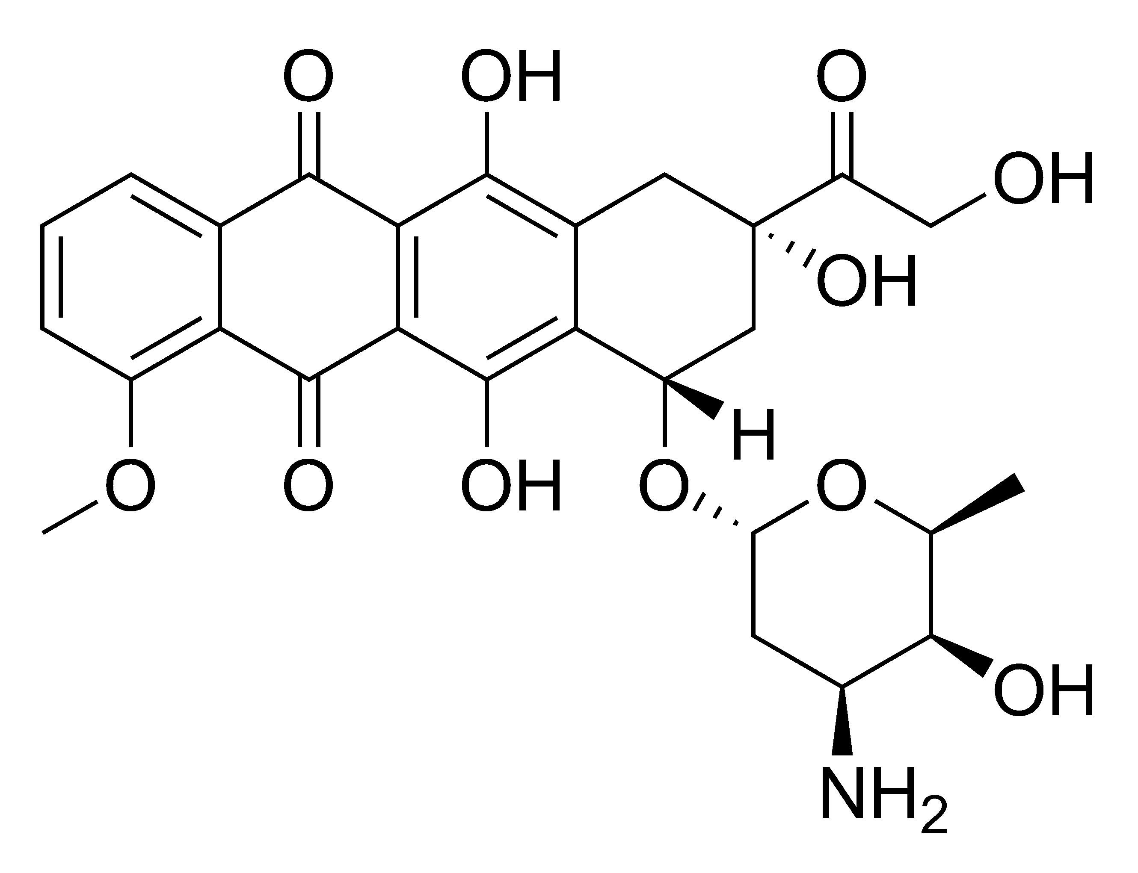
Penicillin g Adriamycin (anticancer)

High Throughput Screening (HTS)

“An industrialized process which brings together validated, tractable targets and chemical diversity to rapidly identify novel lead compounds for early phase drug discovery”
- Allows for screening of a series of compounds
- 50-70% of new drugs originate from an HTS
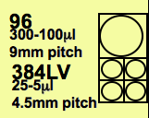
Microtitre Plates – the HTS test tube
- 125 x 1536 well plates
- 500 x 384 well plates
- 2000 x 96 well plates

SPA (Scintillation Proximity Assay)
- First true homogeneous HTS technology
- When a hit occurs (molecule binds to bead), the light turns on
- Allows throughput of ~30K compounds/day in 384 format
- Easy to automate, no significant volume of aqueous waste
- But:
  - Radioactive (safety headaches)
  - Long read times (>30min/plate)
  - Susceptible to quench artefacts
  - Not applicable to all targets

FLIPR (Flourescent Imaging Plate Reader)
- A high throughput fluorimeter
- Real-time simultaneous imaging of 96- & 384- well plates
- Used for HTS Ca²⁺ flux assays and ion channel screening
- How it works:
  - Cells loaded with fluorescent dye sensitive to Ca²⁺ (fluo-3)
  - CCD camera images base of microtitre plate
  - Addition of receptor agonist stimulates Ca²⁺ release, resulting in fluorescence increase
  - Whole plate is read simultaneously, allowing kinetic analysis
- Functional’ screen (i.e.whole cell) – greater relevance than simpler screening methods
- Throughput is 1000x greater than cuvette-based fluorimeter assay

A Clever Example of HTS:
- Solid phase library to bind a lectin
- The library contained a single compound on each bead and contained 1300 unique disaccharide and trisaccharide structures
- Result:
  - Only 25 beads stained blue.
  - 13 of these contained the same core disaccharide acylated with different hydrophobic groups.
  - Of the remaining 12 beads, all the carbohydrate structures were unique and two of these bound the lectin with higher affinity than the native substrate.

Ethnopharmacology
- The study of the use of plant-derived materials in traditional societies for the purpose of maintaining and improving health
- 80% of the world population uses plant materials to treat health problems
- combining random screening of natural product libraries and Ethnopharmacology is a clever strategy
  - e.g. 50% of “new” anticancer drugs come from natural products
- A great example is malaria treatment:
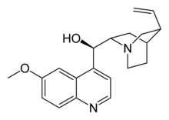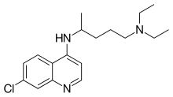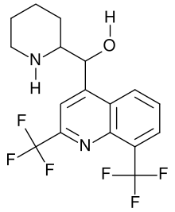

Quinine Chloroquine Mefloquine
- Chinrona tree - 1934-1943 - ~1970
- very first anti-malarial - resistance developed - [Vietnam war]
- parasite developed resistance - [US-Pacific WWII]

- All structures very similar, changes are very slight
- Why fast resistance developed?
  - Malaria serious issue during time of war (when USA was in malaria-ridden places)
  - Wars = need for new drugs
  - Often med-chem and drug development is based upon political/war needs
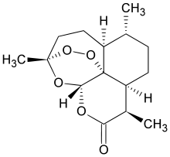
Today we have:
Artimisinin
- Comes from
artemensia annua
(Chinese traditional
medicine)

The Story of Statin Drugs

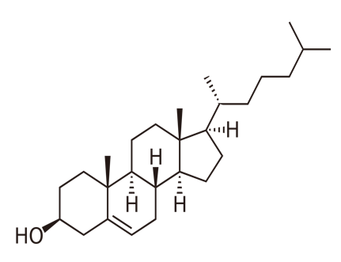
- Excellent example of drug discovery process
- Based upon a complete understanding of cholesterol biosynthetic pathway (biosynthesis)
Cholesterol
Sources include:
- Meats, lard, butter
- Not found in veggies or plant products

How do we use Cholesterol?
- Cell membrane (brain & spinal chord)

Negative Effects
- Arterial plaque (some of this can be controlled by diet)
Cholesterol (C₂₇H₄₆O)

Biosynthesis of Cholesterol
* Mevalonate is the key.

IPP AND DMAP ARE KEY BUILDING BLOCKS FOR CHOLESTEROL.
Mechanism:

* All of this had to be understood before a drug could be made.

The big question is:
How do you inhibit HMG-CoA reductase? (and ultimately reduce/hinder cholesterol biosynthesis to lower blood cholesterol levels)
Answer:
Find a substrate that “looks” like HMG-CoA and binds to the HMG-CoA reductase active site.

Inhibitors of HMG-CoA Reductase

Mevastatin:
- isolated from penicillium mold by Akino Endo (JPN) in the 1970’s
- He identified it as a potent HMG-CoA reductase inhibitor
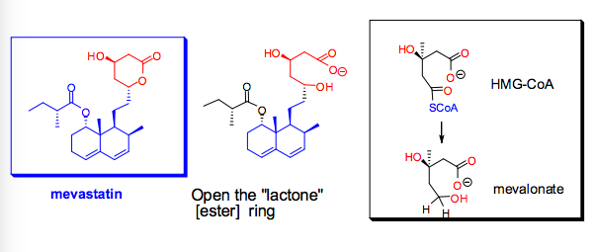
- When the “lactone” [ester] ring of Mevastatin is opened, the structure is called Mevalonate and it highly resembles HMG-CoA

- But Mevastatin was not developed due to toxicity issues

Merck-Frost takes a chance:
- Asked the question – are there other micro-organism or fungal metabolites that inhibit HMG-CoA reductase but do not have the toxicity of Mevastatin?
  - Answer = Oyster Mushroom
Other naturally occurring HMG-CoA reductase inhibitors:

Mevastatin Lovastatin Pravastatin Simvastatin
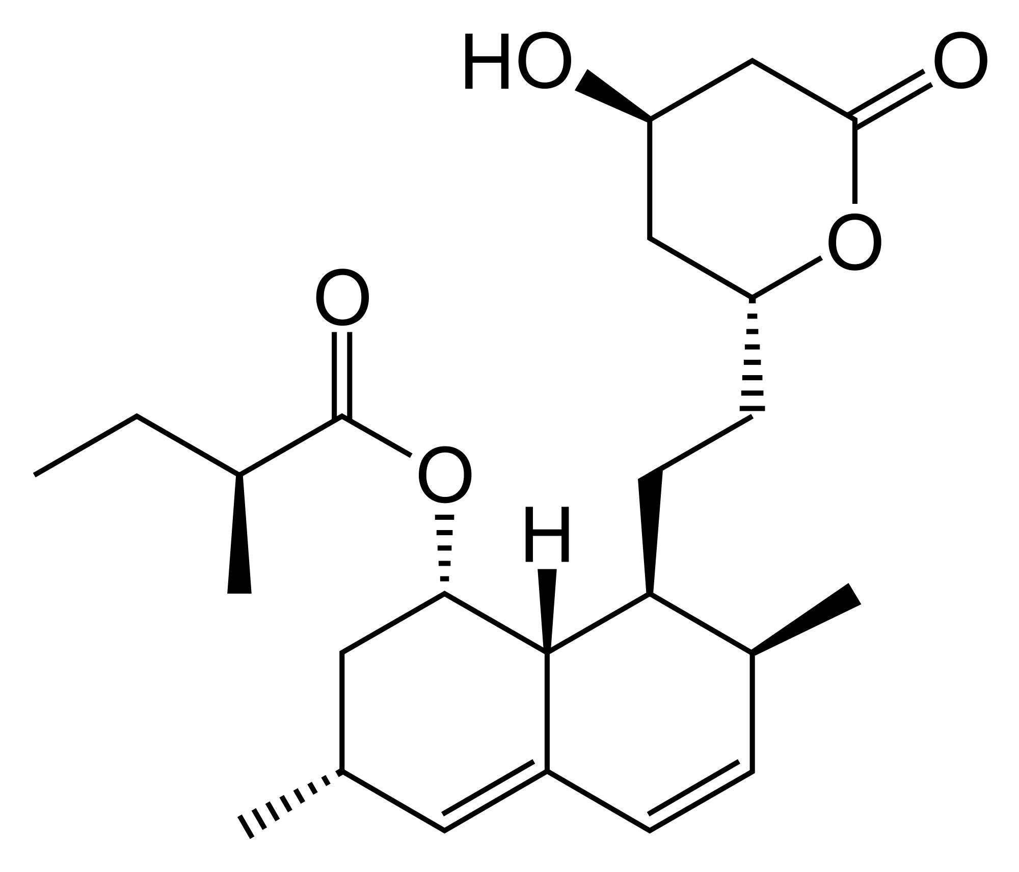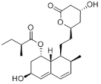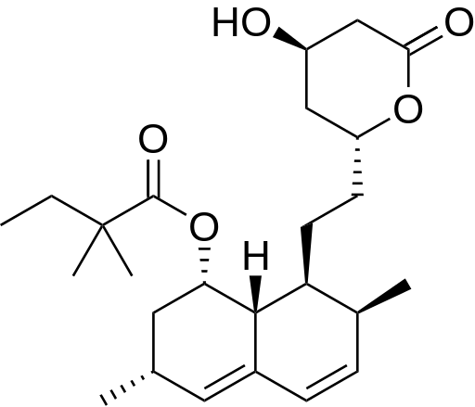

Serious side effects Oyster Mushroom (only difference = OH) Zocor ®
Mevacor ® (only difference = 2 CH₃) (only difference = CH₃) semi-synthetic

Proposals:
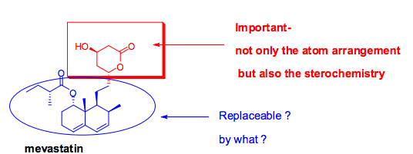
- Make a synthetic vatiation of Mevastatin
  - What part of Mevastatin is crucial? (pharmacore)
  - What part can be replaced? And by what?
- Need imaginative/knowledgeable medicinal chemists

First Approach: Keep the chemistry relatively simple.
- Properties of replaceable substituent:
  - rather large size – hydrophobic
  - Aromatic ring – flat (no stereochemistry issues
- Substituents can be added to:
  - adjust hydrophobic/hydrophilic [Polarity]
  - Increase bio-availability, metabolic stability

The Results: (synthetic statins)
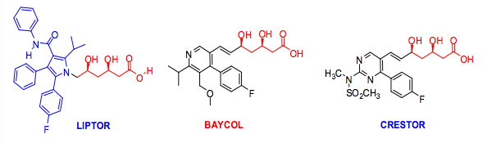

Similarities – all have aromatic ring with fluorine substituent.
Similarities to HMG-CoA – all have same opened lactone ring seen on mevalonate.
Lipitor, etc.

- Lipitor – a member of the “statin” family of drugs – the best seling drug in history
  - Total sales since 1996 > $125 Billion
  - Patent ended ~2011
- Other “important” statins:
  - Mevacor, Crestor, Zocor, Pravachol, Baycol

Epidemiology studies:
- Zocor: ~4500 patients with high cholesterol levels and heart disease
After 5 years: 35% lowering of cholesterol and 42% decrease in deaths from heart attack.
- There are many epidemiology studies due to the widespread use of Statins
  - Some show “good” relationships – one suggested 50% reduction in colorectal cancer
  - Some show “bad” relationships – one showed higher risk of diabetes

Side Effects:
- Most are “tolerable”
- Except rhabdomylolysis [skeletal muscle wasting > kidney failure]
  - Relatively rare: 250,000 patients studied over a long period of time
    - 1 person in 25,000
    - For Baycol (1 person in ~2,500). Withdrawn from market in 2001.

Building a Better Aspirin

- How the discovery of cyclooxygenase-2 enzyme led to development of new Anti-inflammatory drugs
  - From Willow Bark to Aspirin to Ibuprofen (Advil, Motrin) to Vioxx and Celebrex

The early Aspirin Story:
- Willow bark has been used for thousands of years to make a tea as a treatment for pain, fevers and inflammation
- In about 1830:
  - the active ingredient called salicin was first isolated
- By about 1860:
  - it was realized that the salicin could be converted into salicylic acid and that this resulted in a more effective treatment – but had many side effects
- In the 1960’s:
  - Felix Hoffmann (Baeyer, Germany) made the acetyl derivate which was effective and well tolerated – sold under the name Aspirin ®
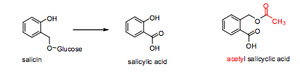
Aspirin – the wonder drug (ASA):
- Many positive effects:
  - Relieves pain (Analgesic); Reduces fever (antipyretic); Relieves inflammation; Reduces blood clotting
- Negative effect:
  - Causes gastric lesions

Use in Canada:
- Each person = 120 ASA tablets a year at 325 mg/tablet = 40g/p/y
- Assume 33 mill. Canadians = 1,320,000,000g = 1,320 tons of ASA annually

Acetyl salicylic acid [ASA] synthesis:
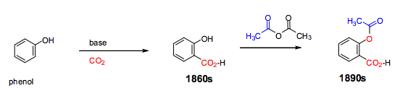

Understanding the mechanism of action of ASA:
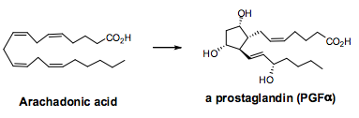
- 1960’s to 1980’s – It was shown that ASA inhibits the formation of prostaglandins from arachidonic acid
    - Prostaglandins – many structure variations mediate different biological processes
    - Arachidonic Acid – a poly-unsaturated fatty acid

Cyclo-oxygenase enzyme:
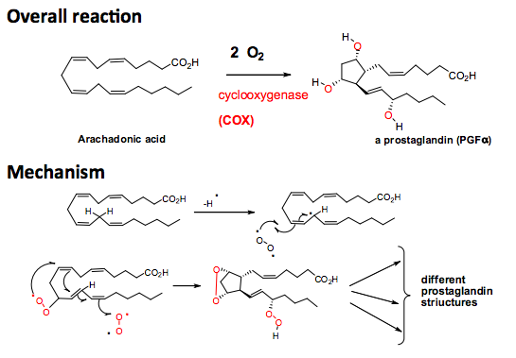
Overall Reaction:

Mechanism:

New anti-inflammatory drugs from 1970 on:
- Compounds that inhibit COX
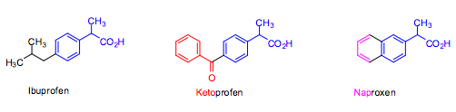
  - Non steroidal anti inflammatory drugs
- Often more potent anti-inflammatory drugs than aspirin (more potent COX inhibitors)
  - But, do not reduce fevers and are not cardio-protective!!
- Major side effect: Gastric lesions and stomach bleeding

Major Breakthrough:
- Academic researchers in the mid to late 1980s discovered that there are two cyclo-oxygenase enzymes that are closely related!!
- Both inhibit prostaglandin formation
  - COX-2 inhibits prostaglandin formation associated with inflammation
  - COX-1 mediates formation of prostaglandins associated with important body functions including renewal of the stomach and esophagus lining
- Opportunity:
  - Molecules that selectively inhibit COX-2 vs. COX-1 should relieve inflammation but not be gastro-toxic

The search for COX-2 selective compounds:
- First– develop a bio-assay that can determine the inhibition of both COX-1 and COX-2 by various compounds
- Once available – test known anti-inflammatory compounds
- Results:
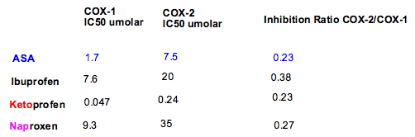 ratios are similar
IC50: Concentration tat inhibits 50% of the activity of a substance (enzyme)

The First COX-2 selective compound:

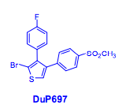
DuP679 (lead structure)

Optimizing lead structure (DuP679):
- Race to be first: Pfizer (USA – Merck Frost (Montreal)
- Medicinal chemists synthesized hundreds of compounds with variations on the DuP679 structure

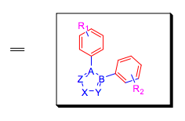
Probable structure requirements:
- Central 5-membered heterocyclic ring; likely aromatic
- Two aromatic rings ortho to each other; likely benzene rings but other 5- or 6-membered aromatic rings also plausible.
- Suitable substituents on the aromatic rings.
- Possible additional substituents on the central 5-membered ring
- Can the central ring be a six membered ring?

Process:
- Develop a synthetic method to prepare the compounds
- Evaluate each and provide feedback to generate more structures

The Synthetic Chemistry Challenge:

- How many plausible structures are there??
Different central rings
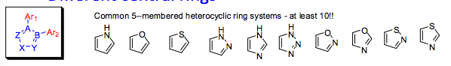
Different Ar1 and Ar2 in different positions
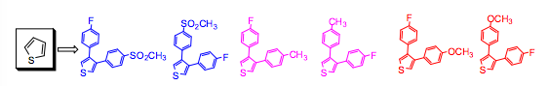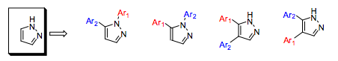

First estimate: 10x3x33 = 1000
- Does not take into account the possible di- and tri- substitution on the aromatic rings
- Does not count changing:
  - CH₃ to C₂H₅… to C₆H₁₁
  - Branching in the chain
  - Making rings
Final tally: Millions – billions of possible structures!!!

Compounds synthesized: Merck created Vioxx & Pfizer created Celebrex.
Marketing of Celebrex and Vioxx:
- Both were approved in 1999/2000 in Canada and the US. (very quick approval ~7 years)
- Heralded as miracle drugs – excellent treatment for inflammation but not likely to cause stomach lesions
- Key applications:
  - Arthritis – long term
  - Accident & sport injuries – short term
- Sales: within one or two years = several billion $

Problems with Vioxx (and NSAIDs):
- Sept. 30, 2004 Merck announces withdrawal of Vioxx from the market.
  - A study concerning the use of Vioxx for the prevention of colon cancers showed that long term use of Vioxx increased the risk of heart attack or stroke by a factor of 2.
- Other clinical data and post marketing surveillance also indicated significant concerns for Vioxx, other COX-2 selective inhibitors and long term use of other NSAIDs (nonsteroidal anti-inflammatory drugs)

Complicated situation:
- After a review of all available data in 20055, both the US FDA and Health Canada approved/recommended the re-introduction of Vioxx
  - Why?
    - Benefits outweighed the risks for some patients
    - The cardiovascular risk for Vioxx seemed no worse than those for Ibuprofen
  - Recommended further studies for all NSAIDs to fully understand the risk/benefit profiles
- Merck has not re-introduced Vioxx – fear of litigation?
- Pfizer stopped advertising and strongly marketing Celebrex after withdrawal of Vioxx, but resumed again three or four years later

Vioxx vs Celebrex:
- Key difference:
  - Vioxx is a much stronger inhibitor of COX-2 than Celebrex
- Speculation:
  - COX-2 does more than simply mediate inflammation!!
  - Is it also present in heart tissue?
  - Does COX-2 serve unknown other cardio-protective functions?
    - It is involved in the production of prostacyclin – a potent vasodilator, and also inhibits platelet aggregation

Natural Products (Secondary Metabolites) as sources of New Drugs

- Terrestrial plants (and to a lesser extent, sea organisms) continue to be a key source of novel drugs
- Surveys have been carried out to show where drugs since the 1960s have originated:
  - 60% of all new antibiotics have a natural product origin
  - 50% of all approved anti-cancer drugs have a natural product origin or are natural product derived
  - Most central nervous system drugs have a synthetic chemistry origin but are based on the naturally occurring alkaloids with CNS Activity
Plant Secondary Metabolites:
(Secondary metabolites – organic compounds that are not directly involved in the normal growth, development, or reproduction of an organism.)
- Purpose of these compounds?
  - Perform key functions necessary for survival of the organism – like animal hormones
  - Ensure propagation – pollination, dispersal of seeds
  - Protection/defense against insects and herbivores
- Phytochemical redundancy and plant defense mechanism
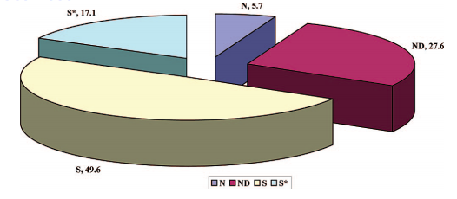
  - Plants make a number of similar compounds to prevent animals and insects from becoming resistant

Origin of new drugs 1983-2008:
N = natural product
ND = natural product derived
S* = synthetic but based on natural product pharmacophore
S = synthetic

Hypotheses for Discovery:

Focused screening:
- by learning from Healers (shamans) ethopharmacology
- via studying available literature describing the use of plants for medicinal purposes – Traditional Chinese medicine
- by focusing on plants belonging to families that are known to have certain types of bio-active compounds

Learning from Healers:
      - Typical “common” health problem
        - Infections
        - Stomach and intestinal ailments
        - Pain
        - Mental/ nervous issues
        - Reproductive issues
      - Healer consensus
      - Bio-assay guided isolation

Random Screening:
- Screening of organisms that have previously not been investigated
- Rare plants from areas not preciously accessed – often give new and unusual compounds
- Micro-organisms growing in areas not previously accessible or growing under unusual conditions
  - Ocean floor at various depths, near toxic dumps, near hot springs or volcanoes

Random (rational) approach:
- Suppose you are searching for an anti-fungal compound.
- Where would you collect plants that might generate anti-fungal compounds?
- New anti-biotic compounds would likely be synthesized by micro-organisms that compete against each other
- Insecticides are likely to be produced by plants that grow in areas with many insects
- Plants may produce compounds toxic to mammals to defend themselves against herbivores (or also bitter compounds)

Natural Product as sources of new drugs:
- Plants
  - Often sources of anti-cancer, anti-fungal, anti-oxidants
  - Also mood altering drugs
  - Most of the alkaloid derived drugs have a plant origin
- Microorganisms
  - Often a source of antibiotics and anti-cancer compounds
- Oceans
  - Typically, many compounds have antibiotic and anti-cancer activity
  - Compounds which incorporate Cl and Br

Recent Publications:
- Journal of the American Chemical Society - “Isolation and First Total Synthesis of PM050489 and PM60184, Two New Marine Anticancer Compounds” (2013)
  - Shows remarkable potential:
    - Show antimitotic properties in human tumor cell lines at sub-nanomolar concentrations and display a distinct inhibition mechanism on microtubules
    - The development of an efficient synthetic procedure has solved the supply problem and, following pharmaceutical development, has allowed PM060184 to start clinical studies as a promising new drug for cancer treatment.
- Pharmaceutical Biology – “New drugs and Biodiversity Conservation” (2009)
  - Estimated 250,000 plant species world wide
  - Approx. 50% occur in the tropical forests which currently cover only 7% of land surface compared to 16% in 1950
  - A relatively modest proportion of the plants have been investigated for their secondary metabolites which may have medicinal potential

The Inherent Advantages of Natural Products:
- Produced by biological systems, so:
  - More likely to be bio-active and bio-available
  - Are produced as single stereoisomers

Racemic Drugs

Isomers:
Enantiomers [non superimposable mirror images] have different biological properties.
Diastereomers [different compounds, same molecular formula] have different biological properties.
- Number of isomers 2^{n} where n represents the number of chiral centers of the molecule
- 8 Isomers: 4 pairs of Diastereomers

Racemic mixtures:
- In a racemic mixture there are equal amount amounts of each enantiomer
- Racemic mixtures of drugs are easier to synthesize (no separation)
- Usually one enantiomer is more active than the other. Second isomer could:
  - Have no biological activity
  - Have other biological activity
  - Be toxic
Chiral vs. Racemic Drugs
- Up to about 1990 most drugs which had chiral centers were marketed as racemates
  - 50/50 mix of isomer that carried activity, and isomer which is essentially inactive
- Reason: Cost!! (much cheaper)
- Consequence: Had to take 2x amount of drug for same effect.
  - Best scenario: the “other” isomer is harmless
  - Other scenarios: the “other” isomer has:
          - Different biological effects
          - Toxicity
Current Regulatory Practice:
- Ideally all chiral drugs should be sold as a single enantiomer
- Allowance is made if it is shown conclusively that the second isomer is harmless OR the drug can only be prepared as a racemate using currently available technology
- That enxymes in the patient convert one into the other – racemize the pure isomer

Biological racemization of drugs:

The most “famous” example – thalidomide
- Only one isomer causes terogenicity (growth retardation, etc.)
- Unfortunately, if the “harmless isomer” is given, it is racemized in the body to make a 50:50 mixture

Ibuprofen (Motrin, Advil)
- A ‘core’ medicine in the World Health Organization’s WHO Model of Essential Medicines, which is a list of minimum medical needs for a basic healthcare system
- Anti-inflammatory drug
- Sold as a racemate
  - (S) isomer is the active one
  - An enzyme in the body is able to convert the (R) isomer into the (S) isomer

Salbutamol:
- Causes dilation of the bronchial smooth muscle
- Used in puffer
- On market currently as a racemate
  - (R) is active enantiomer responsible for the pharmacologic activity
  - (S) is “other” that slows metabolism of it and the (R) isomer

Bio-assay guided isolation of isomers:
- Say a plant extract is shown to have the desired activity
- Extracts are typically prepared by grinding the plant sample, either fresh or dried, with 95% ethanol
  - Other organic solvents used are ethyl acetate and dichloromethane
  - Water is sometimes used
- Extracts have many, often 30-100 or more component compounds
  - what is the active component?
- Use a standard operating procedure
  - Bioassay guided isolation to determine which is the active component

Structure Variety in Natural Products

Antimalarials:

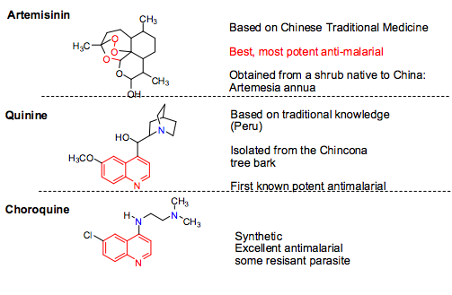

Penicillins: 1928 1942
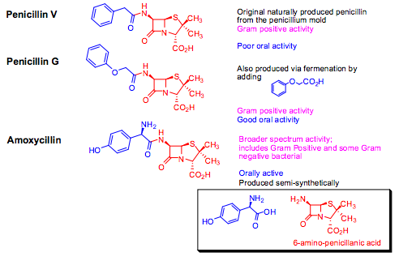
CNS active Alkaloids:
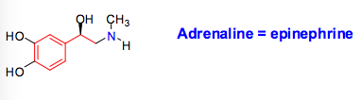
- Common structure requirements for CNS active compounds:
  - Basic nitrogen atom joined to aromatic ring via a saturated two carbon unit
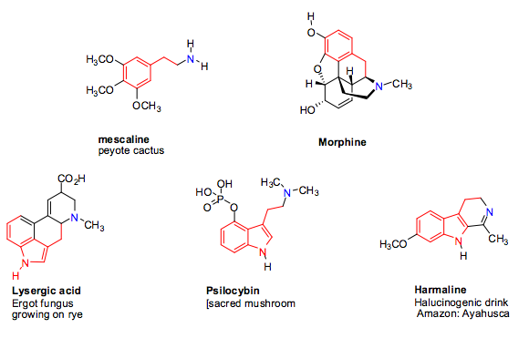

Natural CNS Active compounds:

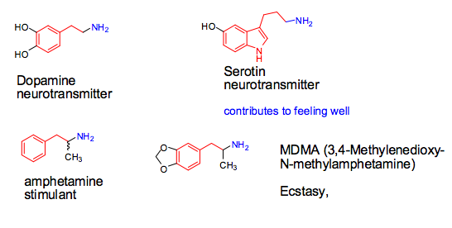

Neurotransmitters and “street drugs”:

- Dopamine, serotonin, and amphetamines

Metabolism

Metabolism – The complex of physical and chemical processes occurring within a living cell or organism that are necessary for the maintenance of life. In metabolism some substances are broken down to yield energy for vital processes while other substances, necessary for life, are synthesized.

- Mainly by liver enzymes belonging to the cytochrome P-450 family
- Almost a dozen variations have been identified in humans
  - The most important one, CYP3A4, is involved in the metabolism of approximately half the drugs that are used today
  - CYP2C19 is next in importance

The CYP-family of enzymes:
- These enzymes accept compounds with widely different shapes and sizes (not common for enzymes – usually very specific)
- Introduce oxygen into the molecule using molecular oxygen

Mechanism:
- Introduction of an OH group at a saturated carbon (sp3 hybridized) atom

Mechanism -1:
- Abstraction of H atom, preferred from a relatively weak H bond, thereby forming a relatively stable carbon centered radical
- Reaction with molecular oxygen to form a hydroperoxy radical
- Abstraction of a H atom from another molecule giving a hydroperoxide
- Reduction of the hydroperoxide to an alcohol.
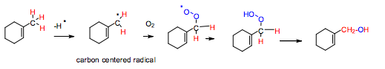
- A key part of the active site I the cytochrome enzymes is the iron center (Fe+2)
- Reaction with oxygen to form an Fe-hydroperoxy radical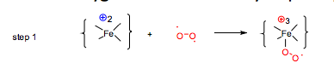
- Abstraction of a relatively weak C-H bond from the substrate to form Fe-hydro-peroxide and a carbon centered radical
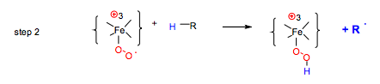
Chemistry: C-H bond dissociation energies:
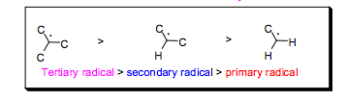
- Bond strenths:
  - Primary C-H bond ~ 98 Kcal/mol
  - Secondary C-H bond ~ 95 Kcal/mol
  - Tertiary C-H bond ~ 91 Kcal/mol
- Allylic and benxzylic radicals are as or more stable than tertiary radicals due to resonance stabilization
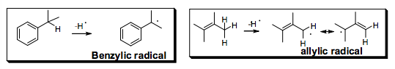

Dimethylation of R₂N(CH₃) and R-O-CH₃:
Why are they favourable?
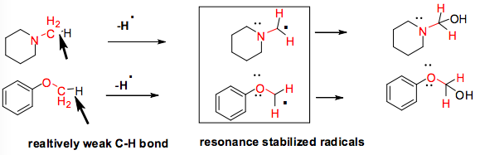

Introduction of OH groups into aromatic rings:
- Mechanism involves formation of an epoxide followed by rearrangement
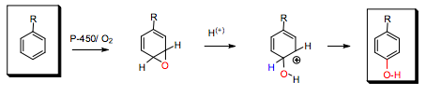

Why a different mechanism in aliphatic systems?
- Aromatic and alkene C-H bond strength is much higher than aliphatic C-H bond strength
- In other words: aromatic and alkene radicals are much less stable than alkyl or allyl radicals
- Result: abstraction of a hydrogen from an aromatic ring or attached to a double bond is difficult for the enzyme

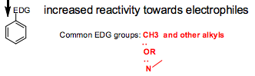
Effect of substituents on aromatic hydroxylation:
- If aromatic ring acts as nucleophile:

  - A substituent on the ring that is electron donating (EDG) will increase reactivity
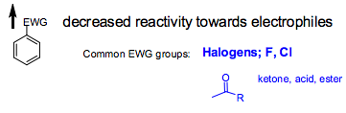
  - A substituent that is electron withdrawing (EWG) will decreases reactivity

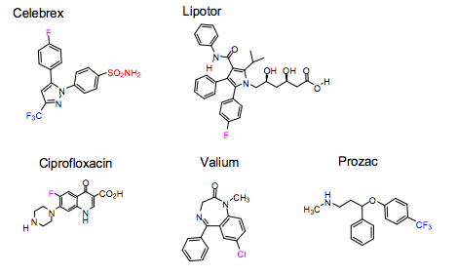
EWG reduce rate of metabolism in drugs:
- In many drugs with aromatic rings EWG substituents are introduced in order to slow down their rate of metabolism and increase their half-life in the body (Other effect of F of Cl: increase lipophilicity)

Metabolism at aromatic rings other than benzene:
- Electron poor aromatic rings tend to be metabolically more stable than a benzene ring

Drug-Drug Interactions:
- Many drug-drug interactions are due to metabolism issues
- Need to be aware of the
  - Metabolism (enzyme involved
  - The degree of Inhibition
  - Therapeutic Index [TI] of the drug

Therapeutic Index [TI]:
- Toxic Dosage for 50% of patients / Therapeutic dosage for 50% of patients
  - TD50/ED50
- Ideally a large number – low toxicity relative to effective dosage
- If less than 5 it gives narrow window and small margin of error for safety
- Digoxin, for coronary heart disease has a rather small TI
- Acetominiphen (Tylenol) has a large TI, a relatively safe drug
- Many cancer drugs have rather small TI’s

Liver Metabolism:
- Avoiding liver enzyme metabolism – also called “first pass metabolism”
- Oral administration: drugs are absorbed through the gut, do to the liver
  - Oxidative metabolisms occur mainly in the liver and gut
  - To avoid this, have the drug go into the blood stream before it can be metabolized by liver enzymes

Methods of administration:
- Oral – most common, reasonable compliance
- Intravenous injection – typical of many anti-cancer drugs, often problems with formulations
- Intramuscular injection – most vaccines, acid sensitive penicillin
- Sublingual (under tongue) – angia drugs – nitoglycerin
- Inhalation – asthma drug – salbutamol “puffer”
- Transdermal – hormones, nicotine patch
- Rectal suppositories – aspirin

