Protocol

Refer to pages 13-19 of the CHM 1321 Introductory Organic Chemistry Laboratory Manual 2017.

Observations:

Part A and B
- Unknown compound has a crystalline structure, it is white
- 2:8 ethyl acetate and hexanes is transparent, it is not viscous at all
- when the two are mixed, there is no change in color or viscosity
- under UV light, TLC plate (covered in silica gel) has a neon yellow color, the dots formed have a fuchsia color
- Both the ethyl acetate and hexanes eluent are clear, and not very viscous
Part C
- Unknown compound is transparent and a faint yellow color
- Reference solution A ortho-bromonitrobenzene is yellow
- Reference solution B meta-bromonitrobenzene is clear
- Reference solution C para-bromonitrobenzene is clear
- Under UV light all three TLC plates are neon yellow/green with fuchsia identification dots

TLC

Part A: Identifying the components of an unknown mixture using TLC

Unknown #93

TLC 1: Biphenyl Reference Solution TLC2: Benzophenone Reference Solution
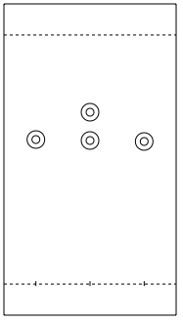
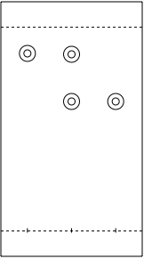

S
C
R
S
R
C

Table 1: Retention Factors using 2:8 ethyl acetate:hexanes solvent system

Reference Solution
 | Biphenyl | Benzophenone
Spot
Reference | o.83 | 0.50
Co-reference | 0.83 | 0.54
Co-sample | 0.63 | 0.50
Sample | 0.60 | 0.50

Part B: Effect of Solvent on TLC

TLC 1: Biphenyl Reference Solution using TLC 2: Benzophenone Reference Ethyl Acetate as the eluent Solution using Ethyl Acetate as the eluent

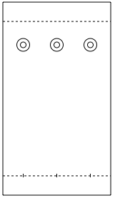

S
C
R
S
C
R

TLC 3: Biphenyl Reference solution TLC 4: benzophenone Reference Solution using Hexanes as the eluent using Hexanes as the eluent
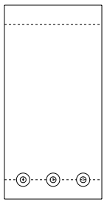
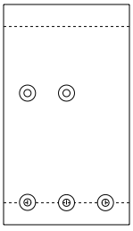

S
C
R
S
C
R

Table 2: Retention factors using reference solution of biphenyl and benzophenone of two different solvent systems; ethyl acetate and hexanes

Spot | Ethyl Acetate Eluent |  | Hexanes Eluent
 | Reference Solution
 | Biphenyl (TLC1) | Benzophenone (TLC2) | Biphenyl (TLC3) | Benzophenone (TLC4)
Reference | 0.91 | 0.95 | 0.4 | 0
Co-reference | 0.91 | 0.95 | 0.4 | 0
Co-sample | 0.91 | 0.95 | 0 | 0
Sample | 0.91 | 0.95 | 0 | 0

Part C: Ratio of Compounds

Using unknown ZZ

TLC A using Reference Solution o-bromonitrobenzene and a solvent system of 9:1 hexanes

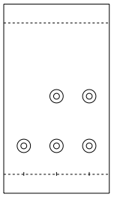

S
C
R

Table 3: Retention Factors for TLC A using Reference Solution of o-bromonitrobenzene

 | Reference | Co-reference | Co-sample | Sample
Rf Value | 0.43 | 0.43 | 0.62 | 0.43 | 0.62

Table 4: TLC B using Reference Solution m-bromonitrobenzene and a solvent solution of 9:1 hexanes

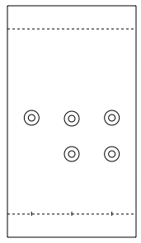

S
C
R

Table 5:Retention Factors for TLC B using reference solution m-bromonitrobenzene

 | Reference | Co-reference | Co-sample | Sample
Rf Value | 0.60 | 0.60 | 0.43 | 0.60 | 0.43

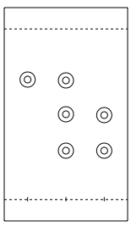
TLC C using Reference solution p-bromonitrobenzene and a solvent solution of 9:1 Hexanes
C
S
R

Table 6: Retention Factors for TLC C using reference solution p-bromonitrobenzene

 | Reference | Co-reference | Co-sample |  | Sample
Rf Value | 0.60 | 0.60 | 0.50 | 0.26 | 0.50 | 0.26

TLC Plate Legend
R | Lane where the reference solution was spotted
C | Lane where both the reference solution and the sample solution were spotted
S | Lane where the sample solution was spotted

Calculations

Retention Factor Calculation

$Rf= \frac{distance travelled by solute}{distance travelled by solvent}$
$Rf=\frac{4cm}{4.8cm }$
$Rf=0.83$

Absorbance Calculation
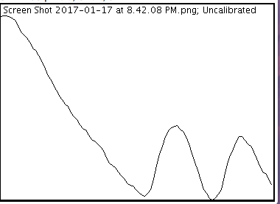
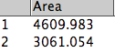
2
1

Absorbance of meta= 4609.983
Absorbance of ortho= 3061.054

% Absorbance of meta= $\frac{meta}{ortho+meta}x 100$
$=\frac{4609.983}{(3061.054+4609.983)}x100$
$=60\%$

% Absorbance of ortho = 100%- %absorbance of meta
= 100-60
= 40%

Mole Percentage Calculation

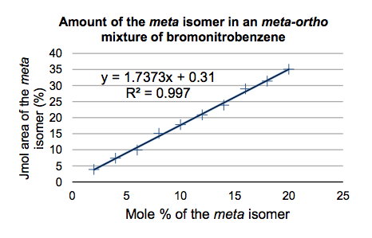

y= % Absorbance of meta isomer = 60%

$y=1.7373x+0.31$
$x=\frac{60-0.31}{1.7373}$
$∴x=$34.36%

The mole percentage of the meta isomer is 34.36%

100%-34.36%= mole percentage of the ortho isomer
= 65.64%

Discussion

In part A of the lab, thin layer chromatography was used to determine the identity of an unknown substance by calculating retention factors and comparing them to known reference solutions. The unknown was number 93, and it was spotted against known reference solutions of biphenyl and benzophenone. When the Rfs were calculated using the aid of ultraviolet light, it was clear that TLC plate 2, using the reference solution of benzophenone was a match, as the three lanes all had the same calculated Rf value of 0.50. This meant that unknown number 93 was composed of benzophenone. On the TLC plate, an additional spot can be view in the co-spot lane. This could be due cross contamination, by not breaking enough of the capillary tube between making spots on the plate, or due to another substance being present in the test tube of either the unknown solution or the benzophenone solution.

In part B of the lab, thin layer chromatography was used to determine the effect of solvent solution on retention factors. This was done by setting up four TLC plates, using the same two reference solutions of benzophenone and biphenyl, samples were tested against two different eluent systems, ethyl acetate and hexanes. When these TLC plates were visualized under the ultraviolent light, it became clear that the more polar the solution, the larger the retention factor. This is because ethyl acetate is the more polar of the two solvents used. Unlike the hexanes solvent, ethyl acetate is an ester meaning it has oxygen ready to undergo hydrogen bonding. This ester linkage makes it more polar than silica gel. Thus, when used as a solvent it can form hydrogen bonding with the spotted samples, and move up the plate in the mobile phase. This resulted in high retention factors of 0.91 for the biphenyl solution and 0.95 for the benzophenone solution. In contrast, the hexanes solvent system, which is less polar than silica gel was unable to form strong bonds with the biphenyl and benzophenone reference solutions, thus, these solutions bonded with the silica gel and stayed in the stationary phase, causing low retention factors for both reference solutions (0.4 for biphenyl and 0 for benzophenone).

In part C of the lab, thin layer chromatography was used to determine which of three bromonitrobenzene isomers were present in an unknown solution. In the experiment, unknown ZZ was used. The solvent system used was a 9:1 hexanes: ethyl acetate mixture, and when the three different TLC plates were viewed under UV light, it was evident based on qualitative chemistry and calculated retention factors, that unknown ZZ was composed of the meta and ortho bromonitrobenzene isomers. In this experiment, three TLC plates were used for clarity, as using one TLC plate would result in over lapping dots leading to incorrect conclusions of the chemical components of the unknown solution. Since the unknown was composed of two different isomers, there were two spots in the sample lane, since the two different isomers have different retention factors. This is due to where the two groups are placed on the parent benzene chain, the slight gap in their position has a small effect on polarity, which is why the two isomers have slightly different polarity and thus slightly different retention factors. Retention factors for these two TLC plates can be viewed in tables 4 and 5. After making these comparisons, TLC C containing p-bromonitrobenzene could be eliminated, as it did not match any of the spots or retention factors for the unknown solution.
Next, Image J software was used to calculated the area of the graph for the ortho and meta function in the sample lane of the TLC plate. On this graph, the two different isomers could be viewed as large spikes on the function. To do calculations for absorbance, these two curves were closed, to calculate the relative area of each isomer. This allowed calculations using these values to be done in order to find the absorbance of each of the isomers in the solution. From this is was found that the meta isomer was 60% absorbed and the ortho isomer was 40% absorbed. From here, given calibration curves, with a known equation were given in order to calculate the mole percent absorbance of each isomer in the solution. These calculations determined that the meta isomer had a mole absorbance of 34.36% and that the ortho isomer had a mole percent of 65.64%.

Questions

- Increasing the polarity of the solvent system causes the retention factors to be larger. This is because the solvent is more polar than the silica gel, thus the spots are able to form stronger polar bonds with the solvent than with the silica gel, causing the substance to be in the mobile phase, and move up the TLC plate, rather than staying in the stationary phase with the silica gel and having a small Rf.

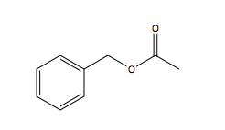
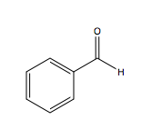
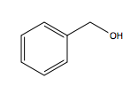
- a.) Benzyl alcohol benzaldehyde benzyl acetate

Of the three above substances, benzyl alcohol would have the smallest Rf on a silica gel TLC. This is because it is the most polar of the substances, due to the –OH functional group, and thus would stay in the stationary phase, forming hydrogen bonds with the silica gel.

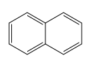
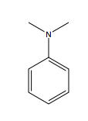
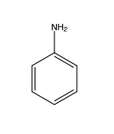
b.) Aniline N,N-dimethylaniline naphthalene

Of the three above substances, aniline would have the smallest Rf on a silica gel TLC, this is because of the three substances it is the most polar. It is the most polar because it has an uneven distribution of dipoles due to the presence of the NH2 functional group. This will allow it to hydrogen bond with the silica gel, and stay in the stationary phase rather than the mobile phase.

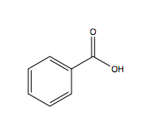
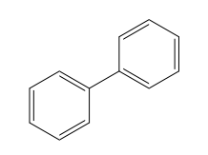
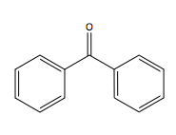
c.) Benzophenone Biphenyl benzoic acid

Of the three substances listed above, benzoic acid would have the smallest Rf on a silica gel TLC plate. This is because of the three substances, benzoic acid is the most polar, due to the carboxylic acid attached to the benzene ring. This allows the acid to undergo hydrogen bonding with the silica gel, and stay in the stationary phase, rather than in the mobile phase with the solvent.

