Introduction to Endocrinology
Chapter 75

Coordination of Body Functions by Chemical Messengers
- Hormones are chemical messengers controlling the activity and functions of cells, tissues and organs.
- Hormones are actually controlling the entire system to work together = maintaining homeostasis
- For example, the adrenal medullae and the pituitary gland secrete their hormones primarily in response to neural stimuli.

Interplay of:
- Neurotransmitters
  - Are released by axon terminals of neurons into the synaptic junctions and ACT LOCALLY to control nerve cell functions
  - Nerve cell communication
- Endocrine hormones
  - Released by glands or specialized cells into the circulating blood and influence the function of target cells at another location in the body
  - Insulin by pancreas
  - They are carried by the circulatory system to cells throughout the body, including the nervous system in some cases, where they bind with receptors and initiate many cell reactions.
  - They affect growth hormones (from the anterior pituitary gland) causes growth in most parts of the body and thyroxine (from the thyroid gland) increases the rate of many chemical reactions in almost all the body’s cells.
- Neuroendocrine hormones
  - Are secreted by neurons into the circulating blood and influence the function of target cells at another location in the body
  - Produced by the nerve cells
  - Neuroendocrine cells, located in the hypothalamus, have axons that terminate in the posterior pituitary gland and median eminence and secrete several neurohormones, including antidiuretic hormone, oxytocin and hypophysiotropic hormones, which control the secretion of anterior pituitary hormones.
- Paracrines
  - Secreted by cells into the extracellular fluid and affect neighboring target cells of a different type
- Autocrines
  - Secreted by cells into the extracellular fluid and affect the function of the same cells that produced them
- Cytokines
  - Are peptides secreted by cells into the extracellular fluid and can function as autocrines, paracrines, or endocrine hormones.
  - Examples: interleukins and other lymphokines that are secreted by helper cells and act on other cells of the immune system.
  - Cytokine hormones produced by adipocytes are sometimes called adipokines.

- Hormones that affect target issues is because these tissues have abundant receptors for the hormone.
  - Adrenocorticotropic hormone from the anterior pituitary gland specifically stimulates the adrenal cortex, causing if to secrete adrenocortical hormones,
  - Ovarian hormones have their main effects on the female sex organs and the secondary sexual characteristics of the female body.

Multiple hormone system plays a key role in regulating almost all body functions:
- Metabolism
  - Without insulin from pancreas, the body’s cells could use little of the food carbohydrates for energy.
- Growth and development
  - Without growth dwarf
- Water and electrolyte balance
- Reproduction
  - Without sex hormones, sexual development and sexual functions would be absent.
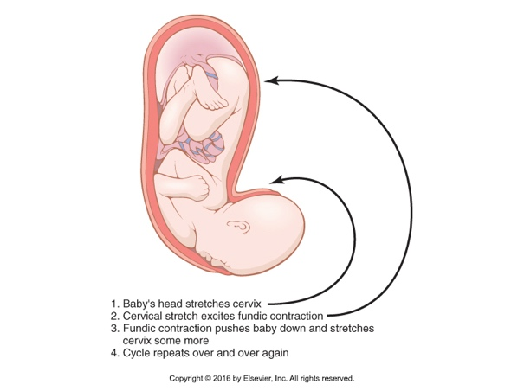
- Behaviour

Chemical Structure & Synthesis of Hormones
Three general classes of hormones exist:
- Protein and polypeptide hormones, i.e.,
  - Insulin and glucagon by pancreas
  - Pituitary hormones
  - Parathyroid hormones
- Steroids
  - Cortisol and aldosterone, by adrenal cortex
  - Estrogens and progesterone, by ovaries
  - Testosterone, by testes
  - Estrogen and progesterone, by placenta
- Derivative of the amino acid tyrosine
  - Thyroxin and triiodothyronine, by thyroid
  - Epinephrine and norepinephrine by adrenal gland

Proteins and polypeptides hormones are stored until needed.
- Most hormones are proteins and polypeptides
- They range in size from small peptides with as few as three amino acids (thyrotropin- releasing hormone) to proteins with almost 200 amino acids (growth hormone and prolactin)
- In general, polypeptides with 100 or more amino acids are called proteins, and those with fewer than 100 amino acids are referred to as peptides.
  - Preprohormones
  - Prohormones
  - Packaged into secretory vesicles
  - Enzymatic cleavage, active hormones are stored
    - Stored in secretory granules
  - Vesicle fusion with the cell membrane
  - Secretion into the interstitial fluid or into the blood stream by exocytosis
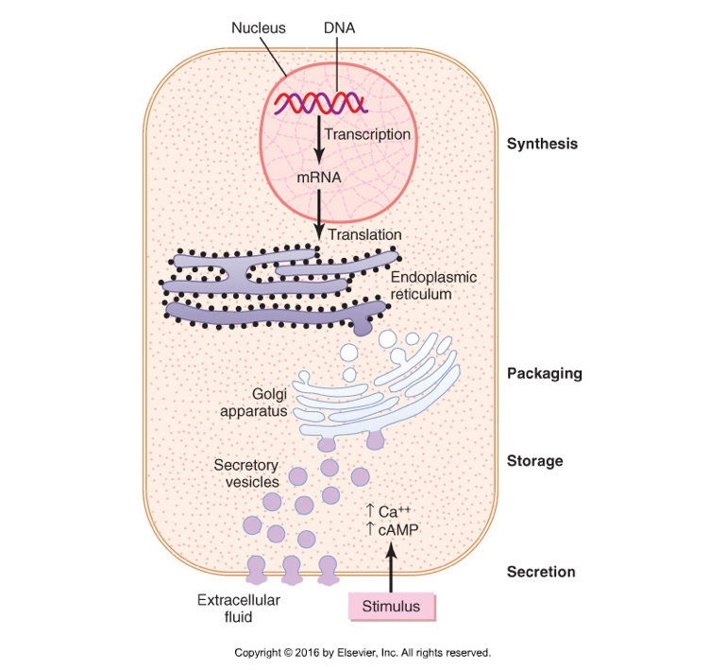
    - To the target cells

- Protein and peptide hormones are synthesized on the rough end of the endoplasmic reticulum of the different endocrine cells, in the same fashion as most other proteins.
- They are usually synthesized first as larger proteins that are not biologically active (preprohormones) and are cleaved to form smaller prohormones in the endoplasmic reticulum.
- These prohormones are then transferred to the Golgi apparatus for packaging into secretory vesicles.
- In this process, enzymes in the vesicles cleave the prohormones to produce smaller, biologically active hormone and inactive fragments.
- The vesicles are stored within the cytoplasm, and many are bound to the cell membrane until their secretion is needed.
- Secretion of the hormones (as well as the inactive fragments) occurs when the secretory vesicles fuse with the cell membrane and the granular content are extruded unto the interstitial fluid of directly into the blood stream by exocytosis.
- In many cases, the stimulus for exocytosis is increased cytosolic calcium concentration caused by depolarization of the plasma membrane.
- In other instances, stimulation of an endocrine cell surface receptor causes increased cyclic adenosine monophosphate (cAMP) and subsequently activation of protein kinases that initiate secretion of the hormone.
  - Kinases = an enzyme that catalyzes the transfer of an phosphate group from ATP to a specified molecule
- The peptide hormones are water soluble allowing them to enter the circulatory system easily, where they are carried to their target tissues.

Steroid hormones derived from cholesterol and not stored.
- Most synthesized from cholesterol:
  - Lipid soluble
  - Consists of three cyclohexyl rings and one cyclopentyl ring combined into a single structure.
  - Little hormone storage
    - Large stores of cholesterol esters in cytoplasm vacuoles can be rapidly mobilized for steroid synthesis after a stimulus.
      - Ester = an organic compound made by replacing the hydrogen of an acid by an alkyl or other organic group.
  - Rapidly produced from plasma cholesterol
    - Also from de novo synthesis
      - Novo synthesis refers to the synthesis of complex molecules from simple molecules such as sugars or amino acids, as opposed to recycling after partial degradation.
  - Because steroids are highly soluble, once they are synthesized, they can simply diffuse across the cell membrane and enter the interstitial fluid and then blood

Amine hormones are derived from tyrosine.
Two groups, formed by enzymatic processing in cytoplasm of the glandular cells:

Thyroid hormones
- Synthesized and stored in the thyroid gland
  - Incorporated into the protein thyroglobulin (macromolecule)
    - Stored in large follicles within the thyroid gland.
  - Hormone secretion occurs when the amines are split from thyroglobulin and the free hormones are then released into the bloodstream.
  - In blood stream, combine with plasma protein, i.e., thyroxine-binding globulin,
    - Which slowly releases it to the target tissues.
- Functions: The thyroid gland uses iodine from food to make two thyroid hormones: triiodothyronine (T3) and thyroxine (T4). It also stores these thyroid hormones and releases them as they are needed. The hypothalamus and the pituitary gland, which are located in the brain, help control the thyroid gland.

Epinephrine & norepinephrine
- Synthesized in adrenal medulla
  - Secretes about 4x more epinephrine > norepinephrine
  - Catecholamines are taken up into preformed vesicles and stored until secreted.
  - Similar to protein hormones, stored in vesicles
    - Stored in secretory granules
  - Secreted by exocytosis
  - Once the catecholamines enter the circulation, they can exist in the plasma in free form or in conjugation with other substances.
- Functions: one is called epinephrine or adrenaline. The second hormone is called norepinephrine. If you have ever experienced an adrenaline rush, then you have experienced the effects of epinephrine and norepinephrine because they are hormones that increase heart rate, blood pressure, cardiac output and blood glucose levels.

Gland/Tissue | Hormones | Major Functions | Chemical Structure
Hypothalamus (Chapter 76) | Thyrotropin-releasing hormone | Stimulates secretion of thyroid-stimulating hormone and prolactin | Peptide
Hypothalamus (Chapter 76) | Corticotropin-releasing hormone | Causes release of adrenocorticotropic hormone | Peptide
Hypothalamus (Chapter 76) | Growth hormone–releasing hormone | Causes release of growth hormone | Peptide
Hypothalamus (Chapter 76) | Growth hormone inhibitory hormone (somatostatin) | Inhibits release of growth hormone | Peptide
Hypothalamus (Chapter 76) | Gonadotropin-releasing hormone | Causes release of luteinizing hormone and follicle-stimulating hormone
Hypothalamus (Chapter 76) | Dopamine or prolactin-inhibiting factor | Inhibits release of prolactin | Amine
Anterior pituitary (Chapter 76) | Growth hormone | Stimulates protein synthesis and overall growth of most cells and tissues | Peptide
Anterior pituitary (Chapter 76) | Thyroid-stimulating hormone | Stimulates synthesis and secretion of thyroid hormones (thyroxine and triiodothyronine) | Peptide
Anterior pituitary (Chapter 76) | Adrenocorticotropic hormone | Stimulates synthesis and secretion of adrenocortical hormones (cortisol, androgens, and aldosterone) | Peptide
Anterior pituitary (Chapter 76) | Prolactin | Promotes development of the female breasts and secretion of milk | Peptide
Anterior pituitary (Chapter 76) | Follicle-stimulating hormone | Causes growth of follicles in the ovaries and sperm maturation in Sertoli cells of testes | Peptide
Anterior pituitary (Chapter 76) | Luteinizing hormone | Stimulates testosterone synthesis in Leydig cells of testes; stimulates ovulation, formation of corpus luteum, and estrogen and progesterone synthesis in ovaries | Peptide
Posterior pituitary (Chapter 76) | Antidiuretic hormone (also called vasopressin) | Increases water reabsorption by the kidneys and causes vasoconstriction and increased blood pressure | Peptide
Posterior pituitary (Chapter 76) | Oxytocin | Stimulates milk ejection from breasts and uterine contractions | Peptide
Thyroid (Chapter 77) | Thyroxine (T₄) and triiodothyronine (T₃) | Increases the rates of chemical reactions in most cells, thus increasing body metabolic rate | Amine
Thyroid (Chapter 77) | Calcitonin | Promotes deposition of calcium in the bones and decreases extracellular fluid calcium ion concentration | Peptide
Adrenal cortex (Chapter 78) | Cortisol | Has multiple metabolic functions for controlling metabolism of proteins, carbohydrates, and fats; also has anti-inflammatory effects | Steroid
Adrenal cortex (Chapter 78) | Aldosterone | Increases renal sodium reabsorption, potassium secretion, and hydrogen ion secretion | Steroid
Adrenal medulla (Chapter 61) | Norepinephrine, epinephrine | Same effects as sympathetic stimulation | Amine
Pancreas (Chapter 79) | Insulin (β cells) | Promotes glucose entry in many cells, and in this way controls carbohydrate metabolism | Peptide
 | Glucagon (α cells) | Increases synthesis and release of glucose from the liver into the body fluids | Peptide
Parathyroid (Chapter 80) | Parathyroid hormone | Controls serum calcium ion concentration by increasing calcium absorption by the gut and kidneys and releasing calcium from bones | Peptide
Testes (Chapter 81) | Testosterone | Promotes development of male reproductive system and male secondary sexual characteristics | Steroid
Ovaries (Chapter 82) | Estrogens | Promotes growth and development of female reproductive system, female breasts, and female secondary sexual characteristics | Steroid
Ovaries (Chapter 82) | Progesterone | Stimulates secretion of “uterine milk” by the uterine endometrial glands and promotes development of secretory apparatus of breasts | Steroid
Placenta (Chapter 83) | Human chorionic gonadotropin | Promotes growth of corpus luteum and secretion of estrogens and progesterone by corpus luteum | Peptide
Placenta (Chapter 83) | Human somatomammotropin | Probably helps promote development of some fetal tissues, as well as the mother’s breasts | Peptide
Placenta (Chapter 83) | Estrogens | See actions of estrogens from ovaries | Steroid
Placenta (Chapter 83) | Progesterone | See actions of progesterone from ovaries | Steroid
Kidney (Chapter 26) | Renin | Catalyzes conversion of angiotensinogen to angiotensin I (acts as an enzyme) | Peptide
Kidney (Chapter 26) | 1,25-Dihydroxycholecalciferol | Increases intestinal absorption of calcium and bone mineralization | Steroid
Kidney (Chapter 26) | Erythropoietin | Increases erythrocyte production | Peptide
Heart (Chapter 22) | Atrial natriuretic peptide | Increases sodium excretion by kidneys, reduces blood pressure | Peptide
Stomach (Chapter 65) | Gastrin | Stimulates hydrogen chloride secretion by parietal cells | Peptide
Small intestine (Chapter 65) | Secretin | Stimulates pancreatic acinar cells to release bicarbonate and water | Peptide
Small intestine (Chapter 65) | Cholecystokinin | Stimulates gallbladder contraction and release of pancreatic enzymes | Peptide
Adipocytes (Chapter 72) | Leptin | Inhibits appetite, stimulates thermogenesis | Peptide

Hormone, secretion, transport & clearance from the blood

Onset of hormone secretion after a stimulus, and duration of action of different hormones.
- Each with characteristic onset and duration of action, performing specific control function:
  - Some secreted and in full action within few seconds after the gland has been stimulated
    - Norepinephrine and epinephrine
  - Others may require months for full effect
    - Thyroxine or growth hormones

Concentration of hormones in the circulating blood and hormone secretion rates.
- Concentrations of hormones required to control most metabolic and endocrine functions are incredibly small.
- Concentration in blood ranges from:
  - 1 picogram per milliliter to a few micrograms.
    - 1 picogram = one millionth of one millionth of a gram
    - 1 microgram = a few millionths of a gram
- Rate of secretion usually measured in:
  - Micrograms or milligrams/day
  - Also very small

Feedback control of hormone secretion.

Negative feedback
- Negative feedback prevents overactivity or oversecretion of hormone systems
- It ensures a proper level of hormone activity at the target tissue
- Post release, resulting products suppress further release.
- In other cases, the degree of the activity of the target tissue may control and inhibit further secretion.
  - The controlled variable is sometimes not the secretory rate of the hormone but the degree of activity of the target tissue. Therefore, only when the target tissue activity rises to an appropriate level will feedback signals to the endocrine gland become powerful enough to slow further secretion of the hormone.
- Feedback regulation can occur at all levels:
  - Gene transcription, translation, post translation, or releasing of the stored hormone.

Surges (rush) of hormones with positive feedback.

Positive feedback
- Biological action of hormone causes additional secretion of hormone, i.e.,
  - Surge of luteinizing hormone (LH), due to stimulatory effect of estrogen on anterior pituitary gland before ovulation,
  - The secreted LH then acts on ovaries to stimulate additional secretion of estrogen.
  - Typical negative feedback occurs when the concentration of LH has reached its optimal.

Cyclic variations in hormone release.
Periodic variations in hormone release are influenced by:
- Seasonal changes
- Various stages of growth and aging
- Daily cycle
- Sleep
  - The secretion of growth hormone is markedly increased during the early period of sleep but is reduced during the later stages of sleep.
* These cyclical variations in hormone secretion are due to changes in activity of neural pathways involved in controlling hormone release.

Transport of hormones in the blood.
Water soluble hormones:
- Peptides and catecholamines dissolve in plasma
- Get transported from their sites of synthesis to target tissues
- Where they diffuse out of the capillaries into the interstitial fluids
- Ultimately to the target cells.

Steroid and thyroid hormones:
- Circulate in the blood when they are mainly bound to plasma proteins,
- Cannot easily diffuse across the capillaries and access their target cells, thus inactive, until they dissociate from the plasma protein.
- Relatively large amounts of hormones bound to proteins serve as reservoirs, replenishing the concentration of free hormones when they are bound to target receptors or lost from the circulation. Binding to hormones to plasma proteins greatly slows their clearance from the plasma.

Clearance of hormones from the blood.
Two factors can decrease or increase hormone concentration:
- Rate of secretion into the blood,
- Rate of removal from the blood, called metabolic clearance rate:
  - Expressed as the number of milliliters of plasma cleared of the hormone per minute.
  - To calculate this clearance rate, one measures:
    - The rate of disappearance of the hormone (nanograms/ milliliter of plasma)
    - Plasma concentration of the hormone (nanograms/ milliliter of plasma)
    - Metabolic clearance rate = rate of disappearance of hormone from the plasma/ concentration of hormone
  - A purified solution of the hormone to be measured is tagged with a radioactive substance. Then the radioactive hormone is infused at a constant rate into the blood stream until the radioactive concentration in the plasma becomes steady. At this time, the rate of disappearance of the radioactive hormone from the plasma equals the rate which it is infused = rate of disappearance. At the same time, the plasma concentration of the radioactive hormone is measured using a standard radioactive counting procedure.

Hormones are cleared from the plasma in several ways:
- Metabolic destruction by the tissues,
  - Hormones are sometimes degraded at their target cells by enzymatic processes that cause endocytosis of the cell membrane hormone-receptor complex; the hormone is then metabolized in the cell and the receptors are usually recycled back to the cell membrane.
- Binding with the tissues,
  - Binding with plasma proteins are cleared from the blood at much slower rate and may remain in the circulation for several hours or even days.
  - Examples:
    - ½ life of adrenal steroids in the circulation ranges between 20 and 100 minutes.
    - ½ life is the protein-bound thyroid hormones may as long as 1 to 6 days.

- Excretion by the liver into the bile,
  - Remain in blood for a short time
- Excretion by the kidneys into the urine.
  - Remain in blood for a short time
  - Example
    - ½ life of angiotensin II circulating in the blood is less than a minute.
- For certain hormones, a decreased metabolic clearance rate may cause an excessively high concentration of the hormone in the circulating body fluids.

Mechanism of Action of Hormones
Hormone receptors and their activation:
- Are large proteins, highly specific for a single hormone up to 100,000/cell.
- First step of a hormone’s action is to bind to its receptor.
- Cells that lack receptors for the hormones do not respond.
- When the hormone combines with its receptors, this action usually initiates a cascade of reactions in the cell, with each stage becoming more powerfully activated so that even small concentrations of the hormone can have a large effect.

The general location for hormone receptors:
- In or on the surface of the cell membrane:
  - Protein, peptide and catecholamines hormones.
- In the cell cytoplasm:
  - Steroid hormones.
- In the cell nucleus:
  - Thyroid hormone (believed to be located in direct association with one or more of the chromosomes)

The number and sensitivity of hormone receptors are regulated.
- The number of receptors in a target cell usually does not remain constant from day to day or even from minute to minute.
- Receptor proteins are often inactivated or destroyed during the course of their function, and at other times they are reactivated or new ones are manufactured by the cell.

Down-regulation of receptors
Decreases the target tissue’s response to hormone:
1. Inactivation of some receptor molecules
2. Inactivation of intracellular protein signalling molecules
3. Temporary sequestration of the receptor to the inside of the cell, away from the site of actions of hormones that interact with cell membrane receptors
4. Destruction of receptors by lysosomes
5. Decreased production of receptors

Some hormones cause up-regulation of receptors and molecular signalling proteins.
- More sensitive to the stimulating effects of the hormone.
The stimulating hormone induces:
- Greater formation of receptors
- Or greater intracellular signalling molecules
- Greater availability of the receptors

Intracellular signalling after hormone receptor activation
- A hormone affects its target cells by first forming a hormone-receptor complex.
  - Formation of this complex alters the function of the receptor, and the activated receptor initiates the hormonal effects.
- Routinely, formation of hormone-receptor complex alters the function of the receptor.

Ion channel-linked receptors:
- Neurotransmitters, such as norepinephrine, acetylcholine combine with receptors in the postsynaptic membrane
- This causes a change in the structure of the receptor, usually opening or closing a channel for ions.
  - I.e. sodium, potassium, or calcium ion-channel-linked receptors
- The altered movement of these ions through the channels causes the following effects on the postsynaptic cells.
  - Although a few hormones may exert some of their actions through activation of ion channel receptors, most hormones that open or close ions channels do this indirectly by coupling with a G protein-linked or enzyme-linked receptors.

- Most hormones do this indirectly by coupling with G-protein-linked or enzyme-linked receptors.
  - Some hormones are coupled to inhibitory G-protein (Gi-proteins), decreasing the activity of intracellular enzymes,
  - Others are coupled to stimulatory G-protein (Gs-proteins).
- Thus, depending on the coupling of a hormone receptor to an inhibitory or stimulatory G protein, a hormone can either increase or decrease the activity of intracellular enzymes.

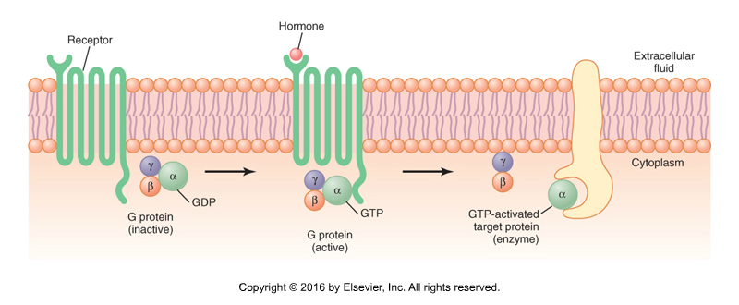
Mechanism of activation of a G-protein-coupled receptor.

- When a ligand is binds to the extracellular part of the receptor, a conformational change occurs in the receptor that activates the G proteins and induces intracellular signals that either:
  - Open or close cell membrane ion channels
  - Change the activity of an enzyme in the cytoplasm of the cell
  - Activate gene transcription
- When the hormone activates the receptor, the inactive α, β and γ G protein complex associates with the reception and is activated, with an exchange of guanosine triphosphate (GTP) for guanosine diphosphate (GDP). This process causes the α subunit (to which the GTP is bound) to dissociate from the β and γ subunits of the G protein and to interact with membrane-bound target proteins (enzymes) that initiate intracellular signals.
- Displacement of GDP to GTP causes the α subunit to dissociate from the complex and to associate with other intracellular signalling proteins.
  - These proteins, in turn, alter the activity of ion channels or intracellular enzymes such as adenynyl cyclase or phospholipase C, which alter cell function.
- The signaling effect stops when the hormone is removed and the α subunit inactivate itself by concerting its bound GTP to GDP; then the α subunit once again combines with β and γ subunits = inactive
- Also called heterotrimeric guanosine triphosphate (GTP)-binding proteins (G-proteins)

Enzyme-linked hormone receptors.
These enzyme-linked receptors, when activated, function directly as enzymes or are closely associated with enzymes that they activate, i.e.,
- Receptor/leptin
  - A hormone secreted by fat cells (leptin)
  - Has many physiological effect
  - Important in regulating appetite and energy balance
  - Member of the cytokine receptors that do not themselves contain enzymatic activity but signal through associated enzymes
- These enzyme-linked receptor are proteins that pass through the membrane only once (not like the G protein that loops around several times)
- When the hormone binds to the extracellular part of the receptor an enzyme immediately inside the cell membrane is activated (or occasionally inactivated).
- Although many enzyme-linked receptors have intrinsic enzyme activity, others rely on enzymes that are closely associated with the receptor to produce changes in cell function.

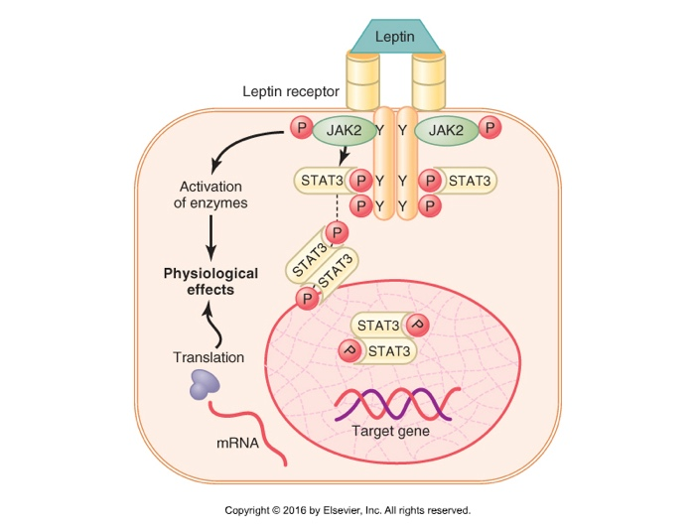
An enzyme-linked receptor – the leptin receptor.

- The receptor exists as a homodimer (two identical parts),
- The leptin receptor exists as a dimer and binding of leptin to the extracellular part of the receptor alters its conformation, enabling phosphorylation and activation of the intracellular associated JAK2 molecules.
- The activated JAK2 molecules then phosphorylate other tyrosine residues within the leptin receptor – JAK2 complex to mediate intracellular signaling,
- The intracellular signals include phosphorylation of signal transducer and activator of transcription (STAT) proteins, which activates transcription by leptin target genes to initiate protein synthesis,
- Phosphorylation of JAK2 also leads to activation of other intracellular enzyme pathways such as mitogen-activated protein kinases (MAPK) and phosphatidylinositol 3-kinase (PI3K).
- Some of the effects of leptin occur rapidly as a result of activation of these intracellular enzymes, whereas other actions occur more slowly and require synthesis of new proteins.

Other examples:
- Hormone to bind with a special transmembrane receptor, which then becomes the activated enzyme adenylyl cyclase at the end that protrudes to the interior of the cell
  - Catalyzes the formation of cAMP, which has a multitude effects inside the cell to control cell activity
    - cAMP is called a second messenger because it so not the hormone itself that directly institutes the intracellular changes
- For a few peptide hormones, such as atrial natriuretic peptide, cyclic guanosine monophosphate, which is only slightly different from cAMP, serves in a similar manner as a second messenger.

Many peptide growth factors, cytokines, and hormones that use the enzyme-linked receptor tyrosine kinases for cell signaling:

- Fibroblast growth factor
- Growth hormone
- Hepatocyte growth factor
- Insulin
- Insulin-like growth factor-1
- Leptin
- Prolactin
- Vascular endothelial growth factor

Intracellular hormone receptors and activation of genes
- Lipophilic hormones, such as steroids, bind with the protein receptors inside the cells,
- Lipid soluble, rapidly cross the cell membrane and interact with the receptors in the cytoplasm or nucleus,
- Hormones that bind inside the cell rather than in the cell membrane:
  - Adrenal and gonadal steroid hormones
  - Thyroid hormones
  - Retinoid hormones
  - Vitamin D
- Activated hormone-receptor complex binds with a hormone response element (promoter), which then can activate or repress transcription of mRNA.
- Therefore, minutes, hours and even days after the hormone has entered the cell, newly formed proteins appear in the cell and become the controllers of new or altered cellular functions.
- *** Many different tissues have identical intracellular hormone receptors, but the genes that the receptors regulate are different in the various tissues.
- An intracellular receptor can activate a gene response only if the appropriate combination of gene regulatory proteins is present, and many of these regulatory proteins are tissue specific.
- Thus, the responses of different tissues to a hormone are determined not only by the specificity of the receptors but also by the expression of genes that the receptor regulates.

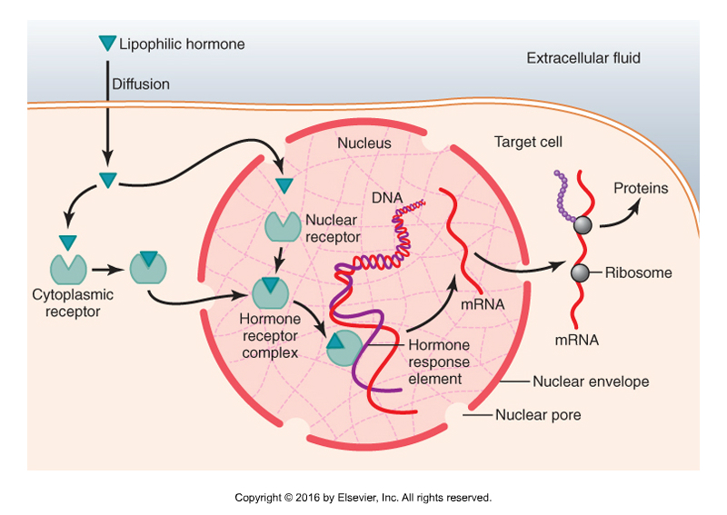
Mechanisms of interaction of lipophilic hormones, such as steroids, with intracellular receptors in target cells.
- The steroid hormone diffuses across the cell membrane and enters the cytoplasm of the cell, where it binds with a specific receptor protein.
- The combined receptor protein-hormone then diffuses into or is transported into the nucleus.
- The combination binds at specific points on the DNA strands in the chromosomes, which activates the transcription process of specific genes to form mRNA.
- The mRNA diffuses into the cytoplasm, where it promotes the translation process at the ribosomes to form new proteins.

Second messenger mechanism for mediating intracellular hormonal functions
- Some hormones exert intracellular actions by stimulating formation of the second messenger cAMP inside the cell membrane.
- Then, cAMP causes following intracellular effects of the hormone,
- Thus, the only effect that hormone has on the cell is to activate a single type of membrane receptor.
- The second messenger does the rest.
- cAMP is not the only second messenger used by the different hormones. Two other important ones:
  - Calcium ions and associated calmodulin
  - Products of membrane phospholipid breakdown

Hormones that use the adenylyl cyclase – cAMP second messenger system:

- Adrenocorticotropic hormone (ACTH)
- Angiotensin II (epithelial cells)
- Calcitonin
- Catecholamines (beta receptors)
- Corticotropin-releasing hormone (CRH)
- Follicle-stimulating hormone (FSH)
- Glucagon
- Growth hormone-releasing hormone (GHRH)
- Human chorionic gonadotropin (hCG)
- Luteinizing hormone (LH)
- Parathyroid hormone (PTH)
- Secretin
- Somatostatin
- Thyroid-releasing hormone (TSH)
- Vasopressin (V₂ receptor, epithelial cells)

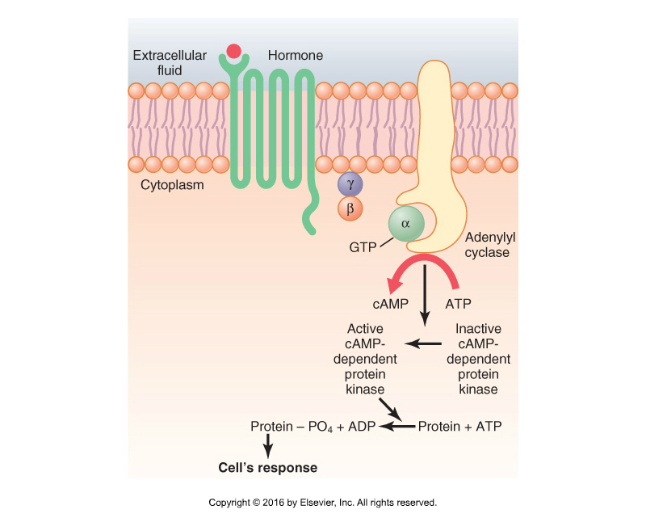
The cyclic adenosine monophosphate (cAMP) mechanism by which many hormones exert their control of cell function.

- Binding of hormones with the receptor allows coupling of the receptor to a G protein.
- If the G protein stimulates the adenylyl cyclase – cAMP system, it is called a Gs protein then catalyzes the conversion of a small amount of cytoplasmic ATP cAMP inside the cell.
- This then activate cAMP-dependent protein kinase, which phosphorylates specific cell proteins, triggering biochemical reaction that ultimately lead to the cell’s response the hormone.
- Once a cAMP is formed inside the cell, it usually activates a cascade of enzymes (one after another).
- The importance of this mechanism is that only a few molecules of activated adenylyl cyclase immediately inside the cell membrane can cause many more molecules of the next enzyme to be activated.
- SO, small amount of hormones = powerful cascading activating force for the entire cell
- If binding of the hormone to its receptors is coupled to an inhibitory G protein (denoted Gi protein), adenylyl cyclase will be inhibited, reducing formation of cAMP and ultimately leading to an inhibitory action in the cell.
- Thus, depending on the coupling of the hormone receptor to an inhibitory or stimulatory G protein (hormone) can either increase or decrease the concentration of cAMP and phosphorylation of key proteins inside the cell.
- The specific action that occurs in responses to increases or decreases of cAMP in each type of target cell depends on the nature of the intracellular machinery; some cells have on set of enzymes, and other cells have other enzymes.

The importance of the second messenger cAMP System:
- Even the slightest amount of hormone acting on the cell surface can initiate an immediate and powerful activating force for the entire cell.

Cell membrane phospholipid second messenger system
- Some hormones activate transmembrane receptors that activate the enzyme phospholipase C attached to the inside projections of the receptors.
- This enzyme catalyzes the breakdown of some phospholipids in the cell membrane PIP2 into two different second messenger IP3 and DAG.
- IP3 mobilizes calcium ions from mitochondria and the endoplasmic reticulum, and the calcium ions then have their own second messenger effects (smooth muscle contraction, change in secretion).
- DAG activates the enzyme protein kinase C, which then phosphorylates a large number of proteins, leading to cell’s response.
- See Figure 75.8 page 935

Hormones that use the phospholipase C second messenger system:

- Angiotensin II (vascular smooth muscle)
- Catecholamines (alpha receptors)
- Gonadotropin-releasing hormone (GnRH)
- Growth hormone-releasing hormone (GHRH)
- Parathyroid hormone (PTH)
- Oxytocin
- Thyrotropin-releasing hormone (TRH)
- Vasopressin (V1 receptor, vascular smooth muscle)

Calcium-calmodulin second messenger system
- This is another second messenger system that operates in response to the entry of calcium into the cells.
- Calcium entry may be initiated by:
  - Changes in membrane potential that open calcium channels
  - A hormone interacting with membrane receptors that open calcium channels
- After entering a cell, calcium ions bins with the protein calmodulin.
- Calmodulin is a protein that has 4 calcium sites and when the calcium binds to it, it changes shape and initiates multiple effects inside the cell, including activation or inhibition of protein kinase.
- Activation of calmodulin-dependent protein kinases causes, via phosphorylation, activation or inhibition of protein involved in cell’s response to the hormone.
- Example: activation of the myosin light chain kinase

Hormones that act mainly on the genetic machinery of the cell
Steroid hormones increase protein synthesis:
- Which can function as enzymes, transport proteins, structural proteins, which in turn provide other functions
  - The function is characteristically delayed for up to hours or even days, in contrast to the instantaneous action of some peptide or amino hormones, i.e., norepinephrine.

Thyroid hormones increase gene transcription in the nucleus:
- To accomplish this increases transcription, these hormones first bind directly with receptor proteins in the nucleus
- These receptors are activated transcription factors located within the chromosomal complex and they control the function of the gene promoters.
- Features of the thyroid hormone in the nucleus:
  - Activate the genetic mechanisms for the formation of many types of intracellular proteins (enzymes)
  - Once bound to the intranucleur receptors, the thyroid hormones can continue to express their control functions for days or even weeks.

Measurement of hormone concentrations in the blood
- Most hormones are present in the blood in minute quantities.
- Radioimmunoassay made it possible to measure the hormones in blood, some 45 years ago.
- Today, the ELISA method has become widely used test in clinical laboratories, because:
  - It does not use radioactive isotopes,
  - Can be automated, using 96 well plates,
  - It is cost effective and accurate.

Basic principles of the enzyme-linked immunosorbent assay for measuring the concentration of a hormone (H).
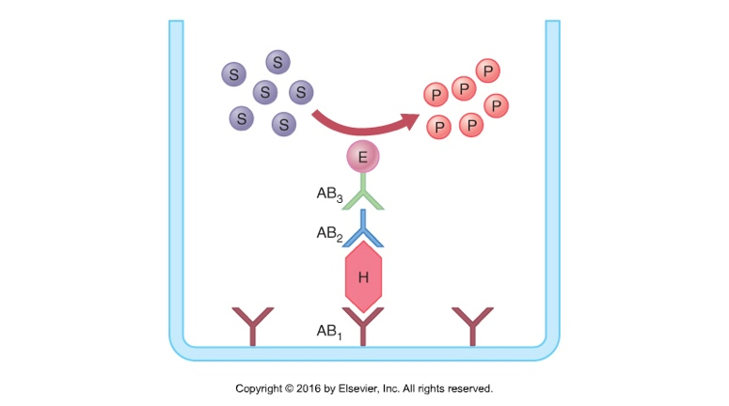

- AB1 and AB2 are antibodies that recognize the hormone at different binding sites, and AB3 is an antibody that recognizes AB2.
- E is an enzyme linked to AB3 that catalyzes the formation of a colored fluorescent product (P) from a substrate (S).
- The amount of the product is measured using optical methods and is proportional to the amount of hormone in the well of these are excess antibodies in the well.

