L3 - Business Analytics
Graphical Solution for LP

Graphical solution
- Any LP with only two variable can be solved graphically
- Graphical methods provide visualization of how a solution for a linear programming problem is obtained

Example: (Bowls and Mug)
Solving this problem using graphical method
- Maximize Z = $40B + 50M
- 1B + 2M <= 40
- 4B + 3M <= 120
- B,M >= 0

Labour constraint:
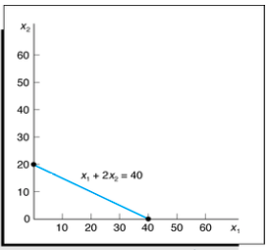

Finding area that satisfies labour constraint:
- Maximize Z- $40B + $50M
- 1B + 2M <= 40
- 4B + 3M <= 120
- B,M >= 0

Area that satisfies labour constraint:
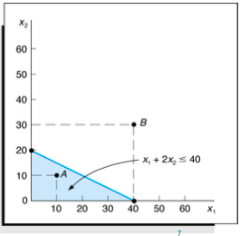

Finding area that satisfies clay constraint:
- Maximize Z = $40B + $50M
- 1B + 2M <= 40
- 4B + 3M <= 120
- M, B >= 0

Area that satisfies clay constraint:
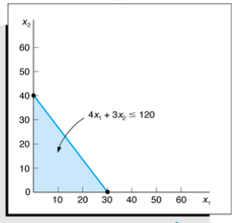

Finding the feasible region for the problem:
- Maximize Z = $40B + $50M
- 1B + 2M <= 40
- 4B + 3M <= 120
- B,M >= 0

Feasible region:
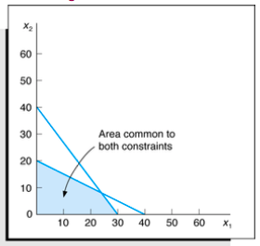

Finding the feasible solutions:
- Any point in the feasible region is a feasible solution
- For point (B,M) to be in the feasible region it must satisfy all the constraints inequalities

- 1B + 2M <= 40
- 4B + 3M <= 120
- B,M >= 0

Which of the following points (S,T and R) are considered a feasible solution?
- Maximize Z = $40B + $50M
- 1B + 2M <= 40
- 4B + 3M <= 120
- B,M >= 0

Feasible solution:
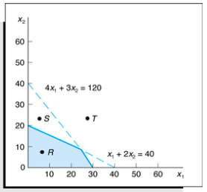

Drawing objective function line
- Having identified the feasible region for the problem, we now search for the optimal solution, which will be the point in the feasible region with the largest values of Z = 40B + 50M
- To find the optimal solution, we need to graph the line on which all points have the same z-value. I call this line an objective function line.

To draw an objective function line, choose any point in the feasible region and calculate its z-value
- Maximize Z = $40B + $50M
- 1B + 2M <= 40
- 4B + 3M <= 120
- B,M >= 0

Objective Function Line for Z = $800
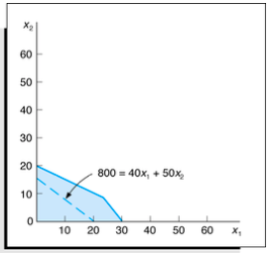

Once we draw one Objective function line, we can find all other Objective function lines by moving parallel to the line we have drawn. Simply because they all have the same slope
- Mazimize Z = $40B + $50M
- 1B + 2M <= 40
- 4B + 3M <= 120
- B,M >= 0

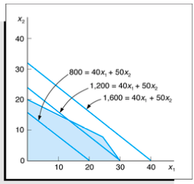

Finding the optimal solution
- It is now clear how to find the optimal solution to a two-variable LP. After you have drawn a single objective function line, generate another objective function line by moving parallel to the drawn line in a direction that increases z (for a max problem). After a point, the objective function lines will no longer intersect the feasible region.
- The last objective function line intersecting (touching) the feasible region defines the largest z-value of any point in the feasible region and indicates the optimal solution to the LP
- For the minimization problem, you should move the line in a direction that minimizes z

Therefore, optimal point will be point B for this problem
- Maximize z = $40B + $50M
- 1B + 2M <= 40
- 4B + 3M <= 120
- B,M >= 0

Finding the optimal solution point:
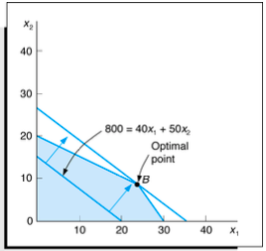

Note that point B is where the lines 1B + 2M <= 40 and 4B + 3M <= 120 intersect. Solving these two equations simultaneously, we find the coordinates of optimal solution.
- Maximize Z = $40B + $50M
- 1B + 2M <= 40
- 4B + 3M <= 120
- B,M >= 0

Hence, optimal solution for decision variables are:
- B*= 24 bowls
- M* = 8 mugs
- Z* = 40(24) + 50(8)

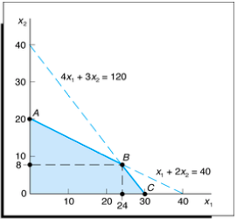

Extreme Points, and LP Solution
Convex sets, extreme points, and LP solution
- The feasible region for this problem is an example of a convex set
- A set of points S is a convex set if the line segment joining any pair of points in S is wholly contained in S
- Extreme point:
  - For any convex set s, a point P in S is an extreme point if each line segment that lies completely in S and contains the point P has P as an endpoint of the line segment
- Extreme points are sometimes called corner points, because if the set S is a polygon, the extreme points of S will be the vertices, or corners, of the polygon
- The feasible region for the problem 1 is a convex set. This is no accident: it can be shown that the feasible region will be a convex set
- It can be shown that the feasible region for any LP has only a finite number of extreme points
- Also note that the optimal solution to the problem 1 (point B) is an extreme point of the feasible region
- Therefore, it can be shown that any LP that has an optimal solution has an extreme point that is optimal
- The result is very important, because it reduces the set of points that yield an optimal solution from the entire feasible region (which generally contains an infinite number of points) to the set of extreme points (a finite set)

You can observe that corner point B has the maximum value of objective function among all corner points and therefore is the optimal solution point
- Maximize Z = $40B + $50M
- 1B + 2M <= 40
- 4B + 3M <= 120
- B,M >= 0
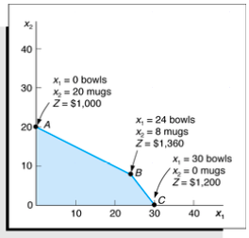

Slack and Surplus Variables
- Standard form of a problem requires that all constraints be in the form of equations (equalities)
- A slack variable is added to a <= constraint (weak inequality) to convert it to an equation (=)
- Slack is the amount of a resource that is unused by a solution
- A surplus variable is subtracted from >= constraint to convert it to an equation (=)
- A surplus variable represents an excess above a constraint requirement level
- A slack or surplus variable contributes nothing to the calculated value of the objective function

Binding and non-binding constraints
- A constraint is binding if the left-hand side and the right-hand side of the constraint are equal when the optimal values of the decision variables are substituted into the constraint
  - Therefore, value of slack or surplus on binding constraints is zero
- A constraint is nonbinding if the left-hand side and the right-hand side of the constraint are unequal when the optimal values of the decision variable are substituted into the constraint
  - Therefore, value of slack or surplus on non-binding constraints is non-zero

What are the binding constraints in this problem?
What are the value of slack/surplus?
- Max Z = 40B + 50M + 0S1 + 0S2
- 1B + 2M + S1 = 40
- 4B + 3M + S2 = 120
- B,M, S1, S2 >= 0
- Where:
  - B = number of bowls
  - M = number of mugs
  - S1, S2 are slack variables

Solver answer report
- Answer report provides useful information about the final values of decision variables, objective function, and status of constraints

Setting up the problem: (refer to Excel formulation posted on BBL)
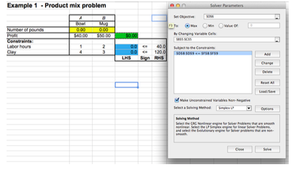

Choose “Answer” from reports section:
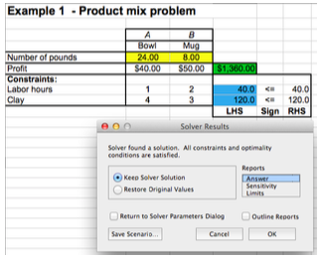

Verify the status of constraints, optimal solution and optimal objective function value in the answer report:


