Chapter 1: Introducing Management
Organization: collection of people working together to achieve a common purpose
- Provide useful good and services that return value to society and satisfy customer needs
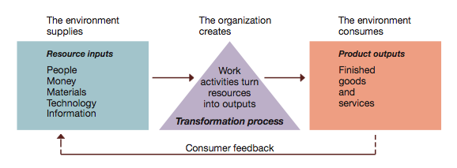
- Organizations as open systems:
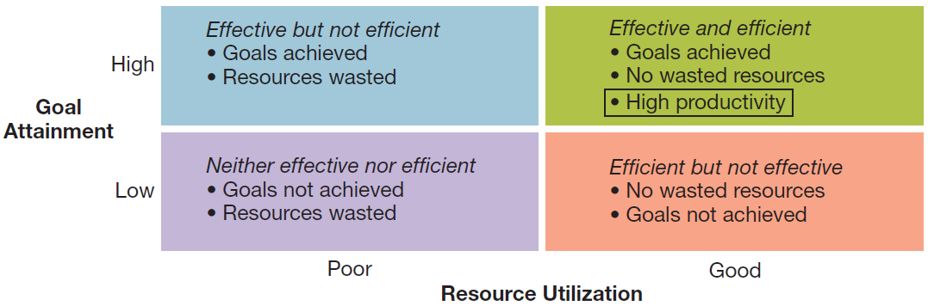
- Productivity and the dimensions of organizational performance
Organizational environment:
- The general environment (all background conditions in external environment of org.)
  - Economic: health of the economy
  - Legal-political: norms, customs, social values
  - Socio-cultural: philosophy/objectives of political party running the government
  - Technological: development and availability of technology
  - Natural environment: nature and conditions of environment
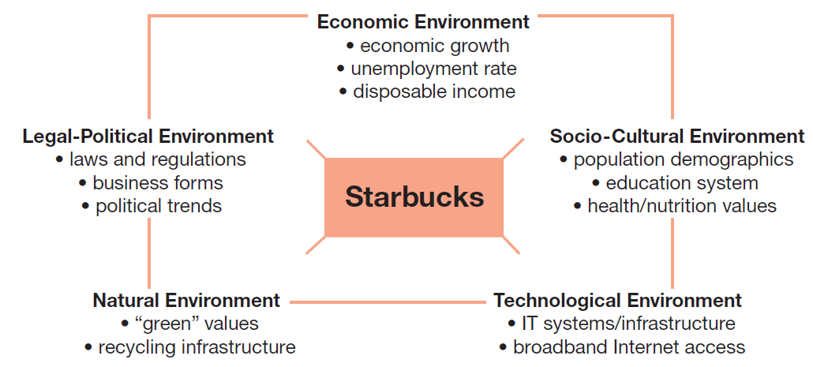
- Sample general environment conditions faced by firms like Starbucks
- The specific (task) environment: actual organizations, groups, and persons with whom organizations interact and conduct business
- Includes stakeholders: customers, suppliers, competitors, regulators, investors/owners
- Value creation: creating value for and satisfying the needs of constituencies
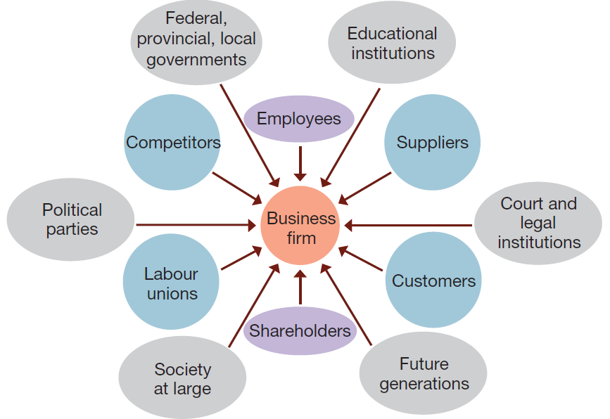
- Multiple stakeholders in the specific environment of a typical business firm

- Environmental uncertainty: lack of complete info regarding what exists and what developments may occur in external environment
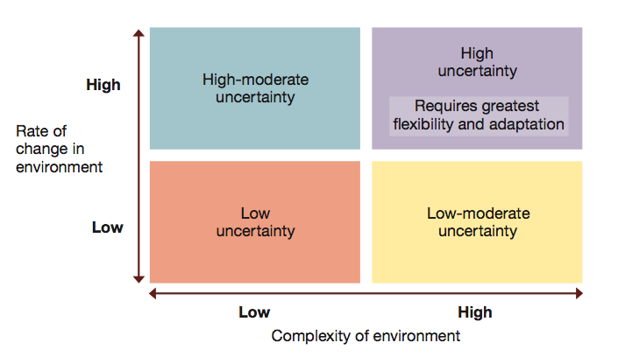
- Two dimensions of environmental uncertainty: Dimensions of uncertainty
  - Degree of complexity
  - Rate of change

Managers in the new workplace
- Levels of management
  - Top managers: responsible for performance of org as whole or for one of larger parts
  - Middle managers: in charge of relatively large departments or divisions
  - Team leaders (supervisors): in charge of small group of non-managerial workers
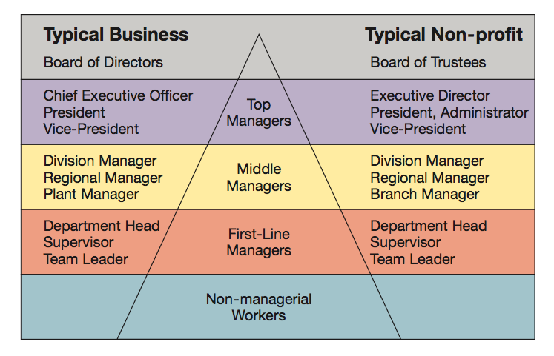
- Management levels in a typical business and non-profit organizations

Management process:
- Managers achieve high performance for orgs by utilizing human and material resources
- Management: process of planning, organizing, leading, and controlling use of resources to accomplish performance goals
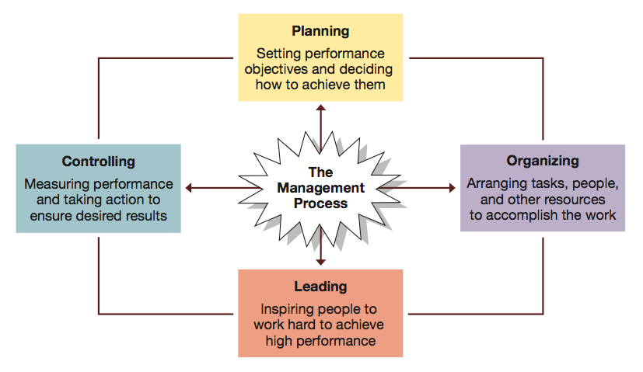
- All managers are responsible for the four functions: POLC

- Managerial activities and roles:
  - Informational roles: involve giving, receiving and analyzing of info
  - Interpersonal roles: interactions with people inside and outside work unit
  - Decisional roles: using info to make decisions in order to solve problems or address opportunities

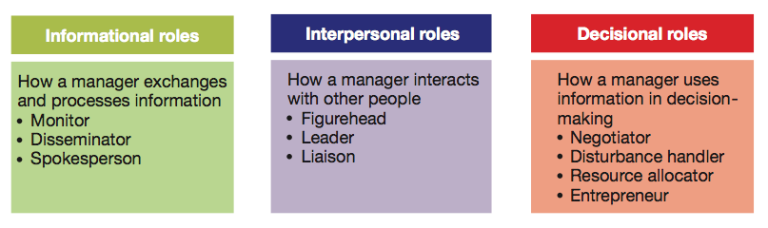
- Mintzberg’s 10 managerial roles

- Essential managerial skills
  - Skill: ability to translate knowledge into action resulting in desired performance
  - Technical skill: able to apply special proficiency or expertise to perform tasks
  - Human or interpersonal skill: able to work well in cooperation with others
    - Emotional intelligence: able to manage ourselves and relationships effect
  - Conceptual skill: able to think critically and analytically to solve hard problems
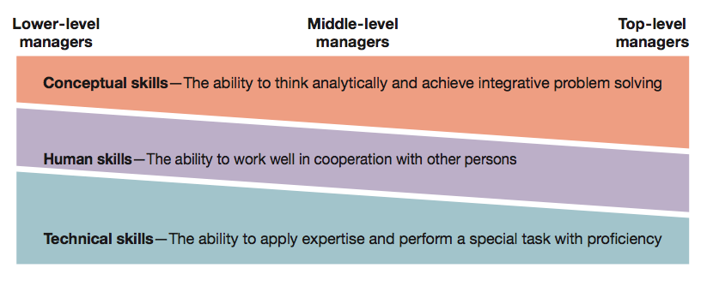
- Katz’s essential managerial skills

Chapter 2: Management learning: past to present
For whence we came…
- Management: getting the right things done through other people
- How was the way we do this, as managers, evolved over time?
- Management thought started over 100 years ago, and has evolved rather quickly
Evolution of management theory
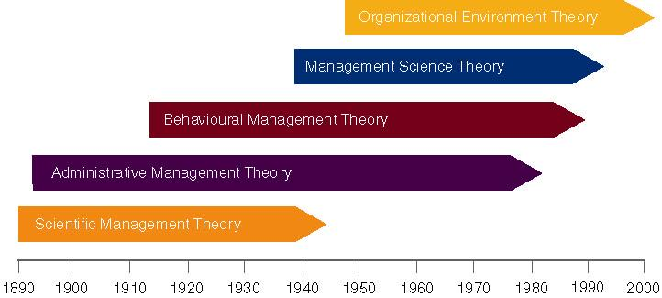

Classical management approaches
- Classical approaches to management Assumption: people are rational
  - Scientific management
    - Frederick Taylor
      - Systematic study of relationships between people and tasks to redesign the work for higher efficiency
      - Taylor sought to reduce time a worker spent on each tasks by optimizing the way the task was done
      - Taylor’s principles to increase efficiency:
        - For every job, develop a science:
          - Rules of motion
          - Standardized work implements
          - Proper working conditions
        - Carefully select workers with right abilities to perform job
        - Train workers and give proper incentives to cooperate with job science
        - Support workers by carefully planning their work
        - Study & codify Select & train Reward
      - Problems:
        - Managers often implement only the increased output side of Taylor’s plan
          - Did not allow workers to share in increased output
          - Specialized jobs became very boring, dull
          - Workers ended up not trusting the scientific management
        - Workers could purposely “under-perform”
        - Management responded with increased use of machines
    - Frank and Lillian Gilbreth
      - They refined Taylor’s methods
        - Made many improvements to time and motion studies
      - Time and motion studies:
        - Break down each action into components
        - Find better ways to perform it
        - Reorganize each action to be more efficient
      - They also studied fatigue problems, lighting, heating and other worker issues
    - Gilbreths vs. Taylor
      - Gilbreths’ studies were more focused on how task was done and how to best eliminate unneeded, fatiguing steps in any process
      - Gilbreths’ form had more developed view of worker and his/her interests vs. Taylor’s predominant view of worker as driven solely by pay
      - Gilbreths used photography as a means to study human motion in completing tasks (micro motion films)
    - Practical lessons from scientific management:
      - Make results-based compensation a performance incentive
      - Carefully design jobs with efficient work methods
      - Carefully select workers with abilities to do these jobs
      - Train workers to perform jobs to the best of their abilities
      - Train supervisors to support workers so can perform jobs to best of abilities
  - Administrative principles (Henri Fayol)
    - Postulated that all admin activities could be divided into 6 groups
      - 1. Technical operations (production/manufacturing)
      - 2. Commercial operations (purchases, sales)
      - 3. Financial operations (finding and controlling capital)
      - 4. Security operations (protecting property and persons)
      - 5. Accounting operations (stocktaking, costing)
      - 6. Administrative operations or managerial activities:
        - Foresight, organizing, commanding, coordinating, controlling
    - Fayol developed set of 14 principles
      - 1. Division of labor: allows for job specialization
        - He noted firms can have too much specialization leading to poor quality and worker involvement
      - 2. Authority and responsibility: he included both formal and informal authority resulting from special expertise
      - 3. Unity of command: employees should have only one boss
      - 4. Line of authority: clear chain from top to bottom of the firm
      - 5. Centralization: degree to which authority rests as the very top
      - 6. Unity of direction: one plan of action to guide the organization
      - 7. Equity: treat all employees fairly in justice and respect
      - 8. Order: each employee is put where they have the most value
      - 9. Initiative: encourage innovation
      - 10. Discipline: obedient, applied, respectful employees needed
      - 11. Remuneration of personnel: payment system contributes to success
      - 12. Stability of tenure: long-term employment is important
      - 13. General interest over individual interest: organization takes precedence over individual
      - 14. Esprit de corps: share enthusiasm or devotion to the organization
  - Bureaucratic organization (Max Weber)
    - Bureaucracy: ideal, intentionally rational and very efficient form of organization
      - Based on principles of logic, order, and legitimate authority
    - Administrative management
      - He developed concept of bureaucracy
        - Formal system of org and admin to ensure effectiveness and efficiency
        - Developed five principles of bureaucracy
          - Manager’s formal authority derives from his/her position
          - People should occupy positions because of performance, not social connections
          - Authority, responsibility of each position relative to every other position should be made clear
          - Positions should be arranged hierarchically
          - Managers must create well defined system of rules standard operating procedures and norms
    - Key points of bureaucracy
      - Authority is power to hold people accountable for their actions
      - Positions in firm should be held based on performance not social contacts
      - Position duties are identified. People should know what is expected of them
      - Lines of authority should be identified. Workers know who reports to who
      - Rules, standard operating procedures (SOPs) and norms used to determine how the firm operates
        - Sometimes, these lead to red-tape and other problems
Behavioral management approaches
- Behavioral management – human resource approaches:
Assumption: people are social and self-actualizing
  - Organizations as communities (Mary Parker Follett)
    - She suggested workers help in analyzing jobs for improvements
    - Worker knows best way to improve job
    - If workers have knowledge of task, then they should control task
  - Hawthorne studies (Elton Mayo)
    - Occurred at Hawthorne Plant of the Western Electric Company in Cicero, Illinois
    - Initially examined physical and environmental influences of workplace (brightness of lights, humidity) and later examined psychological aspects, (breaks, group pressure, working hours, managerial leadership)
    - Four general conclusions:
      - Aptitudes of individuals are imperfect predictors of job performance
      - Informal organization affects productivity
      - Work-group norms affect productivity
      - Workplace is a social system
  - Theory of human needs (Abraham Maslow)
    - Need: physiological or psychological deficiency a person feels forced to satisfy
    - Need levels:
      - Lower-order needs:
        - 1. Psychological needs:
          - Most basic of all human needs
          - Need for biological maintenance: food, water, physical well-being
        - 2. Safety needs:
          - Need for security, protection, stability in events of everyday life
        - 3. Social needs:
          - Need for love, affection, sense of belonging in one’s relationships
      - Higher-order needs:
        - 4. Esteem needs:
          - Need for esteem in eyes of others
          - Need for respect, prestige, recognition
          - Need for self-esteem, personal sense of competence, mastery
        - 5. Self-actualization needs
          - Highest level: need for self-fulfillment; to grow and use abilities to fullest and most creative extent
    - Deficit principle: satisfied need is not a motivator of behavior
    - Progression principle: need becomes motivator once past lower-level is satisfied
    - Both principles cease to operate at self-actualization level
  - Theory X and Theory Y (Douglas McGregor)
    - He proposed two different sets of worker assumptions
      - Theory X: assumes average worker is lazy, dislikes work and will do minimal
        - Managers must closely supervise and control through incentives
      - Theory Y: assumes workers are opposite of other theory
        - Managers should allow worker great latitude and create an organization to stimulate the worker
  - Theory of adult personality/ personality and organizations (Chris Argyris)
Modern management foundations
- Foundations for continuing developments in management

  - Quantitative analysis and tools
  - Systems view of organizations
  - Contingency thinking
  - Commitment to quality
  - Learning organizations
  - Evidence-based management

Chapter 3: Global dimensions of management
What is management?
- Coordinating work activities so they are completed with and through other people
- Process of POLC other people so that organizations and objectives are achieved
What is globalization?
- Merging of national economies into an interdependent global economic system
- Interconnectedness between societies…
- Globalized world is one in which political, economic, cultural, and social events become more and more interconnected
- In other words, emergence of a single global economic system run by a multitude of complex and unique stakeholders
What is a stakeholder?
- Someone, group or something with a perceived stake in operations of the organization
What is global management?
- Process of developing strategies designing and operating systems and working with people around the world to ensure sustained competitive advantage
- Multinational management: formulation of strategies and the design of management systems that successfully take advantage of international opportunities and respond to international threats
Managing globally – some challenges (Many of them are culturally-based (CB))
- Cultural differences
- Political, legal and economic differences (CB)
- Different technological systems and capacities
- Different political and business environments
- Different employee attitudes toward work (CB)
- Different consumers’ needs and preferences (CB)
- Different business management practices (CB)
Advantages of globalization
- Most promising economic growth approach for developing countries and this will reduce poverty and reverse global inequality
- Increases trade and capital flow, generates gains in productivity and creates jobs not only in advanced industrial countries, but also in emerging economies and low-income countries
- Has raised incomes of consumers and their quality of life
Disadvantages of globalization
- Polarizing the world – creating haves and have-nots: developed countries continue to prosper while least developed countries continue, with little rep and influence, become further poverty stricken
- For unskilled workers (developing countries) national frontiers have become rigid and higher – so globalization favors more skilled workers (in developed countries)
- Continual expansion of world trade is causing a range of increasing environmental problems and social problems (ex: exploiting labor)
- Multilateral orgs (ex: WTO, EU, NAFT) is undermining national sovereignty as economic power is shifting from national governments to multilateral organizations
Globalization: some provocative perspectives
- From asgary and walle, the cultural impact of globalization: economic activity and social change, cross cultural management
- 1. Cultural homogenization
  - Result from increased communication, technical convergence
  - Transformation of other regions, cultures, nations and societies by culture of economically dominant west (McDonaldisation)

- Contributing factors
  - a. Global transformation of local culture
    - Mass marketing, on an international level, displaces strategies built around national, regional and cultural differences (McDonalds in Japan and US)
    - Products that are outwardly uniform may be perceived differently by consumers
  - b. Emergence of a consumer mentality
    - Shopping and spending as ends in themselves
    - Consumers bombarded by merchandising and messaging that promotes the consumption of a good that frequently is a homogenized version of an internationally fashionable product
  - c. Impact of elite culture
    - Homogenization and globalization as realm of elite – those capable of buying the products (BMW, Mercedes, Jaguar. Rolex/Omega wrist watches)
    - Elite interact within a westernized cultural paradigm, western culture symbolizing affluence and power – unity among elite
  - d. Influence of the internet
    - Facilitating communication between diverse people
    - Much faster speed of cultural diffusion, potentially increasing level of cultural homogeneity
- 2. Polarization
  - Cultural, regional or national distinctiveness that flies in face of homogeneity
  - A peoples defence of their traditions and way of life
  - Technology can facilitate polarization
- Many cultures oppose being subsumed by western culture, but people can be part of local society and simultaneously part of the national/international community
- Herder – all peoples and nations possess a unique national character and need to be envisioned and interpreted accordingly
- 3. Hybridization and dialectics
  - Hybridization: globalization has not created world represented by mutually exclusive precepts of homogeneity or polarization, but rather some mix of the two
  - Dialectics: explanation of process of hybridization – ongoing interaction of thesis (cloistered culture) with anti-thesis (new cultural traditions introduce) that results in reconciliation of the two extremes that in turn, results in new thesis that then interacts with an anti-thesis, etc.
What is culture?
- Collection of learned and shared values, enduring beliefs, and attitudes, which are seen as relatively permanent perceptual framework influences individuals’ behavior/customs within a society and set of symbols that distinguished a society’s orientation as per above
- C. Multiple dimension models of national culture
  - Hofstede’s five dimensions
    - 1. Collectivism vs. individualism
      - Extent to which people define themselves as autonomous individuals or members of groups
      - Individualistic societies: members concerned with looking after themselves and their immediate families (North America/Western culture)
      - Collectivist societies: members emphasize on groups (Asian, Latin, African culture). Decision making typically occurs by consensus
    - 2. Power distance
      - How society deals with fact that people are unequal in social and status sense
      - Extent to which society accepts that power in society’s institutions and organizations is unequally distributed
      - Large power distance: greater acceptance of unequal power (Japan, China)
      - Small power distance: people want power to be shared equally (USA, Canada)
    - 3. Uncertainty avoidance
      - How society copes with uncertainty and deals with risk
      - People’s conscious avoidance of ambiguous and uncertain situations
      - High uncertainty avoidance: characterized by intolerance for behaviors and ideas that deviate from the norm
    - 4. Femininity vs. masculinity (quality of life vs. career success)
      - Gender-stereotypical learning of society and degree to which society allows overlap between roles of men and women
      - Masculine society: social values such as aggressiveness, acquisition of money and material possessions; gender-based roles clearly differentiated
      - Feminine society: social values such as nurturing sympathy for disadvantaged
    - 5. Time orientation (Confucian dynamism)
      - Employees’ devotion to work ethic and their respect for tradition
Chapter 4: Ethics, social responsibility, and sustainability
Ethics and ethical behavior
- Ethics: beliefs about what is right and wrong; good and bad
- Ethical behaviour: behavior that conforms to individual beliefs and societal norms about what is right and good
How do we define business ethics?
- Rules, standards, codes or principles which provide guidelines for morally right behavior and truthfulness in specific situations
- Applies a group’s standards of right and wrong to the decisions and actions of business organizations, managers, and employees
Common themes emerging from definitions of business ethics
- Right and wrong
- Moral standards: means by which individuals judge their actions and actions of others based upon accepted behavior in society
- Value judgements: subjective evaluations of what is considered important, based on how managers intuitively feel about the goodness or rightness of various goals
Basic approaches to ethical decision-making
- Utilitarian approach: focuses on consequences of a decision – intention is to make decision that results in greatest good for the greatest number
- Moral rights approach: focus on examining moral standing of actions independent of their consequences (some things are just right and some just wrong regardless of consequences)
- Universal approach: choosing course of action you believe can apply to all people under all situations (do unto others as you would have then do unto everyone, including yourself)
- Justice approach: focus on how equitably the costs and benefits of actions are distributed
  - Procedural justice: impartial application of rules or procedures
  - Corrective justice: appropriate compensation for wrongdoings that are suffered
  - Retributive justice: punishment should fit the offence
  - Distributive justice: concern for how all stakeholders are treated
Influences on ethical behavior

- Individual morals
- National and ethical cultures
- Gov’t legislation and regulation
- The legal system
- Religion
- Colleagues or peers
- Education
- Media
- Corporate mission, vision, and value statements
- Union contracts
- Competitive behavior
- Activist or advocacy groups
- Business or industry organizations
- Professional associations

Business ethics
- Two key branches of ethics
  - Descriptive ethics: describing, characterizing and studying morality (what is)
  - Normative ethics: supplying and justifying moral systems (what should be)
Making ethical judgements: deciding what is ethical
- Ethical dilemmas: situations where decision must be made between two equally valid but mutually exclusive courses of action
Corporate social responsibility (CSR)
- What is CSR:
  - Degree of moral obligation that may be ascribed to corps beyond simple obedience to laws of state
  - An org’s obligation to maximize its positive impact and minimize negative effects in being a contributing member to society, with concerns for society’s long-run needs and wants. CSR = being a good steward of society’s economic and HR
  - Intelligent and objective concern for welfare of society that restrains individual and corp. behavior from ultimately destructive activities, no matter how immediately profitable and leads in direction of positive contributions to human betterment, variously as latter may be defined
- Definition
  - Way a corp. achieves balance among economic, social and environmental responsibilities in its operations so as to address shareholder and other stakeholder expectations
  - Capacity of a corp. to respond to social pressure
- Philosophical arguments
  - Can a corp. have social responsibilities?
  - Can a corp. be morally responsible for its actions?
- Case for social responsibility
  - Business must satisfy society’s needs
  - CSR prevents public criticism and government regulation
  - Business and society are interdependent
  - CSR is good for the bottom line
  - Investors and consumers support CSR
  - Addressing social problems can become financial opportunities (e.g., pollution abatement)
  - Business should take long-term CSR approach
  - Social actions improve public image and goodwill
  - Business can solve problems as well as government
  - Proactive approach is better than reactive
  - Businesspeople are also concerned citizens
- Case against CSR
  - Profit maximization is the primary purpose of business
  - Business is responsible to shareholders
  - Social policy is role of government
  - Business lacks training in social issues
  - CSR would give too much power to business
  - Business involvement in social matters increases costs
  - No reliable guidance for business in CSR matters
  - Business cannot be held accountable unlike like social institutions
  - There is divided support in business community for social involvement
Chapter 5: Entrepreneurship and small business management
Small business: owner-managed business with fewer than 100 employees
- 2.3 million in Canada, 97.7% of all employer businesses in Canada are small
- Account for over 2/3 employment in four industries

  - Non-institutional health care
  - Construction
  - Accommodation and food
  - Other services

The entrepreneur and the entrepreneurial process
- Entrepreneurs: people who recognize and seize the opportunity
- Entrepreneurship: process of identifying opportunity in marketplace and accessing resources necessary to capitalize on that opportunity
The entrepreneurial process
- Identify opportunities
  - Idea screening
  - Screening:
    - Idea creates or adds value
    - Idea provides a sustainable competitive advantage
    - Idea is marketable and financially viable
    - Idea has low exit costs
  - Develop the opportunity
- Access the necessary resources
The entrepreneurial process: applied
- Idea:
  - Idea: A domestic cleaning business
  - Example: provide high end sandwich at high end location
  - Why?
    - Aging population, maintaining seniors in their own homes is cheaper for the state
- Screening:
  - How does it create value?
    - Providing a service which there is demand (or future demand or expectation of increasing demand)
  - Screening: Sustainable competitive advantage
  - What can you offer that the competition cannot? How can you sustain this?

    - Higher quality
    - Better service
    - Greater convenience
    - Lower price

  - Screening: idea is marketable and financially viable
    - Marketable: will people buy it?
    - Financially viable: will it be profitable
  - Screening: low exit costs
    - If the idea fails, can you get out of business easily with minimum loss?
      - What can increase exit costs?
        - Contractual obligations with high cancellation penalty clauses
        - Heavy investment in equipment
        - Complicated business structure with several employees
        - Unionized environment
- Resources:
  - Resources: can you get the money to start the business?

    - Cash on hand?
    - Credit?
    - Equity offering?
    - Partner(s)?

The Canadian private sector: forms of business ownership
- Sole proprietorship (SP)
  - Simplest form of business organization available to individual who is legally able to enter into a binding contract
  - SP fall under provincial and municipal jurisdiction
  - Filing a name declaration is not required provided proprietorship operates under a person’s name
  - Owned and operated by one person
  - Advantages:

    - Ease and cost of starting and ending the business
    - Secrecy
    - Flexibility and control
    - Pride of ownership
    - Distribution and use of profit
    - No special taxes – profits are personal income and taxed at individual tax rates
    - No government regulation

  - Disadvantages:

    - Unlimited liability
    - Limited financial resources
    - Limited skill pool
    - Overwhelming time commitment
    - Few fringe benefits
    - Limited growth
    - Limited life span

- Partnership
  - Arrangement whereby two or more people combine some or all of their resources in business undertaking with a view to sharing profits among partners
  - Provincial laws require that partnership must legally register its name and give info about the partners
  - General – complete sharing in the management of the business
    - Partners are not only liable in equal share for debts of partnership (joint liable) but also, each partner is liable for full amount (joint and severally liable)
    - Each member can bind partnership without consent of other partner
    - 1. Senior partners (major management roles, largest share of profits)
    - 2. Junior partners (minor management roles, smaller share of profits)
  - Limited
    - Composed of one or more general partners who conduct business
    - Composed of one or more people who contribute an amount in actual cash (special or limited partners)
    - Special partner’s liability is normally limited only to the amount of cash contributed to partnership
    - 1. Silent partners (known to public, no active management role)
    - 2. Secret partners (unknown to public, active role in management)
    - 3. Nominal partners (lend their name for public relation, not involved)
    - 4. Dormant partners (not known to public, not active in management)
  - Joint venture: partnership established for a specific project or a limited time
  - Advantages:

    - Ease or organization
    - More financial resources (capital and credit)
    - Shared management
    - Combined knowledge and skills
    - Faster decision making
    - Few regulatory controls

  - Disadvantages
    - Unlimited liability
    - Partners are responsible for the business activities of all others
    - Division of profits
    - Disagreements among partners – can be difficult to get rid of partner
    - Life of partnership
- Incorporation (Inc.)
  - Under federal laws
  - Under provincial laws
    - Public corporation
      - Sells shares to public on stock exchange
      - Subject to stricter regulations for filing financial reports, must follow certain audit procedures
      - Must file a prospectus if shares being sold to investing public
    - Private corporation – (including most family businesses)
      - Right to transfer shares is restricted
      - Number of shareholders limited to 50
      - May not sell shares or debentures (bonds or debt instruments) to public
    - Family Business
      - About 2/3 or Canadian business enterprises controlled by families (usually through private corporations)
      - Estimated: 10 000 family business in Canada with two or more generations as owners or managers
      - They control about 1/3 of 100 largest companies in Canada
      - Founder or family members are in executive positions
      - Fam. members hold sufficient shares to make decisions and control operations
      - Approx. 25% survive founder’s demise, bout 10% survive beyond two generations and 3% beyond third generation
- Corporation
  - Recognized as separate legal entity under the law
  - Corporation incorporated under laws of Canada (federally incorporated business) can carry on business in all parts of Canada
    - Federally Inc. businesses include 150 of 200 largest corporation in Canada
    - Federal company cannot be prevented by provincial government from exercising powers that have been validly conferred on company by federal authority (e.g., doing business in a province)
  - Governance of a corporation is responsibility of a Board of Directors
  - Ownership of a corp. is through stock or shares (preferred or common shares – typically voting shares)
  - Subsidiary corporation
    - One that has majority of stocks owned by another corp. known as parent company (e.g., IBM Canada, HP Canada)
  - Holding company
    - Corp. that controls one or more other corps through ownership of common stock
  - Advantages

    - More money for investment
    - Limited liability
    - Separation of ownership/management
    - Ease or ownership change
    - Perpetual life
    - Size

  - Disadvantages

    - Initial cost
    - Paperwork
    - Two tax returns
    - Termination difficult
    - Double taxation

- Alternative business forms
  - Crown corporations – Export Development Corp., VIA Rail
    - For-profit corp. owned and operated by federal, provincial or local government whose focus is providing service
    - Operate in areas where private sector ether could not or would not operate because of high infrastructure or other costs
      - Mail delivery in downtown and remote communities at same cost
      - Areas where return on investment occurs only in long-term (Atomic Energy and Candu Reactors)
      - Areas where risk involved would make it necessary for private sector organization to charge an unaffordable price (Export Development Corp.)
      - Areas where service is intended to make all businesses more profitable (Business Development Bank)
  - Cooperatives – the Farmers COOP
    - Organization composed of individuals or small businesses that have banded together to reap benefits of belonging to larger organization
      - Gay Leas – a Co-op of Ontario Dairy Farmers
      - Ocean Spray – a Co-op of cranberry farmers
    - Co-op is expected to operate without profit
    - Pass savings on to members because Co-op buys in bulk and ad efforts are pooled
  - Non-profit – universities, hospitals, charities
    - Focus more on providing service than making profit, NOT owned by gov’t entity
    - Funded through private donations and grants from government
Corporate expansion – mergers, acquisitions and leveraged buy-outs
- Mergers: two or more companies join to form one company
  - Vertical merger: Chrysler and steel company, electricity and phone companies
    - Firms merge that are involved at different levels of the same business
  - Horizontal merger: Chrysler and Daimler Benz, airplane companies
    - Firms at same level of the business merge
  - Conglomerate merger: Electricity and airplane and construction companies
    - Merger of two firms in unrelated industries
- Acquisition: when one company purchases another by buying most of its stock
  - Acquired company may become subsidiary or assets may be merged
  - Buying company gains control of acquired company’s assets but also assumes responsibilities for its liabilities
- Leveraged buy-out: when a group of investors borrow money from banks and other lending institutions to acquire a company, using the assets of the acquired company as security for repayment of the loan
- Friendly vs. hostile takeovers
  - Corporate raider offers to buy some or all of the company’s stock at a premium over its current price
  - Friendly: both groups agree
  - Hostile: when second company does not wish to be taken over
  - Fending off a hostile takeover attempt:
    - Ask shareholders not to sell to raider
    - File a lawsuit
    - Poison pill: allow shareholders to buy more shares of stock at prices lower than market value
    - Shark repellent: requiring large majority of shareholders to approve takeover
    - White knight: more acceptable firm that is willing to acquire threatened company
The Canadian private sector
- Over last century, Canadian business sector has seen shift from system of enterprises more or less loosely connected by competition through marketplace to corporate system that now dominates scene
- Distribution of business orgs in Canadian manufacturing industries changed dramatically
Chapter 6: Strategy and strategic management
Why and how managers plan
Planning: process of setting objectives and determining how to best accomplish them
- Planning process:
  - Objectives: identify specific results or desires outcomes one intends to achieve
  - Plan: statement of action steps to be taken in order to accomplish objectives
- Steps in planning process:
  - Define objectives
  - Determine where you stand vis-à-vis objectives
  - Develop premises regarding future conditions
  - Analyze and choose among action alternatives
  - Implement plan and evaluate results
- Benefits of planning

  - Improves focus and flexibility
  - Improves action orientation
  - Improves coordination and control
  - Improves time management

- Types of plans used by managers
  - Short-range and long-range plans
    - Short-range plans: 1 year or less
    - Intermediate-range plans: 1 to 2 years
    - Long-range plans: 3 or more years
  - People vary in capability to deal effectively with different time horizons
  - Higher management levels focus on longer time horizons
  - Strategic and tactical plans
    - Strategic plans: set broad, comprehensive, and longer-term action directions for entire organization
    - Tactical plans: define what needs to be done in specific functions to implement strategic plans

      - Production plans
      - Financial plans
      - Facilities plans
      - Marketing plans
      - Human resources plans

  - Operational plans
    - Policies and procedures
      - Policy: broad guidelines for making decisions and taking action in specific circumstances
      - Rules/procedures: plans describe what actions are to be taken in specific situations
    - Budgets: Single-use plans that commit resources to activities, projects or programs
      - Fixed, flexible, and zero-based budgets
- Planning tools and techniques
  - Forecasting:
    - Making assumptions about what will happen in future
    - Qualitative forecasting uses expert opinions
    - Quantitative forecasting uses mathematical and statistical analysis
    - All forecasts rely on human judgment
    - Planning involves deciding on how to deal with implications of a forecast
  - Contingency planning
    - Identifying alt. courses of action that can be implemented if circumstances change
    - Contingency plans anticipate changing conditions
  - Scenario planning
    - Long-term version of contingency planning
    - Identifying alternative future scenarios
    - Plans made for each future scenario
      - Worst-case scenario and best-case scenario
  - Benchmarking
    - Use of external and internal comparisons to better evaluate current performance and identify possible actions for the future
    - Adopting best practices of other orgs that achieve superior performance
- Implementing plans to achieve results
  - Goal setting
    - Can make big difference in how well management does in pointing people in right directions and inspiring them to work hard
  - Great goals are SMART
    - Set Specific goals
    - Make sure goals are Measurable
    - Ensure goals are Attainable
    - Goals must be Referred to regularly
    - Goals must be Timely
  - Goal alignment
    - Make sure goals and plans are well integrated across many people, work units, and levels of an organization as a whole
    - Goals set anywhere in the organization should ideally help advance its overall mission or purpose
Chapter 7: Strategy and strategic management
Strategic management
- Basic concepts of strategy
  - Competitive advantage: operating with attribute or set of attributes that allows org to outperform its rivals
  - Sustainable competitive advantage (SCA): difficult for competitors to imitate
  - Strategy: comprehensive action plan that identifies long-term direction for org and guides resource utilization to accomplish organizational goals with SCA
  - Strategic intent: Focus all organizational energies on unifying and compelling goal
- Typical source of competitive advantage (how to outperform your competition)

  - Cost and quality
  - Knowledge and speed
  - Barriers to entry
  - Financial resources
  - Technology

- Corporate-level strategy formulation
  - Levels of strategies
    - Corporate strategy: sets long-term direction for total enterprise
    - Business strategy: identifies how division or strategic business unit will compete in products/services
    - Functional strategy: guides activities within one specific area of operations
- Major elements in strategic management process
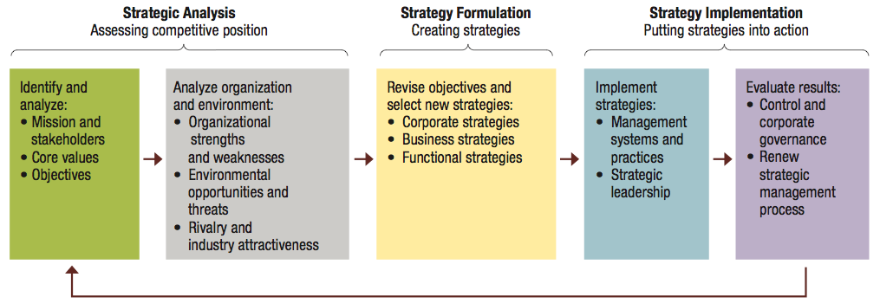

  - Strategic analysis: process of analyzing org, environment, competitive position and current strategies
    - Essentials of strategic analysis
    - 1. Analysis of mission: reason for an organization’s existence
      - As important test of mission is how well it serves organization’s stakeholders
      - External stakeholders as strategic constituencies in an org’s mission statement
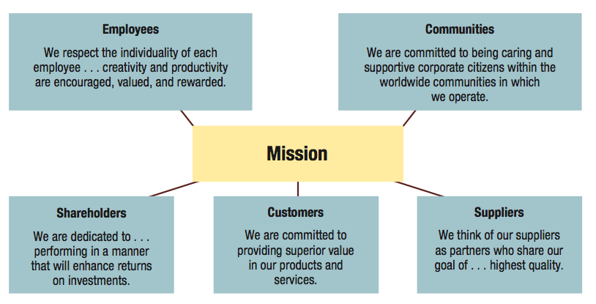

    - 2. Analysis of core values: values are broad beliefs about what is or is not appropriate
      - Organizational culture reflects dominant value system of org as a whole
      - Ex: TELFER core values (Teamwork, Excellence, Leadership, Fun, Engagement, Responsibility)
    - 3. Analysis of objectives: operating objectives for direct activities toward key and specific performance results
      - Typical operating objectives

        - Profitability
        - Market share
        - Human talent
        - Financial health
        - Cost efficiency
        - Product quality
        - Innovation
        - Social responsibility

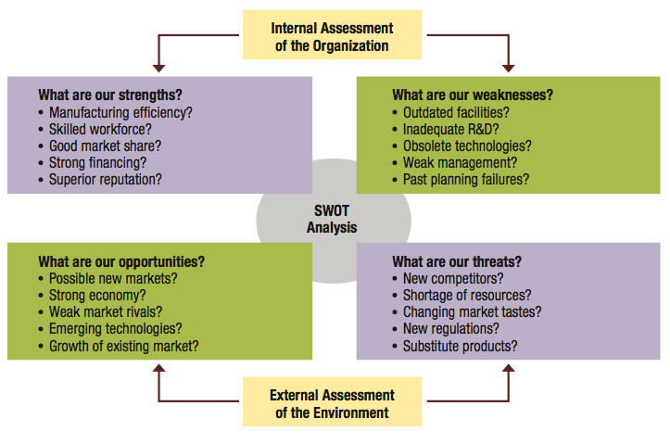

    - 4. Analysis or organizational resources and capabilities
      - Core competency is special strength that gives an org a competitive advantage
      - Important goal of assessing core competencies
      - Potential core competencies
        - Special knowledge or expertise
        - Superior technology
        - Efficient manufacturing approaches
        - Unique product distribution systems
    - Porter’s model of five strategic forces affecting competition
      - Industry competition: intensity of rivalry among firms and comp behavior
      - New entrants: threat of new competitors entering market
      - Substitute products or services: threat of sub products or services
      - Bargaining power of suppliers: ability to influence cost of products or services
      - Bargaining power of customers: ability to influence price paying p or s
  - Strategy formulation: process of crafting strategies to guide allocation of resources
  - Strategy implementation: putting strategies into action
- Strategic management process
  - Strategy formulation: process of crafting strategies to guide allocation of resources
    - Corporate level strategies

      - Master strategies
        - Growth strategies: seek increase in size and expansion of current ops
        - Stability strategy: maintains current ops without substantial changes
        - Renewal strategy: tries to solve problems and overcome weaknesses that are hurting performance
        - Combination strategy: pursues growth, stability or retrenchment in some
      - Growth and diversification strategies
        - Growth strategies: seek increase in size and expansion of current ops
        - Types of growth strategies
          - Concentration strategies
          - Diversification strategies
            - Related diversification
            - Unrelated diversification
            - Vertical diversification
      - Restructuring strategies
        - Tries to correct weakness by changing mix or reducing scale of operations
          - Restructuring through turnaround
          - Restructuring though downsizing
          - Restructuring through divestiture
      - Global strategies
        - Globalization strategy: world is one large market; standardize products and ad as possible
          - Ethnocentric view
        - Multidomestic strategy: customize prods to local markets as possible
          - Polycentric view
        - Transnational strategy: balance efficiencies in global operations and responsiveness to local markets
          - Geocentric view
      - Cooperative strategies
        - Strategic alliances: two or more organizations partner to pursue an area of mutual interest
        - Types of strategic alliances

          - Outsourcing all
          - Supplier alliance
          - Distributive all
          - Coopetition

    - Business level strategies

      - Differentiation strategy
      - Cost leading strategy
      - Focused differentiation
      - Focused cost leading

    - Porter’s generic strategies model
      - Business-level strategies are driven by:
        - Market scope: how broad or narrow the target market is
        - Source of competitive advantage
      - Market scope and source combine to generate four generic strategies
        - Differentiation strategy
        - Cost leading strategy
        - Focused differentiation strategy
        - Focused cost leading strategy
Chapter 8: Organization structures and design
Organizing viewed in relationship with other management functions

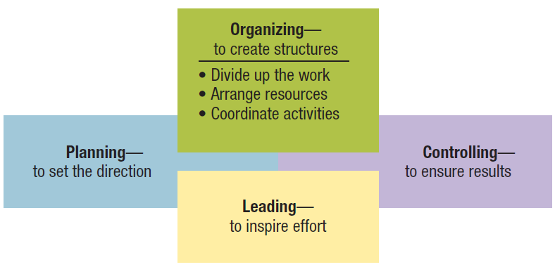

Organizing as a management function
- Organizing and organization structure
  - Organizing: process of arranging people and resources to work together to achieve goal
  - Organization structure: system of tasks, workflows, reporting relationships and communication channels that link together diverse individuals and groups
- Formal structures
  - Structure of organization in its official state
  - Organizational chart: diagram describing reporting relationships and formal arrangement of work positions within an organization
  - Organization chart identifies following aspects of formal structure

    - Division of labor
    - Supervisory relationships
    - Communication channels
    - Major subunits
    - Levels of management

- Informal structures
  - A shadow organization made up of the unofficial, but often critical, working relationships between organization members
  - Potential advantages of informal structures
    - Helping people accomplish their work
    - Overcoming limits of formal structure
    - Gaining access to interpersonal networks
    - Informal learning
  - Potential disadvantages of informal structures
    - May work against best interests of entire organization
    - Susceptibility to rumor
    - May carry inaccurate information
    - May breed resistance to change
    - Diversion of work efforts from important objectives
    - Feeling of alienation by outsiders
Traditional organization structures
- Departmentalization: grouping positions and teams so as to enhance coordination
  - Has resulted in three major types of traditional organization structures
    - Functional: people with similar skills and performing similar tasks are grouped together into formal work units
      - Members work in their functional areas of expertise
      - Are not limited to businesses
      - Work well for small organizations producing few products or services
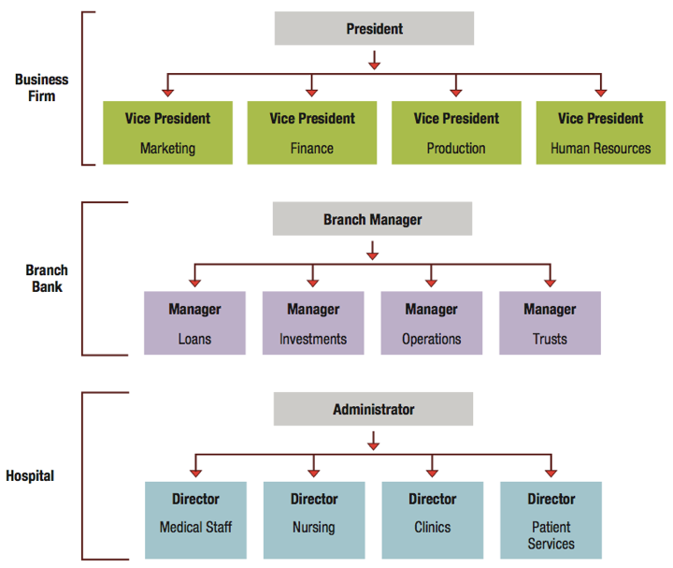

    - Divisional: group together people who work on same product or process, serve similar customers, and/or are located in same area or geographical region
      - Common in complex organizations
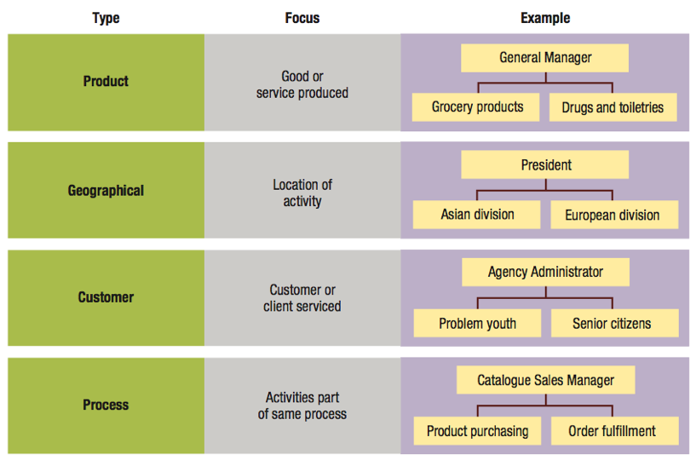
      - Avoid problems associated with functional structures

      - Types of divisional structures and how they group job and activities
        - Product structures focus on single product or service
        - Geographical structure focus on same location or geographical region
        - Customer structure focus on same customers or clients
        - Process structures focus on same processes
    - Matrix: combines functional and divisional to gain advantages and disadvantage of each
      - Used in:

        - Manufacturing
        - Service industries
        - Professional fields
        - Non-profit sector
        - Multinational corps.

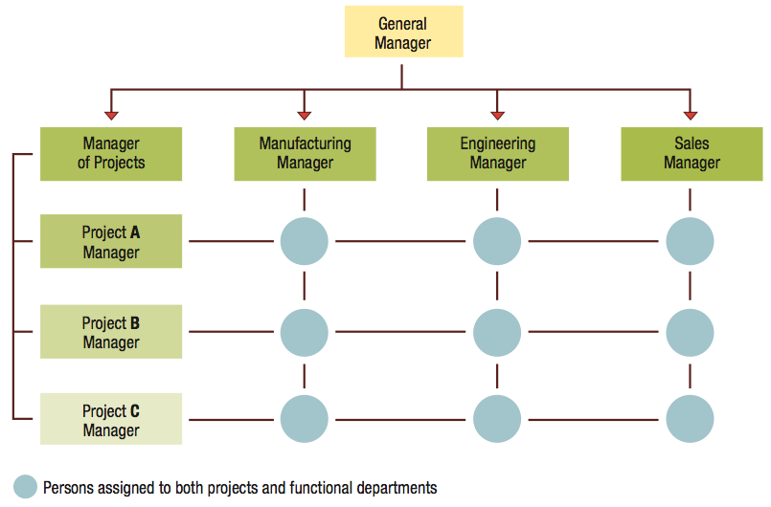
      - Matrix structure in a small multi-project business firm

Horizontal organization structures
- Team structure: extensively use permanent and temporary teams to solve problems, complete special projects and accomplish day-to-day tasks
  - Often use cross-functional teams with members from different functional departments
  - Project teams are convened for special task or project and disbanded once completed
- Network structure: central core that is linked through networks of relationships with outside contractors and suppliers of essential services
  - Own only core components and use strategic alliances or outsourcing to provide other components
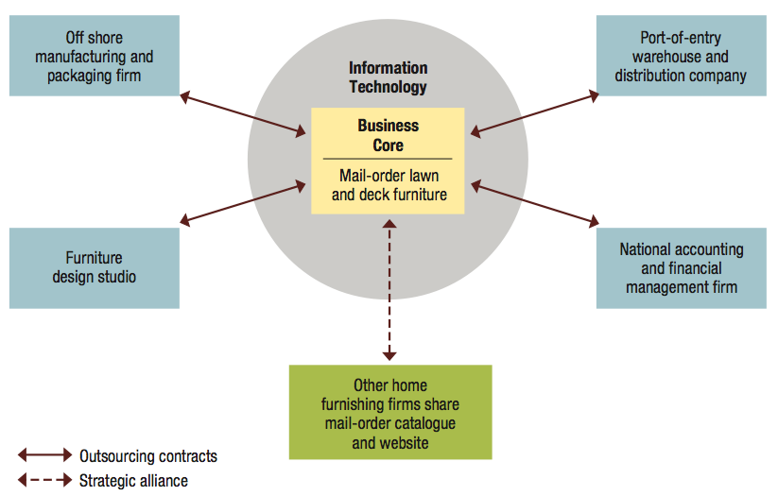
  - Network structure for a Web-based retail business

  - Potential advantages of network structure:
    - Firms can operate with few full-time employees and less complex internal systems
    - Reduced overhead costs and increased operating efficiency
    - Permits operations across great distances
  - Potential disadvantages of network structures
    - Control and coordination problems may arise from network complexity
    - Potential loss of control over outsources activities
    - Potential lack of loyalty among infrequently used contractors
    - Excessively aggressive outsourcing can be dangerous
- Boundaryless structure: eliminate internal boundaries among subsystems and external boundaries with external environment
  - Combo if team and network structures, with addition of temporariness
  - Key requirements

    - Absence of hierarchy
    - Empowerment of team members
    - Technology utilization
    - Acceptance of impermanence

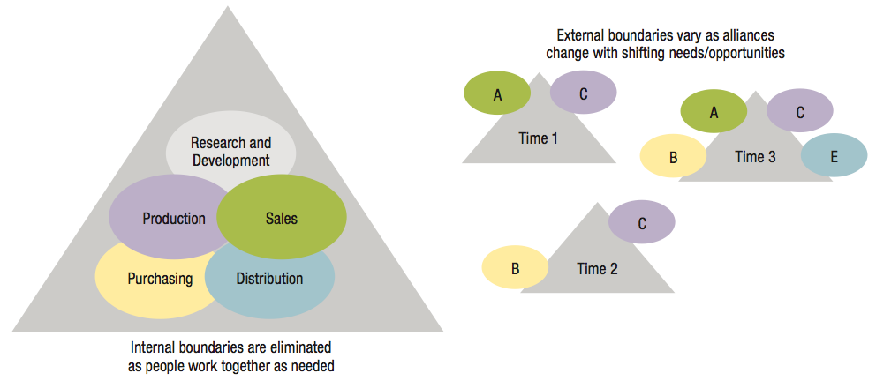
  - Boundaryless organization eliminates internal and external barriers

  - Encourage creativity, quality, timeliness, flexibility, and efficiency
  - Knowledge sharing is both a goal and essential component
  - Virtual organization
    - A special from of boundaryless organization
    - Operates in shifting network of external alliances that are engaged as needed, using IT and the internet
- What is the difference between network structure and boundaryless structure?
Organizational design
- Organizational design
  - Choosing and implementing structures that best arrange resources to serve organization’s mission and objectives
  - Mechanistic or organic
- Continuum or organizational design alternatives: from bureaucratic to adaptive organization
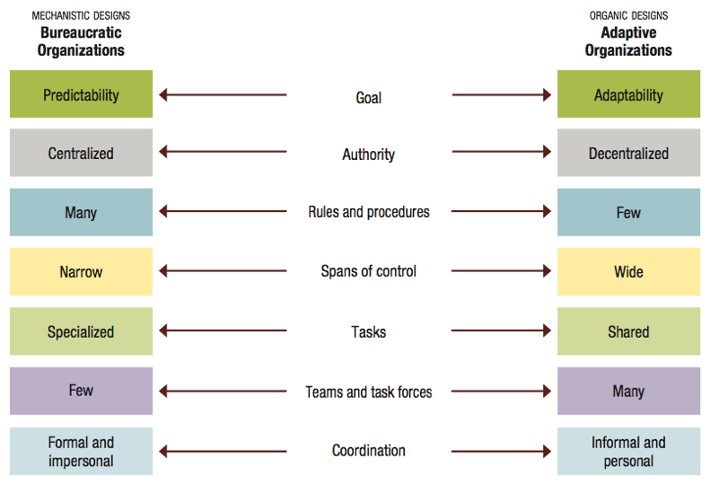

- Contemporary organizing trends include
  - Fewer levels of management

    - Shorter chains of command
    - Less unity of command

  - Wider spans of control
  - More delegation and empowerment
  - Decentralization with centralization
  - Reduced use of staff

