The Solar System and the Origin of the Earth
- Learning Objectives:
  - Understand location of solar system and earth and planets “in space”
  - Review the origin of the elements
  - Explain the different types of planets
  - Explore different theories of the origin of the moon and planets
  - Discuss implications of location and planetary motions
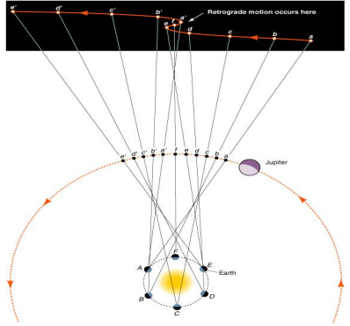
- Geocentric Perspective
  - Proposed by Aristotle (384 – 322 BCE)
  - Earth centric universe deeply entrenched in church doctrine
  - But, was challenged by Aristarchus (312 – 230 BCE)
    - Simple spheres containing the planets and the sun revolving around Earth did not explain the retrograde motion (figure at right) of planets
      - Retrograde motion: Copernicus
        - Suggested that because Mars has the longer retrograde motion it is the closest to the Earth while Saturn, having the smallest retrograde motion is the furthest from the Earth
        - Proposed that the Earth spins on its axis leading to sunrise
  - Ptolemy (150 BCE)
    - Proposed that planets also follow a smaller circular orbit (epicycles)
    - Predictable periods of retrograde motion
- Law of Planetary Motion
  - Kepler (1571 – 1630)
    - Law of Ellipses
      - The orbit of each planet is an ellipse with sun at one focus
    - Law of Orbital Harmony
      - For any planet, the square of the orbital period in years is proportional to the cube of the planet’s average distance from the sun
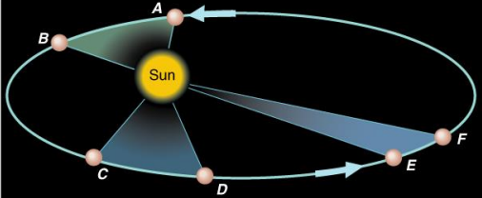
    - Law of Equal Areas
      - A line drawn from a planet to the sun sweeps out equal areas in equal time; the orbital velocity changes
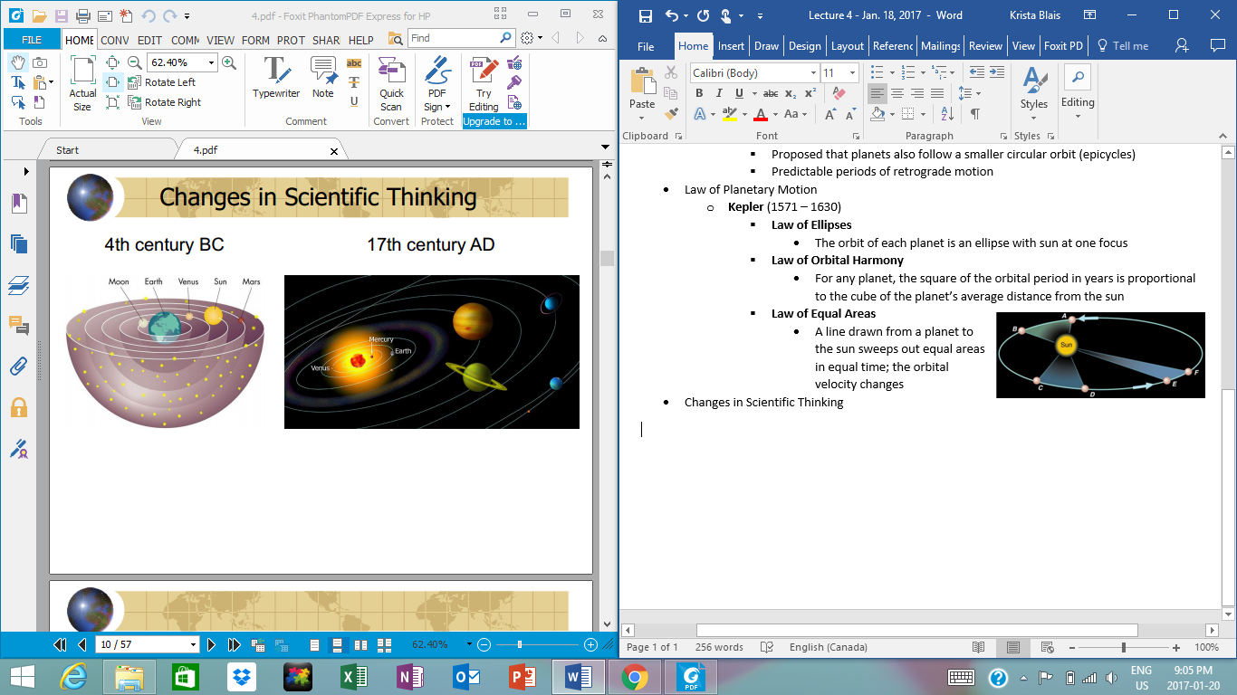
- Changes in Scientific Thinking
- Orbital velocities of movement are fast:
  - Mercury 48 km/s
  - Earth 29 km/s
  - Pluto 5km/s[Grab your reader’s attention with a great quote from the document or use this space to emphasize a key point. To place this text box anywhere on the page, just drag it.]
- What are some of the implications of Earth’s motion in space?
  - Seasons
  - Tides
  - Asteroids
  - Time
  - Length of days
  - Ocean currents
  - Life on earth
  - Wind currents
- Olber’s Paradox; why is the night sky black?
  - A stationary finite universe should collapse on itself due to gravity
  - If dark clouds were present that blocked out light from distant starts, why did they not also scatter light from stars at intermediate distances, just as the fog scatters the light of this approaching car?
- The Cosmic Egg
  - George Lemaître proposed a solution:
    - The universe began during an explosion of a “cosmic egg”, like a bomb
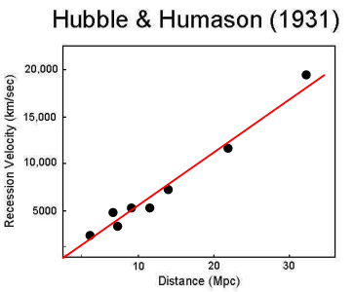
  - This early version of the Big Bang Theory solved Olber’s paradox, at least theoretically. The force of the explosion would have generated an expanding universe that prevented its gravitational collapse.
- Astronomer Edwin Hubble
  - Hubble observed a linear correlation between a star’s distance from Earth and its velocity
  - Edwin Hubble
    - Concluded the universe was indeed expanding
    - Observed a shift toward the red spectra (red shift) of the light from stars in distant galaxies
    - Distant galaxies were speeding away from our galaxy (the Milky Way) at great speeds
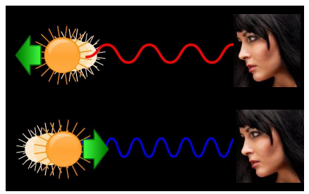
  - Hubble and the Doppler Shift

After the Big Bang…. IT WAS HOT

- In the first few minutes after the Big Bang, it was too hot to form atoms so there were just individual protons, neutrons, and electrons floating around
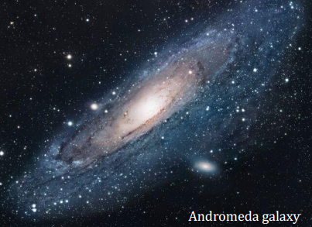
- Big Bang nucleosynthesis: within a few minutes, temperatures dropped to the point where nuclei could form. Hydrogen and helium nuclei were generated at a ratio of 10 H : 1 He, where very small amounts of Li, Be, and B.
- Supernova and Nucleosynthesis
  - After several billion years, gravity caused the clouds of H and He gas to condense, forming galaxies of stars.
- Stellar Nucleosynthesis
  - Nuclear fusion requires temperatures of 50 million degrees Celsius or greater
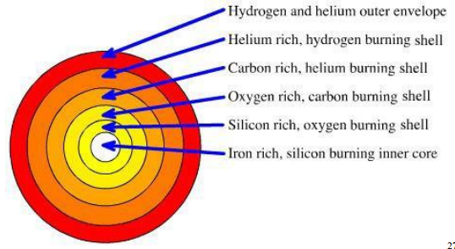
  - Nuclear fusion within large stars is thought to generate nuclei as heavy as iron (Fe)
    - AKA the iron limit
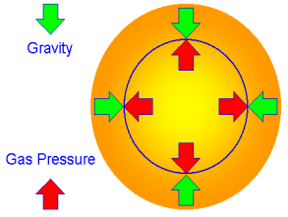
  - These new nuclei – which include the four dominant elements within the terrestrial planets in our solar system (Fe, Mg, Si, and O) in addition to carbon – weigh slightly less than the combined weight of the two nuclei that fused together.
    - Why?
      - The “missing” mass is converted to heat; tremendous amounts of heat are released during nuclear fusion.
      - The escape of this heat to space generates outward-directed pressure responsible for stemming gravitational collapse of the star.
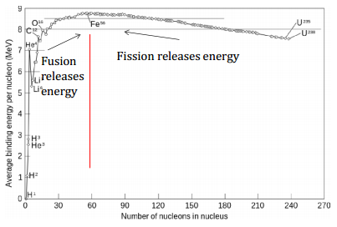
  - Iron Limit: nuclear fires within stars tend to primarily produce elements ranging from He to Fe
  - Supernovae: the resultant catastrophic collapses of massive stars
    - These events are thought to produce the rest of the heavier elements
    - Supernovae fertilize the cosmos
  - February 23, 1987 (Supernovae 1987 A)
    - 250 million times the luminosity of the Sun
    - Made 25, 000 times the mass of Earth iron (plus many other elements)

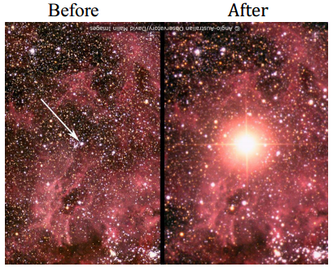
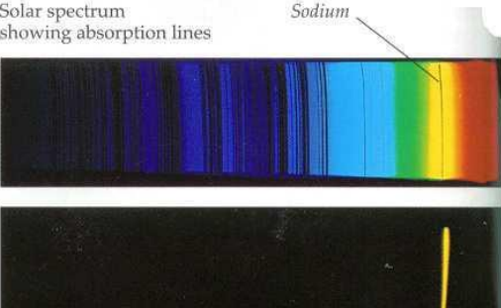
- Fraunhofer Lines
  - Believed to be produced by partial absorption of light by different elements present in the gaseous atmosphere surrounding the star
  - As determined experimentally, the wavelength of each dark band is diagnostic for a specific element
  - The resultant “bar code” is diagnostic of the composition of a star’s halo of gas, and by extension, the star itself.
- Summary of Nucleosynthesis
  - There are three types of nucleosynthesis:
    - Big Bang nucleosynthesis: H and He (10:1), minor Li, Be, and B
    - Stellar nucleosynthesis: up t Fe (iron limit)
    - Supernovae nucleosynthesis: all elements heavier than Fe
- Timeline of the Solar System
  - Our early universe was gaseous; no planets
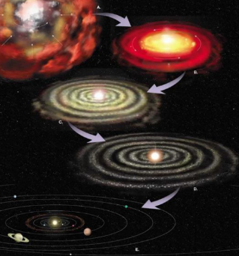
  - Then stars, then planets: the first stars were likely composed of H and He. Their sometimes explosive deaths (supernovae) “fertilized” the cosmos with elements heavier than H and He. As things cooled down, atoms tarted forming organic and inorganic molecules
  - Nebular Hypothesis: the solar system formed when a giant moleculare cloud (a “nebula” in part of the Milky Way started to collapse into a spiralling disk.
    - Cloud of He, H, and some heavier dust from stars and supernova
    - 4.6 – 4.4 Ga ago, gravitational contraction, cloud initates rotation
    - Gravitational collapse, increase temperature, light elements driven towards outer edges of disk
    - Planets result from the accretion of dust, planetismals
    - Sun originates from concentration of mass at the centre
- Solar System
  - Consists of our star, the sun, the planets, their satellites, and asteroids
  - Located on the arm of a very large spiral galaxy
  - Within the Milky Way galaxy
  - Planets:
    - Mercury: diameter = 4,880 km, density = 5.4 g/cm³, 0 satellites, 70% metallic and 30% silicate composition; internally layered, largest T range (-170 degrees – 425 degrees Celsius)
    - Venus: diameter = 12,104 km, density = 5.24 g/cm³, 0 satellites, Earth’s twin; volcanoes, tectonics, thick (deadly) atmosphere (inhibits telescope observation)
    - Earth: diameter = 12,760 km, density = 5.52 g/cm³, 1 satellite
      - Moon: diameter = 3,475 km, density = 3.3 g/cm³
        - Theories of Formation:
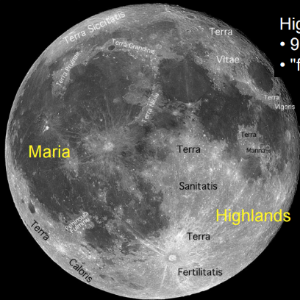
          - Collision with Mars sized protoplanet during initial spiralling of nebula
          - Captured from space
          - Formed with earth during accretion of other planets
        - Moon Evolution:
          - Formation of crust
          - Lunar highlands
          - Maria basins
          - Rayed craters
    - Jupiter: diameter = 143,000 km, density = 1.33 g/cm³, 63 satellites and moonlets, surface is liquid hydrogen, layered atmosphere; giant storms
- Key Concepts:
  - Earth part of Solar System within a Galaxy
  - The sun and stars supernova are he source of our elements. Fusion is an important process
  - Solar nebula theory describes origins f the elements and the solar system.
  - Kepler’s Law describe elliptical planetary orbits.
    - Sense of immense scale of the solar system
  - Different composition of the Terrestrial and Jovian planets
    - Similar geologic processes operating on other planets

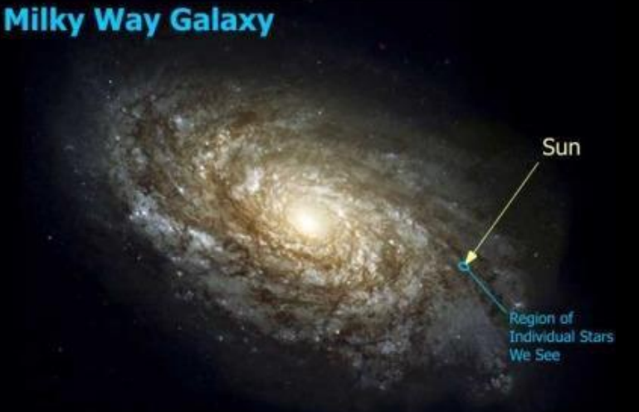
“Stars died so you can live.” – Lawrence Krauss

