To help prepare for exams
For the midterm: questions 1 to 16

- Define: collective agreement, collective bargaining, conversion mechanism, feedback loop, industrial relations, labour relations, strike.

Collective agreement: A written document outlining the terms and conditions of employment in a unionized workplace.

Collective bargaining: The process by which management and labour negotiate the terms and conditions of employment in a unionized workplace. This is the process by which we form collective agreements.

Conversion mechanism: The process used to convert inputs into outputs of the industrial relations system. EX: Collective bargaining, Grievance, Day-to-Day relations, Joint committees, Strikes/lockouts.

Feedback: The mechanism by which outputs of the industrial relations system flow back to the external environment. (when past decisions affect the current reasons for causing a conflict)
The agreement becomes a new element of the environment and will affect the next round of negotiations
The decision has an impact on the environment
The effects of the bargaining agreements have other impacts on the future (ex: increase in pension funds may cause the next negotiation cannot have a decrease in pension funds.)

Industrial relations: The study of employment relationships and issues, often in unionized workplaces.

Labour relations: The study of employment relationships and the issues between groups of employees (usually unionized) and management. (A.K.A. Union-management relation)

Strike: An action by workers in which they cease to perform duties and do not report to work. (a way to convince the other party that your demands are important)

- Characterize these views of IR: neoclassical economics, pluralist and institutional view, human resources/strategic choice, political economy

Neoclassical economics: a view of industrial relations grounded in economics that sees unions as an artificial barrier in the free market. (without unions the supply and demand should be neutral)

Pluralist and institutional view: A view of industrial relations stressing the importance of institutions and multiple actors (including labour) in the employment relationship. (The labour unions act as countervailing force that attempts to balance the interests of employers and employees, with a goal to minimize inherent conflicts)

Human resources/strategic choice: HR strategies ar not anti-union per se, they are often designed to foster cooperation between employees and employers; this view has historically been presented as paying very little attention to the role of unions in the employment relationship.

Political economy: A view of industrial relations grounded in socialism and Marxism (overthrow management and allow employees to have more control over their workplace) that stresses the role of inherent conflict between labour and management. In General it is related to sociology and political science rather than economics.

- Explain this assertion: a fundamental assumption of IR is the conflict of interest.

Labour unions and government policies such as minimum wage laws are seen as socially beneficial because they can moderate the unequal power between employees and employers. The conflict of interest: the gain of one is necessarily the loss of the other.

- Explain Taylor’s proposals and their impact on business organizations.

Fredrick Taylor’s theory of scientific management: 2 key principles:
- Work should be divided into simple tasks, and workers should be trained to perform a small number of these simple tasks.
- Managers should perform all planning and decision-making tasks while workers merely perform simple tasks in accordance with the plans and decisions made by management.
In general Taylor implied that we must search for the most efficient way to complete a task and that larger tasks should be broken down into the smaller, simpler tasks.

- Identify and compare the means of production of each worker
- Choose the OBW, one best way.
- Then divide the OBW in a sequence of tasks.
- For each task, choose a person who has the physical ability to do the job.

- How can it be said that the State has had an impact on the way business organizations deal with their employees?

ALL 4 FOLLOWING CHANGES PRODUCED BY THE STATE

1900: Taylor and the creation of a personnel department in the firm (beginnings of HRM)
1934: Wagner Act** (National Labour relations act) :peaceful legislation to promote unionization (negotiate, strike)
1960: (approximately 100 new laws to be respected and adopted) Normative legislation, new economy and the development of HRM and public policies
1980: Reagan – he was anti-union so he attempted to create ways for the firms to destroy unions. HRM and LR work together more but the real power was to specialists of HRM.
** **
- Establishes norms that workers have to respect if they want to form a union
- The new union must show the state that it respected the norms
- The state will then recognize the new union
Employers didn’t like : if I, the state, recognize the union, whether the firm owner recognizes it or not, the state recognizes it so the employer has to respect the new working conditions. The employer cannot fire people because of unionization, he cannot get involved

- Describe the environmental factors that, in the system theory, influence the actors.

Legal Subsystem: prescribe or limit certain kinds of actions.
Common law (applies to non-union employments relations)
Statutory law (applies to salaries, the job itself, performance and applies to everyone)
Collective bargaining law (applies to administration)

Economic subsystem:
Products/service markets
Labour markets
Money markets
Technology

Ecological Subsystem:
Physical environment
Climate
Natural resources

Political Subsystem:
Government can decide through Legislative action
Executive action

Sociocultural Subsystem:
Value and beliefs influence the industrial relations system
Social structures
Public opinion pressure

Actors: workers, unions, employer, employer associations and the state-house of common, elected officials, and also institutions created by the state.

- In Dunlop’s proposal, what does the concept « ideology » refer to? What ideas are shared by the actors? What ideas are shared?

An Ideology is a set of ideas and beliefs held by the actors that legitimize the role of each and that serves to bind the system together.
The Shared Ideology:
- It is normal that all actors want the firm to make profit.
- Employers give orders and employees execute.

The Shared ideology was seen to define the roles and functions of each of the actors and required that all three actors (the state, Managers and non-manager workers) respect and value the roles of the other two.

- Give examples of conversion mechanisms. Define interest-arbitration, mediation.

Conversion mechanisms: The process used to convert inputs into outputs of the industrial relations system. (A.K.A. methods used for determining how workplace outcomes are determined)
EX:
Collective bargaining: parties negotiate a collective agreement

Grievance: employees and/or their unions can submit a written complaint that the collective agreement has not followed.

Day-to-Day relations/ activities
Joint committees: joint labour management committees that discuss and examine concerns and health and safety.

Strikes and Lockouts: work stoppage, used to bring closure to the negotiation process and produce a collective agreement,

Various third party intervention:
Interest Arbitration: third part process when parties cannot reach a collective agreement.

Mediation: third part attempts to facilitate a resolution between labour and management.

Grievance arbitration: employers and labour cannot resolve a grievance so arbitration makes a decision.

Conciliation: assess proposals of both employer and labour and will send the reports to the appropriate federal or provincial minister of labour prior to a strike/lockout.

Fact Finding:

- Study the case and answer question 1on p. 22.
Student strike UNB
Question 1: using the industrial relations model presented in this chapter (Figure 1.1)
- Identify the name and actors in the case
The actors:

Labour: university professors, librarians, and teaching staff, AUNBT (association of university of new Brunswick teachers.

Employer: The University of New Brunswick.

Government: Jody Carr (new Brunswick minister of post-secondary education, training and labour)

End user: Students.

- Discuss what external inputs you feel are most relevant in this case

Legal:
Statutory law: as the dispute is mainly about the working conditions and the wages associated with it.
Collective bargaining

Economic:
Product/service market: the main thing in questions is the teachers believe they deserve a similar salary that similar university professors are obtaining elsewhere. In other words they believe their service is worth more than they are currently obtaining so they stop providing it until their demands are met.

Ecological:
Not really.

Political subsystem:
Possibility of “back-to-work legislation” to force an end to the strike.

- Name and identify the conversion mechanisms and outputs presented in the case.

Conversion mechanisms:
Collective Bargaining: was used to discuss the outcomes of the dispute: teachers wanted 23 cents. School wanted to give 9.5 they met in the middle due to mediation.

Arbitrator: used to find what salary increase would occur in year 3.

Figure 1.1:
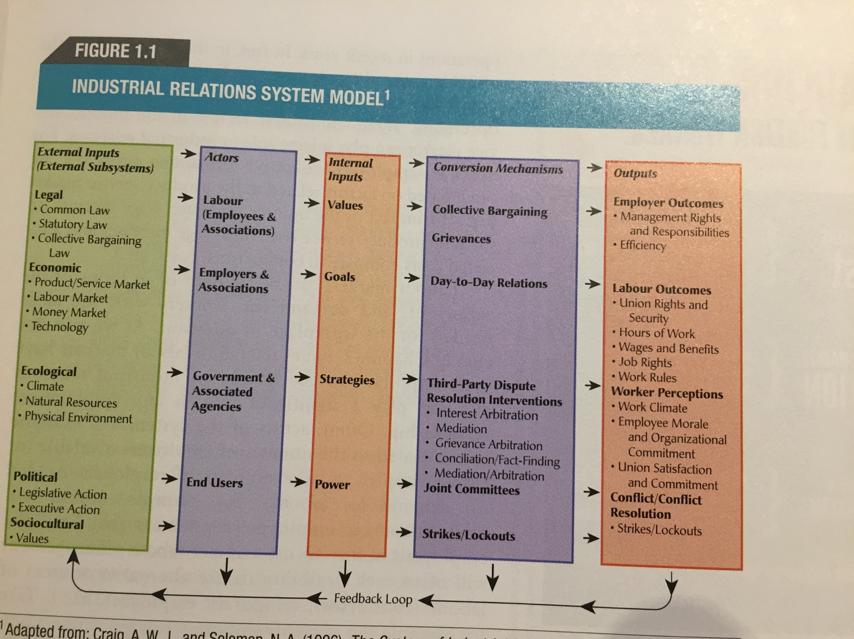

- Present five of Craig’s hypotheses.
Craig’s model is similar to that used in biology. Basically the industrial relations system takes external inputs and converts them into outputs, through a series of conversion mechanisms. These outputs flow back through a feedback loop and begin again as external inputs.

Craigs definition of Industrial relations: it’s a mix of private and public activities, operating in an environment, which is concerned with the allocation of rewards to employees for their services.

- a federal political system – where the regions are responsible for legislation on labor relations – will encourage a decentralized collective bargaining process.

- the probability of a strike increases in a firm where day-to-day relations between managers and employees are hostile.

- in an inflationary period, unions will try to get higher wages and better COLA clauses.

COLA: cost of living adjustments, in inflationary period (inflation 2% or more), wages raise. **non-inflationary period 2% or less

- in a recession, unions will focus on job security.

- at a national level, if an increase in salaries is not compensated by an increase in productivity, prices will increase.

Tendency to inflation.

- when introducing technological changes that result in the decrease of the number of workers, employers tend to use attrition to reduce the labor force.

Attrition: I will offer a better retirement plan to my employees closer to retirement, so I can keep my younger employees that cost me less.

- when workers are informed of their firing because of the introduction of a new technology, they do not believe it; they start looking for a new job only when the first workers are fired.

- the longer the period of time between a) the moment the workers submit an application for certification to a labour board and b) the moment the certification is granted, the more efficient an employer will be in his opposition to the unionization of workers.

Will be looking in depth more in the next classes.

- the probability of a strike increases in “good” economic times and decreases during a recession

- Answer questions 1, 2, 3, 5, 10,11 on p. 84.
1) Describe 2 ways in which labour markets have been liberalized in Canada in the past twenty years?

- Deregulation: a Policy designed to create more competition in an industry by allowing prices to be determined by the market forces
- Privatization: The transfer or contracting out of services to the private sector.
- International agreements (NAFTA)

2)What are Marshall’s four conditions? (known as the employment responsiveness to an increase in wages)
1) Product market: the more competitive the product market, the greater the employment impact of a wage increase and the elasticity of demand for labour.
When unions increase wages, the higher costs may be reflected in reduced sales. Which causes reduced demand for labour. Hence unions have more power when there is less competition in the firm’s production market.
So when a firm has a monopoly unions have more power and an increase in wages doesn’t affect sales.
- In a Competitive (metro, loblaw, etc), an increase in wages will be about an increase in costs, which will increase prices, decrease sales and decrease union power.
- In a Monopoly (hydroquebec), an increase in wages will bring an increase in costs, an increase in prices, there will be NO decrease in sales and will increase union power.

2)Substitution effect:
Replacing labour by capital, if its easy then the power of the union decreases.

- Labour intensity: the degree to which labour costs account for production costs (labour costs as a proportion of total costs). Thus the more labour intensive jobs have less union power as the firm cannot afford to absorb the increased cost of labour.

- Market for substitutes: the more competitive the market for substitute factors of production is, the greater the bargaining power firms will have. The cheaper and more available these substitutes, the greater the impact on employment, and hence the greater the employers bargaining power.

Question 3) What are the barriers to labour supply?
Population growth, immigration, retirement choices, work-family decisions, career patterns, leisure choices and labour mobility.

5)What do economists mean by the term Monopsony? Give 2 examples of occupations that may be in monopsonistic markets.
Monopsony: occurs when a firm is the sole market buyer of a good, service or labour. (aka the firm is so powerful that it has some impact on the wages offered in the market.)

Examples: teachers; increase students but no increase in wages.
Example nurses: in California private hospitals increases the number of patients per nurse and not the wages.

10)What is contingent work? Define the five types
contingent work is a group of workers who work for an organization on a non-permanent basis.
there are alternative work arrangements:
1)part-time: the number of hours worked at the main job is less than 30 hours per week
2)temporary/contingent work: 2 categories: (1) those who have traditionally worked on a temporary or casual basis and (2) a smaller buy growing group of professionals and technical contingent workers who desire the freedom and flexibility provided with contingent work.
3)flex time: permanent workers who start earlier or end later but are there for the required number of hours.
4)compressed work weeks: working the same weekly hours but in fewer days.
5)teleworking: using telecommunication to get work done off the firms site.

11)What is meant by the term work-life balance? Give two examples of factors that may have upset this balance in the past five years.
Work-life balance: the desire on the part of both employees and employers to achieve a balance between workplace obligations and personal responsibilities.
Factors that may upset it:
Role overload,
Work to family interference.
Family interferes with work.
How did it upset the balance in the last 5 years.
- Economic
  - Service economy
  - Deregulation
  - Labour shortages
  - Contingent workers
  - Outsourcing

- Social
  - Daycare needs
  - Increased workloads
  - Flexibility
  - Absenteeism, benefit costs
  - Multitasking

- Demographic
  - Dual-earner and single parent families
  - Aging workforce

- Explain the Snider Case.

Labour relations jurisdiction is provincial (one exception when a firm offers a service that crosses boundaries, ex transportation they fall under federal legislation/federal labour code)
A landmark couty case in 1925 that determined that labour matters would fall under the purview of the provinces under the British North American act.
Toronto Electric power commission vs Snider
Established protocol of the day provided that a conciliation board would be appointed under the IDIA (industrial Dispute Investigation Act)

Labour legislation=jurisdictions only federation that labour legislation are regional.

In general it made it so that under the Canadian labour legislation all employees would be paid under the provincial legislation. The federal government was given responsibility over interprovincial industries ( Communication and transportation) while provinces were given responsibility for all other areas of commerce.

- What is the Wagner Act? What did it change for employees? for management?

The actual Act:
The wagner act : recognizes the respect of the firm. Eg: opening a Metro grocery store, you care about the store, not the whole industry. As a state, when I adopt the wagner act, I let my entrepreneurs compete.
In Europe, the logic is : I, the state, recognize an entrepreneur, a capitalist invests in his firm. He should make profit, and compete with other capitalists on services, products, marketing, etc, but NOT on who exploits his employees the best. Work conditions will be the same within an industry.
In N-A, let the firms do wtv they want to do.
The Canadian Constitution makes things more complicated. Among the 3 countries of N-A, being all federal, in the US, the Wagner act is respected all over the country. In Canada, the supreme court decided that the jurisdiction over working conditions would be regulated by labour codes, provincial or federal. Working conditions that are common for 2 or more provinces are federal (5% of Canadian workers – mostly transportation industry).

Employees of a given firm could belong to more than one union, inter-union conflict over representation rights was not uncommon. To deal with this conflict wager act.
- No longer need to ask boss for permission to form a union.
- Established norms A procedure to form a union
- Who should be the actors.

Management
Took away power to intervene on unionization.
Imposed on management that if the state recognized the workers as a union it forced the management to negotiate with the union.

- Define: certification, duty of fair representation, exclusivity principle, good faith bargaining, unfair labour practice.

Certification: Recognition of a union by a labour board after completion of the procedure under the labour act

Duty of fair representation: a legal obligation on the unions part to represent all employees equally and in a non-discriminatory manner.

Exclusivity principle: The idea that a union is granted the sole right to represent all employees in the defined bargaining unit.

Good faith bargaining: An obligation on unions and management to make a serious attempt to reach a settlement.

Unfair labour practices: Alleged violations of the labour relations act by employers, unions or employees.

- Answer questions 2, 3, 5 on p. 116-117
2)What has been the impact of the snider decision on the development of Canadian labour legislation?
All employees will be paid under their provincial legislation. The distinctive Canadian system of shared jurisdiction was given legal authority. The federal government was given responsibility over such interprovincial industries as communication and transportation, while provinces were given responsibility for all other areas of commerce.

3) How do labour boards determine which persons should be eligible for inclusion in a bargaining unit? Which employees are not eligible?
The labour board typically applies several criteria to decide which employees are eligible to be included in the bargaining unit: management employees (excluded from union representation), community of interest, wishes of employee and employer structure.
Not included: Management

5)What is an unfair labour practice? Give an example. What is the duty of fair representation? Give examples:
Unfair labour practice(only linked to the forming of an unionization): an alleged violation of the labour relations act. Ex: interfere with, restrain or coerce an employee in the exercise of any right conferred by the act. EX: being fired for participating in a union.

Duty of fair representation:
A legal obligation on the union’s part to represent all employees equally and in a non-discriminatory manner. Ex: fails to support grievance because the employee supports to opposition.

- Read case 2 on p. 119. How would the procedure differ if the province were Quebec.
  - Quebec part: compulsory vote: 50% of workers sign membership cards then certification will be granted.
  - VS .in Ontario even if 99% vote yes there will still be vote.
  - The rest is identical.

