Questions for Part 1:

- My visual angular width is 7.9 and the angular eccentricity is 5.3 degrees.
My blind spot was slightly smaller than the typical 5.5 degrees. However, there wasn’t much of a difference between my blind spot compared to the typical; 5.5 standard measure.
- I have not noticed y blind spot up until now, because the blind spot for one eye is
At a different place than the blind spot for the other eye, therefore, one doesn’t notice it because each eye sees what the other eye does not see.
Questions for part 2:

- The Method of Constant Stimuli, was used in this experiment

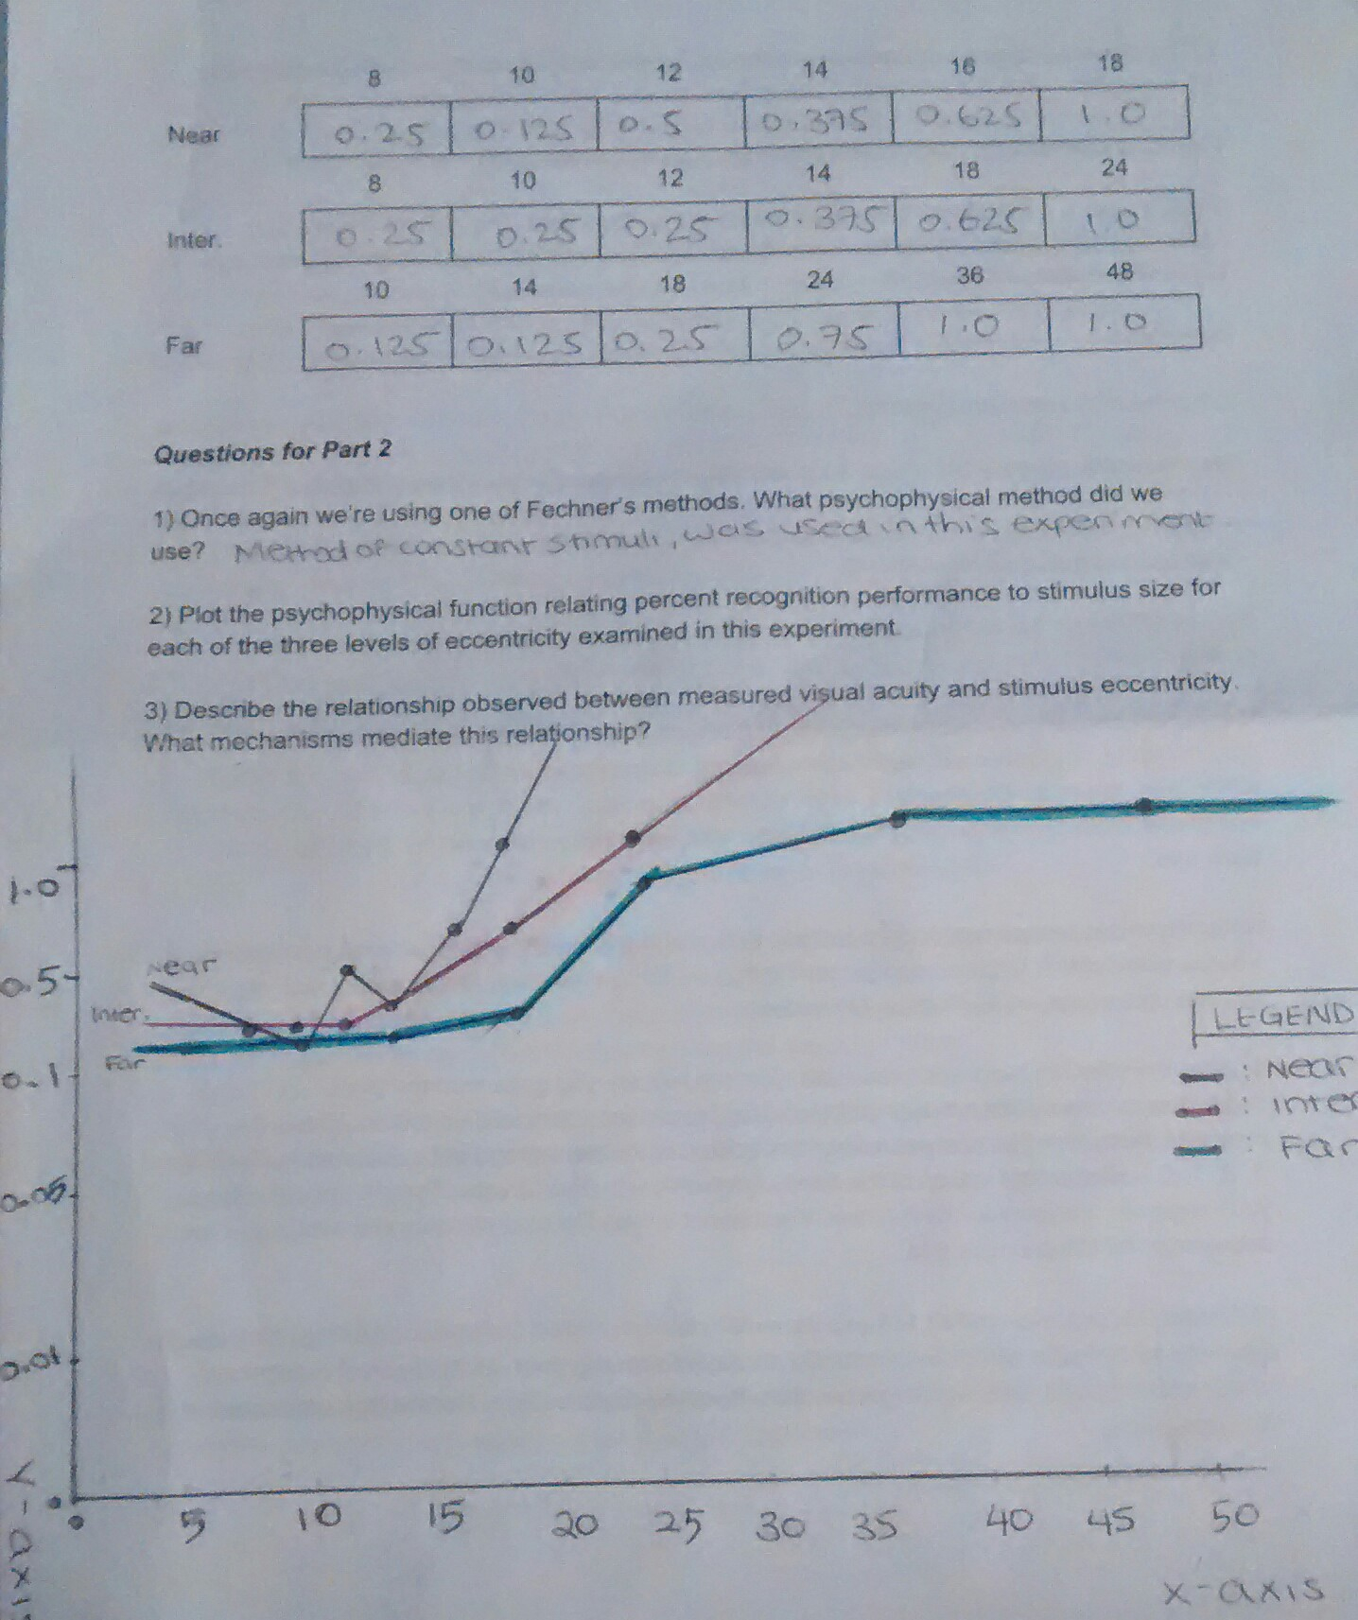
- In terms of the relationship between the observed measured visual acuity and
the stimulus eccentricity, the stimuli became clearer to view as it got closer to the fixation point/ cross. This is due to a certain eye mechanism, where the fovea comes into play. In cases of the stimuli being nearer to the fixation point, The closer one’s cones are clustered together as a group, within the macula, the sharper that person’s vision. Our visual acuity decreases with eccentricity since it is at a farther distance from the fovea. The fewer amount of cones are in the fovea as you fall outside the fovea (away from the fovea) this leads to distortion in the image formed by the optical system compared to the original.

