Sensation

Sensation – sensory input and transmission
- Transduction (at the level of the receptor).
- The body’s sensory receptors are “sensitive” to only a very limited range of the earth’s energy. The receptors are highly specialized.
- Ex. The ear is sensitive to energy in the form of air pressure. Eyes are sensitive to light energy
- Role of sensory receptor is to transduce a very restricted amount of the earth’s energy into something the NS can understand, an electrical signal
- Ex. ear translates one form of energy (air pressure) into an electrical signal that then travels along the auditory nerve as an action potential. The eye translates light energy into an electrical signal that travels along the optic nerve.
- So the “message” that arises in a sensory neuron is always the same: a travelling electrical signal
- However even though the message is the same, what we “experience” is different – ex. Seeing vs. Hearing
- Experience is a “holistic” experience
- Sensation is objective (sensation is probably similar in all humans and presumably all animals that share one or more of our specific receptors.
- Bottom-up processing

Perception - integration of sensory information with permanently stored memories to form “percept”
- Takes place at a “higher” level in the brain
- Perception is very subjective. My perception of the world is different from others. Nevertheless all humans do perceive the world in a similar way.
- The cues we use to for example: perceive depth, perceive motion, perceive smell, etc.
- Top down processing

Bottom-Up Processing
- Sensory receptors and sensory nerves relay basic information to the brain (ex. Responding to a loud sound)
- The brain interprets this information

Top-Down Processing
- Previous experience and expectations affect the detection and analysis of information
- Role of memory. Compare incoming sensory input to what exists in memory
- Role of attention. Attention can alter consciousness of sensory input

Physics of Energy
- Our receptors provide at least 5 critical features of physical characteristics of a stimulus
- Modality – what is the type of experience is bombarding the receptor (light energy, air pressure)
- Frequency – how often is the receptor being stimulated (audition, frequency is transduced into pitch whereas in vision it’s transduced into color)
- Intensity – how much energy is there? (loud, bright?), very high intensity in any modality may cause us to experience pain
- Location – where does the stimulus come from? What is it’s spatial location?
- Duration – how long does the stimulus persist? When does it start/stop
Feature extraction –sensory processing involves the extraction of the basic features. This is bottom up processing

Thresholds
- all receptors require a certain minimum amount of physical energy to result in an AP in the sensory nerve. If there is not enough energy, the sensory neuron won’t fire and it will be impossible to perceive the stimulus
- Absolute threshold
- The minimum amount of physical energy necessary to detect a stimulus on 50% of presentations (i.e. 50% of the time, the stimulus is detected; 50% of the time it is not).
- Difference threshold (just noticeable difference jnd)
- Detection of minimum changes in energy
- Weber’s Law – difference in intensity divided by original intensity = k
- Signal detection theory: the measurement of a threshold requires the observer to consciously perceive a stimulus. The measurement of the threshold can therefore be influenced by subjective factors.
- In short, part of a sensory threshold will indeed be determined by the objective, physical characteristics of the stimulus but subjective perception will also affect it.
- In signal detection methodology, a “catch” trial is included in which no stimulus is presented
- Two types of correct detections and two types of errors emerge. If the observer detects a stimulus when in fact it was actually presented, this is called a “hit” (a true detection). On the other hand, if no stimulus was presented and the observer indicates “no”, such a decision is called a “correct rejection”.
- But if the observer signals the detection of a stimulus when in fact none was presented, this is called a “false alarm” (or “false positive”). If a stimulus has been present and the observer decides it was not presented, this is also an error called a “miss”. The ability to discriminate a signal from no is the ratio of hits to false alarms
- Many factors may affect the ability to discriminate signals. Obviously, the intensity of the signal is a major factor, but the psychological state of the observer also plays an important role. Some of these psychological factors include: strategy, level of attention (signals that are attended are detected easier than those that are ignored), motivation, and learning (a wine taster will have a much more acute sense of smell and taste than I). Similarly, an expert musician will be able to detect much smaller changes in the pitch of a sound than I)
Ex: Signal detection theory has now been generalized to any decision. All yes/no decisions involve a compromise weighing the pros and cons. As an example, you are about to purchase a new computer. Should I purchase this computer? You decide to purchase the computer (yes decision) and it turns out to be a good computer. This is thus a correct decision and is the same as a “hit” in signal detection theory. You purchase the computer and it turns out to be a bad computer. This is thus an error and is equivalent to a false positive. On the other hand, you may decide to not buy the computer but later find out that it was an error. Others who purchased it indicate it was a very good computer. This error is equivalent to a miss. But you might be correct. You decide not to purchase the computer and others who did purchase it indicate it was a poor computer. This is thus a correct decision and is equivalent to a correct rejection.

- Subliminal perception
- Limen means threshold
- Subliminal perception: the ability to perceive stimuli that are below threshold
- There have been claims about being able to do this

Sensory Coding
- How do we come to experience the external world that stimulates our receptors
- Why does a rose look red and smell sweet? – it’s what we perceive (the sweetness or pleasantness of the rose is a result of the activation of a very specific set of neurons within our cortex and ultimately the release of specific NT.
- The experiencing (“consciousness”) only occurs within the cortex
- Personal perception is private and subjective
- We have considerable knowledge about how sensory features are coded. These include:
- Sensory modality – it’s coded by the specific nerve that carries the neuronal message. It’s called Muller’s “specifity” (ex. Auditory nerve codes an auditory signal, optic nerve visual signals)
- Different qualities within a modality might also be coded by a specific nerve. (part of Muller’s specificity) (ex: some optic nerves carry out red code while others the green code, these red and green nerves then synapse at specific (but different) places in the thalamus and in the visual cortex
- The experience (consciousness) of the perception of a stimulus almost always require the cortex. (. A visual stimulus is experienced as light not because the visual receptors of the eye are stimulated but because the visual cortex has been stimulated.)
- Within one modality, neuronal specifity cannot possible code all the sensations that we experience. This would require too many sensory nerves. A single nerve fiber can do many different messages (like a single telephone line can code very complex messages). One group of neurons might encode the intensity of sound and another the pitch
- AP operate in an all-or-none manner
- Limitations of neuron’s all or none law – amplitude modulation of the AP is not possible
- Frequency modulation is possible (message carried by a neuron is coded by how often the neuron fires – max rate is 1000 times/sec (1000Hz))

Adaptation
- As long as stimulation is constant, it is only necessary to perceive the initial onset. There is no reason to have to continually attend to and perceive new, incoming information if it is the same information that has just been perceived.
- If redundant processing is prevented, the limited resources of the cortex can be used for more important things like perceiving what’s different
- We cease the processing of what is redundant through the process of adaptation
- As long as the stimulus does not change, the rate of neuronal firing slows and eventually stops altogether
- Ex. When you enter a flower shop, the initial smell is overwhelming, but over time we barely perceive the odors
- Neuronal fatigue: the receptor is no longer capable of firing (due to a depletion of the NT)
- Contrast adaptation to habituation:
- Habituation occurs at a “higher” level in the brain, and involves a memory process and is claimed to be the simplest for of learning
- Upon repetition of stimulus, we become no longer aware (conscious) of it – this can be because we have adapted or because a memory of the frequently occurring stimulus has formed – as a result we don’t need to process this irrelevant and repetitive stimulus
- Habituation: the subject’s receptor is quite capable of firing (thus, the lack of awareness of the stimulus cannot be due to adaptation)
- Habituation occurs in all modalities, adaptation is especially in olfaction and somatosensory

Sensation: Audition

Physics of Sound
- Ear transduces sound energy
- This is a result of the collision of air molecules resulting in a compression and expansion of air “waves” similar to the ripples of a pond.
- Sound travels best when molecules are densely packed (so a solid) and worse when they are loosely packed
- Sound travels better in solid than liquid, and better in liquid than gas
- Travelling of sound waves vary in:
- Frequency (Hz)
- Time between waves determine the wavelength
- Short time = high frequency sound
- Long time = low frequency sound
- Our ear drum vibrates according to the frequency of the stimulus
- We can hear sounds from 20-20000 Hz
- We experience/perceive the pitch of a sound
- It’s a physical measure
- Intensity (dB)
- The number of molecules that are put in motion is reflected in the strength or intensity of the sound
- It’s a physical measure
- It’s experienced as “loudness”
- Not all frequencies are perceived equally. Human ears are more sensitive to sounds in the range of 500-2000 Hz.

Intensity Scale
- Decibal (dB) – the log scale!
- Measure of sound pressure level
Ex.
- 10 dB 10 (or 10¹) x pressure
- 20 dB 100 (or 10²⁾ x pressure
- 30 dB 1000 (or 10³) x pressure
- Too loud means it could permanently damage the ear

The Ear
• Outer Ear
- pinnae
- auditory canal
• Middle Ear
- ear drum
- hammer, anvil, stirrup
• Inner Ear
- cochlea
- auditory nerve

The Cochlea
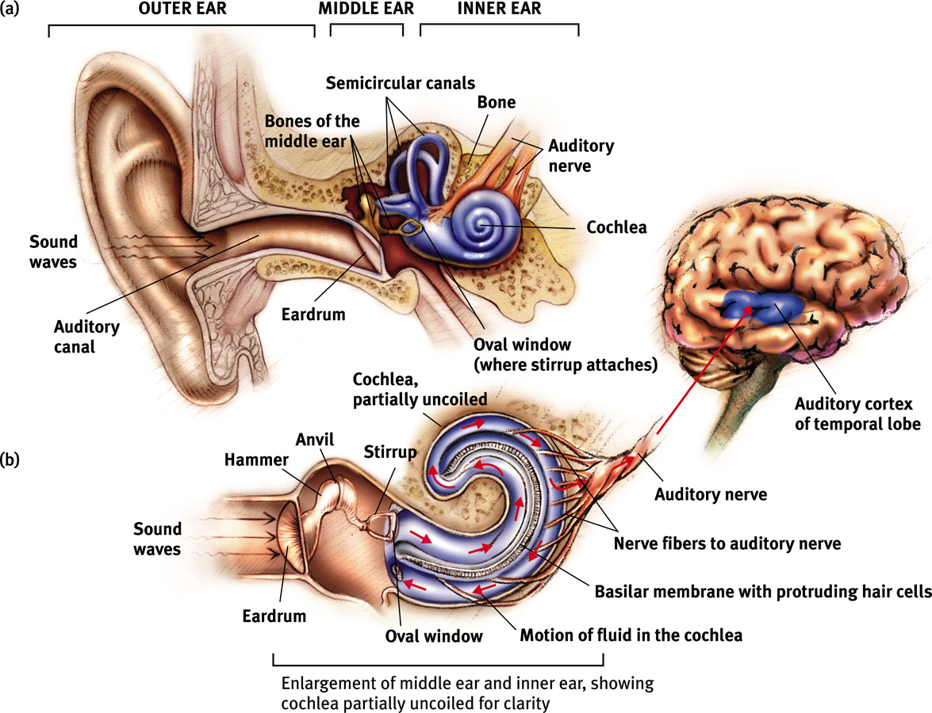

Please note that figure above is not quite accurate. In the lower part of the figure, an enlargement of the cochlea is shown. The auditory nerve emerges at this level. In the Figure, on the right side, it appears that the auditory nerve projects directly into the gyrus of Heschl in the superior region of the temporal lobe (i.e., “auditory cortex of the temporal lobe”). This is not correct. The auditory nerve initially synapses in the medulla of the hindbrain, where information is extracted. It then makes other stops (or “relays”) within the pons and midbrain before projecting to the thalamus. The thalamus then makes an elaborate analysis of the auditory message. It is only if this message is very relevant that it is forwarded to the auditory cortex.

Risks to Hearing
- intense sounds could damage hearing
- temporary hearing loss is reversible permanent is not
- any sound experienced as painful can damage hearing
- loud sounds can be ear-splitting – ear drum severing or cochlea hair cell-ripping
- hearing loss is usually due to prolonged exposure
- other danger is with adaptation – we are less likely to perceive a stimulus if it is continually presented as we adapt to it, but this is bad cause even if a sound is loud we may think it’s not
- conduction hearing loss: damage occurring to the sensitive middle ear mechanical device (a hearing aid can help)
- sensorineural hearing loss: damage to the cochlea (specifically the hairs) or the auditory nerve (a cochlear implant can help)

Cochlear Implants
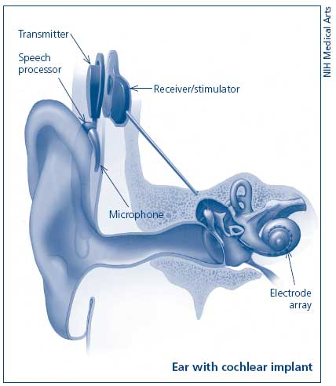
- if cochlea is destroyed, hearing is not possible
- consists of a microphone, a processor, a transmitter and receiver/stimulator, which receives signals from the speech processor and converts them into electric impulses
- an electrode array collects the impulses from the stimulator and sends them to different regions of the auditory nerve
- sound processor sends out a signal that causes an AP in the auditory nerve
- the cochlear implant must carry out the complex encoding

Theory of Pitch & Intensity
How are pitch and intensity coded within the auditory system?

Frequency (Temporal) theory
- The number of times the auditory nerve fires codes frequency (ex. 200 Hz = 200 AP/sec)
- The frequency of firing of the nerve could not then code the intensity of sound.
- Problems with this theory
- Limit to the frequency at which a neuron can fire (upper limit is 1000 Hz)
- We hear frequencies up to 20,000 Hz

Place Theory
- Frequency coded by place stimulated on basilar membrane
- Intensity coded by frequency of firing
- Support
- Damage to basilar membrane will result in hearing loss to predictable frequencies
- Particularly the case for high frequencies
- Ageing results in deterioration of hair cells (perhaps basilar membrane) at predicted locations
- Problems
- Low frequencies generate a general movement of the basilar membrane. We should therefore hear mixed frequencies, but we do not.
- Low frequency hearing loss is extremely rare.

Volley Theory
- Frequency theory cannot explain how higher frequencies are coded.
- Volley theory offers an explanation. A single neuron cannot fire at a rate higher than 1000 Hz. But if the neurons fire in a volley (like cannons), then higher frequencies can be coded.

Localization of Sound
- Having 2 ears helps with localizing the sound in space
- Time difference between arrivals of sounds. Sound coming from the left side will arrive at the left ear before the right.
- Intensity will also be different – sound occurring on the left side will be louder in the left than the right ear
- Sound shadow – head will block the intensity of the sound being transmitted to the right ear
- If sound in front or behind or equidistant from both ears we have difficulty locating it

Sensation: Vision

Physics of Light
- Light is an electromagnetic signal whose wavelength varies from 400 to 700 nm (short, 400-500 nm violet-blue : medium 500-600nm = green: long, 600-700nm red)
- Color depends on wavelength
- Brightness is the amount of energy in the light wave

Anatomy of the Eye
- Eye
- Cornea (protective coating for the eye)
- Lens (accommodation is changing the curvature of the lens and allows the object to be focused precisely on the retina)
- Pupil (an opening in the lens that allows light to reach the retina) – bright light it will constrict, and dilate in dim light
- Retina: rods and cones; fovea; blind spot

The Retina
- The retina consists of 3 layers
  - The rods and cones
  - The bipolar cells
  - The ganglion cells
- The light sensitive rods and cones are located in the back of the retina
- Light must thus pass through the other layers before striking the rods and cones
- The rods and cones have a chemical reaction to light.
- If the reaction is strong enough, the bipolar cells will be activated
- Bipolar cells activate the ganglion cells
- The axons of the ganglion cells converge at the “blind spot” to form the optic nerve.

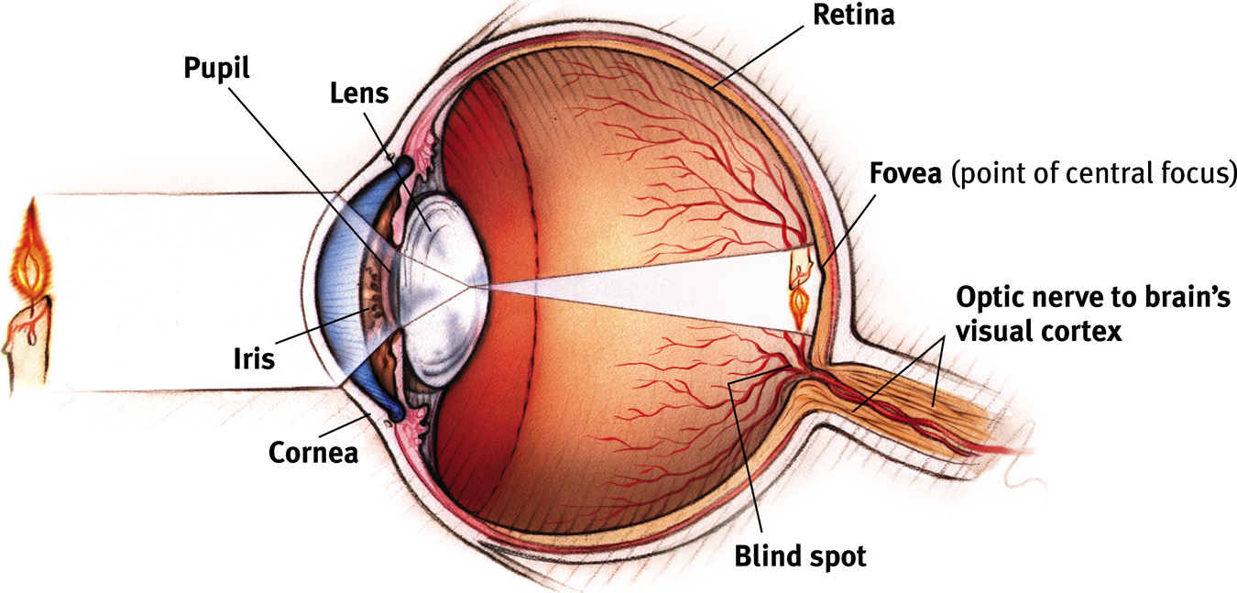
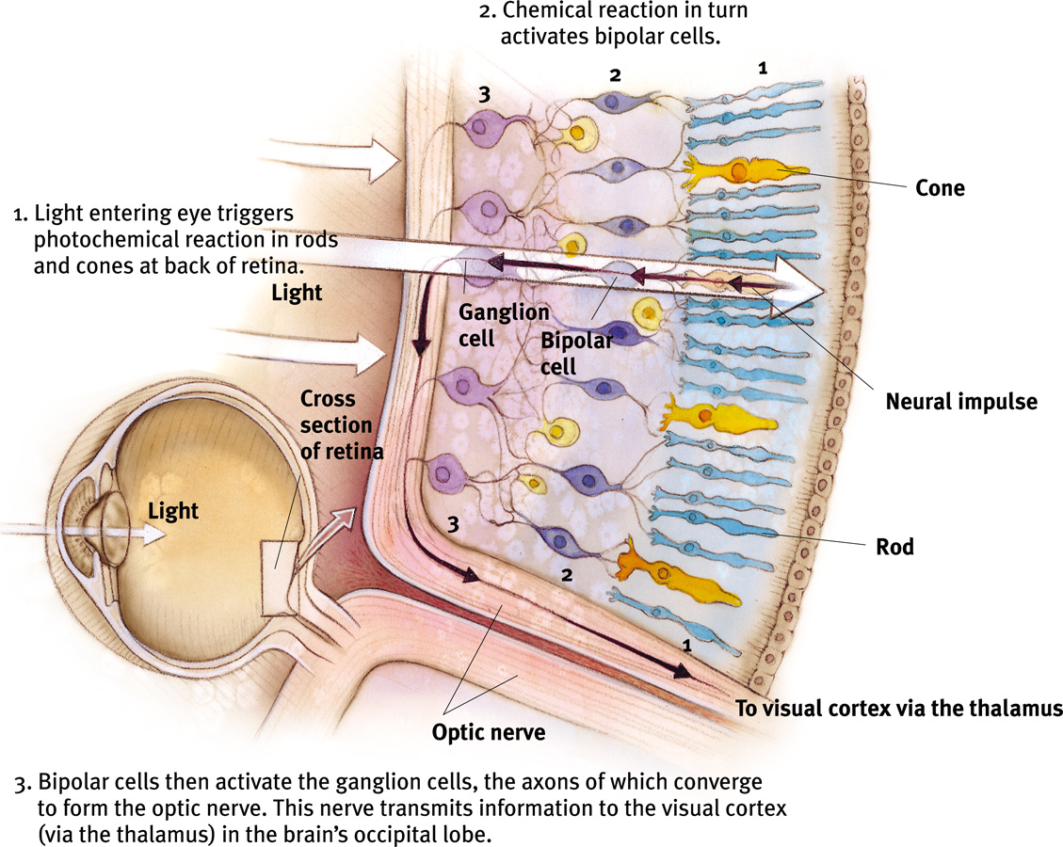
Cones
- Cones – packed in the center of the retina, near the fovea (where vision is most acute)
- Color vision: 3 types of cones ; for red, green and blue
- A single cone may project to a single bipolar cell. Thus, the output of the cone will have to be very high in order for the bipolar cell to be activated. Need very bright light to see in color.

Rods
- Rods - in the periphery. There are many more rods than cones, but the rods are not nearly as densely packed as the cones.
- Because they are relatively far apart, the rods are excellent for detecting movement.
- Not sensitive to color
- Several rods project to a single bipolar cell. Thus, sensitive to very low levels of light.
- Sensitivity of rods and cones. The rods are much more sensitive than the cones. Therefore, in order to see color, the light must be relatively intense. On the other hand, the rods are able to detect light at very low intensities. The rods are therefore used for "night" vision. Logically, we do not see colors well in darkness.
Color Theory:

3-color theory
- First proposed by Young and Helmholtz in early 1800s
- All colors can be created through the mixture of red, green and blue
- Therefore there are 3 types of cones (one sensitive to red, one to blue, one to green)
- A “red” cone synapses with a “red” optic nerve etc.
- All other colors are created at a higher level (probably the cortex) by measuring the number of optic nerves that carry each of the red, blue, and green messages.
- Ex. Yellow light stimulates an equal # of red and green cones
- Support: there are 3 types of cones (red, green and blue)
- Against
- Cant see reddish-green or bluish-yellow (If the green and red cones are simultaneously activated, one should see reddish-green. In actual fact, red & green look yellow)
- Adaptation studies: if you look at a red image for a long time (so red cones adapt and stop firing) and then look at a white surface, one will see a green after image (how can you see green if green cone isn’t being activated)
- Color blindness: one is never blind to red, green or blue but red-green or blue-yellow

2-color theory
- “opponent color theory”
- proposed by Hering in the late-1800s
- The theory claims that the red and green cones jointly synapse with a red-green detector (a neuron). It increases firing when red is presented but decreases firing when green is presented. Same thing for blue-yellow
- Support: color blindness (Colour adaptation studies. If a red circle is presented on a monitor and the observer asked to stare at it for some time, the observer gradually adapts to redness. The firing rate gradually slows to the continually presented red colour. This slowing down of the firing rate is, however, not seen as an absence of colour (black). Rather, it is experienced as a different colour, green.)
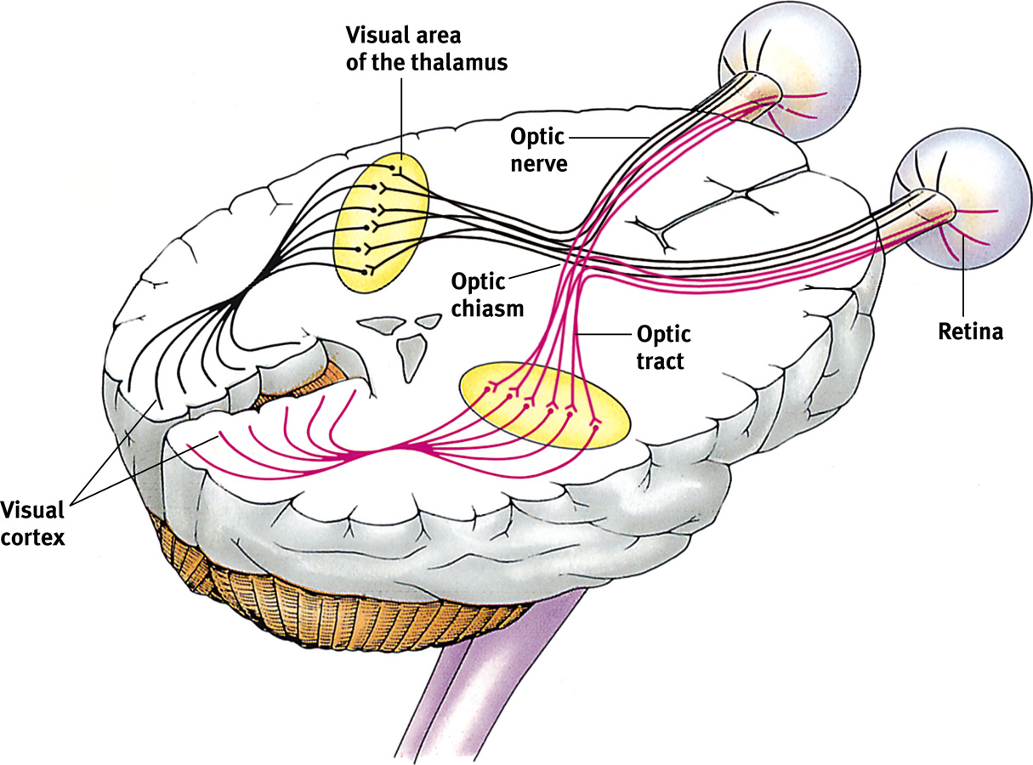
- Against: any evidence supporting 3-color theory

Pathways to the Cortex
- The optic chiasm: half of the optic nerve crosses near the hypothalamus
- Left visual field (not the left eye) projects to the right visual cortex and vice versa
- Optic nerve synapses at the thalamus
- If relevant – the info is forwarded to the primary visual cortex in the occipital lope
Feature Detection
- Single neurons in the primary visual cortex seem to be highly specialized for the detection of very specific features – horizontal and vertical lines at very specific angles or lengths
- That video where they try and fire the neuron but it has to be the right angle and length
- Farther away from the primary visual cortex (in the secondary and tertiary visual cortices) , highly specialized regions detect very specific objects.
- Thus suppose that the single neuron above located in the primary visual cortex detects a line at a very specific angle, and another neuron, also in the primary visual cortex, detects a line that responds a line at a very different angle (say a horizontal line). Both of the highly specialized neurons then project to another neuron in the secondary visual cortex. This neuron would then be specialized for the detection of an object formed by the junction of the line at one angle with a horizontal line such as /_
- As we move farther and farther from the primary visual cortex, features become joined. So, the single neuron might detect rectangles or circles or ellipses. Regions of the visual-parietal cortex begin to be specialized for highly specialized objects

Summary of Visual Processing of Specific Features:
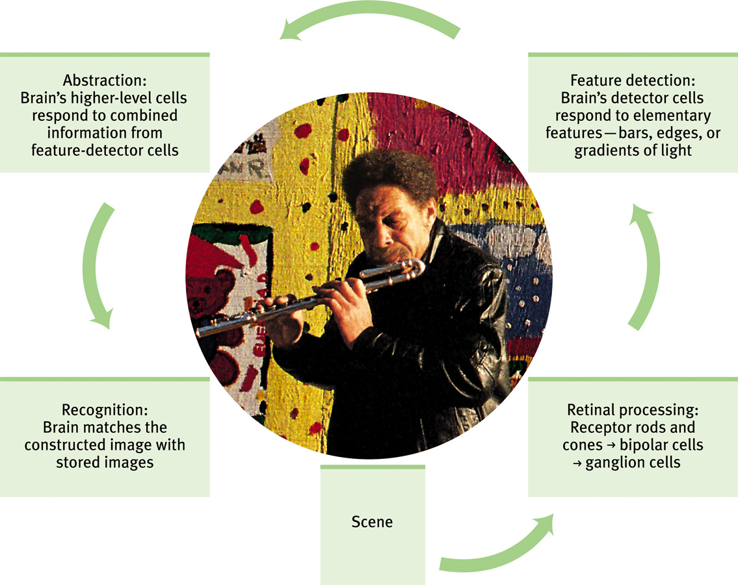

Sensation: Pain

- Common to all senses (pain is encoded within each modality)
- No single stimulus trigger pain, any stimulus that is intense enough to cause damage may cause the sensation of pain
- Nociceptors: receptors that detect pain
- Phasic pain: pain we feel immediately upon intense stimulation (it’s role is protective). It should interrupt processing of other info. it should automatically cause a switch of attention. Goal is to have you take action and remove yourself from the source of the painful stimulus. When the pain begins, we experience sharp, phasic pain. And when the pain ends, we experience a second sharp sensation of phasic pain. Our nervous system is carefully tuned to detect change.
- Tonic Pain: this is long-lasting “chronic” pain that we feel after phasic pain has ceased. It serves to "remind" you of the immediate past and should thus assist you to learn to avoid the painful stimulus in the future. Tonic pain is more subjective. Its perception can be altered by psychological factors such as attention. If you attend to this stimulus rather than the tonic pain, you may become less conscious of the pain. Many so-called pain-killer drugs operate to decrease our perception of tonic pain.
- Memory for pain: we seem to have much better memory for phasic than tonic pain
- Different pain pathways for phasic and chronic pain
- Rapid pathway for phasic pain
- Slow pathway for tonic pain
- Depends on individual differences
- Perception can be easily modulated
- Highly psychological
- Strong placebo effects

- Various theories of pain perception have been postulated.
- Gate control theory (Melzack & Wall) offers an excellent explanation of how pain can be modulated.
- Selective attention: We can control pain by using a second stimulus. Thus, we stimulate the somatosensory (touch) system by shaking our hands when we crush our thumb with a hammer. This might cause us to attend to the somatosensory stimulus rather than the painful one (this is an example of bottom-up processing).
- Alternatively, a higher centre of the brain might willfully block pain signals (perhaps by the release of endorphin neurotransmitters). This is an example of top-down processing.
- Another example of top-down processing can be seen in the influence of learning and experience. Individuals who have had negative experiences in the past (pain was particularly intense) will experience a new painful stimulus as much more painful than individuals who have not had the same experience in the past. We expect the prick of a needle to be very painful. Thus, if we look away, the sensation of the pricking of the needle may be experienced as being less painful.
*The consciousness of pain can be modulated by directing attention elsewhere

