Econ 203 – Review

Chapter 4 – Measuring National Economic Activity and Performance

Inflation Rate = (CPI₂-CPI₁/CPI₁)*100

Employment
- Unemployment Rate = ((LF-EM)/LF)*100
- Participation Rate = (LF/Pop 15+)*100
- Natural Employment = Structural Employment + Frictional Employment + Seasonal Employment
  - Canada: 6-7%
- Employment Rate = (EM/Pop 15+)*100

How to Measure Nominal GDP
- Output-Based GDP
  - Price – Intermediate Input = Value Added
  - Prevents Double Counting
- Expenditure-Based GDP
  - GDP = C + I + G + X – IM
- Income-Based GDP
  - Wages + B + I + CCA +T_{in}

- GDP Deflator = (Nominal GDP/Real GDP)*100

Chapter 5 – Output, Business Cycles and Employment

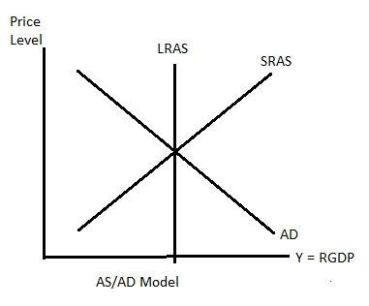

- Aggregate Supply
  - Increases when
    - Wages Decreases (Hire More Workers)
    - Price of Oil Decreases (Cheaper to Run Machines)
  - Decreases when
    - Wages Increases (Hire Less Workers)
    - Price of Oil Increases (More Expensive to Run Machines)

- Aggregate Demand
  - Downward Sloping because of
    - Interest Rate Effect (Higher Interest Rate, Less Spending)
    - Substitution Effect (Prices increases, Exports Decreases, Aggregate Demand Decreases)
    - Wealth Effect (Prices are high, it decreases Real Wealth and People can’t buy as much so Aggregate Demand Decreases)

- Output Gap = (Y – Yp)
  - Inflationary Gap when actual GDP is greater than Potential Output
  - Recessionary Gap when actual GDP is less than Potential Output

- Adjustments to Output Gaps
  - Automatically (No G or Central Bank)
  - Fiscal or Monetary Policies (G or Central Bank)

- Recessionary Gap (Automatic Adjustment)
  - Unemployment Higher
  - Workers are Willing to Work for Less
  - Wages Decreases
  - AS to shift Down and Meet Yp

- Inflationary Gap (Automatic Adjustment)
  - Price Level Increases
  - Higher Wages
  - AS will Shift Up and Meet Yp

- Macroeconomic Policies
  - Fiscal Policy: Government Expenditure and Tax Changes used to Influence AD
  - Monetary Policy: Changes in Interest Rate and Money Supply to Influence AD

Chapter 6 – Output, Aggregate Expenditure and Aggregate Demand

AD and Output in Short Run

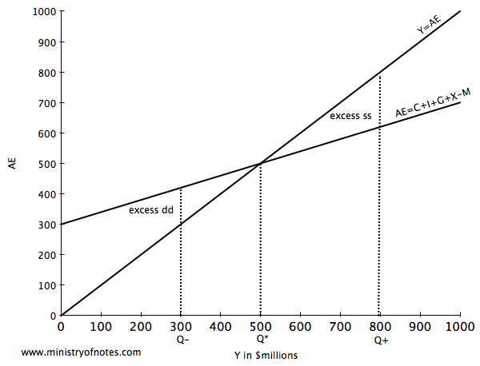

Three Assumptions to Remember
- All Prices and Wages are FIXED at a Given Level
- At these Prices and Wages, Businesses Produce the Output DEMANDED
- Interest rate and Foreign Exchange Rate are FIXED

Aggregate Expenditure
- AE = C + I + X – IM
  - C = cY +C₀
    - cY = Slope of C (Change in C/Change in Y) or MPC
    - C0 = Autonomous Consumption (Doesn’t change depending on Income)

Saving
- MPS = Change in Savings/Change in Y or (1-c)
- Savings = -C₀ + (1 – c)*Y

Investment Expenditure
- Autonomous

Exports Function
- Autonomous
- Canadian Exports Depend on
  - Income Level in other Country
  - Price Levels in those Countries
  - Foreign Exchange Rate

Imports Function
- IM = MPM +M₀

Adjustments towards Equilibrium
- When y > AE the inventory increased and y Output Decreases

Multiplier
- Change in Equilibrium Output/Change in Autonomous Expenditure
- M = 1/(1 - Slope of AE)

Leakages and Injections
- IM + T + S = I + G + X
- Leakages: Money not spent in the economy
- Injections: Autonomous in AE

Chapter 7 – Government, Fiscal Policy and Real GDP

AE = C + I +G + X – IM

- Lump-Sum Tax
  - Yd = T – Y
  - No Effect on Slope of C and AE
- Tax Rate
  - Yd = (1 – t) * Y
  - Taxes Decreases the slope of C and AE

Slope of AE decreases, MPC decreases, Taxes will increase and MPM will increase

Government Budget and Budget Balance
- Revenue Greater than Spending = Budget Surplus
- Revenue Smaller than Spending = Budget Deficit
- Revenue Equal Spending = Budget Balance

BB = tY – G – Does not tell us about the fiscal policy

Structural Budget Balance

SBB = tYp – G
Since the output is the potential one, we will see changes in fiscal policies
- Recessionary Gap
  - Expansionary Fiscal Policy
  - Increase in Government Expenditures and Decrease in Tax
- Inflationary Gap
  - Contractionary Fiscal Policy
  - Decrease in Government Expenditures and Increase in Tax

Automatic Stabilizers
- Decrease the need for fiscal policy
- Anything that lowers the multiplier is an automatic stabilizer
- Income Taxes and Transfer Payments
- ALL LEAKAGES ARE AUTOMATIC STABILIZERS

Public Debt
- Change in PD = -BB
- Debt Ratio: Ratio of PD to GDP

Canadian economy is going into a recession. You want to minimize drop in GDP, you want a small output gap so a small multiplier and since lump-sum tax has no effect on AE slope, we prefer a tax rate. You want a high MPM because it will minimize drop in GDP.

Chapter 8 – Money, Banking and the Money Supply

Money and its Functions
- Bank Cash reserves: Cash held by the bank to meet possible withdrawals
- Money Supply: The amount of currency in CIRUCLATION including the deposits
  - M1 = Cash in circulation + Checking Deposits
  - M2 = M1 + Savings Deposits
  - M3 = M2 + deposits at other financial institutes other than banks

- Cash held by the public+ Deposits = MS

- Monetary Base: All the currency in circulation + the cash reserves

- Cash held by the public + Banks Cash Reserve = MB

- Deposits is a liability of the bank

How Bank Create Money
- Currency Ratio
  - Cash held by the public (Outside of the bank)/Deposits
- Reserve Ratio
  - Cash reserves/Deposits

Monetary Base and Money Multiplier
- Money Multiplier
  - MM = Change in MS/Change in MB
  - MM = (1 + cr)/(rr + cr)
  - Bigger MM means Bigger Loans
- Monetary Base
  - MB = (rr + cr) * Deposits
- Money Supply
  - MS = Cash holding by the Public + Deposits
  - MS = (1 + cr) * D

Chapter 9 – Financial Markets, Interest Rates, FX and AD

- Bond: Financial Contract that makes one or more fixed money payments at specific dates in the future
- Interest Rate: Market Rate paid to Lenders
  - Interest Goes Up, Price of Bonds Go Down
- Price of Bond = Cash/(1 + i)^{n}

- Money Demand
  - How much money people like to hold as cash
  - Affected by
    - Interest Rates
    - Price Level (Goes up, People need more Money)
    - Real Income (Y increases, MD increase)
  - Why people keep money
    - Transaction Motive (Day-to-Day Motive)
    - Precautionary Motive (Uncertainty)
    - Asset Motive (Reduce Portfolio Risk)
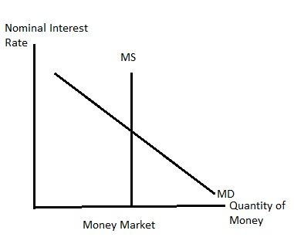
Money Market
MS increases = i Decreases
Banks have more money so they can afford to loan out the money at a lower interest rate

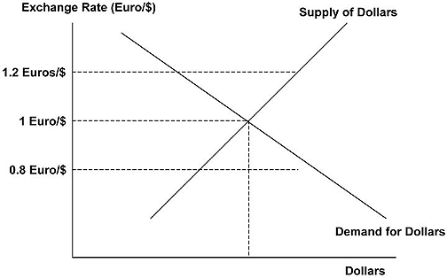
Exchange Rate
When interest rates decreases
- CDN bonds are less attractive
- Supply of foreign will shift left
- Demand will shift right
- CDN$ will depreciate
- ER increases
- NX Increase = Exports Increase – Decrease in Imports
- Loans are cheaper
  - Increase in Consumption
  - Increase in Investment Expenditure
- Increase in Aggregate Expenditure
- Increase in Aggregate Demand
- Increase in Real GDP

See page 73 for the 4 graphs

Chapter 10 – Central Banking and Monetary Policy

Monetary Policy: Policies made by the Central Bank (Bank of Canada, Federal Reserve (US), European Central Bank) that changes money supply, interest rates and exchange rates to adjust AD

Open Market Operations
- Open Market Operations: When the central bank buys or sells government securities (mainly bonds) in the pen financial market
- Open Market Purchase (Public)
  - BoC buys government bonds
  - MB and MS increase, Interest Rate decreases = Expansionary
- Open Market Sales (Public)
  - BoC sells some of its assets
  - Money leaving public’s pockets
  - MB and MS decrease, Interest Rate increases = Contractionary

- SPRA (Special Purchase and Resale Agreement)
  - BoC injects cash into the banking system (MB increases, ONR decreases = Expansionary)
- SRA (Sale and Repurchase Agreement)
  - BoC drains cash from the banking system (MB decreases, ONR increases = Contractionary)

Overnight Rate
- ONR: The interest rate commercial banks receive or pay on loans from one day until the next to one another
- Between Bank Rate (BoC charges banks) and Deposit Rate (BoC gives to Banks) by 0.25%.
  - Lowest DR = O%, ONR = 0.25%, BR = 0.5%

Monetary Policy rules
- Taylor Rule
  - Sets the interest rate according to
    - Inflation Target
    - Output Targets
  - i = i0 + a(π – π*) + b(Y – Yp)

Chapter 11 – Monetary and Fiscal Policy in the Short Run

AD Shocks
- AD Shocks: When changes in autonomous expenditure shift the AD curve
  - AD increase, Shock is positive
  - AD decreases, Shock is negative

AS Shocks
- AS Shocks: When changes in production costs and indirect taxes shift the AS curve
  - AS decreases, Shock is negative
  - AS increases, Shock is positive

Fiscal Policy and the Public Debt
- BB = tY – G – iPD
- PrimaryBB = tY – G (Previous BB learned in Chapter7)
- SPBB = tYp – G (As learned in Chapter 7)

Chapter 14 – BOP, Exchange Rates, Monetary and Fiscal Policy

Balance of Payments (BOP) Accounts
- Records transactions between one country and the rest of the world
  - 3 main accounts
    - Current Accounts (CA)
    - Capital Accounts (KA)
    - Change in Official reserve account (Change in OR)

- Current Account (CA): Records Exports and Imports goods, services and transfer payments
  - Net Exports
- Capital Accounts (KA): Records purchase and sales of real/physical assets (machinery, factories) and financial assets (Bonds and Stocks)
  - Bonds
- Change in Official Reserve (Change in OR): chnge in Government ‘s balance of foreign currency
  - Change in OR is always equal to CA + KA

- BOP = CA + KA – Change in OR (fixed ER)
  - Interest go down = CDN bonds are less attractive = KA decreases = CDN$ depreciates = NX increases = CA increases
  - Interests go down = CDN bonds are less attractive = KA decreases = FIXED ER = CDN$ remains the same = Change in OR decreases (BoC is selling $US to buy $CDN) = MS decreases = Interests Increases

Current Accounts (CA)
- Real Exchange Rate: Relative price of goods and services from different countries measured in common currency
  - RER = (exchange rate * Price Foreign)/Price Domestic
- Purchasing Power Parity (PPP): RER is equal to 1

Capital Accounts (KA)
- Interest Parity: Occurs when expected ER changes make up for interest rate differences between countries
  - Return on domestic bond is the same as overall return on foreign asset
  - Overall Return on Foreign Asset = Foreign interest + % change in expect ER
  - If the Foreign Interest Rate is higher than domestic, we expect the domestic currency to appreciate

Flexible ER
- Monetary Policy is more effective
- Fiscal Policy is less effective
Fixed ER
- Monetary Policy is less effective
- Fiscal Policy is more effective

Crowding Out
- Recessionary Gap –> G increases -> Y increases -> MD increases -> i increases -> C, I, NX decreases -> AE decreases -> AD decreases -> GDP decreases

- With a Fixed ER, less crowding out because NX stays the same

Crowding In
- G decreases -> y decreases -> MD decreases -> i decreases -> C, I, NX increase -> AE increases - > AD increases -> y increases
- The decrease in y is not intentional. The government has to cut their expenditures sometimes to cut their debt
- People want Crowding In
- Prefer Flexible ER

Chapter 13 – Economic Growth

- Economic Growth
  - Yearly Percentage change in Real GDP or Real GDP per capita
- The Very Long Run
  - Y = A * F(L,K)
  - A = Solow Residuals, Level of Technology
  - K = Capital (Machinery)
  - L = Size and productivity of labour force
- (Growth Yp) = (Growth in A) + 2/3(Growth in L) + 1/3(Growth in K)

Constant returns to scale: Labour and Capital are growing at the same rate. Yp will increase at a constant rate. Yp per capita will stay the same

Per Capita GDP = A* L^{2/3} * K^{1/3}

