Experiment 7: Reductive Amination of Vanillin with p-Toluidine

Date: November 21st, 2016

CHM 2123 Section B: Mondays, 6:30-9:30pm

Department of Chemistry

University of Ottawa

Introduction

Amines are a class of organic molecule defined by a nitrogen atom bearing one lone pair of electrons. Humans use amines in many important applications including 90 % of drugs, and many cosmetics, dyes and fertilizers. Amines can also be found in nature, where they are called alkaloids, these can be found in proteins, amino acids, and nucleic acids. When discovered that they have carcinogenic properties, amines became a controlled substance. Amines have some important properties that give them their unique traits. They can form three covalent bonds, while remaining neutral, and still have a lone pair of electrons. This lone pair makes them basic, meaning that they can easily react with positive charges. Primary or secondary substituted nitrogen atoms are also nucleophilic. A primary amine is classified where only one of the three covalent bonds is attach to a carbon atom; a secondary amine is when two of the covalent bonds are attached to carbon atoms. The long electron pair can bond to an electrophile, causing the nitrogen to bear a positive charge. Nitrogen atom nucleophilicity is affected by substituents attached to it. Carbons tend to donate electrons making the nitrogen atom more nucleophilic, until the steric hindrance they cause lessons the reactivity. This occurs when all three of the covalent bonds are attached to separate carbon atoms, forming a trialkylamines.
The increasing nucleophilicity of the nitrogen atom as more carbon groups are attached makes it difficult to selectively add amines into organic compounds. The amine’s increased nucleophilicity after bonding with carbon will cause it to react with any present electrophiles causing multiple, unwanted cross-alkylated-products. This can be prevented by reacting potentially troublesome amines with a carbonyl protecting group to from a more stable imine.
The “protecting” of amines by reacting them with carbonyls is called reductive amination. The imine formed is much less nucleophilic and basic, making it less reactive in general. Imines do not cause unwanted cross-alkylated-products while desired reactions are taking place, and, after the other reactions are done, it is easily removed by a simple reduction reaction. Reductive amination prevents the formation of unwanted side products and allows for more regioselective control of the desired product.
In this experiment a reductive amination was performed on para-toluidine, which is an aromatic amine, and vanillin. This reaction is done without a solvent following principles in green chemistry, which include waste prevention, not using chemicals including solvents unless necessary, and overall efficiency of reactions.
To test the progress of the reaction, or the purity of a product TLC’s were run. This technique involves a strongly polar stationary phase (in this case silica gel) affixed on an aluminum plate, a mobile or eluent phase with a mix of polar and non-polar solvents (4:6 hexanes and ethyl acetate), and the solution being tested. The compounds being tested are spotted a centimeter from the bottom of the TLC plate, which was then put into a developing jar with the mobile phase in the bottom. As the mobile phase is absorbed and travels up the plate it carries the spotted compounds with it, and, depending on how polar they are, they will travel different distances. More polar the compound, the less far it will travel up the plate as they interact more with the polar silica gel. Non-polar compounds on the other and are able to move further up. Therefore, if one solution has different compounds in it, and they have different polarities, they will be separated. This is useful when you are testing for impurities, as the pure product spot will be separate from all contaminates or original reactant spots. When the eluent has absorbed within a centimeter of the top of the plate then the plate is taken out of the jar, and visualized by putting it under UV light, where the spots can be seen and marked in pencil. The eluent of 4:6 hexanes and ethyl acetate was chosen as it will not absorb up the plate too fast as to give too low Rf values, nor will it absorb up the plate too slow and give too high Rf values. Moderate Rf values are ideal as they are easier to read and differentiate.
Sublimation apparatusith cold finger and side arm flask

Mechanism
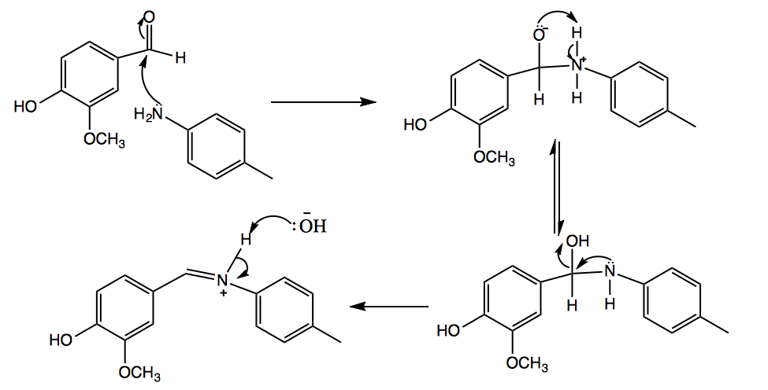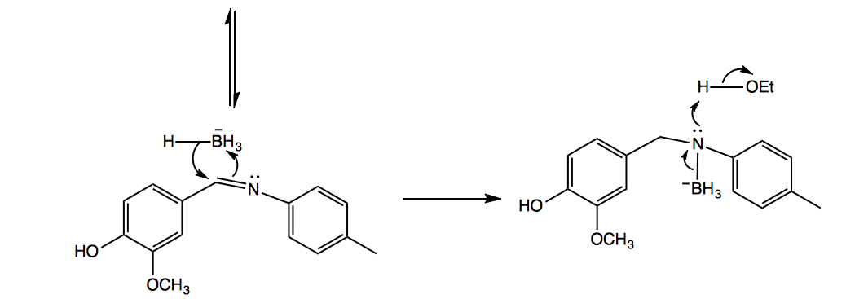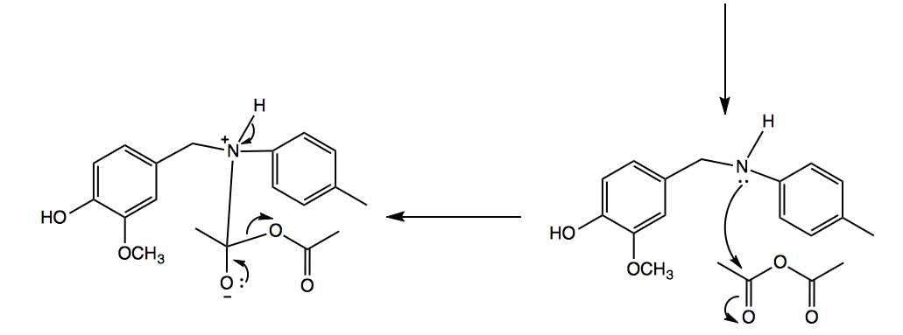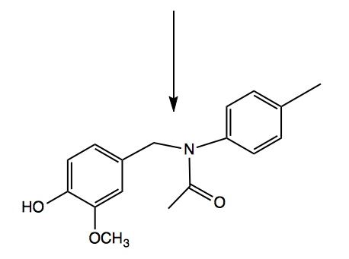

Table 1. Table of Reagents
Name of Compound | Molar Mass (g/mol) | Density (g/mL) | Quantity (g or mL) | Moles (mol) | Equivalents
Vanillin (s) | 152.15 | 1.06 | 0.58 | 0.0038 | 1.0000
p-Toluidine (s) | 107.156 | 1.05 | 0.50 | 0.0038 | 1.0000
95% Ethanol (aq) | 46.068 | 0.789 | 15 | 0.2441 | 64.2368
NaBH₄ (s) | 37.83 | 1.07 | 0.10 | 0.0026 | 0.6842
Glacial Acetic Acid (aq) | 60.05 | 1.05 | 2.0 | 0.0350 | 9.2105
Acetic Anhydride (aq) | 102.09 | 1.08 | 2.0 | 0.0212 | 5.5789
Water (l) | 18.02 | 1.00 | 75 | 4.1620 | 1095.2632

Experimental Procedure
1. Water was placed in a metal tub and set on a hot plate to prepare a steam bath.
2. 0.58 grams of vanillin and 0.40 grams of para-toluidine were combined in a 250mL beaker, using a Teflon rod to stir. A small sample was placed in a test tube and dissolved in 95% ethanol for a TLC analysis.
3. Must be done quickly. Once the reactants have been sufficiently mixed and are a uniform bright orange powder, 15mL of 95% ethanol is added. The solution must be stirred until all of the solid has completely dissolved. If the solid is given too much time to solidify, it becomes difficult to fully dissolve.
4. 0.1 grams of of NaBH₄ was slowly added and stirred in five small increments.
5. Once all of the NaBH₄ was added, the solution was stirred for another 15 minutes. A colourless solution indicated that the reaction was complete. A small sample was placed in a test tube for TLC analysis.
6. 2.0mL of glacial acetic acid was added to the reaction mixture.
7. 2.0mL of acetic anhydride was added to the reaction mixture.
8. The beaker was placed in a steam bath for 45 minutes.
9. 75mL of cold water was added by pouring it slowly down the side of the beaker and simultaneously stirring.
10. The beaker was scratched using a clean metal rod for 20 minutes to induce precipitation.
11. The precipitate was collected by suction filtration. Its mass and melting point were determined. A minimal amount was dissolved in 95% ethanol for TLC analysis.
11. A TLC was taken of vanillin, p-toluidine, the imine product from step 2, the liquid amine-containing product from step 5, and the final amide product in step 10. The TLC plates were developed in a 4:6 hexanes:ethyl acetate co-solvent. The TLC plates were visualized under UV light.

Observations and Results
Two trials were performed. The modifications/improvements that were made that were made in the second trial were used to write the experimental procedure.

Table 2. Qualitative Observations for the Formation of an Amide Via Reductive Amination
Key Steps | Observations
Steps 2 and 3. Combination of vanillin and p-toluidine and addition of ethanol | -Vanillin was off-white, short (3-4mm) hair-like crystals. Exactly 0.58 grams was used in both trials  -Para-toluidine was brown-yellow, large clear crystals. Exactly 0.40 grams was used in both trials  -When combined they created a uniform bright yellow powder that became moist.  -When left for a minute or two, the powder became quite solid and chunky, crusting to the sides of the beaker. Ethanol was able to dissolve this, but it took a few minutes of stirring to get it to fully dissolve. To avoid this during the second trial, the ethanol was premeasured and added immediately after the vanillin and p-toluidine were combined so that it was easier to ensure the solid was completely dissolved.  -The solid dissolved completely and formed a clear bright yellow solution.
Steps 4 and 5. Addition of NaBH₄ | -Exactly 0.1g was added for both trials  -The solution became cloudy pale yellow. There was a lot of bubbling and froth in the solution.  -The solution gradually turned colourless, but remained cloudy. After approximately 15 minutes, the solution was colourless.
Step 6. Addition of glacial acetic acid | -2.0mL was added for both trials  -The solution turned clear and bright yellow again
Step 7. Addition of acetic anhydride | -2.0mL was added for both trials  -No visible change occurred in the reaction mixture
Step 8. Steam bath | -The first trial was left for 15 minutes, but the second trial was left for 45 minutes to ensure maximum effect.  -The reaction mixture gradually became more clear. In the end it had only a yellow tint.
Steps 9 and 10. Addition of water and scratching | -As the water was added the solution instantly turned cloudy white  -Upon close inspection a small amount of precipitate formed inside the solution, however it was very insignificant.  -Scratching was extremely effecting in forcing out the precipitate. Continued scratching yielded a significantly greater amount of precipitate, from a visual aspect.  -For the first trial only approximately 5 minute was spent scratching, while 18-20 minutes was spent during the second trial.
Step 11. Final precipitate | -As the solution filtered crystals were still forming in the mother liquor. The second trial was given much more time for the reaction to complete, so only a very thin line of crystals lined the edge of the flask.  -The final product looked similar to snow. The product from the first trial was much denser and formed into small balls, and was off-white. The second trial yielded a much more pure-appearing product. It was much more white, and was lighter/fluffier.  -Trial 1: 0.77g, 125 °C melting point  -Trial 2: 0.87g, 126 °C melting point  -For trial 1 two samples were tested for melting point on different apparatuses. The first sample had almost completely finished melting at 109 °C, however that apparatus broke, so a second sample and the sample from trial 2 were tested on a different apparatus. More explanation of this discrepancy can be found in the discussion.

Table 3. Melting Point Observed for the Final Amide Reaction Product
Compound | Theoretical Melting Point (°C) | Experimental Melting Point (°C) | % Error
Final - Amide | 127-128 | 126 | 0.79 or 16.67***
***Refer to discussion

Table 4. Amount of Product Yielded from each Trial
Trial | Mass of final product | % Yield
1 | 0.77 | 74.13
2 | 0.87 | 83.75

TLC Plates

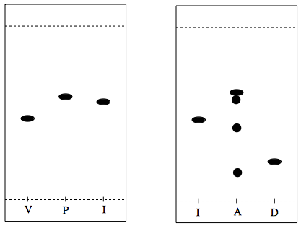

V = vanillin [Rf: 0.47], P = p-toluidine [Rf: 0.59], I = imine (step 2) [Rf: 0.56], A = amine (step 5) [Rf: 0.61, 0.58, 0.44, 0.17], D = amide (final product) [Rf: 0.23]
- TLC’s were run in a 4:6 hexanes:ethyl acetate co-solvent
- The solids: vanillin, p-toluidine, imine, and amide were dissolved in 95% ethanol

Yield Calculations

% yield of final product – the limiting reagent can be either starting material
- Molecular weight of amide product: 273.36 g/mol
- NaBH₄ is not the limiting reagent – it is only used for proton transfer and has a sufficient number of hydride equivalents
- Calculations were done on a 1:1 ratio of vanillin and p-toluidine.
Moles of product = 0.87g / (273.36g/mol)
= 0.0031826 mol
% yield
= ( Experimental value / Theoretical value ) x 100%
= ( moles of product / moles of limiting reagent ) x 100%
=[ moles of product / (moles of vanillin)] x 100%
= [ ( 0.0031826 ) / ( 0.0038 mol ) ] x 100%
= 83.75%

% error of melting point of amide product
= ( | Theoretical value – Experimental value | / Theoretical value ) x 100%
= ( | 127 – 126 | / 127 ) x 100%
= 0.79%

Rf = (distance traveled by spot) / (distance traveled by co-solvent)
= 2.4cm / 5.1cm
= 0.47

Discussion

The purpose of this lab was to create an amine and then turn it into an amide via reductive amination. In step 2 of the experiment, the vanillin and para-toluidine were combined to form an imine. The double bond on the carbonyl group broke open and the lone pair of electrons on the nitrogen atom of toluidine bonded to the carbon. The result of this was one larger molecule with a negatively charged oxygen and a positively charged nitrogen. These charges were neutralized via proton transfer, creating an OH group and leaving a lone pair of electrons on the nitrogen atom. These lone electrons bumped the OH group off of the neighbouring carbon and formed a double bond. Under any kind of protic conditions, the OH would have been protonated to form –O⁺H2, which is an excellent leaving group. After the formation of the double bond, the nitrogen was positively charged. The electrons from the N-H bond tranfered to the nitrogen and the H⁺ bonded to the OH⁻. This created the imine intermediate. Next, the NaBH₄, acting as a hydride source, popped open the C=N bond and gave an H⁻ to the carbon, and –BH₃ to the nitrogen. When ethanol was added, the H-O bond broke as the nitrogen dissociated from the –BH₃ and bonded to the H⁺. This product was the amine intermediate. Some bubbles formed as the NaBH₄ was added, most likely from H₂ gas formed from the H- anion from the –BH₄ reacting with H from the HO group on the ethanol, this unwanted side reaction may have lowered yield. The glacial acetic acid is added to the solution to improve the solubility of the solvent for the amide product of the next reaction. The lone electron pair on the nitrogen group attack one of the carbonyl bonds on the acetic anhydride. The O-C bond attaching the rest of the molecule breaks to stabilize and form the protecting group, making it an amide. The solution was heated to add energy to the system to push the reaction to completion. The cold water was slowly added to precipitate the amide out of the solution and leave the more polar contaminates dissolved in the water.
Two trials were performed in this experiment. Throughout the first trial notes were taken of difficulties and points where the procedure could have been improved. In the first trial, after the vanillin and –p-toluidine were combined, the beaker was left to sit while the ethanol was prepared. The imine product became very hard and crusty. The ethanol was able to dissolve it, however, it took a lot of stirring and crushing to accomplish this. It is likely that very small pieces were left undissolved in the solution. To fix this, in the second trial, the ethanol was premeasured so that as soon as the vanillin and p-toluidine were combined the ethanol could be added. This prevented the imine from crusting and made it much easier to dissolve. In the first trial the beaker was left in the steam bath for 15 minutes because after the prescribed 10 minutes it appeared that the solution was still changing. When very little precipitate formed the beaker was scratched to induce precipitation. During filtration crystals continued to form in the mother liquor that had been drained out, which was still cloudy, indicating that not enough time was given for the reaction to complete. For the second trial, more time was given for both the steam bath (45 minutes) and for scratching (20 minutes). During filtration, a very thin line of crystals lined the edge of the flask along the surface of the solution, however the mother liquor was much more clear and a significantly smaller amount of crystals formed. Additional time to allow the solution to precipitate would have given an even better yield, however the modifications made were effective.
The TLC’s were run in a 4:6 hexanes:ethyl acetate co-solvent. The final amide column shows a single dot (Rf = 0.23) indicating that the product yielded was pure. The amine lane shows many spots, an indication of contamination. If compared to the first TLC, the various spots appear to be similar to the vanillin, p-toluidine, and imine. If this was the case, remnants from each step of the reaction were present, contaminating the desired product. This impurity possibly could have come from some of the imine product remaining stuck on the side of the flask and not reacting, only to later fall into the flask and contaminate the product, this is a potential drawback to “single-pot” type chemical reactions. A more thorough stirring would mitigate this problem. Any vanillin or p-toluidine present would indicate that step 2 was not done thoroughly enough. Because they were combined on a 1:1 ratio, if both reactants were present, they should have combined to form the imine. Assuming that is what happened, the presence of only one spot in the imine lane simply indicates that there was no unreacted vanillin or p-toluidine in the sample tested. The dot appearing at the bottom of the amine lane that does not match spots in any other lane is presumed to by the actual amine molecule.
The melting point for trial 1 was 125°C, and 126°C for trial 2. The lab manual contradicts itself in regard to the melting point of the final amide product. One range given is 127°C-128°C (page 84), and another is 102°C-108°C (page 83). Because of this, the experimental melting point had a % error of either 0.79% or 16.67%, respectively. Given this discrepancy, is it unclear whether or not the final product was extremely pure. All of the reactants had intermediates had lower melting points, so it was likely a contamination from either incomplete filtration or using dirty glassware. Another problem that possibly could have lead to this discrepancy is the apparatuses that were used to determine melting point. Two amide samples were tested for melting points for trial 1. The first sample was almost completely melted when the thermometer read 109°C, however after that point the reading started to drop drastically and within 10 seconds it said the temperature was 62°C. Because of this error, a second sample was tested on a different apparatus, which gave the melting points of 125°C and 126°C for trials 1 and 2, respectively. The significant difference between the two apparatuses and the error that occurred with the thermometer indicated that it was a relatively unreliable method for measuring melting point.
The products of both trials had similar melting points, so it can be assumed that they were also similar in purity. The first trial had a % yield of 74.13%. After the noted modifications were made to the procedure the second trial yielded 83.75%. This clearly indicates that the modifications made did improve the experimental yield. A lot of product was left on the sides of the reaction beaker which was extremely difficult to get out. This left a lot of product behind that was not included in the final mass taken. Additionally, as the solution was being filtered, some crystals continued to form in the filtered liquid. A much smaller amount formed during the second trial. The additional time spent in the steam bath and scratching/waiting for the precipitate to form improved yield, however, in is clear that more time was required to allow the reaction/precipitate to fully form.

Questions

1.
Principle 2: Maximize atom economy
- By using equal moles of Vanillin and p-Toluidine (the reaction proceeds on a 1:1 ratio), no reagent was wasted.
Principle 5: Use safer solvents and reaction conditions
- Aside from the TLC’s, no solvents were used in the experiment
Principle 6: Increase energy efficiency
- The reaction was performed under ambient conditions.

2. The acetylate amide product is less reactive than the free amine because the acetylate amide provides significant steric hindrance and it has resonance that draws electron density away from the nitrogen atom much better than the hydrogen atom that it replaces.

3.
a)

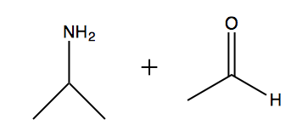 or 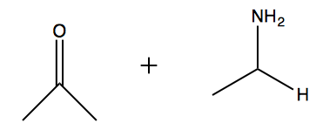

b)

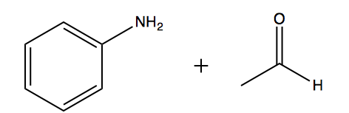

4.
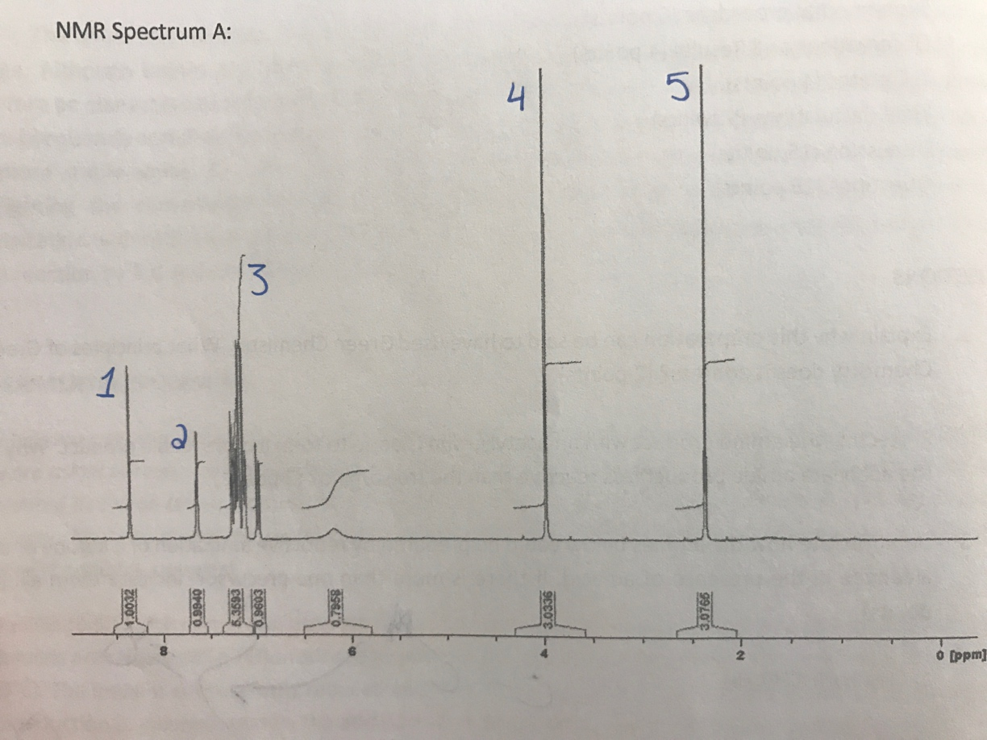
Spectrum A: Imine
Peak 1: Proton on the OH
Peak 2: Proton on the carbon across the double bond from nitrogen
Peak 3: Protons on the benzene group
Peak 4: Protons on the methyl attached to the oxygen off the benzene ring of vanillin
Peak 5: Protons on the methyl from the p-toluidine

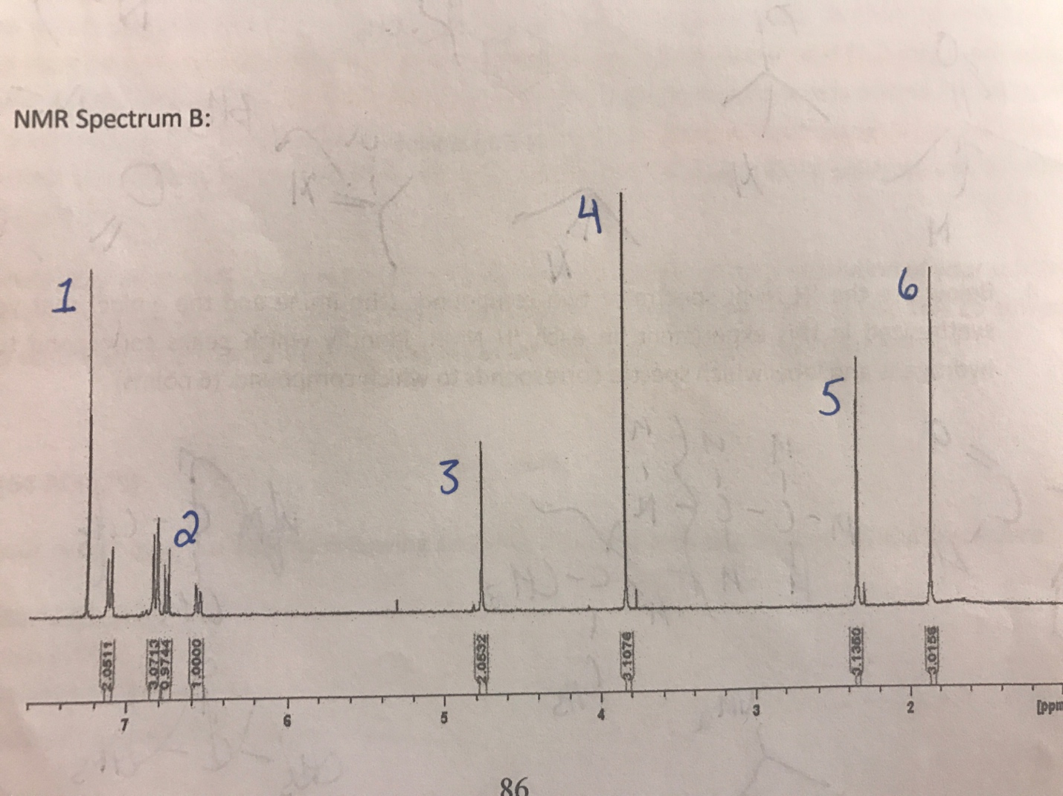
Spectrum B: Amide
Peak 1: Proton on the OH
Peak 2: Protons on the benzene group
Peak 3: Protons on the CH₂ next to the nitrogen
Peak 4: Protons on the methyl attached to the oxygen off the benzene ring of vanillin
Peak 5: Protons on the methyl from the p-toluidine
Peak 6: Protons on methyl attached to carbonyl

Sources:

1. Solid-Solid Synthesis of Imines: A Green Chemistry Experiment. Retrieved November 19th, 2016, from http://greenchem.uoregon.edu/ACSGoingGreenSite/PDFs/20050315TuesPM/Exp1Dragojlovic.pdf

2. Green Amine Chemistry. Retrieved November 19th, 2016 from courses.chem.indiana.edu/s343/documents/8.greenaminechemistry.doc

