CHEM 208 Notes
By Vanessa Dulgar
Module 2: The Scientific Method and Matter
Significant figures
Nx10^{n} , must have one digit (not 0) before period and two or one after
Ex: N can be the value of YES = 4.56 NO = 33.76 NO = 0.293
n can only be a whole, - or + number.
*Does not apply to exact numbers or conversion factors
Ex: 60 6.0 x 10¹
SigFig rules for ADDITION (+)
1,495.2 + 1.9903 = 1,497.2
(Keep the least # of decimal places)
SigFig rules for MULTIPLICATION AND DIVISION (X AND /)
60 x 5.0839 = 305.034
60 x 5.0839 = 300.000
(only know 2 sig figs (60), so everything after “30” are 0s)
60 x 5.0839 = 3.0x10²
(Keep the least # of sig fic total)
SigFig rules for MEASURED quantities
(Keep all numbers as is, do not edit them or round them)
Rules of Sig Figs
- All non-zero numbers are sig figs
- Counting begins from the left with the first non-zero numbers
- Zeros between non-zero number are sig figs
- Terminal zeros count, not beginning zeros
*3= infinite amount of sig figs
Definitions
Integer: whole number
Density: Does not depend on the amount of substance = ratio mass to volume
Dimensional analysis: A method for solving numerical problems that uses 'conversion factors' to cancel out unwanted units and results in an answer with the desired units (i.e., dimensions).
Steps to the Scientific Method:
1) Performing experiments steps to test hypothesis
2) Making observations qualitative/quantitative #
3) Proposing a hypothesis explanation for observations
4) Confirming the hypothesis must be NO INCONSISTENCE (or repeat steps 1-4)
5) Proposing a scientific law by repeating experiments and reformulating hypothesis
Rules of Rounding Off Chemical Equations (rounded to 3 sig figs)
- # > 5 = bigger than 5 = round up
- # < 5 = smaller than 5 = round down
- # = 5 = If odd, round up and if even, stays the same
SI System of Units
1) Length: in meter (m)
2) Volume: cubic meter (m³), liter (l), milliliter (mL)
3) Density: kilogram per cubic meter (kg/m³), g/mL, g/L
4) Mass: kilogram (kg)
Ex:
“Nanometre” = (ns = 10⁻⁹ s)
“Milliliter” = (mL = 10⁻³ L)
“Micrometer” = (um = 10⁻⁶ m)
Module 3: The Periodic Table and Naming Compunds
  1. When was the periodic table invented?  1859  1869  1954 | 2. Who invented the periodic table?  Dmitri Mendeleev  Dmitri Mendeleev and Lothar Meyer  Albert Einstein
3. The periodic table is:  not so important  important  very important | 4. Which is the first element in the periodic table?  Helium  Gold  Hydrogen
5. Aurum is:  the Greek name of gold  the Hebrew name of gold  the Latin name of gold | 6. The rows of the periodic table are called:  rows  periods  lines
7. The columns of the periodic table are called:  groups.  periodicals  elements | 8. Mg is the symbol for:  milligram  megahertz  magnesium
9. All of the elements in a period have the same:  atomic weight  number of atomic shells  color | 10. All of the elements in a group have the same number of:  neutrons  molecules  electrons in their outer shell
11. The periodic table is called this way because:  it describes the periodic motion of celestial bodies.  it describes the periodic arrangement of chemical elements.  it describes the signs of the zodiac in a new way. | 12. Pu is the symbol for:  plutonium  Pluto  pollution
The atomic number is the number of protons in the nucleus of an atom.  13. What is the atomic number?  the number of electrons in an atom.  the number of protons in the nucleus of an atom.  the number of shells belonging to an atom | The noble gases are located in the far right column of the periodic table.  14. Where, in the periodic table, are located the noble gases?  in the far left column of the periodic table  in the far right column of the periodic table  in the middle of the periodic table
15. Which has a greater atomic number, uranium or plutonium?  uranium  plutonium  both have the same atomic number | 16. "C" is the symbol for:  Carbon  the C programming language  the speed of light

Periodic table: column = groups (group B = transition elements, group A = main group elements ), row = period
All elements from same Period have same: # of atomic shells
All elements from same Group have same: #of electrons on outter shell
Atomic number = # protons (makes each element unique) and = #electron BUT
- Missing electron = + electrically charged atom
Relative Atomic mass = #protons + #neutrons (commonly found in nature)
- Atomic mass – Atomic number = #neutrons
Isotope = same elements, different #neutrons
Rules for Naming and Deriving Formulas
Ionic Compounds

Groups:

CATIONS (+), names first, finishes in “ium”
1A +1
2A +2
3A +3

ANIONS (-), ends with “ide”
5A -3
6A -2
7A -1
Must say Cation first and sodium second
All anions that end with “ate” forms acids that ends with “ic”
All atoms that end with “ite” acid forms “ous”
https://www.youtube.com/watch?v=mlRhLicNo8Q See 9:50

Covalent Compounds

- Rule #1: Name the first element in the formula first.  - Rule #2: Name the second element as an anion.  - Rule #3: Use prefixes to indicate the number of atoms of each element.  - Rule #4: Do not use the prefix mono- for the first element. | Note: Some compounds are still known by their old names (and not by using the system of nomenclature):  - Water (H₂O) [not dihydrogen monoxide]  - Ammonia (NH₃) [not nitrogen trihydride]  - Hydrogen sulfide (H₂S) [not dihydrogen monosulfide]  - Hydrogen peroxide (H₂O₂) [not dihydrogen dioxide]  - Methane (CH₄) [not carbon tetrahydride]  - Ozone (O₃) [not trioxygen]

Definitions

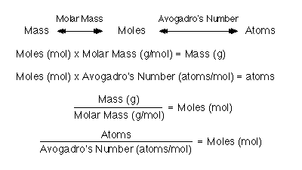

Alkali metal
Any element belonging to Group IA (located in the left-most column) of the periodic table, with the exception of hydrogen. These Group IA metals all form monovalent cations (i.e., a singly charged cation).
Alkaline earth metal
Any element belonging to Group IIA of the periodic table. All of the Group IIA metals form divalent cations (i.e., cations with a charge of +2).
Halogen
Any element belonging to Group VIIA of the periodic table. Halogens are non-metals.
Noble gas
Any element belonging to Group VIIIA of the periodic table. Noble gases are also referred to as a rare or inert gases.
Ionic compound
A compound consisting of a cation and an anion (generally a metal and a non-metal) where the bond is formed through the electrostatic interaction between the cation and the anion.
Polyatomic ion
An ion (i.e., a species possessing a net overall charge) that is composed of two or more atoms that are held together through a covalent bond.
Acid
A chemical substance that produces protons (H⁺ ions) when dissolved in water. The pH of the resulting solution is less than 7.
Base
A substance that produces hydroxide ions (OH¯) when dissolved in water. The pH of the resulting solution is greater than 7.
Mole
A convenient unit of measure, used by chemists, indicating the number of items of a particular substance present. It is defined as the number of carbon atoms in 12 g (1 mole) of pure ¹²C and corresponds to 6.022x10²³ (Avogadro's number) atoms.
Atomic mass
The weighted average mass of the naturally occurring isotopes (i.e., an atom containing the same number of electrons and protons but differing in the number of neutrons) of an element. The weighting of each isotope mass in the weighted average mass correspond to the percentage of each isotope occurring in nature.
- Organic: Compounds that contain at least one carbon atom.
- Inorganic: Compounds that contain atoms other than carbon. Exceptions are inorganic compounds such as carbon monoxide (CO), carbon dioxide (CO₂), etc.
For the purpose of nomenclature (systematic naming), inorganic compounds are classified as those:
- containing a metal and a nonmetal (ionic compounds)
- containing two nonmetals (covalent compounds)

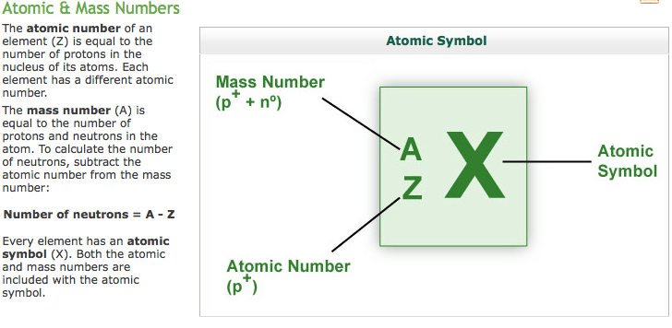
Module 4: Hazards in the Work Environment
Physical Agents
1) Pressure & Temperature
2) Noise & Vibration
3) Radiation

Chemical Agents
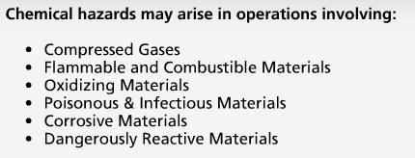
Examples for each:

- Compressed Gases:

- Flammable and Combustible Materials:
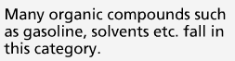
- Oxidizing Materials:
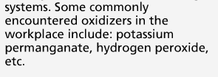
- Poisonous & Infectious Materials:
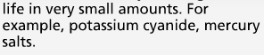

- Corrosive Materials:
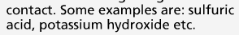
- Dangerously Reactive Materials:
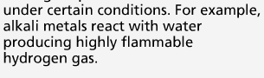
Biological Agents
Food poisoning, rabies, tuberculosis and hepatitis are some of the infections caused by biological agents.
These include: bacteria, fungi, viruses and other micro-organisms and their associated toxins
Ergonomic Stresses
Ergonomics can be defined as the science or study of work. It is a way of designing a work environment to fit people.
Additional Notes
-Noise is a form of irregular vibrations
-The mere presence of a causative agent does not necessarily constitute a hazard. It is hazardous only in certain circumstances.
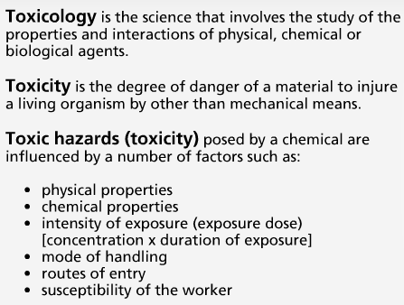
Dose = unit in mg/kg
Exposure = mg/m³ and ug/m³ , ppm, ppb, %
Threshold Limit Value
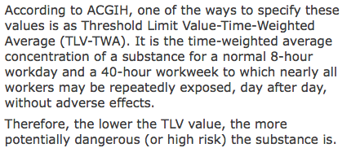
Effects of Toxicants
Classification for the effects of over exposure to toxicants based on: | - Duration of the effect  - Organs affected and physiological action
Duration of effect = 1) Acute: Soon to exposure (fast), brief exposure, high contaminant
2) Chronic: Late in exposure (slow), low and repeated exposure
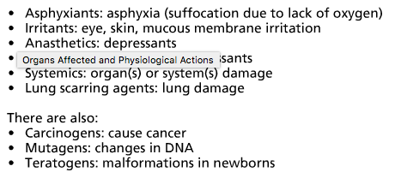
W.H.M.I.S.
(Workplace Hazardous Materials Information System)
The Workplace Hazardous Materials Information System (WHMIS) is a Canada-wide system developed over several years through the collective efforts of Labour, Industry, and Federal, Provincial, and Territorial Governments. Published in January 1988, it became legislation in October 1988.
The system consists of three key elements:
- cautionary labeling of containers of hazardous materials
- provision of Material Safety Data Sheet (MSDS), which provides more detailed information on the hazardous nature of the material
- provision of worker education program
Container Labels
1) Product Identifier (name)
2) Risk Phases
3) Precautionary Measures
4) First Aid Measures
5) Refer to the MSDS (Material Safety Data Sheet)
- MSDS contains:
- Properties
- Potential hazards
- Safe use
- Emergency procedures

6) Supplier Identifier
Workplace Hazardous
GHS
The symbol for a potent carcinogen, one of the new symbols implemented by the GHS for substances hazardous to the human health

The Globally Harmonized System (GHS) for Hazard Classification and Labelling
Systems similar to WHMIS (for hazard communication) exist in other countries.
In 1992, the United Nations Conference on Environment and Development (UNCED) agreed to develop a Globally Harmonized System (GHS) for hazard classification and labelling. It is anticipated that such a system will facilitate safe use of chemicals and reduce trade barriers.

Some of the anticipated changes are:
- Inclusion of consumer, transport and workplace sectors rather than workplace only.
- Inclusion of all chemicals except pharmaceutical and cosmetic products intended for consumer use.
- Hazard classification format in the MSDSs.
- Hazard communication format in the labels.

Roles of workers

- Suppliers: provide hazard information through labels and MSDS on all controlled products/containers of controlled products.
- Employers (Supervisors): ensure WHMIS labels, identifiers and MSDSs for all containers of controlled products. Employers also ensure availability and accessibility of MSDS information to employees and provide effective worker training to ensure understanding among employees of the labels, MSDSs, and precautionary measures for hazardous materials in their workplace.
- Employees: handle controlled products safely and inform supervisors of damaged/missing labels and missing MSDS information.
Regulators: develop and administer WHMIS legislation.

Additional Notes
- Confined space hazards arise due to oxygen deficiency
- A causative agent is classified as hazardous in certain circumstances such as: high intensity
LABELS WITH MEANING
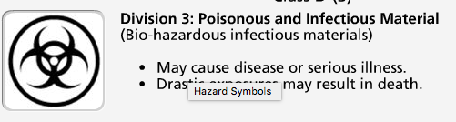
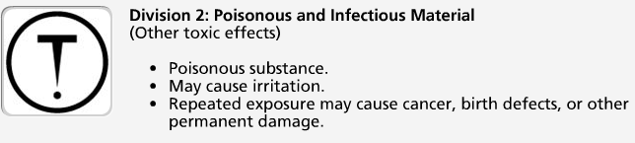
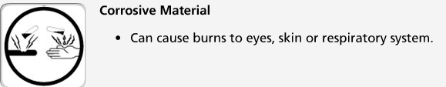
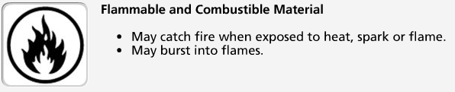
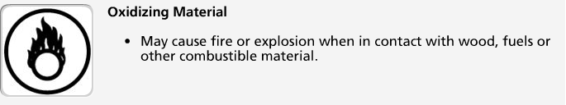
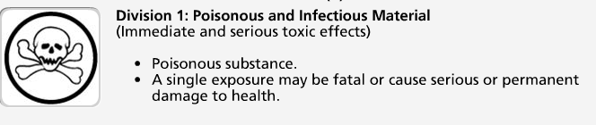
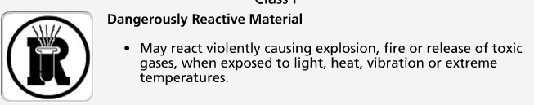
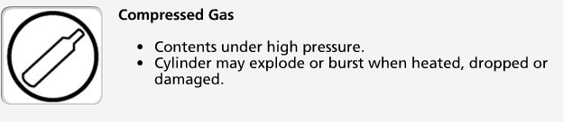
Module 5: Air and Water
Atmosphere
The mixture of gases extending from the Earth's surface. It is divided into several distinct layers (troposphere, stratosphere, etc.), each separated by a region known as a pause (e.g., the tropopause separates the troposphere and the stratosphere). While each layer can be related to a particular altitude region, the criterion for separation is actually based on temperature variations.
The atmosphere is a layered structure divided into layers according to a variety of criteria such as gradually changing:
- Altitude  - Pressure  - Temperature | - Electrical nature  - Chemical composition and concentration
Dry air consists of 21% oxygen and 78% nitrogen plus traces of other substances that are both natural and human-made.

Major components of air:
- Nitrogen (N₂)
- Oxygen (O₂)
- Water (H₂O)
- Carbon dioxide (CO₂)
Some minor components of air:
- Carbon monoxide (CO)
- Ozone (O₃)
- Oxides of Sulfur (SO_{x})
- Oxides of Nitrogen (NO_{x})

The burning of fossil fuels
- to generate energy
- transportation
in industrial processes that use a great deal of energy sources
These elements responsible for the presence of minor components. That is, they are the major sources of human-created air pollution.
Complete combustion (enough Oxygen) of fossil fuels:
CO₂ + H₂O
Incomplete combustion (NOT enough Oxygen) of fossil fuels:

CO
  - Other sources of CO: volcanoes, forest fires, and combustion of organic matter
  - Effect of CO: decrease in athletic performance, cardiac problem, can’t use Oxygen
Ozone (O₃) : in stratosphere, protects Earth from harmful UV
Ground-level ozone produced from:
1) Photochemical reactions between volatile organic compounds (VOCs) released in automobile exhaust
2) Oxides of nitrogen (NOx) in sunlight
3) Arc welding
Effect of Ground-level O₃:
1) Damaged biological tissues and cells
2) Reduced lung function
3) Breathing difficulties
4) Itchy/Burning/Watery eyes
Oxides of Sulfur SO_{x} released from:
- Mainly, during processing (smelting) of mineral ores
- Combustion of fossil fuels (coal, petroleum)
- Industrial processes (ex: pulp and paper production, petroleum refining) (SO₂ and SO₃)
- *** SO₂ ₌ most commonly found from volcanoes
- Reactions from atmosphere sulphuric acid (H₂SO₄) and sulphate (SO₄²⁻)
Effect of Oxides of Sulfur SO_{x}:
- Problems breathing (especially ppl w/ asthma)
- Respiratory illnesses
Oxides of Nitrogen NO_{x} released from:
- A LOT:
- 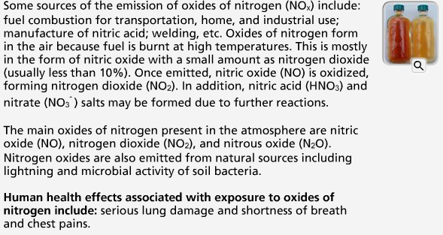
Effect of Oxides of Nitrogen NO_{x}:
- Serious lung damage
- Shortness of breath
- Chest pains

Risk Assessment
In order to assess the health risks due to air pollutants, we require exposure and effects assessment.

- Exposure assessment: estimates concentrations using chemical measurements.
- Effects assessment: relies on toxicity testing (estimates of exposure toxicity) and computer models to extrapolate data from human population, animal, and bacterial toxicity studies. Quantitative analysis of epidemiological, toxicological and exposure data that are based on the accurate scientific evidence estimates exposure toxicity and risk.

Measuring Exposure

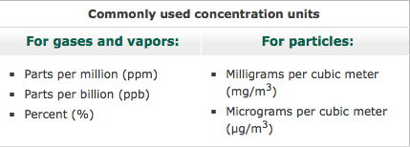

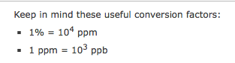 KNOW THIS CONVERSTION

Threshold Limit Values

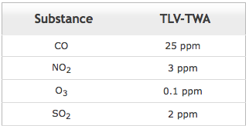

Control Strategies

The North American Free Trade Agreement (NAFTA) obliges all the three signatories to enforce environmental laws. There is a move in all the three nations toward tougher and thorough reporting of releases of pollutants to the environment. In Canada, National Pollutant Release Inventory (NPRI) is a publicly accessible database of pollutants released to the Canadian environment.

Among the global initiatives is the establishment of the International Register of Potentially Toxic Chemicals (IRPTC). It is a computer-based database that:
- Identifies the potential hazards of using chemicals and to make people aware of them.
- Provides access to information regarding production, distribution, release and disposal of hazardous chemicals.
- Includes information on environmental and health effects of such chemicals.

Extra Notes:
SO_{x} represents:
a) |  |  | Mixture of SO₂ and SO₃
  Some sources of emission of the oxides of nitrogen include:
  a) | Welding
  b) | Burning of coal
  c) | Microbial activity of soil bacteria
  d) | All of the answers apply right answer
 | 16. Hydrogen bonds are:
 | a) | Intramolecular attractive forces
 | b) | Intermolecular attractive forces right answer
  19. In the case of air pollutants, exposure toxicity and risk are estimated by quantitative analysis of:
  a) | Epidemiological data
  b) | Toxicological data
  c) | Exposure data
  d) | All of the answers apply right answer

Risk characterization integrates the exposure and effects components to estimate the risk.
Dipole
A pair of electric charges of equal, but opposite, magnitude, separated by a finite distance. Dipoles are characterized by dipole moments, which are a measure of the magnitude of the charge and their intervening separation.
Capillary action
A mechanical force that combines surface tension (intermolecular forces between same or like molecules) and adhesion (intermolecular forces between unlike molecules). Adhesion induces an upward force on the surface of a liquid while surface tension holds the surface intact, causing the whole liquid to move up a small tube (capillary).
Water (H₂0)
- Polar covalent bonds = O- strong attraction = O is (-)ve & H is (+)ve
- Partial charges (water attracts other water = weaker than polar covalent bonds ) Unique properties

Water is a good solvent because…:

▪ High Polarity
▪ Hydrogen bonding ability

It is an excellent solvent for:
- Ionic (e.g., table salt) the ions are separated from the solid and caged (solvated) by polar water molecules, thus keeping them in solution.
- Polar covalent (e.g., sugar, ethanol and glucose) Polar covalent compounds dissolve in water by the formation of hydrogen bonds.
- Non-polar (e.g., oxygen) compounds

Thermal Properties
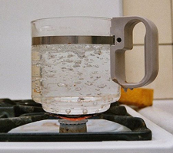
The presence of hydrogen bonds high boiling point, specific heat and heat of vaporization. A portion of the heat = from breaking the hydrogen bonds.
Specific heat is defined as the amount of heat energy required to increase the temperature of 1 g of a substance by 1°C.
High specific heat of water:
- Regulates and stabilizes the temperatures (geographical) regions and organisms
- Allows planet to support life.
Heat of vaporization: quantity of heat required for the conversion of 1 g of a liquid entirely into its vapor at a constant temperature.
- Helps in regulating the temperature of our body
- Powers the winds and storms of our planet

Water Density

Ice has a hexagonal open. When ice melts, the open spaces are filled with liquid water, causing the crystal structure to break down reduction in volume for the same mass and hence an increase in density (density = mass/volume).

The higher density :
- Floating of ice on water
- Survival of aquatic life during winter
- Nutrient turnover in bodies of water
- Formation of pebbles, soil and sand
- Bursting of frozen water pipes

Surface Properties
The high surface tension and capillarity of water is due to the presence of hydrogen bonds. Water is the liquid with the highest surface tension. Plant debris rests

Capillary action (also due to high surface tension) makes water in soil available to plants.

Extra Notes

1. Hydrogen bonds in water are:
a) | Stronger than ionic bonds
b) | Stronger than covalent bonds
c) | Of the same bond strength as covalent bonds
d) | None of the answers apply right answer
  7. Glucose (a polar covalent compound) dissolves in water by the formation of a:
  a) | Covalent bond
  b) | Hydrogen bond right answer

Module 6: Household Products
^{*Hydrophilic Polar}
^{Hydrophobic Non-polar}
Polar attracts Polar, Non-polar attracts Non-Polar
Water must be made to spread and thus wet surfaces effectively, i.e., its surface tension must be reduced.This is achieved by surfactants.
- Soaps & detergents = surfactants
Surfactants:
- water-soluble
- surface-active
- composed of a hydrophilic/polar (water-soluble) head
- hydrophobic/non-polar (fat-soluble, water-hating) tail
- Hydrophilic = stable (solubilized in water)
- Hydrophobic (long chain hydrocarbon) = stable (surrounded by other organic groups)

Classes of Surfactants (after dissociation in water):
- Anionic surfactants (-) charge = soaps, detergents
- Cationic surfactants (+) charge
- Non-ionic surfactants no charge = detergents
- Amphoteric surfactants both (-) & (+) charge.

Soaps (anionic (-) surfactants):
long hydrocarbon tails of fatty acids
polar heads of sodium or potassium salts of fatty acids (found in fats and oils of animals and plants)

ADVANTAGE:
1) natural and renewable sources
2) Biodegradable
DISADVANTAGE:
- Formation of soap film (or scum) in water containing Ca²⁺ and Mg²⁺ ions (hard water)
- The calcium and magnesium ions calcium and magnesium salts of fatty acids = insoluble in water and impair the surfactant properties of soap because the amount of soap available for cleaning is reduced. Soap scum is difficult to rinse + visible
- Poor adaptability to diversity of fibers, washing temperatures and water conditions.
- Clog sewage systems (gelling properties)

Composition and Limitations of Detergents
Detergents (anionic or non-ionic surfactants) made from petrochemicals.

^{ADVANTAGES}
- Detergents are less affected by calcium and magnesium ions in water, thus acting as better cleaning agents and almost eliminating the film formation.
- Detergents perform well under diverse conditions such as adaptability to diversity of fibers, washing temperatures and water conditions.
^{DISADVANTAGES}
- Detergents are made from non-renewable petroleum-based oils.
- Majority of detergents are not biodegradable.
Thermal interaction helps dissolve grease
Mechanical interaction helps release grease
Laundry detergents made from:
- Surfactants (to bind and suspend grease and dirt in the washing water)
- Builders (to remove Ca²⁺ and Mg²⁺ from hard water and soil)
- Bleaching agents to remove stains and kill bacteria
- Enzymes to catalyze the degradation and elimination of some stains
- Miscellaneous chemicals such as foam stabilizers, fabric brighteners, fragrances, corrosion inhibitors etc. are added in small quantities.

Environmental Impact

- The Safer Detergent Stewardship Initiative (SDSI) program of the U.S. Environmental Protection Agency (EPA) recognizes corporate environmental leaders using safer surfactants which break down quickly into non-polluting chemicals and thus protect aquatic life.

Recent Trends
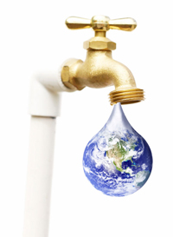 | The present trend is to develop home and fabric care products that:  - Contain surface protectors or modifiers that repel soil and stains more effectively.  - Deliver active ingredients in a controlled way.  - Are effective in cold water.  - Contain natural or naturally derived ingredient(s).  - Do not contain chemicals of concern with respect to toxicity.  - Generate less carbon dioxide during production (smaller environmental footprint).

Notes
1. In order for water to wet a surface effectively, it is necessary to reduce its:
a) Boiling point
b) Freezing point
c) Density
d) Surface tension
2. Surfactants are:
a) Water soluble
b) Surface active agents
c) Composed of a hydrophilic head and a hydrophobic tail
d) All of the answers apply

5. Laundry detergents are formulated by mixing many ingredients in order to:
a) Make them colorful
b) Perform diverse functions
c) Inflate the price
d) None of the answers apply

7. Which of the following statements is false?
a) Calcium and magnesium salts of fatty acids are insoluble in water
b) Surfactants are used to decrease the surface tension of water
c) Soaps almost eliminate scum formation because they are less affected by ions causing water hardness
d) None of the answers apply

10. Hard water contains certain alkaline earth cations.
a) True
b) False

Reducing agent
A substance that reduces (i.e., donates electrons) another substance and in turn gets oxidized (i.e., accepts electrons).
Oxidizing agent
A substance that oxidizes (i.e., accepts electrons) another substance in a chemical reaction and in turn gets reduced (i.e., donates electrons).

Microcapsules in:
1) Shampoos
Lipsticks
Face creams
Toothpastes

Active ingredients delivered by microcapsules rupture on the applied surface (e.g., skin) due to:

1) Rubbing
2) Presence of moisture
3) Change in pH
4) Presence of naturally occurring bacteria

SHAMPOO (-) = Anionic Surfactant Foam to lift oil and dirt from scalp
CONDITIONER (+) = Cationic Surfactant rinse out shampoo and provide softer, manageable hair

Some influencing factors include:
- Aging population  - Changing attitudes of men | - More women in the workplace  - Concerns about exposure to ultraviolet radiation

3 steps to curling hair:

1) Treat hair w/ reducing agent (electron donor) that breaks certain covalent bonds

2) Shape hair

3) Treat hair w/ oxidizing agent (electron acceptor), dilute hydrogen peroxide, to reform broken covalent bonds in new shape

2 steps to coloring hair:

1) Oxidization of natural hair pigment w/ bleach colorless hair
2) Application of organic, synthetic dye to get desired colour

Dye contains:
-surfactants
-hydrogen peroxide
-ammonia
* Reduce damage and smell of ammonia w/ ammonium carbonate

Major developments for hair coloring:

-more hair colors
-improved delivery system to enhance the adhesion of hair color to the hair
-more effective conditioners to neutralize the effects of dye chemicals

MOISTURIZERS Increase water content of skin

Active ingredients:

1) Humectants: Absorb moisture and hold it in the skin. (ex: Glycerin, urea)

2) Emollients: Lubricate and smooths skin. (ex: Lanolin, mineral oil)

3) Miscellaneous: Antioxidants, fragrances, minerals, plant extracts, vitamins

SUNSCREENS

- Inorganic: titanium dioxide and zinc oxide reflect and scatter UV light
- Organic: absorbs UV light and dissipates it as heat

HIGH SPF = Organic + Inorganic compounds
Effectiveness = ability to block UVB rays (skin burns)
SPF = Sun Protection Factor
Higher SPF, better protection against UVB rays

Protection depends on:
- Type of skin
- Activities
- Amount + frequency of application
- Solar intensity
- Amount absorbed into the skin

Safety in the Sun
In an attempt to inform the consumers, the level of UV-A protection in sunscreens, the US Food and Drug Administration (US FDA) is proposing a four-star rating system to be displayed near the SPF rating on the label.
1 star = low UV-A protection, 4 stars = highest UV-A protection

COSMECEUTICALS
The term cosmeceuticals = cosmetics containing ingredients which may affect the structure or any function of the body like pharmaceutical ingredients.
Ex: alpha hydroxy acids AHA: reduce signs of aging, sun-damaged skin and wrinkles by breaking down and lifting off part of the top layer of dead skin cells in order to get rid of some surface damage and accelerate growth of living cells = cosmeceuticals.

With a doctor's prescription and supervision
-Botox (for a more youthful look)
-Vaniqa (to eliminate unwanted facial hair)
-Propecia (for bald men).

Perfumes
Perfumes are alcoholic solutions of organic compounds with pleasant odours (fragrant compounds). Large variety of natural and synthetic compounds create fragrances for perfumes. In creating perfumes, the ingredients are blended based on their molecular size and volatility.

Deodorants
Odors may originate from the conversion of certain compounds (present in the perspiration) to unpleasant odors by bacteria. Thus the effective chemical ingredients in such products are antibacterial agents and perfumes.
Cosmetics
Facial cosmetics such as lipstick and mascara generally contain oils, waxes, pigments and perfumes. Lipstick manufacturers blend various proportions of oils, waxes and emollients (to soothe the skin) to formulate the base for their unique brand. Fragrances, pigments, preservatives, antioxidants and a variety of other ingredients are then added.
A recent testing of a number of brands of lipstick by the US FDA (United States Food and Drug Administration) has shown the presence of low levels of lead.

Notes:
1. The oxidizing agent generally used during hair curling is:
a) H2O
b) H2O2
c) O3
d) H3O+

2. Fragrances for perfumes are created by using:
a) Naturally occurring compounds only
b) Synthetic compounds only
c) Gases only
d) None of the answers apply

7. In creating perfumes, the ingredients are blended based upon their:
a) | Molecular size only
b) | Molecular size and volatility
c) | Volatility only
d) | Color

10. The impact of household cleaners on the environment is minimized because these products are formulated:
a) | Free of chemicals
b) | With natural ingredients only
c) | To change into environmentally friendly ingredients immediately after use
d) | None of the answers apply
7. Which of the following statements is false?
a) Laundry detergents contain builders to bind and suspend grease and dirt
b) Laundry detergents contain bleaching agents to remove stains and bacteria
c) Laundry detergents contain surfactants to bind and suspend grease and dirt
d) All of the answers apply
Module 7: Drugs and Medications

Functional group
A specific grouping of atoms that can be considered the chemically functioning part of the molecule. More importantly, though, is that the properties (i.e., how they behave both physically and chemically) of such groups are transferable from one molecule to another.

Single bond
A covalent bond in which one pair of electrons is shared by the two atoms participating in the covalent bond.

Double bond
A covalent bond between two atoms involving the sharing of two pairs of electrons (a total of four electrons).

characteristics of carbon

- Covalent single, double and triple bonds with some other elements, including carbon.
- Covalent bonds with other carbon atoms to build chains and cyclic structures.
- Covalent bonds with elements such as hydrogen (H), nitrogen (N), oxygen (O) and halogens.
Ex:

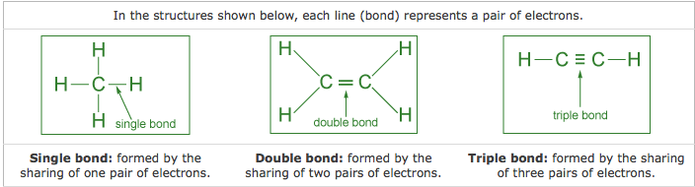

Cyclic structures, 5- or 6-membered rings = common.

The hexagonal (6 carbon atoms) ring with 3 single + 3 double bonds is called a benzene ring.

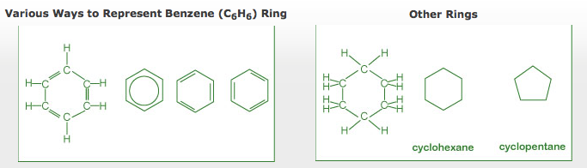

  - Benzene: 6 C & 6 H 2) Cyclohexane 6 C & 12 H

Functional groups are responsible for:
1) Their action
2) Rate of Reuptake
3) Time of residence of drug in the body
4) Chemical function of a molecule

Functional Groups:

- Alcohol: (-OH)

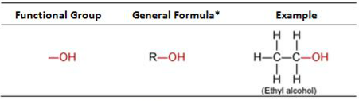

- Aldehyde: (O - - C-H)

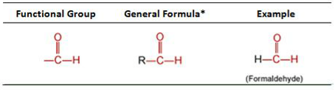

- Carboxylic Acid: (O - - C - OH)

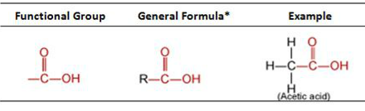

- Amine: (NH₂ = N –H –N )

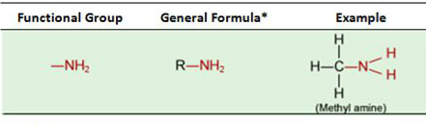
- Ester: (O - - C – O – R )
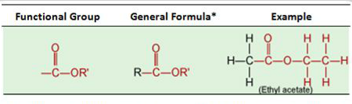
- Ether: (- O -)

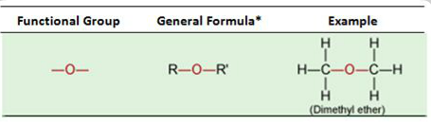
- Ketone: (-C- - O(@TOP)- )

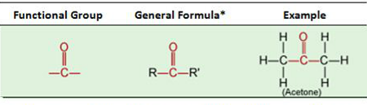
Notes

Carbon = non-metal
Carbon-Carbon bond = covalent

1. The carbon-carbon bond in organic compounds is:
a) Ionic
b) Carbonic
c) Electrovalent
d) None of the answers apply

8. A compound with the formula CH3 (CH2)2CH2COOH contains:
a) Four carbon atoms
b) Eight hydrogen atoms
c) One oxygen atom
d) One functional group

Drugs and Medications

Overview
From the Sumerians (2200 BC) to the present, the discovery and usage of drugs has gone through a number of phases such as:
- Medicinal preparations and concoctions from plants, minerals and animal sources.
- Isolation and the use of plant ingredients as medications.
- Synthesis and testing of a variety of chemicals as potential cures for ailments.
- New areas of research into marine plants and organisms as potential drugs.
- Molecular modeling in designing drugs.

Antibiotics
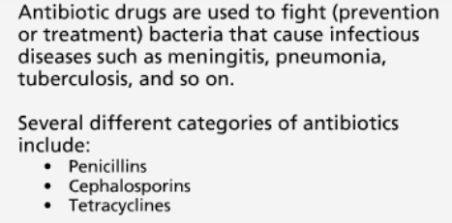
Antibiotics kill bacteria, not viruses. Fight/prevent/treat
Destroy/inhibit growth of bacteria
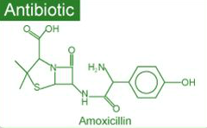

Alter/inhibit structure:
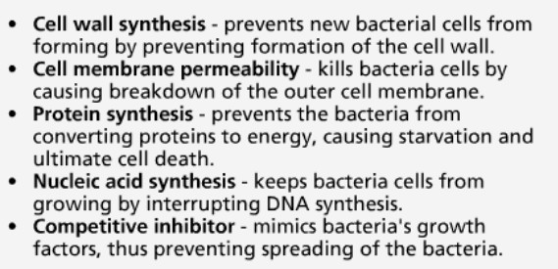

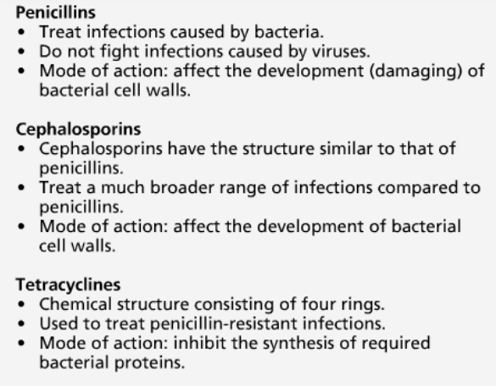
Superbugs = resistant to antibiotics

Antiviral Drugs
Antiviral drugs are used to treat (cure or control) viral infections such as:
  - Flu
  - Polio
  - Herpes
  - AIDS (Acquired Immune Deficiency Syndrome).

Prevention through vaccination
When a vaccine (consisting of inactivated virus) is injected, antibodies to fight off a virus are developed and stored in the body. The stored antibodies become available to fight future infection.

Use of antiviral drugs
- Nucleoside derivatives inhibit the synthesis of viral DNA, thus preventing the virus from spreading.
- Protease inhibitors, on the other hand, interfere with the viral protein formation, thus preventing their reproduction.
- A three-drug cocktail consisting of different nucleoside derivatives and protease inhibitors has shown considerable promise in the treatment of AIDS. This triple cocktail treatment is also known as Highly Active Antiretroviral Therapy (HAART). The success of the therapy is probably due to the cocktail's ability to disrupt the viral replication at different stages. It is important to note that the therapy is very expensive and patients must adhere to their dosing schedule.
Problems w/ multiple drug therapy:
  - Moderate effectiveness
  - Lack of response in some cases
  - Serious to severe side effects
  - Drug resistance by the virus
Fight AIDS with:
  - Viral entry inhibitors (i.e., the drugs that will prevent HIV from attaching and consequently entering into the cell)
  - Vaccines
Chemotherapeutic Agents:
- Alkylating Agents: introduces defects in DNA to prevent rapid cell mutation, due to their high reactivity
Affects the growth of normal cells mutation
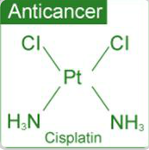
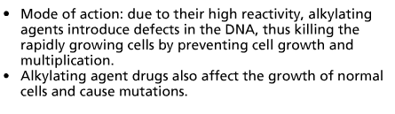
- Antimetabolites:
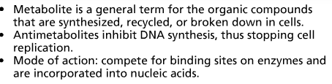
- Topoisomerase inhibitors:
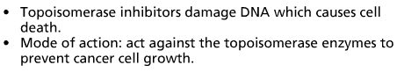
4) Hormone Therapy:
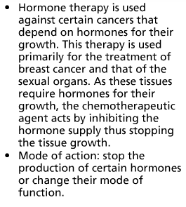
Cancer Mutation in DNA cell spread through blood stream and lymphatic system

Antidepressants
Lack of serotonin Neurotransmitter
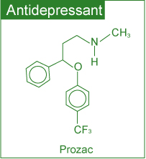
Commonly used antidepressants include:
- Selective Serotonin Reuptake Inhibitors (SSRIs) (e.g. Prozac, Paxil and Zoloft)
- Monoamine Oxidase Inhibitors (MAOIs) (e.g. Nardil, Marplan and Parnate)
- Serotonin and Norepinephrine Reuptake Inhibitors (e.g. Effexor)
- Norepinephrine and Dopamine Reuptake Inhibitors (e.g. Welbutrin)
- Tricyclics (e.g. Norpramine, Pamelor and Tofranil)

SSRIs target: serotonin levels only
Tricyclics affect: the brain levels of other neurotransmitters (including serotonin).

Anti-Inflammatory Drugs
Inflammation from: rapid transport of blood proteins and other substances to a damaged tissue site or an area under attack by a foreign organism.
Certain steroids are used as potent anti-inflammatory drugs suppress the inflammatory responses of the body, thus reducing inflammation.
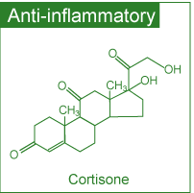

Over the Counter Drugs

OTC= No prescription needed, still some RISKS

Famous one: Aspirin

Non Prescription Drug Manufacturers Association in US says: 600 + OTCD

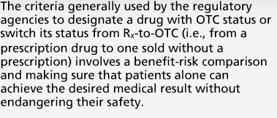

Aspirin helps with…

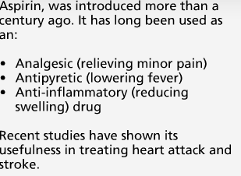

Aspirin’s effectiveness by reducing prostaglandins and thromboxanes …:
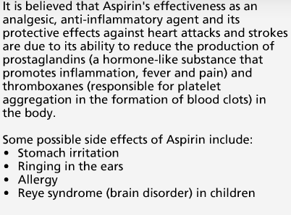

Drug Delivery Systems

Active pharmaceutical ingredient (API)

drug delivery advantages:
- User convenience
- Improved drug performance
- Better patient compliance
Methods include:
- Pulmonary delivery: The system is noninvasive and facilitates the rapid absorption of the drug on the large surface area of the lungs followed by rapid desorption into the bloodstream.
- Skin absorption: Skin patches are being used to deliver the medication via skin absorption.
- Nanocrystals: This method reduces the drug particle size to nanoscale (<400 nm) making it more soluble in body fluids.

Effects & Trends

Environmental Effects of Pharmaceuticals
Some of the effects observed include:
- Feminization of male fish due to estrogenic compounds: The signs of feminization in male fish have been concluded as a response to estrogen (in birth control pills) exposure.
- Slow development of fish and frogs due to certain antidepressants: Profound effects on spawning and other behaviors in shellfish can occur with antidepressants such as Selective Serotonin Reuptake Inhibitors (SSRIs).

Recent Trends in Pharmaceutical Development
- A shift from blockbuster drugs (drugs that work for a large number of patients) to personalized medicine: In personalized medicine, therapies are catered towards genetic profiles of patients and their diseased cells.
- Exploring marine organisms in an attempt to obtain new compounds with therapeutic potential: Several of these compounds are being investigated as potential anticancer agents, analgesics and anti-inflammatory drugs.

Medications & Health
In order to reduce risks, it is strongly recommended that all individuals:
- Read drug labels carefully.
- Learn about the warnings of all drugs taken.
- Inform health care providers of all prescription and OTC drugs and dietary supplements taken.
- Keep a record of all medications taken.

Notes

Viral infections:
1) Flu
2) Polio
3) Herpes
4) AIDS (Acquired Immune Deficiency Syndrome)

Bacterial infections:
- meningitis
- pneumonia
- tuberculosis

Apsirin Reye’s syndrome

4. Which of the following is a viral infection?
a) | Acquired Immune Deficiency Syndrome
b) | Depression
c) | Reye’s syndrome
d) | All of the answers apply

5. Several different categories of antibiotics include:
a) | Penicillins
b) | Cephalosporins
c) | Tetracyclines
d) | All of the answers apply

1. The cyclohexane ring contains:
a) | Five carbon atoms
b) | Twelve hydrogen atoms
c) | Two double bonds
d) | None of the answers apply

9. Aspirin is used as an:
a) | Antipyretic
b) | Antibiotic
c) | Antidepressant
d) | Anticancer drug

10. Reye’s syndrome is a possible side effect due to the consumption of:
a) | Trans fats
b) | Excess salt
c) | Aspirin
d) | All of the answers apply
12. The number of hydrogen atoms in a benzene ring is:
a) | 4
b) | 12
c) | 6
d) | 10

1. Tetracyclines act as antibiotics because these drugs:
^{a)} Inhibit the synthesis of required bacterial proteins
^{b)} ^{Consist of four rings}
^{c)} Are more expensive than Penicillins
^{d)} ^{None of the answers apply}

9. Alkylating agents are used as chemotherapeutic agents.
^{a)} ^{False}
^{b)} ^{True}
Module 8: Some Environmental Concerns

A specific grouping of atoms

Fossil fuel
Fuel that is believed to originate from the natural decomposition of organisms and trapped in sedimentary rock. Such fuels consist of carbon containing compounds such as coal, petroleum and natural gas.
Acid rain
Rain that is more acidic than expected. The increased acidity is attributed to oxides of sulfur and nitrogen, which dissolve in rain droplets and react with the water to form strong acids.

Acid Rain
When atmospheric carbon dioxide dissolves in water it forms carbonic acid.
CO₂ (g) + H₂O (ℓ) H₂CO₃ (aq)
The acid formed dissociates partially generating small amounts of hydrogen ions.
H₂CO₃ (aq) H⁺ (aq) + HCO₃⁻ (aq)

The hydrogen ions formed are responsible for the weakly acidic nature of rain.

The pH Scale
pH < 7: solution is acidic
pH > 7: solution is basic
pH = 7: solution is neutral

Vinegar acid (pink)
Water = Neutral (purple)
Detergent base (green)

↑ Acidity = ↓ pH = ↑ Solubility

pH of rain (as well as fog, dew and snow) under normal atmospheric conditions = 5.3.
Field measurements in many areas, on the other hand, show much lower pH values (4.1- 4.5).
Higher acidity (lower pH) is due to the reactions of
NO_{x} and SO_{x} present in the atmosphere.

2 SO₂ (g) + O₂ (g) + 2 H₂O (ℓ) 2 H₂SO₄ (aq)
H₂SO₄ (aq) H⁺ (aq) + HSO₄⁻ (aq)
HSO₄⁻ (aq) H⁺ (aq) + SO₄²⁻ (aq)
4 NO₂ (g) + O₂ (g) + 2 H₂O (ℓ) 4 HNO₃ (aq)
HNO₃ (aq) H⁺ (aq) + NO₃⁻ (aq)

Limestone
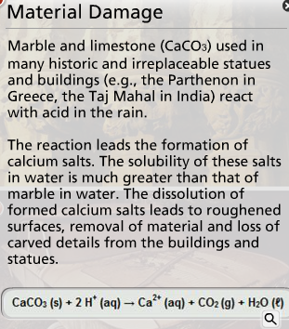

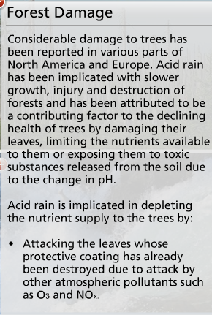
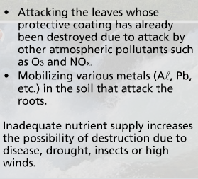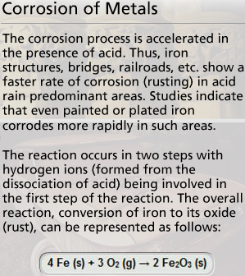

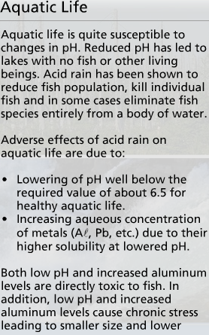

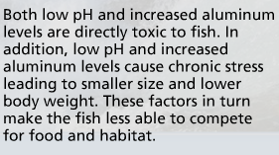

Reduction of SOx:

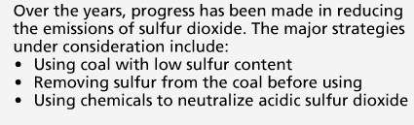

Reduction of NOx:

Using cleaner energy source (alcohol + hydrogen) in TRANSPORTATION:

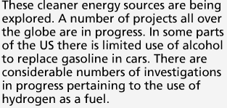

Using alternate energy (hydroelectric, nuclear, wind):

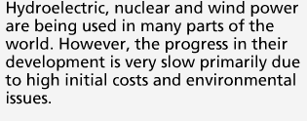

Notes:

2. Weakly acidic nature of rain is due to dissolved:
a) | CO (g)
b) | CO₂ (g)
c) | O₂ (g)
d) | N₂ (g)
1. The weakly acidic nature of rain is due to dissolved:
a) | Ozone
b) | Ammonia
c) | Methane
d) | None of the answers apply

7. The corrosion product of iron has the formula:
a) | O₂
b) | Fe
c) | Fe₂O₃
d) | CaCO₃

10. The solubility of lead at a pH of 7.0 is higher than at a pH of 1.2.
a) | True
b) | False

8. The reaction of limestone with H2SO4 (aq) generates gaseous:
a) Sulfur dioxide
b) Carbon monoxide
c) Sulfur trioxide
d) None of the answers apply

Global Warming
= increase in the Earth’s average temperature result of increased absorption by the atmosphere of infrared (IR) radiated back from Earth's surfaceincrease in concentration of [greenhouse gases] that trap heat in the atmosphere.

Carbon dioxide (CO₂) | Methane (CH₄) | Nitrous oxide (N₂O) | Fluorinated gases
It enters the atmosphere due to the burning of fossil fuels (oil, natural gas, and coal), waste materials, and as a result of other chemical reactions. | Main sources of emission are the production and transport of fossil fuels, livestock, agricultural practices and organic waste decay. | It is emitted during agricultural and industrial activities as well as during the combustion of fossil fuels and waste materials. | These fluorine containing compounds are emitted from a variety of industrial processes and are sometimes called High Global Warming Potential (GWP) gases.

It is estimated that the temperature of the atmosphere may increase anywhere from 1.5 ºC to 3.5 ºC during the next fifty years

Environment Effects

Climatic changes:

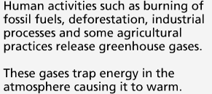

Changes in sea level due to melting of polar ice caps:

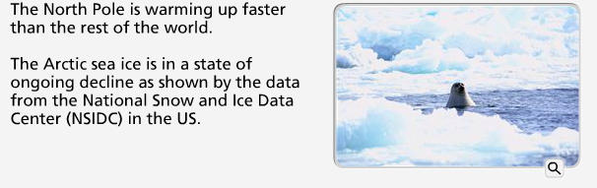

Possibility of droughts and increased frequency of heat waves due to warming:

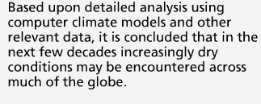

Changes in ecosystem:

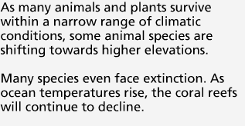

Effects on Human Health:

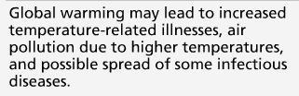

Control Strategies
Reduction in CO₂ emissions: The governments all over the globe are working to reduce their country's carbon dioxide emissions by:
- Promoting that alternate non-fossil sources such as hydroelectric, solar, nuclear and wind are developed and used
- Capturing the carbon dioxide generated by burning fossil fuels
- Supporting new fuels and technologies (like electric cars) to reduce carbon dioxide emissions from transport
- Setting 'carbon budgets' to cap overall carbon dioxide emissions.
Encouraging energy conservation: This will lead to lesser energy consumption and hence lower production and reduced emissions.
Using carbon dioxide sinks: A carbon dioxide sink is any resource (natural or artificial) that captures and stores atmospheric carbon dioxide.
Natural carbon dioxide sinks: include forests, oceans and soil. Thus replanting forests is being encouraged globally.
Some of the artificial carbon dioxide sinks being studied involve removing carbon dioxide from the atmosphere and storing it in rocks, injecting it deep into the oceans or trapping it via chemical reactions.

IPCC 1988

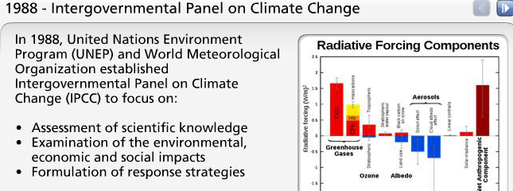
IPCC 2007

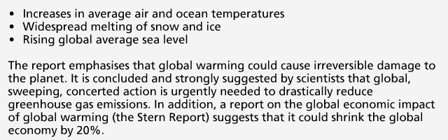

Kyoto Protocol 1997

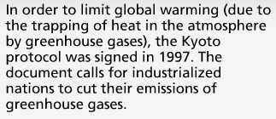

Today’s Kyoto Protocol
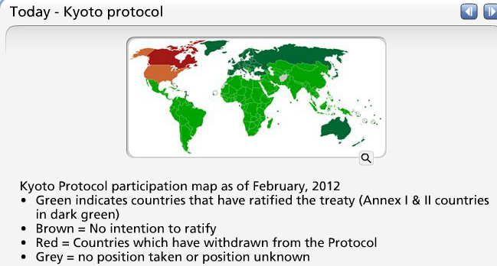

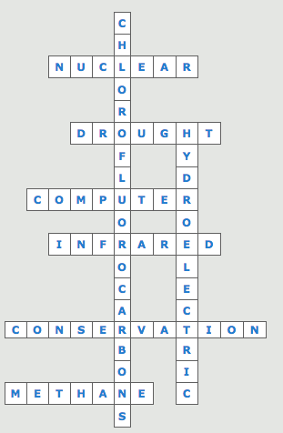

Notes
Greenhouse gases:

chlorofluorocarbons
water vapor
carbon dioxide
methane
nitrous oxide

2. One of the gases responsible for global warming is:
a) | CO
b) | N₂O
c) | N₂
d) | O₂

Ozone Depletion
Ozone plays a double role in our environment:
- In our immediate atmosphere, it acts as an air pollutant contributing to photochemical smog
- In the stratosphere (in conjunction with oxygen), it filters the solar ultraviolet (UV) radiation, thus protecting us against its harmful effects
In our immediate atmosphere exposure to ozone may occur in operations involving:
- High-intensity UV light such as mercury vapor lamps, plasma torches, glass blowing, etc.
- High-voltage electrical equipment
- Welding
In all the above operations, the interaction of high energy with oxygen in the surrounding atmosphere leads to the formation of O₃:
3 O₂ (g) + Energy 2 O₃ (g)

Ozone Formation
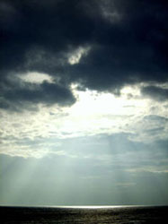
Sunlight shining through clouds in Northumberland, UK (Source: Christopher Down, neuro, Wikimedia)
In the stratosphere, oxygen and ozone interact with energy (ultraviolet radiation) from solar radiation to form a dynamic system involving the following reactions:
When ultraviolet light strikes oxygen molecule, individual oxygen atoms are produced. | O₂ + Energy 2 O
The combination of atomic oxygen with oxygen molecule leads to the formation of ozone. | O₂ + O O₃
The interaction of ozone molecule with ultraviolet light splits it into a molecule of oxygen and an atom of oxygen. | O₃ + Energy O₂ + O
Recombination of ozone molecule with an oxygen atom leads to the formation of oxygen molecule. | O₃ + O 2 O₂
The above processes = ozone-oxygen cycle or Chapman cycle. This constitutes the O₂/O₃ screen that filters out the ultraviolet component of the solar radiation.

Environmental Concern
Ozone stratospheric depletion less efficient filtration of harmful solar UV rays.
Depletion by: 1) natural (water vapour, nitric oxide) & 2) human-made (chlorofluorocarbons, halons) sources
These manufactured chemicals, containing chlorine and/or bromine are called "ozone-depleting substances" (ODS). popularity of these chemicals due to their stability and low toxicity.
Chloroflurocarbons (CFCs) and halons
have been used as:
- Foam-blowing agents  - Solvents | - Fire-extinguishing agents  - Refrigerants
However, their stability and long lifetime (up to several centuries) allows them to reach the stratosphere. molecules + UV light in the stratosphere generation of chlorine and bromine destroy stratospheric ozone.

Effects of Depletion
Increase UV radiation affects:
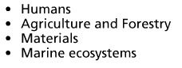
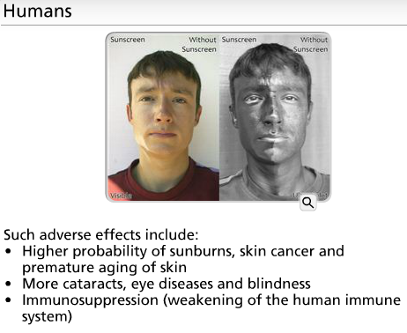
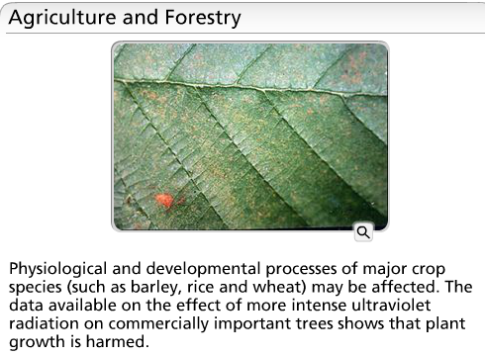

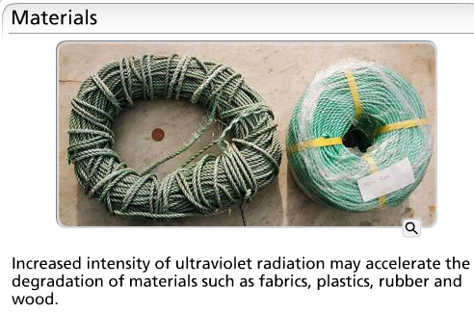

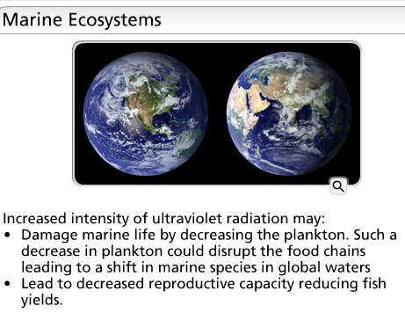

Ozone Depletion

Control Strategies
In North America, the use of chlorofluorocarbons (as propellants in spray cans) was banned in 1978 in response to the threat of ozone depletion. The global response to the threat of ozone depletion came with the signing of the Montreal Protocol (in 1987). It set out to reduce and ultimately ban the manufacture and use of CFCs and other ozone depleting substances.
The international agreement has been effective in reducing risks in the long term; ultraviolet radiation remains a health hazard. In view of this, we as individuals should protect ourselves against it.
Notes
3. The agreement to reduce and ultimately ban the manufacture and use of chlorofluorocarbons goes by the name of:
a) | Basel Convention
b) | North American Free Trade Agreement
c) | Geneva Convention
d) | Montreal Protocol

5. As an air pollutant, ozone contributes to:
a) | Photochemical smog
b) | Acid rain
c) | Global cooling
d) | None of the answers apply

6. Oxygen and ozone interact with solar radiation to form a dynamic system in the:
a) | Chlorosphere
b) | Bromosphere
c) | Iodosphere
d) | None of the answers apply

8. The depletion of stratospheric ozone is caused by:
a) | H₂O vapor
b) | NO
c) | Halons
d) | All of the answers apply

