PHGY 210 – Endocrine Summary

Lecture 1

Endocrinology
- Coordination of Physiological Processes:
Movement, respiration, circulation, digestion, excretion & metabolism
CNS and ES (endocrine system) = 2 major coordinators
- Long Distance Communication:
Releasing cells in endocrine gland release hormones (chem substances) in blood interact w/ specific receptor on distant target cell specific phgy effect

Neuroendocrine Signaling
- Same as all other kinds of endocrine signaling but cells releasing hormones are nerves

Paracrine Signaling
- Signaling within an organ, short distance signaling:
One cell adjacent to another releases hormone interacts w/ receptor on cell
Never really enters systemic circulation

Autocrine Signaling
- Cell releases hormone and also expresses receptors for the hormone

Communication by Hormones (or neurohormones) – 6 steps:
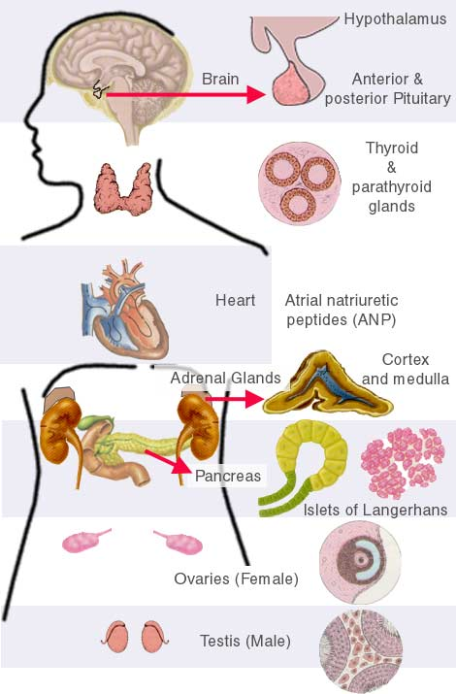
- Synthesis hormone by endocrine cells
- Release them
- Transport to target by blood
- Detection by specific receptor protein on target cells***
- Change in cellular metabolism due to hormone-receptor interactions***
- Removal of hormone often terminates cellular response
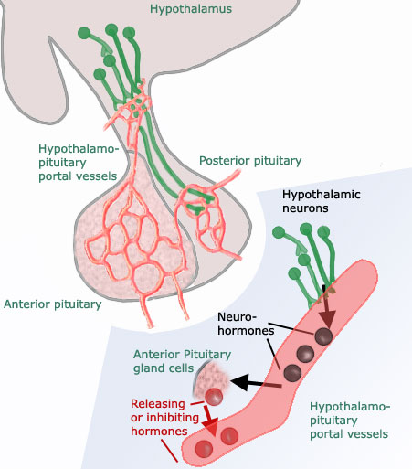
All steps are site for phgy regulation

Classical Endocrine Organs:
- Virtually any cell type in body can send/receive signals

Hypothalamic-Pituitary Signaling
- H-P signaling via blood vessels of pituitary stalk
- Hypothalamic-Hypophyseal Portal System: hypothalamus adenohypophysis (anterior pituitary)
- Hypothalamic neurohormones activate (releasing hormones/factors) or inhibit (inhibiting hormones/factors) activity of 1 of 6 types of hormone-producing cells in anterior pituitary
- Ex: Hypo talks to pituitary through gonadotropin-releasing hormone which tells pituitary to release a hormone which goes to the gonads (cascade effect)

Classes of Hormones Based on Structure
- Glycoproteins, polypeptides, steroids, amines, ionic calcium
- Peptide, glycoprotein or polypeptide: a gene encodes it
- Steroid, amine or calcium: no gene encodes it only genes encode enzymes for their synthesis but it doesn’t encode the hormone itself
- Some may be glycosylated:
Go through protein synthesis naked stretch of aa transport mechanism secretory pathway in form of glycoprotein tree trimmed and modified, etc.
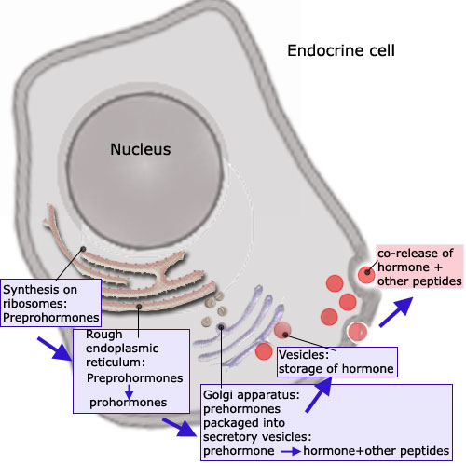
- Ionic Ca: not even a molecule but it acts like a hormone because there’s a Ca sensing receptor & Ionic Ca controls Ca homeostasis

Synthesis of Protein Hormones
- Protein is translated endoplasmic reticulum (ER), produced as a longer version of itself w/ additional N terminal peptide sequence (synthesized: N C terminus)
- Prosequences = tags indicating its going to secretory system
Tags cleaved off during maturation = as it goes into vesicles that release it
When hormone is released – no longer has these sequences attached to it
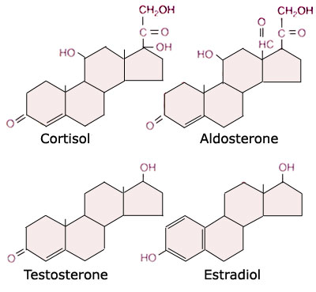

Structure of Some Steroid Hormones
- Same basic 4 ring structure C based structure
- Only thing that differs b/w testosterone & estradiol = methyl group
- First ring of estradiol = aromatic
- Enzyme aromatase that burns methyl group off testosterone into estradiol
Converted locally in males, essential for normal phgy

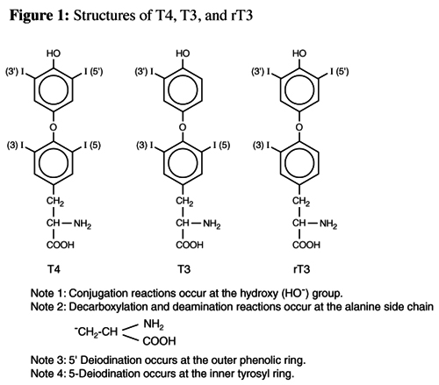
Structure of Thyroid Hormones
- NOT STEROIDS
- Derived from Tyrosine (amino acid)
- T3 or 4 based on # of iodine attached
- Reverse T3 (rT3) is not a thyroid hormone (doesn’t bind thyroid hormone receptor)
- High rT3 = hyperthyroid

Properties of Hormone Receptors:
- Specificity – recognize a single hormone/hormone family = “lock & key” mechanism
- Affinity – binding hormone at its phgy concentration
Receptor w/ affinity for high [hormone] that’s only present in [low] no binding
Recep. w/ affinity for low [hormone] that’s present in [high] a lot binding no control
Want hormone-receptor interactions in tune fluctuate over phgy range of [hormone]
Ex: Estrogens levels are low don’t want to saturated estrogen recep. brain wont know there’s a problem only saturate when levels are high (ex: during menstruation)
- Saturability – finite # of receptors
- Measurable Biological Effect – due to hormone-receptor interaction

Receptor Regulation:
- Up regulated – increasing activity in response to binding of hormone or their synthesis
Childbirth – increase oxytocin levels in uterus
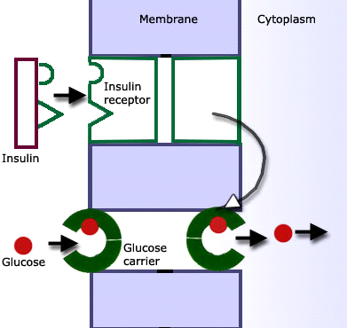
- Down regulated – decreasing activity or synthesis

3 Mechanism by which a hormone can exert effects on target cells:
    - Direct effects on function at cell membrane
- Receptors directly/physically associated w/ regulatory proteins
- Binding hormone to receptor changes interaction influence activity of regulatory protein
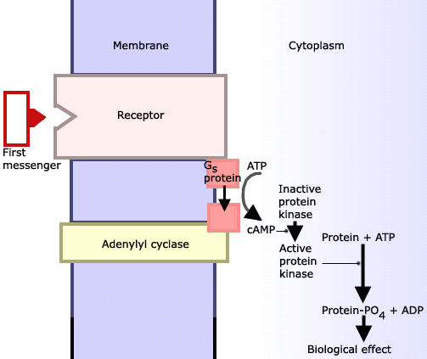
Reg prot. can indirectly couple: Ex: binding of insulin, lowers blood glucose by indirectly activating glucose carriers to uptake it
    - Intracellular effects mediated by second messenger systems
- Interaction b/w hormone & recep changes activity of protein released into cytoplasm influences function of proteins
- Many 2nd messengers are kinases = enzyme in cytoplasm that phosphorylates its substrates & influences their activity distributing hormonal signal of the cell
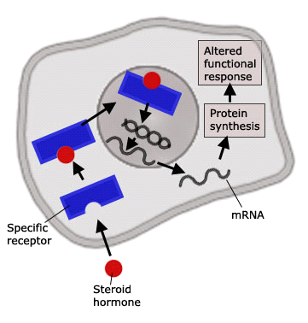
    - Intracellular effects mediated by genomic or nuclear action
- Steroid = lipophilic can cross cell memb, ex: estrogen
- Ex: Estradiol enters nucleus of cell binds to estrogen recep estrogen recep changes the way gene transcription is regulated in target cells
Exerts its biomech effects by changing prot content of cells by stimulating a subset of genes to produce more of those cells & suppressing others

Lecture 2

Feedback Control of Hormone Secretion:
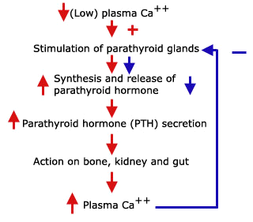
- Hormone secretion regulated by feedback mechanisms
- Negative Feedback: excess hormone/hormonal activity decrease hormone secretion (& vice versa)
- Ex: Ca⁺⁺ acts in neg. feedback loop regulate plasma Ca levels
PTH acts on end organs increase recovery of Ca in kidneys (pee out less Ca), recover Ca from bones + stimulate Ca absorb in intestine
Ca binds to Ca sensing receptor on parathyroid stop PTH
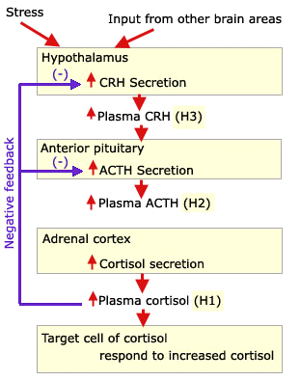

Hormonal Feedback Mechanisms
- CRH: corticotopin releasing hormone - hypothal
- ACTH: adrenocorticotropic hormone – ant pit
- Cortisol (glucocorticoid) – adrenal cortex
- Adrenal cortex stimulated release glucocorticoids to ant pituitary + hypothalamus “calm down!”

(II) Endocrine Glands & Their Secretions
  - Anatomic Location
  - Hormones Secreted
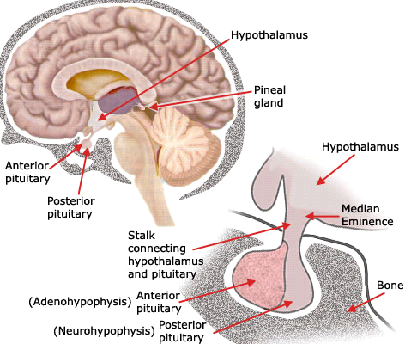
  - Chemical Nature of Hormones
  - Effects
  - Mechanism of Action
  - Control of Release
  - Problems (too much or not enough)
  - Treatment

Pituitary Gland
- 2 distinctly different tissues:
- Adenohypophysis (anterior pituitary or pars distalis) endocrine tissue
- Neurohypophysis (posterior pituitary or pars nervosa) neural tissue (hypothal. extension)
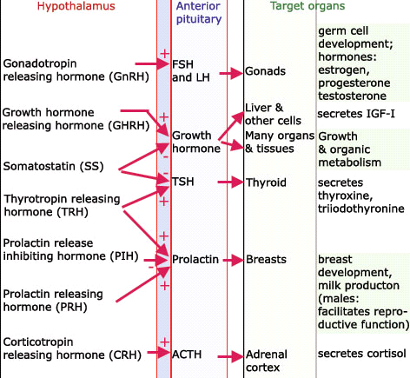

Signaling b/w Hypothalamus and Pituitary
- FSH: follicle stimulating hormone
- LH: luteinizing hormone
- IGF-1: insulin-like growth factor 1
- Prolactin release inhibiting hormone = dopamine (hormone & NT)

Hypothalamic Hormones
- Posterior Pituitary Hormones
- Oxytocin
- Arginine Vasopressin = antidiuretic hormone = ADH
Both have similar structures & affect sm. muscle tone/action
- Hypophyseotropic Hormones (target: Anterior Pituitary)
- TRH, GnRH, GRH, somatostatin, CRH = peptide
- PIH, dopamine = not a peptide

Posterior Pituitary Gland
- Secretes oxytocin and vasopressin (ADH)
Synthesized in 2 hypothalamic nuclei (supraoptic & paraventricular = grps of neurons)
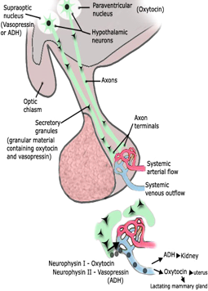
Axons run down pituitary stalk & end in post. pituitary (close to capillaries)
- Prohormones processed in secretory granules during axonal transport
- Mature hormones liberated from carrier molecules = neurophysins
- Circulating ½ lives: 1-3 minutes

Oxytocin
- Behavioral effects: reduces anxiety, enhances bonding & pro-social behavior
- Females
      - Parturition: assists w/ child birth
      - Milk ejection in lactating mother: causes milk filled ducts to contract
- Males
    - Ejaculation: assists epididimal passage of sperm & ejaculation

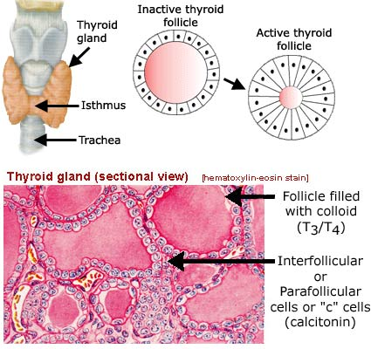
Thyroid Gland
- 15 to 20g, varies size (ex: female>male)
Only 3g of healthy thyroid needed for euthyroid state
- Colloid: major component is thyroglobulin (large protein = 700,000Da)
- Contains thyroid hormones thyroxine (T4) and triiodothyronine (T3)
- Thyroid hormone produced in colloid by modifying (iodination) tyrosine on thyroglobulin = transformation from 1 aromatic ring T3 or T4
- T4 & T3 split off thyroglobulin (storage) in blood bind plasma proteins
- TSH controls synthesis of thyroglobulin
- C-cells (parafollicular) produce calcitonin in thyroid gland

Thyroid Hormones Contain Iodine
- Iodine is limited to terrestrial vertebrates
- Thyroid gland concentrates, utilizes & conserves iodine
- Thyroid follicular cells actively transport iodide across the cell (against a chemical gradient)
- 1st aromatic ring = di-iodinated to bind to thyroid hormone receptor
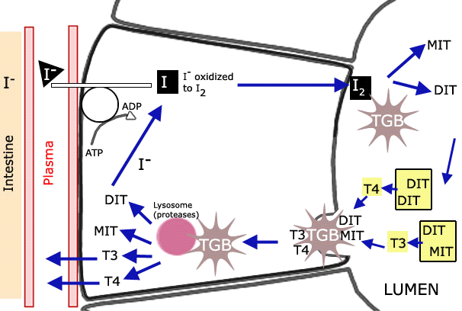
- Hyperthyroid too much hormone bi-product = high levels of reverse T3 doesn’t bind to thyroid hormone receptor = isn’t di-iodinated
- Thyroid uptake of iodine extremely important for its function

Synthesis of Thyroid Hormones
- Iodine (I2) used for iodination of tyrosine residues of thyroglobulin (TGB) to form monoiodotyrosine (MIT) & diiodotyrosine (DIT)
- Oxidative coupling: of 2 DIT forms thyroxine (T4) & of 1 MIT w/ 1 DIT forms triiodothyronine (T3)
- Hormones are stored linked to thyroglobulin
- Rate of all steps of T4 and T3 formation in Colloid & increased by TSH

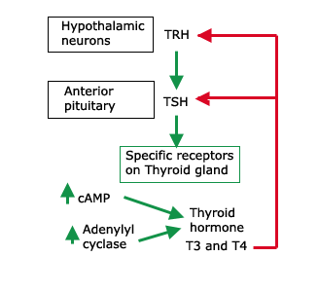
Control of Thyroid Activity
- TSH interacts w/ specific receptors on follicular cells increase production of T4 & T3 w/out TSH = thyroid has low turnover of thyroid hormones
- Hypothalamic Thyrotropin Releasing Hormone (TRH) controls TSH synthesis/release
- T4 & T3 enter blood negative feedback at hypothalamic & pituitary levels decrease release of TRH & TSH
- TSH is also a g-coupled protein receptor 2nd messenger = cAMP in thyroid cells that are stimulated by TSH & transmits signal to increase release of T4&3 neg feedback

Iodine Deficiency
- Iodine deficiency decrease thyroid hormone synthesis = dec in T4 & T3 in circulation inc hypothalamic pituitary signalling increase TSH release thyroid follicular cells are constantly stimulated thyroid tries to compensate becomes hypertrophic No thyroid hormone
- Thyroid enlarges & may form a goiter (visible lump)
- Non-toxic goiter due to iodine deficiency thyroid can’t synthesize thyroid hormones
- If not producing thyroid hormones the neg feedback loop doesn’t function

Summary of the Effects of Thyroid Hormones
- Thyroid hormone affects:
Metabolic rate – causes build up or break down of proteins, carbs & lipids
Stimulates calorie consumption
Promotes normal growth
Necessary for nerve generation, branching & connections = most severe in young children

Effect of Thyroid Hormones on Basal Metabolic Rate:
- Increase calorigenesis (calorie consumption) or basal metabolic rate (BMR: fuel energy)
Increase breakdown of carbs, lipids & proteins increases need of O2
- Cooperate with growth hormone to stimulate growth
- Important effect on CNS early stage of brain/neuronal development (w/ out it = retardation)
Thyroid hormones stimulate synthesis of nerve growth factor (NGF)

Molecular Mechanisms of Action of Thyroid Hormone:
- T3 & T4 enter target cell nucleus bind to cognate nuclear receptor (steroid family) up or down regulate transcription of specific genes change prot content, biochem fcn, phgy effects
These effects require thyroid hormone binding to recep recep binding to DNA adjacent to target genes regulation of gene transcription de novo production or loss of proteins whose genes are expressed
- Thyroid hormones interact w/ plasma membrane & mitochondria
Specific T4/T3 receptor in inner mitochondrial membrane
Not blocked by inhibitors of protein synthesis no de novo gene expression & protein synthesis necessary
- T4/T3 act directly at plasma membrane & increase uptake of amino acids independent of protein synthesis

FAQs
- Stable Iodine – protects gland from radioactive isotopes by saturating iodine transport, used in nuclear power plants & treats thyroid cancer

Abnormalities of Thyroid Function
  - Not enough - Hypofunction of thyroid gland = hypothyroidism low levels of thyroid hormones
  - Too Much - Hyperfunction of thyroid gland = hyperthyroidism high levels of thyroid hormones
- Such abnormalities in activity of thyroid gland present at birth (genetic) or occur later in life

Major Physiological Consequences of Hyperthyroidism & Hypothyroidism
- Hyper elevated hormone levels, elevated BMR, weight loss, increased appetite
- Hypo opposite effects of hyperthyroidism

(I) Hypothyroidism
    - Primary hypothyroidism (Myxedema):
- Level = thyroid inability to synthesize active thyroid hormones
Women > man (age ~40-60)
- Causes:
- Thyroid atrophy
- Autoimmune Thyroiditis/Hashimoto’s disease: antibodies destroy thyroid cellular components
- Goitrous Hypothyroidism or Non-Toxic Goitre: blockage in a step of T4/T3 synthesis
Thyroid gland increases in size = goitre formation (non-toxic)
Ex: Lack of enzyme production necessary for T4/T3 synthesis
    - Secondary hypothyroidism:
- Level = pituitary synthesis of little or no TSH
    - Tertiary hypothyroidism:
- Level = hypothalamus synthesis of little or no TRH
    - Infantile hypothyroidism:
- Absence of thyroid gland or incomplete development of thyroid gland at birth (genetic defect)
- At birth infant is normal (fetus uses mother’s T4/T3) after few months: child exhibits decreased physical growth & mental development growth (dwarfism) & mental retardation
- Treatment:
All types of hypothyroidism are effectively treated by administration of thyroid hormones
There is a hypothalamic pituitary thyroid axis

Thyroid Dysfunction
- Cretinism: growth defect (dwarfism) due to hypothyroidism from birth
- Nontoxic goiter: hypothyroidism (treat w/ thyroid hormone)
- Ectopic thyroid: wrong side of trachea

(II) Hyperthyroidism
        - Primary hyperthyroidism: level = thyroid gland
- Toxic Diffuse Goiter (Graves Disease):
- Autoimmune disease Long Acting Thyroid Stimulator (LATS) is an antibody produced by lymphocytes that mimics action of TSH (stimulating release of T4/3) destroys thyroid fcn
- LATS stimulation increases mass of thyroid bypass neg feedback (LATS is under different control) tons of T4/3 but no TSH or TRH toxic goitre (synthesizes active T4/T3)
    - Thyroid adenoma or thyroid cancer:
- Synthesize of thyroid hormones independent of TSH stimulation
- Secondary hyperthyroidism: level = anterior pituitary gland Ex: pituitary tumor
- No negative feedback from increased levels of T3/T4 overproduction TSH
        - Tertiary Hyperthyroidism: level = hypothalamus hypothalamic tumor
- No negative feedback from increased levels of T3/T4 overproduction TRH

Treatment:
- Depending on the severity of hyperthyroidism:
- Remove thyroid (surgery) & replacement therapy (administration of thyroid hormones)
- ~5 mCi of radioactive Iodide (¹³¹I) concentrates in cells of thyroid follicles & destroys them
- Anti-thyroid drugs administration (ex: propylthiouracil - blocks addition of iodine to thyroglobulin) don’t inhibit all synthesis of thyroid hormones cause hypothyroidism

Lecture 3

Endocrine Control of Calcium Homeostasis
- Ca²⁺ plays a key role in many fundamental biological processes:
more important for cell function than bones
Skeleton structural component
Normal blood clotting
W/ Na+ & K+ = maintains transmembrane potential of cells
Excitability of nervous tissue
Muscle contraction
Release of hormones and neurotransmitters
- Concentration in cellular and extracellular fluid ~10mg/100ml
In circulation 50% free & 50% bound to albumin
~99 % of body’s Ca is in bone (loosely bound) Bone = Ca reservoir if lacking in circulation
- Hormonal Control
Maintenance of plasma Ca by exchange b/w bone & plasma under influence of hormones
Hormones also affect intestinal absorption of Ca & excretion of Ca by kidneys

Three hormones in particular are of importance
- Parathyroid hormone (PTH): protein produced by parathyroid glands
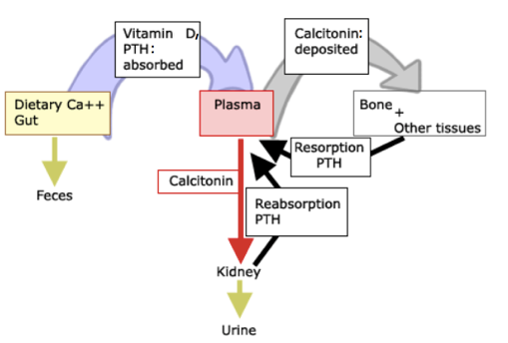
Increases circulating levels of Ca⁺⁺
Have their name sit on back of thyroid but have own phgy
- Calcitonin: protein produced by parafollicular or “C” cells of thyroid gland
Lowers circulating levels of Ca++
Does opposite of parathyroid hormone (can live w/out it)
- Vitamin D hormonally active form: increases circulating levels of Ca++
- Calcium Cycle:
Obtained in the diet (milk, cheese, eggs, butter etc.)
Absorbed from digestive tract (duodenum & upper jejunum) increased by Vit D & PTH
            - Ca absorbed in Plasma:
Some Ca goes in bone (calcitonin increases amount) or cells of other tissues
Some goes to kidney & into urine (calcitonin increases this loss)
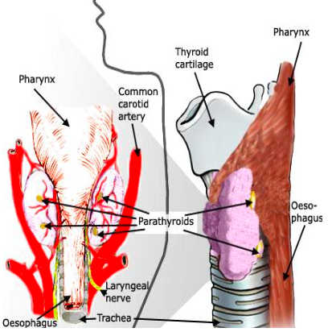
If plasma [Ca] < 10mg/100ml PTH stimulates reabsorption of Ca from kidney & Ca removal from bone (bone resorption)

Parathyroid Hormone (PTH)
- Extremely important for Ca homeostasis
- Secreted from parathyroid chief cells embedded in surface of thyroid
- 4 parathyroid glands on back side of thyroid gland
- Removal parathyroid: big drop in plasma [Ca] tetanic convulsions & death
- PTH Structure:
84 a.a. polypeptide: only N- terminal 34 a.a. important for full activity they bind to parathyroid hormone receptor & can send signal
Synthesized as part of a larger protein = preproparathyroid hormone undergoes proteolytic cleavage to produce PTH
Very short half-life = 3-18 mins depending on individual
Constantly being tuned – not only Ca level but hormones regulating it

Function of PTH
- Increase plasma [Ca]:
- Bone Resorption: increases bone demineralization increases Ca in body fluids
- Kidney: increase Ca reabsorption in proximal convoluted tubule
- Vitamin D synthesis: conversion of 25-hydroxyvitamin D3 (precursor = long ½ life) from liver to 1,25-dihydroxyvitamin D3 (active vit D) in kidney
- Gut: PTH & 1,25D3 facilitate absorption of Ca++ from the gut
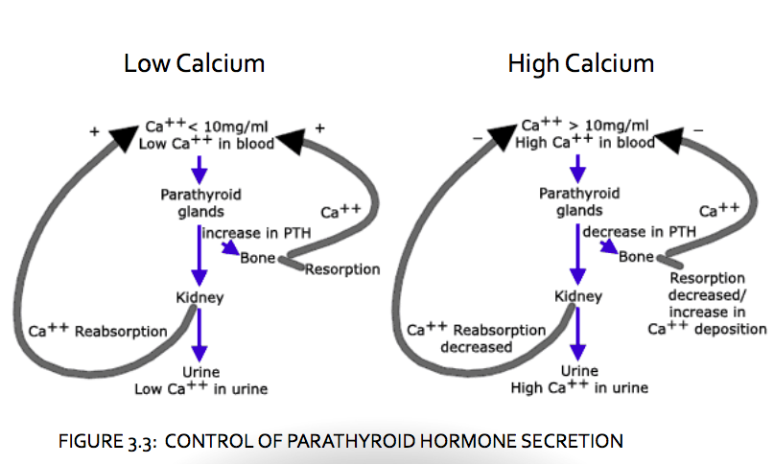
- PTH release is controlled directly by circulating [Ca]
- Mechanism of PTH activity binds to cognate receptor on target cells

Calcium Homeostasis Summary
- Low Ca release of parathyroid hormones from parathyroid glands Ca increases in circulation
- High Ca Ca-sensing receptor on parathyroid decrease PTH synthesis/release (- feedback loop)

Problems with Parathyroid Gland Function
        - Hypofunction
- Hypoparathyroidism: low levels of PTH in circulation
- Symptoms:
low plasma calcium (hypocalcemia)
low production of active vit D
Tetany & convulsions = more serious
Ca⁺⁺ <7mg/100ml – increased neural over excitability - muscle spasms
Spasms of laryngeal muscles = death by asphyxiation
Treatment: bypasses requirement of PTH administer active Vit D and Ca supplement
          - Hyperfunction
- Primary hyperparathyroidism = defect @ level of PT (2ndary = defect elsewhere)
Caused by parathyroid adenoma (benign growth) make too much PTH
Inc production of 1,25D3 increases Ca absorption from intestines
Bone resorption & Ca reabsorption by kidney
Inc Ca in circulation
Form kidney stones
Severe cases: cardiac arrhythmias, depressed neuromuscular excitability, Ca deposition on blood vessel walls & cartilaginous regions of bones
- Treatment: surgery to remove (affected) parathyroids & replacement therapy of 1,25D3 & Ca⁺⁺

Vit D:
- From dietary sources (cod liver oil, fatty fish)
- Synthesized from a cholesterol metabolite not a vitamin
- Synthesis:
- UVB light + 7-dehydrocholesterol in skin
- 25-hydroxylation in liver followed by...
- 1-hydroxylation in kidney & several peripheral tissues 1,25-dihydroxyvitamin D3
- Physiological Function:
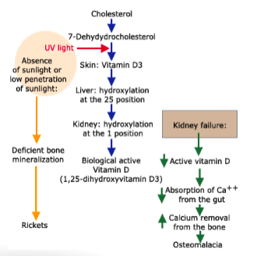
  - Primary function: increase Ca absorption from intestine
  - Regulates immune system anti-inflammatory
  - Anticancer properties

Regulation of Vit D Synthesis in Kidney:
- Low Ca Vit D & PTH increase
- High Ca Vit D decrease
- Under control of PTH
- Absence of UVB (northern countries) Vit D deficiency & deficient bone mineralization (Rickets in growing individuals)
More severe in dark-skinned people
Low vit D in adults osteomalacia (soft bone)
Renal failure low 1-hydroxylation low Vit D synthesis
- Genetic defects leading to Rickets:
  - Can’t to produce active vit D (lack of enzyme: 25d1,25d) Treat: administer active vit D
  - Lack of vit D recep = Hereditary vitamin D-resistant Rickets lose hair Treat: massive doses of Ca (not totally effective)

Calcitonin
- 32 amino-acid Ca-lowering peptide hormone (need all 32 a.a.)
- Made in parafollicular or “C” cells in thyroid gland
- Lowers plasma Ca inc Ca from blood to bone & Ca urinary excretion
- Inc plasma [Ca] inc calcitonin release
- Dec plasma [Ca] dec calcitonin release
- Less important than PTH & 1,25 D3 absence doesn’t affect Ca homeostasis

Adrenal Glands
- On upper surface of kidneys (heavier in male than female)
- Comparison of Cortex & Medulla (2 types of tissue)
    - Appearance:
Cortex: large epithelial cells w/ lipids
Medulla: chromaffin cells-fine brown granules when fixed w/ potassium bichromate
    - Origin: Cortex (from mesoderm) & Medulla (from neural crest)
    - Function:
Cortex: steroid hormones glucocorticoids (cortisol-human/corticosterone-rodents) & mineralocorticoids (aldosterone), progestins & sex steroids (2^{ndry} source in normal phgy)
Medulla (not important): catecholamines epinephrine & NE & peptide hormones

Adrenal Cortex
- 3 different layers functionally different
- Pituitary hormone adrenocorticotropin (ACTH) controls synthesis of adrenal steroids
- Corticosterone & aldosterone: small molecules (not peptides) make up hormones (no genes encoding them but genes encoding enzymes necessary for their biosynthesis)
- Difference in fcn of layers arise from different enzymes they encode for:
18-hydroxylase in 1 layer = need it to make mineralocorticoids = mineralocorticoids specific
17a-hydroxylase in another layer = glucocorticoids specific (no 18-hydroxy = no mineraloc.)
- Pregnenolone = precursor of many enzymes = cholesterol metabolite interconnects hormones
Mineralicorticoid (aldosterone) & glucocordicoid (cortisol) similar structure (bind to each others recep under abnormal conditions = high levels)
Why you get other sex steroids produced from same types of precursors
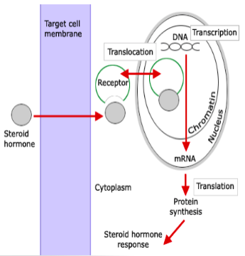
Molecular Mechanisms of Action of Steroid Hormones
- Fcn: inc/dec transcription of hormone/receptor-specific target genes
- Genes regulated vary w/ target tissue & relate specifically to those fcns regulated by each steroid hormone & tissue phgy fcn
- Molecular steroid hormone receps (active vit D) part of nuclear receptor family
Can always be in nucleus (PTH receptor) or be in cytoplasm until they bind their hormone (glucocordicoid receptor)
Important: work in nucleus in presence of hormone to regulate transcription of hormone specific genes of that receptor

Physiological Roles of Adrenal Hormones
Aldosterone
- Na metabolism increases kidney reabsorption of Na+
- Uptake of + ion either by:
- Taking in an anion at the same time
- Exchange + ion out: affects plasma [K+] & [H+] = lose K+ & H+ in urine balance Na+ reabsorb

Glucocorticoids:
- Cortisol (humans) & corticosterone (rodents)
  - Salt retention:
- Less effective than aldosterone (important when: pathology = plasma cortisol stays high)
  - Effects on protein and carbohydrate metabolism:
- Stimulate synthesis of gluconeogenic enzymes in hepatocytes & enzymes that breakdown proteins in muscle & other tissues released amino acids enter liver converted to glucose & glycogen (gluconeogenesis)
- Decrease glucose uptake by muscle & adipose tissue & decrease glycolysis conserve glucose for tissue inc blood glucose inc insulin secretion
- Inc blood glucose due to excess glucocorticoid activity = adrenal diabetes – prolonged, leads to destruction of beta-cells of pancreas & true diabetes mellitus
  - Lipid metabolism:
- Glucocorticoids maintain or inc lipolytic enzymes in adipose tissue cells & inc lipolytic action of other hormones (ex: epinephrine)
- Muscles use lipids as fuel excess glucocorticoids hyperlipidemia & hypercholesterolemia
  - Anti-inflammatory and immunosuppressive actions of glucocorticoids:
- Reduce inflammatory responses (ex: at sites of injury)
- Cause atrophy of lymphatic system (lymph nodes, thymus, spleen)
- Dec circulating lymphocytes & dec antibody formation use glucocorticoids in organ transplant
- Dec histamine formation dec allergic reactions
  - Effects of glucocorticoids on bone:
- Dec bone protein matrix due to protein catabolic effect inc Ca loss from bone osteoporosis

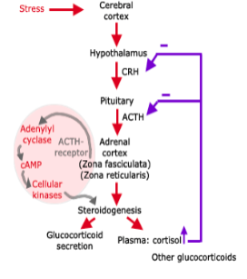
Control of Glucocorticoid Secretion
- Controlled by pituitary adrenocorticotropin (ACTH) = 39 a.a polypeptide, made as part of larger protein = proopiomelanocortin (POMC)
- Hypothalamus & ant. pituitary control feedback of cortisol secretion
- In enzyme deficiencies (lack of 11b- hydroxylase) cortisol is not produced ACTH secretion is unchecked congenital adrenal hyperplasia
- No neg feedback loop: lots of hormone released to adrenals adrenal hyperplasia (like non-toxic goiter: iodide deficiency in thyroid no hormone)
- Treatment: give cortisol corrects deficiency & normalizes ACTH secretion
- Adrenals = end organ of the hypothalamic-pituitary axis
- Corticotropin releasing molecule (CRH) impinges on pit stimulates prod of ACTH glucocorticoids inc double neg feedback loop at pit & hypo

Mechanism of Action of ACTH
- Binds to specific ACTH receptor on membranes of zona fasciculata & zona reticularis cells
- Stimulation of adenylyl cyclase inc production of cyclic AMP
- Activates steroidogenic enzymes inc synthesis & release of steroid hormones
- Daily rhythm of plasma cortisol & ACTH: diurnal rhythm of ACTH & cortisol secretion = min at midnight & max in morning = circadian rhythm of metabolization controlled by glucocorticoid
- Rhythm = independent of sleep & abolished by stress & Cushing’s disease

Glucocorticoids and Stress-Response
- Stress stimuli (psychological or physical) increase synthesis/release of CRH, ACTH & cortisol
Ex: pain, fear, exercise, hunger, cold, hemorrhage etc.
- Advantageous effects of cortisol in stress: gives energy & a.a by breakdown of tissue proteins
Important: normal feeding not feasible
- Disadvantageous effects: cortisol inhibits wound healing
- Prolonged stress high levels of glucocorticoids inc blood glucose (true diabetes mellitus), dec immune responses (infections), loss of bone etc.

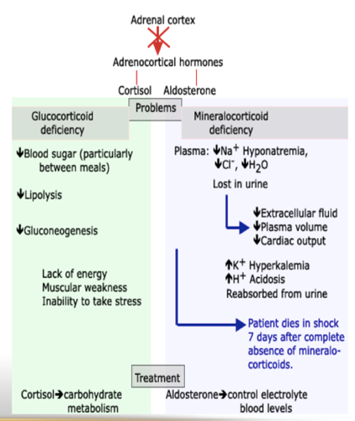
Lecture 4
Pathophysiology of Adrenal Cortex
- Addison’s Disease: hypofunction
- Adrenal failure cortex can’t produce adrenocortical hormones
- Can cause total gland destruction
- Atrophy of glands due to tuberculosis & involves medulla & cortex
- Deficiency in prod of cortisol and aldosterone
- Cushing’s Disease: hyperfunction
- Hyperplasia of adrenal cortex = inc circ levels of ACTH (no control of prod)
- Excessive production of glucocorticoids & inc production of mineralocorticoids
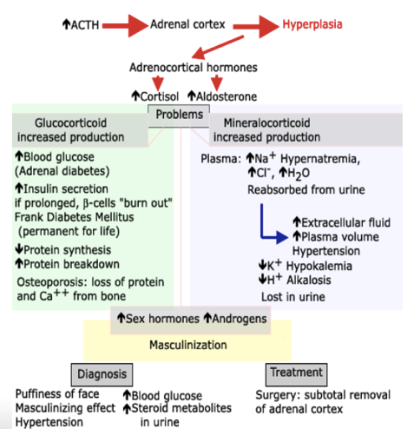
- Effects from sex hormones produced females get masculinization

The Pancreas as an Endocrine Organ
- Behind stomach
- 99% of pancreas is exocrine & secretes digestive enzymes
- Small endocrine structures: Islets of Langerhans - compact mass of cells w/ good vascularization:
~60 % of cells = beta-cells synthesize insulin
~25 % of cells = alpha-cells synthesize glucagon
- Insulin & glucagon: small protein hormones control [glucose] in blood
- Insulin is more important than glucagon
- Insulin deficiency or absence can lead to death
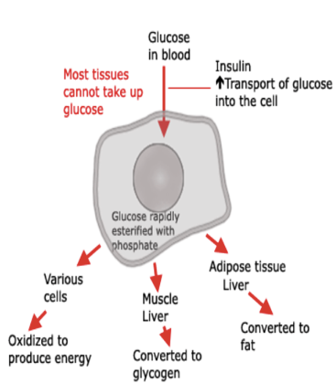
Actions of Insulin
- Insulin: Only hormone that acts primarily to dec blood glucose
- Glucose always in blood (fasting level ~80mg/100ml, ~5mM) but very little free in tissues (consumed very quickly)
- Glucose doesn’t diffuse readily into most cells must be transported
    - liver & muscle cells it’s converted to glycogen
    - adipose tissue it’s converted to fat & stored
    - many cells it’s oxidized to produce energy
- Insulin membrane receptor: stimulates insertion of glucose transport proteins in cytoplasm into plasma membrane inc glucose uptake
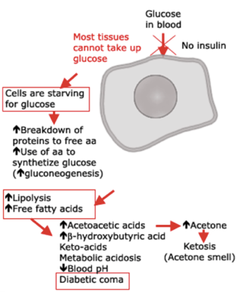
Insulin Deficiency
- B-cells are destroyed Diabetes Mellitus - most tissues can’t take up glucose efficiently glucose accumulates in circulation
- Occurs even if no glucose in diet inc gluconeogenesis (protein breakdown to a.a & synthesis of glucose in the liver)
- Free fatty acids (FFA) become principal energy source – inc lipolysis (alternative sources of fuel – due to no glucose uptake)
- Fat inefficiently used = incomplete oxidation inc acetoacetic acid & b-hydroxybutyric acid (metabolic acidosis) & acetone (ketosis - acetone smell in breath)
- Leads to dec blood pH, diabetic coma & death unless treated
Other Symptoms of Diabetes Mellitus:
- At >180mg% glucose enters urine = glycosurea
- Loss of H2O in urine (follows glucose) polyurea - dehydration & inc thirst (polydipsia)
- Untreated diabetes leads to ketosis & metabolic acidosis
- Insulin is needed to restore individual back to normal
- Diabetic comas: acidosis, electrolyte imbalance must be corrected & administer insulin

Causes of Diabetes Mellitus:
- Diabetes: “running through” used to describe polyurea (peeing a lot)
- Mellitus: “sweet” distinguishes urine polyurea in ADH deficiency (diabetes insipidus)
- In adults diabetes mellitus may be due to:
- Insulin deficiency (type 1 insulin- dependent diabetes mellitus)
- Hyporesponsiveness to insulin (type 2 or insulin- independent diabetes mellitus) – obesity

Type 1 or Insulin-Dependent Diabetes Mellitus
- Destruction of b-cells of pancreas (usually autoimmune) – no beta cells = no synthesis of insulin
- Defective insulin release - drugs stimulating insulin release could be administered
- Treatment: administration of insulin or drug stimulating its release, proper diet & exercise
- Dose control of insulin is important too much insulin decrease in blood glucose at 20-30mg/100ml = brain doesn’t get sufficient amount of glucose coma = insulin shock or hypoglycemic coma w/ out immediate administration of glucose = death or brain damage

Type 2 or Insulin-Independent Diabetes Mellitus
- Insulin levels normal or abnormally high problem = insulin receptors
- Hyporesponsiveness (resistance) of target cells to insulin = dec # of insulin receptors
- Inc carbs (obesity) inc glucose prolong inc insulin down regulate insulin receps (dec # or dec responsiveness) = negative feedback loop
- Treatment: proper diet & endurance exercise (independent of body weight) dec caloric intake dec insulin receptors up regulation response to frequent endurance exercise
- Juvenile diabetes mellitus: child w/ autoimmune or obesity = insulin dependent b-cells of pancreas do not produce insulin treatment: administration of insulin

Measurement of Glucose Tolerance - Glucose Tolerance Test:
- Glucose tolerance: dec in diabetes (low or no insulin) & inc in hyperinsulinism
- Patient fasts overnight blood taken given 0.75 to 1.5g of glucose/kg body weight blood taken every 30- 60 min for 3-4 hrs & glucose is measured
- Normal: glucose inc in 1 hr (80mg/100ml to 130mg/100 ml) & after ~2-3 hrs, returns to normal
- Diabetic: inc in glucose is greater & returns to normal more slowly insulin stimulates glucose transport/uptake w/ out insulin the body can’t take up glucose

Control of Insulin Secretion
- Many feedback mechanisms control of insulin release to avoid hypoglycemia
- Beta cells secrete little or no insulin when glucose is low & more when glucose is high
- Beta cells also induce insulin release from pancreas before inc glucose due to gastrin & vagal impulses as bolus comes into intestine

Glucagon
- Peptide hormone, synthesized & released by a-cells of pancreas
- Functions are opposite of insulin’s
- Inc blood sugar by inc glycogenolysis (glycogen breakdown) & gluconeogenesis (glucose synthesis) in liver
- In adipose tissue, glucagon inc rate of lipolysis inc free fatty acids in circulation
- Low glucose increase glucagon & high glucose decreases glucagon
- Not as important as insulin other hormones can increase blood glucose

Growth Hormone (Somatotropin = STH)
- Single chain polypeptide made by anterior pituitary
- Responsible for growth
- Inc protein synthesis in tissues (bone, muscle, kidney, liver) by inc a.a uptake by cells & accelerating transcription & translation of mRNA
- Inc lipolysis rate & FFA to energy direct effect of GH not mediated by somatomedins
- Produces somatomedins if it isn’t acting directly on target
- Somatomedins
Produced by liver under stimulation of GH
Structurally similar to insulin named insulin-like growth factors I & II (IGF- I & IGF-II) bind to each others receptors at high concentration
Inc protein synthesis & stimulate growth

Control of GH Release
- Feedback mediated by 2 hypothalamic neurohormones:
- GH releasing hormone (GRH) = somatoliberin stimulates GH release
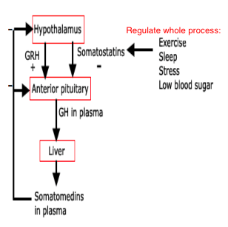
- Somatostatin (GH inhibiting hormone) inhibits GH release
- Neural, metabolic & hormonal factors regulate GRH & somatostatin
- Diagram: GH releasing hormone GH into circ somatomedins in circ feedback to calm down system
- Somatostatins release (dif peps prod from same gene) = neg inhibitors
- Not like Ca homeostasis levels should be pretty flat
- GH released in circadian manner highest during sleep

Pathophysiology of Growth Hormone
- GH Deficiency: in young, no GH leads dec physical growth
- Excess GH: in young leads to gigantism
- Excess GH: in adult acromegaly = bones get longer and heavier at cartilaginous regions

Reproduction
- Primary reproductive organs: gonads (testes & ovaries) = very important endocrine organs
- Accessory reproductive organs: ducts that transport sperm/eggs & glands that they empty into & female breasts
- Gonads serve 2 functions:
  - Gametogenesis: make reproductive cells (gametes = spermatozoa or ova)
  - Secrete sex hormones (steroids): testosterone (androgen) - male and estrogen & progesterone - females
- Male & female differences in reproductive endocrinology is quantitative & not qualitative
Same hormones but different concentrations
Testes make a little estrogen & androgens becomes estrogens by single enzymatic step in non gonadal tissues (ex: bone)
Ovaries make a little androgens & adrenals make a lot
- Although men don’t have follicles but they have FSH

Estrogen Maintains Bone Density in Males
- A man got 2 bad copies of estrogen receptor became mutated
- Estrogen is needed for normal bone growth & maintenance of bone density
- Without it estrogen deficiency osteoporosis-like
- In males, it’s not an endocrine hormone it’s more para or autocrine

Estrogen in Males
- Estrogen in males made locally in tissues (by aromatase: testosterone the estrogen estradiol)
- Estrogen deficiency in males:
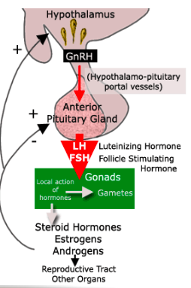
- Increased body fat
- Contributes to sexual desire and erectile function

Control of Reproductive Function
- A similar chain of signals function in males & females
- Gonadotropin releasing hormone (GnRH), secreted by hypothalamus, goes to anterior pituitary via hypothalmo-pituitary portal vessels
- Stimulates release of pituitary gonadotropins: follicle-stimulating hormone (FSH) & luteinizing hormone (LH)
FSH & LH named for their effects in female, but fcn in males too
- FSH and LH stimulate development of spermatozoa or ova & secretion of sex steroids leads to local & systemic production of steroid hormones
- Sex steroids exert effects in gonads, in other parts of reproductive system & body (ex: estrogen bone density & prevents osteoporosis)
- Gonads also produce inhibin protein that feeds back on ant pituitary

Male Reproductive System: Function of the Testes
- Principal function of testes is production of mature germ cells (spermatogenesis) and steroid hormones (steroidogenesis)
- Females have all ova at birth & males renew precursor germ cells (spermatogonia) constantly
- Spermatogenesis is in the coiled seminiferous tubules (SNT) of the testes
- Maturation of immature spermatogonia to mature spermatozoon takes ~60 days in humans
- SNT: under control of sertoli cells
- Seminiferous tubules (SNT), Sertoli cells & Spermatozoa/Sperm all in the same place

Two Cell Types are Critical for Maturation of Spermatozoa
- Leydig cells: outside seminiferous tubules respond to LH & synthesize androgens
- Sertoli cells: within seminiferous tubules involved w/ sperm maturation - envelop germ cells during development & respond to FSH & synthesize Androgen Binding Protein (ABP) & inhibin
- ABP: sponge for androgen
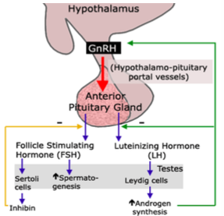
- Leydig cells produce androgen which talks to sertoli cells

Spermatogenesis
- Dependent on [androgen] in seminiferous tubules ~10x higher than [androgen] in circulation if not spermatogenesis ceases
- ABP ensures high [androgen] in seminiferous tubules
- Testicular androgen synthesis regulated by 2 neg feedback loops:
- Hypothlamic-pituitary-Leydig cell axis: GnRH stimulates LH & FSH release stimulate Leydig cells & Sertoli cells Leydig cells make androgen to inhibit GnRH, LH & FSH release
- Hypothalamic-pituitary-seminiferous-tubules axis: non steroidal inhibin secreted by sertoli cells inhibits FSH release
- Note: Contrary to females, no (+) feedback control in males

Female Reproductive System: Ovarian Function
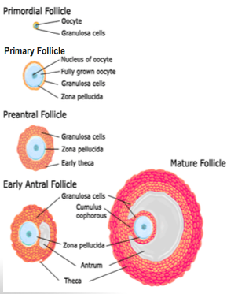
- Principal fcns: make mature eggs & steroid hormones regulate reproductive tract & influence sexual behavior
- At birth ovary contains ~2 million oocytes = whole life supply of ova & at puberty only ~400,000 ova left
- Oocytes are surrounded by a single layer of granulosa cells & a basement membrane making up primordial follicles - fundamental reproductive units of the ovary
- Growth of primordial follicles into primary follicles begins by an unknown initiating event (independent of pituitary)
- Once initiated, growth controlled by gonadotropins & steroid hormones until the follicles either ovulate or degenerate (atresia)
- Once fertilized, egg goes through rapid cell division but doesn’t change in size so it needs to be big so a lot of food can surround it

Follicular Growth – Development of Oocytes Suitable for Ovulation, but also Development of new Endocrine Organ
  - Enlargement & differentiation of oocyte grows & elaborates zona pellucida (acellular layer rich in glycoproteins surrounding oocyte)
  - Granulosa cells divide & inc to 2 or more layers (primary follicles) influenced by FSH & estrogens estrogens inc LH receptors sensitivity stimulates more granulosa cells
  - FSH & LH influence primary follicle to develop into a 2^{ndary} follicle that expresses FSH, estrogens & LH receptors follicular antrum contains granulosa cells secretions
  - FSH & LH influence granulosa cells to elaborate follicular fluid takes up larger portion of preovulatory follicle = late secondary/Graafian/mature follicle
- Important: follicle matures (primary secondary) cells from ovarian stroma surrounding follicle differentiate & become steroid producing cells = theca cells (theca interna)
- Theca interna & granulosa cells collaborate for inc estrogen synthesis
- Relationships:
- Estrogen signaling (estro + its recep) & LH signaling (LH + it’s recep)
- Estrogen & progesterone (downstream of estrogen)
- Estrogen w/ itself - follicular development leads to production of cells inc estrogen pos feedback to inc cells estrogen levels go up

Follicular Development Leads to One of 2 events
- Follicular Atresia: many follicles initiate growth and development in each reproductive cycle, but only 1 will ovulate in each reproductive cycle the rest degenerate = atresia
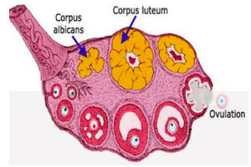
- Ovulation: mechanism of follicular rupture may be due to inc in intrafollicular pressure & proteolysis of ovarian wall of mature Graafian follicle

Luteinization (after ovulation)
- Ruptured follicle becomes Corpus Luteum – secretes progesterone & continues to produce estrogen
- Theca & granulosa cells contribute to formation of corpus luteum = temporary endocrine structure in ovary making progesterone & estrogens
- Progesterone & estrogens are made in large amounts by corpus luteum for few days after ovulation then dec unless fertilized ovum is implanted
- If implantation: corpus luteum becomes corpus luteum of pregnancy responsible to make progesterone & estrogens that act on endometrium to cause growth & specialization so the endocrine environment can maintain pregnancy until progesterone and estrogen synthesis by placenta established
- Luteolysis: no implantation = limited life span of corpus luteum = degrades = dec steroids
Prostaglandins dec LH binding (= steroidogenesis) induces luteal regression
Dec of plasma progesterone & estrogen neg feedback to pit & hypo stop inc FSH initiation of next reproductive cycle = follicular dev

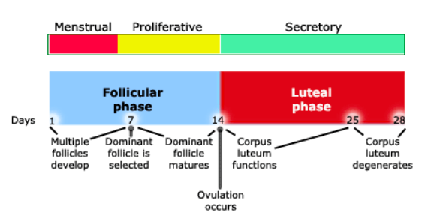
Lecture 5
The Menstrual Cycle
- Prior to day 1 - estradiol causes endometrium to thicken & progesterone induces appearance of specialized glycogen-secreting glands
- Day 1 – 1st day of detectable vaginal bleeding - deterioration of uterine endometrium
- Menses (bleeding) begins when estradiol & progesterone very low due to degeneration of corpus luteum = when blood vessels supplying endometrium constrict reducing blood supply
- Endometrium deteriorates, flows through the cervix into vagina
- Bleeding for ~5 days while ovaries are endocrinologically inactive
- Low estradiol & progesterone lead to inc pituitary FSH secretion (no –ve feedback loop)
- Dec in non-steroidal ovarian inhibin inhibits secretion of FSH
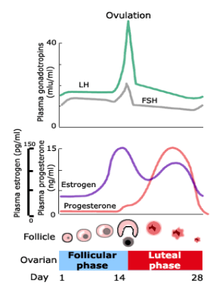
- Inc FSH release ovarian follicles develop by stimulating granulosa cells to proliferate producing estrogen that stimulates granulosa cell proliferation (+ feedback)
- Day 8, 1 follicle becomes dominant & committed to further development & rest of the follicles degenerate by atresia
- Dominant follicle produces increasingly more estradiol, which becomes important in late stages of cycle
- Increasing estradiol stimulates uterine endometrium proliferation
- By day 13, endometrium very thick & estradiol induces production of endometrial progesterone receptors
- Estrogen inc prod of estrogen receps in growing endometrium which makes it responsive to increasing conc of progesterone

Estradiol Effects on Brain and Pituitary
Moderate estradiol concentrations:
- Negative feedback on FSH release stimulates synthesis of LH by pituitary & increase sensitivity of pituitary to GnRH stimulates LH synthesis
- Moderate [estradiol] stimulate LH synthesis but inhibit LH release LH accumulates to high levels within pituitary
- Estrogen keeps going up at some point, a switch is slipped LH surge
High estradiol concentrations:
- Under influence of developing follicle [estrogen] continue to build
Elevated [estrogen] stimulate LH release - LH surge
- ~day 14 small increase in FSH release (ovulation day)
- Stimulation of LH synthesis by estradiol & inc sensitivity of anterior pituitary to GnRH leading to inc LH synthesis by anterior pituitary known as estrogen +ve feedback control mechanism
- GnRH comes down from hypo - impinges on pit that has tons of GnRH wave of signaling bolus of LH produced = LH surge ovulation
- Estrogens exert -ve feedback - dec GnRH & LH release. +ve feedback - inc sensitivity of anterior pituitary cells to GnRH & inc LH synthesis.
- In ovary the follicle has become huge sudden surge of LH causes the follicle to rupture (mechanism unclear) and ovum is ejected

Feedback Mechanism of Steroid Hormones on Gonadotropin Action
- Moderate [estrogen] double neg feedback loop, inhibin inhibits FSH release
- High amounts of estrogen: surge ovulation and prod of CL prod of steroid hormones
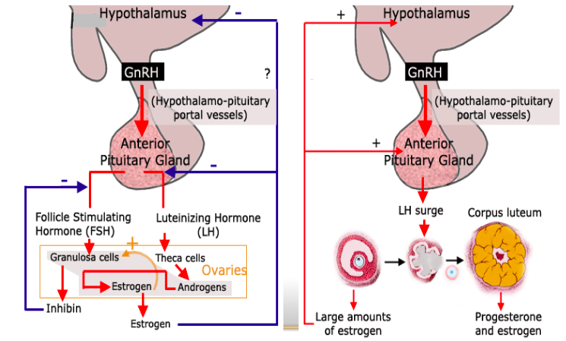

Oral Contraceptives
- Pills w/ estrogen & progesterone - maintain circulating levels of 2 hormones to suppress LH & FSH release from pituitary & prevent ovarian follicles from maturing and being ovulated
99% success: if pill is taken for 21 consecutive days w/ 7 days of no medication that would induce menstruation

Corpus Luteum
- LH influences the follicle to become corpus luteum
- Produces large amounts of estradiol & progesterone induce endometrial growth of uterus
- Progesterone influences endometrium to become glandular
- Progesterone (acts downstream of estradiol which stimulates production of progesterone receptors in endometrium) turns it into a hospitable organ for implantation
- Endometrium is now fully prepared to receive & support the development of a growing embryo

Luteal Phase
- No fertilization - egg & corpus luteum degenerates (luteolysis)
- For 14 days = luteal phase of cycle steroids produced by corpus luteum dominate
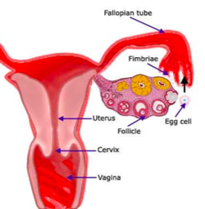
- 14 days w/ out implantation corpus luteum degenerates, steroid levels dec, uterine endometrium degenerates, menstruation begins & pituitary starts to inc its secretion of FSH & restart cycle

Fertilization and Implantation
- Ovulation: fimbria of oviduct (f tube) propel unfertilized egg to lumen of uterus
- Sex during ovulation: spermatozoa in vagina travels to oviduct to fertilize egg
- Egg divides rapidly w/out net growth to blastocyst stage during its transport from oviduct into uterine lumen (=endometrium where it continues developing)
- Ectopic (in wrong place) pregnancy: partial development of egg in F tube
After Implantation
- Blastocyst differentiates into trophoblast (becomes placenta) & inner cell mass (forms embryo)
- Trophoblast invades uterine mucosa inserting of developing embryo in endometrium
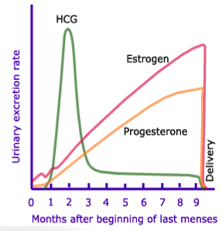
- At implantation: (LH drops after surge) but trophoblast starts synthesizing human chorionic gonadotropin (HCG) has LH-like properties & stimulates corpus luteum to secrete gonadal steroids (estrogen/progesterone) until ~12th week when placenta is developed enough to take over production (endocrine function)
- Placenta + developing fetus = fetoplacental unit
- Close functional interdependence b/w fetal & maternal compartments, & fetal liver fcns to synthesis estriol (an estrogen)
- Placenta produces human chorionic somatotropin, progesterone & relaxin
- HCG appears in blood & urine basis of biological or immunological pregnancy test
- Graph: in placenta hormones have very short ½ life during puberty
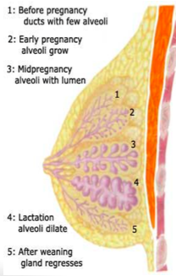
Lactation
- Lactation: breast (mammary glands) secrete milk
- Normal mammary development into mature non-pregnant mammary glands (ductal) under endocrine control
During puberty by inc in estrogen (duct & a little alveolar growth builds main structure) & progesterone (more alveolar growth becomes specialized endocrine structure)
Most breast enlargement due to fat deposition under glandular tissue

Pregnant Mammary Gland (Lobulo-alveolar)
- Due to estrogen, progesterone, prolactin & human placental lactogen ductal & alveoli develop
- Prolactin controls milk production in pregnancy & high estrogen levels inhibit secretion
- Estrogen levels are high due to placenta w/ fetus don’t need milk yet (baby isn’t out)
- Lactating mammary gland
After parturition/birth: dec estrogen but prolactin remains high
Prolactin induces milk synthesis & alveoli secrete milk filling ducts
- Nursing: oxytocin causes ducts to contract milk ejection
- Prolactin from ant pituitary & oxytocin from post pituitary stimulated by afferent nipple fibers
Afferent fiber signaling stops dopamine (prolactin inhibiting hormone) secretion
- Milk: water, protein, fat, carbohydrate lactose & antibodies (& infectious agents = viruses + drugs from mom)
- Fetus doesn’t have gut bacteria to digest lactose baby gets it from exiting the vagina
Problem w/ C section

Lactational Amenorrhea:
- Nursing stimulates prolactin production inhibits FSH & LH secretion blocks resumption of reproductive cycle (natural contraception)
- Suckling intensity & frequency important parameter for reproductive cycle & ovulation blockade not freq = ovulation & pregnancy can occur

Menopause - loss of ovarian steroid production:
- End of reproductive period most ovarian follicles undergo atresia & few 100 were ovulated in menstrual periods
- Follicles depletion ovary loses capacity to make steroid hormone (estrogen & progesterone)
- No estrogens hot flashes, dry vagina, restlessness, bone loss (osteoporosis - long term), etc.
Symptoms dec from estrogen replacement therapy but fertility can’t be restored (no follicles)
- No hormone production eliminates –ve feedback loop & inc plasma gonadotropins FSH & LH
Constantly high plasma FSH = most reliable menopause indicator
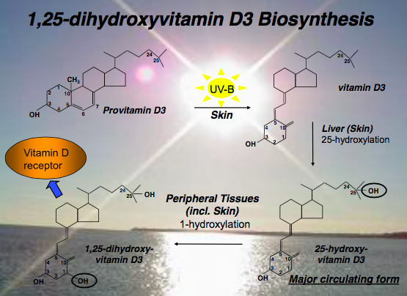
New Insights into Vitamin D Physiology
- Synthesis of hormonal vit D3: provit D3 double bonds are sensitive to UV-B photochemical cleavage become vit D3 liver (skin can do it too) to be 25-hydroxylated - precursor w/ long circulating ½ life (weeks) to kidney where it is 1 hydroxylated (rate depends on amount of PTH – responsive to reduction in Ca) classic model = it goes into circ & acts as an endocrine hormone that model is starting to fall a part
- New findings: hormonal vit D is produced/acts/degraded locally

Vitamin D Winter
- 2 reasons for vit D deficiency: lack in western diet & need high intensity of UVB light to produce it in the skin but most gets absorbed by atmosphere
Vit D3 comes from metabolites of cholesterol plants do not produce vit D
Mushrooms produces something similar to cholesterol produces vit D2 goes to same vit D receptor as vit D 3 UVB
- Levels of major circulating vit D metabolite, 25-hydroxyvitamin D3, in African and Caucasian Americans dark skin 6x less UV radiation from light skin

3 Types of Diseases have demonstrated North-South Gradients (city vs country)
- Certain types of cancers (digestive cancers & leukemias)
- Autoimmune diseases (multiple sclerosis)
- Infectious diseases (tuberculosis)

Colon Cancer Rates & Summer Surface UVB Levels
- Vit D signaling induces many molecular events that protect against cancer formation
- Areas with less UVB more colon cancer

Cells of Immune System Become Responsive to 25D3* After Sensing the Presence of Bacterial Cell Wall (B.C.W.) Components
- Macrophage detect pathogens by surface receptors that act like hormones receptors but detect molecules that are characteristic of pathogens (ex: flagellum, components of cell walls)
- Experiment: macrophages tickled w/ bac cell wall components turn on capacity to produce mRNA encoding 1-hydroxylase enzyme
Immune sys cell detects a pathogen gets capacity to convert circulating 25-hydroxy D into 1-25-dihydroxy D hormonal form
- An example of the circulating precursor determining hormonal status and not hormone itself

Treatment of Cells w/ 1,25-dihydroxyvitamin D3 Induces Secretion of Antibacterial Activity in the form of Antimicrobial Proteins
- Treated cells in a culture w/ hormonal vit D over 48hrs & took medium from the cells incubated it w/ bacteria medium acquired the capacity to kill bacteria
- Summary: immune sys has capacity to detect pathogens generates hormonal vit D binds to vit D receptor stimulates transcription of genes that encode immune responses = make antimicrobial/antibiotics

Stimulation of Antimicrobial Peptide Gene Transcription by Serum from African & Caucasian Americans
- Human serum incubated w/ primed (prod 1-25 D) macrophages looked at downstream antimicrobial response
- Serum from blacks < Serum from whites degree of response depends on conc of 25-hydroxy D over a phgy range
- Other experiments: patients treated w/ placeboo or vit D how many infections do we get in the 2 conditions? 2 options: no diff or vit D is beneficial
- Problem: nutritional supplement trial ≠ drug trial in cancer placebo person is vit D sufficient already or goes to Florida screws it up

