Chapter Four: Assessment & Therapy (PSYC340)

Therapy:
Evidence-Based Treatment:
- Efficacy studies: Control & internal validity
- Randomized Controlled Trials: Participants are randomly assigned to treatment or placebo control groups
- A lot of control, cause & effect, high validity
- Only difference is the treatment (age, gender and other factors are the same)
- Problems with this design for psychotherapy
- Determining placebo condition (see next slide)
- Variability between therapists providing treatment
- Ecological validity (manualized treatment (guidelines on what to do, step by step), clients with “pure” disorders (“pure” = when people don’t have comorbidity, 2 disorders but ONLY ONE “pure” disorder, example OCD))
- Effectiveness studies: External validity
- Examine outcomes of therapy in real world settings (clinicians routinely providing services in clinical settings)
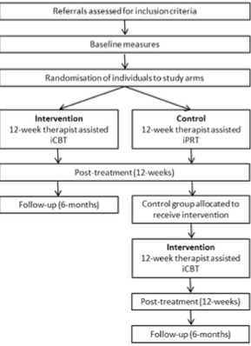
Examples of Empirically Supported Treatments:
- Exposure for Phobia
- Exposure and Response Prevention for OCD
- Behaviour Therapy, CBT, IPT for Depression
- Social Skills Training for Schizophrenia
- Dialectical Behaviour Therapy for Borderline Personality Disorder
- Parent Management Training for Oppositional Defiant Disorder

- Biological Approaches to Treatment
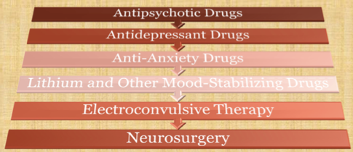

Antipsychotic Drugs:

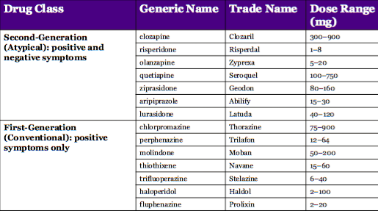
- 2nd generation: no tardive dyskinesia, but weight gain

- HUGE change on mental illness (break through)
- Help “positive” things, this that are ADDED to the behaviour
- Example: elusions
- “Negative” symptoms the things that take away from the individual
- Example: lack of happiness or emotions
- Problems side effect weight gain, psychological well being and health

Antipsychotic Drugs:
- Most widely prescribed (90% of patients being treated): effects 3-5 weeks
- MAOIs first (1950s): fatal side effects w/ foods rich in amino acid tyramine
- Tricyclics (1960s-1990): side effects, toxic in high doses

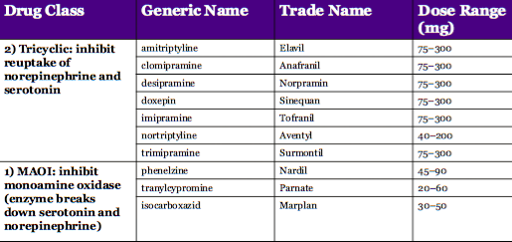

- Effects can take a long time until it kicks in some may work and may not work (long process)
- Problem: fatal

Antidepressant:
- SSRIs: “second generation” – 1988 = Prozac; better tolerated, not fatal
- Inhibit uptake of serotonin
- Side effects: nausea, diarrhea, insomnia, sexual problems
- Increased suicidal ideation among adolescents?
- SNRI: Block reuptake of norepinephrine and serotonin
- Similar side effects to SSRIs; treatment of severe depression/non-responsive to SSRIs
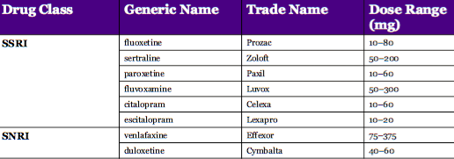Not anymore better BUT more acceptable and NOT fatal

Antianxiety Drugs (Anxiolytics)
- Not a cure; short term relief: absorbed quickly
- Benzodiazepines:
- Low dose: ↓ anxiety; high dose: sleep
- Addictive potential; withdrawal symptoms
- Enhance gamma aminobutyric acid (GABA) activity in parts of brain implicated in anxiety (e.g., limbic system)

Lithium (1970s)
- Common in treatment of bipolar disorder
- Natural compound: can’t patent (delay)
- 70-80% patients in manic state improve within 2-3 weeks
- Prevention of further episodes
- Mixed evidence
- Relapse probability 28x higher if not taking (always have to be monitoring)
- Toxic effect on kidneys: blood monitoring
- Compliance can be hard: miss highs, energy
- Antidepressants can kick start a bipolar disorder

Medication Vs. Psychotherapy
- Mild forms, first line treatment = therapy
- Severe forms = psychiatrist for medication + therapy
- First to JUST have threpay, medication ONLY for sever forms
- Medication works faster than therapy
- Unwanted side effects
- Drugs don’t cure psychological disorders
- Risk of relapse when discontinued

Medication Vs. Psychotherapy
Combined Treatment
- Currently quite common
- Evidence for effectiveness of combined treatment is variable for different disorders
- Medication can help engage in therapy
- Medication can help in the acute phase; therapy for broad and enduring change
- Medication is necessary in some cases (e.g., schizophrenia, bipolar disorder)
**medication can help benefit for the individual to seek treatment

Psychotherapy:
- Psychodynamic therapy
- Behaviour therapy
- Cognitive behavioural therapy

- Psychodynamic Therapy:
- Insight therapy: identify and resolve childhood conflicts in context of adult reality; uncover repressed memories, thoughts and fears
- Overuse, inflexibility of defense mechanisms
- Reduce anxiety but avoid (vs. confront) unconscious conflict
- Uses techniques that bring conflicts into conscious awareness; identifies defense mechanisms
- Constantly censoring ourselves to protect from unpleasant thoughts

Psychodynamic Therapy: Techniques
- Free association:
- Say whatever comes to mind, no matter how personal, painful, or seemingly irrelevant
- Whatever come to mind first, even if it doesn’t make sense
- Unintentionally give voice to repressed mental content, processes
 **Pull information from the unconscious, can bring out repressed thoughts
- Actual responses AND any hesitations provide clues for therapist
- Therapist’s job is to tie together ideas in meaningful way to give insight into relationship b/t maladaptive beh. & unconscious events that drive it

- Dream analysis:
- “royal road to the unconscious”
- Repressive defenses lowered; expression of unconscious impulses
- Three sources of input into dreams:
- Concurrent sensory stimulation (e.g., barking dog, ringing phone); absorbed into dreams (things that are happening around us when we are sleeping)
- Current concerns: thoughts, feelings, concerns of waking life (example: you have an exam coming up, might dream that you are late for your exam, things that are currently happening in your life.)
- Unconscious id impulses: blocked from expression while awake; related to core conflicts; reveals most about personality (everything that is repressed when we are awake)

- Manifest content: actual content & sensory images
- Our description of a dream
- What we believe we saw
- Latent content: disguised meaning
- E.g. Fork in the road
- Used dream work to interpret
- The disguised meaning
- Free associate with actual whole dream and then each particular detail

DreamWorks: Classified Images Into 5 Processes:
- Displacement: when the desire for one thing or person is symbolized by something or someone else
- Projection: when the dreamer propels their own desires and wants onto another person
- Symbolization: when the dreamer's repressed urges or suppressed desires are acted out metaphorically; symbols used to disguise concepts
- Condensation: the process in which the dreamer hides their feelings or urges by contracting it or underplaying it into a brief dream image or event; two latent thoughts condensed into one image
- Rationalization: final stage of dreamwork; the dreaming mind organizes an incoherent dream into one that is more comprehensible and logical

Psychodynamic Therapy: Techniques
- Analysis of resistance
- Unconscious avoidance of threatening material (delays, refusal to respond, switches topic)
- Therapist attempts to identify source of resistance

- Transference
- Analyst becomes object of client’s feelings toward significant others (transferred onto therapist)
- Working through
- Resolving old conflicts in safety of the therapeutic setting

Psychodynamic Therapy
- Traditionally long-term, very expensive
- Modern approaches much shorter duration, but many essentials maintained
- Less emphasis on psychosexual stages, more on interpersonal issues
- Emerging evidence for the effectiveness of some newer psychodynamic approaches

- Behavior Therapy
- Both normal & abnormal behavior products of lifetime of learning

- Key to recovery is to learn new, more functional behaviors

- Exposure (& subtypes: e.g., ERP, prolonged exposure therapy)
- Relaxation training
- Systematic desensitization
- Modelling
- Social skills & assertiveness training
- Behavioral activation
- Contingency management

- Exposure:
- Directly face the feared stimulus, no negative consequences
- Anxiety diminishes over time (habituation); fear becomes extinguished
- In vivo, imaginal interceptive
- “Flooding”: immediately face most feared stimulus
- More gradual approach now preferred
- Treat phobias least to greatest fear
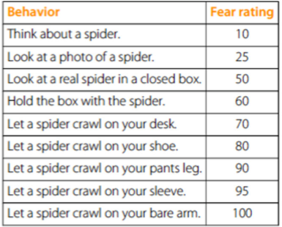
- Relaxation Training:
- Stress management, anxiety, pain, anger, panic Reduces stress symptoms, increases self-efficacy
- Deep (diaphragmatic) breathing (4 square) …breath 4 sec, hold 4 sec
- Manage day to day stress
- Visualization/guided imagery
- Progressive muscle relaxation (example script on Moodle)
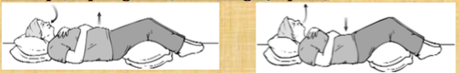

- Systematic Desensitization:
- “Counterconditioning”: replace fear response with relaxation response
- imitationg the therapist
- practice appropriate behavior
- working though things out loud to know how to act in certain situations
- ex: watch therapist touch dog may see it as less harmful now
- Three steps:
- Relaxation training
- Construct fear hierarchy
- Imagine exposure to fear hierarchy while engaging in relaxation
- Difficult to experience anxiety and relaxation at same time
- Relaxation may be counterproductive in exposure therapy
- Neutralizes anxiety vs. letting it decrease naturally
- Client learns relaxation as crutch vs. learning anxiety isn’t dangerous and will decrease on its own

- Modelling:
- Leaning new skills through imitation
- Therapist performs behavior required and client practices
- Fearlessness when confronting items on fear hierarchy
- Decision-making processes (said out loud by therapist)
- Appropriate behaviors when interacting with peers
- Social skills for interacting with others
- Assertiveness

- Social skills & Assertiveness training:
- Education
- Identifying problem areas
- Practice/role play
- Apply to situation in real world

- Behavioral Activation
- Used in the treatment of depression
- Activity schedule to increase positive activities and reduce avoidance
- Being with short term goals; introduce small changes, building up to long-tem goals

- Contingency Management:
- Selective use of reinforcement/ punishers to adjust behavior
- Therapist deliberately presents/withdraws reinforcers or aversive stimuli following behaviors that they want to change
- Temper tantrums, autism, hyperactivity, aggression
- Very useful with young children
- Used with young children (+ reinforce behavior, - punish behavior)

Behavioural Therapy:
- Highly scientific – proven efficacy for several disorders
- Works quickly
- May not work with more “complex” problems
- May only tackle observable symptoms, not hidden problems

- Cognitive-Behavioral Therapy:
- Maladaptive beliefs (schemas) give rise to negative automatic thoughts
- Schema ⇒ Appraisal ⇒ Automatic Thought ⇒ Emotion & Behavior
- Video: Client & therapist work together
- Identify inaccurate and maladaptive beliefs & thinking styles
- Give rise to automatic thoughts (& don’t test accuracy)
- Courtroom analogy
- Prosecutor= shows all the bad of a person (negative)
- Defense= trys to show all the good of a person (positive)
- Someone with depression has a bad “defense” lawyer, only sees the bad
- More realistic representation of self/situation/future

- If we have negative/positive schemas this triggers positive/negative behavior
Cognitive Behavioural Therapy:
- Learn to identify automatic thoughts
- Keep thought records
- Evaluate the accuracy of the automatic thoughts
- Identify a more balanced thought
- Evaluate the effects of this process on subsequent mood & behaviour

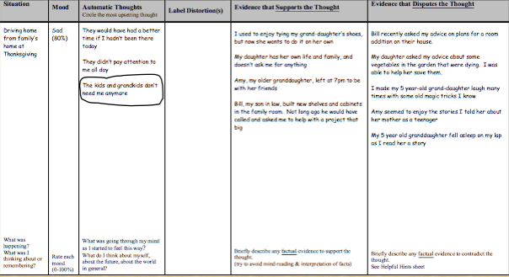
**Rate the mood at the start/ how sad are you= 80%

**Kids not needing him anymore is the main thing that is making him so sad

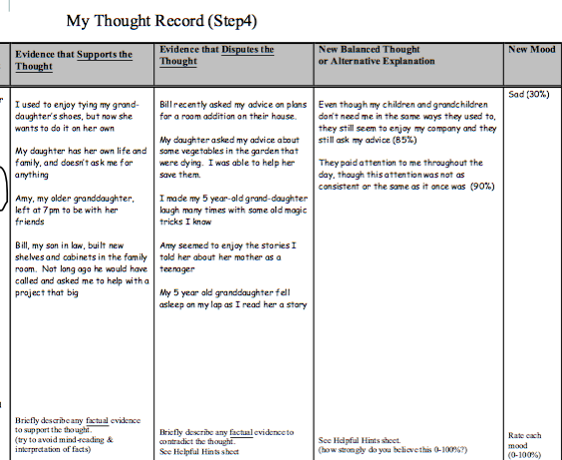
**Evidence that disputes the thought: defense lawyer (positive thoughts)
**Rate mood at the end= 30% sad
Case Study Example
Q= Case example: Mary has a genetic vulnerability to depression and has experienced many serious life stressors and strains (e.g., childhood abuse, familial deaths, and multiple failure experiences). She has likely developed negative schemas such as “I’m no good” (self), “others can’t be trusted” (others), and “effort doesn’t pay off” (world).
- To overcome depression, she would need to make cognitive and behavioral changes BUT therapeutic strategies unlikely to be attempted or maintained unless change in schemas
- WORLD = erode motivation to attempt change
- SELF = prevent recognition of progress in therapy
- OTHERS = problems in therapeutic relationship and family/friends who could provide support
Cognitive Behavioural Therapy:
- If alternative schemas exist (“I am good” when in non- depressive state), basic CT will work relatively quickly
- If no alternative schema available, clients will see evidence against their beliefs, but will still say “I am bad”
- Must identify and strengthen alternative schemas
- Must be developed before looking at evidence against thoughts
- Dual goal: Weaken maladaptive schemas, develop adaptive
__________________________________________________________________________________________________________

“Third Wave” Therapies:
- Mindfulness-based behaviour therapies: brining your thoughts into exactly what is happening, NOW; the PRESENT (not the past/future) … the here and now
- Mindfulness based CBT (MBCBT)
- Dialectical behaviour therapy (DBT)
- Acceptance and commitment therapy (ACT)
- Consciously bringing awareness to your here-and-now experience with openness, interest and receptiveness.’
- Living in the present moment
- Engaging fully in what you are doing rather than ‘getting lost’ in your thoughts
- Allowing your feelings to be as they are, letting them come and go rather than trying to control them
- You’re always going to have “bumps in the road” its important to live in the presence

“Third Wave” Therapies:
- Acceptance and commitment therapy (ACT)
- Assumption that psychological processes of a normal human mind are often destructive and create psychological suffering
- Actively fighting these processes = distress
- Instead: create a rich and meaningful life, while accepting the pain that inevitably goes with it; symptom reduction is not goal
- Six core principles of ACT:
- Cognitive defusion; acceptance; contact with the present moment; the Observing Self; values; committed action.

Couple/Marital Therapy:
- Previous gold standard: traditional behavioural couple therapy (TBCT)
- 10-26 sessions, emphasizing change
- Focuses on changing behaviours through reinforcement
- exchange of positive behaviours (behavioural exchange through contingency contracts)
- Training in communication skills and problem-resolution
- ~60—70% couples report improvement in satisfaction

- New gold standard: integrative behavioural couple therapy (New method, more positive results)
- 4 sessions assessment/feedback; 20-22 sessions therapy
- Acceptance is key: come to terms and accept partner’s limitations
- Integrate with change behaviours
- Focuses on broad themes of struggle vs. specific problems
- Sessions focus on salient incident (e.g., argument) that occurred, is not occurring, or will occur in future; emotional acceptance
- ~70—80% couples report improvement in satisfaction; more happy than those treated with TBCT, longer lasting

Eclectic & Integrative Approaches:
- Most therapists self-identify as “eclectic”
- Borrow from different approaches as seems suitable for the individual client
- Integrative
- Attempt to develop a cohesive overarching theory and integrate various approaches into this theory

Therapeutic Outcomes
- How well clients do in therapy is related to
- Motivation for seeking therapy (self directed? Court ordered?)
- Severity of mental illness & length of maladaptive behaviour patterns
- Environment (financial stability, family, etc.) …helpful, less stressors
- Expectations and confidence in therapist
- The working alliance they have with their therapist…that their expectations are not to high and that they are attenable
- Self-directed usually do better (within the person)

The Therapeutic Relationship:
- This can be a challenge
- Many clients have maladaptive interpersonal behavioral

- Components of a therapeutic alliance
- Sense of working collaboratively
- Therapist must be warm, welcoming and work together
- Agreement about the goals and tasks of therapy
- Affective bond between the patient and therapist
- Therapist must be empathetic and warm (work with what the client wants)
- Positive environment, working together
- Restate their sayings so you’re truly understanding what they are saying

- Client characteristics:
- Motivation
- Expectations

The Therapeutic Relationship:


