Chapter 1-scientific understanding of behavior

Methods of Acquiring Knowldege

- 1. Unscientific
- 1. Intuition: unquestioning acceptance of own judgment
  - Pros: more quickly and easily access knowledge, allows us to understand values that are imp. To us
  - Cons: difficult to analyze and critique, subject to prejudices and misconceptions
  - Usually used to find an explanation for own or other’s behaviors or explain intriguing events that you observe
  - Illusory correlation (no longer looking for long term love increases the chances of finding it)
- 2. Authority: Knowledge based on information from “credible other”
  - Pros: minimizes need to acquire knowledge on our own, many people of authority have legitimate credentials to be considered “authority”
  - Cons: Authorities may be wrong, or use intuition, experience or fold wisdom;
“Authority” may be due to perceived cues of credibility (e.g. attractiveness, popularity)
- 3. Common Sense/Folk Wisdom: appealing to what on expects everyone else to know
  - Pros: There is an explanation for every situation; a short, mutually understood way of communicating more complicated idea
  - Cons: Often contradictory, rendering them meaningless; cannot be refuted or falsified
- 4. Experience: Replying on personal experience to make decisions
  - Pros: May be representative of collection of all possible experiences, vivid examples that are easy to remember
  - Cons: May not be representative of collection of all possible experiences, cannot account for alternative explanations
- 2. Scientific
- Scientific skepticism: Recognize that our own ideas are just as likely to be as wrong as anyone else’s and question other people’s pronouncements of truth, regardless of their prestige or authority
- -The fundamental characteristics of scientific model, Empiricism: knowledge is based on structured, systematic observation

Ideal processes of scientific design
- Universalism: scientific observations are systematically structure and evaluate objectively using accepted methods of the discipline
- Communality: Method and results are to be shared openly so that others can replicate to ensure the effects are not just random flukes. In addition, results of many studies of the same phenomenon can be combined in meta analyses to examine overall effect
- Disinterestedness: Scientists should be rewarded for their honest and careful quest for truth, and ideally not motivated primarily for personal gain
- Organized skepticism: Peer review, before a study is published in a scientific journal, it must be reviewed by other scientists who have the expertise to carefully evaluate the research and recommended whether the research should be published

Science as Way to Ask and Answer Questions

Scientific approach provides an objective set of rule for gathering, evaluating, and reporting evidence

-Researchers are only interested in falsifiable ideas. If an idea is falsifiable, then it can be either refuted or supported using empirical data.

Checklist for detecting for detecting some warning signs of pseudoscience:

*Claims are not falsifiable

*If tests are reported, methodology is not scientific and accuracy of data is questionable

*Supportive evidence is anecdotal or relies heavily on authorities who are “so-called” experts in the area of interest. Genuine, peer-reviewed scientific references are not cited

*Claims ignore conflicting evidence

*Claims are stated in scientific-sounding terminology and ideas

*Claims tend to be vague, rationalize strongly held beliefs, and appeal to preconceived ideas

*Claims are never revised to account for new data

Pseudoscience: use scientific terms to make claims look compelling but without using scientific data

- Logic: knowledge derived from rules of logical thinking
  - Pros: lead to internally consistent reasoning and decisions. Easy to analyze and critique (premises, clearly laid out)
  - Cons: logical reasoning may be based on incorrect premises or information, or other logical fallacies; What may be logically consistent may actually differ from what occurs in the world
  - Between scientific and unscientific

- Canons of Science
- Determinism
  - the assumption that the universe is orderly
  - Events occur due to some meaningful and systematic cause
  - Foundation of research
- Empiricism
  - We understand the world by making structured, systematic observations
  - Making such observations is best way to figure out orderly principles
- Parsimony
  - When two theories can explain the same set of empirical observations, preference Simpler
  - Forces scientists to make as few assumptions as possible
  - Aka Occam’s Razor
  - When complex and simple idea equally able to explain a set of data simpler idea as it is more easily tested

- Testability
  - Researchers should be able to put scientific theories to empirical
  - It is particularly important that theories are falsifiable (more easily falsify simple ideas)

- Goals of Science-what it tries to do
- 1. describe behavior (description of behavior)
- 2. predict behavior: once it has been observed with some regularity that 2 events are systematically related to one another, it becomes possible to make predictions and anticipate events
- 3. determine causes of behavior: to know how to change behavior, we need to know the causes of behavior

Criteria for Causal Claim
- Covariation of cause and effect: When the cause is present, the effect occurs; when the cause is not present, the effect does not occur
- Temporal precedence: Cause precedes the event
- Alternative explanation: nothing other than a causal variable could be responsible for the observed effects
- 4. understand/explain behavior: why the event or behavior occurred
- 5. apply knowledge to solve problems

Basic and Applied Research

Basic Research

Basic research: attempts to answer fundamental questions about the nature of behaviors

*studies are often designed to develop and test aspect of theories about phenomena

*purpose is theory testing

Applied Research

Applied research: conducted to address practical problems and potential solutions

*offers insight into problems or solutions, and some offers specific tools to address those problems in specific settings

Careers in Applied Research

Program evaluation: tests the efficacy of social reforms and innovations that occur in government, education, and institutions.

*social programs are designed to achieve certain outcomes, and social scientists should evaluate each program to determine whether it is having its intended effect

Integrating Basic and Applied Research

-much applied research is guided by the theories and findings of basic research investigation

-in turn, the findings obtained in applied settings often suggest modification of existing research theories and thereby spur more basic research

-research with no apparent practical application value ultimately can be very useful

Chapter 2- Where to start

- Terms Defined
- Theory: a system of logical ideas that are proposed to explain a particular phenomenon and its relationship to other phenomena
  - Overarching framework that organizes and explains phenomena and data
  - Generates hypotheses that test boundaries of the theory

Hypothesis
- -A tentative statement about a relationship that may or may not be true, is informed by past research or derived from a broader theory, and is waiting for evidence to support or refute it
- Prediction
- -Specific statement regarding the expected outcome of a study
- Parismony
- -multiple theories are equally successful at explaining the same phenomena, principle of parsimony dictates that the least complex theory is most desirable, because it is easiest to entirely falsify

Research Article

Abstract: summarizes the entire report

Introduction: explains the problem under investigation

*Read to found out the purpose of the study, the past research and theories relevant to study and the hypothesis

Method: describes in detail the exact procedures used in the study

*Read to find out characteristics of the participants, what they were asked to do, what materials were used, and the overall study design

Results: presents the specific finds

*Read for tables, graphs, and sentences that summarize the pattern of findings. This section will become easier to read as you increase your knowledge of statistics

Discussion: concludes the article, in which the researcher may speculate on the broader implications of the results, address potential alternative explanations for the results, discuss reason that a particular hypothesis may not have been supported by the data and/or make suggestions for further research on the problem

*Read for conclusions about the hypothesis, the study’s strength and limitations, and contributions it makes to understanding the topic

Reference: lists all the sources that were cited throughout the article

Other types of article: literature reviews and Meta-analyses

Literature review (uses narrative techniques) or a meta-analysis ( uses statistical techniques)

-review articles will have all six sections except for results and methods

Scientific method
- 1. Theory Hypothesis Prediction (DEDUCTION- top down) general specific
- P Q; P therefore Q;
- strongest scientific method (certain in the validity of the premise certain in the validity of the conclusion)
- Observation:
- -Every time I eat peanuts, my throat swells up
- Hypothesis:
- -The next time I eat peanuts, my throat will continue to swell up
- Theory:
- -I probably have allergy to peanuts

- 2. Observation Hypothesis Theory (INDUCTION) specific general
- Boundary condition <Theory>
- Observation:
- -Patient presents with shortness of breath, headache, fatigue
- What happened?
- -Anemia, Lung Cancer…etc

- 3. Observation What the heck happened? (ABDUCTION)
- absence of theory; most common in everyday lives
- If P Q; Q therefore P

Example Study: Deduction

Theory:
  - Human Behavior is a function of their life experience and exposure to stimuli in their lives
    - Builds on previous research
- Hypothesis:
  - After playing violent games rather than non-violent games, one will become ore aggressive even after the game is over
- Method
  - 24 hours later, participants played competitive game with partner
  - Option to punish partner for losing (Blast loser with painful noise through headphones)

Results
  - Calculate average score on outcome variable for each group
  - Compare averages
    - use inferential statistics
- Prediction
  - After 24 hours, participants who played a violent game will give a stronger noise to partners

Discussion

Data support/ (in)consistent with hypotheses
  - **never confirm/(dis)prove
  - important to take the weight of the evidence

- What makes theories good?
- 1. supported by data
- 2. falsifiable
  - falsifiability is ability for one to show a theory to be wrong
    - there can exist data that is inconsistent with a theory
- 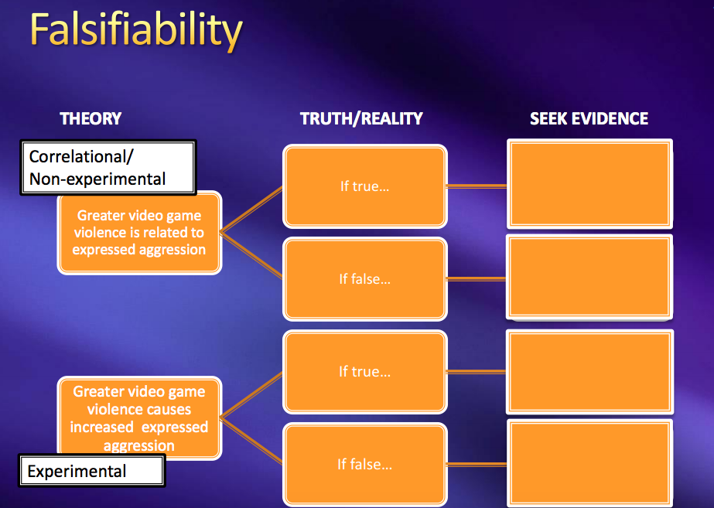
  - falsifiability can also be considered as a matter of degree
    - Flip a coin 10 times. Make 4 predictions of the coin when it first lands
      - More heads than tails (no set #)
      - Heads until someone looks
      - HTTTHTHHTH (most falsifiable, set #)
      - Heads does not equal tail
- 3. parsimonious: simpler theories are preferred to more complex theories that can explain the same phenomena
  - Simpler has 2 meanings
    - Requires fewer conceptual relationships/assumptions
    - Requires fewer adjustments to established relationships in science
    - If equally helpful at explaining existing research and generating new hypotheses the simpler theory more scientifically interesting because needs only one leg to fail to destroy the whole thing…
  - Ex) Violence in video games aggressive behavior by children

Violence in video games children desensitized to violence aggressive behavior by children?

Which theory is more parsimonious? A, because fewer links in causal chain

Which theory is more falsifiable?

Good Hypothesis | Bad Hypotheses
-make predictions that exposes itself to falsification  -Make specific predictions=strong support | -make predictions that are difficult to falsify  -make general predictions=weak support

Chapter 4- Research Design Fundamental
- Parsimony and Falsifiability:
- Parsimony: simpler theories are preferred to more complex theories that can explain the same phenomenon
- Simpler has 2 meanings:
  - Fewer conceptual relationships (assumptions)= less data required to counter a theory
  - Fewer adjustments to established relationships in science= less data required to test adjustments

-We are evaluating the whole theory

-More parsimony and more falsifiability is good

Essentialism and Operationism

Essentialism: There is an unchanging, underlying essence of an entity that can be defined
- Sense of fixedness
- Focus is on the meaning of words

Operational definition: a definition of the variable in terms of the operations or techniques used to measure or manipulate it in a specific study so variables could be studied empirically
- When considering options for operational definitions, it is helpful to think about variables in 3 categories:
- Situational variable: characteristics of a situation or environment (ex. Length of words you read in book, # of bystanders…etc)
  - Measured in designs or manipulated in experimental designs
- Response variable: responses of behaviors of individuals (ex. Reaction time)
  - Measured in either experimental or non-experimental design
- Participant variable: characteristic that individuals bring to a study including cultural, intelligence, and personality traits

Avoiding confounds in operational definitions

Confounding variable: variables that are intertwiened with another variable so that you cannot determine which of the variables is operating in a given situation

Video games violence and aggression

Target hypothesis: playing violent video games leads people to become more aggressive

Study’s Hypothesis: playing violent video games is associate with greater aggression

Operational definition:
  - playing violent video games
    - Frequency of playing favourite games x rating of a game’s violence
  - Aggression:
    - Self-reported hostility
    - Scores on the cook and medley hostility scale
- Prediction:
  - As one plays more violent games, the scores on the Cook and Medley Hostility Scale increases
- Method
  - 607 8th and 9th graders
- 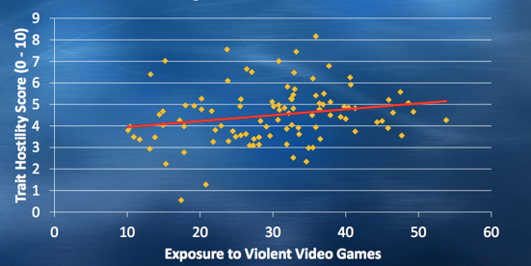
  - Conclusion
    - These finds suggest that children may be affected by violent video games
    - The results support our hypothesis that playing the violent game would result in more aggression than would playing the nonviolent game
  - Flaw:
    - Self-report measure
    - Correlation NO causation
  - Follow-up study
    - Change operational definition of aggression
      - Change operational definition of aggression
        - Self report of hostility might bot be accurate
        - Use number of actual physical fights
  - Theory/broad framework
    - Playing violent games leads on to exhibit greater aggression
      - Do we have evidence of this? No causal relationship
      - Do these data convince you of this theory? No
      - Do you see any more problems with these data? Yes

Nonexperimental method
Non experimental: relationships are studied by observing or otherwise the variable of interest
- Correlation design: a type of non-experiment simply measuring variables
- correlation coefficient (r): a statistic that indexes the degree of linear relationship between two variables
- Also called Pearson product moment correlation
- cannot conclude causation and deal with linear relationship (bi-directionality problem and third variable problem)
- Types of relationships
  - Positive linear relationship
  - Negative linear relatopnship
  - Curvilinear relationship: increase in the values on variable are accompanied by both increases and decreases in the values of other variable
  - No relationship- flat line
  - Mediating variable: a psychological process that occurs between two variables that helps to explain the relationship between them
-Reduce random error or error variability by conducting additional research

Interpreting non-experimental results
Two problems preventing researchers from making causal statements when the non-experimental method is used
- Difficulty in determining the direction of cause and effect (issue of temporal precedence)
- The third-variable problem- that is extraneous variables may cause an observed relationship (offers alternative explanation)
**Third variables cause the apparent relationship between 2 other variables (correlational study), whereas confounding variables are intertwined with another variable in your study so that you cannot tell which is at work (experiment)

Experimental Method
Experimental: direct manipulation and control of variables
-Independent variable (x-axis) dependent variable (y-axis)
-Internal validity: the ability to infer that one variable causes changes in another variable
1. Covariation between two variables (participants in experimental condition show a different effect relative to participants in a control condition)
2. Temporal precedence (cause has to preceded the effect)
3. Eliminate plausible alternative explanations
- Achieving internal validity (eliminating alternative explanations)
- Experimental control: treat participants in all groups in the experiment identically so that the only difference between groups is the independent variable and minimize confounds
- Random assignment of people to condition: ensures extraneous variables are just as likely to affect one experimental group as they are to affect the other group, as long as there are enough participants in the study
-Another criteria: cause-and-effect relationship when cause is both necessary and sufficient for the effect to occur
Choosing a method: Advantages of Multiple Methods
- Artificiality of Experiments
- Field Study: IV is manipulated in a natural setting

Disadvantage: researchers lose ability to directly control many aspects of situation

Advantage: IV investigated in natural context
- Laboratory experiment

Disadvantage: create an artificial atmosphere that may limit either the question that can be addressed or the generality of the results

Advantage: more easily keep extraneous variables constant
- Ethical and Practical Considerations

-Sometimes experimental method is not feasible because unethical or impractical (ex. effects of alcoholism and divorce)

-no random assignment so causation cannot be established

3. Describing behavior

- causal claims irrelevant therefore experiments are unnecessary

4. Predicting future behaviors

-Cause and effect of little concern

**Confidence in findings and understanding of phenomenon increased when multiple studies using multiple methods point to same conclusion

How do we design studies to maximize chances that we’ll be able to…

-conclude that IV caused changes in DV? Experimental control, including ruling our alternative explanations

-Detect an effect if it’s there? Optimize our operational definitions

Practical Considerations

-Experimental control
- Ensuring only the IV changes across conditions
- Avoiding alternative explanations, such as demand characteristics, experimenter expectancy effect

-Optimizing our operational definitions of the IV and the DV
- Avoiding ceiling and floor effects
- Appropriately pairing IV and DV

Demand Characteristics

Demand characteristics: any feature of an experiment of an experiment that might inform participants on the purpose of the study (threat to internal validity)

-participants might try to help/hurt you
- Hawthorne Effect
- Evaluation apprehension

Options for Avoiding Demand Characteristics

-single blind study (keep participant blind to the hypothesis of the study)

-distractor/ filler items (questions/items that have little to do with the actual)

Experimenter Expectancy Effect

-When a researcher knows what condition participants are in and therefore unconsciously manipulates an experiment in order to find the expected effect (threat to internal validity)

Options for Avoiding Experiment Expectancy

-Double-blind study

-computer study (minimize interactions between researcher and participant)

Interaction effects

-Various social components of the researcher/participant interaction may affect the results
- Biosocial Effect: the influenced exerted on research by the researcher’s own biological and social characteristics. Without intending to, an experimenter gives off subtle signals or cues which act as expectancies
- Psychosocial effect: effect caused by environmental and/or biological factors on individual’s social and/or psychological aspects.

Ceiling effect

-too easy

-everybody does very well

-very little variability

-hard to see effect of IV

Floor effect

-too difficult

-everybody does very poorly

-very little variability

-hard to see effect of IV

Chapter 9- conducting studies

Options for Manipulating Independent Variable
Straightforward manipulations: manipulate variable by simply presenting the material to participants (mundane realism: study mimic experiences and conditions present in everyday life)
Staged Manipulations: indirectly elicit a state, create a series of events that occur during the experiment to manipulate the IV (experimental realism: when a study engages and involves participants in a real way)
-Deception is used
Used for…
- Creating some psychological state in the participants
- Simulate something that occurs in real world (usually employ a confederate)
-Difficult to replicate
-complex manipulation is difficult to interpret

Straightforward | Staged
PRO: simple and common | PRO: Better simulation and avoid demand characteristics
CON: artificial and demand characteristics | CON: may arouse suspicion, can be difficult to proceed as planned

Consideration when manipulating IV
Manipulation Strength: try to make manipulation as strong as possible by making the level of IV maximally different, while keeping everything else between the 2 groups the same
Strong: good shot at creating a big change in DV
Weak: good at making fine distinctions in DVs but usually can’t create big effects
Cost of manipulation: straightforward manipulations usually less costly
Manipulation checks: a method by which researchers can quantify the effectiveness of a manipulation
- If used in pilot study and reveals your manipulation was not effective, can change procedures- increase strength of IV
- If results show no effect of IV on DV (know that problem was not due to problem with manipulation)
Options for measuring variables
- Self report: measure explicit attitudes, judgments, thoughts, or characteristics
- Behavioral: direct observation and coding of behaviors
- Physiological: recording of response of body (ex. Galvanic skin response, EMG, EEG, ECG, MRI, fMRI)
Additional considerations when measuring variable
Sensitivity: DV should be sensitive enough to detect resulting differences between groups
Ceiling effect: IV might appear to have no effect on dependent measure only because participants quickly reach the maximum performance level (task too easy)
Floor effect: Task is too difficult that hardly anyone can perform well

Multiple measures: when you have more than one measure, the question of order arises.
Strategy:
- Present more important variable first and the less important ones later
- Counterbalance the order of presenting the measures
Cost of measure

Advanced considerations for ensuring control

Controlling for participant expectations
- Demand characteristics: any feature of a study that might inform participants of its purpose and consequently affect the behavior
*deception
*filler items: to disguise the dependent measure by placing measure in a set of unrelated filler items
*asking about perception of study
2. Placebo effect
waitlist control condition: participants in control condition given treatment after study is completed
Balanced placebo effect: (1) given nicotine-told nicotine (2) given nicotine- not told nicotine (3) not given nicotine-told no nicotine (4) not given nicotine-told nicotine

Controlling for experimenter bias:
-experimenters aware of the purpose of the study and may develop expectations for how participants should respond
single blind study: the person conducting study or making observation is blind regarding what is being studied or which condition the participants are in
double blind study: neither participant nor experimenter knows the participant’s condition. Usually requires 2 experiments- one to administer IV and one to administer DV

Seek ethics approval
-Seek approval from Research Ethics Board (REB)
-debriefing: provides an opportunity for the researcher to explain the ethical and educational implications of the study
-Funnelled debrief: specific set of question to probe for suspicion

Collecting data
Pilot study: researcher does a “trial run” with a small number of participants drawn from the same population as the sample
when procedures are particularly elaborate or costly or when there will be only a single opportunity to collect data
Researcher commitments
-researcher there during data collection
-if promise to send summary of results to participants, should so immediately
-course credit

Analyzing and interpreting results
-are variables significantly related to each other? Does IV have small or large or no effect on DV? Might conduct follow up study to see if results can be replicated with new sample of participants

Communicating Research To Others
-Professional conferences, journal articles

Chapter 7
Surveys
Panel study (longitudinal design): when the same people are traced and surveyed at 2 or more points in time

Response bias in survey research
-assumption people are able to provide truthful and accurate answers
Response set: tendency to respond to all questions from a particular perspective rather then to provide answers that are directly related to the questions
- Social desirability: answer in the most socially acceptable way (extent to which people claim familiarity with fake facts)
- Ensuring confidentiality
Constructing questions to ask
- Defining research objectives
3 types of survey questions:
- Attitudes and beliefs
- Facts and demographics
- Behaviors (exercise)
Question wording
Unnecessary complexity: questions should be simple and avoid jargon and technical terms people won’t understand
Double-barrelled questions: ask 2 things at ones (ex. “Should senior citizens be give more money for recreation and food assistance programs?”)
Loaded questions: Written to lead people to response in one way (ex. “Do you favor eliminating the wasteful excess in the public school budget?”) Emotionally charge words ( rape, immoral, waste, dangerous) can influence response
Negative wording: Avoid phrasing questions with negative (ex. “Do you believe that the city should not approve the proposed women’s shelter?”) Reduces reliability and validity
Yea-saying/Nay-saying: either disagreeing or agreeing with all the questions
**use reverse-scored questions
ex. We need to have strict gun control vs everyone should be free to own a gun

Closed vs. open ended questions
Close-ended: limited number of response alternatives
PROs: easier to code
CONs: lead to different conclusion
Open-ended: free to answer in any way they like
PROs: valuable insight into what people are thinking
CONs: require time to code responses and costly, response cannot be categorized

Rating scales for close-ended questions
- Labelling response alternatives (more labelled scales are more reliable)
- Number of response alternatives
  - Recommended that neutral option is avoided because people choose that when they don’t know how to respond (fence-sitting)
  - High frequency vs low frequency scale
    - Asking about behavioral frequency
- Graphic rating scale: requires a mark along a continuous 100 mm line that is anchored with descriptions at the end
- Semantic differential scale: measure the meaning that people ascribe to concept. Respondents rate any concept on a series of bipolar adjectives using a 7 point scale
- Evaluation (good-bad, wise-foolish, kind-cruel)
- Activity (passive-active, slow-fast, excitable-calm)
- Potency (weak-strong, hard-soft, large-small)
- Forced choice
- Non verbal scale

Formatting questionnaire and refining questions
-should appear attractive and professional
-space between questions
-use scale format consistently
-order of question (ask most interesting first)
-shorter questionnaires produce higher response rate

Chapter 8- experimental design

Planning a basic experiment
- Obtaining 2 equivalent groups of participants
- There are 3 basic ways to assign participants to control group
- Independent group design: Randomly assign to only one level of IV
- Repeated measures design: assign to all levels of IV
- Matched pair design: First match 2 people on a characteristic and then randomly assign one of each pair to only one level of IV
- Introducing the IV
- Operationally define IV, creating at least 2 levels
- Measuring the effect of the IV on DV
- Operationally define DV

Between subjects Design
Independent group design (between-subjects design): different participants are assigned to each level of IV using random assignment
pretest-posttest design: pretest scores for 2 groups are compared to ensure 2 groups were equivalent on that critical variable before manipulation was given
posttest-only design: no pretest given
Advantages of pretest :
- small sample size
- to select appropriate participants
- when participants might group out of study (mortality: drop out factor)
- Allows researchers to examine whether mortality is a plausible alternative explanation for differences between groups on DV
Disadvantages
- Time consuming and awkward to administer in the context of the particular experimental procedures being used
- Can sensitize participants to what you are studying and figure out hypothesis
-deception
-Solomon four-group design: assess impact of pretest directly. Pretest is considered the second IV 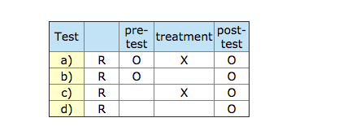
- Pretest may affect results and difficult to generalize

Within subject design
Repeated measures design: participants are measured on the DV after being in each condition of the experiments

Advantages:
- Fewer participant because everyone participates
- Extremely sensitive to detecting differences between levels of IV
Disadvantages:
- Order effect: the order of presenting the treatments affects the DV
- Practice effect: performance improvise because of repeated practice with task
- Fatigue effect: performance worsens as participants become tired, bored, or distracted
- Contrast effect: response to the second condition is altered because the two conditions are contrasted to one another (after reading about murder in first condition, reading about theft in second condition might seem much milder)
To deal with it…
(1) using counterbalancing technique
- All possible order of presentation are included in experiment
- Calculate average of different order and if similar, results suggest no order effect
- With 3 levels there are 3! (6 possible orders)
- Partial counterbalancing- Latin square: a limited set of orders constructed to ensure that (1) each condition appears at each ordinal position and (2) each condition precedes and follows each condition
(2) ensuring the time between conditions is long enough to minimize the influence of the first condition on second

concurrent measures design
- Participants exposed to both conditions at the same time
- Associated with a single attitudinal or behavioral preference as dv
One group either violent one or non violent video game ask a series of questions

Advantages:
- Very simple to administer and quick to run

Disadvantages:
- Severe restrictions of research questions and DV
- Strong demand characteristics
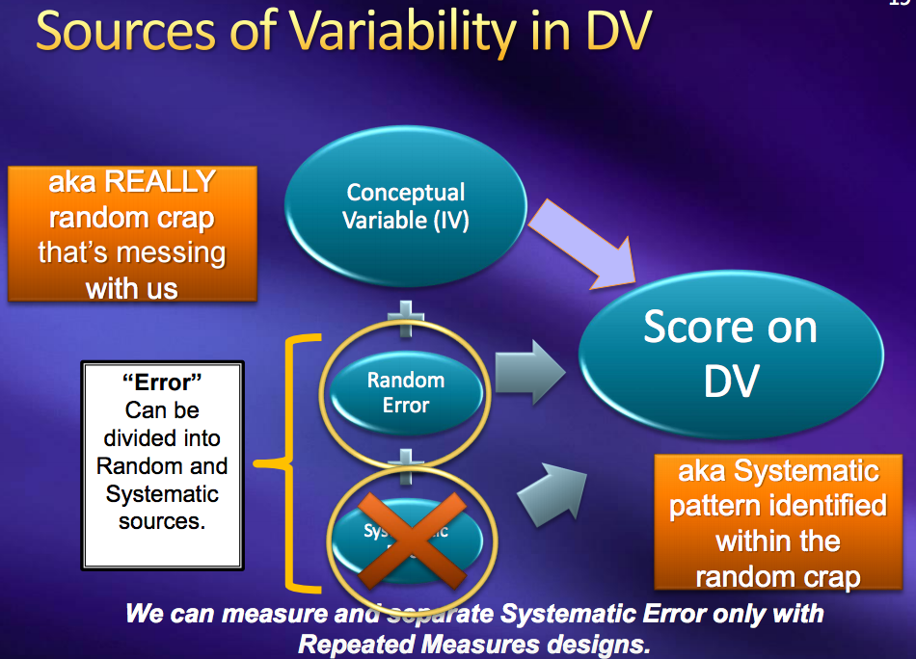

Advantage of repeated measures over independent group design:
- Less participants
- Removing some error variance means that any effect of the IV hat exist will be easier to detect using statistics

-We encounter only 1 condition w/o contrasting comparisons (ex. Characteristics of defendant in trial because jurors focus on a single defendant in trial) independent group design
-We encounter variable in repeated measures fashion (ex. Employers consider several job applications at once)

Weak IV repeated measures design
Non-sensitive DV repeated measures design

Strong IV doesn’t matter
Sensitive DV doesn’t matter

Matched pairs design
Matched pairs design: goal is to firsts match people on a crucial participant characteristic. The matching variable will be either the DV itself or another variable that is strongly related to it
-mostly likely use hen only few participants are available or costly to run large number of people
-help to remove some random error to
-may be costly and time consuming because they require measuring participants on matching variables

