Experiment 1
1. Did the coefficient of static friction change when the weight was doubled?
Theoretically, the coefficient of friction should remain relatively consistent as the mass increases. An increase in mass will cause an increase in the force of friction and the normal force, therefore maintaining the coefficient of friction. Conditions involving sandpaper and masses showed a slight difference of o0.0304, however conditions featuring rubber and masses showed slightly more variability with a difference of 0.0413.

2. Did the coefficient of static friction change when the surface changed?
Yes, there was an observable difference in the coefficient between the different surfaces. The sandpaper has a rougher surface than the rubber, causing for more resistance. A smoother surface has more atoms coming into contact with each other, which allows the two objects to move easily against each other.

3. Name two sources of error that affect the accuracy of this method? How can these errors be minimized?
Possible sources of error could be attributed to the grit that is rubbed off of the sandpaper and being left of the force plate would cause for an increase in friction. Another source of error would be the angle at which the trays are pulled. These errors could be remedied by wiping the force plates between each trial, and also by pulling the trays in a consistent manner.

4. What assumptions are necessary to ensure the validity of this method?
To ensure the validity of this experiment, it should be assumed that the tray is being pulled at a consistent speed and angle to ensure the normal force is constant.

5. How can you modify the coefficient of static friction between two surfaces? Think of an example in your daily life?
The coefficient of friction can be manipulated to reduce or increase the friction depending on the situation or activity. For example, walking would not be possible if there was no friction between one’s shoes and the ground. The friction helps to keep the shoe to the ground allowing you to move forward. Walking on ice is a very difficult activity, due to the little friction present.

Experiment 2
1. Did the coefficient of static friction change when the weight was doubled?
The coefficient of friction was relatively consistent when using the sandpaper against the inclined surface. However, there was more variance when using the rubber surface but not a large standard deviation.
2. Did the coefficient of static friction change when the surface changed?
The coefficient of friction changed when using the sandpaper and rubber surfaces on an inclined plane. This is attributed to the different microscopic textures, which cause friction and add resistance to the movement.
3. What limitations are inherent with this method?
This experiment requires one to raise the inclined surface in a uniform manner. This method is highly dependent on the operator, with a high risk of human error. Should the operator raise the surface too quickly the pucks would slide down at an inappropriate time giving an incorrect read of the angle.

Making Connections
1. Discuss and explain the relationship found between mu static and weight. Are your results consistent with what you expected to find based on the literature?
Based on this experiment, there is no relationship between weight and the coefficient of static friction. The coefficient of static friction between two solid surfaces is constant despite the weight, but it is the normal force and therefore the frictional force that changes. This was observed using sandpaper against the test surface. The differences observed between the different weights and the rubber surfaces are due to the nature of the object. Rubber is a deformable object and when pushing down on the object, it will temporarily retain the imprint of the force. As a result, it gives the impression of being a different surface with a different weight during testing, and does not give an accurate value for the coefficient of friction between it and the testing surface.
2. Discuss and explain then relationship found between mu static and surface. Are your results consistent with what you expected to find based on the literature?
The coefficient of friction is consistent within each tested surface, but differ from each other when put under different conditions (surfaces can be manipulated to change the coefficient of static friction based upon need). The coefficients gathered for each condition showed some variability. These differences are likely attributed to the testing methods used and the limited number of trials with consistent results.

6. 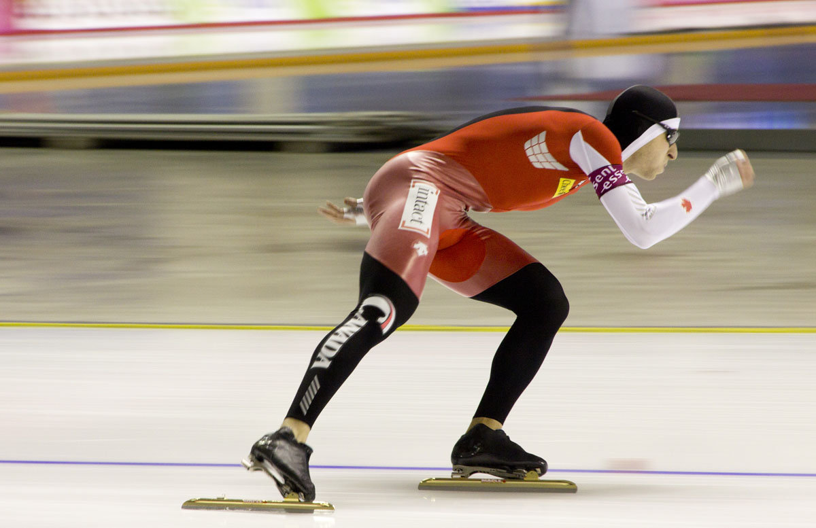
Image: James Mackenzie, James Mackenzie Photo
All Around Speed Skating Champs

From: http://www.jamesmackenziephoto.com/allround-speed-skating-champs/

During speed skating, athletes use frictional forces to propel themselves forward with each stride. Athletes maximize the force of friction by exerting a force mainly in the horizontal where the force of friction enables them so push off, without slipping, allowing them to accelerate forward.

Table 1. Calculated coefficient of friction between surfaces for varied conditions observed.
 | Sandpaper Bottom | Rubber Bottom
Mass (kg) | 2.30 4.50 | 2.30 4.50
Normal Force (N) | 26.4 47.9 | 27.3 48.6
 | F_{f}(N) M_{s} F_{f}(N) M_{s} | F_{f}(N) M_{s} F_{f}(N) M_{s}
Trial
1 | 13.5 0.511 20.2 0.422 | 18.4 0.676 29.6 0.609
2 | 13.4 0.508 21.4 0.447 | 17.0 0.625 34.8 0.716
3 | 13.2 0.500 23.8 0.497 | 18.4 0.675 29.8 0.612
4 | 13.9 0.527 37.0 0.772 | 17.7 0.648 35.1 0.722
5 | 13.2 0.500 26.8 0.560 | 16.2 0.594 37.2 0.766
Mean | 13.4 0.509 25.8 0.540 | 17.5 0.644 33.3 0.685

Table 2. Angle and coefficient of friction between surfaces observed using an inclined plane.
 | Sandpaper | Rubber
Number of pucks | 1 2 | 1 2
 | θ M_{s} θ M_{s} | θ M_{s} θ M_{s}
Trial
1 | 22.0 .404 36.0 .727 | 24.0 .445 30.0 .577
2 | 22.0 .404 34.0 .675 | 28.0 .532 30.0 .577
3 | 22.0 .404 38.0 .781 | 25.0 .466 30.0 .626
4 | 24.0 .445 36.0 .727 | 24.0 .445 32.0 .577
5 | 22.0 .404 37.0 .754 | 24.0 .445 30.0 .625
6 | 22.0 .404 37.0 .754 | 24.0 .445 30.0 .577
7 | 22.0 .404 35.0 .700 | 24.0 .445 30.0 .577
8 | 22.0 .404 38.0 .781 | 24.0 .445 30.0 .577
9 | 22.0 .404 37.0 .754 | 24.0 .445 30.0 .577
10 | 22.0 .404 34.0 .675 | 24.0 .445 30.0 .577
Mean * | 22.2 .408 36.1 .729 | 24.5 .445 30.4 .587
Standard Deviation * (+/-) | .632 .013 1.45 .039 | 1.27 .456 .843 .020
*Calculated using Microsoft excel file.

