Semiotics of Art - (Week one)
The desolate man full of despair goes to his lover for comfort. He needs her. Their arms passionately embrace each other, showing their eternal love for one another. She literally thirsts for his flesh, because she cannot live without him. She drains him of his blood, life, and love. He loves her anyway. They need each other. Their love is unconditional and pure despite what she is. He does not try to escape. His need for her is greater than his pain. She softly holds him as she fulfills her need, consoling him during his beautiful sacrifice. He continues to hold her in return as she drains him of his life…he wants her to need him as much as he needs her, no matter what the cost.
There are many parallels between art and language. Artists began using structural linguistics as a means to assess the underlying principles, methods, and rules of art. New branches of aesthetics developed from theorists such as Ferdinande de Saussure. Saussure focused on semiotics, which is a science of signs within society. Language is “a system of signs that express ideas,” consisting of two components. They are langue, the system of language that is internalized by a given speech community, and parole, the individual acts of speech. One of these components cannot exist without the other. It is a self-contained system of signs. Structure is how cultural meaning is produced. These signs are what give us culture and identity. Signs are made up of signifiers, such as sound or image, and the signified, which is the concept or meaning. Structuralism analyzes cultural phenomena according to the principles derived from linguists such as Saussure. Emphasis is on the systematic interrelationships among the elements of any human activity, which is the basis for the social production of meanings.
A new belief was that art possessed an internal logic that could be understood through language theory. Art was perceived as a primitive language that combined visual signs and linguistic principles. Structuralism in art focused on the language that exists between compositional elements and the conventions of art, rather than form or subject matter. It centered on process and system analysis. Structural art does not inspire the viewer through aesthetic perception, but was a model for the analytic appraisal of art. Structuralism interpreted art like a sentence. Images are often thought of as a second form of communication that is just as expressive as a natural language.
In visual art, semiotics interprets messages based on their signs and symbolism. Most signs are iconic as well as symbolic. According to Saussure, the heart of semiotics is the realization that the whole of human experience is an interpretive structure sustained by signs. Humans use these signs to convey feelings, thoughts, ideas, and ideologies. Semiotic analysis uses cultural and psychological patterns that underlie language and art. There are many similarities between a visual image and the image that written language creates. Semiotics translates a picture from an image to words. Art subconsciously consists of signs, signals and symbolism.
Symbolism is a literary movement that spread to painting in the 1880s. Symbolists were trying to cope with the notion of subjective ideas, which determined that the senses are inseparable from human emotions and that people and objects are symbols of a deeper existence. Visual language is an expression of deep, emotional, ambiguous thoughts. (See image next page)
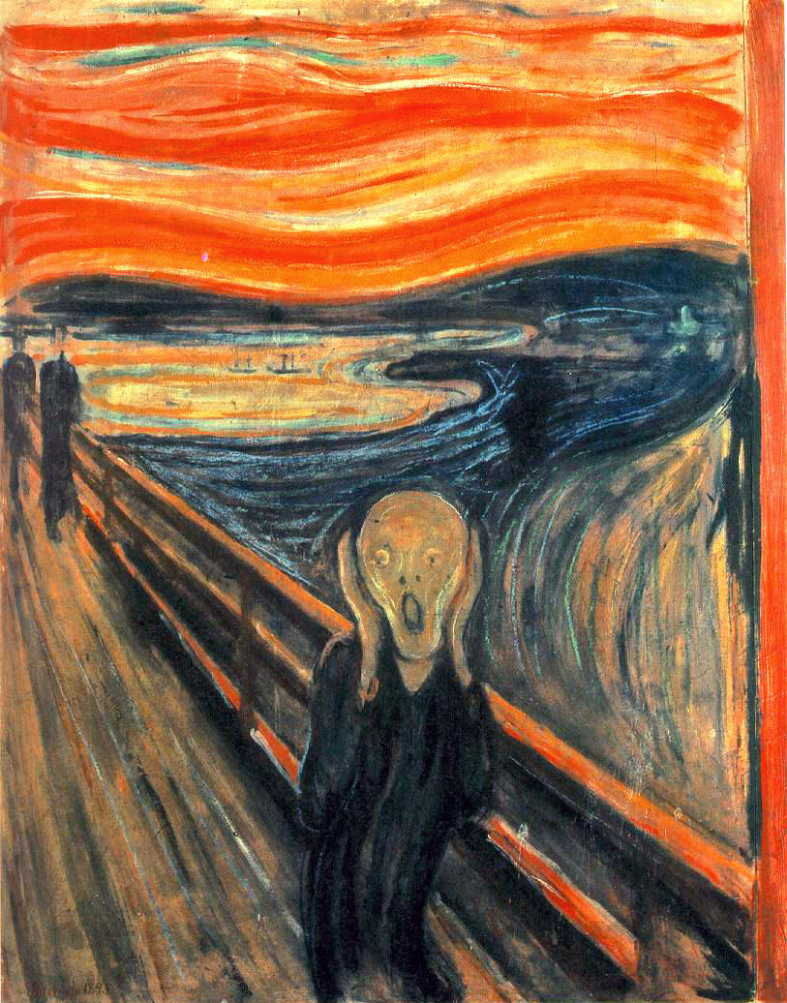
The above painting is a work by the Norwegian symbolist painter Edward Munch (Norwegian pronunciation: [ˈmʉŋk]). He is known for his most famous painting, “The Scream.” For an improved view google Edward Munch, ‘The scream’.
The said painting is a great example of how society uses signs and symbolism to interpret meaning. Most pictures use signs that have both a symbolic and visual meaning. Symbols and signs may also simply be a representation of the real thing. Artists often use this as a means to differentiate between the signifiers and the signified. Is the woman in the painting consoling her lover, or is she sucking his blood? It can be perceived as both.
The painting was originally titled “Love and Pain,” which Munch said to be nothing more than “just a woman kissing a man on the neck.” The title is very important because it is the only actual ‘text’ linked to the image. It is the only sign that is actually made up of words. Using this original title as a means of interpretation, the image represents love through an embrace between two lovers. It is as if the man is seeking comfort from the woman. It suggests a relationship between falling in love and getting hurt. The painting seems to evoke a soft intimacy between the two, yet the woman is the strong, dominant one in the painting, while the man is vulnerable and weak. The title refers to the duality and power struggle inherent in the nature of love. The lovers depict love’s paradox of tenderness and pain. The man’s arm is also embracing the woman, which would depict a mutual feeling between the lovers. They are connected through their own self-fulfilling desires and sacrifice. Munch portrays the woman in the painting as a frail, innocent sufferer. Sorrow is depicted by the woman’s helplessness to do anything except console the man, forever entwining her suffering in his own as long as she remains with him. Although some believe the painting to reflect Munch’s sexual anxieties, it is also considered to be a representation of his turbulent relationship with love itself. However, there is a dynamic exchange of power presented in the painting, and Munch successfully romanticized the representation of a gruesome and horrifying death.
Now known as “Vampire, “ this title alone evokes a completely different interpretation and meaning from the viewer. Munch intentionally made the relationship between the two figures ambiguous. A Polish critic named Stansilaw Przyszeksi noticed its vampirish image and misinterpreted the painting, saying “A broken man and on his neck a biting vampire’s face…The man is rolling about in the bottomless pit, weakly, powerlessly, rejoicing in the fact that he can roll about weakly as a stone. Yet he cannot free himself from the vampire, nor can her free himself of the pain, and the woman will always be sitting there, forever biting with a thousand viper’s tongues, with a thousand poison fangs.” Munch’s literal interpretation was rejected, and eventually he accepted the title of the painting as we know it today, saying, “It was the time of Ibsen, and if people were really bent on reveling in symbolist eeriness and called the idyll ‘Vampire,’ why not?” It is hard to deny the vampire-like content of the image.
“Vampire” was part of a 20-work project called “Frieze of Life,” based on themes of love, betrayal, fear, death, and sex. All of these are symbolized in this painting. Munch’s art was based on the misery and conflict of society during his time, as well as his own unhappiness in life. He followed themes of childhood tragedy, intense and dramatic love affairs, and ceaseless traveling. His paintings show his social awareness and tendency to express the basic fears and anxieties of mankind. This relates back to the semiotics, using the signs found in art in relation to society and the cultural identity we receive from it. According to Munch, “We want more than a mere photograph of nature. We do not want pretty pictures to be hung on drawing room walls. We want to create, or at least lay the foundations of, and art that gives something to humanity. An art that arrests and engages. An art of one’s innermost heart.” His works explored the fundamental stages of human development and experience. “Vampire” consists of sex, death, and willful abandon on the form of a vampire seductress, enveloping her object of desire. This paradox of love is still the main theme, with its components of struggle and release, and of fear and desire. The painting is able to embody these intense, conflicting emotions.
In visual art, color is an important, obvious sign used for interpretation. The dark colors and shadows in the background illuminate the figures in their dark embrace. This coincides with Munch’s dark and romantic aesthetic vales. The red tones excite the dramatic vampire subject matter. The woman’s hair is red, which symbolized blood pouring over the lovers. Her hair is also depicted as snake-like, symbolizing the man as her victim whose blood she is sucking. The woman’s arm is bright white, which is a sign of strength purity, yet is also related to the characteristic of a vampire. The redness in her face represents passion. The shadows and rings of color around the figures are meant to create an atmosphere of fear, menace, anxiety, and sexual intensity. Following themes of life, love, fear, death, melancholia, anxiety, infidelity, jealous, sexual humiliation, and separation in life and death, which the artist based off of his own personal feelings, and fears, the painting is a cross between myth and reality.
Another important factor in Structuralism is the existence of binary opposites. This painting has several obvious binaries, such as love and evil, comfort and despair, pleasure and pain, harming and helping, and of course man and woman. The difference here is that the woman is the hierarchy in the binary opposite, while it is generally the man.
This painting was at the forefront of emerging images of devilish women that spread throughout pop culture to remind society the dangers associated with unrestrained female sexuality. Munch was the first to personify this feminine threat using a complex psychological representation. It illustrated the sexual desire and delicate nature that a romantic relationship cannot exist without through its use of grim representation of death. The painting as a whole is a symbol for tragedy in a sexual relationship. It is still seen as the emblem of sex and seduction, and the daring romance rarely seen in modern art. It is an iconic image that is able to stand apart from its historical context, and is often referenced in the cultural lexicology of contemporary art. Other artist of his time idealized women and the dominance of man. Munch’s women possessed somber beauty whose inaccessibility became a terror for the artist. The woman is depicted as a vampire to symbolize the draining of life-blood from the artist, representing the unresolved experience of the mystery of sexuality. The woman consoles the man, yet uses this to her advantage to gain what she needs- his blood. The mutual embrace seems to symbolize their need for one another, rather than the woman taking advantage of the man.
“Vampire” is known to be haunting beautiful, making the viewer feel both love and uneasiness, comfort and despair. Art depends on the signs found within semiotics just as much as language does, because without these signs we would have no way of interpreting the meaning of visual art.
WORKS CITED:
Ferreira, Angela. How useful is semiotics as a method for analyzing works of art? Art & Perception: multi-disciplinary dialog. 25 Feb. 2007. Web. 20 July2010.
Saussure, Ferdinand. "Course in General Linguistics." Leitch, Vincent. The Norton Anthology of Literary Theory and Criticism. New York: W.W. Norton & Co., 2001. Print.
OcVirck, Otto, Robert Stinson, Philip Wigg, Robert Bone, and David Cayton. ArtFundamentals: Theory and Practice. New York: McGraw-Hill, 2002. Print.
Semiotics in Visual Art. 3 Dec. 2008. Web. 20 July 2010.
Vukits, Matt. Black Angels Watching Over Me. Matt Vukits Blog. 17 Feb. 2007. Web. 20 July 2010.

