Lesson 1

- The height in metres of a ball dropped from the top of the CN Tower is given by
,where t is time elapsed in seconds.

a) Draw the graph of h with respect to time.

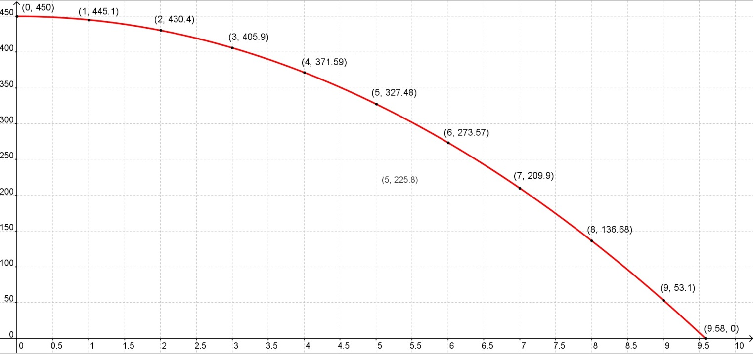

b) Find the average velocity for the first 2 seconds after the ball was dropped.

c) Find the average velocity for the following time intervals:

i) 1 ≤ t ≤ 4

ii) 1 ≤ t ≤ 2

iii)1 ≤ t ≤ 1.5

d) Use the secant method to approximate the instantaneous velocity at
t =1 second.

Let the points be A (1, 445.1) & B(0.9035, 446)

2. The mass M in grams of un dissolved sugar left in a teacup after t seconds is given by .

a) When will all the sugar dissolve?
Sugar will dissolve at M=0 g

Therefore,

b) Find the average rate of change in the interval 0 ≤ t ≤ 1.

c) Draw on graphing paper a graph of M with respect to t and use the secant method to approximate the instantaneous rate of change at t=2 seconds.

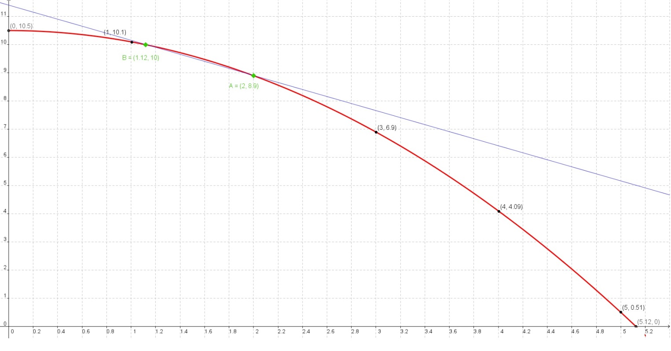
Let the points be A(2, 8.9) & B(1.12, 10)

3. As a car moves from a traffic light, the distance in metres of the car from the traffic light after t seconds is given by

a) D-T graph here

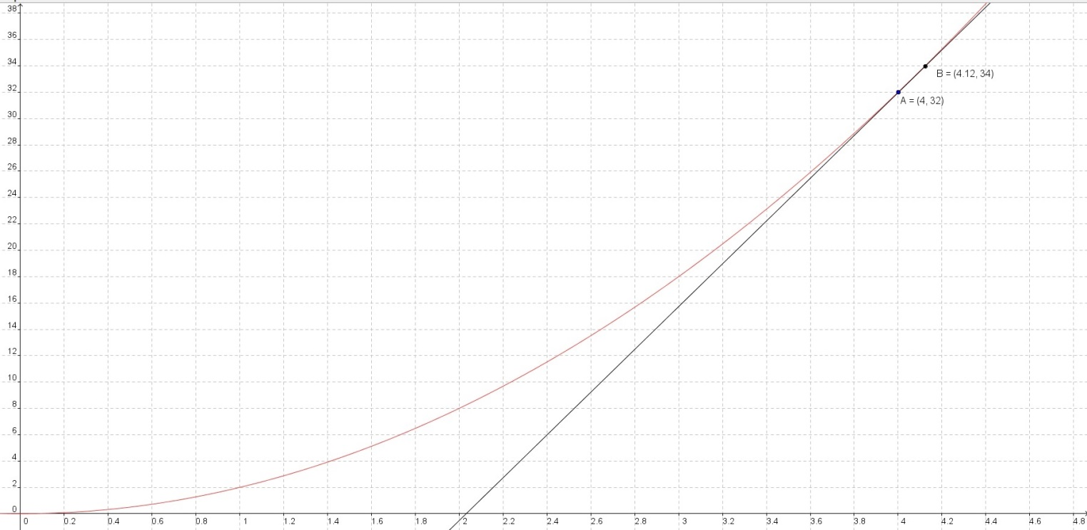

b) Calculate the average speed when 4 ≤ t ≤ 7.

c) Use the secant method to approximate the instantaneous velocity at
t = 4 sec.

Lesson 2

4. a) To find an instantaneous rate change of a function [ f(x) ] at a point [say p] a very small value [say h]is added to “p” now input the value [p] in the function [f(p)] and now input the value [p+h] in the function [f(p+h)] and now reduce the function [f(p)] from [f(p+h)] and divide it by the difference of the value [(p+h)-p],apply the limits set the very small added to zero. Now, the result will be the instantaneous rate of change at that point.
This is written as,

b)
i)

ii)

5.
a) A ball is thrown in the air. Its height from the ground in metres after t seconds is modelled by . What is the instantaneous velocity of the ball at t = 2 seconds?

Instantaneous velocity:

b) A particle’s motion is described by the equation where d and t are measured in metres and seconds. Show that the particle is at rest when t = 4.

Therefore the Object is at rest
Lesson 3

6. For the following graph:
a) Determine the intervals between which the rate of change is positive and negative.
-1 < x < 1 Negative
x < -1 , x > 1 Positive

b) State where the rate of change is zero.

Its zero at x=1 and x=-1

- List the local maximum and local minimum of the function.

Local Maximum at 2
Local Minimum at -2

7. For the function

a) Find the instantaneous rate of change at x = 0 and x = 1.

At x = 0

At x = 1

b) Is the function increasing or decreasing at x = 0? How about at x = 1?

At x=0, the function is Increasing
At x=1, the function is Decreasing

c) Do you expect a local maximum or a local minimum when0 < x < 1? Explain your answer.

Yes, a Local maximum; Since at x=0 the function is increasing and at x=1 the function is decreasing. In simple words there is a raise at x=0 and there is a fall at x=1. Therefore there is a critical point which is a local maximum between x=0 and x=1

