Hss 2102

Chapter 2

Your self-concept represents the sum of total beliefs you have about yourself
- Not only are you defined by characteristics (age, race, religion, gender), you are also defined by your life experiences, attitudes, and personality traits that influence your opinions of yourself.
- Your self concept changes as you change; you are always becoming
Sources of self concept
- You aren’t born with a self concept
- Factors influence how you develop a self concept: self awareness, cultural perspectives, influence of others, past experiences
  - Self-awareness
    - It is an understanding of your core identity
    - It requires realistic objective appraisal of your traits, thoughts, and feelings
    - The ability to monitor feelings from moment to moment is crucial to psychological insight and self understanding
    - An inability to notice our true feelings leaves us at mercy
    - Awareness of your thoughts and feelings is referred to self monitoring
    - Effective self-monitoring helps you realize feelings.
    - It gives you the opportunity to modify or control anger rather than allowing it to take over your mind and body
    - Self monitoring also helps you differentiate emotional responses: love vs lust, disappointed vs depression, and anxiety vs excitement.
    - by becoming aware of your thoughts and feelings, you can avoid mistaking lust for everlasting love, avoid letting minor problems trigger anxiety, and avoid mistaking fear for anger.
    - People who are high self monitors constantly watch other people, what they do, and how they respond to the behaviour of others.
    - Low self monitors often seem oblivious to how others see them and may march to their own different drums.
  - Influence of others
    - Self awareness may be the keystone of emotional intelligence, but the influence of other people is a more powerful cause of your self concept
    - These influences include significant others, the groups to which you belong, the roles you assume, and the rewards you receive from others.
  - Past experiences
    - Without past experiences and personal memories, you would have little basis for a coherent self concept
    - Eg. A vivid memory of traumatic event can affect how you interpret and react to current events and personal circumstances
    - It is not surprising that you have a tendency to distort memories
      - You tend to remember the past as if it were a drama in which you were the leading player
      - This is personalizing a situation/event
    - When we tell stories about the past, we cast ourselves at the center of action rather than as bit players or observers.
  - Cultural background
    - Culture plays a significant role in determining who you are and how you understand yourself
    - Cultures have different ways of being, and different ways of knowing, feeling and acting
    - Western cultures for eg., emphasize the value of independence and self-sufficiency whereas east Asian cultures often emphasize the value of group memberships
    - The self generally isn’t perceived outside its relationship to other
- The influence of others
  - Significant others are people whose onions you value, such as a family member, friends, co-workers, and mentors
  - Reference groups are groups with whom you identify
  - Roles are adopted patterns of behaviours associated with an expected function in a specific context or relationship. Your behaviour often changes when you shift to a different role. You learn how to behave in a role largely by modelling others in that role
  - Reward are recognitions received from others at home, at school, on the job, or in community for good work. Meaningful praise and words of encouragement from others affect your-self concept
- Assessing yourself
  - Self-appraisals are evolutions of your self-concept in terms of your abilities, attitudes, and behaviours.
  - “I’m not popular” or “I’m good at basketball” are examples of self-appraisals
  - It is not surprising that when your appraisals are positive, you are more likely to succeed
  - Positive beliefs about your abilities can make you more persuasive when asking for a promotion, or assignment extension, or better able to deal with rejection
  - Your mind may try to protect you from potentially harmful or threatening feedback from others
  - These ego defence mechanisms can mislead us into forming a distorted self-image
  - Examining and understanding self-concept is difficult because we tend to view ourselves favourably
  - Human self-deception is where we fool ourselves about ourselves, often deceiving ourselves about the things we want to be true
    - To minimize this kind of self-deception, you should enlist 2 forms of self-appraisals: actual performance and social comparison
  - Actual performance
    - Your actual performance or behaviour is the most influential source of self-appraisals
    - If you repeatedly succeed at something, you are more likely to evaluate your performance in that area positively
  - Social comparison
    - it is the process of you evaluating yourself in relation to the others in reference groups
    - We also compare ourselves with others in terms of appearance and physical ability.
- How we make ourselves look good
  - In order to maintain a positive self-concept, we tend to:
    - Attribute successes to our own abilities and blame failures on external factors
    - View evidence depicting us unfavourably as flawed
    - Forget negative feedback and remember positive feedback
    - Compare ourselves to others who make us look good
    - Overestimate how many people share our opinions and under estimate how many people share our abilities
    - Believe our good traits are unusual while our fault traits are common

Building self esteem
- Self-esteem represents your judgements about yourself
  - Self-esteem is the reputation we acquire with ourselves
  - Your personal beliefs, behaviours, and performance influence your level of self esteem
  - Studies consistently find that people with self-esteem are significantly happier than people with low self esteem
  - They are also less likely to be depressed
  - High self-esteem emerged as the strongest factor in overall life satisfaction
  - If your self-esteem isn’t very positive, you can take steps to improve it by self-monitoring and learning new ways of communication with others.
  - Keep in mind that engaging in these practices requires persistence and effort
- Beware of self-fulfilling prophecies
  - A self fulfilling prophecy is an impression formation process in which an initial impression elicits behaviour that conforms to the impression
  - It is a prediction you make that you cause to happen or become true
  - Eg. If young girls are told that boys are better at math than girls, they may believe it and stop trying to succeed.
    - They won’t do as well in math as boys, just as predicted
  - Researchers show that people tend to accept genetic explanations as powerful and permanent which can lead to self fulfilling prophecies
  - High self esteem will not solve all your personal problems, nor will it automatically improve your ability to communicate effectively and ethically
- Strategies to improve self esteem
  - Practice self acceptance
    - Self acceptance means recognizing, accepting, and owning your thoughts, feelings and behaviours. You may not like your actions, but be willing to accept them as a part of who you are.
    - Exception: but not as an excuse: self acceptance isn’t an excuse for bad behaviours.
  - Practise self responsibility
    - Self responsibility means taking responsibility for your own happiness and for achieving your goals. If you assume responsibility for what you do, you are more likely to be happy and satisfied
    - Exception: But don’t try to control everything: resist the urge to control everything so you don’t end up feeling overburdened, frustrated, and angry with others. Ask for, and accept help when you need it
  - Practice assertiveness
    - Stand up for yourself in appropriate ways to satisfy your needs and pursue your goals. Don’t become obsessed with getting approval from others
    - Exception: but respect the needs of others: be assertive, not aggressive, when you peruse your goals. Don’t stand in the way of others when you stand up for yourself.
  - Practice personal integrity
    - Personal integrity means behaving in ways that are consistent with your values and beliefs, don’t simply think about what you should do; instead actually do the right thing
    - Exception: but understand and respect for others: the right thing for you may not be the right thing for someone else. Make sure your actions do not offend or hurt others and consider their beliefs and values
  - Practice positive self-talk
    - Self-talk represents the silent statements you make to yourself about yourself. Replace negative, self-defeating statements with more positive and productive statements
    - Exception: but listen to others too: listening to yourself should never substitute for, or prevent you from listening to others. It is important to balance our perception with the views of others.
Perception in interpersonal communication
- 2 people are in the same situation, but each of your perceived the experience differently. This is described as your position
- Perception is the process through which you select, organize, and interpret sensory stimuli in the world around you.
- The accuracy of your perceptions determines how well you interpret and evaluate experiences and people you encounter
- Once you reach a conclusion, it is often difficult to change your perception. This is often described as position
- Even though you run the risk of drawing incorrect conclusions, you would be lost in a confusing world without your perceptions.
- Perceptions help you make sense of other people’s behaviours and it also helps you decide what you will do or say.
- There are 3 components to perception: selection, organization and interpretation
  - Selection
    - You use your senses to notice and choose from the many stimuli around you
    - Your needs, wants, interests, moods, and memories largely determine which stimuli you will select
    - According to the figure ground principle of perception, people focus on certain features while deemphasizing less relevant background stimuli
    - Ultimately, what you select to focus on will affect how you organize and interpret the events around you and how well you communicate in those situations
  - Organization
    - You took the information, or stimuli, and you observed and categorized it.
    - Eg: you see an old woman walking through campus you will assume she’s a professor
    - Context influences the way you organize information
  - Information principles
    - You sort and arrange the sensory stimuli you select into useful categories based on your knowledge and past experiences with similar stimuli
    - Four principles influence how you organize or categorise information: The proximity principle, the similarity principle, the closure principle, and the simplicity principle.
    - Proximity principle: The closer objects/events/people are to one another, the more likely you will perceive them as belonging together.
    - Similarity principle: Similar elements/people are more likely to be perceived as part of a group. When 2 individuals share one characteristic/trait, you may conclude that they also have other things in common. The similarity principle can lead to stereotyping and inaccurate conclusions
    - Closure principle: we often fill in missing elements to form a more complete impression of an object/person/event.
    - Simplicity principle: We tend to organize information in a way that provides simplest interpretation.
  - Interpretation
    - A number of factors influence your interpretation of experiences:
      - Past experiences
      - Knowledge
      - Expectations
      - Attitudes
      - Relational involvement
    - These same factors may also lead to inaccurate perceptions
- Perception checking
  - Perception often is a poor representation of reality
  - It is important to recognize that a person’s behaviour is controlled less by what is actually true, than what the person believes is true.
  - Perceptions may be more important than reality in determining behaviour
  - Perception checking involves noticing and analyzing how you select, organize, and interpret sensory stimuli, whether you consider alternative interpretations, and whether you try to verify your perceptions with others
  - Perception checking can help you assess and make appropriate responses in difficult communication situations
  - Perception checking helps you decode messages more accurately, reducing the likelihood of misunderstanding or conflict, and respond fairly and appropriately to others.

Perception checking guidelines
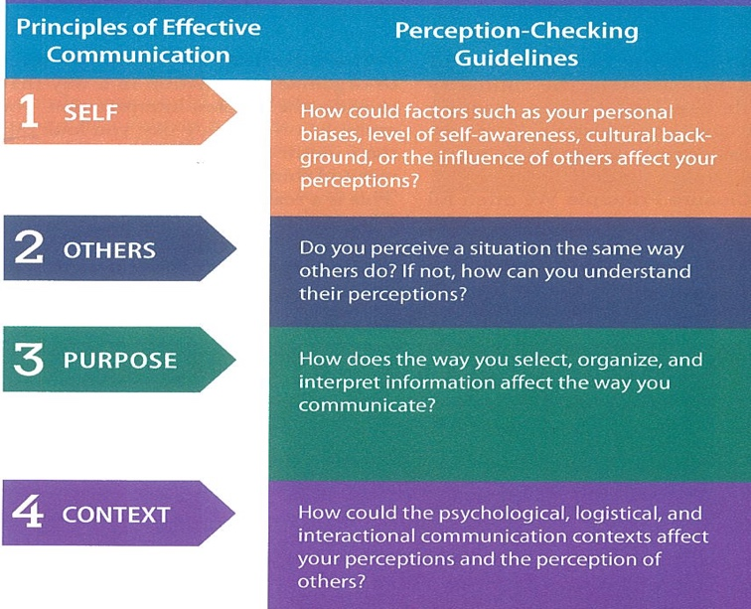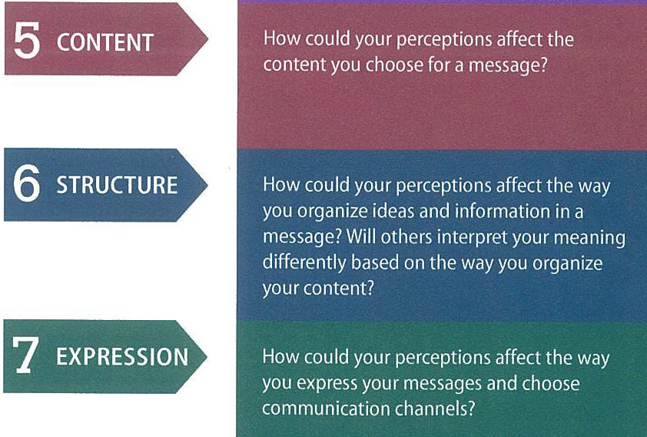

communicating with confidence
- Your self-concept and level of self-confidence directly affect how you successfully communicate
- If you lack confidence, you are less likely to share what you know or voice your opinion
- When you feel good about yourself, you can engage in a conversation with ease, defend your ideas in a group, and give successful presentations
- Communication apprehension
  - The anxiety you may experience when speaking to others is referred to by many names: communication apprehension, speech anxiety, stage fright.
  - Communication apprehension is an individual’s fear or anxiety associated with either real or anticipated communication with another person or persons.
  - It occurs in a variety of communication contexts, such as group discussions, meetings, interpersonal conversations, public speaking, and job interviews.
  - Communication apprehension is a type of stress that manifests itself in real physiological responses
- Strategies for becoming a confident communicator
  - Always remember that in most cases, your anxiety is invisible
  - Most of us think we display more anxiety than listeners report noticing
  - Prepare
    - Although you may not be able to predict unexpected situations or anticipate the nature of everyday conversations, you can prepare for many of the communication situations you encounter.
    - When you are prepared, you know a great deal about the ideas you wish to discuss, the others who will be involved, the context of the situation, the content and structure of your message and how you will express yourself.
  - Relax, rethink, revision
    - By learning to relax your body, you can reduce your level of communication apprehension
    - You also need to change the way you think about communication
    - When you have confident thoughts, you begin to feel more confident
    - Three strategies can help you rethink your attitudes, visualize your message and relax your body
      - Cognitive restructuring: is a method for reducing anxiety by replacing negative, irrational thoughts with more realistic positive self-talk
      - Visualization: is a powerful method for building confidence, and it allows you to imagine what it would be like to communicate succesffully
        - By visualizing youself communicating effectively, you are mentally practicing the skills you need to succeed while also building a positive self image.
      - Systematic desensitization: relaxation and visualization technique to reduce anxiety associated with stressful situations. You start with deep muscle relaxation. In this relaxed state, you then imagine yourself in a variety of communication contexts ranging from very comfortable to highly stressful. By working to remain relaxed while visualizing various situations, you gradually associate communication with relaxation rather than nervousness
  - One of the best ways to build confidence is to concentrate on your message. When you focus on getting your message across, you don’t have time to think about how you look or sound
  - The best way to become good at something is to practice, regardless of whether its communicating or cooking
    - In addition to enhancing your confidence, it stimulates your brain in positive ways
    - Stimulating an act is, in the brain, the same as performing it
    - Practicing communication mentally and physically is as important as practicing the piano/gymnastics routine.
- Sources of communication apprehension
  - Fear of failure
    - The fear of a negative evaluation is the number 1 cause of communication anxiety. When you focus your thoughts on the possibility of failures, you are more likely to fail (self-fulfilling prophecy). Try to shift your focus to positive feedback you see from others. When you sense that a listener likes you and your message, you may gain extra confidence you need.
  - Fear of others
    - Fear of others is heightened when talking to a powerful person, an influential group, or a large audience. Usually this fear is based on an exaggerated feeling of being different from or inferior to others. If you don’t know much about the people around you, you are more likely to feel apprehensive. Learning more about your listeners can decrease your anxiety. You may have more in common with them than you realize.
  - Fear of breaking the rule
    - Rules of communication aren’t rigid and shouldn’t be treated as though they are enforceable laws. Good communicators learn not to sweat the small stuff and that sometimes rules should be broken or bent
  - Fear of unknown
    - Many are fearful of the unknown. Performing an unfamiliar or unexpected role can transform a usually confident person into a tangle of nerves
  - Fear of spotlight
    - Although a little attention may be flattering, being the center of attention makes many people nervous. The more self-focused you are, the more nervous you become.

