Chapter 1: Overview of Marketing

Introduction
- Companies constantly protect their brand in the market
- Businesses must grow and change their product offerings and corporate citizenry to keep pace with customer needs and tastes
- Company’s must provide good value to their customers

What is Marketing?
- Marketing is a set of business practices designed to plan for and present an organization’s products or services in ways that build effective customer relationships
- Good marketing requires thoughtful planning with emphasis on the ethical implications of any of those decisions on consumers and society
- A marketing plan is a written document analyzing the current marketing situation (SWOT), marketing objectives and strategy of the four Ps, action programs, and projected financial statements
- Firms develop a marketing plan that specifies their marketing activities for a specific period of time
- The marketing plan is broken down into various components:
  - How the product or service will be conceived or designed
  - How much it should cost
  - Where and how it will be promoted
  - How it will get to the customer
- The buyer and seller should always be satisfied with the value they obtained from the transaction
- The core aspects of marketing:
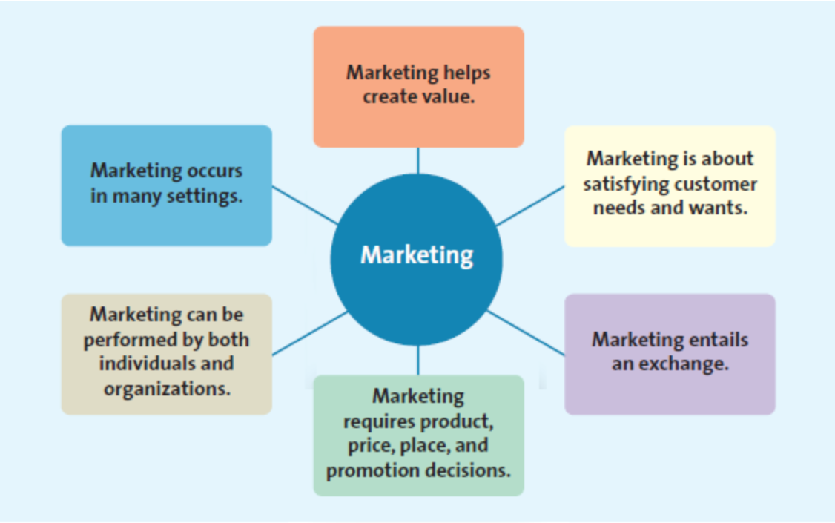
Marketing is About Satisfying Customer Needs and Wants
- Understanding and satisfying customer needs and wants is fundamental to marketing success
- A need is when a person feels deprived of the basic necessities of life, such as food, clothing, shelter, or safety
- A want is the particular way in which the person chooses to fulfill his or her need, which is shaped by a person’s knowledge, culture, and personality
- To understand customer needs and wants, the company must first identify the customers or market for its product/service
- A market refers to the groups of people who need or want a company’s products or services and have the ability and willingness to buy them
- Because marketing costs money, good marketers carefully seek out potential customers who have both an interest in the product and an ability to buy it
- A target market is the customer segment or group to whom the firm is interested in selling its products and services
- The process of identifying customer segments the company wants to target with its products and services requires market research

Marketing Entrails an Exchange
- Marketing is about an exchange – the trade of things of value between the buyer and the seller so that each is better off as a result
- Sellers provide goods or services, then communicate and facilitate the delivery of their offering to consumers
- Buyers complete the exchange by giving money and information to the seller

Marketing Requires Marketing Mix Decisions
- Marketing traditionally has been divided into a set of four interrelated decisions known as the marketing mix or four Ps (product, price, place, and promotion) – the controllable set of activities that a firm uses to respond to the wants of its target markets

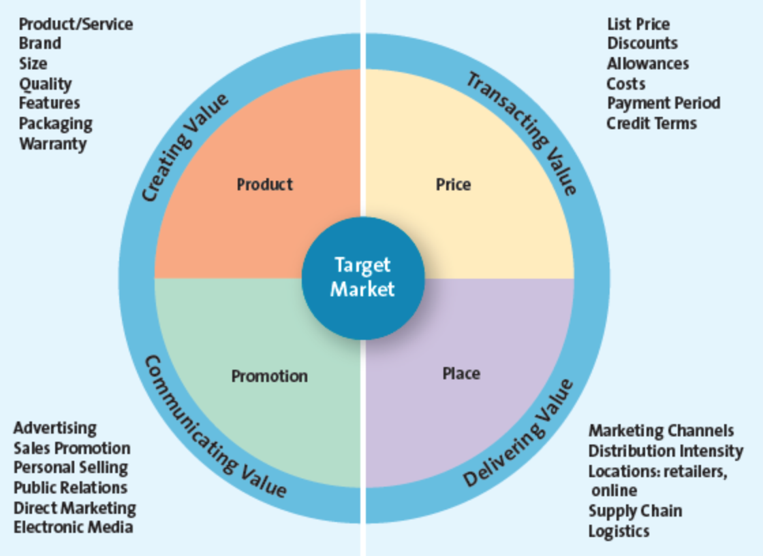

PRODUCT: CREATING VALUE
- The fundamental purpose of marketing is to create value by developing a variety of offerings, including goods, services, and ideas, to satisfy customer needs
- Goods are items that you can physically touch
- Services are intangible customer benefits that are produced by people or machines and cannot be separated from the producer
- Ideas include thoughts, opinions, philosophies, and intellectual concepts that also can be marketed

PRICE: TRANSCATING VALUE
- Price is everything the buyer gives up – money, time, energy – in exchange for the product
- Marketers must determine the price of a product carefully on the basis of the potential buyer’s belief about its value

PLACE: DELIVERING VALUE
- Place described all the activities necessary to get the product from the manufacturer or producer to the right customer when that customer wants it
- Place deals specifically with retailing and marketing channel management
- Marketing channel management, also known as supply chain management, is the set of approaches and techniques that firms employ to efficiently and effectively integrate their suppliers, manufacturers, warehouses, stores, and other firms involved in the transaction into a seamless value chain in which merchandise is produced and distributed in the right quantities, to the right locations, at the right time, while minimizing system wide costs and satisfying the service levels required by the customers

PROMOTION: COMMUNICATING VALUE
- Even the best products and services will go unsold if marketers cannot communicate their value to customers
- Promotion is communication by a marketer that informs, persuades, and reminds potential buyers about a product or service to influence their opinions or elicit a response
- Promotion generally can enhance a product or service’s value

- Marketers can deliver greater value to consumers by treating the 4Ps as a whole rather than as separate components
- The product/service offered must satisfy the target customers’ specific needs and wants, be priced appropriately, be available at locations where customers want it, and be promoted in a manner and through media that are consistent with the target consumers

Marketing Can Be Performed by Both Individuals and Organizations
- The process in which businesses sell to consumers is known as B2C (business-to-consumer) marketing
- The process of selling merchandise or services from one business to another is called B2B (business-to-business) marketing
- The process in which consumers sell to other consumers is called C2C (consumer-to-consumer) marketing
- Social media is quickly becoming an integral part of marketing and communications strategies

Marketing Impacts Many Stakeholders
- Marketing works well in the nonprofit sector
- Some marketers are greening their marketing practices to communicate that they are socially responsible in their business practices
- Marketing is often designed to benefit an entire industry, which can help many firms simultaneously

The Four Orientations of Marketing
PRODUCT ORIENTATION
- Product-oriented companies focus on developing and distributing innovative products with little concern about whether the products best satisfy customers’ needs

SALES ORIENTATION
- Companies that have a sales orientation basically view marketing as a selling function where companies try and sell as many of their products as possible rather than focus on making products consumers really want
- Profits come from sales volume rather than from repeat business from satisfied customers

MARKET ORIENTATION
- Market-oriented companies start out by focusing on what consumers want and need before they design, make, or attempt to sell their products and services
- Most successful firms today are market oriented

VALUE-BASED ORIENTATION
- Value-based companies provide their customers with greater value than their competitors
- Value reflects the relationship of benefits to costs, or what you get for what you give
- a creative way to provide value to customers is to engage in value cocreation – where customers can act as collaborators to create the product or service (Nike ID)
- every value-based marketing firm must implement its strategy according to what its customers value
How Do Firms Become More Value Driven?
- Firms become value driven by focusing on four activities:
- They share information about their customers and competitors across their own organization and with other firms that might be involved in getting the product or service to the marketplace, such as manufacturers and transportation companies
- They strive to balance their customers’ benefits and costs
- They concentrate on building relationships with customers
- They need to take advantage of new technologies and connect with their customers using social and mobile media

SHARING INFORMATION
- In a value-based, market-oriented firm, marketers share information about customers and competitors that has been collected through customer relationship management, and integrate it across the firm’s various departments
- Sharing and coordinating information represents a critical success factor for any firm

BALANCING BENEFITS WITH COSTS
- Value-oriented marketers constantly measure the benefits that customers perceive against the cost of their offering
- In this task, they use available customer data to find opportunities in which they can better satisfy their customer’s needs and in turn develop long-term loyalties

BUILDING RELATIONSHIPS WITH CUSTOMERS
- Marketers have begun to develop a relational orientation as they have realized the need to think about customers in terms of relationships rather than transactions
- To build relationships, firms focus on the lifetime value of the relationship, not much money is made during each transaction
- This relationship approach uses a process known as customer relationship management (CRM), a business philosophy and set of strategies, programs, and systems that focus on identifying and building loyalty among the firm’s most valued customers
- Firms that employ CRM systematically collect information about their customers’ needs and then use that information to target their best customers with the products, services, and special promotions that appear most important to them

CONNECTING WITH CUSTOMERS USING SOCIAL AND MOBILE MEDIA
- Marketers are steadily embracing new technologies, such as social and mobile media, to allow them to connect better with their customers and thereby serve their needs more effectively

Why Is Marketing Important?
- Marketing has evolved into a major business function that crosses all areas of a firm or organization
- Marketing advises production about how much of the company’s product to make and then tells logistics when to ship it
- It creates mutually valuable relationships between the company and the firms from which it buys
- It identifies those elements that local customers value and makes it possible for the firm to expand globally

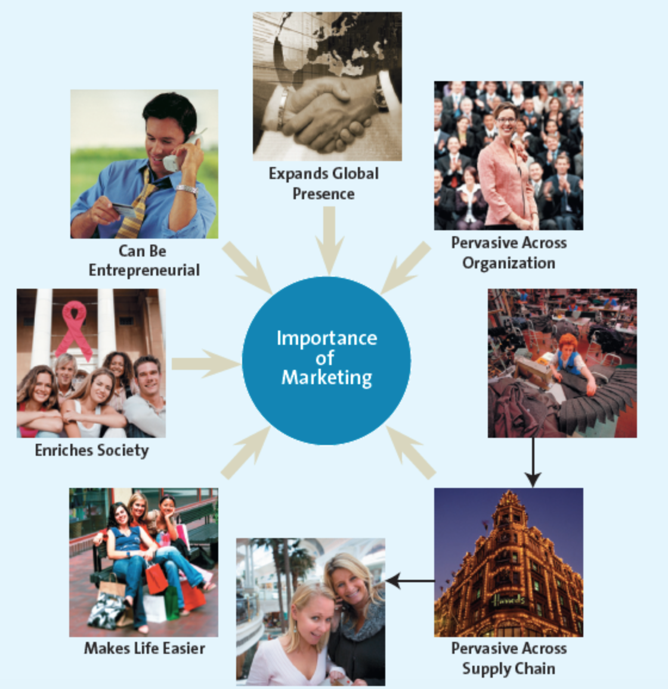

MARKETING EXPANDS FIRMS’ GLOBAL PRESENCE
- Understanding customers is critical and without the knowledge that can be gained by analyzing new customers’ needs and wants on a segment-by-segment, region-by-region basis – one of marketing’s main tasks – it would be difficult for a firm to expand globally

MARKETING IS PERVASIVE ACROSS MARKETING CHANNEL MEMBERS
- Firms typically do not work in isolation (manufacturers, suppliers, retailers)
- The supply chain is the group of firms and set of techniques and approaches firms use to make and deliver a given set of goods and services
- Excellent supply chains effectively and efficiently integrate their supply chain partners to produce and distribute goods in the right quantities, to the right locations, and at the right time

MARKETING ENRICHES SOCIETY
- Canada’s best-known corporations encourage their employees to participate in activities that benefit their communities and invest heavily in socially responsible actions and charities

MARKETING CAN BE ENTREPRENEURIAL
- Marketing is at the centre of the successes of numerous new ventures initiated by entrepreneurs, or people who organize, operate, and assume the risk of a business venture
- Key to the success of many such entrepreneurs is that they launch ventures that aim to satisfy unfilled needs

Chapter 2: Developing Marketing Strategies and a Marketing Plan

What Is A Marketing Strategy
- A marketing strategy identifies 1) a firm’s target market(s), 2) a related marketing mix – the four Ps, and 3) the bases upon which the firm plans to build a sustainable competitive advantage
- A sustainable competitive advantage is an advantage over the competition that is not easily copied and thus can be maintained over a long period of time
- There are four strategies that focus on aspects of the marketing mix to create and deliver value and to develop sustainable competitive advantages:
- Customer excellence: focuses on retaining loyal customers and excellent customer service
- Operational excellence: achieved through efficient operations and excellent supply chain and human resources management
- Product excellence: having products with high perceived value and effective branding and positioning
- Locational excellence: having a good physical location and internet presence

Customer Excellence
- Customer excellence is achieved when a firm develops value-based strategies for retaining loyal customers and provides outstanding customer service

RETAINING LOYAL CUSTOMERS
- Having loyal customers is an important method of sustaining an advantage over competitors
- Viewing customers with a lifetime value perspective, rather than on a transaction-by-transaction basis, is key to modern customer retention programs
- Companies can achieve customer loyalty by creating an emotional attachment through loyalty programs

CUSTOMER SERVICE
- Firms that offer good customer service must instill its importance in their employees over a long period of time so that it becomes a part of the organizational culture
- Once a marketer has earned a good service reputation, it can sustain this advantage for a long time because a competitor is hard pressed to develop a comparable reputation

Operational Excellence
- Firms achieve operational excellence through their efficient operations, excellent supply chain management, and strong relationships with their suppliers
- Efficient operations enable firms to provide their consumers with lower-priced merchandise
- Firms achieve efficiencies by developing sophisticated distribution and information systems as well as strong relationships with vendors
- Firms with strong relationships may gain exclusive rights to:
- Sell merchandise in a particular region
- Obtain special terms of purchase that are not available to competitors
- Receive popular merchandise that may be in short supply

Product Excellence
- Product excellence occurs by having products with high perceived value and effective branding and positioning
- Companies can maintain their sustainable competitive advantage by investing in their brand itself; positioning their product or service by using a clear, distinctive brand image, and constantly reinforcing that image through their merchandise, service, and promotion

Locational Excellence
- A competitive advantage based on location is sustainable because it is not easily duplicated

Multiple Sources of Advantage
- A single strategy is not sufficient to build a sustainable competitive advantage
- Firms require multiple approaches

The Marketing Plan
- Firms carefully plan their marketing strategies to react to changes in the environment, the competition, and their customers by creating a marketing plan
- A marketing plan is a written document composed of an analysis of the current marketing situation, opportunities, and threats for the firm, marketing objectives and strategy specified in terms of the four Ps, action programs, and projected or pro forma income (and other financial) statements
- The three major phases of the marketing plan are planning, implementation, and control
- A marketing plan entrails five steps:
- Marketing executives, in conjunction with other top managers, define the mission and objectives of the business (planning)
- They evaluate the situation by assessing how various players, both inside and outside the organization, affect the firm’s potential for success (planning)
- Marketing managers identify and evaluate different opportunities by engaging in a process known as segmentation, targeting, and positioning (implementation)
- They implement the marketing mix by using the 4Ps (implementation)
- They evaluate the performance of the marketing strategy by using marketing metrics and taking any necessary corrective actions (control)

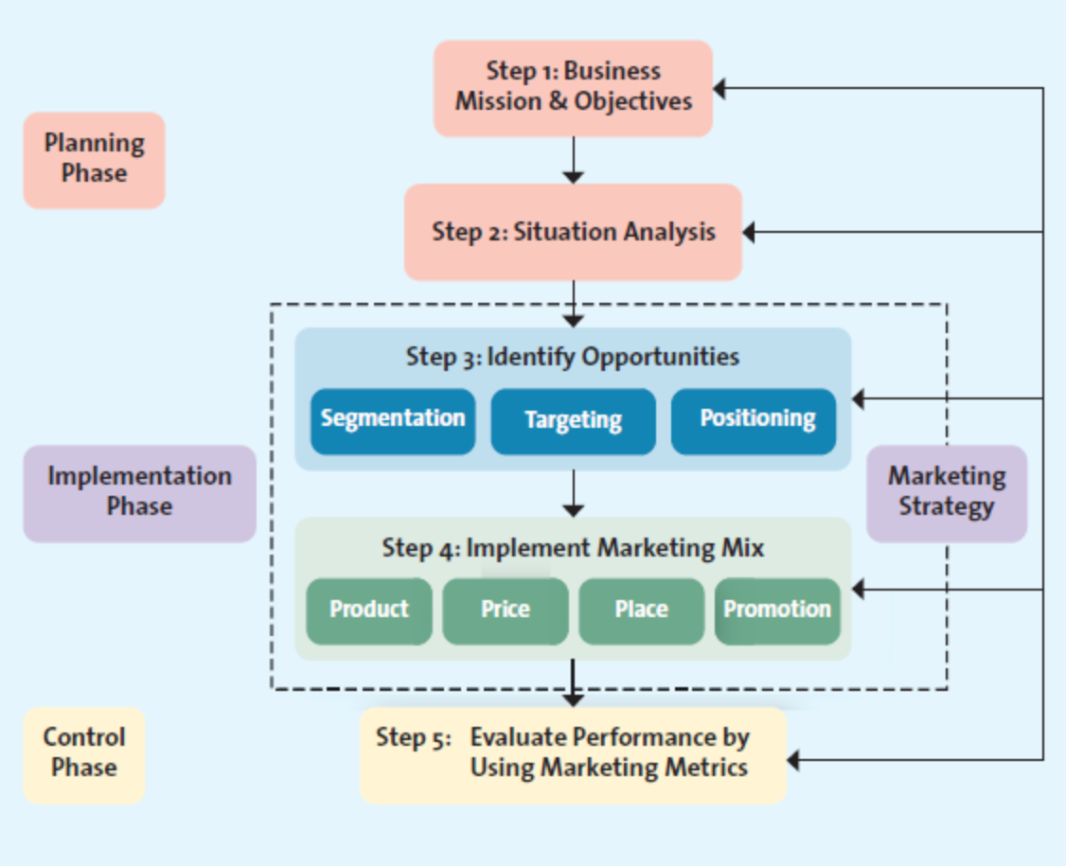
- It is not always necessary to go through the entire process for every evaluation

Step 1: Define the Business Mission and Objectives
- The mission statement, a broad description of a firm’s objectives and the scope of activities it plans to undertake, attempts to answer two main questions: what type of business are we? And what do we need to do to accomplish our goals and objectives?

Step 2: Conduct a Situation Analysis
- After developing its mission, a firm must next perform a situational analysis, using a SWOT analysis that assesses both the internal environment with regard to its Strengths and Weaknesses (internal analysis) and the external environment in terms of its Opportunities and Threats (external analysis)
- Situation analysis also includes an examination of market trends, customer analysis, and competitive analysis
- Firms should assess the opportunities and uncertainties of the marketplace due to changes in Cultural, Demographic, Social, Technological, Economic, and Political forces (CDSTEP)
- A SWOT analysis is designed to help the firm determine areas in which it is strong and areas where it is weak and vulnerable
- A SWOT analysis requires the firm to undertake a critical assessment of its resources, capabilities, organization, strategies, and performance in relation to competitors
- Opportunities and threats are outside the control of the firm; therefore, the firm can decide only how it wants to respond

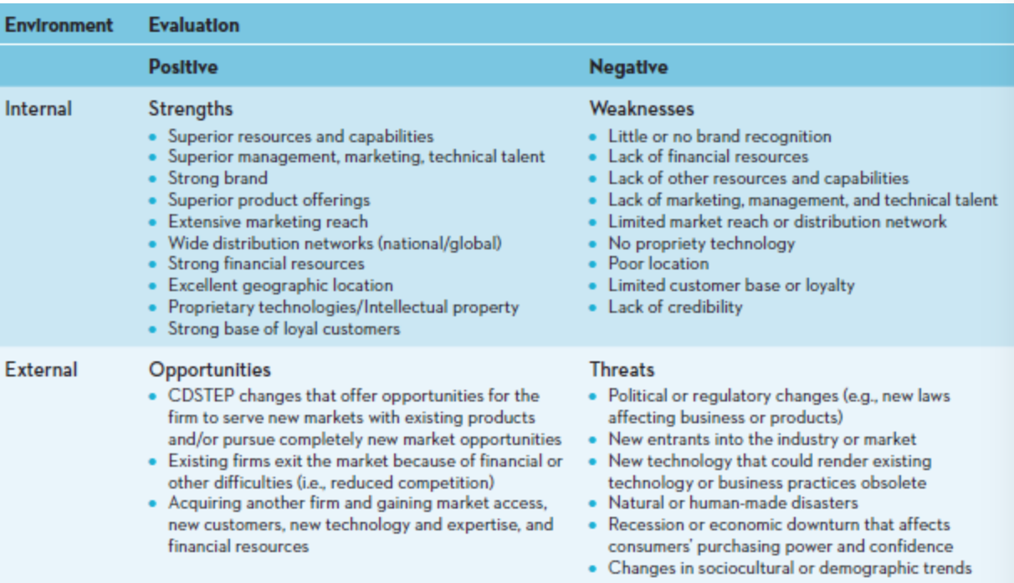

Step 3: Identify and Evaluate Opportunities by Using STP (Segmentation, Targeting, and Positioning)
- With STP, the firm must first understand customer needs and wants through market research, then divide the market or customers into distinct subgroups or segments, determine which of those segments it should pursue or target, and finally decide how it should position its products and services to best meet the needs of those chosen targets

SEGMENTATION
- A market segment is a group of consumers who respond similarly to a firm’s marketing efforts
- Market segmentation is the process of dividing the market into distinct groups of customers where each individual group has similar needs, wants, or characteristics – who therefore might appreciate products or services geared especially for them in similar ways

TARGETING
- After a firm has identified the various market segments it might pursue, it evaluates each segment’s attractiveness and decides which to pursue by using a process known as target marketing or targeting

POSITIONING
- When the firm decides which segments to pursue, it must determine how it wants to be positioned within those segments
- Market positioning involves the process of defining the marketing mix variable so that target customers have a clear, distinct, desirable understanding of what the product does or represents in comparison with competing products

Step 4: Implement Marketing Mix and Allocate Resources
- Marketers implement the marketing mix (4Ps) for each product and service on the basis of what it believes its target markets will value
- Each element of the 4Ps must be fully integrated to achieve a coherent strategy

PRODUCT AND VALUE CREATION
- Firms attempt to develop products and services that customers perceive as valuable enough to buy

PRICE AND VALUE FOR MONEY
- Value-based marketing requires that firms charge a price that customers perceive as giving them good value for the products and services they receive
- Marketers should base price on the value that the customer perceives

PLACE AND VALUE DELIVERY
- The firm must be able to make the product or service readily accessible when and where the customer wants it

PROMOTION AND VALUE COMMUNICATION
- Marketers communicate the value of their offering, or the value proposition, to their customers through a variety of media, including TV, radio, magazines, buses, trains, blimps, sales promotion, publicity, the sales force, and the internet
- Retailers add value to their offerings through their efficient and effective communications strategies
- Marketers must consider the most efficient and effective methods to communicate with their customers

Step 5: Evaluate Performance by Using Marketing Metrics
- A metric is a measuring system that quantifies a trend, dynamic, or characteristic
- Metrics are used to explain why things happened and to project the future
- Understanding the causes of the performance, regardless of whether that performance exceeded, met, or fell below the firm’s goals, enables firms to make appropriate adjustments

WHO IS ACCOUNTABLE FOR PERFORMANCE?
- At each level of an organization, the business unit and its manager should be held accountable only for the revenues, expenses, and profits that they can control
- Performance evaluations are used to pinpoint problem areas
PERFORMANCE OBJECTIVES AND METRICS
- One approach is to compare a firm’s performance over time or to competing firms, using common financial metrics such as sales and profits
- Another method is to view the firm’s products or services as a portfolio
- Depending on the firm’s relative performance, the profits from some products or services are used to fuel growth for others

FINANCIAL PERFORMANCE METRICS
- Some commonly used metrics to assess performance include revenues, or sales, and profits
- An attempt to maximize one metric may lower another
- Managers must understand how their actions affect multiple performance metrics
- The metrics used to evaluate a firm vary depending on 1) the level of the organization at which the decision is made and 2) the resources the manager controls

SOCIAL RESPONSIBILITY PERFORMANCE METRICS
- As Canadian companies become more convinced of the importance of social responsibility, we will likely see an increasing number of companies report corporate social responsibility metrics

Strategic Planning is Not Sequential
- The actual planning process can move back and forth among the five steps

PORTFOLIO ANALYSIS
- In portfolio analysis, management evaluates the firm’s various products and businesses – its “portfolio” – and allocates resources according to which products are expected to be the most profitable for the firm in the future
- Portfolio analysis is typically performed at the strategic business unit (SBU) or product line level of the firm, though managers can also use it to analyze brands or even individual items
- An SBU is a division of the company that can be managed somewhat independently from other divisions since it markets a specific set of products to a clearly defined group of customers
- A product line is a group of products that consumers may use together or perceive as similar in some way

Growth Strategies
- Firms consider pursuing various market segments as part of their overall growth strategies
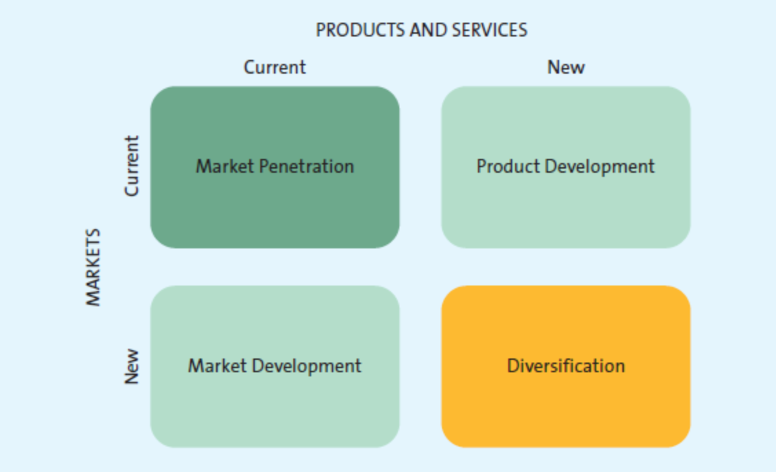

- The rows distinguish those opportunities a firm possesses in its current markets from those it has in new markets, whereas the columns distinguish between the firm’s current marketing offering and that of a new opportunity

MARKET PENETRATION
- A marketing penetration strategy employs the existing marketing mix and focuses the firm’s efforts on existing customers
- A marketing penetration strategy generally requires greater marketing efforts, such as increased advertising, additional sales and promotions, or intensified distribution efforts in geographic areas in which the product or service is already sold

MARKET DEVELOPMENT
- A market development strategy employs the existing marketing offering to reach new market segments, whether domestic or international or segments not currently served by the firm
- International expansion is generally riskier than domestic expansion

PRODUCT DEVELOPMENT
- A product development strategy offers a new product or service to a firm’s current target market

DIVERSIFICATION
- A diversification strategy introduces a new product or service to a market segment that is currently not served
- Diversification opportunities may be either related or unrelated
- In a related diversification opportunity, the current target market and/or marketing mix shares something in common with the new opportunities
- In an unrelated diversification, the new business lacks any common elements with the present business (very risky)

- A market penetration strategy is the easiest to implement since it focuses on promoting existing products to existing customers
- With market development or product development, marketers have experience with one element and must learn the other element
- Diversification requires marketers to go outside both their current products and markets, and the risks of making mistakes are substantially greater
- The particular growth strategy a company chooses depends on its goals and capabilities
- Marketers tend to pursue multiple growth strategies simultaneously
- Marketers may also develop strategies for downsizing their business operations by either exiting markets or reducing their product portfolios

Chapter 3: Analyzing the Marketing Environment

A Marketing Environment Analysis Framework
- Marketers that understand and manage the changes in their marketing environments are able to adapt their product and service offerings to meet new challenges and opportunity
- Many marketers get their ideas for new products or services from monitoring and studying the marketing environment
- Analyzing the marketing environment also helps marketers assess their continued strengths and the value of their products and services, and any weaknesses resulting from changes in the marketing environment
- Companies analyze their marketing environment using a framework
- At the heart of the analysis is the consumer
- Consumers may be influenced directly by the firm’s microenvironment, including immediate actions of the focal company, the company’s competition, and the corporate partners that work with the firm to make and supply products and services to consumers
- The firm, and therefore consumers indirectly, is influenced by the macro environment, which includes influences such as culture and demographics, as well as social, technological, economic, and political/legal factors
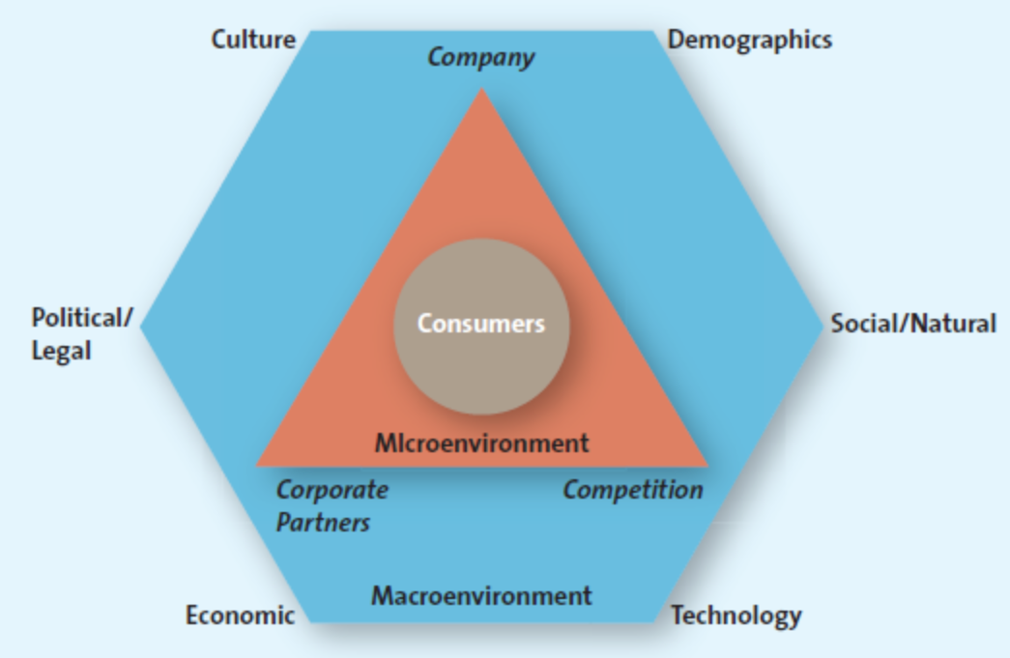
- One of the goals of value-based marketing is to provide greater value to consumers than competitors offer
- This provision requires that the marketing firm looks at the entire business process from a consumer’s point of view
- Consumers’ needs and wants, as well as their ability to purchase, are affected by a host of factors that change and evolve over time
- Firms use a variety of tools to keep track of their competitors’ activities and communicate with their corporate partners
- They monitor their macro environment to determine how such factors influence consumers and how they should respond to them
- Sometimes, firms can anticipate trends
Micro-environmental Factors
- The figure below illustrates the factors affecting consumers’ microenvironment: the company (its capabilities), its competition, and its corporate partners
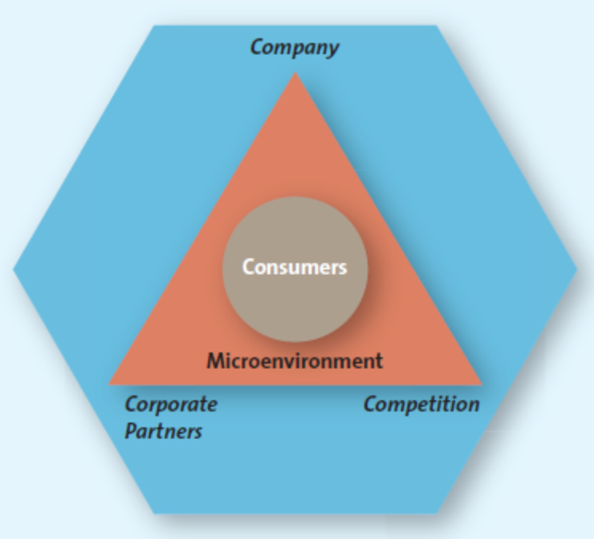

Company Capabilities
- In the firm’s microenvironment, the first factor that affects the consumer is the firm itself
- Successful marketing firms focus their efforts on satisfying customer needs that match their core competencies
- Marketers can use an analysis of the external environment (SWOT) to categorize an opportunity as either attractive or unattractive, and if it appears attractive, to assess it relative to the firm’s existing competencies

Competition
- Competition also significantly affects consumers in the microenvironment
- Greater competition may mean more choices for consumers, which influences their buying decisions
- It is critical that marketers understand their firm’s competitors, including their strengths, weaknesses, and likely reactions to the marketing activities their own firm undertakes
- Firms use competitive intelligence (CI) to collect and synthesize information about their position with respect to their rivals
- CI enables companies to anticipate changes in the marketplace rather than merely react to them
- CI strategies include:
  - Simply sending a retail employee to a competitive store to check merchandise, prices, and foot traffic
  - Reviewing public materials, including websites, press releases, industry journals, annual reports, subscription databases, permit applications, patent applications, and trade shows
  - Interviewing customers, suppliers, partners, or former employees
  - Analyzing a rival’s marketing tactics, distribution practices, pricing, and hiring needs

Corporate Partners
- Few firms operate in isolation
- Parties that work with the focal firm are its corporate partners

Macro Environmental Factors
- Marketers must understand the macro environmental factors that operate in the external environment, namely, the culture, demographics, social/natural trends, technological advances, economic situation, and political/legal environment, or CDSTEP, as shown below
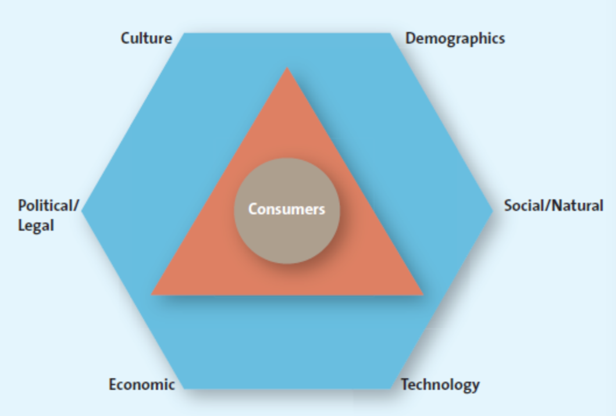
Culture
- Culture is the shared meanings, beliefs, morals, values, and customs of a group of people
- Transmitted by words, literature, and institutions, culture is passed down from generation to generation and learned over time
- People participate in many cultures
- The challenge for marketers is to have products or services identifiable by and relevant to a particular group of people
- Our various cultures influence what, why, how, where, and when we buy
- Two dimensions of culture that marketers must take into account as they develop their marketing strategies are the culture of the country and that of a region within a country

COUNTRY CULTURE
- The visible nuances of a country’s culture, such as artefacts, behaviour, dress, symbols, physical settings, ceremonies, language differences, colours and tastes, and food preferences, are easy to spot
- But the subtle aspects of culture are trickier to identify and navigate

REGIONAL SUBCULTURES
- The region in which people live in a particular country affects the way they react to different cultural rituals, or even how they refer to a particular category

Demographics
- Demographics indicate the characteristics of human populations and segments, especially those used to identify consumer markets
- Typical demographics such as age – which includes generational cohorts – gender, income, race, and ethnicity are readily available from market research firms
- Demographics provide an easily understood “snapshot” of the typical consumer in a specific target market

GENERATIONAL COHORTS
- A group of people of the same generation, generational cohorts, have similar purchase behaviours because they have shared experiences and are in the same stage of life
- Baby boomers and Generation Xers both gravitate toward products and services that foster a casual lifestyle

TWEENS
- Not quite teenagers but not young children either
- In Canada, tweens spend their money mainly on food and drinks, electronics, and clothing

GENERATION Y
- Generation Yers are also called millennials
- They represent 27% of the population
- Tech savvy

GENERATION X
- They represent 8% of the population
- More cynical and risk averse

BABY BOOMERS
- Largest cohort representing 30% of the population
- They are individualistic
- Leisure time is a high priority for them
- They believe they will always be able to take care of themselves
- They have an obsession with maintaining their youth

SENIORS
- Seniors are over the age of 65
- They make up Canada’s fastest-growing group

Income
- Canadians may be classified into distinct groups based on their income and other factors such as background, education, and occupation: upper class, middle class, working class (or low-income earners), and underclass (at or below poverty)
- Upper-class consumers are very affluent, and their spending patterns are not influenced by economic conditions
- They have high discretionary incomes and tend to purchase luxury items
- They are more likely to be highly educated and work in managerial and executive roles
- About 48% of Canadian households are in the upper class
- Middle-class families earn between $30000 and $70000, with the majority tending toward the higher end of this scale
- They can afford a good life most of the time
- They tend to be careful about their spending and are often value conscious
- About 38% of Canadian households fall in the middle class
- Working-class, or low-income families, earn between $20000 and $30000, barely sufficient income to cover their basic needs
- Family income distribution in Canada varies by province, education level, gender, and profession
- This broad range in incomes creates marketing opportunities at both the high and low ends of the market

Education
- Higher levels of education lead to better jobs and higher incomes
- For some products, marketers can combine education level with other data such as occupation and income to obtain quite accurate predictions of purchase behaviour

Gender
- Male/female roles have been blurred
- This shift in attitude and behaviour affects the way many firms design and promote their products and services
- More firms are careful about gender and neutrality in positioning their products and attempt to transcend gender boundaries whenever they can
- Women make the majority of purchasing decisions and then influence most of the remainder
- Although the gap is narrowing, men still earn more than women

Ethnicity
- Ethnic groups or visible minorities will make up 23% of the population by 2017 because of immigration and increasing birth rates among various ethnic groups
- Aboriginal people represent 4.3% of the population
- The growing number of ethnic groups or visible minorities represents both a challenge and a marketing opportunity
- The challenge is for marketers to understand the culture, value, and spending patterns of the various groups and determine the best way to communicate and serve them
- Ethnic Canadians spend more than their white counterparts on big-ticket items such as cars, clothing, and home furnishings
- Some tactics retailers are taking to accommodate the ethnic consumer include adapting signs and flyers to feature different languages; choosing ethnic-targeted media to advertise; celebrating important ethnic holidays with events, promotions, and seasonal products; and offering ethnic merchandise for sale and ensuring it is merchandised correctly

Technological Advances
- Technological advances have accelerated greatly during the past few decades, improving the value of both products and services
- Advanced technology makes consumers increasingly dependent on the help they can provide, especially in terms of making decisions and communicating with others
- Firms use the technology called RFID (radio frequency identification device) to track an item from the moment it was manufactured, through the distribution system, to the retail store, and into the hands of the final consumer
- Because they are able to determine exactly how much of each product is at a given point in the supply chain, retailers can also communicate with their suppliers and collaboratively plan to meet their inventory needs
- Mobile devices enhance the customer’s experience by making it easier to interact with the manufacturer or retailer or other customers, and they add a new channel of access, which makes customers more loyal and more likely to spend more with a particular retailer
- Not only are marketers trying to make social media an integral part of their marketing strategy, but also consumers are also using social media to share information and their experiences and frustrations with products, services, and marketers
- The relative ease with which consumers can use social media has dramatically increased the power of consumers to affect a firm’s marketing strategy
- Some firms have embraced social media as a way to get excellent feedback from consumers, which is then used to design new or redesign existing products, services, and marketing campaigns and strategies

Economic Situation
- Marketers monitor the general economic situation both in their home country and abroad, because it affects the way consumers buy merchandise and spend money
- Some major factors that influence the state of an economy include the rate of inflation, foreign currency exchange rates, interest rates, and recession
- Inflation refers to the persistent increase in the prices of goods and services
- Increasing prices cause the purchasing power of the dollar to decline; in other words, a dollar buys less than it used to
- In a similar fashion, foreign currency fluctuations can influence consumer spending
- Interest rates represent the cost of borrowing money
- Recession is a period of economic downturn when the economic growth of the country is negative for at least two consecutive quarters
- In a recession, the stock market declines sharply, unemployment increases, business and consumer confidence falls, and spending by both businesses and consumers is severely reduced
- Shifts in the four economic factors make marketing easier for some and harder for others

Political/Legal Environment
- The political/legal environment comprises political parties, government organizations, and legislation and laws that promote or inhibit trade and marketing activities
- Organizations must fully understand and comply with any legislation regarding fair competition, consumer protection, or industry-specific regulation
- The government has enacted laws that promote both fair trade and competition by prohibiting the formation of monopolies or alliances that would damage a competitive marketplace, fostering fair pricing practices for all suppliers and consumers, and promoting free trade agreements among foreign nations
- Legislation has also been enacted to protect consumers in a variety of ways:
  - Regulations require manufacturers to abstain from false or misleading advertising practices that might mislead consumers
  - Manufacturers are required to identify and remove any harmful or hazardous materials that might place a consumer at risk
  - Organizations must adhere to fair and reasonable business practices when they communicate with consumers
- The government also enacts laws focused on specific industries and on consumers
- The government has developed laws to regulate consumer behaviour
- Government regulations may have a negative or positive impact on marketers

Social and Natural Trends

GREENER CONSUMERS
- Green marketing involves a strategic effort by firms to supply customers with environmentally friendly merchandise
- The “green” trend is growing
- Many consumers believe that each person can make a difference in the environment
- The trend for green marketing is likely to persist as we still have a long way to go
- For companies selling environmentally friendly products, the green marketing trend represents a great opportunity
- The demand for green-oriented products has been a boon to the firms that supply them
- By offering environmental responsibility, these green products add an extra ounce of value that other products don’t have

MARKETING TO CHILDREN
- Many companies are working to ensure proper advertising to children

PRIVACY CONCERNS
- More and more consumers worldwide sense a loss of privacy
- At the same time that the internet has created an erupting volcano of accessibility to consumer information, improvements in computer storage facilities and the manipulation of information have led to more and better credit-check services
- Three-quarters of Canadians are concerned about the security and privacy of the information they provide over the internet

THE TIME-POOR SOCIETY
- Reaching a target market has always been a major challenge, but it is made even more complicated by several trends that increase the difficulty of grabbing those markets’ attention
- In the majority of families, both parents work, and the kids are busier than ever
- Consumers today have hundreds of shows and programs available to them through TV, radio, PDAs, DVDs, smartphones, personal computers, and the internet
- With many shows and programs available on the internet, consumers can choose when, where, and what shows they want to watch or listen to at their convenience
- By fast-forwarding through commercials they can miss all the messages marketers are attempting to send them
- Many consumers attempt to cope with their lack of leisure time by multitasking and their divided attention means they simply cannot focus as well on the advertisements that appear in those media
- Marketers are thus faced with the challenge of finding more creative ways to get their marketing messages out to consumers
- To find and develop methods that make life easier for many diverse consumers in a time-poor society, marketers often rely on technology

HEALTH AND WELLNESS CONCERNS
- Health concerns, especially those pertaining to children, are prevalent, critical, and widespread
- With the increase of obesity, consumers’ interest in improving their health has opened up several new markets and niches focused on healthy living

Chapter 4: Consumer Behaviour

The Consumer Decision Process
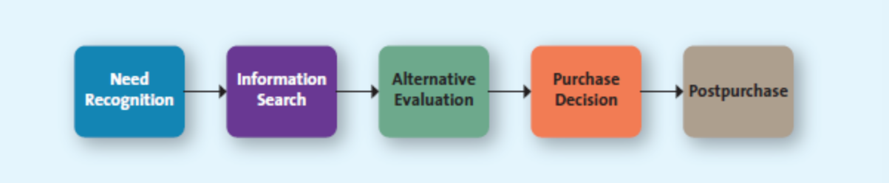
- The consumer decision process model represents the steps that consumers go through before, during, and after making purchases

Step 1: Need Recognition
- The consumer decision process begins when consumers recognize they have an unsatisfied need and want to go from their needy state to a different, desired state
- The greater the discrepancy between these two states, the greater the need recognition will be
- Functional needs pertain to the performance of a product or service
- Psychological needs pertain to the personal gratification consumers associate with a product/service
- The vast majority of products and services are likely to satisfy both functional and psychological needs
- A key to successful marketing is determining the correct balance of functional and psychological needs that best appeals to the firm’s target markets
- Marketers use numerous tactics to either remind customers of a need or create new needs
- Researching and understanding what products and services customers need or want and why, are the first steps in developing appropriate tactics
- Common tactics marketers employ include using reminder advertising for their products, creating awareness about a new product and its capabilities, showing how a product could enhance consumers’ image, and even altering the physical layout of a store or where products are placed in stores

Step 2: Information Search
- The second step, after a consumer recognizes a need, is to search for information about the various options that exist to satisfy that need
- The length and intensity of the search are based on several factors, including the degree of perceived risk associated with purchasing the product or service and the importance of the product to the consumer
- In an internal search for information, the buyer examines his or her own memory and knowledge about the product or service, gathered through past experiences
- In an external search for information, the buyer seeks information outside his or her personal knowledge base to help make the buying decision
FACTORS AFFECTING CONSUMERS’ SEARCH PROCESSES
- The perceived benefits versus perceived costs of search: is it worth the time and effort to search for information about a product or service?
- The locus of control: people who have an internal locus of control believe they have some control over the outcomes of their actions, in which case they generally engage in more search activities whereas with an external locus of control, consumers believe that fate or other external factors control all outcomes in which case they believe it doesn’t matter how much information they gather; if they make a wise decision, it isn’t to their credit, and if they make a poor one, it isn’t their fault
- Actual or perceived risk: five types of risk associated with purchase decisions can delay or discourage a purchase:
  - Performance risk involves the perceived danger inherent in a poorly performing product or service
  - Financial risk is risk associated with a monetary outlay and includes the initial cost of the purchase, as well as the costs of using the item or service
  - Social risk involves the fears that consumers suffer when they worry others might not regard their purchases positively
  - Physiological risk (safety risk) refers to the fear of actual harm should the product not perform properly
  - Psychological risks are those risks associated with the way people will feel if the product or service does not convey the right image
- The higher the risk, the more likely the consumer is to engage in an extended search
- Knowing that consumers go through various levels of information search, marketers must try to understand the sources customers use to search for information and the importance of each source
- With this knowledge, marketers could implement various tactics, including providing information about their products or even educating customers about their product in general or a product category as a way to build trust and credibility
- Marketers must ensure they communicate tactics aimed at reducing risks to customers

Step 3: Alternative Evaluation
- Once consumers have recognized a problem and explored the possible options, they must sift through the choices available and evaluate the alternatives
- Alternative evaluation often occurs while consumers are engaged in the process of information search
- When consumers begin to evaluate different alternatives, they often base their evaluations on a set of important attributes or evaluation criteria
- Evaluative criteria consist of a set of salient, or important, attributes about a particular product that are used to compare alternative products
- Determinant attributes are product or service features that are important to the buyer and on which competing brands or stores are perceived to differ
- Because many important and desirable attributes are equal among the various choices, consumers look for something special – a determinant attribute – to differentiate one brand or store from another and on which to base their choice
- Consumer decision rules are the set of criteria that consumers use consciously or subconsciously to quickly and efficiently select from among several alternatives
- Consumer decision rules take several different forms: compensatory, noncompensatory, or decision heuristics
- A compensatory decision rule assumes that the consumer, when evaluating alternatives, trades off one characteristic against another, such that good characteristics compensate for bas characteristics
- A noncompensatory decision rule is when the consumer chooses a product or service on the basis of a subset of its characteristics, regardless of the values of its other attributes
- Decision heuristics are mental shortcuts that help consumers narrow down their choices: price, brand, product presentation
- Generally, the extent of alternative evaluation depends on several factors, such as the types of products or services, the importance of the purchase, the perceived risks, and the expressive value of the purchase
- Marketers can assist consumers in their evaluation process not only by educating them about the company’s products, but also by providing detailed comparison information on price, technical specifications, unique features and benefits, and so on

Step 4: Purchase Decision
- After evaluating the alternatives, customers are ready to buy
- Retailers use various tactics to increase the chances that customers will convert their positive evaluations into purchases
- After consumers purchase the product or service, they usually consumer it, or “put it to the test”
- Ritual consumption refers to a pattern of behaviours tied to life events that affect what and how we consume
- Situational factors can also help facilitate purchases

Step 5: Postpurchase
- Marketers hope to create satisfied customers who become loyal, purchase again, and spread positive word-of-mouth
- There are three possible postpurchase outcomes:

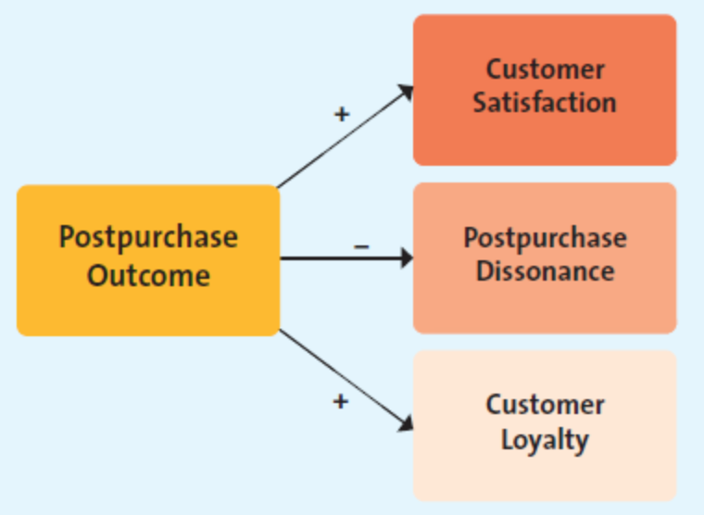

- Customer satisfaction
- Postpurchase cognitive dissonance (buyer’s remorse): an internal conflict that arises from an inconsistency between two beliefs, or between beliefs and behaviour
- Customer loyalty: customer loyalty develops over time with multiple repeat purchases of the product or brand from the same marketer
- Although firms want satisfied, loyal customers, sometimes they fail to attain them
- Passive customers are those who don’t repeat purchase or fail to recommend the product to others
- Negative word-of-mouth occurs when consumers spread negative information about a product, service, or store to others

Factors Influencing Consumer Buying Decisions
- The consumer decision process can be influenced by several factors
- First there are psychological factors, which are influences internal to the customer, such as motives, attitudes, perceptions, learning and lifestyles
- Second, there are social factors, such as family, reference groups, and culture
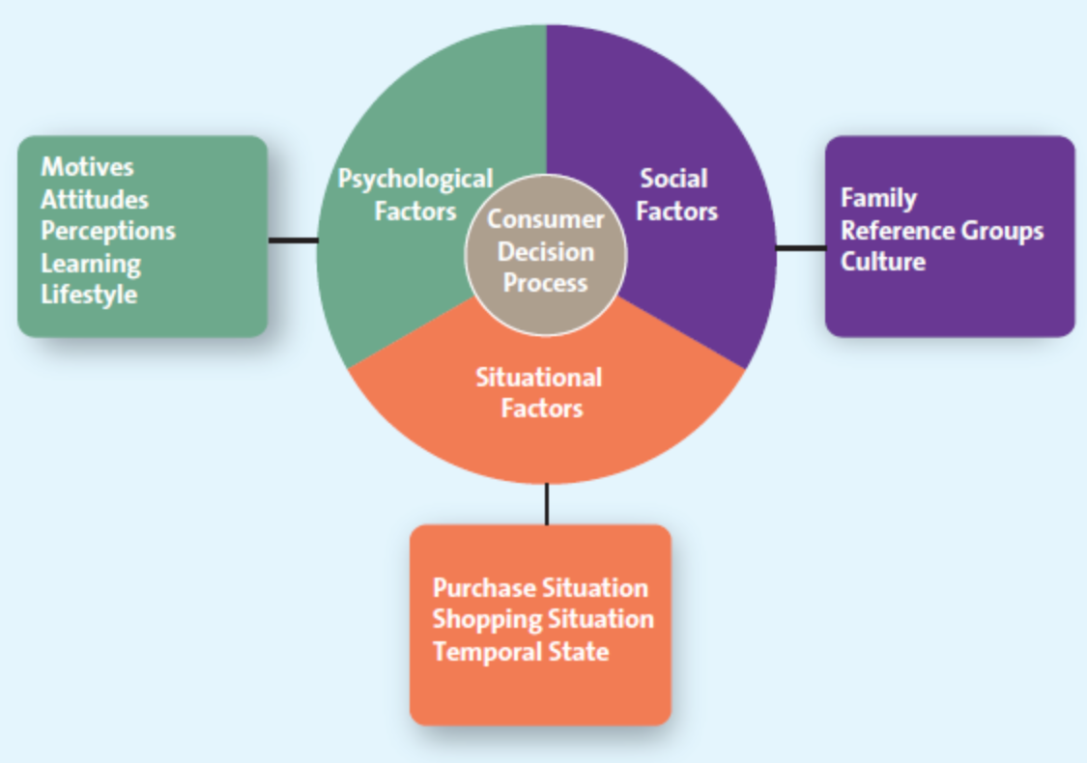
- Third, there are situational factors, such as the specific purchase situation, a particular shopping situation, and temporal states (the time of day)

PSYCHOLOGICAL FACTORS
- Motives:
- A motive is a need or want that is strong enough to cause the person to seek satisfaction
- Abraham Maslow categorized five groups of needs: physiological (food, water, shelter), safety (secure employment, health), love (friendship, family), esteem (confidence, respect), and self-actualization (people engage in personal growth activities and attempt to meet their intellectual, aesthetic, creative, and other such needs)

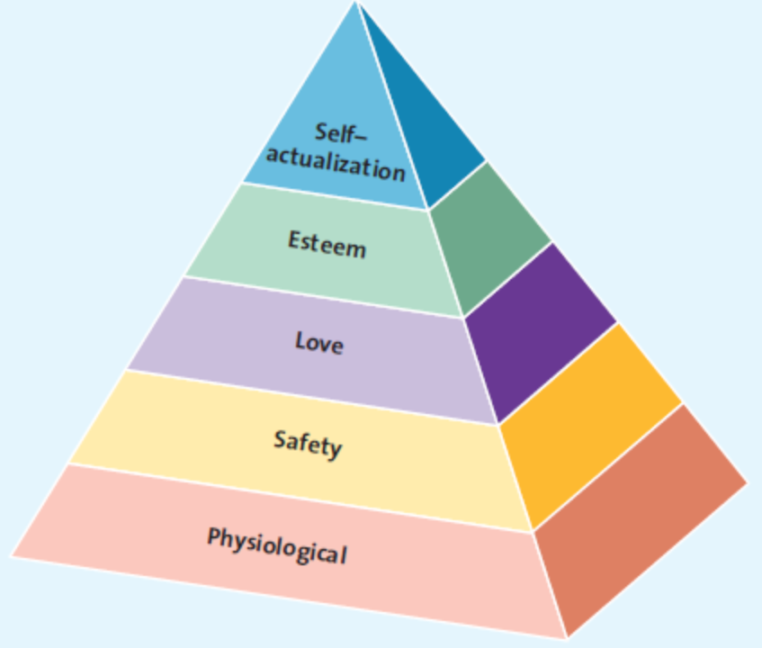

- Attitude:
- An attitude is a person’s enduring evaluation of his or her feelings about and behavioural tendencies toward an object or idea
- An attitude consists of three components:
- The cognitive component reflects what we believe to be true
- The affective component involves what we feel about the issue at hand – our like or dislike of something
- The behavioural component comprises the action(s) we take based on what we know and feel

- Perception:
- Perception is the process by which we select, organize, and interpret information to form a meaningful picture of the world
- In trying to influence perceptions, marketers must understand and focus on the four components of perceptions: selective exposure, selective attention, selective comprehension, and selective retention

- Learning:
- Learning refers to a change in a person’s thought process or behaviour that arises from experience and takes place throughout the consumer decision process
- Learning affects both attitudes and perceptions

- Lifestyle:
- Lifestyle refers to the way consumers spend their time and money to live

SOCIAL FACTORS
- Family:
- Many purchase decision are made about products or services that the entire family will consumer, thus, firms must consider how families make purchase decisions and understand how various family members might influence these decisions

- Reference Groups:
- A reference group is one or more persons an individual uses as a basis for comparison regarding beliefs, feelings, and behaviours
- A consumer might have various reference groups, including family, friends, coworkers, or famous people the consumer would like to emulate
- These reference groups affect buying decisions by 1) offering information, 2) providing rewards for specific purchasing behaviours, and 3) enhancing a consumer’s self-image

- Culture:
- Culture is the shared meanings, beliefs, morals, values, and customs of a group of people
- Culture is one of the most pervasive factors influencing consumer behaviour, therefore, marketers must work hard to understand how it is different not only in Canada but also in those countries to which they plan to market their products
- A subculture is a group of people whose beliefs and values are different from the rest of the larger society in which they live

SITUATIONAL FACTORS
- Situational factors are factors specific to the situation, override, or at least influence, psychological and social issues
- Purchase Situation:
- Customers may be predisposed to purchase certain products or services because of some underlying psychological trait or social factor, but these factors may change in certain purchase situations
- Shopping Situation:
- Consumers might be ready to purchase a product or service but for a variety of reasons be completely derailed once they arrive in the store
- Marketers use several techniques to influence consumers at this choice stage of the decision process: store atmosphere, salespeople, crowding, in-store demonstrations, promotions, and packaging

- Temporal State:
- Our state of mind at any particular time can alter our preconceived notions of what we are going to purchase
- A purchase situation may have different appeal levels depending on the time of day and the type of person the consumer is

- People’s lives are lived in different contexts and consumer decisions are made in unique contexts
- Marketers who understand this fact are better positioned to serve their target consumers
- All the factors that affect the consumer decision process are all impacted by the level of consumer involvement

Involvement and Consumer Buying Decisions
- Consumers engage in two types of buying process/decisions depending on their level of involvement: extended problem solving for high-priced, risky, infrequent, or highly expressive purchases; and limited problem solving, which includes impulse buying and habitual purchases/decision making
- Involvement is the consumer’s degree of interest or concern in the product or service
- Consumers may have different levels of involvement for the same type of product
- The elaboration likelihood model proposes that high- and low-involvement consumers process different aspects of a marketing message or advertisement
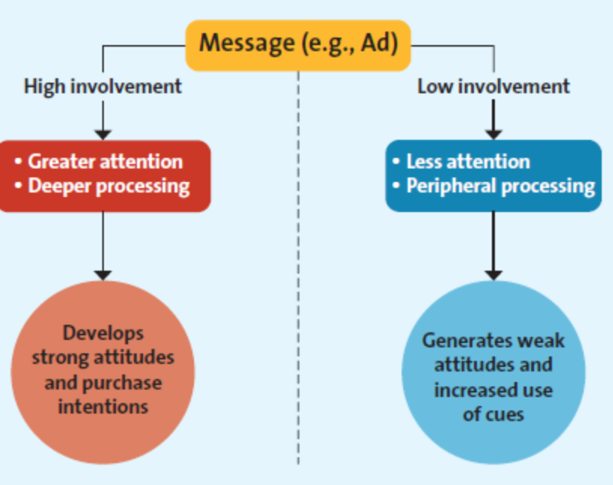

- A high-involvement consumer will scrutinize all the information provided and process key elements of the message deeply
- A low-involvement consumer will likely process the same advertisement in a less through manner and pay less attention to the key elements of the message and focus on heuristic elements such as brand name, price, and the presence of a celebrity endorser
- The impressions of the low-involvement consumers are likely to be more superficial

Extended Problem Solving
- Extended problem solving is a purchase decision process during which the consumer devotes considerable time and effort into analyzing alternatives; often occurs when the consumer perceives that the purchase decision entails a great deal of risk

Limited Problem Solving
- Limited problem solving occurs during a purchase decision that calls for, at most, a moderate amount of effort and time
- Customers engage in this type of buying process when they have had some prior experience with the product or service and the perceived risk is moderate
- Impulse buying is a buying decision made by customers on the spot when they see the merchandise
- Habitual decision making describes a purchase decision process in which consumers engage with little conscious effort

Chapter 5: Business-to-Business Marketing
Introduction
- Business-to-business (B2B) marketing refers to the process of buying and selling goods or services to be used in the production of other goods and services, for consumption by the buying organization, or for resale by wholesalers and retailers
- B2B marketing involves manufacturers, wholesalers, retailers, and service firms that market goods and services to other businesses but not to the ultimate consumer
- The distinction between a B2B and a B2C transaction is not the product or service itself; rather, it is the ultimate purchaser and user of that product or service

B2B Markets
- Just like organizations that sell directly to final consumers in B2C transactions, B2B firms focus their efforts on serving specific types of customer markets to create value for those customers
- Manufactures, resellers, institutions, and governments are all involved in B2B transactions

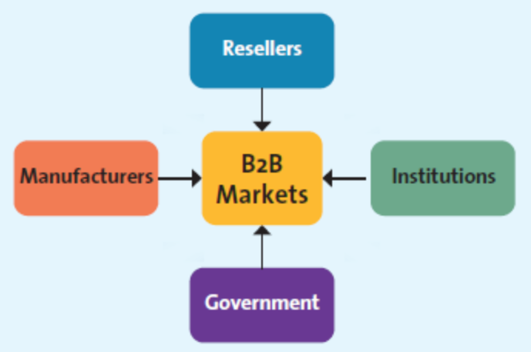

Manufacturers or Producers
- Manufacturers buy raw materials, components, and parts that allow them to manufacture their own goods
- Today, many B2B companies are demanding, as a condition for doing business, that suppliers demonstrate social responsibility by putting in place policies and practices to reduce their carbon footprint

Resellers
- Resellers are marketing intermediaries that resell manufactured products without significantly altering their form
- Wholesalers, distributors, and retailers are all resellers
- Institutions, such as hospitals, educational organizations, prisons, religious organizations, and other non-profit organizations, also purchase all kinds of goods and services for the people they serve

Government
- In most countries, the central government tends to be one of the largest purchasers of goods and services

Key Challenges of Reaching B2B Clients
- For marketers to be effective and successful at B2B marketing, they must master three key challenges for each business customer they want to serve:
- The first challenge is to identify the right persons or decision makers within the organizations who can authorize or influence purchases
- Second, marketers must understand the buying process of each potential client
- The third challenge is to identify the factors that influence the buying process of potential clients
- B2B markets differ in varying degrees on these three dimensions; hence, marketers must invest the time and resources to understand these challenges
- To address the complexity of B2B markets, many companies have salespeople or a sales team dedicated to specific clients
- Unique characteristics of B2B markets that distinguish them from B2C markets:

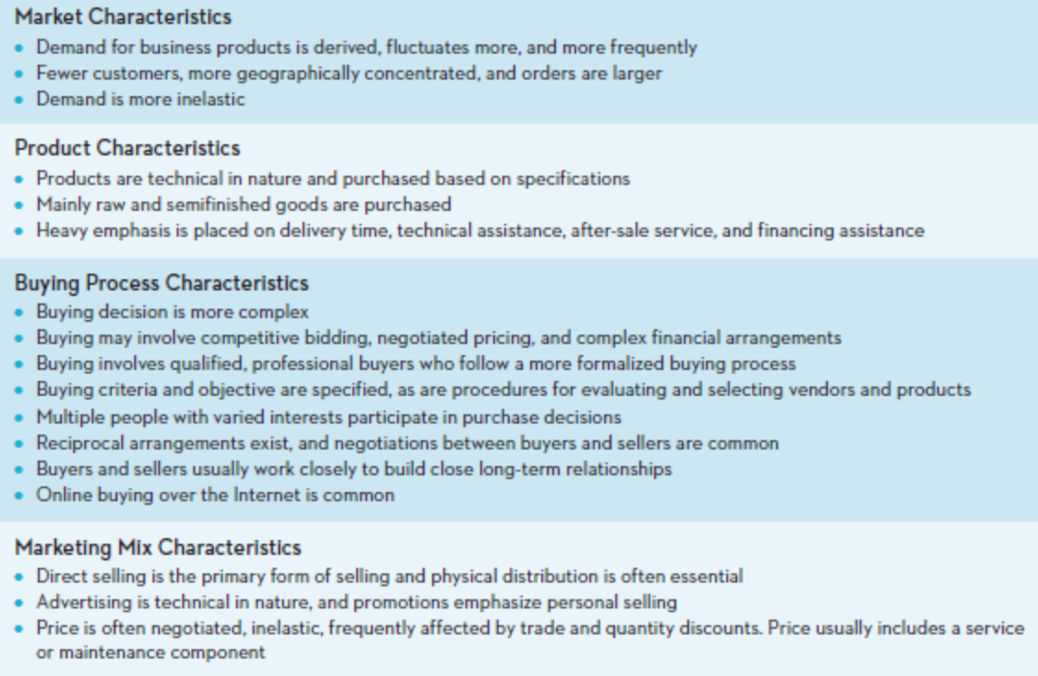

MARKET CHARACTERISTICS
- In B2C markets, consumers buy goods to satisfy their own individual or household needs and are heavily influences by price, personal tastes, brand reputation, or personal recommendations of friends and family
- In B2B markets, demand for goods and services is often derived from B2C sales in the same supply chain
- Derived demand is the linkage between consumers’ demand for a company’s output and its purchase of necessary inputs to manufacture or assemble that particular output
- Demand for raw material and semi finished goods purchased by business firms tend to fluctuate more, and more frequently
- Demand in many business markets is inelastic
- The number of business buyers is substantially fewer than in B2C markets, and the business buyers are more concentrated in big cities, towns, and industrial areas
- The sizes of the orders are substantially larger than consumer purchases

PRODUCT CHARACTERISTICS
- In B2B markets, the products ordered are primarily raw materials and semi finished goods that are processed or assembled into finished goods for the ultimate consumers
- In certain B2B markets (aerospace, medical, pharmaceutical, shipping, defence), the products are very technical and sophisticated in mature and must conform to technical standards specified by the buyer
- Orders must be delivered on the dates agreed to by both buyers and sellers
- Technical services and financing assistance are important aspects of B2B buying behaviour
- In B2C markets, consumers buy finished goods for their own personal consumption

BUYING PROCESS CHARACTERISTICS
- Generally, for routine purchases or small-dollar-value purchases, only one of a few individuals within a department or the company may be responsible for the buying decision
- However, for purchases of highly technical or complex products involving thousands or millions of dollars, the buying effort is much more structured, formalized, and professional
- More people are usually involved in complex buying decisions
- They are usually technically trained and qualified professionals, and they represent different interests within the organization
- The group of people involved in the buying decision is often referred to as the buying centre
- Most companies have formal policies and procedures to guide buying decisions that must be closely followed by the people involved in the buying decisions
- Examples of such procedures include rules governing competitive bidding, negotiated pricing, complex financial arrangements, buying criteria, and objectives, as well as procedures for evaluating competitive bids
- Another major difference between B2B and B2C buying lies in the nature of the relationship between the firm and its suppliers
- Generally, the buying decision is based on negotiations, which for complex purchases could be quite extended
- The negotiated contract normally covers a range of concerns, including price, delivery, warranty, technical specifications, and claim policies
- In B2B markets, buyers and sellers strive to develop close relationships with each other and so will often provide help or advice to ensure a win-win situation for both parties
- Some firms may engage is reciprocal buying arrangements – a practice where two firms agree to buy each other’s products and services
- Consequences of reciprocal buying are that it excludes other vendors from participating in the buying process and may limit the firms to each other’s products, which may not be the best thing

Marketing Mix Characteristics
- Another major difference between the typical B2B and B2C transaction is the role of the salesperson
- On the one hand, while salespeople are an important component of the communications mix for B2C transactions such as sales of real estate, insurance, jewellery, consumer electronics, and high-end apparel, most fast-moving consumer goods (FMCG) found in grocery and discount stores are not sold with the aid of salespeople
- On the other hand, in most B2B sales, the salesperson is an integral component of the transaction

B2B Classification System and Segmentation
- Statistics Canada collects data about business activity in Canada through its classification scheme, which categorizes all firms into a hierarchal set of six-digit North American Industry Classification System (NAICS) codes
- The NAICS was developed jointly by Canada, the US, and Mexico to provide comparable statisics about business activity in all of North America
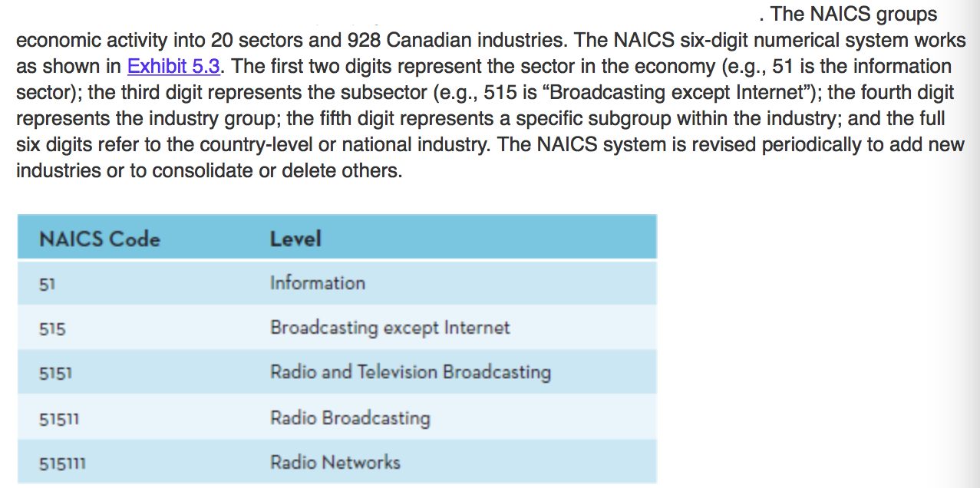
- The NAICS codes replaces the Standard Industrial Classification (SIC) system that had been in use since the 1930s
- The NAICS classification system can be quite useful to B2B marketers for segmenting and targeting markets
- In addition to NAICS, marketers may segment B2B markets in several other ways, including geographic location, firm size, account size, and types of products purchased

The B2B Buying Process
- The B2B buying process parallels the B2C process, though it differs in many ways
- Both start with need recognition, but the information search and alternative evaluation stages are more formal and structured in the B2B process
- Typically, B2B buyers specify their needs in writing and ask potential suppliers to submit formal proposals, whereas B2C buying decisions are usually made by individuals or families and sometimes are unplanned and impulsive
- The final decision rests with a committee, as is the case for most B2B buying decisions, which often demand a great deal of consideration
- Finally, in B2C buying situations, customers evaluate their purchase decision and sometimes experience post purchase dissonance
- However, formal performance evaluations of the vendor and the products sold generally do not occur, as they do in the B2B setting

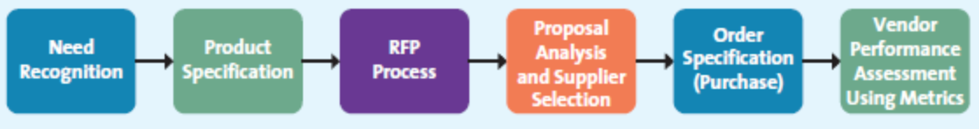

Stage 1: Need Recognition
- In the first stage of the B2B buying process, the buying organization recognizes, through either internal or external sources, that it has an unfilled need

Stage 2: Product Specification
- After recognizing the need and considering alternative solutions, the firm writes a list of potential specifications that vendors might use to develop their proposals

Stage 3: RFP Process
- The request for proposals (RFP) is a common process through which buying organizations invite alternative suppliers to bid on supplying their required components
- The purchasing company may simply post its RFP needs on its website, work through various B2B web portals, or contact potential suppliers directly
- Firms may narrow the process to a few suppliers, often those with which they have existing relationships
- Responding to RFPs can be time consuming and costly

Stage 4: Proposal Analysis and Supplier Selection
- The buying organization, in conjunction with its critical decision makers, evaluates all the proposals it receives in response to its RFP
- Many firms narrow the process to a few suppliers, often those with which they have existing relationships, and discuss key terms of the sale, such as price, quality, delivery, and financing
- Some firms have a policy that requires them to negotiate with several suppliers, particularly if the product or service represents a critical component or aspect of the business
- The policy keeps suppliers on their toes; they know that the buying firm can always shift a greater portion of its business to an alternative supplier if it offers better terms

Stage 5: Order Specification (Purchase)
- In the fifth stage, the firm places its order with its preferred supplier(s)
- The order will include a detailed description of the goods, prices, delivery dates, and, in some cases, penalties if the order is not filled on time
- The supplier then will send an acknowledgement that it has received the order and fill it by the specified date

Stage 6: Vendor Performance Assessment Using Metrics
- Just as in the consumer buying process, firms analyze their vendors’ performance so they can make decisions about their future purchases
- The difference is that, in a B2B setting, this analysis is typically more formal and objective

The Buying Centre
- The six-stage B2B buying process may be influenced by three factors within the purchasing organization: the buying centre, the buying organization’s philosophy or corporate culture, and the buying situation
- In most large organizations, several people typically are responsible for the buying decisions
- These buying centre participants can range from employees who have a formal role in purchasing decisions, to members of the design team that is specifying the particular equipment or raw material needed, to employees who will be using a new machine that is being ordered
- All these employees are likely to play different roles in the buying process, which vendors must understand and adapt to in their marketing and sales efforts
- We can categorize six different buying roles within a typical buying centre
- One or more people may take on a certain role, or one person may take on more than one of the following roles:
- Initiator: the person who first suggests buying the particular product or service
- Influencer: the person whose views influence other members of the buying centre in making the final decision
- Decider: the person who ultimately determines any part of or the entire buying decision – whether to buy, what to buy, how to buy, or where to buy
- Buyer: the person who handles the paperwork of the actual purchase
- User: the person(s) who consumes or uses the product or service
- Gatekeeper: the person(s) who controls information or access, or both, to decision markers and influencers
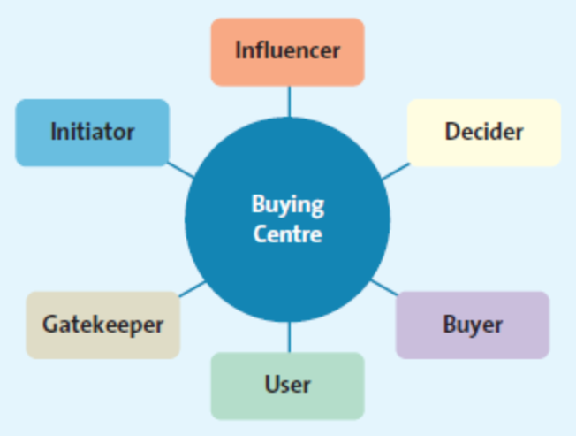

- In the end, the final purchase decision must take into consideration every single buying centre participant

Organizational Culture
- A firm’s organizational culture reflects the set of values, traditions, and customs that guides its managers’ and employees’ behaviour
- The firm’s culture often comprises a set of unspoken guidelines that employees share with one another through various work situations
- Organizational culture can have a profound influence on purchasing decisions, and corporate buying centre cultures might be divided into four general types: autocratic, democratic, consultative, and consensus
- Knowing which buying centre culture is prevalent in a given organization helps the seller decide how to approach that particular client, how and whom to deliver pertinent information, and to whom to make the sales presentations
- In an autocratic buying centre, though there may be multiple participants, one person makes the decision alone, whereas the majority rules in a democratic buying centre
- A consultative buying centre uses one person to make a decision, but he or she solicits input from others before doing so
- In a consensus buying centre, all members of the team must reach a collective agreement that they can support a particular purchase
- Cultures act like living, breathing entities that change and grow, just as organizations do
- Even within some companies, culture may vary by geography, division, or functional department
- Whether you are a member of the buying centre or a supplier trying to sell to it, it is extremely important to understand its culture and the roles of the key players in the buying process
- Not knowing the roles of the key players in that case could waste a lot of time – both yours and the buying centre’s – and could even alienate the real decision maker

Building B2B Relationships
- In B2B contexts, there are a vast variety of ways to enhance relationships
- Blogs and social media can build awareness, provide search engine results, educate potential and existing clients about products or services, and warm up a seemingly cold corporate culture
- An expert who offers advice and knowledge about products increases brand awareness, and a blog is a great medium for this information
- Web analytics, such as traffic on the website and the number of comments, can offer tangible evaluations, but a better measure is how often the blog gets mentioned elsewhere, the media attention it receives, and the interaction, involvement, intimacy, and influence that it promotes

Buying Situations
- The type of buying situation also affects the B2B decision process
- Most B2B buying situations can be categorized into three types: new buys, modified rebuys, and straight rebuys

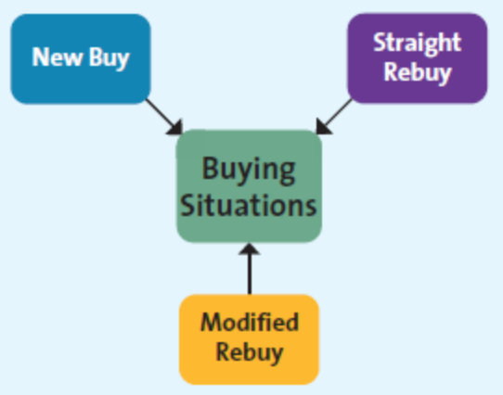

- In a new buy situation, a customer purchases a good or service for the first time, which means the buying decision is likely to be quite involved because the buying organization does not have any experience with the item
- In a modified rebuy, the buyer has purchased a similar product in the past but has decided to change some specifications, such as the desired price, quality, level, customer service level, and options
- A straight rebuy occurs when the buyer or buying organization simply buys additional units of products that has previously been purchased
- These varies types of buying situations call for very different marketing and selling strategies
- The most complex and difficult is the new buy because it requires the buying organization to make changes in its current practises and purchases
- As a result, several members of the buying centre will likely become involved, and the level of their involvement will be more intense than in the case of modified and straight rebuys
- In new buying situations, buying centre members also typically spend more time at each stage of the B2B buying process, similar to the extended decision-making process that consumers use in the B2C process
- In comparison, in modified rebuys, the buyers spend less time at each stage of the B2B buying process, similar to limited decision marking in the B2C process
- In straight rebuys, however, the buyer is often the only member of the buying centre involved in the process
- Similar to a consumer’s habitual purchase, straight rebuys often enable the buyer to recognize the firm’s need and go directly to the fifth step in the B2B buying process, skipping the product specification, RFP process, and proposal analysis and supplier selection steps

Conclusion
- In various ways, B2B marketing both differs from and mirrors the B2C process
- The differences in the six stages of the buying process make sense in view of the many unique factors that come into play
- The constitution of the buying centre, the culture of the purchasing firm, and the context of the buying situation all influence the B2B buying process in various ways, which means that sellers must be constantly aware of these factors if they want to be successful in their sales attempts
- Finally, the internet has radically changes some elements of the B2B world, increasing the frequency of both private electronic exchanges and auctions
- Chapter Six: Consumer Behaviour
- The Consumer Decision Process
1. Need Recognition
2. Information Search
3. Alternative Evaluation
4. Purchase
5. Post Purchase
- Step 1: Need Recognition
– the beginning of the consumer decision process; occurs when consumers recognize they have an unsatisfied need and want to go from their actual, needy state to a different desired state
- Consumer needs can be classified as functional, psychological, or a combination of both:
- a) Functional Needs – pertain to the performance of a product or service
- materials like Thinsulate have been viewed as functionally superior to others for outerwear
- b) Psychological Needs – pertain to the personal gratification consumers associate with a product/service
- people pay $500 for shoes to satisfy a psychological need
- Step 2: Search for Information
- the consumer searches for information about the various options that exist to satisfy that need
- the length and intensity of the search depend on the degree of perceived risk and costs associated with purchasing a product or service
- Consumers rely on two key types of information: internal and external
- a) Internal Search for Information – occurs when the buyer examines his or her own memory and knowledge about the product or service, fathered through past experiences
- ie. Buying music always from Apple store because they have had good experiences with it
- b) External Search for Information – occurs when the buyer seeks information outside his or her personal knowledge base to help make the buying decision
- may fill their personal knowledge gaps by talking with friends, family, salespeople or the Internet
- Factors Affecting Consumers’ Search Processes
a) The perceived benefits vs. perceived costs of search
- is it worth the time and effort to search for information about a product/service?
- b) The locus of control
Internal Locus of Control – consumers believe they have some control over the outcomes of their actions, in which case they generally engage in more search activities
- External Locus of Control – consumers believe that fate or other external factors control all outcomes
- c) Actual or perceived risk
- three types of risk associated with purchase decisions can delay/discourage a purchase:
a) Performance Risk – involves the perceived danger inherent in a poorly performing product/service
b) Financial Risk – risk associated with a monetary outlay (warranties help alleviate this)
c) Psychological Risk - associated with the way people will feel if the product/service doesn’t convey
the right image
- d) Type of product or service
- three types of goods/services:
a) Specialty Goods/Services – products/services toward which the customer shows a strong
preference and for which they will expend considerable effort to search for the best suppliers
b) Shopping Goods/Services – consumer will spend time comparing alternatives
c) Convenience Goods/Services – consumer isn’t willing to spend any effort to evaluate prior to
purchase
- Step 3: Evaluation of Alternatives
- once a consumer has recognized a problem and explored the possible options, they must sift through the choices available and evaluated the alternatives
- when consumers begin to evaluate different alternatives, they often base their evaluations on a set of important attributes or evaluative criteria
- Evaluative Criteria – consist of a set of salient, or important, attributes about a particular product
- ex. Consumer looking to buy an MP3 player may take into consideration things like features, selling price, looks and popularity of the different brands
- Determinant Attributes – product or service features that are important to the buyer and on which competing brands or stores are perceived to differ
- Consumer Decision Rules – the set of criteria that consumers use consciously or subconsciously to quickly and efficiently select from among several alternatives
- these rules take several different forms: compensatory, noncompensatory or decision heuristics
- a) Compensatory Decision Rule – at work when the consumer is evaluating alternatives and trades off one characteristic against another
- b) Noncompensatory Decision Rule – at work when consumers choose a product/service on the basis of a subset of its characteristics, regardless of the values of its other attributes
- may reject something solely on price; not willing to spend more than a particular amount
- c) Decision Heuristics – mental shortcuts that help narrow down choices
- ex. Price, brand and product presentation
- may choose the most expensive option thinking that it will be better quality
- buying brand name goods allows some consumers to feel safe
- the manner in which the product is presented can influence the decision process
- Step 4: Purchase and Consumption
- value is a strong driver of consumers’ purchase decisions
- Ritual Consumption – a pattern of behaviours tied to life events that affect what and how people consume (ex. Going to Tim Hortons every morning for breakfast)
- Step 5: Postpurchase
- marketers can take several steps to ensure postpurchase satisfaction:
- build realistic expectations – not too high or low – and deliver on those expectations
- demonstrate correct product use
- stand behind the product/service by providing money-back guarantees
- encourage customer feedback to cut down on negative word of mouth
- periodically make contact with customers to show the company cares about them
- Postpurchase Dissonance – the psychologically uncomfortable state produced by an inconsistency between beliefs and behaviours that evokes a motivation to reduce the dissonance; buyer’s remorse
- typically occurs when a consumer questions the appropriateness of a purchase after the purchase has been made
- Marketers attempt to solidify a loyal relationship with their customers in this stage. They want customers to be satisfied with their purchase and to buy from them again.
- Negative Word of Mouth – when consumers spread negative information about a product to others
- Types of Consumer Buying Decisions
- involvement refers to the time and effort a buyer invests searching and evaluating information when buying a product or service
 | High Involvement | Low Involvement
Significant perceived differences  between brands | Complex Buying Behaviour | Variety-Seeking Behaviour
Few perceived differences  between brands | Dissonance Reducing Behaviour | Habitual Buying Behaviour
- a) Complex Buying Behaviour – consumers are highly involved in the purchase and perceive significant differences among available brands
- b) Dissonance Reducing Buying Behaviour – consumers perceive few differences among brand when buying expensive, infrequent, or risky products
- c) Habitual Buying Behaviour – consumers make purchase decisions with little or no thought
- d) Variety-Seeking Behaviour – consumers have low involvement but notice differences among brands
- Factors Influencing Consumer Buying Decisions
- psychological, social, cultural and situation factors may influence buying decisions
1. Psychological Factors
a) Motives – a need or want that is strong enough to cause the person to seek satisfaction
- PSSP Hierarchy of Needs – argues that when lower-level, more basic needs (physiological and safety) are fulfilled, people turn to satisfying their higher-level needs (social and personal)
- Level 1: Physiological Needs – those relating to the basic biological necessities of life
- food, drink, rest and shelter
- Level 2: Safety Needs – pertain to protection and physical well-being
- Level 3: Social Needs – relate to one’s interactions with others
- Level 4: Personal Needs – relate to ways people satisfy their inner desires
- b) Attitude – a person’s enduring evaluation of his or her feelings about and behavioural tendencies toward and object/idea; consists of three components: cognitive, affective and behavioural
- Cognitive Component – reflects what a person believes to be true
Affective Component – reflects what a person feels about the issue at hand
- their like or dislike or something
Behavioural Component – comprises the actions a person takes with regard to the issue at hand
- c) Perception – the process by which people select, organize, and interpret information to form a meaningful picture of the world
- d) Learning – refers to a change in a person’s thought process or behaviour that arises from experience and takes place throughout the consumer decision process
- 2. Social Factors
a) Family
b) Reference Groups – people whom an individual uses as a basis for comparison regarding beliefs, feelings, and behaviours
- 3. Culture
- 4. Situational Factors – factor affecting the consumer decision process: those that are specific to the situation that may override, or at least influence, psychological and social issues
- purchase situation – a thrifty shopper may buy an expensive wedding present for a special occasion
- shopping situation – store atmosphere, salespeople, crowding, in store demonstration, packaging and promotions can be used to influence consumers at this stage
- temporal state – different times of day may affect the appeal products have on different people
Chapter 7: Marketing Research

The Marketing Research Process
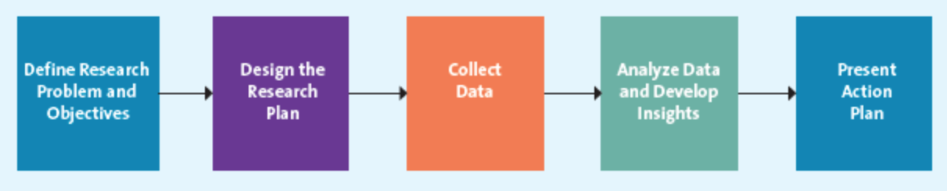
Step 1:Define the Research Problem and Objectives
- Because research is both expensive and time consuming, it is important to establish in advance exactly what problem needs to be solved
- Correctly defining the problem is one of the most important elements of the marketing research process
- Once the research problem is defined, marketers must specify the research objectives or questions to be answered
- Marketing research efforts and resources can be wasted if the research objectives are poorly defined
- Poor design arises from three major sources: basing research on irrelevant research questions, focusing on research questions that marketing research cannot answer, or addressing research questions to which the answers are already known

Step 2: Design the Research Plan
- In this step, researchers identify the type of data needed and determine the type of research necessary to collect it
- The objectives of the project drive the type of data needed

Step 3: Collect Data
- Data collection begins only after the research design process
- Based on the design of the project, data can be collected from secondary or primary data sources
- Secondary data are pieces of information that have been collected prior to the start of the focal research project
- Secondary data include both external and internal data sources
- Primary data are those data collected to address specific research needs
- Some common primary data collection methods include focus groups, in-depth interviews, and surveys
- No company can ask every customer their opinions or observe every customer, so researchers must choose a group of customers who represent the customers of interest, or a sample, and then generalize their opinions to describe all customers with the same characteristics
- They may choose the sample participants at random or they may choose to select the sample on the basis of some characteristic

Step 4: Analyze Data and Develop Insights
- To generate meaningful information, researches analyze and make use of the collected data
- Data can be defined as raw numbers or other factual information that, on their own, have limited value to marketers
- When the data are interpreted, they become information, which results from organizing, analyzing, and interpreting the data, and putting it into a form that is useful to marketing decision makers
- The purpose of converting data to information is to describe, explain, predict, and/or evaluate a particular situation and then use it to develop insights
- It is important for market researchers to analyze and interpret the data in an objective manner
- Misinterpreting the findings or manipulating the statistics to suit the researcher’s hunch or prediction could lead to the wrong decision, which could have serious consequences for marketers

Step 5: Present Action Plan
- In the final phase of the marketing research process, the analyst prepares the results and presents them to decision makers, who undertake appropriate marketing actions and strategies
- A typical marketing research presentation includes an executive summary, the body of the report (which discusses the research objectives, methodology used, and detailed findings), the conclusions, the limitations, and appropriate supplemental tables, figures, and appendices
- To be effective, written reports must be short, interesting, methodical, precise, lucid, and free of errors
- The reports should use a style appropriate to the audience, be devoid of technical jargon, and include recommendations that managers can actually implement

Secondary Data
- A marketing research project often begins with a review of the relevant secondary data
- Secondary data might come from free or very inexpensive external sources such as census data, information from trade associations, books, journal articles, and reports published in magazines and newspapers
- Although readily accessible, there inexpensive sources may not be specific or timely enough to solve the market’s research needs and objectives
- Firms can purchase more specific or applicable secondary data from specialized research firms
- Secondary sources can be accessed through internal sources, including the company’s sales invoices, customer lists, and other reports generated by the company itself

INTERNAL SECONDARY DATA
- One of the most valuable resources firms have at their disposal is their rich cache of customer information and purchase history
- Data-mining uses a variety of statistical analysis tools to uncover previously unknown patterns in the data or relationships among variables
- Firms hope to use data mining to generate customer-based analytics that they can apply to their strategic decision making, and thereby make good customers better, and make better customers their best
- Firms can also use secondary data to assess the profitability of their customers by determining the customer lifetime value (CLV)

EXTERNAL SECONDARY DATA
- Some sources of external secondary data can be accessed quickly and at relatively low cost
- Researchers must ensure that the secondary data they use, especially from external sources, are current and relevant, and can shed light on the research problem or objectives
- Syndicated data are data available for a fee from commercial research firms
- Scanner data are obtained from scanner readings of UPC codes at checkout counters and used in quantitative research
- Panel data are information collected from a group of consumers (the panel) over time
- The data collected from the panellists often include records of what they have purchased (secondary data), as well as their responses to survey questions that the client gives to the panel to ask the panellists (primary data)
- Both panel and scanner data provide firms with a comprehensive picture of what consumers are buying or not buying
- The key difference between scanner research and panel research is how the data get aggregated
- Scanner research typically focuses on weekly consumption of a particular product at a given unit of analysis
- Panel research focuses on the total weekly consumption by a particular person or household
- When it comes to secondary data, marketers must pay careful attention to how the secondary data were collected

Primary Data Collection Techniques
- In many cases, the information researchers need is available only through primary data, or data collected to address the specific research needs/questions currently under investigation
- Markets collect primary data by using a variety of means, such as observing consumer behaviour, conducting focus groups, or surveying customers by using the mail, telephone, in-person interviews, or the internet
- Primary data collection can help eliminate some of the problems inherent to secondary data
- Depending on the nature of the research problem, the primary data collection can use a qualitative or a quantitative approach
- A major advantage of primary research is that it can be tailored to fit the research questions
- Disadvantages of primary research it that it is usually more costly to collect primary than secondary data, and the collection typically takes longer
- Marketers often require extensive training and experience to design and collect primary data that are unbiased, valid, and reliable
- Qualitative research attempts the begin to understand the phenomenon of interest; it also provides initial information that helps the researcher more clearly formulate the research problem or objectives
- Qualitative research is more informal than quantitative research methods and includes observation, following social media sites, in-depth interviews, focus groups, and projective techniques
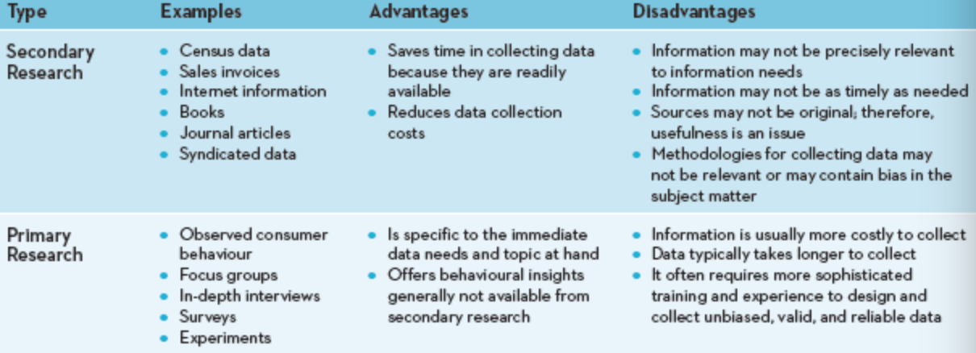

- Reliability is the extent to which you will get the same result if the study is repeated under identical situations
- Validity is the extent to which the study actually measures what it is supposed to measure
- A market research study must be both reliable and valid for it to be useful
- A sample is a segment or subset of the population that adequately represents the entire population of interest
- Generally, larger samples tend to yield more reliable results up to a certain point
- Quantitative research provides the information needed to confirm preliminary insights, and that managers can use to pursue appropriate courses of action
- Quantitative research offers a means to confirm implicit hunches through surveys, formal studies such as specific experiments, scanner and panel data, or some combination of these
- Quantitative research enables researchers to test their prediction or hypothesis, which is a statement or proposition predicting a particular relationship among multiple variables

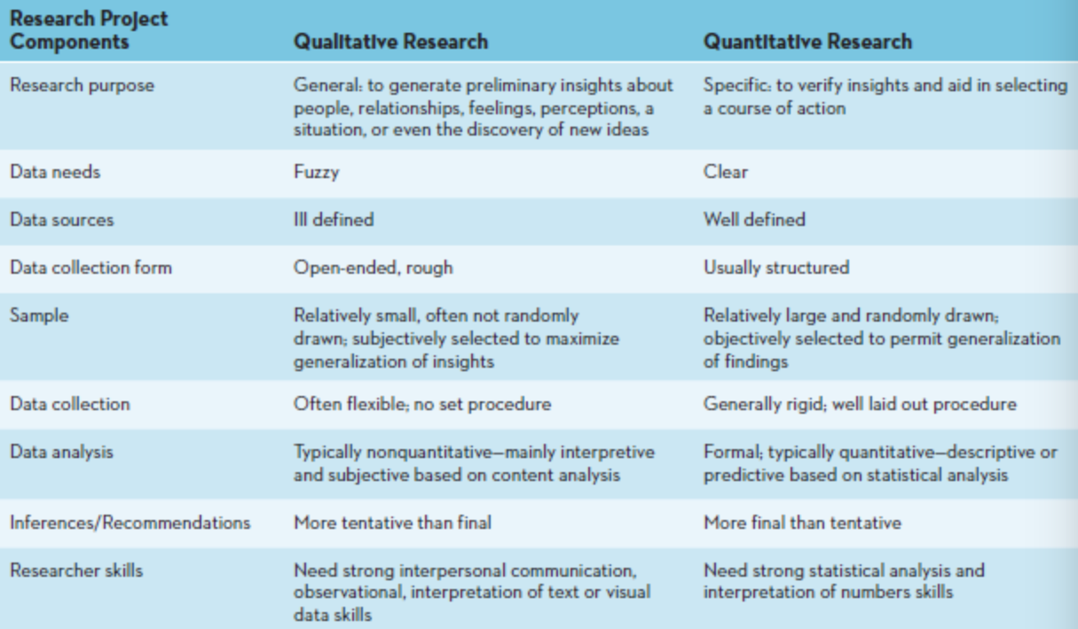

Qualitative Research Methods

OBSERVATION
- The observation research method entails examining purchase and consumption behaviours through personal means or the use of technology, such as video camera or other tracking devices
- Ethnography is an observational method that studies people in their daily lives and activities in their homes, work, and communities

SOCIAL MEDIA
- Social media sites are a booming source of data for marketers
- Marketers have realized that social media can provide valuable information that could aid their marketing research and strategy endeavours
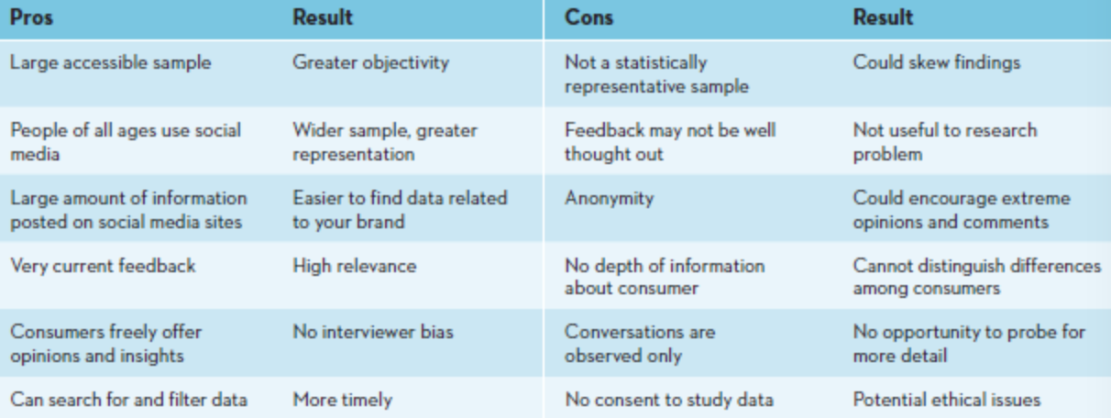

IN-DEPTH INTERVIEWS
- In an in-depth interview, trained researchers ask questions, listen to and record the answers, and then pose additional questions to clarify or expand on a particular issue

FOCUS GROUP INTERVIEWS
- In a focus group, a small group of persons (usually 8 to 12) comes together for an in-depth discussion about a particular topic
- Using an unstructured method of inquiry, a trained moderator guides the conversation on the basis of a predetermined general outline of the topics of interest

PROJECTIVE TECHNIQUE
- A projective technique is a type of qualitative research in which subjects are provided a scenario and asked to express their thoughts and feelings about it

- Generally, focus groups and in-depth interviews are used more frequently than personal observations, especially ethnography
- Deciding which technique to use depends on several important considerations, such as the objective of the research, the cost to undertake the research, the time required to undertake the research, how soon the results are needed, and whether the marketer has the research expertise in-house or has to hire a market research firm to do the research, especially with methods such as ethnography and projective techniques
- Marketers have to make a trade-off between these considerations to get the results in a timely and cost-effective manner
- Often a company may use several methods together to get actionable results

Quantitative Research Methods
- Quantitative research is intended to verify and to aid decision makers in selecting a specific course of action
- Quantitative research can be descriptive and experimental
- Quantitative research can be collected from the merchandise that is scanned at a store, or from a group of customers, known as a panel

SURVEY RESEARCH
- A survey is the most popular type of quantitative, primary data collection method used in marketing research
- Surveys are widely used to study consumers’ attitudes, preferences, behaviours, and knowledge about products and brands
- Surveys are generally more cost-effective than other methods for reaching a large sample of consumers
- Survey questionnaires usually yield quantitative data that can be easily analyzed by using sophisticated statistical methods to examine the relationship among variables
- Shortcomings of the surveys are that consumers may be unable to answer some of the questions on the questionnaire, may not be able to recall the information, or may even interpret the questions differently than the researches intended
- A survey is a systematic means of collecting information from people that generally uses a questionnaire
- A questionnaire is a form that features a set of questions designed to gather information from respondents and thereby accomplish the researchers’ objectives
- Survey questionnaires can take different forms: phone, mail, fax, delivered via internet, or even conducted in person
- Individual questions on a questionnaire can be either unstructured or structured
- Unstructured questions are open-ended and allow respondents to answer in their own words
- Structured questions are closed-ended questions for which a discrete set of response alternatives, or specific answers, is provided for respondents to evaluate
- The questions in a questionnaire must be carefully designed to address the specific set of research questions
- For a questionnaire to produce meaningful results, its questions cannot be misleading in any fashion, and they must address only one issue at a time
- Questions must be worded in vocabulary that will be familiar and comfortable to those being surveyed and must be sequenced appropriately; general questions first, more specific questions next, and demographic questions at the end
- The layout and appearance of the questionnaire must be professional and easy to follow, with appropriate instructions in suitable places
- Marketing surveys can be conducted online or offline, but online marketing surveys offer researchers the chance to develop a database quickly with many responses, whereas offline marketing surveys provide a more direct approach that includes interactions with the target market

PANEL RESEARCH
- Panel research can be either secondary or primary

EXPERIMENTAL RESEARCH
- Experimental research is a type of quantitative research that systematically manipulates one or more variables to determine which variable(s) have a causal effect on another variable

Emerging Technology and the Ethics of Using Customer Information
- A strong ethical orientation must be an integral part of a firm’s marketing strategy and decision making
- Marketing researches must be careful to not abuse their ability to access customer data, which can be very sensitive
- Marketers must take every step possible to protect customer data from security breaches from hackers and other unauthorized individuals
- The Canadian government has implemented various regulations, such as the Privacy Act and PIPEDA to govern the collection, use, disclosure, and retention of personal information by certain parts of the private sector
- It is extremely important to adhere to ethical practices when conducting marketing research
- Marketing research should be used only to produce unbiased, factual information

