INST 250 – Introduction to Literacy Skills

- Lesson 2: Information Literacy

Information literacy is considered an essential lifelong learning skill. It is one of a collection of “The skills you need to enter, stay in, and progress in the world of work – whether you work on your own or as part of a team.”

The Conference Board of Canada separates skills into three categories – Fundamental Skills (most relevant to this course), Personal Management Skills, and Teamwork Skills.

Seven Pillars Model for Information Literacy

1: Identify a need for information. - Information Gap
2. Scope is recognizing the information gap. – How do I find the information that I’m missing?
3. Plan strategies for locating and accessing information. – How to identify best sources for your needs
4. Gather relevant information. – Develop search strategies
5. Evaluate the information retrieved.
6. Manage the information to compare and contrast.
7. Present. Linking newfound information to existing knowledge.

Flowchart Process

Begins broadly and narrows down as system unfolds

Step 1: Background Reading - Select topic/pose question that is of interest and requires in depth investigation
Step 2: Develop Preliminary Thesis Statement & Informal Outline – Provide tentative answer to question
Step 3: Conduct Literature with Library Catalogues/Databases/Internet – Literature Search
Step 4: Create Working Bibliography – Occurs throughout the literature search
Step 5: Read & Evaluate Sources – Find quality, accurate, credible and relevant sources.
Step 6: Write Final Thesis Statement – Using knowledge and what you learned to develop final thesis.
Step 7: Prepare Paper & Bibliography – Building on your outline and writing paper.

The Publication Cycle

Time Cycle: indication of the time it takes for information to be published in a specific form
Knowledge Cycle: stage where the original research goes from being an idea being researched to appearing in a conference, journal, then final publication
Publication Cycle: tells us the format in which the information appears. Ex: from a research diary to scholarly article
Access Cycle: tells us the methods we can use to access the information

- Lesson 3: Finding a topic for my inquiry

The Research Topic

A good research topic must meet 4 demands:

It must examine a narrow issue, not a broad topic.
It must address a knowledgeable reader and carry that reader to another level of knowledge.
It must have a serious purpose, in that it demands analysis of the issues, argues from a position, and explains complex details.
Meet the expectations of the instructor and the course requirements.

A research topic should have a built-in issue so that the researcher can interpret the issue and cite the opinions of outside sources.

What is Not Suitable for a Research Paper?

1 | Too autobiographical — draws primarily on your own experience  The idea of the research paper is to use published literature to argue a stand that you have taken, not to write a personal essay. For example, my trip to Paris may have been an interesting experience, it would not be a suitable research topic.
2 | Too subjective — where your whole argument is based on personal taste or opinion.  For example the fact that you believe the Liberals are the best political party may result in a biased, one-sided discussion of their platform.
3 | Too current — today’s headlines.  This is the case where there is very little published literature available on the topic. Today’s headlines may be interesting but there may not have been an opportunity to develop a body of published literature on a particular headline.
4 | Too restrictive — usually a mechanical process which can be explained by one source.  For example, symptoms of child abuse.
5 | Too specialized — in that the terminology is too technical.  This is the case where the literature provides valuable information but it is in such technical terms that you are not able to understand it.

A good research topic should:

Be narrow enough to be developed fully - Do not try to write a biography of Picasso or analyze all of his work, focus on perhaps the Blue period.

Require research and not just be an essay expounding what you know and your opinion, or drawing solely on your personal experience.

Be a topic you consider objectively. If your convictions on a topic are so strong that they prevent you from acknowledging the other side of a controversial topic, then you might want to avoid that topic.

Be a topic that you are curious about, but not thoroughly familiar with. Being curious about a topic will hold your interest and not being thoroughly familiar with it means that your research will provide you with new insights and discoveries.

Two types of reference sources:

- General: Broad in scope, useful for many subjects. Geared to a general audience. Not appropriate for research. Example: Encyclopedia Britannica

- Subject: Material is devoted to a specific field such as art, or literature, or chemistry. Geared to a specialized audience. Appropriate for research. Example: Kirk-Othmer Encyclopedia of Chemical Technology.

Six types of dictionaries:

- General: Unabridged (over 250,000), Abridged (80,000 or less), Collegiate or Pocket. Used by a general audience (e.g. Webster)
- Historical: Provide origin of a word (e.g. Oxford English Dictionary)
- Foreign Language: one language or translating
- Subject: Geared to a specific field (e.g. Dictionary of Finance)
- Special Purpose: e.g. Dictionary of Slang
- Biographical: Essay and Data (e.g. Current Biography)

Additional Reference Sources:

ALMANACS: Compendiums of facts, dates, statistics relating to people, events, countries, and subjects. An example of an almanac would be the Almanac of British Politics.

DIRECTORIES: Gives the names and addresses of persons, organizations, or institutions. It may provide other information such as the purposes, the dues, and the officers of organizations. An example of a directory is the Directory of Services and Programs for Abused Men in Canada = Répertoire des services et programmes pour hommes violentés au Canada.

HANDBOOKS AND MANUALS: Contains common information in a concise form and provide a quick reference to more detailed sources. An example of a handbook is the Handbook of forensic sociology and psychology.

YEARBOOKS: Provides concise summaries of the events of a particular year, or within a particular country. They are designed to be factual and statistical. An example of a yearbook is the European Yearbook of International Economic Law 2011.

Fact vs. Opinions

Fact: denotes something that actually exists, meaning that a fact can be verified or proven. For example if we were to state that the unemployment rate in Canada averaged 7% in a particular geographic location at a particular time, this is figure that we can verify. It can be proven.

Opinion: is more abstract. It is an idea about a fact or about another opinion. If we were to examine the possible ways of reducing cancer deaths, there is an element of supposition inherent in this opinion.

The heart of your thesis should be an opinion of your own. You use both facts to support your thesis and opinions as supplemental support. Any research paper will contain both facts and opinion taken from outside sources.

Thesis Statement:

Also according to Lester, it performs three tasks:

- It sets the argument that will focus the entire paper.
- It introduces an idea that will be developed and defended.
- It specifies to the reader the point of the research.

Developing a preliminary thesis statement
 | Develop idea | Question | Result
1 | Literacy in children at  risk of failure | What about it? | Programs to improve literacy in children at  risk of failure
2 | Programs to improve literacy in children at risk of failure | Where? | Programs to improve literacy in Canadian children at risk of failure
3 | Programs to improve literacy in Canadian children at risk of failure | When? | Early intervention programs to improve literacy in children at risk of failure
4 | Early intervention programs to improve literacy in children at risk of failure | Why? | Early intervention programs aimed at improving literacy in children at risk of failure will lead to societal benefits.
Preliminary thesis statement (the result of Why?)
Early intervention programs aimed at improving literacy in children at risk of failure will lead to societal benefits.

Outlines:

Informal (or Preliminary) outlines
- Used for one's own needs
- Written prior to the literature search
- Developed throughout the process
Formal outlines
- Written prior to writing the paper
- Shows how the paper supports the thesis statement
- Used as a means to check the paper's organization and emphasis
- Two types: Topic and Sentence

- Lesson 4 – Types of Materials

Primary Sources: original words of the writer
Ex: poems, films, diaries, speeches, letters, novels, autobiographies, interviews, case studies, findings from research, manuscript, paintings

When paraphrasing or quoting, try to rely on primary sources as they have direct relevance to paper

Secondary Sources: writings about primary sources. Discuss researchers findings, authors work, individuals accomplishments
Ex: book or film review, analysis of a study, article in a newspaper that discusses current affairs

Periodicals:
Less time delay than books and are scholarly journal articles.
Material that is published at regular intervals (daily, weekly, monthly, annually)
More up to date and reflect contemporary opinion
Reveal trends.

Magazines:
Type of periodical with wide circulation and broad appeal
- Written for general audience
- Published frequently by commercial publishers
- Not used for scholarly research
- Examples: life, readers digest, fortune, macleans, time, sports illustrated

Periodical formats:
Older magazines and newspapers available in microfiche
Older journals may be available only in printed format

CLUES
- Call number - first number is classification number indicating subject area.
- Title: can indicate if resource is electronic
- Publisher: can indicate if it's a reputable source, gives hint or credibility
- Year available: indicates the various electronic databases that the issues are available from
- Publication history: when the journal began publication
- Series: a periodical will sometimes be part of a series.
- Notes: notes that the user may not need but the library staff uses
- Access restricted: informs the user that only members of the Concordia community can access it
- Technical details: related to mode of access
- Subject heading: form of controlled vocabulary that are used to retrieve this item during a subject search
- Alternate author: different authors. Not always individuals.
- Alternate title: item may also be located under this title
- ISSN: international standard serial number. Unique number used internationally between libraries publishers and bookstores.
- Other criteria: purpose, authority, scope, audience, and date

Government publications:
For the most part not included in the library catalogue
Any publication issued under the authority of the government or one of its agencies.
Ex: statistical Canada, debates of House of Commons, environment Canada,

Theses: written by master’s students. Small scale study. Literature reviews.

Dissertations:
Written by doctoral students in partial fulfillment of their degree. Original research. Extensive bibliography. Excellent sources for research.

Both theses and dissertations are evaluated with the same criteria as books:

Purpose
Authority
Scope
Format
Audience

Unpublished sources found on the web:
No one needs to review or approve this content before posting it on the web. You must become the reviewer. Different evaluation criteria.

Authority: who is the author, qualifications, credibility of sponsoring institutions, who links to the site, good grammar and composition? Contact info

Accuracy: reliable and error free, so documented facts or personal opinion. Includes reputable sources and lists references

Currency: content up to date? date of creation, date of last revision, broken links,

Coverage: comprehensive, is the info relevant and useful for your needs. Looks at boundaries of coverage of the topic

Objectivity: purpose of site, personal bias, fair and reasonable arguments

- Lesson 5 – Conducting the Literature Search

Art of Skimming

For a journal article: quickly read through the abstract, intro and conclusion, and maybe discussion section

For a book: skim the table of contents, check the index to see whether it refers to writers you have already found sources for

When you're done, make a quick post it note with the following points:
- What’s it about
- Main themes / subtopics
- Useful - yes/no
- Things to follow up on

Take notes:
- Keep your topic
- Think about how the material relates to your topics
- Don't take endless notes
- Don't summarize whole article

Personal notes:
- Express your own thoughts and ideas
- Personal responses to info
- Word your original thoughts
- Notes you take should also be linked to your working bibliography
- Academic reading is reading for meaning: by writing down your thoughts write away , your thinking will be clearer for essay

Note taking has 3 formats usually:

Summarizing:
- General concepts or ideas of the original work are briefly condensed in your own words. 1-2 sentences
- Aim is to reduce whole piece to only main ideas

Paraphrasing:
- Original authors ideas are restated in your own words. Don't borrow text
- Extract principle idea from a passage
- Not simply changing the order of works or using synonyms
- Not necessarily aimed at reducing in length
- Acknowledge authors

Quoting:
- Exact copy of original source
- Must be enclosed with quotation marks
- Keep quotes short
- Don't use a lot of quotes

Quoting within text: fewer than 40 words should be integrated into your text and in (")

Block quotation: longer than 40 words should be displayed a block quotation. Start on a new line. Remove quotation marks and indent the entire paragraph completely from left margin

Words omitted: if you omit a word or passage from quotation, insert an ellipsis (…) in its place

Quote modified: put ([ ]) around any added or modified text

How does plagiarism happen?
No acknowledgements
Web, books, course pack and not referenced
Incomplete acknowledgement
Sourced but borrows too heavily from original

Bibliography

Book: note the author, title, place of publication, publisher and publication date, page numbers for quotes

Journal article: author, title of article, title of journal, volume, issue, date and inclusive page numbers

Web page: URL, as much info about webpage as possible, date accessed,

Working bibliography: gathering a variety of sources, you are compiling working bibliography. Arranged alphabetically.
Preliminary: because the arguments in your preliminary outline may change and develop
Dynamic: as it will expand as the literature search unfolds

Ref works: created to help researchers store, organize, and manage their working bibliography

- Lesson 6 – Keyword Searching

In order to design a search strategy that will be used in a variety of retrieval tools,
it is necessary to break down the thesis into the core concepts or keywords.

  Example: Plan A
  Early intervention programs aimed at improving the literacy in children at risk of failure will lead to societal benefits.
  The key concepts can also be expressed as:
  - literacy  - young children  - programs  - at risk | - reading  - elementary  - intervention  - potential drop outs
  Example: Plan B
  Early intervention programs aimed at improving the literacy in children at risk of failure will lead to societal benefits.
  The key concepts can also be expressed as:
  - early literacy  - programs  - at risk  - benefits | - beginning reading  - intervention  - potential drop outs  - impact, advantages

Tips:
- use specific keywords that describe your concept
- don’t go off topic or too broad. Ex: don’t use “learning disabilities” to replace “dyslexia”
- think about different endings
- don’t use commonly used words or words with multiple meanings

Boolean Operators: helps arrange keywords in logical order

AND: used between both keywords, both keywords must be present for the item to appear (decreases number of hits/matches) Ex: Literacy AND elementary

OR: used between synonyms or related terms, when you want EITHER keyword to appear (increases number of hits received) Ex: Literacy OR Reading

NOT: used to eliminate unwanted keywords from search results, when you want to exclude a word, (decreases items but not as much as AND) Ex: Literacy NOT adult – Some databases like CLUES use AND NOT

Examples:
- (“eating disorders” AND bulimia AND “anorexia nervosa”) OR (adolescents AND adolescence AND teenagers) OR (girls AND females) OR (“self esteem” AND “self image” AND “self confidence”)
WRONG – reversed. Related terms should be linked through OR, not AND.

- “eating disorders” AND adolescents AND girls AND “self esteem”
WRONG – relevant synonyms not using OR

- (“eating disorders” OR bulimia OR “anorexia nervosa”) NOT (adolescents OR adolescence OR teenagers) NOT (girls AND females) NOT (“self esteem” OR “self image”OR “self confidence”)

WRONG - different concepts should be connected through the "AND" operator, not the "NOT" operator. NOT is used to
eliminate unwanted records.

- (“eating disorders” OR bulimia OR“anorexia nervosa”) AND (adolescents or adolescence or teenagers) AND (girls OR females) AND (“self esteem” OR “self image” OR “self confidence”)

CORRECT - as all the keywords have been connected through the correct usage of the Boolean operators. Synonyms have
been ORed and different concepts have been ANDed

- “eating disorders” OR bulimia OR“anorexia nervosa” AND adolescents or adolescence or teenagers AND girls OR females AND “self esteem” OR “self image” OR “self confidence”

WRONG - as Nesting has not been used. Nesting is when keywords that have been connected through the OR operator, are enclosed in parentheses. This ensures that the system processes the search statement in the correct order.

Conducting Literature Search:

CLUES: Concordia Libraries User Enquiry System
- Web based catalogue of Concordia’s holdings (union catalogue)
- Books, periodicals, AV & non-print material, reserve lists, dissertations and special collections
- Access to online material (i.e ejournals, ebooks)
- NOT: periodical articles, most government documents
- Clues.concordia.ca

Phrase Searching  Along with the ability to use Boolean operators, phrase searching may be used when you want to retrieve two or more terms side by side – for example, “anorexia nervosa” or “sudden infant death syndrome”. | - Use quotes around two or more words  - Terms will appear side by side in the order specified
Truncation  Truncation is used instead of ORing a keyword with multiple endings. For example, one can truncate the keyword canad – to pick up Canada as well as Canadians. | - Searches the stem word  - Allows for the retrieval of words with alternate endings  - Use “*” to search the root of a keyword  - Example: Canad*  - Used instead of OR – i.e. (canada OR canadians)
Limiting fields  Limiting fields are those that contain information that is common to many records within a database. Most databases allow the user to restrict their search results by certain limits. Language, Material type, Date are examples of some of these fields in CLUES. | - Those fields that contain information common to many records  - Restrict search results by certain limits  - Examples: Language, Date, Material type

- Used advanced search (more flexibile) AND / OR
- Building Block Approach: refine by eliminating or adding concept if too many hits
- Limit: restrict results to specific fields

The Call Number System

Items housed in library are assigned a call number so they can be easily retrieved.
- Same call numbers used across different libraries for given item
- Books on same subject shelved together
- Library of Congress Classification
- Alpha-numerical call number system. (Letters then numbers)
- 4 main components:
  - 1) each begin with at least one letter from 21 main divisions each present a particular field
  - Some subjects have subtopic, which has a second letter. (first component of call number)
  - 2) Series of numbers that follow the letters. Describes topic of the book.
  - 3) Cutter number: letter and number combination used to describe author of book.
  - 4) Date of publication: no 2 books have same call number.

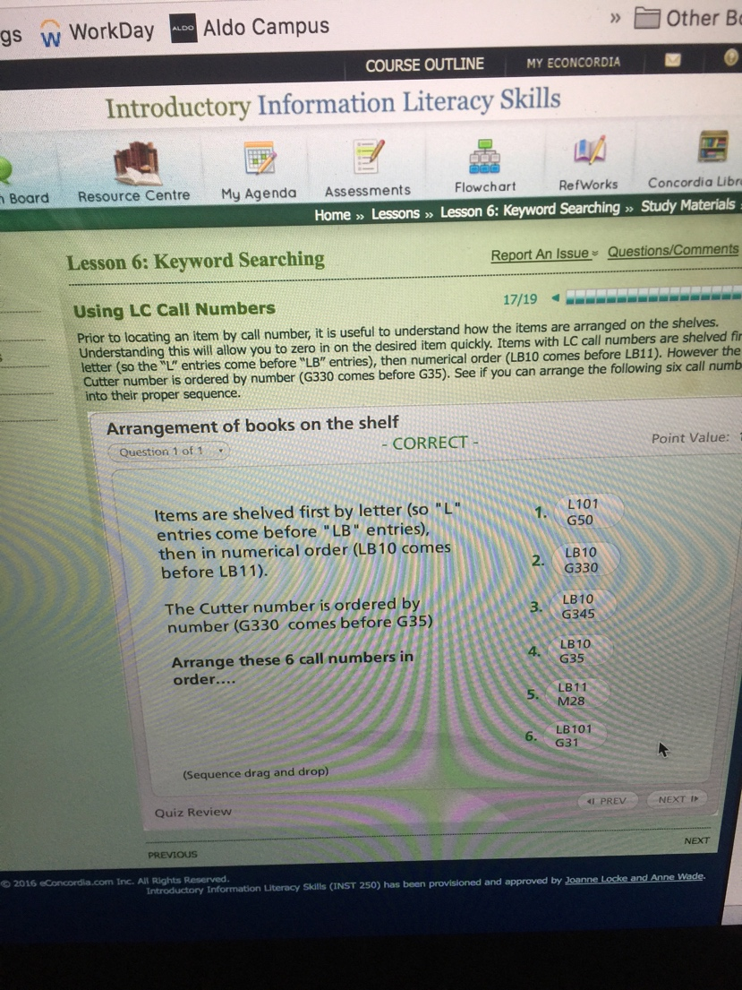
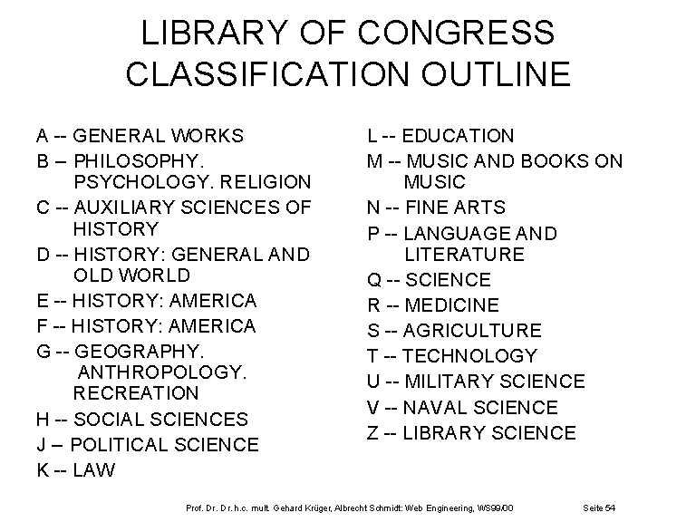

- Lesson 7 – Subject Searching

How to use LCSH

Using the LCSH listing is easy because the headings are arranged alphabetically. Any word or phrase may be looked up:

- Start by looking up the main concept of your thesis. It is best to start from the specific and if this fails then move to a more general heading.
- In our case, a search under “early literacy” was unsuccessful, so the heading “literacy” was looked up. If the heading is printed in bold then it is a legitimate LCSH.
- If it is printed in light-face type, look for the cross reference on the next line which states: "Use" and turn to that word or phrase. For example, “Literacy and Computers” is not a valid heading. Instead the user is referred to “Computers and Literacy”.

There are four (4) categories of subdivisions.
Topical | Subdivisions limit the concept expressed by the main heading to a special subtopic. Most of the subdivisions included in the LCSH listing are of this type. It is useful to scan these under a main heading you have looked under, as there may be a topical subdivision that more accurately represents the topic you are interested in.  - Limits the concept expressed by the main heading to a subtopic  - Example: Literacy – Government Policy
Form | Subdivisions indicate the form in which a particular item on a subject is organized. These are added as the last element to any heading. They represent what a work is (not what it is about). For example, a handbook, a dictionary, a conference proceeding. As you conduct subject searches you will become familiar with the different types of form subdivisions.  - Indicates the form of the material and is added at end  - Not written up in the LCSH volumes  - Example: Literacy - Encyclopedias
Chronological | Subdivisions limit a heading to a particular time period. They are usually used under the names of countries to denote a particular historical period. They may also be used with literature or art headings to describe a particular period.  - Limits a heading to a particular time period  - Example: Canada - History - 1945-
Geographic | Subdivisions limit a heading to a geographic location. If a heading may be subdivided geographically, look for the notation “May Subd Geog” after the heading. This means that you can apply any location (by country, province, state, or city) after the heading. This is useful if you are interested in limiting your search to Canadian material for example.  - Limits a heading to a geographic location  - Not written up in the LCSH volumes  - Look for (“May Subd Geog”) after the main subject heading  - Example: Literacy (May Subd Geog)

Bibliographies:

- A list of works on a specific subject or research topic
- Listed at the end of a research paper, encyclopaedia article, book, scholarly article etc
- Also published in book form:
  - Lists works (articles, books, dissertations, reports etc.) on a specific subject
  - Provides the groundwork for researchers
  - Located in the reference department
  - Annotated bibliographies provide evaluative summaries for each entry
  - Webliographies: a list of hypertext links surrounding a common subject or theme

Subject Search
- Restrict search to the subject heading field only
- Requires the use of a valid LCSH
- Is a more precise way of searching
Keyword Search
- System scans the title, notes, contents, series, technical notes and subject heading fields
- Uses natural language in the form of keywords
- More flexible way of searching (one can use Boolean operators, truncation etc.)

Quiz 2: 7 questions

- Preliminary Outline (4 outlines, select best one)
- Key Concepts from preliminary thesis (understand keyword)
- Search Strategies (Boolean logic, how to make logical search statement)
  - Or, And, Truncation – how to arrange (AND = different concepts/OR=synonyms and related concepts)
- CLUES: how to read CLUES record
- Library of Congress Subject Headings
- Evaluation Criteria for published material (use 5 evaluation criteria to answer questions)
  - Currency, format, intended audience, scope

- Lesson 8 – Searching the Databases

Subject Indexes:
- List the articles written within a specific field in specified periodicals within certain time period
- Points out sources of info on specific topic within a field
- Provides enough info for user so they can determine location of the item (citation)
- Available in print and electronic (database) form

Abstracting Sources:
- Critical retrieval tools for scholarly information
- Different than indexes because they provide a summary of the items they list
- Contents, findings, and conclusions
- Scanning an abstract can save you a lot of time because you can see if it’s relevant or not
- Abstracts also more focused on specific discipline
- Provides access to other related materials, conference proceedings, reports, dissertations and books and foreign language material
- Most available in database form

Types of Databases: 4 main types of databases accessible from Concordia

SUBJECT
- Equivalent to a printed subject index or abstracting source
- Provides access to the most recent scholarship within a field
- Most important tool within a field
- Contains citation and abstracts to periodical articles and other material
- Examples: ERIC, PsycINFO, Philosopher’s Index, PAIS International

MULTI-DISCIPLINARY

- Contains citations, abstracts and the complete text of periodical articles
- May also include non-scholarly information (e.g. from newspapers, magazines)
- Usually multidisciplinary with no print counterpartman
- Examples: Lexis Nexis, CBCA Complete, EBSCO Academic Search Complete

NUMERIC
- Contains numeric, financial or statistical information
- Often used in business or for government stats
- Examples: CANSIM, Census 2001, Financial Post Advisor

OTHER
- Indexes specific material such as dissertations, government documents

Databases:
- Suppliers: Ebsco, ProQuest, ESI
- Standard Features: basic and advanced searches, keyword and subject searches, Boolean operators, truncation, limiting fields etc.
- Locate a database by title:

Search Strategy:

- Review your list of keywords, synonyms and related terms
  - Are they still valid? Are there any concepts that you wish to add? Or delete?
- Prepare your search statement(s), because this will:
  - Help to logically and systematically review what it is you are looking for
  - Help to plan backup strategies depending on the results found
- Review your original search statement(s):
  - How many concepts should be used given you will be searching more specialized databases? Adding a third concept is a good strategy.
  - Have the Boolean operators been used correctly? Should truncation be used on any keywords?
- Don’t forget to use Nesting (parentheses) for “ORed” keywords.

  Example: Plan A
  Early intervention programs aimed at improving the literacy in children at risk of failure will lead to societal benefits.
  The key concepts can also be expressed as:
  - literacy  - young children  - programs  - at risk | - reading  - elementary  - intervention  - potential drop outs
  In our example, we need to locate studies that have looked at the effectiveness of literacy programs designed for young at-risk students. So our search statement will look like this.
  Click here to see Plan A search statement
  (literacy OR read*) AND (“young children” OR elementary) AND (program* OR intervention) AND (“at risk” OR “potential dropouts”)
  Example: Plan B
  Early intervention programs aimed at improving the literacy in children at risk of failure will lead to societal benefits.
  The key concepts can also be expressed as:
  - early literacy  - programs  - at risk  - benefits | - beginning reading  - intervention  - potential drop outs  - impact, advantages
  We may need to use a different tactic once we get inside ERIC, so we have a Plan B.
  Our search statement will then look like this.
  Click here to see Plan B search statement
  (“early literacy” OR “beginning read*”) AND (program* OR intervention) AND (“at risk” OR “potential dropouts”) AND (benefit* OR advantage* OR impact*)

Records
- Each entry within a database represents a record
- A record can represents a citation (and abstract) to a book, a chapter in a book, an article, a conference paper etc.
- An example of a record in the ERIC database is a citation (including an abstract and descriptors) to an article that appeared in the journal Early Childhood Research Quarterly

Fields
- Records are composed of different fields
- Some fields will vary depending on the type of material being indexed (e.g. journal article, book chapter, report etc.)
- Field labels may be used to abbreviate field names (e.g. AU, TI, AB)
- There are some fields that are common to all the records within a subject database (see image right), such as the Title (1), Author (2) and Source (3), Descriptors (4), and Abstract (5) fields. This item also has a DOI No. which is listed in the URL (6) field.

- Journal Article VS Report
- Journal Article had field for ISSN
- Report has Corporate Source field.

Keyword Searches in Databases

- Similar to conducting a Keyword search in a catalogue as multiple fields are searched to locate your keywords
- Boolean operators and truncation should be used
- Limit commands are also recognized. They may include: Document type, Peer review, Language, Methodology used
- Full-text availability
  - Full-text may not be available from the subject databases
  - Click on “Find It @ Concordia” to learn location of item. This will bring you into CLUES.
  - Or check the URL field as there may be a link to the full-text on a website

Subject Searches in Databases
- More effective and more efficient way of searching
- New topic, little literature,
- All subject databases use online thesaurus
- Use valid descriptors you get from thesaurus and select SUBJECT HEADING
- No need to use truncation when searching with valid subject headings

REVIEW: http://connect.econcordia.com/p6329f6k709/?launcher=false&fcsContent=true&pbMode=normal

Multidisciplinary Databases:

- For topics than span over different fields
- Headings will be more general
- Select Peer Reviewed
- Keyword search followed by advanced search and consult thesaurus

Academic Search Complete:

- One of the largest/most popular multidisciplinary databases
- Concordia version supplied by EBSCO
- Every academic area of study
- Material from many fields, accountancy, economics, education, marketing, psychology, engineering, etc..
- Full text – most items are available in full from database
- Non scholarly material also – access to periodicals, journals, magazines, newspapers,
- Important to limit to peer reviewed only.

ASC: Keyword – begin with keyword search

ASC: Subject – 1) use online thesaurus / 2) enter each concept in Browsing Subject Terms / 3) Thesaurus will lead you to more narrow and related subject terms. Ex: Early literacy not a valid subject term – but Emergent literacy is good.

ProQuest:
- Dissertations provide most recent scholarship within a field – more current than journal articles
- Access thesaurus by clicking LOOK UP SUBJECT TERMS since subject terms are very general in this database as it has material from every discipline

Other – Government Documents:

- GD – issued under authority of government or agency, municipal, provincial, federal (stats, reports, debates)
- CRI – Canadian research index is for publications from all levels of government (annual reports)
  - Supplied by proquest, not a full text, still need to locate document,
  - Same method of searching, start by keyword search, then subject field,
  - Subject search – use different key words, statistics, reports, (key words could relate to income, earnings)
- Stats Canada – provided by stats can, most available over the web (via their website and also a subject list)

Discovery Search:

Advantages | Disadvantages
- Easy way to access all of the resources accessible from Concordia  - Quick view of how many items are in the Library Catalogue vs the Digital Collection (see under Limits)  - Quick access to the online version of material  - Lots of flexibility in terms of limiting results, by clicking on the Limits (or Facets) on left sidebar  - Can quickly learn how many items are available on topic and in what form (see under Limits --> numbers next to each entry)  - Can restrict results to a specific database (Limits --> Database) or type of material (Limits --> Format) | - Because each database has its own list of Subject Headings, one can not customize a search strategyas they would when searching within the database  - One can design a more sophisticated search when searching directly within a database (e.g., use of Limits specific to that database, subject terminology specific to that database etc.)

Three ways to conduct a search on Discovery:
- On the Library home page, enter your Keywords into the search window

- On the Library home page, under Find, select Discovery search

- Go to: https://encore.concordia.ca. This will provide access to the Advanced search screen.

Evaluating Material found on Databases:

Purpose: Why was the item written or why was the study conducted?

Authority: Is the author credible and knowledgeable on the subject?

Scope: Is the item directly related to an aspect of your topic that you wish to discuss?

Format: Does the author include any interesting features that are of value (e.g. a survey that was used to gather data, tables of findings, a bibliography)?

Audience: Is the item intended for a scholarly audience?

- Lesson 9 – Searching the Web

The Internet:
- size, lack of organization, lack of control

- Developed in the early 1990s
- Gateway to all of the services available on the Internet
  - File Transfer Protocol: ftp://
  - Email: emailto://
  - Telnet: telnet://
  - Hypertext Protocol: http://
- Web pages are text and multimedia files formatted in hypertext markup language (HTML)
- Web browsers are used to display the HTML files either by entering a URL or by following a hyperlink
- Origins lie in the scholarly exchange of information
- E-commerce the most dominant

Users experience problems due to:
- Size of internet and dynamic nature of information – info changes constantly
- No bibliographic control – dates of published and retrieval become very important
- Keyword searching only method to access info – punch in one or two words in google
- Searching a database and not entire contents of the web
- Automation of search tools – no ability to focus a search – searches based on exactly what was entered
- Users don’t realize info they’re looking for is inaccessible from retrieval tools

What type of info am I looking for? – opinions, facts, stats, scholarly, product info

What type of info have I found? – domain name helps form judgement about type info on that site
Goal is to locate article, government document, research report, etc…Resources, Publications, Research

What is the quality of the info I found? – use evaluation criteria

Three main types of web search tools:

- Directories:
- Compiled by humans
- Database of selected resources classified by subject
- Table of Contents approach to the web
- One Browses through the categories

- Search Engines:
- Fully-automated
- Keyword approach to the web
- 3 components: Spider (or crawler software), Index (or database), Search software
- Ranking of results based on relevancy
- Ex: Yahoo, Google, Ask, Bing

Images:  http://images.google.ca/ | The Image database contains billions of different types of images found on the web. Explore the Canadian database to see if you can locate any tables or charts summarizing literacy rates by entering the phrase “literacy rates”. Don’t forget to enclose phrases within quotation marks.
Videos:  http://video.google.com/ | Try locating a video on research-based early literacy programs in the video database by searching on "early literacy programs" research
Maps:  http://maps.google.ca/ | Discover which Canadian literacy organizations exist and where they are located by searching in the Canadian Map database on “literacy”
News:  http://news.google.ca | Scan over 4,500 news sources to learn if there are any articles written about literacy rates in Canada by searching "literacy rates" Canada. Click on the sidebar 2003-2009 and see the article entitled Canada is losing billions because of illiteracy
Google Scholar:  http://scholar.google.com/  Google Books:  http://books.google.com/  Website (main):http://www.google.ca | It is important to spend some time thinking about the type of information that you would like to find prior to searching on the web as there is quite a range available.  Google has compiled other large databases specific to scholarly material, books, French websites, and of course its main database of websites.

REMEMBER:
- Web Basic search window: Calculator, Dictionary, Spell checker, Conversion tables etc.
- Start with a Keyword search
- Keywords are automatically ANDed together
- Select Advanced Search and refine your strategy
  - Use search windows to search multiple concepts using Boolean logic
  - Apply limits: Languages, File format, Date, Domain name

- Don’t forget that Google will AND each line together so do not enter the same keywords (or concepts) on multiple lines.
Google also provides a variety of limiting commands, such as Language, Date, Domain name, and File type. You can even instruct the search software to look in specific files (such as the URL or title) for your keywords.
- Limiting your results to .edu domains and/or to PDF files are a great way to locate scholarly information.

Tutorial Google Searching: http://connect.econcordia.com/p3xfm7kz5yo/?launcher=false&fcsContent=true&pbMode=normal

Generations of Search Engines:

1st: (1990) Location and frequency of key words on page determine ranking
2nd: (2000s) Link Analysis – spider looks at number of links pointing to specific site, words surrounding link determine relevancy, Google, Yahoo Search,
3rd: (present) Personalized search – use of intelligent software to guide people to results they’re looking for, auto-complete, search ahead, categorization, bookmarking, networking, Twitter

- Meta Search Engines:

- Search multiple search engines’ databases in one query  - Collate and display the results in one listing  - Saves time because only one search is performed  - Offers Advanced searching and some will cluster the results by category | Examples:  - Fazzle,  - Yippy,  - Dogpile,  - Clipblast (for videos),  - Ixquick (see below)

WHEN TO USE WHAT TOOL?

Directories (Table of Contents Browse)
- Novice searchers
- Broad topic (e.g. breast cancer) or general idea
- Expert lists

Search Engines (Index Search by Keyword)
- Focused or narrow topic
- Combination of multiple terms (e.g. use of Boolean logic)
- Use of limiting commands (e.g. file formats, domains)
- Search for images, news stories, etc.

Meta Search Engines
- Looking for indication of amount of material on the web
- Obscure topics

EVALUATING WEB SOURCES:

Authority:

- Who is the author?
- Qualifications?
- Credibility of sponsoring institution?
- Who links to the site? (Google link)
- Does the site exhibit good grammar, composition?

Accuracy:
- Reliable and error-free?
- Documented facts or personal opinion?

Currency:

- Content up-to-date?
- Date of creation?
- Date of last revision?
- Broken links?

Coverage:

- Comprehensive?
- Is the information relevant or useful for your needs?

Objectivity:

- Purpose of site?
- Personal bias?

- Lesson 10 – Putting information to Work

