Question 1

Let a = elastic limit, the corresponding strain is 0.002; we know the stress at loading is 1.2*a with a corresponding strain of 0.004. The amount of permanent strain = 0.004 – x, where the quantity (x) is to be found as follows:

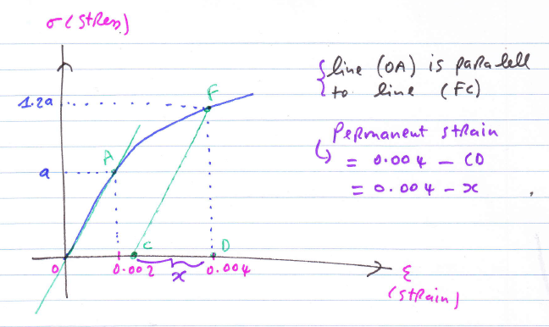

Modulus of elasticity = E = slope of line OA = a / 0.002;

Modulus of elasticity = E = slope of line CF = FD/CD = FD/x = 1.2*a / x;

We can now solve for (x) as follows:

a / 0.002 = 1.2*a / x

x = 1.2*0.002 = 0.0024

The amount of permanent strain = 0.004 – x = 0.004 – 0.0024 = 0.0016.

Question 2

- Calculation of stress σ

Stress = Force (load)/Area = F/A = F / PI*(d/2)^2

Plugging in the numbers, d=diameter=8mm, PI=3.141592654...

Stress = σ = 10000 / PI*(0.004)^2 = 198.94 Mpa

- Calculation of strain e

Elasticity = E = Stress / Strain = σ /e.

Solving for the strain e, we get: Strain = e = Stress / Elasticity = σ /E.

Plugging in the numbers, we get:

Strain= e = 198.94 / 200000 = 0.0009947

- Calculation of elongation ΔL

Strain= e = ΔL / L

L=150mm (initial gauge length). Solving for the elongation ΔL, we get:

ΔL= e*L = 0.0009947*150 = 0.149 mm.

- Change in diameter Δd

Δd = -v*d*e

Given the constant v=0.27 (Poisson ratio). Solving for the elongation Δd, we get:

Δd= - v*d*e = -2.7*8*0.0009947= - 0.002148 mm.

Question 3

Assume original gauge length of L= 40mm and original diameter of D=10mm.

We recall that Area is given by A=PI*(D/2)^2.

- Complete stress-strain curve, using all data (Using Excel).

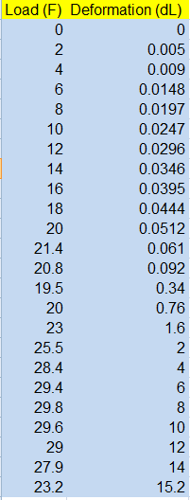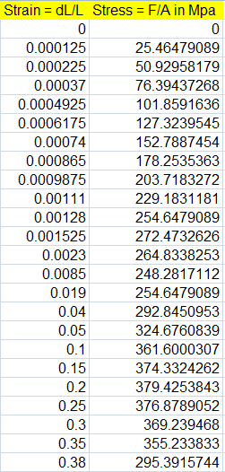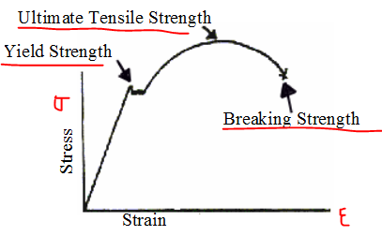

- Stress-strain curve only up to the yield point (with a different scale than a.)

2.1 Modulus of Elasticity (Mpa)
From the stress–strain diagram, we can compute the slope of the line through the origin (0; 0) to the point (0.00128; 254.65). So the modulus of elasticity is estimated as the slope to be about: E= (254.65 – 0)/(0.00128 – 0) = 198945.3125 Mpa.
E = 198945.3125 Mpa
2.2 Ultimate strength (Mpa)
We can compute the ultimate tensile strength as follows: we divide the maximum load (force) by the original cross-sectional area. So: UTS = 379.4254 / PI*(0.01/2)^2 = 4830994.036 Mpa.
UTS = 4830994.036 Mpa
2.3 Breaking strength (Mpa)
We can compute the breaking strength as follows: we divide the breaking load (force) by the original cross-sectional area. So: BS = 295.3915 / PI*(0.01/2)^2 = 3761042.337 Mpa.
BS = 3761042.337 Mpa

