ADM 1370 – APPLICATIONS OF INFORMATION TECHNOLOGY
Lecture #1 – January 9th and 11th, 2016 (Chapter 1 & 2)
____________________________________________________

CHAPTER 1
Social Media
- Social Media is a group of Internet-based applications that build on the ideological and technological foundations of Web 2.0, and that allow the creation and exchange of User Generated Content.

Types of Social Media
- Social Networks: Keep in touch through personal and business profiles
Ex: Facebook, LinkedIn, Google+, Instagram

- Blogs: Publish and discuss opinions and experiences
Ex: Bloggr, Tumblr
- Micro-Blogs: Sign up for personal broadcast feed
Ex: Twitter, Identi

- Discussion Forums: Discuss topics in open communities
Ex: Technorati, The Nest

- Multimedia Sharing: Upload, Share and comment of photos, videos and audio
Ex: Flickr, Youtube

- IGN Boards: Individual Gaming Boards
Ex: IGN.com

- Content Aggregators: gathers Web content from different online sources for reuse or resale
Ex: Reddit, Digg

- Social/Collaborative Bookmarking & Tagging:
Ex: Stumbleupon, Diigo

Other Social Media Outlets
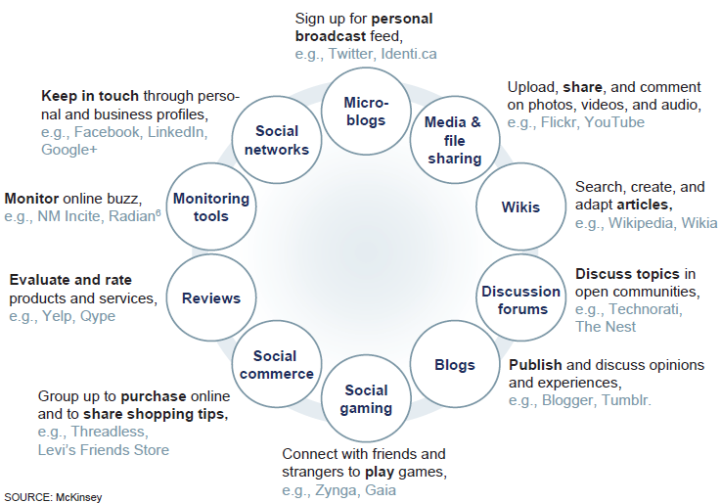

Web 2.0 and Social Media
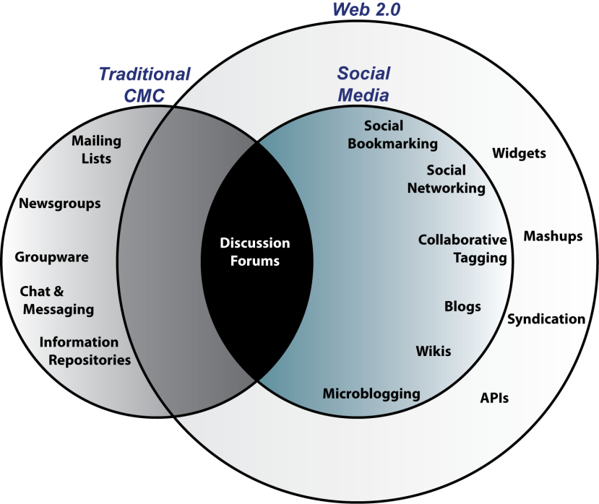

Can you think of uses of social media for specific business functions?

- Marketing & Sales
- Public Relations
- Research & Development
- Human Resources

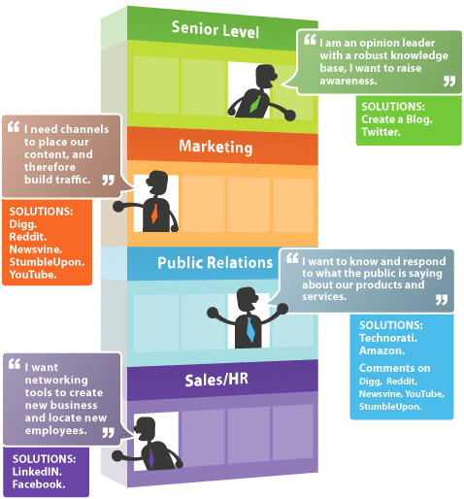

Old Wine New Bottles
- Social media does not change the business processes we do… rather, it changes how we do the processes
- It increases the value of information (but does not necessarily change the information itself)
- It also increases coefficient of connectivity - this is what connects people, information and processes

Digital goods or e-goods: Intangible goods that exist in digital form.

- E-books,
- Downloadable music,
- Internet television
- Internet coupons;
- Electronic tickets;
- Online casino

Economics of Digital Goods
- Cost of producing first unit is almost the entire cost of the product: marginal cost of producing 2nd unit is almost zero
- Costs of delivery over the Internet are very low
- Marketing costs remain the same
- Consumer costs are also reduced

How Does Social Media Make Money?
YouTube for Example:
- Advertisements were launched on the site beginning in March 2006
- In April 2006, YouTube started using Google AdSense
- Recently, YouTube began add revenue splitting with copyright holders
- Given its traffic levels, video streams, and page views, YouTube’s potential revenues is millions per month

Other Revenue Generation Strategies in Social Networks
- Offer premium service for monthly or per service fee
- Organizations partner with the social networks, paying them a monthly service fee
- Some social networks have a network of thousands of local physical venues where members can meet; these venues may pay a fee to be associated with the network (ex: subscribe fee)
- Basically there are 3 Strategies:
    - Advertising
    - Subscriptions
    - Commissions

The Permeation Trends of Social Media and Social Business
The new scale of Social Media based on three main themes:
- Convergence of information and communication
- Social media’s permeation of industry and corporate discipline
- Big social data and the accessibility of public information

CONVERGENCE OF INFORMATION AND COMMUNICATION
- Social media was made for people, not for businesses.
- A shift in the way that people use social networking sites.
- Today, more social media users are using the communication tools provided by social media websites to seek out information for their professional and private use.
- The move from equal access and limited amount of information that was originated from a finite number of news sources.
TO
- The digital age, which began with the advent of the Internet and the advance of wireless technologies,
- Our media consumption as well as our communication become digital.
Distinct opportunities provided by convergence of information and communication
- Reach out and engage with customers, prospects, partners, and your network.
- Create opportunity by communicating and sharing information.
- Manage your reputation and discover new business through monitoring information.

SOCIAL MEDIA’S PERMEATION OF INDUSTRY AND CORPORATE DISCIPLINE

- Social media has evolved from an inside-out promotional medium to an outside-in
- Conversations happening throughout social media affect the way that some companies do business.
- This signify the evolution from social media to social business,
- This evolution will help you create a social media strategy with your entire company in mind, which will be beneficial for your business in the long run.

Big Social Data and The Accessibility Of Public Information
- A growing amount of this big data comes from the world of social media in the form of uploaded videos, photos, podcasts, blog posts, status updates, discussions, and messages.
- Although much of big social data is hidden behind privacy settings that limit public access to them, there is a growing amount of data that is publically available for businesses to analyze and learn from.
- EX: the ability to see and evaluate conversations among customers, competitors, and prospects going on around the world and utilizing those data to predict future consumption trends.

CHAPTER 2

Before we start the Social Media Strategy let us understand the principles of the market strategy; THEN we can map our understanding to these principles to build the social media strategy.

Let us start with the following questions:
For your business
  - Who sets up the product prices?
  - Who determines your market share?
  - Who determines your profit level?
  - Who determines how fast you grow?
  - Who determines the future of your growth?

You cannot ignore your competitors, while you are planning your strategy
You have to know:

  - Where are they sitting?
  - How big they are?
  - What is their plan?
  - Why people buy from them?
  - Can I get their customers to buy from me
  - How they react when I get their customer?

The 4 principles of competitor’s strategy which must be mapped to your Social media are:

- Specialization
- Differentiation
- Segmentation
- Concentration

Specialization: A method of production where a business focuses on the production of a limited scope of products or services

Differentiation:
- Identify and create a better competitive advantage and convey it to your customers
- Your area of excellence: Your superiority, the area in which you perform better than anyone else
- Unique Selling Proposition: This called USP, the USP is the one thing you offer that no other competitor can

Segmentation: Who are the people who appreciate your area of superiority?

- who are your best customers?
- what are their demographics; and
- what are their psychographics?
  - what motivates your customers?
  - What are their goals and ambitions?
  - How can you describe your customers in terms of wants, needs, education and income position?

Concentration: A strategic approach in which a business focuses on a single market or product. This allows the company to invest more resources in production and marketing in that one area

The Framework for the Ever-Changing World of Social Media
- Managing social media for your business has a huge potential elevate and manage the outcome of the internal processes of your business.
- The need of how your social media program is doing and what other things you could be doing to maximize your social.
- The need of a road map to provide structure to manage social media programs over time.

WHY IS THERE A NEED FOR A SOCIAL MEDIA STRATEGY?

What is strategy: a plan of action or policy designed to achieve a major or overall aim.
- A social media like any other business processes needs strategy to reach the goals:
  - The required resources.
  - Tactics to pursue in social media. It serves as your road map for the present and future.
  - Managing your social media return on investment (ROI).
  - create metrics to assess whether or not you achieved a positive social media ROI.

A concise social media strategy with well-defined objectives, tactics, and metrics is the only rational solution to help you manage and make sense of all the social media activities in which your staff engages.
No longer will you have to question how well you’re doing in social media; on the contrary, once you have a social media strategy, you’ll be wondering what more you can be doing to maximize your business success from your social media efforts!

THE EVER-CHANGING SPECTRUM OF SOCIAL MEDIA
- When looking at the past of social media, there is an interesting trend that bubbles to the surface and best explains why social media has always been—and will always be—in flux:
- The users of each social media channel are always changing.
- The way we use each social media website is ever changing.
- The functionality provided by each site is constantly in flux.

PDCA: A LOGICAL FRAMEWORK FOR SOCIAL MEDIA STRATEGY CREATION
- Social media sound like big experiment,
- It requires the Deming, or PDCA, cycle.
- The Deming cycle is named after its founder, W. Edwards Deming, This is an important concept in Japan

What is PDCA

PDCA is extremely simple and eloquent in concept:
P stands for plan, which is, in essence, the social media strategy that you will create.
D stands for do, which is the implementation of your social media strategy according to plan.
C stands for check, which means analyzing the KPIs and metrics regarding your social media and check if the strategy objective met.
A stands for act, but it could also mean adjust, meaning that based on the results from step C, you optimize your P and repeat the cycle.

The cycle, as you can imagine, is never ending, because the eternal flux of people and social media means you will never be operating at optimal performance. Only by constantly planning, implementing, checking, and optimizing will your business achieve excellence in social media, regardless of what your specific corporate objectives might be.

THE ESSENTIAL COMPONENTS IN ANY SOCIAL MEDIA STRATEGY

- Objective:
This is the reason for the existence of your social media strategy. Without a clearly defined objective, you’ll never be able to create clearly defined KPIs that will allow you to measure your ROI.

- Customer:
Who is your target customer? The more detailed demographic details you know about the type of people with whom you want to engage, the better you can align your social media activities with them.

- Share:
If social media is about the convergence of communication and information, what on earth is your business going to share with social media users? If you work in a business-to-business (B2B) company, this will often come down to content that you might already be sharing with your current and prospective clients on sales

- Who:
It’s one thing to write a social media strategy, but it’s even more important to decide who is going to implement the strategy on your behalf: Will it be an internal employee, or will the work be outsourced to an agency?

- Brand:
Most businesses already have brand guidelines, and these should be applied to your social media properties as well. After all, branding is all about consistency. *

ADM 1370 – APPLICATIONS OF INFORMATION TECHNOLOGY
Lecture #1 – January 16th and 18th, 2016 (WIKI and Chapter 3)
______________________________________________________________________

WIKI – WEB 2.0

- “wiki wiki” means “quick" in the Hawaiian language
- A wiki is a website or similar online resource which allows users to add and edit content collectively
  - Example: www.wikipedia.com

- Wikis are collaboration tools
- Blogs and chats are more turned towards conversation
- Wikis are intended to maintain a series of unique documents as their content evolves
- Wikis have built-in version control
- No changes can be made without creating a record of who made those changes
- Reversion to an earlier version is always possible

Some Attributes of Web 2.0:

- The ability to tap into the collective intelligence of users
- Data is made available in new or never-intended ways
- Relies on user-generated and user-controlled content and data
- Lightweight programming techniques and tools let nearly anyone act as a Website developer
- The virtual elimination of software-upgrade cycles makes everything a perpetual beta or work-in-progress. Applications can be designed quickly to meet changing needs

Key Take-Aways for Web 2.0:

- Users can access applications entirely through a browser
- An architecture of participation and digital democracy encourages users to add value to the application as they use it
- A major emphasis on social networks and computing
- Strong support for information sharing and collaboration
- Rapid and continuous creation of new business models

Extract from a Long Definition:
software as a continually-updated service that gets better the more people use it, consuming and remixing data from multiple sources, including individual users, while providing their own data and services in a form that allows remixing by others, creating network effects through an architecture of participation

Salient Features of Web 2.0:
- The Web as a Technology Platform in itself
- Information Sharing, Collaboration and Interactive Functionality of the web:
    - Interconnectivity and Interactivity of web-delivered content !
- Architecture based on Participation

Popular Examples of Web 2.0 based Applications:
- Social Networking Sites, Video Sharing Sites, Wikis, Blogs, and Folksonomies.
- Mashups and APIs (Application Programming Interfaces).

Rich Internet Applications are a predominant feature of Web 2.0.

- Attributes:
- web applications that have many of the characteristics of desktop software:
  - e.g. powerful interfaces that provide the responsiveness of traditional desktop applications.
- typically delivered either through specialized browsers, browser plug-ins, or client virtual machines.

- Uses:
- rendering multiple forms of content (text, audio, video etc.) in an integrated fashion
- engaging users via interactive user-friendly interfaces
- performing complex data visualization, including dynamic charting or graphical presentation of data.

RSS (Rich Site Summary) (Really Simple Syndication):

- A standardized data format to publish frequently updated works
such as blog entries and news headlines.
- Website material is made available to end-users or other sites
through web feeds.
- A web feed (or news feed) is a data format used for providing users with frequently updated content.
- Content distributors syndicate a web feed, thereby allowing users to subscribe to it.
RSS (Web) Feeds are usually accessed through an aggregator tool:
    - Making a collection of web feeds accessible in one spot is known as aggregation, which is performed by an aggregator.
    - Aggregators can be scheduled to check for new content periodically. Web feeds are an example of pull technology, although they may appear to push content to the user.

What are Mashups?
- A mashup is a web application that combines data or functionality from more than one source into a single integrated interface or tool:
- Content used in mashups is typically sourced from a third party via a public interface or API (Application Programming Interface):

- API (Application Programming Interface):
- An abstraction that defines and describes an interface for interaction with a set of functions used by components of a software system.
- For the consumer or user, abstraction helps focus on the essential elements with unwanted detail omitted.

- The word “Mashup” originated in the music industry, where a mashup was a combination of two or more songs to create a new experience:
- The technology industry extended this definition to encompass a new class of applications that described the combination of two or more sources into an integrated application.
Ex: google map with search engine

Mashups and Web 2.0

- Web 2.0 movement talks about cooperation, instead of control:
  - mashup is created from several data sources and services, mashing up (combining, stitching together) the sources and services to create something new, or add value in some way.
- The popularity of mashups stems from emphasis on interactive user participation.
- Mashups offer an informal, quick, low-barrier, and relatively effort-free integration that can be deployed with simple tools and techniques.

Industry and Market Disruptors

Disruptors: Companies that introduce a significant change in their industries thus cause disruption in the way business is done
Checklist of questions to help identify disruptors:

- Is the service or product simpler, cheaper, or more accessible?
- Does the disruptor change the basis of competition with the current suppliers?
- Does the disruptor have a different business model?
- Does the product or service fit with what customer’s value and pay for?
Social Capital

- Social capital is a core concept in business, economics, organizational behavior, political science, and sociology, defined as the advantage created by a person's location in a structure of relationships. It explains how some people gain more success in a particular setting through their superior connections to other people.
- Remember business is about building relationships of all sorts to create “Social Capital.” – these relationships can be with customers, suppliers, media etc.

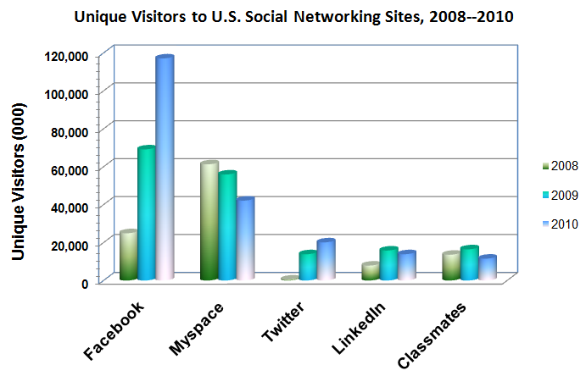

Social Network Analysis: The mapping and measuring of relationships and flows between people, groups, organizations, computers, or other information or knowledge processing entities
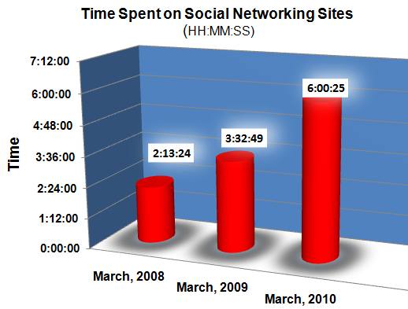

Network Classification
- Aggregators: Linkedin, Facebook, Xing, Ecademy etc.
- Geographic: “Link to” sites: Chicago, Charlotte, Nashville, New York etc. etc.
- Industry: Wireless Factors, Wine & Spirits, Motor Sports, Entrepreneurs etc.
- Topical: Politics, Music, Sports Investments, etc.

Internet Business Models

Based on who is involved
  - B2C (business to consumer)
  - B2B (business to business)
  - C2C (consumer to consumer)
  - C2B (consumer to business): consumer indicates a need; businesses compete to fulfill it
  - B2E (business to employee): an organization delivers services and information to its employees
  - G2C (government to citizen): government provides services or information to businesses or citizens (also called e-government)

Based on the medium
  - M-commerce (mobile commerce): e-commerce transactions conducted using handheld wireless devices (cell phones, etc.)
  - L-commerce (location commerce): m-commerce transactions targeted to individuals in specific locations

Many of these models emerged because of the collaborative nature of Web 2.0 and the Flatteners from Friedman

Social Media:
- Mobile & Web-based technologies that facilitate an interactive environment for individuals and communities to share, co-create, discuss, and modify user-generated content.
How is Social Media different from Web 2.0?
- Social media is a subset of Web 2.0
- Web 2.0 provides the technical and philosophical foundation for creating, implementing, and using social media applications and tools.

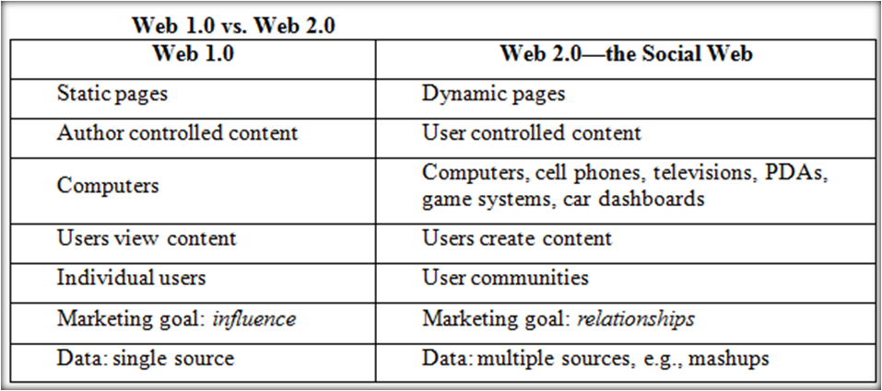
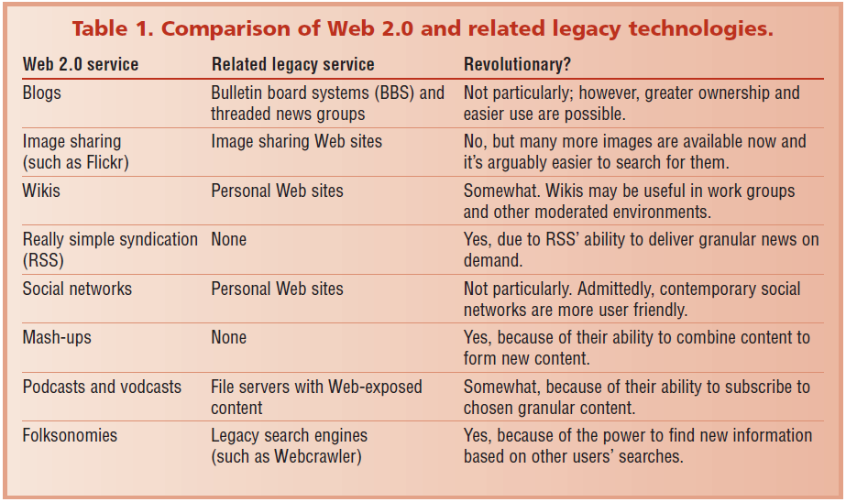

Metrics and Evaluation
- Answers the question how do we know this works?
- Standard metrics are not always applicable
- New metrics are needed to evaluate the contribution of social media
- Social concepts present new measurement difficulties

4 basic categories:
- Tool
- Tactic
- Strategic
- ROI

Social Media Metrics
Management depends on data-driven measurements, or metrics

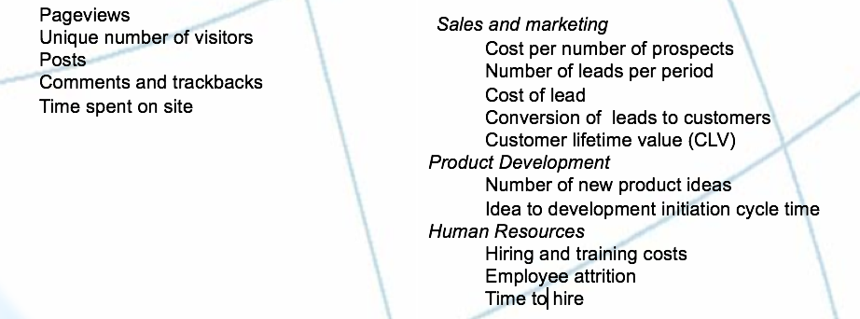
Activity Metrics ROI Metrics

Social Media Monitoring & Measurement

- Tool-Based Metrics:
- Metrics a company uses are determined by what the company is trying to achieve.
- In some cases, a company will define its objectives based on a specific Web 2.0 tool.
- Tactical Metrics:
- Another way for organizations to define their objectives for social media is by tactical objectives.
- Based on these tactical objectives, companies can develop specific actions that support the objectives and then monitor progress.

Examples of Tactical Objectives:
- Increase traffic to our Web site by 10%
- Increase requests for product information via our Web site by 15%
- Increase number of people who create a user account on our Web site by 12%

Strategic Metrics:
  - Aim to more fully capture the potential of social media than what is described by focusing on a specific Web 2.0 tool or tactical objectives.

5 Categories of Social Media Use Objectives:
  - Listening: Pay attention to what customers are saying online
  - Talking: Communicate with your customers by engaging in conversations
  - Energizing: Encourage customers and fans to spread the word through ratings, reviews and other positive “buzz”
  - Support: Provide information and online resources, such as user forums, knowledge bases and other tools
  - Embracing: Invite customers to generate ideas for new products and services

Characteristics of Web 3.0:
Web 3.0 = (4C + P + VS)
3C = Content, Commerce, Community
4th C = Context
P = Personalization
VS = Vertical Search

3C = Content, Commerce, Community
4th C = Context: Defines the intent of the user; for example, trying to purchase music, find a job, or share memories with friends and family.
P = Personalization: Refers to the user’s personal characteristics that impact how relevant
VS = Vertical Search: Refers to a search strategy that focuses on finding information in a particular content area, such as travel, finance, legal, and medical.
Semantic Web
Languages of Web 3.0: e.g., RDF (Resource Description Framework), OWL, and SPARQL; API (Application Programming Interfaces)
Artificial intelligence (AI)
Mobility – pushes drive for new technologies
Barriers
- Closed data sources
- Incompatible data structures and format
- Fractured Web
- Lack of Net Neutrality

CHAPTER 3

BUSINESS OBJECTIVES AND PROJECTED OUTCOMES

- You have to be very clear of what you want to achieve from social media.
- What the outcome would look like.
- How can you judge the return on investment (ROI) of your social media program?
- One way, is to map the current corporate annual strategy or a three- to five-year strategy to the key points in your strategy. *
- If you don’t have any place to start—and you want to align your social media strategy objectives with clearly defined ROI metrics—you might want to consider the following:

Achieving SM strategy

1. Increase Sales
- Develop new business for new clients or new products.
- Improve your customer retention rate.
  - Increase sale to current customers by offering them preferences – commission – reduced sale prices
- Increase your brand awareness in the market by promoting your advertisements

2. Decrease Expenses

- Use social media to recruit new employees or add to your talent pipeline.
- Invest SM for CRM - This will potentially decrease customer expenses by providing more efficient support through this new platform.
- Achieve cost benefit ratio of your SM
  - Shift some of your marketing budget to social media and see if you can achieve more with social media than you did with traditional marketing activities. Common areas that are decreased to make room for social media include traditional media advertising, search engine optimization, and pay-per-click (PPC) advertising budgets.
Pay per click (PPC), also called cost per click, is an internet advertising model used to direct traffic to websites, in which advertisers pay the publisher (typically a website owner) when the ad is clicked. It is defined simply as “the amount spent to get an advertisement clicked.”

Determining Objectives and Background for Your Social Media Program

- The creation of any social media strategy starts with very thorough searching to determine the objectives or what you want to achieve through your social media program.
- Once the objective is decided, the first step is to explore other areas:
  - Target demographic group,
  - Market focus, and
  - branding guidelines

The remainder of your strategy will be leveraging the above areas.

TARGET DEMOGRAPHIC GROUP

- Your current or potential customer
- People using social media channels
The more details you know about your target customers, the easier it will be for you to decide SM strategy.

How to figure out who your target demographic:
- Generate a survey for your current clients.
- Manually research information available on public websites

FACTORS OF TARGET DEMOGRAPHIC GROUP

- Gender
- Age
- Language(s) spoken
- Location
- Education
- Profession
- Interests (related and not related to your product)
- Media consumed (Where do they go online/offline for information?)
- Social media channels most active on

If you’re having trouble creating one target demographic group or if your demographic group varies from product to product or industry to industry, pick the leading demographic characteristic on which to base your social media strategy. In the future, you can include other demographic characteristics and target them in a strategic way as part of a phased approach to your social strategy.
TARGET MARKET FOCUS

Although the target demographic section of your social media strategy should focus on the detailed specifics regarding your target customer in a micro fashion, the section on target market focus should look at potential markets that you want to engage with from a macro level.

What different between Micro and Macro level:
Macro-level: looks at large-scale social processes, such as social stability and change.
Micro-level: sociology looks at small-scale interactions between individuals, such as conversation or group dynamics.

You have to ask the following questions:
- Are you purely targeting the consumer market or
- Business-to-business market?
- Are you targeting certain industries? or
- Regions of the country or World? or
- Focus on a combination of the above?

Ideally,
- Your social media strategy should concentrate on only one strategic market.
- Then it is easier to widen your approach for additional markets, or
- Supplement your current strategy with additional instructions to optimize your strategy for other markets.

BRANDING GUIDELINES
Your social media strategy should be aligned with the branding
Normally, your branding guidelines considered to the keystone of corporate consistency across channels.

Aligning your branding guidelines might need modify some of the following areas:

- Tone of voice: To increase engagement in certain conversational social media channels, such as Facebook, using a more conversational voice might be worth considering individual posts.
- You should also be aware of your target demographic group and ensure that the voice you use in social media is aligned with their expectations.
- Imagery: The use of imagery (eye candy), specifically photography and illustration, should be a part of any strategic plan, because it is an effective way to engage with social media users.
- Video: A social media strategy uses video as an embeddable technology— Ex: link to YouTube

CHAPTER 4

EXISTING DIGITAL PROPERTIES AND MARKETING CHANNELS
- A website can be fully integrated with social media.
- Newsletters can be integrated with social media.
- Events of all types can be integrated with your social media efforts in many exciting ways.
- Pay-per-click (PPC) – Ex: YouTube, Apps
- Traditional print, radio, and television ads can be integrated with social media. Could be added to (URL, Linked Icon) your social media

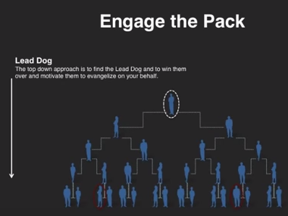
This approach called the Domino’s: This bottom up approach is based on strength in number. The key is to find individuals and motivate them to create a chain reaction in their personal networks.

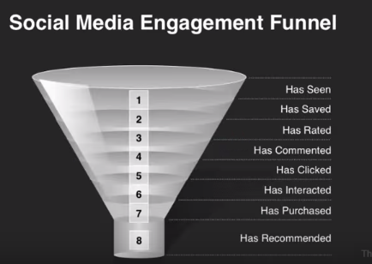
Very important to approach to auditing to characterize customer’s engagement levels

A basic social media audit should include:
An internal review which assesses:
- What you’re already doing in the social media world,
- Who’s doing it,
- What the missing pieces might be,
- Looks at some basic goals you may have in your social media.
An external review looks at:
- How well you’re doing social media compared to your key competitors.
Based on these initial assessments, you can start to formulate your short and long-term goals for social media engagement, and put the tools and personnel into place that can ensure your growth and increase your community engagement and overall success.

There are three major goals that likely apply:

- Brand-building/market penetration, and
- Product showcase, which would optimally lead to sales
- A third goal could be market research:
- what do your customers think or feel about your products;
- what is missing from your products,?
- how can they be improved, what resonates with them, etc.

AUDIT METRICS

- Customer base/market share: Helps to conduct a comparative analysis of your social media with competitors
- Website rank: website traffic after implementing your social media strategy
- Reach: the number of fans/followers sign of a potential reach in to your particular social media channel
- Frequency: How often are you posting on each of your social media channels?
- Engagement: How often are you posting on each of your social media channels?
- Facebook tabs: what are your main calls to action for your Facebook fans?
- Influence: measure a brand’s influence in social media
- Social media presence on your home page: When looking at your home page, where are your social icons?

CHAPTER 5

Based on social media strategy consulting experience and social media strategy, there are certain elements or concepts that must be in the actual document. Although there is general overlap among these concepts, they should be listed in the social media strategy individually:

BRANDING: Including Branding into social media consider in the following areas:
  - Naming
  - Color scheme and imagery
  - Voice
Naming: Normally the SM takes the same name as your company
Color Scheme and Imagery
Voice: The voice of a company in social media is equivalent to the tone of its conversations in tweets, Facebook posts, and blog posts.

CONTENT:
- New product, campaign
- New events or highlights from recent events
- Original blog post entries, which are ideally targeted articles based on a category/keyword strategy
- YouTube videos from your channel, customers, or events
- Photos of your latest products, customers, or events
- Conversations from other social media channels (cross-posting), such as responses to questions or surveys
- Engagement questions or quotes (especially for Facebook)
- Crowdsourcing content from your customers (guest blog posts, photos, videos)

CURATION
- Digital curation is the selection, preservation, maintenance, collection and archiving of digital assets
- Curation lets companies be viewed less as marketing entities and more as community resources.

CHANNELS
- Blog
- Facebook
- LinkedIn
- Twitter

FREQUENCY

ENGAGEMENT

LISTENING
software that either archives or searches conversations from Twitter, Facebook, LinkedIn, YouTube, blogs, forums, and other social media channels in real time.

CAMPAIGN: Social media campaigns are essential to continuously engage with fans, attract new ones

INFLUENCERS
If you already know who your influencers are, you simply need to find where they are on social media and on which platforms they are most active, this will lead to the right auditing of your SM

