STUDY WORK UNIT THREE:
A polynomial equation is written in the form:
$f\left(x\right)= a_{n}x^{n}+a_{n-1}x^{n-1}…..$
$where an, an-1 and an-2 are constants and n is a natural number.$

$examples of polynomial functions:$
$Linear function:y=3x-7$
$Cubic function:f\left(x\right)=8x^{3}-11x^{2}+5x-3$$$Quartic function:g\left(x\right)=6x^{4}+2x^{3}-7x^{2}+12x-1 \\ Quintic function:h\left(x\right)=10x^{5}-24x^{4}-12x^{3}+3x^{2}-23x+64$$
$$Quadratic function:y=5x^{2}-14x+9$$

$term with the highest exponent=dominant term.$$$number appearing infront of variable x of dominant term=leading coefficient. \\ Exponent in dominant term=degree of polynomial$$
$$ex 1. in the equation y=3x-7 , dominant term is 3x, leading coefficient is 3, degree is 1. \\ ex 2. f\left(x\right)=5x^{2}-14x+9, dominant term is 5x^{2}, leading coefficient is 5, degree is 2.$$EXAMINING GRAPHS OF POLYNOMIAL FUNCTIONS

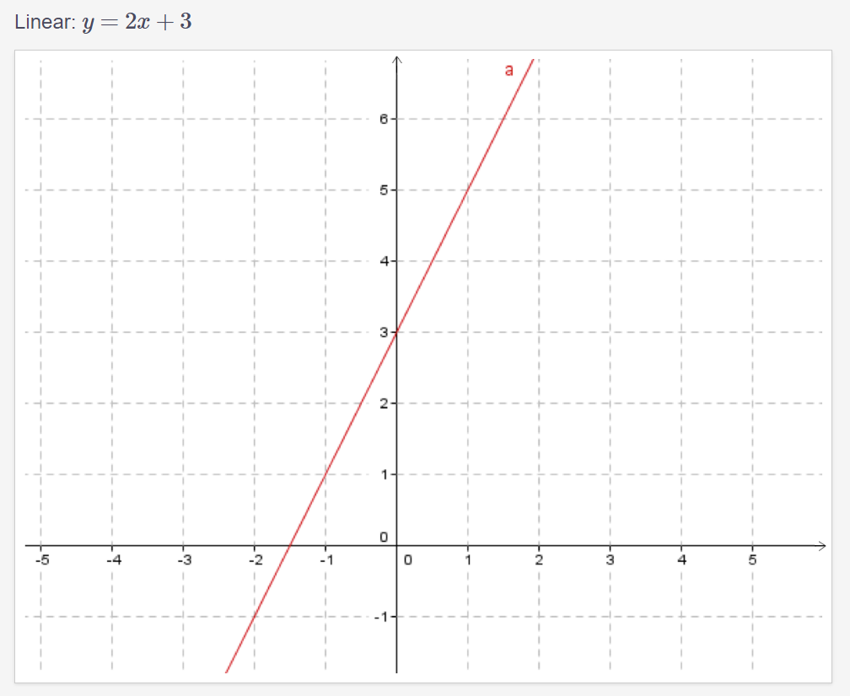
Note: Graph of this linear function has a positive slope (graph goes upwards from left to right.) We say that this graph is increasing (as opposed to a decreasing graph, one which goes the opposite way.)
Polynomials with a higher degree can have two or more directions.
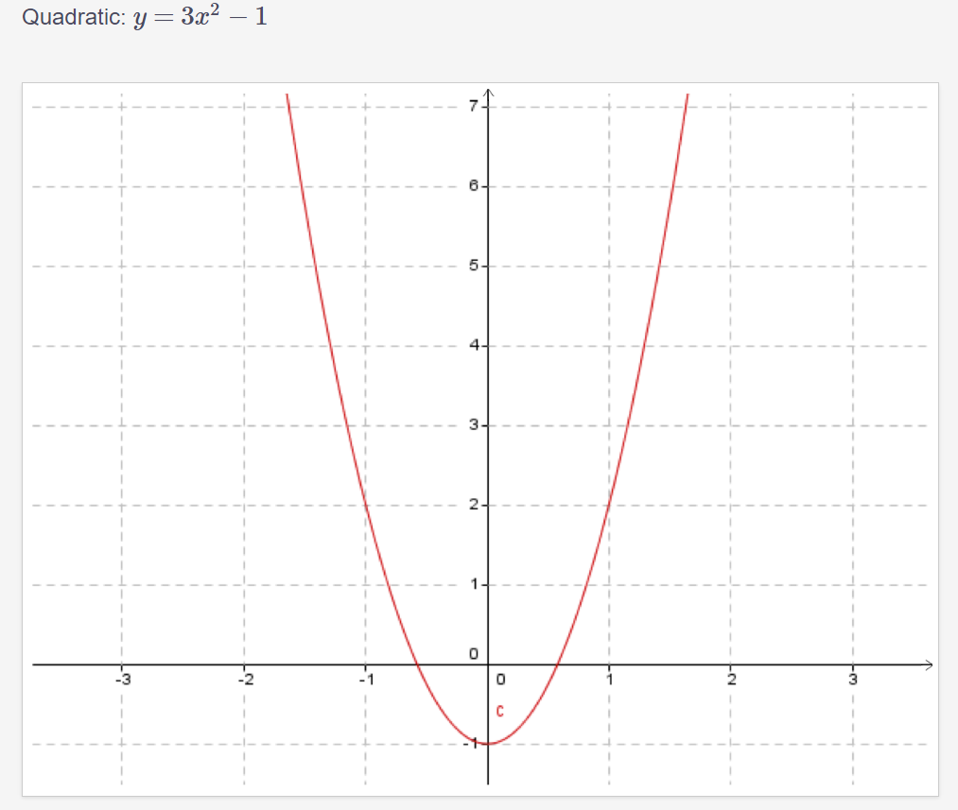
This graph has two directions. It goes from decreasing, to increasing. Point of change is called the minimum point as it is the lowest point on the graph. Graphs of quadratics always have two directions. If they go from increasing to decreasing they have a maximum point rather than a minimum point.
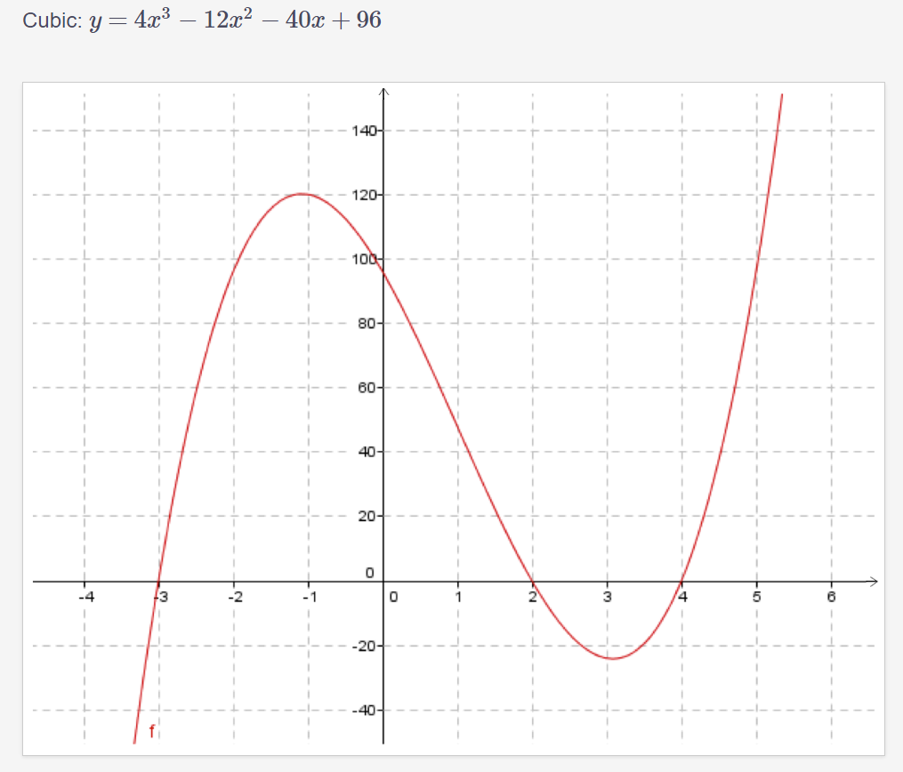
The graph of this cubic function has three directions. It increases, then decreases, then increases again. Cubic functions have a maximum of three directions. They can also have fewer than three directions, but never more than three.

Example of cubic function with one direction:
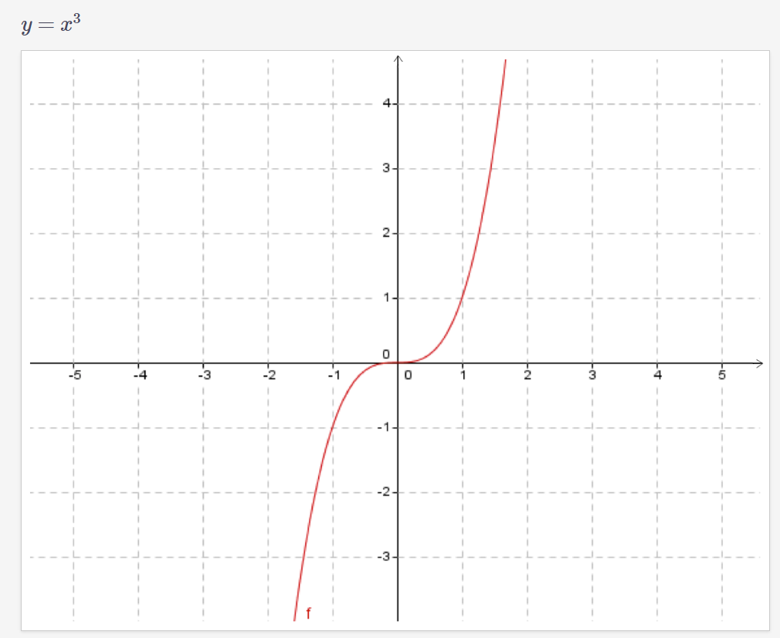

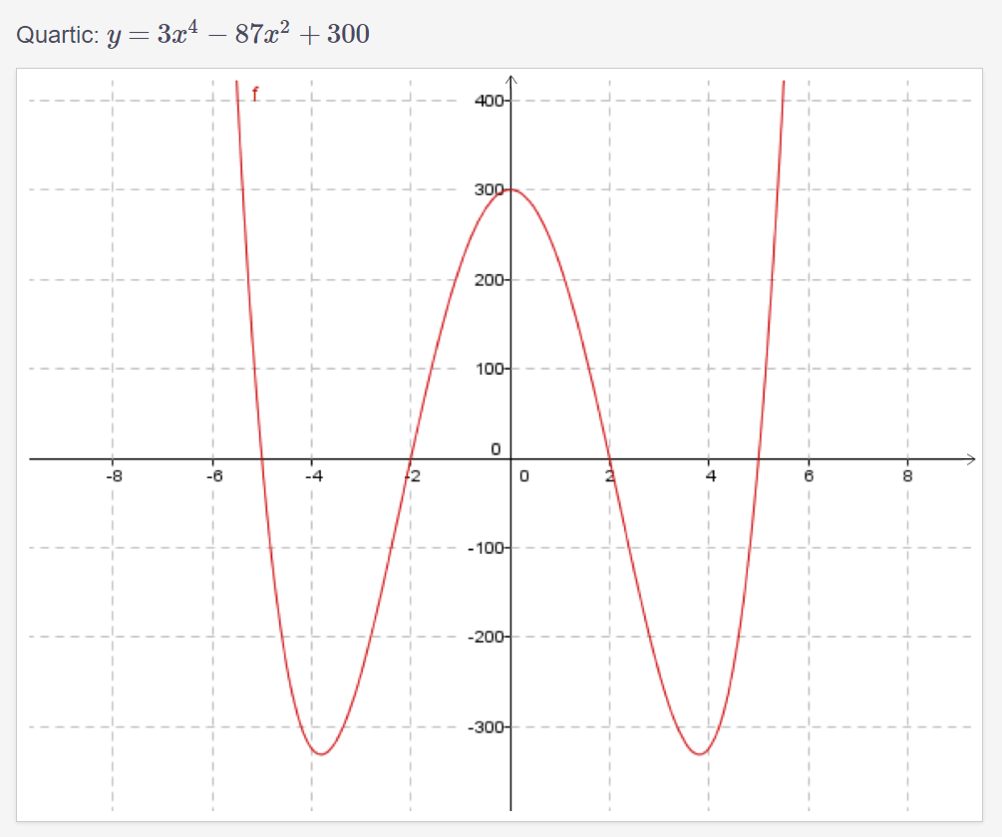
This quartic has four directions. Quartic equations have a maximum of four directions. They can never have more than four.
Example of quartic function with two directions:
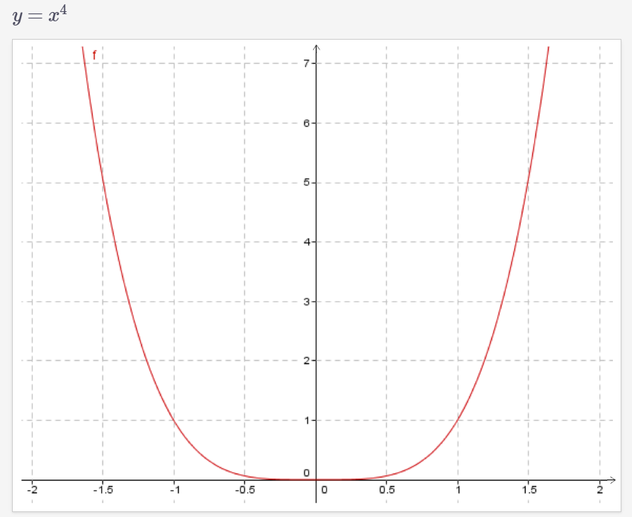
Notice how the maximum number of direction for each function matches the degree of polynomial.
The end behaviours of a graph describe what the graph does, as it approaches the left or right hand side of the grid. It includes how the graph starts and ends.
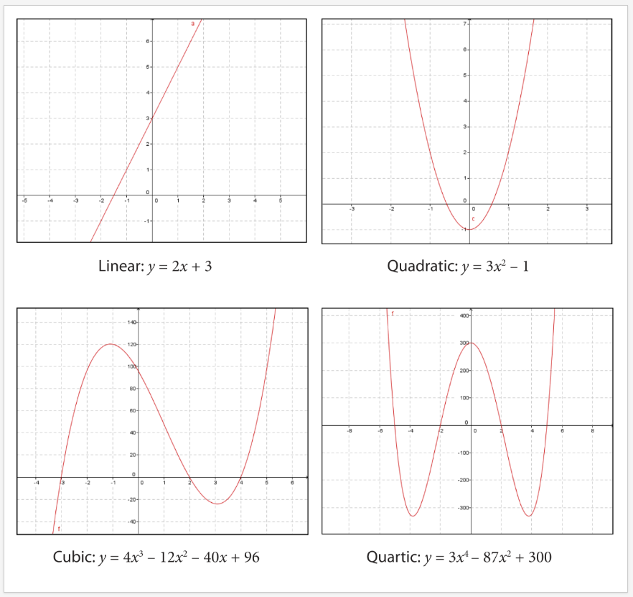

$10a^{2}-25a$$$5a\left(2a-5\right) \\ x^{4}-x^{2}-4x \\ x\left(x^{3}-x-4x\right) \\ 12b^{2}-6b \\ 6b\left(2b-1\right) \\ Difference of squares: \\ Factor binomial x^{2}-25 \\ \left(x+5\right)\left(x-5\right) \\ Factor binomial 4a^{2}-9b^{2}$$
$$\left(2a+3b\right)\left(2a-3b\right) \\ 81h^{2}-100 \\ \left(9h-10\right)\left(9h+10\right) \\ {\left(4ab\right)}^{2}-c^{2} \\ \left(2ab-c\right)\left(2ab+c\right) \\ \left(x^{2}\right)-{\left(x-y\right)}^{2} \\ (x-(x+y)(x+(x-y) \\ \left(2x-y\right)\left(y\right) \\ Simple trinomial factoring:$$
Coefficient of dominant term is 1. Find a number which multiplied by another number is equal to the last number, but also adds to the middle number.$$x^{2}-7x+12 \\ \left(x-4\right)\left(x+3\right) \\ x^{2}+9x+14 \\ \left(x+7\right)\left(x+2\right) \\ a^{2}+2a-15 \\ \left(a+5\right)\left(a-3\right) \\ k^{2}+4k-5 \\ \left(k+5\right)\left(k-1\right) \\ Complex trinomial factoring:$$
In this problem, we are simply multiplying 6 by 1, and then finding two numbers that add up to 5 but if multiplied together equal 6(1). $$6x^{2}+5x+1 \\ =6x^{2}+3x+2x+1$$
We now find a common term between the two, in this case it is 2x+1. This makes sense because 2x+1 goes into 6x+3 and goes into 2x+1$$3x\left(2x+1\right)+1\left(2x+1\right)$$
Now all you need to do is look at the problem, you’ll notice that within the brackets we have 2x+1 and outside of the brackets we have 3x+1. Giving us:$$\left(2x+1\right)\left(3x+1\right)$$

In this problem we first multiply 8(5), giving us 40. Now we need to find two terms when multiplied together equal 20, but when added together equal -18. $$8x^{2}-18x-5 \\ 8x^{2}+2x-20x-5$$
Now we need to find a common term between these. Which is 4x+1. 4x+1 goes into the last terms 5 times, and the first times 2x times. $$2x\left(4x+1\right)-5\left(4x+1\right)$$
We once again just look at the problem giving us:$$\left(4x+1\right)\left(2x-5\right)$$
In this one, we need something that adds up to 1x, but equals 15(2) =30.$$15x^{2}+x-2 \\ 15\left(2\right)=30 \\ 15x^{2}-5x+6x-2$$
We now find a common term for both sides. Which happens to be 3x-1. $$5x\left(3x-1\right)+2\left(3x-1\right) \\ \left(3x-1\right)\left(5x+2\right) \\ Factor the expressions completely: \\ 3x^{2}-48 \\ 3\left(x^{2}-16\right) \\ 3\left(x+4\right)\left(x-4\right) \\ 5x^{2}+5x-10 \\ 5\left(x^{2}+x-2\right) \\ 5\left(x+2\right)\left(x-1\right) \\ 28x^{2}-2x-6 \\ 2\left(14x^{2}-x-3\right) \\ 2\left(14x^{2}+6x-7x-3\right) \\ 2[2x\left(7x+3\right)-1(7x+3) \\ 2(2x-1)(7x+3)$$

Practice questions:
$$x^{2}+4x-32 \\ \left(x+8\right)\left(x-4\right) \\ 12x^{2}+5x-2 \\ 12x^{2}+8x-3x-2 \\ 4x\left(3x+2\right)-1\left(3x+2\right) \\ \left(4x-1\right)\left(3x+2\right)$$
$$3x^{2}-3x-90 \\ 3x^{2}+15x-18x-90 \\ 1x\left(3x+15\right)-6\left(3x+15\right) \\ \left(1x-6\right)\left(3x+15\right) \\ -2x^{3}-6x^{2}+56x \\ -2x\left(x^{2}+3x-28\right) \\ -2x\left(x^{2}+7x-4x-28\right) \\ -2x[1x\left(x+7\right)-4(x+7) \\ -2x(x+7)(1x-4)$$
$2x^{2}-11x-6$$$2x^{2}+1x-12x-6 \\ 1x\left(2x+1\right)-6\left(2x+1\right) \\ \left(1x-6\right)\left(2x+1\right) \\ 2x^{2}+3x-5 \\ 2x^{2}+5x-2x-5 \\ 1x\left(2x+5\right)-1\left(2x+5\right) \\ \left(1x-1\right)\left(2x+5\right)$$
$2x^{2}+11-6$$$2x^{2}+12x-1x-6 \\ 2x\left(1x+6\right)-1\left(1x+6\right) \\ (2x-1)(1x+6)$$

$$2x^{2}-7x+3x \\ 2x^{2}-6x-1x+3x \\ 2x\left(1x-3\right)-1\left(1x-3\right) \\ (2x-1)(1x-3)$$

$$3x^{2}+14x-24 \\ 3x^{2}+18x-4x-24 \\ 3x\left(x+6\right)-4\left(x+6\right) \\ \left(3x-4\right)\left(x+6\right)$$

$$12x^{2}+19x+4 \\ 12x^{2}+3x+16x+4 \\ 3x\left(4x+1\right)+4\left(4x+1\right) \\ \left(3x+4\right)\left(4x+1\right)$$

$$2x^{2}+3x+1 \\ 2x^{2}+2x+1x+1 \\ 2x\left(x+1\right)+1\left(x+1\right) \\ \left(2x+1\right)\left(x+1\right)$$
$$6x^{2}+19x+10 \\ 6x^{2}+15x+4x+10 \\ 3x\left(2x+5\right)+2\left(2x+5\right) \\ (3x+2)(2x+5)$$
$$8x^{2}+14x+5 \\ 8x^{2}-10x-4x+5 \\ 2x\left(4x-5\right)-1\left(4x-5\right) \\ (2x-1)(4x-5)$$

$$2x^{2}+3x-2 \\ 2x^{2}+4x-1x-2 \\ 2x\left(x+2\right)-1\left(x+2\right) \\ \left(2x-1\right)\left(x+2\right)$$
$$4x^{2}-4x-3 \\ 4x^{2}+2x-6x-3 \\ 2x\left(2x+1\right)-3\left(2x+1\right) \\ \left(2x-3\right)\left(2x+1\right)$$

$$6x^{2}-13x+5 \\ 6x^{2}+2x-15x+5 \\ 2x\left(3x+1\right)-5\left(3x-1\right) \\ \left(2x-1\right)\left(3x-5\right)$$

$$2x^{2}-9x+10 \\ 2x^{2}-5x-4x+10 \\ 1x\left(2x-5\right)-2\left(2x-5\right) \\ \left(1x-2\right)\left(2x-5\right)$$
$$Factoring cubic functions; \\ factor f\left(x\right)=x^{3}+5x^{2}-4x-20$$

Definitions:
Term: String of constants and variables multiplied together.

Expression: String of terms put together with plus and minus signs.
Coefficients:
Numerical constant places before and multiplying the variable in an algebraic expression.
ex. $the 4 in 4x^{y}$
Polynomial function:
An expression consisting of variables and coefficients that involve only the operations of: addition, subtraction, multiplication, and non-negative integer exponents.
Like exponential functions, equations of polynomial functions include exponents.
Difference:
exponential equations: bases of the powers are numbers, exponents variables.
Ex. $3^{x}$
polynomial expressions: bases of powers are variables, exponents are numbers.
Ex. $x^{3}$

