Chapter 09 Reporting and Interpreting Property, Plant, and Equipment; Natural Resources; and Intangibles
1. | Tangible operational assets differ from intangible operational assets in that tangible assets have physical substance whereas intangible assets have no physical substance.  True False

2. | A corporation may choose to list its operational assets in the current asset section of the balance sheet.  True False

3. | Intangible assets have value to a business because they represent rights that are useful to the business.  True False

4. | Noncurrent assets are those that a business retains for long periods of time for use in the course of normal operations rather than for sale.  True False

5. | One of the most important challenges facing managers is forecasting the level of productive capacity (fixed assets) needed in the long run to meet customer demand.  True False

6. | Because of its large investment in equipment, West Jet closely monitors the unused seats on flights since it may be more profitable to reduce fares to fill more seats thereby using more of the capacity.  True False

7. | The cost allocation method utilized affects the amount of net property, plant, and equipment that is used in the computation of the fixed asset turnover ratio.  True False

8. | Building and equipment are recorded at their cost at acquisition and are subsequently reported at cost less accumulated amortization.  True False

9. | When an operational asset is acquired for noncash consideration, the cost of the asset received always is measured as the book value of the noncash consideration given up.  True False

10. | If a second-hand machine is purchased for operational use in a business, all renovation and repair costs on the used machine incurred by the purchaser prior to its operational use should be excluded from the cost of the asset.  True False

11. | Acquisition cost of property, plant, and equipment is the cash-equivalent purchase price plus all reasonable and necessary expenditures made to acquire and prepare the asset for its intended use.  True False

12. | Expenditures made after the asset is in use are always capital expenditures.  True False

13. | Behren Company purchased a building and the parcel of land on which the building was located for a total purchase price of $810,000. To record the acquisition, the account, Building, should be debited for $810,000.  True False

14. | Because of depreciation, the net carrying amount of an asset declines over time and profit is reduced by the amount of the expense.  True False

15. | When a company acquires land by issuing 10,000 of its common shares currently trading for $20 per share, the company must get an appraisal of the land and recognize a gain if the appraised value is more than the $200,000 value of the shares issued.  True False

16. | A company that is self-constructing a new store, which will open upon completion, is allowed to capitalize the interest during the period of construction if they finance the construction with actual loans.  True False

17. | In conformity with the historical cost principle, cost (less any estimated residual value) is allocated to periodic expense over the periods benefited.  True False

18. | The cost of a major addition to an operational asset should be recorded as an asset and amortized over its useful life.  True False

19. | All tangible operational assets (classified as property, plant, and equipment) are subject to amortization.  True False

20. | When events or changes in circumstances reduce the estimated future cash flows of long-lived assets below their book value, the book values should be written down (by recording a loss) to the fair value of the assets.  True False

21. | In accounting for amortization, acquisition cost and useful life usually are known quantities, whereas residual value is an estimate because it relates to an amount in the future.  True False

22. | Revenue expenditures on operational assets are accounted for as expenses, while capital expenditures are accounted for as assets.  True False

23. | Extraordinary repairs on operational assets are classified as capital expenditures if they extend the life of the asset.  True False

24. | Ordinary repairs and maintenance of operational assets should be capitalized and amortized over the remaining useful life of the related asset.  True False

25. | Only the actual acquisition cost, the estimated useful life, and the method of amortization of an operational asset are required to compute the amortization expense for a period.  True False

26. | Amortization and depletion conceptually are different because they apply to different kinds of operational assets.  True False

27. | One example of a capital expenditure is ordinary maintenance cost such as an oil change for a company truck.  True False

28. | If an accountant calculates amortization expense on an asset without taking into account the asset's residual value of $5,000, amortization expense for the periods will be lower than it should have been.  True False

29. | No clear line distinguishes capital expenditures (assets) from revenue expenditures (expenses); therefore, it requires managers to exercise judgment in making a subjective decision.  True False

30. | When Ford Motor Company expenses a $200 tool used in manufacturing, instead of capitalizing its cost as an asset, it does so because of the conservatism convention.  True False

31. | The estimated useful life is the total years we expect an asset to be used by all potential users.  True False

32. | The declining-balance method of amortization is based on the assumption that amortization expenses can be regarded as a constant function of time.  True False

33. | The book value of an operational asset initially declines less rapidly under the straight-line method than under the declining-balance method.  True False

34. | When using the declining-balance method of amortization, a declining percentage is applied to a constant book value.  True False

35. | The straight-line amortization method assumes an approximately equal decline in the economic usefulness of the asset each period and provides greater tax benefits early in the useful life of the asset.  True False

36. | Accelerated amortization methods are not desirable from the income tax point of view because the asset will produce a greater net income when it is new (the early years) than when it is older (the later years).  True False

37. | When either the estimated useful life or estimated residual value (or both) of an operational asset are changed, all prior financial statements are reissued reflecting the correction retroactively.  True False

38. | A change in the estimated useful life of a tangible operational asset may be required due to economic or technological changes.  True False

39. | The declining-balance method of amortization is appropriate for companies that expect their equipment or other assets to become obsolete fairly rapidly.  True False

40. | Regardless of the method of amortization used under generally accepted accounting principles (GAAP), the ending book value will be the same at the end of the asset's economic life.  True False

41. | The estimate of residual value made at the beginning of the useful life has no relationship to the book value at the end of the asset's useful life.  True False

42. | Since the Capital Cost Allowance is used by most corporations for tax reporting, the majority of corporations no longer use accelerated methods for financial reporting since there is no tax advantage to be gained by using those methods.  True False

43. | While estimated residual value is not used to calculate annual amortization expense under the double declining-balance method, it is used in calculating the asset's book value at the end of its estimated useful life.  True False

44. | The consistency principle requires we use only one method of amortization for all our types of operational assets.  True False

45. | Use of an accelerated amortization method would lead to a higher reported expense and lower income in the first year of an asset's life in comparison to a non-accelerated method.  True False

46. | It is illegal to maintain two sets of books so we must adopt the same amortization method for both financial reporting and tax reporting.  True False

47. | Companies cannot change the method of amortization adopted for a group of assets.  True False

48. | Amortization expense, as computed for financial reporting, has a direct effect on a corporation's cash flow.  True False

49. | Acquiring and disposing of long-lived assets are financing activities on the cash flow statement.  True False

50. | Depreciation expense is a noncash expense that has no effect on cash.  True False

51. | The fixed asset turnover ratio is computed by dividing net income by the average fixed assets amount.  True False

52. | When assets are disposed of through sale or abandonment, recognize any gains or losses when the asset's net carrying amount is not equal to the cash received.  True False

53. | When assets are disposed of through sale or abandonment, record additional depreciation since the last adjustment was made.  True False

54. | The fixed asset turnover ratio measures how much net income is generated by use of operational (fixed) assets.  True False

55. | A company with relatively small amounts of long-lived operational assets but which has a high level of inventory would most likely have a lower total asset turnover but a higher fixed asset turnover ratio.  True False

56. | Use of straight-line amortization will lead to reporting a higher fixed asset turnover in the early years of an asset's life in comparison to using an accelerated amortization method.  True False

57. | An expanding company that is acquiring more operational assets most likely will experience a decrease in its asset turnover ratio until higher future sales are generated.  True False

58. | The cost principle should be applied in recording the acquisition of natural resources and intangible assets.  True False

59. | Natural resources should be depleted (usually by the units-of-production method) usually with the amount of the depletion expense capitalized to a revenue account.  True False

60. | Intangibles with definite useful lives are amortized using the straight-line method.  True False

61. | Most companies do not estimate a residual value for intangible assets since the legal benefits they provide are completely used up at the end of their useful or legal lives, whichever is shorter.  True False

62. | Operational assets do not include which of the following kinds of assets?
  A. | Plant and equipment in use.
  B. | Land held for resale.
  C. | Patents in use.
  D. | Mineral deposits being mined.

63. | Wilson, Inc., a manufacturing company, is preparing their annual financial statements. Which of the following accounts would not be grouped under operational assets?
  A. | Buildings.
  B. | Land on which the building is located.
  C. | Equipment.
  D. | Finished goods inventory.

64. | What are operational assets that have physical substance called?
  A. | Long-term investments.
  B. | Tangible assets.
  C. | Intangible assets.
  D. | Current assets.

65. | Tangible assets include which of the following?
  A. | Land, buildings, and leaseholds.
  B. | Land, buildings, and natural resources.
  C. | Natural resources, buildings, and franchises.
  D. | Licenses, trademarks, and land.

66. | Intangible assets include which of the following?
  A. | Natural resources, patents, and trademarks.
  B. | Accounts receivable, franchises, and trademarks.
  C. | Copyrights, licenses, and land.
  D. | Leaseholds, patents, and copyrights.

67. | Depletion is recorded for which of the following?
  A. | Uncollectible accounts receivable.
  B. | Natural resources.
  C. | Intangible assets.
  D. | Land and buildings.

68. | Which of the following would be classified as an operational (fixed) asset?
  A. | Land purchased and held for sale by a realtor.
  B. | Land purchased and held for development by Wal-Mart as a new store site.
  C. | Land and buildings owned by Toys "R" Us that are store sites closed due to restructuring and consolidating operations.
  D. | A Ford Motor Company manufacturing plant used to manufacture the Taurus line in Oakville, Ontario.

69. | On March 1, Chapine Company purchased a new stamping machine for $5,000. Chapine paid cash for the machine. Other costs associated with the machine were: transportation costs, $300; sales tax paid, $200; and installation cost, $100. What cost was recorded for the machine?
  A. | $5,000
  B. | $5,200
  C. | $5,500
  D. | $5,600

70. | To which account should the amount of sales tax paid on the purchase of new machinery should be debited?
  A. | A sales tax expense account.
  B. | A separate deferred charge account.
  C. | The machinery account.
  D. | Accumulated depreciation for machinery.

71. | Airbury Company acquired manufacturing equipment at an invoice price of $80,000 and paid $750 to have it delivered to the factory. $400 was spent to repair a door that was damaged while installing the equipment. At what amount should this equipment be recorded on the company's books?
  A. | $80,000
  B. | $80,400
  C. | $80,750
  D. | $81,150

72. | Martinelli Company recently purchased a truck. The price negotiated with the dealer was $85,000. Martinelli also paid sales tax of $6,000 on the purchase, shipping and preparation costs of $950, and insurance for the first year of operation of $2,000. For the truck, what amount should be debited to the asset account Vehicles?
  A. | $85,000
  B. | $85,950
  C. | $91,000
  D. | $91,950

73. | Belmont Corporation made a basket purchase of land, a building and equipment, paying a total of $1,500,000. Market values for the assets were not available, but the appraised values were $300,000 for the land, $900,000 for the building, and $600,000 for equipment. What amounts should be recorded in the Land, Building, and Equipment accounts, respectively?
  A. | $300,000, $900,000, and $600,000
  B. | $1,500,000, $-0-, and $-0-
  C. | $250,000, $750,000, and $500,000
  D. | $500,000, $500,000, and $500,000

74. | What is the book value of a tangible operating asset?
  A. | Acquisition cost.
  B. | Current estimated market value.
  C. | Acquisition cost minus the balance in accumulated amortization.
  D. | Total amortization that has been recorded on the asset to date.

75. | Which of the following costs would be excluded from the acquisition cost of equipment purchased from a supplier?
  A. | Cost to install the equipment.
  B. | The cost of freight paid to get the equipment to our factory.
  C. | The cost to widen an entrance in the building to bring the equipment into the facilities.
  D. | A purchases discount offered by the supplier.

76. | The Land account would include all of the following costs except
  A. | drainage costs.
  B. | the cost of building a fence.
  C. | title fees.
  D. | the cost of tearing down a building.

77. | Which of the following would not be included in the acquisition cost of a building?
  A. | An apportioned amount of the purchase cost when both the land and building are acquired in a basket purchase.
  B. | The cost of putting new windows and doors in the building before it opens for operations.
  C. | The cost of paving the parking lot and outdoor lighting in the lot.
  D. | The cost of paying an architect to design the remodelling modifications of the building before the store opens.

78. | Peters Clinic Ltd. purchases land for $87,500 cash. The title and legal fees totalled $1,200. The clinic has the land graded for $3,000. What amount does Peters Clinic record as the cost for the land?
  A. | $87,500.
  B. | $88,700.
  C. | $90,500.
  D. | $91,700.

79. | When may a company include interest cost as part of the cost of the asset?
  A. | When they buy a piece of equipment and finance its acquisition by a bank loan.
  B. | When they must borrow money to finance the manufacture of their inventory items.
  C. | When they are self-constructing a piece of equipment they will use to manufacture their products, but only during the period of construction.
  D. | Interest is never allowed to be capitalized.

80. | Johnson Company acquires land and building for $4,000,000 including all fees related to acquisition. The land is appraised at $2,700,000 and the building at $2,100,000. The building is then renovated at a cost of $750,000. What amount is capitalized to the building account?
  A. | $2,078,125
  B. | $2,500,000
  C. | $2,375,000
  D. | $4,000,000

81. | The apportionment of the acquisition cost of an operational asset to future periods in which the benefits contribute to earning revenue must be which of the following?
  A. | Systematic and/or rational.
  B. | Systematic and rational.
  C. | Systematic.
  D. | Rational.

82. | A company purchases a remote site building for computer operations. The building will be suitable for operations after some expenditures. The wiring must be replaced to computer specifications. The roof is leaky and must be replaced. All rooms must be repainted and recarpeted and there will also be some plumbing work done. Which of the following statements is true?
  A. | The cost of the building will not include the repainting and recarpeting costs.
  B. | The cost of the building will include the cost of replacing the roof.
  C. | The cost of the building is the purchase price of the building, while the additional expenditures are all capitalized as Building Improvements.
  D. | The wiring is part of the computer costs, not the building cost.

83. | What is the main purpose of recording amortization?
  A. | To allocate the cost of a tangible asset to the periods in which its use contributes to earning revenue.
  B. | To estimate the remaining useful life of the asset.
  C. | To report the asset on the balance sheet at the estimated amount for which the asset could be sold on the balance sheet date.
  D. | To estimate the current replacement cost of the asset.

84. | Residual value is which of the following?
  A. | Equal to the acquisition cost of a tangible operational asset.
  B. | The same as book value of an asset.
  C. | The amount expected to be recovered when an asset is disposed of at the end of its estimated useful life.
  D. | The current value of an asset as of the balance sheet date.

85. | In accounting for tangible operational assets, the continuity assumption is important because of which of the following?
  A. | It helps a company decide whether to use straight-line depreciation or an accelerated depreciation method.
  B. | It justifies depreciating the asset over its expected useful life, without anticipating that the business will liquidate in the near future.
  C. | It provides justification for including residual values in calculating depreciation.
  D. | It is consistent with maintaining assets in the accounting records at market value rather than acquisition cost.

86. | What is an extraordinary repair to a building?
  A. | It is a revenue expenditure and it is debited to an expense account.
  B. | It is a capital expenditure and it is debited to an asset account.
  C. | It is a capital expenditure and it is debited to an expense account.
  D. | It is a revenue expenditure and may be debited to accumulated amortization.

87. | In 20B, Gamma Company made an ordinary repair to a delivery truck at a cost of $300. Gamma's accountant debited the asset account, Delivery Vehicles. Was this treatment an error, and if so, what will be the effect on the financial statements of Gamma?
  A. | The repair was accounted for correctly.
  B. | The error increased assets and net income in 20B.
  C. | In the years following 20B, net income will be too high.
  D. | The error decreased net income in 20B.

88. | If a company classifies an expenditure as a capital expenditure instead of a revenue expenditure, which of the following will be false?
  A. | Income for the year of acquisition will be higher.
  B. | The initial cost basis of the asset will be higher.
  C. | Amortization expense will be higher over the asset's life.
  D. | It will be expensed in the year in which the expenditure takes place.

89. | Which of the following would most likely not be a revenue expenditure?
  A. | Replacing carpet in the sales department's offices.
  B. | Repairing a leaky roof.
  C. | Putting a hydraulic lift on our delivery truck making it easier and quicker to deliver appliances.
  D. | Painting the exterior of our store.

90. | In 2010, WD Company reported the cost of their parks, resorts and other related property at $15,869 million and accumulated depreciation on these assets at $6,220 million. The remaining estimated life of these assets is approximately
  A. | 61%.
  B. | 39%.
  C. | 45%.
  D. | Cannot be determined from the given information.

91. | With respect to depreciation policies, the principle of consistency means:
  A. | A company should disclose on the financial statements the depreciation method for all its capital assets.
  B. | A company should use the same depreciation method from year to year for a given capital asset.
  C. | A company should use the same depreciation methods as other companies in the same industry.
  D. | A company should use the same depreciation method in computing depreciation expense on all its assets.

92. | On January 1, 20A, Straight, Inc., purchased a machine with a cash price of $9,500. Straight also paid $500 for transportation and installation. The expected useful life of the machine is 5 years and the residual value is $500. Assuming straight-line amortization, the annual amortization expense would be which of the following?
  A. | $1,800
  B. | $1,900
  C. | $2,000
  D. | $2,100

93. | Lowe Company purchased a machine at a cash cost of $25,000 and is amortizing it over a 10-year estimated useful life with a residual value of $3,000. At the beginning of the eighth year, a major overhaul on it was completed at a cost of $8,000, and the total estimated useful life was changed to 12 years with the residual value unchanged. Amortization expense for year 8 would be which of the following (assuming straight-line depreciation)?
  A. | $2,200
  B. | $2,920
  C. | $3,100
  D. | $8,800

94. | A machine, acquired for a cash cost of $6,000, is being amortized on a straight-line basis of $900 per year. The residual value was estimated to be 10% of cost. What is the estimated useful life?
  A. | 3 years
  B. | 4 years
  C. | 5 years
  D. | 6 years

95. | Bethany Company plans to depreciate a new building using declining-balance amortization with 200 percent acceleration rate. The building cost $400,000. The estimated residual value of the building is $50,000 and it has an expected useful life of 25 years. Assuming the first year's amortization expense was recorded properly, what would be the amount of amortization expense for the second year?
  A. | $15,360
  B. | $16,000
  C. | $29,440
  D. | $32,000

96. | Which method of amortization results in periodic amortization expense that fluctuates from one period to the next, not necessarily in a steadily upward or downward direction?
  A. | Straight-line.
  B. | Units-of-production.
  C. | Amortization.
  D. | Declining-balance.

97. | Management should select the depreciation method that
  A. | is easiest to apply.
  B. | best measures the asset's fair value each period over its useful life.
  C. | best reflects the pattern in which the asset's future economic benefits are to be consumed.
  D. | has been used most often in the past by the company.

98. | Bubba Inc. purchased an asset on January 1, 20A. Bubba chose the straight-line method to amortize the asset. Had Bubba chosen an accelerated amortization method, which of the following would be false?
  A. | Amortization expense would be greater in 20A.
  B. | The book value of the asset would be less at the end of 20A.
  C. | Net income would be less in 20A.
  D. | Amortization expense would be the same each year.

99. | On January 1, 20A, Johns Company purchased an asset that cost $10,000 (no estimated residual value, estimated useful life 8 years, straight-line amortization is used). An error was made because the total cost amount was debited to an expense account for 20A and no amortization on it was recorded. Pretax income for 20A was $11,250. What was the correct pretax income for 20A?
  A. | $12,000
  B. | $19,200
  C. | $20,000
  D. | $20,750

100. | Trumble Company purchased a machine on January 1, 20B, for $10,000. The company bookkeeper incorrectly used a 6-year life instead of a 5-year life to depreciate the machine. What would be the effect of this error on the 20B financial statements?
  A. | Overstatement of assets offset by an understatement of shareholders' equity.
  B. | Overstatement of assets offset by an understatement of retained earnings.
  C. | Overstatement of assets, income, and shareholders' equity.
  D. | Overstatement of assets and an understatement of liabilities.

101. | Sure Company purchased a machine on January 1, 20A, at a cash cost of $12,000. The estimated useful life is 10 years, and the estimated residual value is $3,000. The company will use the declining-balance method based on a 150 percent acceleration rate. What will be the amortization expense for the second year?
  A. | $900
  B. | $1,350
  C. | $1,530
  D. | $1,800

102. | Bangor Industries purchased a car for $22,000 on January 1, 20A. The car had an estimated useful life of 80,000 miles and an estimated residual value of $4,000. In the second year of ownership (20B), the car was driven 25,000 miles. Using the units of production method, what was the amount of amortization expense for 20B?
  A. | $4,500
  B. | $5,000
  C. | $5,625
  D. | $6,875

103. | A company decided to use the units of production method to calculate amortization on a car to be driven by the sales manager. The amount of annual amortization will vary with which of the following?
  A. | Age of the car.
  B. | Balance in accumulated amortization.
  C. | Number of miles the car is driven.
  D. | Amount of maintenance expense incurred on the car.

104. | A depreciable asset that cost $100,000 had an estimated useful life of 5 years and estimated residual value of $10,000. What is the first year for which amortization would be greater under the straight-line method than under the declining-balance method with an acceleration rate of 200%?
  A. | The first year.
  B. | The second year.
  C. | The third year.
  D. | The fourth year.

105. | Most companies keep separate sets of accounting records for financial reporting and for income tax computations. Which of the following statements is true?
  A. | They do it even though this practice is illegal and in violation of generally accepted accounting principles.
  B. | They do it because the Income Tax Act requires companies to keep separate records for tax purposes.
  C. | They do it because financial reporting rules and ITA regulations differ in many ways.
  D. | They do it to enable a company to do a reconciliation between taxable income and reported net income.

106. | Belton Corporation uses straight-line amortization and, for assets acquired during the fiscal year, follows the policy of recording a full month's amortization for all assets acquired on or before the 15th of the month. No amortization is recorded for the month if an asset is acquired after the 15th. On May 22, 20A, Belton purchased a car that cost $22,000 which had an estimated residual value of $2,000 and an estimated useful life of five years. To the nearest dollar, what is the amount of amortization that should be recorded on the car for 20A?
  A. | $2,000
  B. | $2,333
  C. | $2,667
  D. | $4,000

107. | Angstrom Corporation purchased a truck at a cost of $60,000. It has an estimated useful life of five years and estimated residual value of $5,000. At the beginning of year three, Angstrom's managers concluded that the total useful life would be four years, rather than five. There was no change in the estimated residual value. What is the amount of amortization that Angstrom should record for year 3 under the straight-line method?
  A. | $8,250
  B. | $11,000
  C. | $15,500
  D. | $16,500

108. | Recording amortization expense does which of the following?
  A. | It reduces both net income and the amount of cash generated by a company.
  B. | It does not affect net income or the amount of cash generated by a company.
  C. | It reduces net income and increases the amount of cash generated by a company.
  D. | It reduces net income but does not affect the amount of cash generated by a company.

109. | How should an expenditure for an ordinary repair to factory equipment be recorded?
  A. | As an expense in the period incurred.
  B. | Debited to an asset account but not amortized over future years.
  C. | Debited to an asset account and amortized over the current and future years.
  D. | Debited to accumulated amortization.

110. | Helm Corporation purchased a machine with an initial cost of $80,000, a residual value of $5,000, and an estimated useful life of 10 years. At the beginning of the fifth year, Helm spent $10,000 for an extraordinary repair. Following the repair, Helm estimated that the machine had a remaining useful life of 8 years, and that the residual value was unchanged. Calculate amortization expense on the machine for the fifth year, assuming that Helm uses the straight-line method.
  A. | $5,625
  B. | $6,875
  C. | $7,250
  D. | $7,500

111. | How is the matching principle related to the recording of amortization on tangible operational assets?
  A. | The matching principle requires a company to use the same amortization.
  B. | Once a particular amortization method is adopted for a particular asset, the owner must continue to use the same method.
  C. | The accountant who calculates the amortization may assume that the company will continue in business as long as the estimated useful life of the asset.
  D. | A portion of the cost of the asset should be allocated as an expense for the periods in which the asset helps the business to earn revenue.

112. | Which of the following is false?
  A. | The book value at the end of an asset's useful life will be the same under all the amortization methods allowed under GAAP.
  B. | The total amortization in the accumulated amortization account will be the same at the end of the asset's useful life under all the methods allowed under GAAP.
  C. | The annual amortization expense will differ under the various amortization methods.
  D. | The annual amortization expense using the straight-line method increases each year.

113. | Under what conditions would a company most likely adopt the double declining-balance method for financial reporting?
  A. | They have high technology, robotic equipment in their plant that becomes obsolete quickly and declines in utility to the company more rapidly in the early years of the assets' lives.
  B. | They have a fleet of trucks where repair costs increase annually as the fleet ages.
  C. | They expect the asset to lose its market value more rapidly in the first few years of its life.
  D. | Two of the responses are correct.

114. | Which of the following is a false statement?
  A. | Companies can change the method of amortizing assets from one year to the next.
  B. | Companies can affect the book value at the end of an asset's life by choosing one method of amortization over another.
  C. | Companies can use one method of amortization for some of their operational assets but then use a different method for another group or type of operational assets.
  D. | Companies cannot change their estimate of the salvage value of a long-term asset.

115. | Jeffers Inc. purchased a warehouse and the land upon which it was located. The total price was $450,000. The land was appraised for $180,000 while the warehouse was appraised for $360,000. What account balances should Jeffers show in its general ledger?
  A. | Land $180,000; Warehouse $360,000
  B. | Land $150,000; Warehouse $300,000
  C. | Land $166,667; Warehouse $333,333
  D. | Land $150,000; Warehouse $350,000

116. | Barnes Company purchased a machine on April 4, 2009, for $210,000. The machine had an estimated useful life of five years and a salvage value of $30,000. The machine is being depreciated using the double declining balance method. Barnes depreciates its assets from the first day of the month nearest the date of purchase. The asset balance, net of accumulated depreciation, at December 31, 2010, should be:
  A. | $75,600
  B. | $88,200
  C. | $94,800
  D. | $105,600

117. | Which of the following statements is false?
  A. | A company can change the method used for amortizing assets if the change can be justified because it provides a better measure of the company's income.
  B. | A change in estimate requires the company to recalculate and restate all the prior years' estimates of amortization and adjust the impact on the balance sheet and income statement.
  C. | A change in estimate is frequently necessary because the estimates of useful lives or residual values may change over time because conditions change.
  D. | Either a change in estimate or a change in method can only be justified on the basis it provides a better measure of income.

118. | Godfrey's Gadgets sold an obsolete piece of equipment for $4,000. Original cost of the item had been $12,500 and its accumulated depreciation was $7,200. This transaction would result in a:
  A. | Loss of $3,200
  B. | Loss of $1,300
  C. | Gain of $4,000
  D. | Loss of $8,500

119. | Which of the following statements is false?
  A. | Amortization expense is added to net income in the operating activities section of the statement of cash flows because it had no cash effect on net income under the indirect method.
  B. | Amortization expense is included in the investing activities section of the cash flow statement.
  C. | The only cash effect for amortization is the tax savings provided by its deduction to derive taxable income.
  D. | Amortization is a non-cash expense that reduces net income but involves no outflow of cash.

120. | WD Company reports net income in 2010 of $1,300 million and depreciation expense of $851 million. They also report investment in new theme parks, resorts, and other property of $2,134 million for 2010. Which of the following disclosures would appear on their statement of cash flows?
  A. | Amortization of $851 million would be deducted from net income under operating activities and the $2,134 million would be added under investing activities
  B. | Amortization of $851 million would be added to net income under operating activities and the $2,134 million would be added under investing activities
  C. | Amortization of $851 million would be added to net income under operating activities and the $2,134 million would be deducted under investing activities
  D. | Amortization of $851 million would be deducted from net income under operating activities and the $2,134 million would be deducted under investing activities

121. | The records of Pam Company showed the following about a machine on January 1, 20H:  Purchased 1/1/20E for $35,000  Accumulated amortization at January 1, 20H, $26,400  On July 1, 20H, the machine was sold for $7,000. Amortization for the first six months of 20H was $1,467. The gain or loss on disposal would be which of the following?
  A. | $133 loss
  B. | $133 gain
  C. | $1,600 loss
  D. | $1,600 gain

122. | If a company sold an operational asset at a price equal to its book value, the selling company would record which of the following?
  A. | No gain or loss.
  B. | A gain.
  C. | A loss.
  D. | An extraordinary item.

123. | Kovacic Company purchased a computer that cost $10,000. It had an estimated useful life of five years and residual value of $0. The computer was amortized by the straight-line method and was sold at the end of the fourth year of use for $3,000 cash. What should Kovacic record?
  A. | A gain of $1,000.
  B. | A loss of $1,000.
  C. | Neither a gain nor a loss - the computer was sold at its book value.
  D. | Neither a gain nor a loss - the gain that occurred in this case would not be recognized.

124. | In 2001, DAL Co. had a fixed asset turnover of 1.63 compared to ABC Co. of 1.10. What is the most likely cause of DAL Co.'s higher ratio?
  A. | DAL Co. is less efficient in generating net sales from its operational assets.
  B. | DAL Co. is more efficient at generating net income from employing its operational assets.
  C. | DAL Co. is able to generate greater sales from its operational assets.
  D. | DAL Co. is able to generate less net income from its operational assets.

125. | In 2009, DAL Co. reported a fixed asset turnover ratio of 1.83 and in 2010, 1.63. What was the most likely cause of this drop?
  A. | An increase in sales.
  B. | An increase in fixed assets.
  C. | A decrease in fixed assets.
  D. | An increase in net income.

126. | Which statement is false?
  A. | Shortening the estimated useful lives of our assets will increase the fixed asset turnover.
  B. | Using an accelerated amortization method instead of straight-line will lead to reporting a higher fixed asset turnover.
  C. | Acquiring more operational assets when a company is growing will lead to a lower fixed asset turnover.
  D. | Selling off operational assets while maintaining sales will cause fixed asset turnover to decrease.

127. | On March 1, 20A, Jance Company purchased a producing oil well at a cash cost of $100,000. It is estimated that 250,000 barrels of oil can be produced over the remaining life of the well. By December 31, 20A (end of the accounting period), 1,500 barrels of oil were produced and sold. What would be the amount of depletion expense for 20A on this well?
  A. | $300
  B. | $450
  C. | $600
  D. | $750

128. | On January 1, 2010, Stacy Company purchased the College Book Store for $350,000. At the date of purchase, it was determined the recorded assets had a total market value of $325,000, comprised of inventory (books), $275,000; fixtures, $30,000; and other assets $20,000. It is estimated that the goodwill (if any) has an economic useful life of 20 years. What is the amount of amortization expense for goodwill for 2010?
  A. | $1,250
  B. | $1,500
  C. | $16,250
  D. | $17,500

129. | Carpenter Corporation purchased a mineral deposit, making payment as follows: Cash $10,000 and 6,000 Carpenter Corporation common shares. On the date of the purchase, the mineral deposit had an appraised value of $75,000; the common shares were quoted on the market at $11 per share. Other acquisition costs amounted to $3,000 cash. What was the cost recorded for the mineral deposit?
  A. | $70,000
  B. | $73,000
  C. | $75,000
  D. | $79,000

130. | The Orser Mining Company acquired a gold mine for $8,000,000. It is estimated that 40,000 ounces of gold can be extracted from the mine. In the first year of operations, 15,000 ounces of gold were extracted. The Orser Mining Company would recognize:
  A. | An increase in net income of $3,000,000
  B. | Amortization expense of $3,000,000
  C. | Cost of goods sold of $3,000,000
  D. | Depletion expense of $3,000,000

131. | Which of the following methods ordinarily would be the most appropriate to determine depletion of natural resources for financial reporting purposes?
  A. | Straight-line.
  B. | Two hundred percent declining-balance.
  C. | Specific identification.
  D. | Units of production.

132. | What is the term used for matching the cost of an intangible asset with the revenues generated through the use of the asset?
  A. | Depletion.
  B. | Amortization.
  C. | Appraisal.
  D. | Book value.

133. | Which of the following is true of a failure to record amortization on a patent during the current year?
  A. | It would cause net income to be overstated for the year but would have no effect on total assets.
  B. | It would cause both net income for the year and total assets to be overstated.
  C. | It would cause total assets to be overstated but would have no effect on net income for the year.
  D. | It is allowed under Generally Accepted Accounting Principles.

134. | Which of the following is true of depletion recorded for natural resources?
  A. | It recognizes increases in market value with the passage of time.
  B. | It matches the cost of resources used up with the revenues that are earned.
  C. | It is also recorded on buildings and equipment used in extracting the resource.
  D. | It is determined by a method similar to declining balance depreciation.

135. | In accounting, which of the following is true of goodwill?
  A. | It may be recorded whenever a company achieves a level of net income that exceeds the industry average.
  B. | It does not need to be amortized because its useful life is indeterminate.
  C. | It may be recorded when a company purchases another business.
  D. | It must be expended in the period it is recorded because benefits from goodwill are difficult to identify.

136. | On January 1, 20A, Reagan Company purchased a machine. The price quoted by the seller was $10,000 less 2% if paid within 15 days of the invoice date. Paid with cash were: transportation, $300; installation, $600; and sales tax, $200. Give the entry to record the acquisition.

137. | Rebuild Inc. purchased a plant and the land on which the plant was located for a total of $300,000 cash. The separate market values of the plant and land were not known, so Rebuild hired an independent appraiser who gave the following estimated market values: plant, $220,000; land, $110,000. Complete the entry to record the acquisition (show computation).

138. | Raco Inc. purchased two used machines together to get a lower total cash price of $90,000. The machines were different, although of the same general type. They were designated as Machines A and B. New machines of the same type could be purchased for: Machine A, $25,000; Machine B, $75,000. Complete the following entry to record the purchase and show your computations.  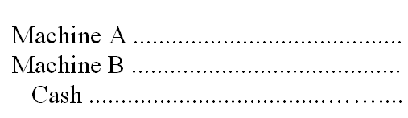

139. | Yell Company made a lump sum purchase of an office building, including the land and some fixtures, for cash of $160,000. The tax assessments for the past year reflected the following: Land, $22,500; Building, $58,500; and Fixtures, $9,000. Complete the following entry for the acquisition:  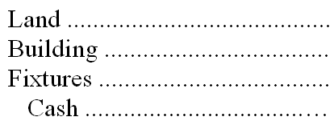

140. | In 2010, WD Company reported the cost of its theme parks, resorts, and other assets at $14,037 million and the accumulated depreciation at $5,382 million. In that same year, "Toys 4 U" reported $5,610 million in operating assets and accumulated depreciation on them of $1,398 million.  1. Estimate the approximate remaining life of the assets for WD Company and "Toys 4 U"  2. Which company appears to have newer assets with longer remaining lives?

141. | Chamber Company purchased a truck on January 1, 20A, at a cash cost of $10,600. The estimated residual value was $400 and the estimated useful life 4 years. The company uses straight-line amortization computed monthly. On July 1, 20D, the company sold the truck for $1,700 cash.  A. What was the amortization expense amount per month?  B. What was the amount of accumulated amortization at July 1, 20D?  C. Give the required journal entries on the date of disposal, July 1, 20D. (Assume no 20D amortization had yet been recorded).

142. | Sutter Company purchased a machine on January 1, 20A, for $16,000. The machine has an estimated useful life of 5 years and a $1,000 residual value. It is now December 31, 20B, and Sutter is in the process of preparing financial statements. Complete the following schedule assuming declining-balance method of depreciation with a 150% acceleration rate.  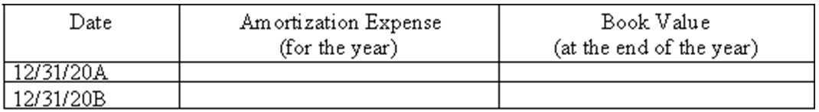

143. | The financial statements of Betty Company contained the following errors:  Respond to each of the following (disregard income taxes):  A. Income for 20A, was understated or overstated (circle one).  B. Total combined income for the two-year period ended December 31, 20B, was overstated or understated (circle one).

144. | On January 1, 20A, Stern Company (a calendar year corporation) purchased a heavy duty machine having an invoice price of $13,000 plus transportation and installation costs of $3,000. The machine is estimated to have a 4-year useful life and a $1,000 residual value. Assuming the company uses the declining-balance method amortization and a 150% acceleration rate, complete the following schedule (round to the nearest dollar).  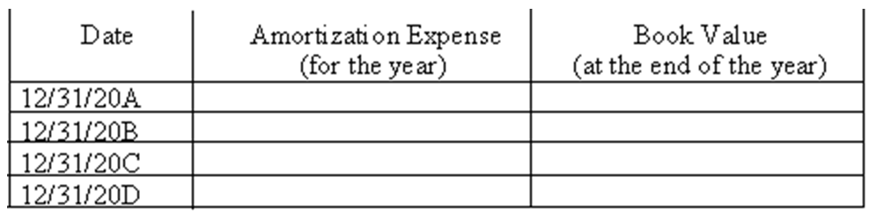

145. | Tweed Feed & Seed purchased a new machine on January 1, 20A:  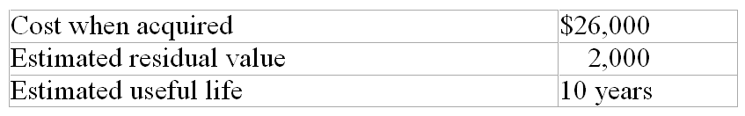  Accumulated amortization at the end of year 5 (assume straight-line amortization) $12,000  It is now the beginning of year 6 and the management re-evaluated the estimates related to the machine. Compute the amortization expense for year 6 under each of the following independent cases:  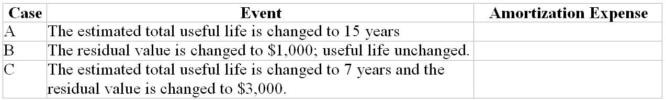

146. | Duval Company acquired a machine on January 1, 20A, that cost $2,700 and had an estimated residual value of $200. Complete the following schedule using the three methods of amortization: A.) straight-line, B.) units-of-production, C.) declining-balance at 150% acceleration rate.  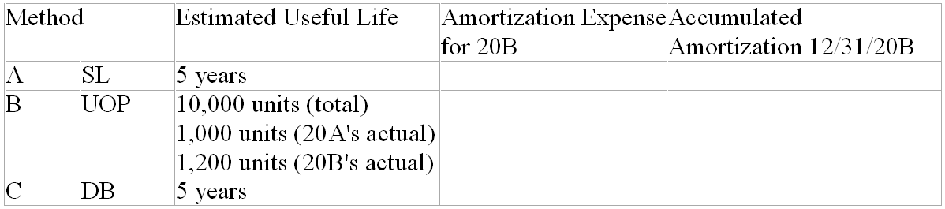

147. | On January 1, 20B, Walton Corporation made a basket purchase of land, a building, and furniture and fixtures. The total purchase price was $313,000. Walton also paid $3,000 for title fees and $4,000 in legal fees related to the purchase. Appraised values at the time of the purchase were: land $70,000; building, $227,500; and furniture and fixtures, $52,500.  Required:  1. Make the journal entry to record the purchase of the assets, with cost based on appraised values.  2. The building had an estimated useful life of 20 years and residual value of $30,000. Make the journal entry to record amortization for 20B using the declining-balance method and a 150% acceleration rate.  3. The furniture and fixtures are expected to have useful lives of 5 years and no residual value. What is the amount of amortization on the furniture and fixtures for 20B, assuming that Walton uses the straight-line method of amortization for such assets.  4. Based on the information in part 3, what is the book value of the furniture and fixtures at the end of 20B?  5. Under generally accepted accounting principles, would Walton be able to use the declining-balance method for the building and the straight-line method for furniture and fixtures? Discuss briefly.

148. | Macon Assembly Company purchased a machine on January 2, 20C, by paying cash of $85,000. The machine has an estimated useful life of five years (or the production of 200,000 units) and an estimated residual value of $5,000.  Required:  1. Determine amortization expense (to the nearest dollar) for each year of the machine's useful life under (a). straight-line amortization; and (b). the declining-balance method with a 200% acceleration rate.  2. What is the book value of the machine after three years with the declining-balance method and a 200% acceleration rate?  3. What is the book value of the machinery after three years with straight-line amortization.  4. If the machine was used to produce and sell 48,000 units in 20C, what would the amortization expense be under the units of production method?

149. | On September 7, 20B, Belverd Corporation purchased a building and land at a total acquisition cost of $500,000. An appraiser estimated that 80% of the purchase price should be assigned to the building and the remainder to the land.  Required:  1. Make the journal entry for the acquisition of the land and building.  2. Make the journal entry to record amortization of the building for 20B. Belverd takes a full month of amortization for assets acquired in the first half of the month and uses the straight-line method. The building has a residual value of $40,000 and an estimated useful life of 20 years.  3. Based on the information in part 2, what will the book value of the building be at the end of 20C?  4. Why was it important for Belverd to separate the cost of the land and the cost of the building?

150. | Hilman Company purchased a truck on January 1, 20A, at a cost of $34,000. The company estimated that the truck would have a useful life of 4 years and a residual value of $4,000.  Required:  1. Complete the following table:  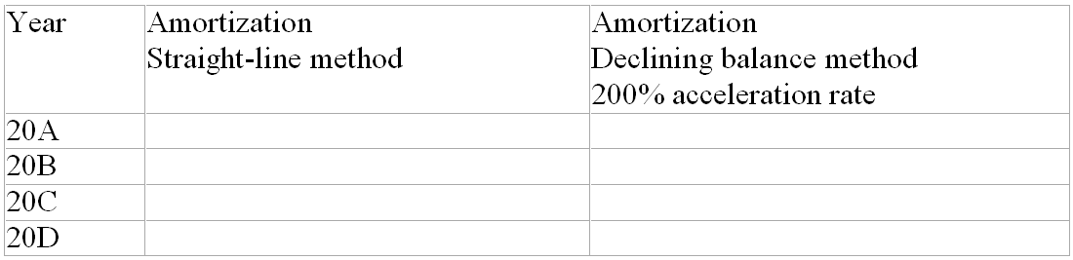  2. Which of the two methods in part 1 would result in:  a. Lower net income in 20A? ___________  b. Lower net income in 20D? ___________

151. | FAL Corporation purchased a robot to be used in manufacturing. The purchase was made at the beginning of 20A by paying cash of $500,000. The robot has an estimated residual value of $20,000 and an expected useful life of 10 years. At the beginning of 20C, FAL concluded that the total useful life of the robot will be 8 years rather than 10, and that the residual value will be zero. FAL uses the straight-line method for amortization.  Required:  1. Make the journal entry to record amortization on the robot for 20B.  2. Make the journal entry to record amortization on the robot for 20C, including the effect of the changes in estimates.  3. Describe how a business should account for a change in the estimated useful life and/or residual value of a amortizable asset.

152. | The following information is available for C Co. and P Co.:  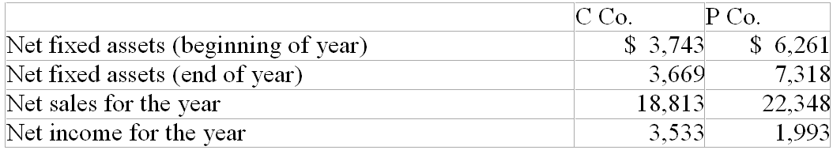  (1) Compute the fixed asset turnover ratio for the year for both C Co. and P Co.  a. C Co. __________  b. P Co. __________

153. | Soule Corporation purchased a machine that had an original cost of $60,000 and an estimated residual value of $10,000. The useful life was expected to be 8 years and straight-line amortization is used. At the end of 20E, the book value of the machine was $35,000. Soule sold the machine for $32,000 cash on October 1, 20F.  Required:  A. Prepare the journal entry to record amortization for 20F up to the date of sale. Round the amount to the nearest dollar.  B. Prepare the journal entry to record the sale of the machine.

154. | Give the required adjusting entry at December 31, 20F, the end of the annual accounting period for the three items below. If no entry is required, explain why.  A. Web Company acquired a patent that cost $4,260 on January 1, 20F. The patent was registered on January 1, 20A. The legal life of a patent is 17 years from registration. Web expects to use the patent the remaining legal life.  B. Web Company acquired a gravel pit on January 1, 20F, that cost $24,000. The company estimates that 30,000 tons of gravel can be extracted economically. During 20F 4,000 tons were extracted and sold.  C. On January 1, 20F, Web Company acquired a dump truck that cost $6,000 to use hauling gravel. The company estimated a residual value of 10% of cost and a useful life 4 years. The company uses straight-line amortization.

155. | Weaver Mining Company purchased a site containing a mineral deposit in 20C. The purchase price was $820,000, and the site is estimated to contain 400,000 tons of extractable ore. Weaver constructed a building at the site, at a cost of $500,000, to be used while the ore is being extracted. When the ore reserves are gone, the building will have no further value.  Required:  1. Explain the purpose for recording depletion on natural resources.  2. Calculate Weaver's amortization rate per ton of ore for this deposit.  3. Make the journal entry to record depletion for the year 20C, when Weaver mined and sold 150,000 tons of ore.  4. Make the journal entry to record amortization on the building for 20C. Weaver calculates amortization on the building using the units of production method based on the amount of ore extracted (150,000 tons in 20C).

156. | On January 2, 20D, Daintry Company purchased a patent for $380,000 from an inventor who had developed a new manufacturing process. At the time of the purchase, the patent had a remaining legal life of 12 years, but Daintry estimated the useful life to the company to only be 10 years.  Required:  1. Prepare the journal entry to record Daintry's purchase of the patent.  2. Prepare the journal entry to record amortization of the patent for 20D, assuming that no contra account is used.  3. At the start of 20G, after amortization had been recorded for three years, Daintry concluded that the total useful life of the patent would be 7 years, rather than 10. Record Daintry's amortization expense for 20G.

157. | Pied Piper Pies has been in business 8 years with 4 stores in the San Francisco bay area. Their local reputation for making savoury pies such as curried potatoes is well recognized. A national food distributor has offered to purchase the company. Pied Piper has $1.2 million of assets on their books but those assets have $1.5 million in value at fair market value and $.3 million of liabilities. If the distributor offers to buy Pied Piper for $3.5 million and assume the liabilities of Pied Piper, how much will goodwill be based on the offered purchase price?

158. | A company purchased equipment for $800,000 and has depreciated it for the past 5 years when its original life was estimated to be 10 years with a $200,000 residual value. The equipment's utility to the company has declined because they expect it to generate a net cash flow over the remaining years of $200,000 from its operation. If the asset has been impaired, how much will be recorded as a loss in the current year?

159. | Match the assets with the cost allocation method by entering the appropriate letter.
  1. None | Uranium reserves (being exploited) | ____
  2. Depletion | Building, Tex-Mex Chile Franchise (in use) | ____
  3. Amortization | Long-term investment in shares of Swift Tea, Inc. | ____

160. | Match each type of asset category with the appropriate allocation method.
  1. Depletion | Intangible assets, Property, plant, and equipment | ____
  2. Amortization | Natural resources | ____

161. | Write the letter of the definition in the blank before the term.
  1. leasehold | Cost minus accumulated amortization of a tangible operational asset. | ____
  2. property, plant and equipment | Expenditure for an asset that is debited to an asset account. | ____
  3. patent | An exclusive right to make a product or use a particular process. | ____
  4. residual value | An asset that confers rights upon the owner and that lacks physical substance. | ____
  5. units-of-production amortization | Causes the amortization expense for an asset to decrease with passage of time. | ____
  6. capital expenditure | Estimated amount to be recovered at the end of the useful life of an operational asset. | ____
  7. book value | An ordinary repair, for example. | ____
  8. amortization | Rights granted to a lessee under the terms of a contract. | ____
  9. depletion | A heading used on the balance sheet for tangible operating assets. | ____
  10. revenue expenditure | Allocation of the cost of a natural resource to the periods in which revenues are earned. | ____
  11. intangible asset | Allocation of the cost of an intangible asset to the periods when it is used. | ____
  12. declining-balance amortization | Causes the amortization expense for an asset to vary with the use of the asset. | ____

Chapter 09 Reporting and Interpreting Property, Plant, and Equipment; Natural Resources; and Intangibles Key
1. | Tangible operational assets differ from intangible operational assets in that tangible assets have physical substance whereas intangible assets have no physical substance.  TRUE

Difficulty: Easy
Learning Objective: 1
Libby - Chapter 09 #1

2. | A corporation may choose to list its operational assets in the current asset section of the balance sheet.  FALSE

Difficulty: Easy
Learning Objective: 1
Libby - Chapter 09 #2

3. | Intangible assets have value to a business because they represent rights that are useful to the business.  TRUE

Difficulty: Easy
Learning Objective: 1
Libby - Chapter 09 #3

4. | Noncurrent assets are those that a business retains for long periods of time for use in the course of normal operations rather than for sale.  TRUE

Difficulty: Easy
Learning Objective: 1
Libby - Chapter 09 #4

5. | One of the most important challenges facing managers is forecasting the level of productive capacity (fixed assets) needed in the long run to meet customer demand.  TRUE

Difficulty: Easy
Learning Objective: 1
Libby - Chapter 09 #5

6. | Because of its large investment in equipment, West Jet closely monitors the unused seats on flights since it may be more profitable to reduce fares to fill more seats thereby using more of the capacity.  TRUE

Difficulty: Medium
Learning Objective: 1
Libby - Chapter 09 #6

7. | The cost allocation method utilized affects the amount of net property, plant, and equipment that is used in the computation of the fixed asset turnover ratio.  TRUE

Difficulty: Medium
Learning Objective: 1
Libby - Chapter 09 #7

8. | Building and equipment are recorded at their cost at acquisition and are subsequently reported at cost less accumulated amortization.  TRUE

Difficulty: Medium
Learning Objective: 2
Libby - Chapter 09 #8

9. | When an operational asset is acquired for noncash consideration, the cost of the asset received always is measured as the book value of the noncash consideration given up.  FALSE

Difficulty: Hard
Learning Objective: 2
Libby - Chapter 09 #9

10. | If a second-hand machine is purchased for operational use in a business, all renovation and repair costs on the used machine incurred by the purchaser prior to its operational use should be excluded from the cost of the asset.  FALSE

Difficulty: Medium
Learning Objective: 2
Libby - Chapter 09 #10

11. | Acquisition cost of property, plant, and equipment is the cash-equivalent purchase price plus all reasonable and necessary expenditures made to acquire and prepare the asset for its intended use.  TRUE

Difficulty: Medium
Learning Objective: 2
Libby - Chapter 09 #11

12. | Expenditures made after the asset is in use are always capital expenditures.  FALSE

Difficulty: Medium
Learning Objective: 2
Libby - Chapter 09 #12

13. | Behren Company purchased a building and the parcel of land on which the building was located for a total purchase price of $810,000. To record the acquisition, the account, Building, should be debited for $810,000.  FALSE

Difficulty: Easy
Learning Objective: 2
Libby - Chapter 09 #13

14. | Because of depreciation, the net carrying amount of an asset declines over time and profit is reduced by the amount of the expense.  TRUE

Difficulty: Medium
Learning Objective: 2
Libby - Chapter 09 #14

15. | When a company acquires land by issuing 10,000 of its common shares currently trading for $20 per share, the company must get an appraisal of the land and recognize a gain if the appraised value is more than the $200,000 value of the shares issued.  FALSE

Difficulty: Hard
Learning Objective: 2
Libby - Chapter 09 #15

16. | A company that is self-constructing a new store, which will open upon completion, is allowed to capitalize the interest during the period of construction if they finance the construction with actual loans.  TRUE

Difficulty: Hard
Learning Objective: 2
Libby - Chapter 09 #16

17. | In conformity with the historical cost principle, cost (less any estimated residual value) is allocated to periodic expense over the periods benefited.  FALSE

Difficulty: Medium
Learning Objective: 2
Libby - Chapter 09 #17

18. | The cost of a major addition to an operational asset should be recorded as an asset and amortized over its useful life.  TRUE

Difficulty: Medium
Learning Objective: 3
Libby - Chapter 09 #18

19. | All tangible operational assets (classified as property, plant, and equipment) are subject to amortization.  FALSE

Difficulty: Medium
Learning Objective: 3
Libby - Chapter 09 #19

20. | When events or changes in circumstances reduce the estimated future cash flows of long-lived assets below their book value, the book values should be written down (by recording a loss) to the fair value of the assets.  TRUE

Difficulty: Easy
Learning Objective: 4
Libby - Chapter 09 #20

21. | In accounting for amortization, acquisition cost and useful life usually are known quantities, whereas residual value is an estimate because it relates to an amount in the future.  FALSE

Difficulty: Medium
Learning Objective: 3
Libby - Chapter 09 #21

22. | Revenue expenditures on operational assets are accounted for as expenses, while capital expenditures are accounted for as assets.  TRUE

Difficulty: Medium
Learning Objective: 2
Libby - Chapter 09 #22

23. | Extraordinary repairs on operational assets are classified as capital expenditures if they extend the life of the asset.  TRUE

Difficulty: Easy
Learning Objective: 2
Libby - Chapter 09 #23

24. | Ordinary repairs and maintenance of operational assets should be capitalized and amortized over the remaining useful life of the related asset.  FALSE

Difficulty: Easy
Learning Objective: 2
Libby - Chapter 09 #24

25. | Only the actual acquisition cost, the estimated useful life, and the method of amortization of an operational asset are required to compute the amortization expense for a period.  FALSE

Difficulty: Medium
Learning Objective: 3
Libby - Chapter 09 #25

26. | Amortization and depletion conceptually are different because they apply to different kinds of operational assets.  FALSE

Difficulty: Medium
Learning Objective: 3
Libby - Chapter 09 #26

27. | One example of a capital expenditure is ordinary maintenance cost such as an oil change for a company truck.  FALSE

Difficulty: Easy
Learning Objective: 2
Libby - Chapter 09 #27

28. | If an accountant calculates amortization expense on an asset without taking into account the asset's residual value of $5,000, amortization expense for the periods will be lower than it should have been.  FALSE

Difficulty: Easy
Learning Objective: 3
Libby - Chapter 09 #28

29. | No clear line distinguishes capital expenditures (assets) from revenue expenditures (expenses); therefore, it requires managers to exercise judgment in making a subjective decision.  TRUE

Difficulty: Easy
Learning Objective: 1
Libby - Chapter 09 #29

30. | When Ford Motor Company expenses a $200 tool used in manufacturing, instead of capitalizing its cost as an asset, it does so because of the conservatism convention.  FALSE

Difficulty: Easy
Learning Objective: 1
Libby - Chapter 09 #30

31. | The estimated useful life is the total years we expect an asset to be used by all potential users.  FALSE

Difficulty: Medium
Learning Objective: 3
Libby - Chapter 09 #31

32. | The declining-balance method of amortization is based on the assumption that amortization expenses can be regarded as a constant function of time.  FALSE

Difficulty: Medium
Learning Objective: 3
Libby - Chapter 09 #32

33. | The book value of an operational asset initially declines less rapidly under the straight-line method than under the declining-balance method.  TRUE

Difficulty: Medium
Learning Objective: 3
Libby - Chapter 09 #33

34. | When using the declining-balance method of amortization, a declining percentage is applied to a constant book value.  FALSE

Difficulty: Medium
Learning Objective: 3
Libby - Chapter 09 #34

35. | The straight-line amortization method assumes an approximately equal decline in the economic usefulness of the asset each period and provides greater tax benefits early in the useful life of the asset.  FALSE

Difficulty: Easy
Learning Objective: 3
Libby - Chapter 09 #35

36. | Accelerated amortization methods are not desirable from the income tax point of view because the asset will produce a greater net income when it is new (the early years) than when it is older (the later years).  FALSE

Difficulty: Medium
Learning Objective: 3
Libby - Chapter 09 #36

37. | When either the estimated useful life or estimated residual value (or both) of an operational asset are changed, all prior financial statements are reissued reflecting the correction retroactively.  FALSE

Difficulty: Medium
Learning Objective: 3
Libby - Chapter 09 #37

38. | A change in the estimated useful life of a tangible operational asset may be required due to economic or technological changes.  TRUE

Difficulty: Medium
Learning Objective: 3
Libby - Chapter 09 #38

39. | The declining-balance method of amortization is appropriate for companies that expect their equipment or other assets to become obsolete fairly rapidly.  TRUE

Difficulty: Medium
Learning Objective: 3
Libby - Chapter 09 #39

40. | Regardless of the method of amortization used under generally accepted accounting principles (GAAP), the ending book value will be the same at the end of the asset's economic life.  TRUE

Difficulty: Medium
Learning Objective: 3
Libby - Chapter 09 #40

41. | The estimate of residual value made at the beginning of the useful life has no relationship to the book value at the end of the asset's useful life.  FALSE

Difficulty: Medium
Learning Objective: 3
Libby - Chapter 09 #41

42. | Since the Capital Cost Allowance is used by most corporations for tax reporting, the majority of corporations no longer use accelerated methods for financial reporting since there is no tax advantage to be gained by using those methods.  TRUE

Difficulty: Medium
Learning Objective: 3
Libby - Chapter 09 #42

43. | While estimated residual value is not used to calculate annual amortization expense under the double declining-balance method, it is used in calculating the asset's book value at the end of its estimated useful life.  TRUE

Difficulty: Medium
Learning Objective: 3
Libby - Chapter 09 #43

44. | The consistency principle requires we use only one method of amortization for all our types of operational assets.  FALSE

Difficulty: Medium
Learning Objective: 3
Libby - Chapter 09 #44

45. | Use of an accelerated amortization method would lead to a higher reported expense and lower income in the first year of an asset's life in comparison to a non-accelerated method.  TRUE

Difficulty: Easy
Learning Objective: 3
Libby - Chapter 09 #45

46. | It is illegal to maintain two sets of books so we must adopt the same amortization method for both financial reporting and tax reporting.  FALSE

Difficulty: Medium
Learning Objective: 3
Libby - Chapter 09 #46

47. | Companies cannot change the method of amortization adopted for a group of assets.  FALSE

Difficulty: Medium
Learning Objective: 3
Libby - Chapter 09 #47

48. | Amortization expense, as computed for financial reporting, has a direct effect on a corporation's cash flow.  FALSE

Difficulty: Medium
Learning Objective: 3
Learning Objective: 7
Libby - Chapter 09 #48

49. | Acquiring and disposing of long-lived assets are financing activities on the cash flow statement.  FALSE

Difficulty: Easy
Learning Objective: 7
Libby - Chapter 09 #49

50. | Depreciation expense is a noncash expense that has no effect on cash.  TRUE

Difficulty: Medium
Learning Objective: 7
Libby - Chapter 09 #50

51. | The fixed asset turnover ratio is computed by dividing net income by the average fixed assets amount.  FALSE

Difficulty: Medium
Learning Objective: 1
Libby - Chapter 09 #51

52. | When assets are disposed of through sale or abandonment, recognize any gains or losses when the asset's net carrying amount is not equal to the cash received.  TRUE

Difficulty: Medium
Learning Objective: 5
Libby - Chapter 09 #52

53. | When assets are disposed of through sale or abandonment, record additional depreciation since the last adjustment was made.  TRUE

Difficulty: Medium
Learning Objective: 5
Libby - Chapter 09 #53

54. | The fixed asset turnover ratio measures how much net income is generated by use of operational (fixed) assets.  FALSE

Difficulty: Medium
Learning Objective: 1
Libby - Chapter 09 #54

55. | A company with relatively small amounts of long-lived operational assets but which has a high level of inventory would most likely have a lower total asset turnover but a higher fixed asset turnover ratio.  TRUE

Difficulty: Hard
Learning Objective: 1
Libby - Chapter 09 #55

56. | Use of straight-line amortization will lead to reporting a higher fixed asset turnover in the early years of an asset's life in comparison to using an accelerated amortization method.  FALSE

Difficulty: Medium
Learning Objective: 3
Libby - Chapter 09 #56

57. | An expanding company that is acquiring more operational assets most likely will experience a decrease in its asset turnover ratio until higher future sales are generated.  TRUE

Difficulty: Medium
Learning Objective: 1
Libby - Chapter 09 #57

58. | The cost principle should be applied in recording the acquisition of natural resources and intangible assets.  TRUE

Difficulty: Medium
Learning Objective: 6
Libby - Chapter 09 #58

59. | Natural resources should be depleted (usually by the units-of-production method) usually with the amount of the depletion expense capitalized to a revenue account.  FALSE

Difficulty: Medium
Learning Objective: 6
Libby - Chapter 09 #59

60. | Intangibles with definite useful lives are amortized using the straight-line method.  TRUE

Difficulty: Easy
Learning Objective: 6
Libby - Chapter 09 #60

61. | Most companies do not estimate a residual value for intangible assets since the legal benefits they provide are completely used up at the end of their useful or legal lives, whichever is shorter.  TRUE

Difficulty: Medium
Learning Objective: 6
Libby - Chapter 09 #61

62. | Operational assets do not include which of the following kinds of assets?
  A. | Plant and equipment in use.
  B. | Land held for resale.
  C. | Patents in use.
  D. | Mineral deposits being mined.

Difficulty: Medium
Learning Objective: 1
Libby - Chapter 09 #62

63. | Wilson, Inc., a manufacturing company, is preparing their annual financial statements. Which of the following accounts would not be grouped under operational assets?
  A. | Buildings.
  B. | Land on which the building is located.
  C. | Equipment.
  D. | Finished goods inventory.

Difficulty: Easy
Learning Objective: 1
Libby - Chapter 09 #63

64. | What are operational assets that have physical substance called?
  A. | Long-term investments.
  B. | Tangible assets.
  C. | Intangible assets.
  D. | Current assets.

Difficulty: Easy
Learning Objective: 1
Libby - Chapter 09 #64

65. | Tangible assets include which of the following?
  A. | Land, buildings, and leaseholds.
  B. | Land, buildings, and natural resources.
  C. | Natural resources, buildings, and franchises.
  D. | Licenses, trademarks, and land.

Difficulty: Medium
Learning Objective: 1
Libby - Chapter 09 #65

66. | Intangible assets include which of the following?
  A. | Natural resources, patents, and trademarks.
  B. | Accounts receivable, franchises, and trademarks.
  C. | Copyrights, licenses, and land.
  D. | Leaseholds, patents, and copyrights.

Difficulty: Medium
Learning Objective: 1
Libby - Chapter 09 #66

67. | Depletion is recorded for which of the following?
  A. | Uncollectible accounts receivable.
  B. | Natural resources.
  C. | Intangible assets.
  D. | Land and buildings.

Difficulty: Medium
Learning Objective: 6
Libby - Chapter 09 #67

68. | Which of the following would be classified as an operational (fixed) asset?
  A. | Land purchased and held for sale by a realtor.
  B. | Land purchased and held for development by Wal-Mart as a new store site.
  C. | Land and buildings owned by Toys "R" Us that are store sites closed due to restructuring and consolidating operations.
  D. | A Ford Motor Company manufacturing plant used to manufacture the Taurus line in Oakville, Ontario.

Difficulty: Medium
Learning Objective: 1
Libby - Chapter 09 #68

69. | On March 1, Chapine Company purchased a new stamping machine for $5,000. Chapine paid cash for the machine. Other costs associated with the machine were: transportation costs, $300; sales tax paid, $200; and installation cost, $100. What cost was recorded for the machine?  Calculation: $5,000 + 300 + 200 + 100 = $5,600
  A. | $5,000
  B. | $5,200
  C. | $5,500
  D. | $5,600

Difficulty: Medium
Learning Objective: 2
Libby - Chapter 09 #69

70. | To which account should the amount of sales tax paid on the purchase of new machinery should be debited?
  A. | A sales tax expense account.
  B. | A separate deferred charge account.
  C. | The machinery account.
  D. | Accumulated depreciation for machinery.

Difficulty: Easy
Learning Objective: 2
Libby - Chapter 09 #70

71. | Airbury Company acquired manufacturing equipment at an invoice price of $80,000 and paid $750 to have it delivered to the factory. $400 was spent to repair a door that was damaged while installing the equipment. At what amount should this equipment be recorded on the company's books?  Calculation: $80,750 = 80,000 + 750
  A. | $80,000
  B. | $80,400
  C. | $80,750
  D. | $81,150

Difficulty: Medium
Learning Objective: 2
Libby - Chapter 09 #71

72. | Martinelli Company recently purchased a truck. The price negotiated with the dealer was $85,000. Martinelli also paid sales tax of $6,000 on the purchase, shipping and preparation costs of $950, and insurance for the first year of operation of $2,000. For the truck, what amount should be debited to the asset account Vehicles?  Calculation: $85,000 + 6,000 + 950 = $91,950
  A. | $85,000
  B. | $85,950
  C. | $91,000
  D. | $91,950

Difficulty: Medium
Learning Objective: 2
Libby - Chapter 09 #72

73. | Belmont Corporation made a basket purchase of land, a building and equipment, paying a total of $1,500,000. Market values for the assets were not available, but the appraised values were $300,000 for the land, $900,000 for the building, and $600,000 for equipment. What amounts should be recorded in the Land, Building, and Equipment accounts, respectively?  Calculation: $300/$1,800 x $1,500,000 = $250,000; $900/$1,800 x $1,500,000 = $750,000; $600/$1,800 x $1,500,000 = $500,000
  A. | $300,000, $900,000, and $600,000
  B. | $1,500,000, $-0-, and $-0-
  C. | $250,000, $750,000, and $500,000
  D. | $500,000, $500,000, and $500,000

Difficulty: Medium
Learning Objective: 2
Libby - Chapter 09 #73

74. | What is the book value of a tangible operating asset?
  A. | Acquisition cost.
  B. | Current estimated market value.
  C. | Acquisition cost minus the balance in accumulated amortization.
  D. | Total amortization that has been recorded on the asset to date.

Difficulty: Easy
Learning Objective: 2
Libby - Chapter 09 #74

75. | Which of the following costs would be excluded from the acquisition cost of equipment purchased from a supplier?
  A. | Cost to install the equipment.
  B. | The cost of freight paid to get the equipment to our factory.
  C. | The cost to widen an entrance in the building to bring the equipment into the facilities.
  D. | A purchases discount offered by the supplier.

Difficulty: Medium
Learning Objective: 2
Libby - Chapter 09 #75

76. | The Land account would include all of the following costs except
  A. | drainage costs.
  B. | the cost of building a fence.
  C. | title fees.
  D. | the cost of tearing down a building.

Difficulty: Medium
Learning Objective: 2
Libby - Chapter 09 #76

77. | Which of the following would not be included in the acquisition cost of a building?
  A. | An apportioned amount of the purchase cost when both the land and building are acquired in a basket purchase.
  B. | The cost of putting new windows and doors in the building before it opens for operations.
  C. | The cost of paving the parking lot and outdoor lighting in the lot.
  D. | The cost of paying an architect to design the remodelling modifications of the building before the store opens.

Difficulty: Medium
Learning Objective: 2
Libby - Chapter 09 #77

78. | Peters Clinic Ltd. purchases land for $87,500 cash. The title and legal fees totalled $1,200. The clinic has the land graded for $3,000. What amount does Peters Clinic record as the cost for the land?  Calculation: $87,500 + $3,000 + $1,200 = $91,700
  A. | $87,500.
  B. | $88,700.
  C. | $90,500.
  D. | $91,700.

Difficulty: Medium
Learning Objective: 2
Libby - Chapter 09 #78

79. | When may a company include interest cost as part of the cost of the asset?
  A. | When they buy a piece of equipment and finance its acquisition by a bank loan.
  B. | When they must borrow money to finance the manufacture of their inventory items.
  C. | When they are self-constructing a piece of equipment they will use to manufacture their products, but only during the period of construction.
  D. | Interest is never allowed to be capitalized.

Difficulty: Medium
Learning Objective: 2
Libby - Chapter 09 #79

80. | Johnson Company acquires land and building for $4,000,000 including all fees related to acquisition. The land is appraised at $2,700,000 and the building at $2,100,000. The building is then renovated at a cost of $750,000. What amount is capitalized to the building account?  Calculation: ($4,000,000 x $2,100/$4,800) + $750,000 = $2,500,000
  A. | $2,078,125
  B. | $2,500,000
  C. | $2,375,000
  D. | $4,000,000

Difficulty: Medium
Learning Objective: 2
Libby - Chapter 09 #80

81. | The apportionment of the acquisition cost of an operational asset to future periods in which the benefits contribute to earning revenue must be which of the following?
  A. | Systematic and/or rational.
  B. | Systematic and rational.
  C. | Systematic.
  D. | Rational.

Difficulty: Medium
Learning Objective: 2
Libby - Chapter 09 #81

82. | A company purchases a remote site building for computer operations. The building will be suitable for operations after some expenditures. The wiring must be replaced to computer specifications. The roof is leaky and must be replaced. All rooms must be repainted and recarpeted and there will also be some plumbing work done. Which of the following statements is true?
  A. | The cost of the building will not include the repainting and recarpeting costs.
  B. | The cost of the building will include the cost of replacing the roof.
  C. | The cost of the building is the purchase price of the building, while the additional expenditures are all capitalized as Building Improvements.
  D. | The wiring is part of the computer costs, not the building cost.

Difficulty: Easy
Learning Objective: 2
Libby - Chapter 09 #82

83. | What is the main purpose of recording amortization?
  A. | To allocate the cost of a tangible asset to the periods in which its use contributes to earning revenue.
  B. | To estimate the remaining useful life of the asset.
  C. | To report the asset on the balance sheet at the estimated amount for which the asset could be sold on the balance sheet date.
  D. | To estimate the current replacement cost of the asset.

Difficulty: Easy
Learning Objective: 3
Libby - Chapter 09 #83

84. | Residual value is which of the following?
  A. | Equal to the acquisition cost of a tangible operational asset.
  B. | The same as book value of an asset.
  C. | The amount expected to be recovered when an asset is disposed of at the end of its estimated useful life.
  D. | The current value of an asset as of the balance sheet date.

Difficulty: Easy
Learning Objective: 3
Libby - Chapter 09 #84

85. | In accounting for tangible operational assets, the continuity assumption is important because of which of the following?
  A. | It helps a company decide whether to use straight-line depreciation or an accelerated depreciation method.
  B. | It justifies depreciating the asset over its expected useful life, without anticipating that the business will liquidate in the near future.
  C. | It provides justification for including residual values in calculating depreciation.
  D. | It is consistent with maintaining assets in the accounting records at market value rather than acquisition cost.

Difficulty: Medium
Learning Objective: 3
Libby - Chapter 09 #85

86. | What is an extraordinary repair to a building?
  A. | It is a revenue expenditure and it is debited to an expense account.
  B. | It is a capital expenditure and it is debited to an asset account.
  C. | It is a capital expenditure and it is debited to an expense account.
  D. | It is a revenue expenditure and may be debited to accumulated amortization.

Difficulty: Medium
Learning Objective: 2
Libby - Chapter 09 #86

87. | In 20B, Gamma Company made an ordinary repair to a delivery truck at a cost of $300. Gamma's accountant debited the asset account, Delivery Vehicles. Was this treatment an error, and if so, what will be the effect on the financial statements of Gamma?
  A. | The repair was accounted for correctly.
  B. | The error increased assets and net income in 20B.
  C. | In the years following 20B, net income will be too high.
  D. | The error decreased net income in 20B.

Difficulty: Medium
Learning Objective: 2
Libby - Chapter 09 #87

88. | If a company classifies an expenditure as a capital expenditure instead of a revenue expenditure, which of the following will be false?
  A. | Income for the year of acquisition will be higher.
  B. | The initial cost basis of the asset will be higher.
  C. | Amortization expense will be higher over the asset's life.
  D. | It will be expensed in the year in which the expenditure takes place.

Difficulty: Medium
Learning Objective: 2
Libby - Chapter 09 #88

89. | Which of the following would most likely not be a revenue expenditure?
  A. | Replacing carpet in the sales department's offices.
  B. | Repairing a leaky roof.
  C. | Putting a hydraulic lift on our delivery truck making it easier and quicker to deliver appliances.
  D. | Painting the exterior of our store.

Difficulty: Hard
Learning Objective: 2
Libby - Chapter 09 #89

90. | In 2010, WD Company reported the cost of their parks, resorts and other related property at $15,869 million and accumulated depreciation on these assets at $6,220 million. The remaining estimated life of these assets is approximately  Calculation: ($15,869 - $6,220) ÷ $15,869 = 61%
  A. | 61%.
  B. | 39%.
  C. | 45%.
  D. | Cannot be determined from the given information.

Difficulty: Medium
Learning Objective: 3
Libby - Chapter 09 #90

91. | With respect to depreciation policies, the principle of consistency means:
  A. | A company should disclose on the financial statements the depreciation method for all its capital assets.
  B. | A company should use the same depreciation method from year to year for a given capital asset.
  C. | A company should use the same depreciation methods as other companies in the same industry.
  D. | A company should use the same depreciation method in computing depreciation expense on all its assets.

Difficulty: Medium
Learning Objective: 2
Libby - Chapter 09 #91

92. | On January 1, 20A, Straight, Inc., purchased a machine with a cash price of $9,500. Straight also paid $500 for transportation and installation. The expected useful life of the machine is 5 years and the residual value is $500. Assuming straight-line amortization, the annual amortization expense would be which of the following?  Calculation: [($9,500 + $500) - $500] ÷ 5 = $1,900
  A. | $1,800
  B. | $1,900
  C. | $2,000
  D. | $2,100

Difficulty: Medium
Learning Objective: 3
Libby - Chapter 09 #92

93. | Lowe Company purchased a machine at a cash cost of $25,000 and is amortizing it over a 10-year estimated useful life with a residual value of $3,000. At the beginning of the eighth year, a major overhaul on it was completed at a cost of $8,000, and the total estimated useful life was changed to 12 years with the residual value unchanged. Amortization expense for year 8 would be which of the following (assuming straight-line depreciation)?  Calculation: $25,000 - {[($25,000 - $3,000) ÷ 10] x 7} = $9,600; ($9,600 + $8,000 - $3,000) ÷ 5 = $2,920
  A. | $2,200
  B. | $2,920
  C. | $3,100
  D. | $8,800

Difficulty: Medium
Learning Objective: 3
Libby - Chapter 09 #93

94. | A machine, acquired for a cash cost of $6,000, is being amortized on a straight-line basis of $900 per year. The residual value was estimated to be 10% of cost. What is the estimated useful life?  Calculation: ($6,000 x 90%) ÷ $900 = 6
  A. | 3 years
  B. | 4 years
  C. | 5 years
  D. | 6 years

Difficulty: Medium
Learning Objective: 3
Libby - Chapter 09 #94

95. | Bethany Company plans to depreciate a new building using declining-balance amortization with 200 percent acceleration rate. The building cost $400,000. The estimated residual value of the building is $50,000 and it has an expected useful life of 25 years. Assuming the first year's amortization expense was recorded properly, what would be the amount of amortization expense for the second year?  Calculation: [$400,000 - ($400,000 x 2 ÷ 25)] x 2 ÷ 25 = $29,440
  A. | $15,360
  B. | $16,000
  C. | $29,440
  D. | $32,000

Difficulty: Hard
Learning Objective: 3
Libby - Chapter 09 #95

96. | Which method of amortization results in periodic amortization expense that fluctuates from one period to the next, not necessarily in a steadily upward or downward direction?
  A. | Straight-line.
  B. | Units-of-production.
  C. | Amortization.
  D. | Declining-balance.

Difficulty: Easy
Learning Objective: 3
Libby - Chapter 09 #96

97. | Management should select the depreciation method that
  A. | is easiest to apply.
  B. | best measures the asset's fair value each period over its useful life.
  C. | best reflects the pattern in which the asset's future economic benefits are to be consumed.
  D. | has been used most often in the past by the company.

Difficulty: Easy
Learning Objective: 3
Libby - Chapter 09 #97

98. | Bubba Inc. purchased an asset on January 1, 20A. Bubba chose the straight-line method to amortize the asset. Had Bubba chosen an accelerated amortization method, which of the following would be false?
  A. | Amortization expense would be greater in 20A.
  B. | The book value of the asset would be less at the end of 20A.
  C. | Net income would be less in 20A.
  D. | Amortization expense would be the same each year.

Difficulty: Medium
Learning Objective: 3
Libby - Chapter 09 #98

99. | On January 1, 20A, Johns Company purchased an asset that cost $10,000 (no estimated residual value, estimated useful life 8 years, straight-line amortization is used). An error was made because the total cost amount was debited to an expense account for 20A and no amortization on it was recorded. Pretax income for 20A was $11,250. What was the correct pretax income for 20A?  Calculation: $11,250 - ($10,000 ÷ 8) + $10,000 = $20,000
  A. | $12,000
  B. | $19,200
  C. | $20,000
  D. | $20,750

Difficulty: Medium
Learning Objective: 3
Libby - Chapter 09 #99

100. | Trumble Company purchased a machine on January 1, 20B, for $10,000. The company bookkeeper incorrectly used a 6-year life instead of a 5-year life to depreciate the machine. What would be the effect of this error on the 20B financial statements?
  A. | Overstatement of assets offset by an understatement of shareholders' equity.
  B. | Overstatement of assets offset by an understatement of retained earnings.
  C. | Overstatement of assets, income, and shareholders' equity.
  D. | Overstatement of assets and an understatement of liabilities.

Difficulty: Medium
Learning Objective: 3
Libby - Chapter 09 #100

101. | Sure Company purchased a machine on January 1, 20A, at a cash cost of $12,000. The estimated useful life is 10 years, and the estimated residual value is $3,000. The company will use the declining-balance method based on a 150 percent acceleration rate. What will be the amortization expense for the second year?  Calculation: [$12,000 - (12,000 x 1.5 x 10%)] x 1.5 x 10% = $1,530
  A. | $900
  B. | $1,350
  C. | $1,530
  D. | $1,800

Difficulty: Hard
Learning Objective: 3
Libby - Chapter 09 #101

102. | Bangor Industries purchased a car for $22,000 on January 1, 20A. The car had an estimated useful life of 80,000 miles and an estimated residual value of $4,000. In the second year of ownership (20B), the car was driven 25,000 miles. Using the units of production method, what was the amount of amortization expense for 20B?  Calculation: ($22,000 - $4,000) ÷ 80,000 x 25,000 = $5,625
  A. | $4,500
  B. | $5,000
  C. | $5,625
  D. | $6,875

Difficulty: Medium
Learning Objective: 3
Libby - Chapter 09 #102

103. | A company decided to use the units of production method to calculate amortization on a car to be driven by the sales manager. The amount of annual amortization will vary with which of the following?
  A. | Age of the car.
  B. | Balance in accumulated amortization.
  C. | Number of miles the car is driven.
  D. | Amount of maintenance expense incurred on the car.

Difficulty: Easy
Learning Objective: 3
Libby - Chapter 09 #103

104. | A depreciable asset that cost $100,000 had an estimated useful life of 5 years and estimated residual value of $10,000. What is the first year for which amortization would be greater under the straight-line method than under the declining-balance method with an acceleration rate of 200%?  Calculation: Straight-line: ($100,000 - $10,000) ÷ 5 = $18,000 per year; declining-balance: $100,000 x 2 x 20% = $40,000 first year; $60,000 x 2 x 20% = $24,000 second year; $36,000 x 2 x 20% = $14,400 third year.
  A. | The first year.
  B. | The second year.
  C. | The third year.
  D. | The fourth year.

Difficulty: Hard
Learning Objective: 3
Libby - Chapter 09 #104

105. | Most companies keep separate sets of accounting records for financial reporting and for income tax computations. Which of the following statements is true?
  A. | They do it even though this practice is illegal and in violation of generally accepted accounting principles.
  B. | They do it because the Income Tax Act requires companies to keep separate records for tax purposes.
  C. | They do it because financial reporting rules and ITA regulations differ in many ways.
  D. | They do it to enable a company to do a reconciliation between taxable income and reported net income.

Difficulty: Easy
Learning Objective: 3
Libby - Chapter 09 #105

106. | Belton Corporation uses straight-line amortization and, for assets acquired during the fiscal year, follows the policy of recording a full month's amortization for all assets acquired on or before the 15th of the month. No amortization is recorded for the month if an asset is acquired after the 15th. On May 22, 20A, Belton purchased a car that cost $22,000 which had an estimated residual value of $2,000 and an estimated useful life of five years. To the nearest dollar, what is the amount of amortization that should be recorded on the car for 20A?  Calculation: [($22,000 - $2,000) ÷ 5] x 7/12 = $2,333
  A. | $2,000
  B. | $2,333
  C. | $2,667
  D. | $4,000

Difficulty: Medium
Learning Objective: 3
Libby - Chapter 09 #106

107. | Angstrom Corporation purchased a truck at a cost of $60,000. It has an estimated useful life of five years and estimated residual value of $5,000. At the beginning of year three, Angstrom's managers concluded that the total useful life would be four years, rather than five. There was no change in the estimated residual value. What is the amount of amortization that Angstrom should record for year 3 under the straight-line method?  Calculation: ($60,000 - {[($60,000 - $5,000) ÷ 5] x 2} - $5,000) ÷ 2 = $16,500
  A. | $8,250
  B. | $11,000
  C. | $15,500
  D. | $16,500

Difficulty: Medium
Learning Objective: 3
Libby - Chapter 09 #107

108. | Recording amortization expense does which of the following?
  A. | It reduces both net income and the amount of cash generated by a company.
  B. | It does not affect net income or the amount of cash generated by a company.
  C. | It reduces net income and increases the amount of cash generated by a company.
  D. | It reduces net income but does not affect the amount of cash generated by a company.

Difficulty: Easy
Learning Objective: 3
Libby - Chapter 09 #108

109. | How should an expenditure for an ordinary repair to factory equipment be recorded?
  A. | As an expense in the period incurred.
  B. | Debited to an asset account but not amortized over future years.
  C. | Debited to an asset account and amortized over the current and future years.
  D. | Debited to accumulated amortization.

Difficulty: Medium
Learning Objective: 2
Libby - Chapter 09 #109

110. | Helm Corporation purchased a machine with an initial cost of $80,000, a residual value of $5,000, and an estimated useful life of 10 years. At the beginning of the fifth year, Helm spent $10,000 for an extraordinary repair. Following the repair, Helm estimated that the machine had a remaining useful life of 8 years, and that the residual value was unchanged. Calculate amortization expense on the machine for the fifth year, assuming that Helm uses the straight-line method.  Calculation: ($80,000 - $5,000) ÷ 10 = $7,500; $80,000 - ($7,500 x 4) = $50,000; ($50,000 + $10,000 - $5,000) ÷ 8 = $6,875
  A. | $5,625
  B. | $6,875
  C. | $7,250
  D. | $7,500

Difficulty: Hard
Learning Objective: 2
Learning Objective: 3
Libby - Chapter 09 #110

111. | How is the matching principle related to the recording of amortization on tangible operational assets?
  A. | The matching principle requires a company to use the same amortization.
  B. | Once a particular amortization method is adopted for a particular asset, the owner must continue to use the same method.
  C. | The accountant who calculates the amortization may assume that the company will continue in business as long as the estimated useful life of the asset.
  D. | A portion of the cost of the asset should be allocated as an expense for the periods in which the asset helps the business to earn revenue.

Difficulty: Medium
Learning Objective: 3
Libby - Chapter 09 #111

112. | Which of the following is false?
  A. | The book value at the end of an asset's useful life will be the same under all the amortization methods allowed under GAAP.
  B. | The total amortization in the accumulated amortization account will be the same at the end of the asset's useful life under all the methods allowed under GAAP.
  C. | The annual amortization expense will differ under the various amortization methods.
  D. | The annual amortization expense using the straight-line method increases each year.

Difficulty: Medium
Learning Objective: 3
Libby - Chapter 09 #112

113. | Under what conditions would a company most likely adopt the double declining-balance method for financial reporting?
  A. | They have high technology, robotic equipment in their plant that becomes obsolete quickly and declines in utility to the company more rapidly in the early years of the assets' lives.
  B. | They have a fleet of trucks where repair costs increase annually as the fleet ages.
  C. | They expect the asset to lose its market value more rapidly in the first few years of its life.
  D. | Two of the responses are correct.

Difficulty: Hard
Learning Objective: 3
Libby - Chapter 09 #113

114. | Which of the following is a false statement?
  A. | Companies can change the method of amortizing assets from one year to the next.
  B. | Companies can affect the book value at the end of an asset's life by choosing one method of amortization over another.
  C. | Companies can use one method of amortization for some of their operational assets but then use a different method for another group or type of operational assets.
  D. | Companies cannot change their estimate of the salvage value of a long-term asset.

Difficulty: Medium
Learning Objective: 3
Libby - Chapter 09 #114

115. | Jeffers Inc. purchased a warehouse and the land upon which it was located. The total price was $450,000. The land was appraised for $180,000 while the warehouse was appraised for $360,000. What account balances should Jeffers show in its general ledger?  Calculation: 180,000/(180,000 + 360,000) = 33.33% x $450,000 = $150,000
  A. | Land $180,000; Warehouse $360,000
  B. | Land $150,000; Warehouse $300,000
  C. | Land $166,667; Warehouse $333,333
  D. | Land $150,000; Warehouse $350,000

Difficulty: Medium
Learning Objective: 2
Libby - Chapter 09 #115

116. | Barnes Company purchased a machine on April 4, 2009, for $210,000. The machine had an estimated useful life of five years and a salvage value of $30,000. The machine is being depreciated using the double declining balance method. Barnes depreciates its assets from the first day of the month nearest the date of purchase. The asset balance, net of accumulated depreciation, at December 31, 2010, should be:
  A. | $75,600
  B. | $88,200
  C. | $94,800
  D. | $105,600

Difficulty: Hard
Learning Objective: 3
Libby - Chapter 09 #116

117. | Which of the following statements is false?
  A. | A company can change the method used for amortizing assets if the change can be justified because it provides a better measure of the company's income.
  B. | A change in estimate requires the company to recalculate and restate all the prior years' estimates of amortization and adjust the impact on the balance sheet and income statement.
  C. | A change in estimate is frequently necessary because the estimates of useful lives or residual values may change over time because conditions change.
  D. | Either a change in estimate or a change in method can only be justified on the basis it provides a better measure of income.

Difficulty: Hard
Learning Objective: 3
Learning Objective: Sup A
Libby - Chapter 09 #117

118. | Godfrey's Gadgets sold an obsolete piece of equipment for $4,000. Original cost of the item had been $12,500 and its accumulated depreciation was $7,200. This transaction would result in a:  Calculation: 12,500 - 7,200 = $5,300 > $4,000 = ($1,300)
  A. | Loss of $3,200
  B. | Loss of $1,300
  C. | Gain of $4,000
  D. | Loss of $8,500

Difficulty: Hard
Learning Objective: 5
Libby - Chapter 09 #118

119. | Which of the following statements is false?
  A. | Amortization expense is added to net income in the operating activities section of the statement of cash flows because it had no cash effect on net income under the indirect method.
  B. | Amortization expense is included in the investing activities section of the cash flow statement.
  C. | The only cash effect for amortization is the tax savings provided by its deduction to derive taxable income.
  D. | Amortization is a non-cash expense that reduces net income but involves no outflow of cash.

Difficulty: Hard
Learning Objective: 3
Learning Objective: 7
Libby - Chapter 09 #119

120. | WD Company reports net income in 2010 of $1,300 million and depreciation expense of $851 million. They also report investment in new theme parks, resorts, and other property of $2,134 million for 2010. Which of the following disclosures would appear on their statement of cash flows?
  A. | Amortization of $851 million would be deducted from net income under operating activities and the $2,134 million would be added under investing activities
  B. | Amortization of $851 million would be added to net income under operating activities and the $2,134 million would be added under investing activities
  C. | Amortization of $851 million would be added to net income under operating activities and the $2,134 million would be deducted under investing activities
  D. | Amortization of $851 million would be deducted from net income under operating activities and the $2,134 million would be deducted under investing activities

Difficulty: Medium
Learning Objective: 3
Learning Objective: 7
Libby - Chapter 09 #120

121. | The records of Pam Company showed the following about a machine on January 1, 20H:  Purchased 1/1/20E for $35,000  Accumulated amortization at January 1, 20H, $26,400  On July 1, 20H, the machine was sold for $7,000. Amortization for the first six months of 20H was $1,467. The gain or loss on disposal would be which of the following?  Calculation: $7,000 - ($35,000 - $26,400 - $1,467) = -$133
  A. | $133 loss
  B. | $133 gain
  C. | $1,600 loss
  D. | $1,600 gain

Difficulty: Medium
Learning Objective: 3
Libby - Chapter 09 #121

122. | If a company sold an operational asset at a price equal to its book value, the selling company would record which of the following?
  A. | No gain or loss.
  B. | A gain.
  C. | A loss.
  D. | An extraordinary item.

Difficulty: Easy
Learning Objective: 5
Libby - Chapter 09 #122

123. | Kovacic Company purchased a computer that cost $10,000. It had an estimated useful life of five years and residual value of $0. The computer was amortized by the straight-line method and was sold at the end of the fourth year of use for $3,000 cash. What should Kovacic record?  Calculation: $3,000 - [$10,000 - ($10,000 x 4/5)] = $1,000
  A. | A gain of $1,000.
  B. | A loss of $1,000.
  C. | Neither a gain nor a loss - the computer was sold at its book value.
  D. | Neither a gain nor a loss - the gain that occurred in this case would not be recognized.

Difficulty: Medium
Learning Objective: 5
Libby - Chapter 09 #123

124. | In 2001, DAL Co. had a fixed asset turnover of 1.63 compared to ABC Co. of 1.10. What is the most likely cause of DAL Co.'s higher ratio?
  A. | DAL Co. is less efficient in generating net sales from its operational assets.
  B. | DAL Co. is more efficient at generating net income from employing its operational assets.
  C. | DAL Co. is able to generate greater sales from its operational assets.
  D. | DAL Co. is able to generate less net income from its operational assets.

Difficulty: Medium
Learning Objective: 1
Libby - Chapter 09 #124

125. | In 2009, DAL Co. reported a fixed asset turnover ratio of 1.83 and in 2010, 1.63. What was the most likely cause of this drop?
  A. | An increase in sales.
  B. | An increase in fixed assets.
  C. | A decrease in fixed assets.
  D. | An increase in net income.

Difficulty: Medium
Learning Objective: 1
Libby - Chapter 09 #125

126. | Which statement is false?
  A. | Shortening the estimated useful lives of our assets will increase the fixed asset turnover.
  B. | Using an accelerated amortization method instead of straight-line will lead to reporting a higher fixed asset turnover.
  C. | Acquiring more operational assets when a company is growing will lead to a lower fixed asset turnover.
  D. | Selling off operational assets while maintaining sales will cause fixed asset turnover to decrease.

Difficulty: Hard
Learning Objective: 1
Libby - Chapter 09 #126

127. | On March 1, 20A, Jance Company purchased a producing oil well at a cash cost of $100,000. It is estimated that 250,000 barrels of oil can be produced over the remaining life of the well. By December 31, 20A (end of the accounting period), 1,500 barrels of oil were produced and sold. What would be the amount of depletion expense for 20A on this well?  Calculation: ($100,000 ÷ 250,000) x 1,500 = $600
  A. | $300
  B. | $450
  C. | $600
  D. | $750

Difficulty: Medium
Learning Objective: 6
Libby - Chapter 09 #127

128. | On January 1, 2010, Stacy Company purchased the College Book Store for $350,000. At the date of purchase, it was determined the recorded assets had a total market value of $325,000, comprised of inventory (books), $275,000; fixtures, $30,000; and other assets $20,000. It is estimated that the goodwill (if any) has an economic useful life of 20 years. What is the amount of amortization expense for goodwill for 2010?  Calculation: ($350,000 - $325,000) ÷ 20 = $1,250
  A. | $1,250
  B. | $1,500
  C. | $16,250
  D. | $17,500

Difficulty: Medium
Learning Objective: 6
Libby - Chapter 09 #128

129. | Carpenter Corporation purchased a mineral deposit, making payment as follows: Cash $10,000 and 6,000 Carpenter Corporation common shares. On the date of the purchase, the mineral deposit had an appraised value of $75,000; the common shares were quoted on the market at $11 per share. Other acquisition costs amounted to $3,000 cash. What was the cost recorded for the mineral deposit?  Calculation: $10,000 + (6,000 x $11) + $3,000 = $79,000
  A. | $70,000
  B. | $73,000
  C. | $75,000
  D. | $79,000

Difficulty: Medium
Learning Objective: 6
Libby - Chapter 09 #129

130. | The Orser Mining Company acquired a gold mine for $8,000,000. It is estimated that 40,000 ounces of gold can be extracted from the mine. In the first year of operations, 15,000 ounces of gold were extracted. The Orser Mining Company would recognize:  Calculation: (15,000/40,000)*8,000,000 = 3,000,000
  A. | An increase in net income of $3,000,000
  B. | Amortization expense of $3,000,000
  C. | Cost of goods sold of $3,000,000
  D. | Depletion expense of $3,000,000

Difficulty: Medium
Learning Objective: 6
Libby - Chapter 09 #130

131. | Which of the following methods ordinarily would be the most appropriate to determine depletion of natural resources for financial reporting purposes?
  A. | Straight-line.
  B. | Two hundred percent declining-balance.
  C. | Specific identification.
  D. | Units of production.

Difficulty: Easy
Learning Objective: 6
Libby - Chapter 09 #131

132. | What is the term used for matching the cost of an intangible asset with the revenues generated through the use of the asset?
  A. | Depletion.
  B. | Amortization.
  C. | Appraisal.
  D. | Book value.

Difficulty: Easy
Learning Objective: 6
Libby - Chapter 09 #132

133. | Which of the following is true of a failure to record amortization on a patent during the current year?
  A. | It would cause net income to be overstated for the year but would have no effect on total assets.
  B. | It would cause both net income for the year and total assets to be overstated.
  C. | It would cause total assets to be overstated but would have no effect on net income for the year.
  D. | It is allowed under Generally Accepted Accounting Principles.

Difficulty: Medium
Learning Objective: 6
Libby - Chapter 09 #133

134. | Which of the following is true of depletion recorded for natural resources?
  A. | It recognizes increases in market value with the passage of time.
  B. | It matches the cost of resources used up with the revenues that are earned.
  C. | It is also recorded on buildings and equipment used in extracting the resource.
  D. | It is determined by a method similar to declining balance depreciation.

Difficulty: Easy
Learning Objective: 6
Libby - Chapter 09 #134

135. | In accounting, which of the following is true of goodwill?
  A. | It may be recorded whenever a company achieves a level of net income that exceeds the industry average.
  B. | It does not need to be amortized because its useful life is indeterminate.
  C. | It may be recorded when a company purchases another business.
  D. | It must be expended in the period it is recorded because benefits from goodwill are difficult to identify.

Difficulty: Medium
Learning Objective: 6
Libby - Chapter 09 #135

136. | On January 1, 20A, Reagan Company purchased a machine. The price quoted by the seller was $10,000 less 2% if paid within 15 days of the invoice date. Paid with cash were: transportation, $300; installation, $600; and sales tax, $200. Give the entry to record the acquisition.  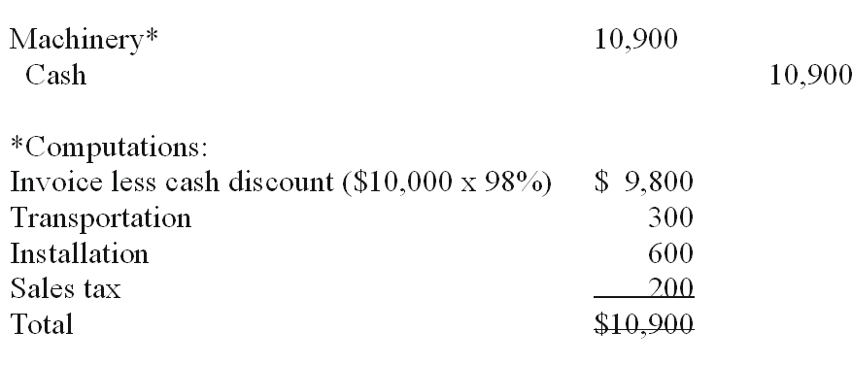

Difficulty: Hard
Learning Objective: 2
Libby - Chapter 09 #136

137. | Rebuild Inc. purchased a plant and the land on which the plant was located for a total of $300,000 cash. The separate market values of the plant and land were not known, so Rebuild hired an independent appraiser who gave the following estimated market values: plant, $220,000; land, $110,000. Complete the entry to record the acquisition (show computation).  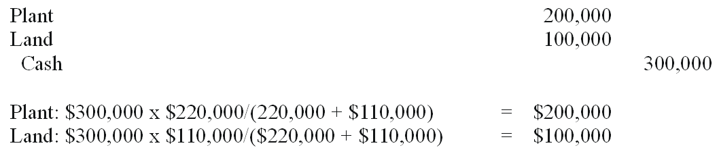

Difficulty: Hard
Learning Objective: 2
Libby - Chapter 09 #137

138. | Raco Inc. purchased two used machines together to get a lower total cash price of $90,000. The machines were different, although of the same general type. They were designated as Machines A and B. New machines of the same type could be purchased for: Machine A, $25,000; Machine B, $75,000. Complete the following entry to record the purchase and show your computations.  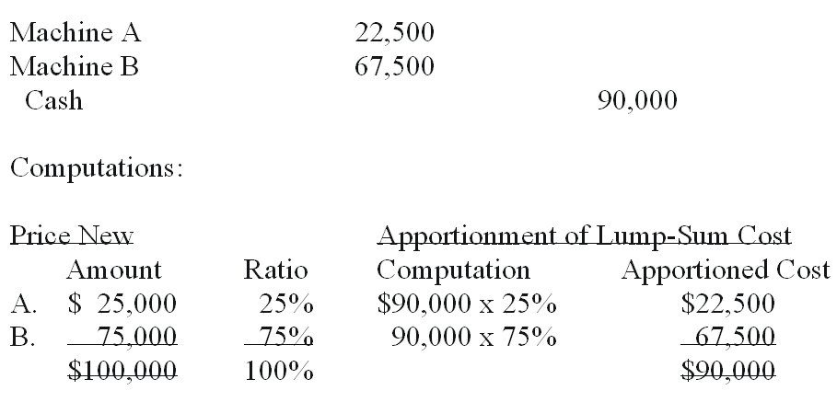

Difficulty: Medium
Learning Objective: 2
Libby - Chapter 09 #138

139. | Yell Company made a lump sum purchase of an office building, including the land and some fixtures, for cash of $160,000. The tax assessments for the past year reflected the following: Land, $22,500; Building, $58,500; and Fixtures, $9,000. Complete the following entry for the acquisition:  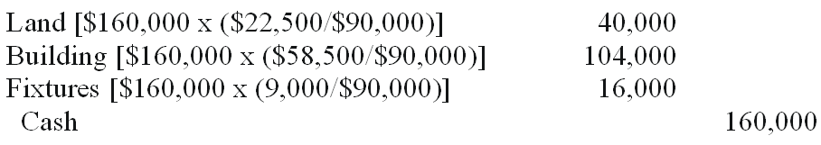

Difficulty: Medium
Learning Objective: 2
Libby - Chapter 09 #139

140. | In 2010, WD Company reported the cost of its theme parks, resorts, and other assets at $14,037 million and the accumulated depreciation at $5,382 million. In that same year, "Toys 4 U" reported $5,610 million in operating assets and accumulated depreciation on them of $1,398 million.  1. Estimate the approximate remaining life of the assets for WD Company and "Toys 4 U"  2. Which company appears to have newer assets with longer remaining lives?  (1) a. 62% ($14,037-$5,382)/$14,037; b. 75% ($5,610-$1,398)/$5,610;  (2) "Toys 4 U" appears to have "newer" assets than WD Company because 75% of their assets' value remains in book value while "Toys 4 U" has 62% in remaining book value.

Difficulty: Medium
Learning Objective: 3
Libby - Chapter 09 #140

141. | Chamber Company purchased a truck on January 1, 20A, at a cash cost of $10,600. The estimated residual value was $400 and the estimated useful life 4 years. The company uses straight-line amortization computed monthly. On July 1, 20D, the company sold the truck for $1,700 cash.  A. What was the amortization expense amount per month?  B. What was the amount of accumulated amortization at July 1, 20D?  C. Give the required journal entries on the date of disposal, July 1, 20D. (Assume no 20D amortization had yet been recorded).  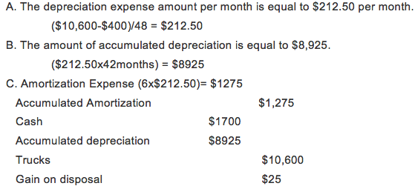

Difficulty: Medium
Learning Objective: 3
Libby - Chapter 09 #141

142. | Sutter Company purchased a machine on January 1, 20A, for $16,000. The machine has an estimated useful life of 5 years and a $1,000 residual value. It is now December 31, 20B, and Sutter is in the process of preparing financial statements. Complete the following schedule assuming declining-balance method of depreciation with a 150% acceleration rate.  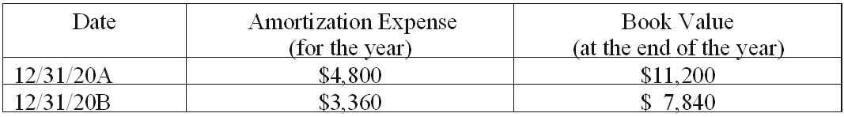

Difficulty: Medium
Learning Objective: 3
Libby - Chapter 09 #142

143. | The financial statements of Betty Company contained the following errors:  Respond to each of the following (disregard income taxes):  A. Income for 20A, was understated or overstated (circle one).  B. Total combined income for the two-year period ended December 31, 20B, was overstated or understated (circle one).  A. Overstated; B. Understated

Difficulty: Easy
Learning Objective: 3
Libby - Chapter 09 #143

144. | On January 1, 20A, Stern Company (a calendar year corporation) purchased a heavy duty machine having an invoice price of $13,000 plus transportation and installation costs of $3,000. The machine is estimated to have a 4-year useful life and a $1,000 residual value. Assuming the company uses the declining-balance method amortization and a 150% acceleration rate, complete the following schedule (round to the nearest dollar).  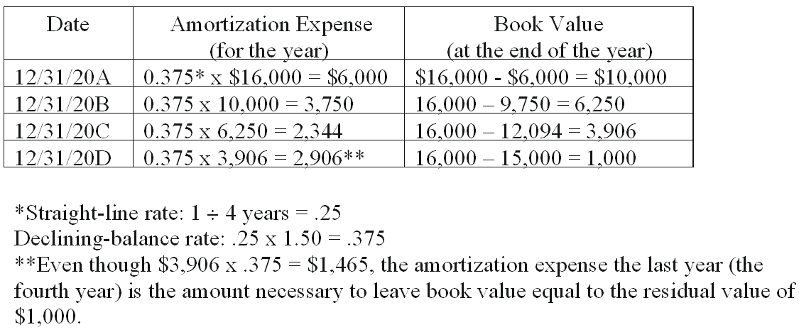

Difficulty: Medium
Learning Objective: 3
Libby - Chapter 09 #144

145. | Tweed Feed & Seed purchased a new machine on January 1, 20A:  Accumulated amortization at the end of year 5 (assume straight-line amortization) $12,000  It is now the beginning of year 6 and the management re-evaluated the estimates related to the machine. Compute the amortization expense for year 6 under each of the following independent cases:  CASE A: (26,000 - 12,000 - 2,000) ÷ (15 years - 5 years) = $1,200 Amortization expense  CASE B: (26,000 - 12,000 - 1,000) ÷ (10 years - 5 years) = $2,600 Amortization expense  CASE C: (26,000 - 12,000 - 3,000) ÷ (7 years - 5 years) = $5,500 Amortization expense

Difficulty: Medium
Learning Objective: 3
Libby - Chapter 09 #145

146. | Duval Company acquired a machine on January 1, 20A, that cost $2,700 and had an estimated residual value of $200. Complete the following schedule using the three methods of amortization: A.) straight-line, B.) units-of-production, C.) declining-balance at 150% acceleration rate.  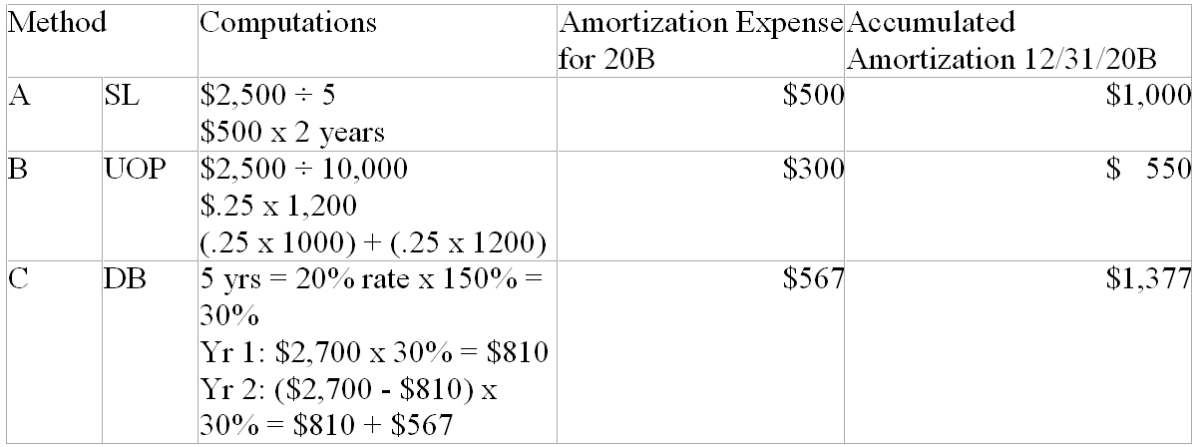

Difficulty: Medium
Learning Objective: 3
Libby - Chapter 09 #146

147. | On January 1, 20B, Walton Corporation made a basket purchase of land, a building, and furniture and fixtures. The total purchase price was $313,000. Walton also paid $3,000 for title fees and $4,000 in legal fees related to the purchase. Appraised values at the time of the purchase were: land $70,000; building, $227,500; and furniture and fixtures, $52,500.  Required:  1. Make the journal entry to record the purchase of the assets, with cost based on appraised values.  2. The building had an estimated useful life of 20 years and residual value of $30,000. Make the journal entry to record amortization for 20B using the declining-balance method and a 150% acceleration rate.  3. The furniture and fixtures are expected to have useful lives of 5 years and no residual value. What is the amount of amortization on the furniture and fixtures for 20B, assuming that Walton uses the straight-line method of amortization for such assets.  4. Based on the information in part 3, what is the book value of the furniture and fixtures at the end of 20B?  5. Under generally accepted accounting principles, would Walton be able to use the declining-balance method for the building and the straight-line method for furniture and fixtures? Discuss briefly.  1.  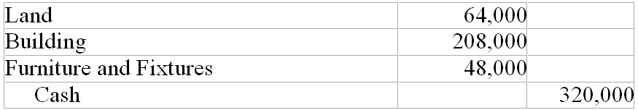  Computations:  Total acquisition costs: $313,000 + $3,000 + $4,000 = $320,000  Total appraised value: $70,000 + $52,500 + $227,500 = $350,000  Land: ($70,000 x $320,000)/$350,000 = $64,000  Building: ($227,500 x $320,000)/$350,000 = $208,000  Furniture and Fixtures: ($52,500 x $320,000)/$350,000 = $48,000  2.  $208,000 x 1/20 x 150% = $15,600  3. $48,000 ÷ 5 years = $9,600  4. $48,000 - $9,600 = $38,400  5. Generally accepted accounting principles allow a company to use different amortization methods for different assets or groups of assets. Walton would be able to use the declining-balance for buildings and straight-line amortization for furniture and fixtures.

Difficulty: Medium
Learning Objective: 3
Libby - Chapter 09 #147

148. | Macon Assembly Company purchased a machine on January 2, 20C, by paying cash of $85,000. The machine has an estimated useful life of five years (or the production of 200,000 units) and an estimated residual value of $5,000.  Required:  1. Determine amortization expense (to the nearest dollar) for each year of the machine's useful life under (a). straight-line amortization; and (b). the declining-balance method with a 200% acceleration rate.  2. What is the book value of the machine after three years with the declining-balance method and a 200% acceleration rate?  3. What is the book value of the machinery after three years with straight-line amortization.  4. If the machine was used to produce and sell 48,000 units in 20C, what would the amortization expense be under the units of production method?  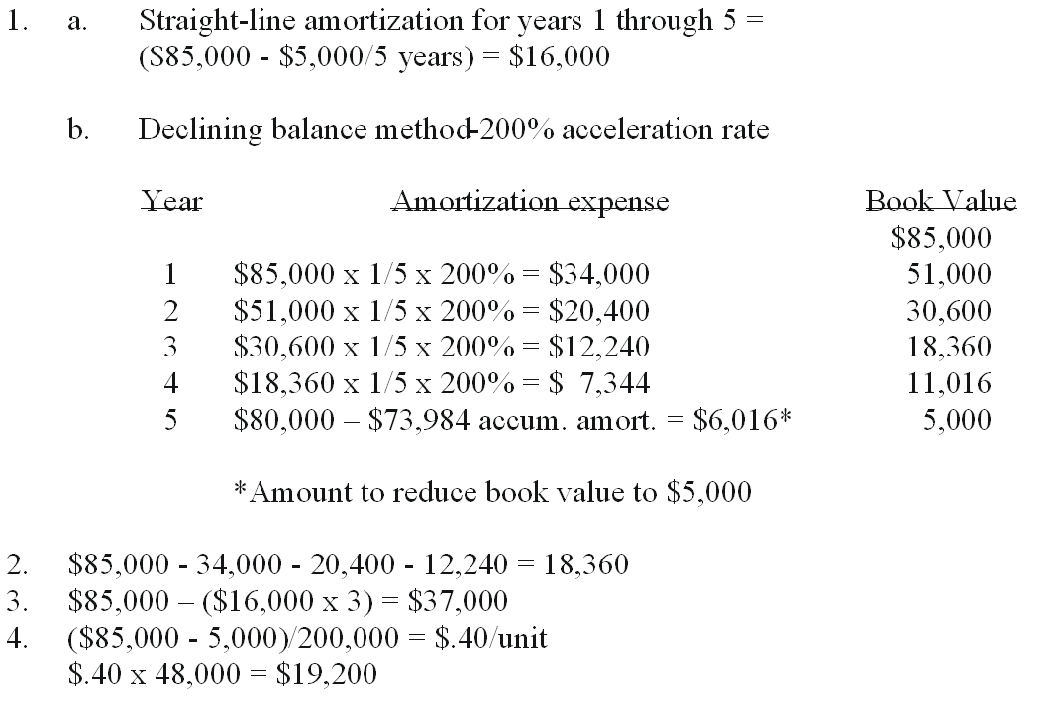

Difficulty: Medium
Learning Objective: 3
Libby - Chapter 09 #148

149. | On September 7, 20B, Belverd Corporation purchased a building and land at a total acquisition cost of $500,000. An appraiser estimated that 80% of the purchase price should be assigned to the building and the remainder to the land.  Required:  1. Make the journal entry for the acquisition of the land and building.  2. Make the journal entry to record amortization of the building for 20B. Belverd takes a full month of amortization for assets acquired in the first half of the month and uses the straight-line method. The building has a residual value of $40,000 and an estimated useful life of 20 years.  3. Based on the information in part 2, what will the book value of the building be at the end of 20C?  4. Why was it important for Belverd to separate the cost of the land and the cost of the building?  1.  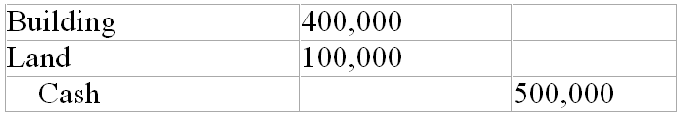  2.  Computation:  ($400,000 - 40,000)/20 years = $18,000/year  $18,000/yr x 4 months/12 months = $6,000  3. Book value = $400,000 - 24,000 accumulated amortization = $376,000  4. Belverd separated the cost of the building and the cost of the land when it made the original entry to record the acquisition because amortization must be recorded for the building and not for the land. Recording the assets in separate accounts simplifies the process of properly recording amortization.

Difficulty: Medium
Learning Objective: 2
Learning Objective: 3
Libby - Chapter 09 #149

150. | Hilman Company purchased a truck on January 1, 20A, at a cost of $34,000. The company estimated that the truck would have a useful life of 4 years and a residual value of $4,000.  Required:  1. Complete the following table:  2. Which of the two methods in part 1 would result in:  a. Lower net income in 20A? ___________  b. Lower net income in 20D? ___________  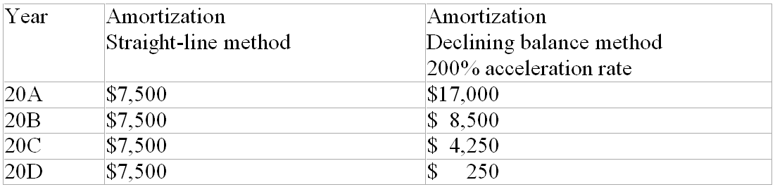  Straight-line: ($34,000 - 4,000)/4 years = $7,500  Declining-balance:  20A 1/4 x 200% x $34,000 = $17,000  20B 1/4 x 200% x ($34,000 - $17,000) = $8,500  20C 1/4 x 200% x ($34,000 - $25,500) = $4,250  20D Book value $4,250 - $4,000 target book value = $250  2. Lower net income: (a) 20A Declining-balance 200% acceleration rate; (b) 20D Straight-line

Difficulty: Medium
Learning Objective: 3
Libby - Chapter 09 #150

151. | FAL Corporation purchased a robot to be used in manufacturing. The purchase was made at the beginning of 20A by paying cash of $500,000. The robot has an estimated residual value of $20,000 and an expected useful life of 10 years. At the beginning of 20C, FAL concluded that the total useful life of the robot will be 8 years rather than 10, and that the residual value will be zero. FAL uses the straight-line method for amortization.  Required:  1. Make the journal entry to record amortization on the robot for 20B.  2. Make the journal entry to record amortization on the robot for 20C, including the effect of the changes in estimates.  3. Describe how a business should account for a change in the estimated useful life and/or residual value of a amortizable asset.  1.  Computations:  ($500,000 - $20,000)/10 years = $48,000/year  2.  Computations:  $500,000 - $48,000 amortization/year x 2 years = $404,000 remaining amortizable value $404,000/6 year remaining useful life = $67,333  3. A change in estimate of residual value or useful life requires the company to calculate a new annual amortization amount. The change in estimates affects the amount of amortization for current and future years. There is no restatement of financial statements for prior years.

Difficulty: Medium
Learning Objective: 3
Libby - Chapter 09 #151

152. | The following information is available for C Co. and P Co.:  (1) Compute the fixed asset turnover ratio for the year for both C Co. and P Co.  a. C Co. __________  b. P Co. __________  (1) a. 5.08 ($18,813/[$3,743 + $3,669]/2); b. 3.29 ($22,348/[$6,261 + $7,318]/2)

Difficulty: Medium
Learning Objective: 1
Libby - Chapter 09 #152

153. | Soule Corporation purchased a machine that had an original cost of $60,000 and an estimated residual value of $10,000. The useful life was expected to be 8 years and straight-line amortization is used. At the end of 20E, the book value of the machine was $35,000. Soule sold the machine for $32,000 cash on October 1, 20F.  Required:  A. Prepare the journal entry to record amortization for 20F up to the date of sale. Round the amount to the nearest dollar.  B. Prepare the journal entry to record the sale of the machine.  Computations:  ($60,000 - 10,000)/8 years = $6,250  $6,250 x 9/12 = $4,688  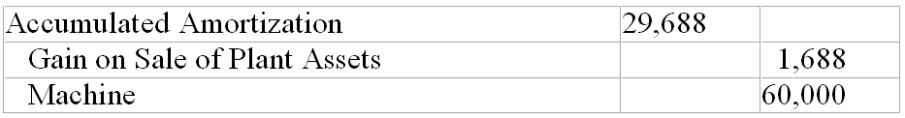

Difficulty: Medium
Learning Objective: 3
Learning Objective: 5
Libby - Chapter 09 #153

154. | Give the required adjusting entry at December 31, 20F, the end of the annual accounting period for the three items below. If no entry is required, explain why.  A. Web Company acquired a patent that cost $4,260 on January 1, 20F. The patent was registered on January 1, 20A. The legal life of a patent is 17 years from registration. Web expects to use the patent the remaining legal life.  B. Web Company acquired a gravel pit on January 1, 20F, that cost $24,000. The company estimates that 30,000 tons of gravel can be extracted economically. During 20F 4,000 tons were extracted and sold.  C. On January 1, 20F, Web Company acquired a dump truck that cost $6,000 to use hauling gravel. The company estimated a residual value of 10% of cost and a useful life 4 years. The company uses straight-line amortization.  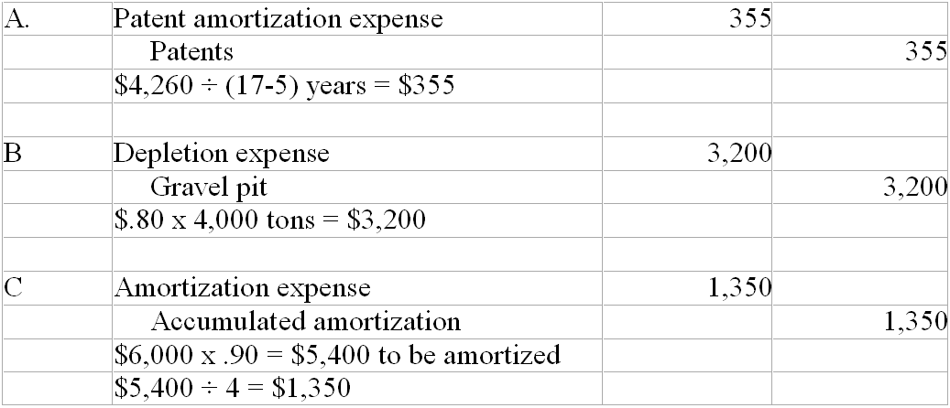

Difficulty: Medium
Learning Objective: 3
Learning Objective: 6
Libby - Chapter 09 #154

155. | Weaver Mining Company purchased a site containing a mineral deposit in 20C. The purchase price was $820,000, and the site is estimated to contain 400,000 tons of extractable ore. Weaver constructed a building at the site, at a cost of $500,000, to be used while the ore is being extracted. When the ore reserves are gone, the building will have no further value.  Required:  1. Explain the purpose for recording depletion on natural resources.  2. Calculate Weaver's amortization rate per ton of ore for this deposit.  3. Make the journal entry to record depletion for the year 20C, when Weaver mined and sold 150,000 tons of ore.  4. Make the journal entry to record amortization on the building for 20C. Weaver calculates amortization on the building using the units of production method based on the amount of ore extracted (150,000 tons in 20C).  1. The purpose of recording depletion is to match the cost of a natural resource with revenues earned from extracting and selling the resource.  2. $820,000/400,000 tons = $2.05/ton  3.  4.

Difficulty: Medium
Learning Objective: 6
Libby - Chapter 09 #155

156. | On January 2, 20D, Daintry Company purchased a patent for $380,000 from an inventor who had developed a new manufacturing process. At the time of the purchase, the patent had a remaining legal life of 12 years, but Daintry estimated the useful life to the company to only be 10 years.  Required:  1. Prepare the journal entry to record Daintry's purchase of the patent.  2. Prepare the journal entry to record amortization of the patent for 20D, assuming that no contra account is used.  3. At the start of 20G, after amortization had been recorded for three years, Daintry concluded that the total useful life of the patent would be 7 years, rather than 10. Record Daintry's amortization expense for 20G.  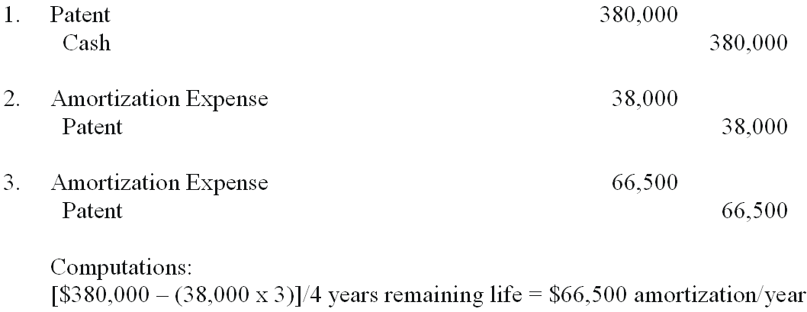

Difficulty: Medium
Learning Objective: 6
Libby - Chapter 09 #156

157. | Pied Piper Pies has been in business 8 years with 4 stores in the San Francisco bay area. Their local reputation for making savoury pies such as curried potatoes is well recognized. A national food distributor has offered to purchase the company. Pied Piper has $1.2 million of assets on their books but those assets have $1.5 million in value at fair market value and $.3 million of liabilities. If the distributor offers to buy Pied Piper for $3.5 million and assume the liabilities of Pied Piper, how much will goodwill be based on the offered purchase price?  $2.3 million ($3.5 million minus {$1.5 million minus $.3 million})

Difficulty: Medium
Learning Objective: 6
Libby - Chapter 09 #157

158. | A company purchased equipment for $800,000 and has depreciated it for the past 5 years when its original life was estimated to be 10 years with a $200,000 residual value. The equipment's utility to the company has declined because they expect it to generate a net cash flow over the remaining years of $200,000 from its operation. If the asset has been impaired, how much will be recorded as a loss in the current year?  $300,000 (Remaining book value $500,000 minus $200,000 expected cash flow)

Difficulty: Medium
Learning Objective: 4
Libby - Chapter 09 #158

159. | Match the assets with the cost allocation method by entering the appropriate letter.
  1. None | Uranium reserves (being exploited) | 2
  2. Depletion | Building, Tex-Mex Chile Franchise (in use) | 3
  3. Amortization | Long-term investment in shares of Swift Tea, Inc. | 1

Difficulty: Easy
Learning Objective: 3
Learning Objective: 6
Libby - Chapter 09 #159

160. | Match each type of asset category with the appropriate allocation method.
  1. Depletion | Intangible assets, Property, plant, and equipment | 2
  2. Amortization | Natural resources | 1

Difficulty: Easy
Learning Objective: 3
Learning Objective: 6
Libby - Chapter 09 #160

161. | Write the letter of the definition in the blank before the term.
  1. leasehold | Cost minus accumulated amortization of a tangible operational asset. | 7
  2. property, plant and equipment | Expenditure for an asset that is debited to an asset account. | 6
  3. patent | An exclusive right to make a product or use a particular process. | 3
  4. residual value | An asset that confers rights upon the owner and that lacks physical substance. | 11
  5. units-of-production amortization | Causes the amortization expense for an asset to decrease with passage of time. | 12
  6. capital expenditure | Estimated amount to be recovered at the end of the useful life of an operational asset. | 4
  7. book value | An ordinary repair, for example. | 10
  8. amortization | Rights granted to a lessee under the terms of a contract. | 1
  9. depletion | A heading used on the balance sheet for tangible operating assets. | 2
  10. revenue expenditure | Allocation of the cost of a natural resource to the periods in which revenues are earned. | 9
  11. intangible asset | Allocation of the cost of an intangible asset to the periods when it is used. | 8
  12. declining-balance amortization | Causes the amortization expense for an asset to vary with the use of the asset. | 5

Difficulty: Medium
Learning Objective: 1
Libby - Chapter 09 #161

Chapter 09 Reporting and Interpreting Property, Plant, and Equipment; Natural Resources; and Intangibles Summary
Category | # of Questions
Difficulty: Easy | 36
Difficulty: Hard | 17
Difficulty: Medium | 108
Learning Objective: 1 | 24
Learning Objective: 2 | 41
Learning Objective: 3 | 72
Learning Objective: 4 | 2
Learning Objective: 5 | 6
Learning Objective: 6 | 20
Learning Objective: 7 | 5
Learning Objective: Sup A | 1
Libby - Chapter 09 | 161

