Terms:
Law of Conservation of Mass: A law which states that "mass is neither created nor destroyed in chemical reactions". This essentially means that the same number of atoms of each type occurring on the reactant side must also appear on the product side.
Integer: whole number (no fractions)
Uncertainty: A characteristic of every measurement, indicating the error in a reported value. This is generally specified using significant figures.
Significant figures: A method for reporting the results of a measurement that includes all known or certain digits and a final digit that is considered uncertain.
SI unit: The International System of units that is based on the metric system and uses SI derived units for length, mass, time, etc. and prefixes to indicate magnitude (i.e., powers of 10).
Density: The physical property of a substance that corresponds to the ratio of its mass to volume. This property does not depend on the amount of substance.
Dimensional analysis: A method for solving numerical problems that uses 'conversion factors' to cancel out unwanted units and results in an answer with the desired units (i.e., dimensions).

Steps of the scientific method (when performing a study):
1. Perform experiments: procedures performed under controlled conditions to propose or test a hypothesis
2. Making observations: qualitative (no numbers – flower is purple) and quantitative (measurement)
3. Propose hypothesis (tentative explanation/assumption of phenomena)
4. Confirm hypothesis with repeated tests (no inconsistencies b/w hypothesis and experimental observations). If any inconsistencies steps 1-4 must be repeated.
5. Propose a scientific law (from repeated experiments and modification of hypotheses to account for observations from the experiments.
Explain how these steps are used to propose a Scientific Law.
Expression of numerical values: Certain rules apply to the expression of the numerical value and the system of units used in scientific measurements.
Including: scientific notation: number is expressed as N x 10 +-n Solve diverse calculations using dimensional analysis and use scientific notation.
Example of SN: if the number is 598.46, N would be 5.9846 and n would be 2, so the Sn would be
5.9846 x ${10}^{2}$ (N only contains one non-zero digit to the left of the decimal and n is an integer. ${10}^{0}$ = 1
10^-3 = 0.001 --- 10¹ = 10 (1 decimal point move forward)
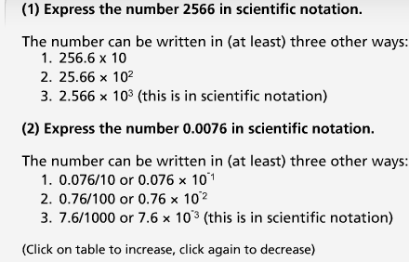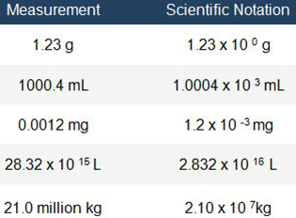

Significant figures:
All numbers have uncertainty due to experimental error thus the last digit of a measurement is uncertain. Significant figures include all certain and one uncertain digit. Significant figures are used to indicate precision of measurements, but does not apply to counted exact numbers (5 cars) and defined conversions (1 inch = 2.54cm) since these have an infinite number of significant figures.
Rule 1: all non-zero digits are significant figures
Rule 2: counting begins from the left with the first non-zero number – 0.78920120
Rule 3: zeros between non-zero digits are counted as SFs
Rule 4: terminal zeros (zeros to the right/end) are always significant if the value contains a decimal point. Sometimes the decimal makes 0’s significant but usually SN is used.
ex. 3.00 x 10*3 has 3 significant figures, not 1.z
Apply significant figures and SI units correctly.
Significant figures in chemical calculations (rules) – all depends on the function performed.
Rule 1: calculations have same number of decimals as the number with the least (4.87g + 4.2g + 8.983g = 15.2g).
Rule 2: division and multiplication calculations uses least number of significant figures of numbers used. (ex. 4.87 has 3, 8.381 has 4, multiplied is 26.7 which has 3). Or 3.52g/1.291g = 1.51g
Rule 3: the number of SF is dictated by the measured quantity involved. Constants have no effect on # of SF.
(ex. If mass of steel ball is 2.32g (measured) x 8 balls – the total mass is 2.32 x 8 = 18.6g
(ex 2. How many centimeters in 31.10 inches – 1in is 2.54cm so 2.54 x 31.10 = 78.99cm in 31.10 inches.
(ex 3. Formula c= a x b – calculate value of b when a is 22.65cm (measured) and c is 1.2cm/s (constant) just substitute values for the numbers – no need to solve).
If a measurement is equal to a last digit of 5. 17.65 is rounded down to 17.6 since 6 is an even number and 17.75 is rounded up to 17.8 since 7 is an odd number (when using chemical measurements like mL).
Number of significant figures for 135.200 = 6, 0.001524 = 4, 3 x 10^-3 = 3 SF’s.
SI (system of units in metric system) such as volume (cubic meter such as L or mL –
1L = 1dm^3 = 10^-3m^3), length(SI unit is m), mass (kg), density (kg per cubic meter(m^3) = k/mL or L – Density = mass/ volume – larger or smaller units than the base unit can be obtained using prefixes like kilo, centi, milli), temperature and time.
- µ symbol for micro (1mL = 10^3µL
- area = m^2 (d x d = m x m – d is length)
- volume = m^3 (d x d x d)
Density:
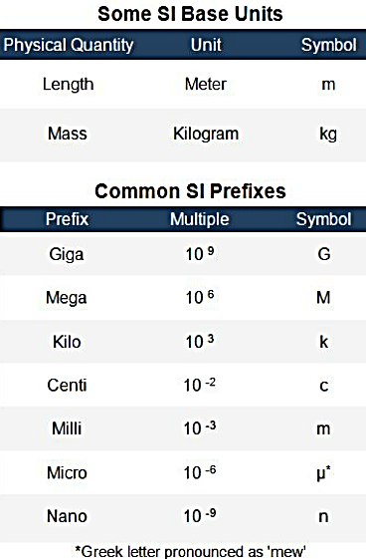
Dimensional analysis: solving using numbers and units and involves conversion. Identical units are multiplied or cancelled out. Example: 1.0cm x 2.1cm = 2.1cm^2
Step 1: convert mass from grams to milligrams – 1.0g = 10^3mg
convert volume from liters to microliters – 1.0L = 10^6 µL
Step 2: state relationship as fractions (aka conversion factor)
Answers always round up or down when any number in equation has only one decimal point 2.3 + 2.53…
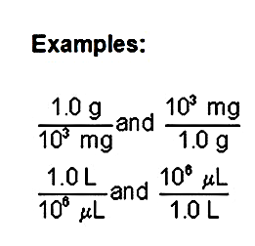
Step 3: conversion factor cancels unwanted units
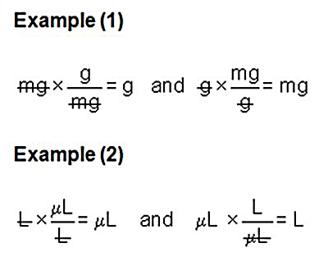 1) convert mg to g 2) convert mL to L
we must multiply the measured quantity by the conversion factor to conver mg to grams (just remove the numbers for now)
Example: how many canadian dollars need to buy thing costing 250 rupees. 31 rupees = 1 dollar
250 rupees x 1$/ 31 rupees = 8.12$
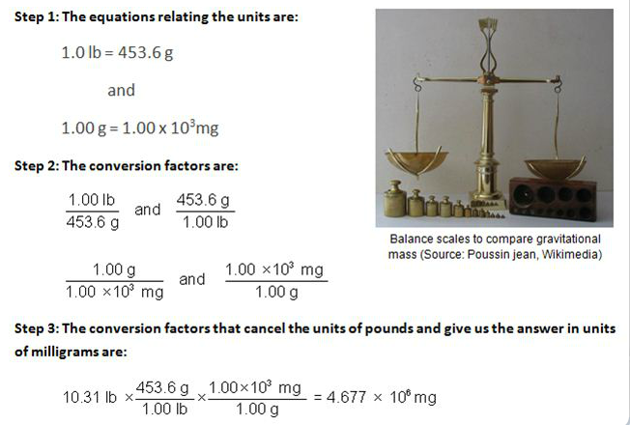
MATTER
Definitions:
Matter: Anything that possesses mass, occupies space, and is perceivable by our senses. It is generally classified in terms of a physical state and a chemical composition
Mixture: A non-pure substance made of two or more elements or compounds that can be separated by physical, as opposed to chemical, procedures. For example, a mixture of sodium chloride salt (an ionic compound) and water (a covalent compound) can be separated by removing the water through evaporation, leaving behind solid sodium chloride.
Elements: A substance composed of only one type of atom. Elements typically classified as being metal, nonmetal or semi-metal (metalloid).
Compound: A substance composed of more than one atom. The elements are bound to one another in fixed numbers and can be broken down only through chemical reaction. The properties of a compound differ from those of the individual elements.
Atoms: The smallest unit of any element. It is composed of a positively charged nucleus, containing protons and neutrons, surrounded by a cloud of negatively charged electrons. The number of protons and electrons are identical, resulting in an overall neutral charge.
Electrons: A negatively charged sub-atomic particle (i.e., a particle that is smaller than an atom) that is found outside of the nucleus. The sharing or exchange of electrons between two different atom types is responsible for the formation of compounds.
Protons: A positively charged sub-atomic particle (i.e., a particle that is smaller than an atom) found in the nucleus of an atom.
Neutrons: An uncharged sub-atomic particle (i.e., a particle that is smaller than an atom) found in the nucleus of an atom.
Nucleus: It is the center of an atom where the protons and neutrons are located and which the electron(s) surround.
Atomic number: A number that is unique to each type of atom and indicates the number of protons in the nucleus of each individual atom.
Mass number: Equal to the sum of the number of protons and neutrons in the nucleus of an atom.
Molecule: A discrete unit consisting of two or more atoms of the same or different elements bound together. Molecules are a combination of atoms in a definite proportion e.g., molecule of water (H2O; hydrogen:oxygen = 2:1).
Ions: An atom or molecule that has gained or lost electrons and is thus charged. Simply, ions are charged species formed by loss or gain of electron(s) from an atom. Cations are positively charged (i.e., having lost electrons) while anions are negatively charged (i.e., having gained electrons).
Cation: An atom or molecule that has lost one or more electrons and thus possesses a positive charge. Such species are generated by the removal of electrons and are typically metals.
Cation generation: M (g) -> M^+(g) + e- (loss of e^-) [M = metal; g = gaseous state]
[where M⁺, a positively charged ion is the cation]
Anion: An atom or molecule that has gained one or more electrons and thus possesses a negative charge. Such species are generated by the capture of electrons and are typically non-metals.
Anion generation: X (g) + e⁻ X⁻ (g) (gain of e⁻) [X = nonmetal]
[where X⁻, a negatively charged ion is the anion]
Ex: NaC(table salt) a compound, consists of Na⁺(cation) & C⁻ (anion) ions.
-------
Matter (atoms, ions and molecules).. (physical state of air, water, gas, solid or chemical composition of its element (copper), compound (sugar), or mixture (antifreeze))
Elements are composed of one type of element (either metal, non-metal or metalloid (semi-metal)
Compounds: combination of elements in definite proportion, atoms are chemically combined. A chemical change can break down a compound to its individual elements.
Mixture: non-pure substance made of 2 or more elements or compounds that can be separated by physical instead of chemical procedures.
Atoms:
the nucleus contains the neutrons and protons. The electrons surround the nucleus and are equal to the number of protons in a neutral atom.
Protons have a positive charge (p^+), electrons have negative charge and neutrons have no charge (n^o)
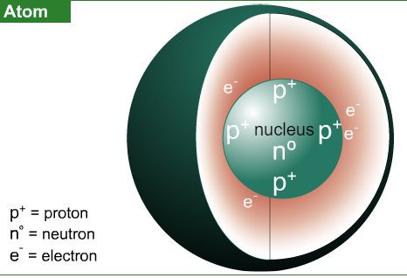 p⁺ is the symbol for proton

Atomic & Mass Numbers:
The atomic number of an element (Z) is equal to the number of protons in the nucleus of its atoms (p^+). Each element has a different atomic number.
The mass number (A) is equal to the number of protons and neutrons in the atom. To calculate the number of neutrons, subtract the atomic number from the mass number:
Number of neutrons = A - Z
Every element has an atomic symbol (X). Both the atomic and mass numbers are included with the atomic symbol.
Exercise 1: A neutral atom contains 6 electrons and has a mass number of 12. The number of neutrons in the atom is 6 (6+6 = 12)
Neutral atoms have equal number of protons and electrons (1:1 ratio)
MODULE TEST
1) A volume of 12.6 mL is also equal to: 1.26 × 10^-2 L
2) atomic number of an element doesn’t equal its mass number
3) If the density of a liquid is 1.92 g/mL, what is the mass of 6.49 × 10³ μL of this liquid? 1.25 x 10 g
1.92 x 0.649 ( 0.00649L = 6.49 ml)- turn to mass (g) – turn 12.49 to 1.25 (3 SF) x 10g
4) If 9.20 mL of a liquid has a mass of 15.6 g, what is its density? 1.70 x 10⁰ g/mL = 1.7 x 1
5) The speed of light is 3.00 × 1010 cm/s. How far will a beam of light travel in 3.00 ns? 9.00 × 10^-1 m
6) The volume of a sphere [given by the relationship: 4.19 × (radius)³] of diameter 2.51 cm is:
8.28 × 100 cm³ ---- 2.51/2 (radius is half of diameter) x 4.19 =
7) How many micrograms are there in 2.0 mg? 2.0 × 10³ μg
8) How many liters are there in 12.0 μL? 1.20 × 10^-5 L

