Final Exam Review

2 hours
chap 2-7: 4 questions/chapter 24 questions
chap 8-14: 8 questions/ chapter 56 questions
80 questions

MID-TERM

Chapter 1

OB: is the field of study devoted to understanding explaining and ultimately improving the attitudes and behaviours of individuals and groups in organizations.

The role of management theory

Classical Approaches: Scientific management, bureaucracy

HR Approach: Psychological attributes of individual workers and the social forces within work, groups have important effects on OB.

Does OB matter?
- OB practices were associated with better firm performance
- Firms that value OB had a 19% higher survival rate
- Good people comprise a valuable resource
- There is no “magic bullet” OB practice

INTEGRATIVE MODEL of OB

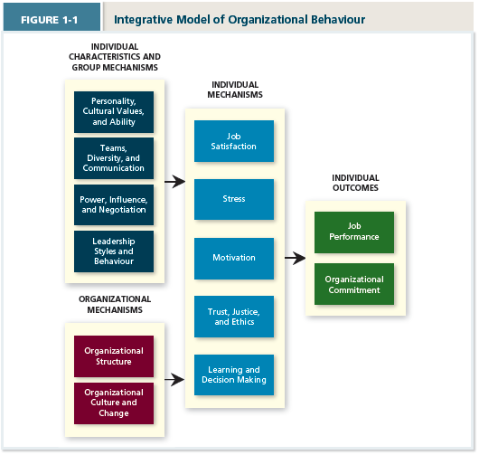

Individual outcomes:

The rightmost position of the model contains the two primary outcomes of interest to organizational behaviour researchers (and employees and managers in organizations):

Employees Two primary goals for working lives:
- perform job well: Job performance
- remain members of an organization that they respect: Organizational Commitment

Managers two primary goals for their employees:
- Maximize their job performance
- Retain these employees for a significant length of time.

Individual Mechanisms

Individual mechanisms that directly affect job performance and organizational commitment.

Job satisfaction: Captures what employees feel when thinking about their job and doing they day-to-day work.

Stress: which reflects employees; physical responses to job demands that tax or exceed their capacities.

Motivation: captures the energetic forces that drive employees work effort.

Trust, Justice, and Ethics: Reflect the degree to which employees’ feel their company conducts business with fairness, honesty, and integrity.

Learning and decision making: which deal with how employees gain job knowledge and how they use that knowledge to make accurate judgements on the job.

CHAPTER 2

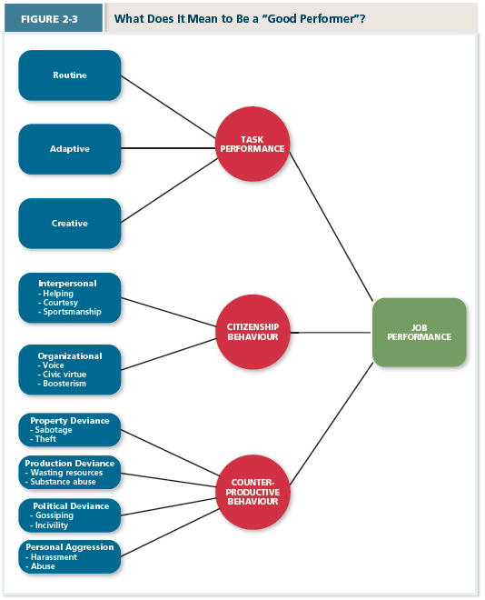

Task Performance:
Employee behaviours that are directly involved in transformation of organizational resources into the goods or services that the organization produces.
- Set of explicit obligations that an employee must fulfill to receive compensation and continue employment.
Routine task performance: Well-known or habitual responses by employees to predictable task demands. (flight attendant demonstration of seatbelt)

Adaptive Task performance: Thoughtful responses by an employee to unique or unusual task demands. Adaptability. Flight attendant during accident)

Creative task performance: Ideals or physical outcomes that are both novel and useful. Enable organizations to stay ahead of their competition.

Citizenship Behaviour:
Voluntary employee behaviour that contribute to organizational goals by improving the context in which work takes place.

Interpersonal Citizenship Behaviour: Going beyond normal job expectations to assist, support, and develop co-worker and colleagues.
- Helping
- Courtesy
- Sportsmanship

Organizational Citizenship Behaviour: Going beyond normal expectations to improve operations of the organization, as well as defending the organization and being loyal to it.
- Voice: speaking up to offer constructive suggestions for change, often in reaction to a negative work event.
- Civic Virtue: participation in a company at a deeper-than-normal level through voluntary meetings, readings, and keeping up with news that affects the company.
- Boosterism: positive representing the organization when in public

Counterproductive Behaviour:
Employee behaviour that intentionally hinders organizational goal accomplishment.

Property Deviance: Behaviours that harm the organization’s assets and possessions.
- Sabotage
- Theft
Production Deviance: Intentionally reducing organizational efficiency of work output.
- Wasting resources
- Substance abuse
Political Deviance: Behaviours that intentionally disadvantages other individuals.
- Gossiping
- Incivility: communication that is rude, impolite…
Personal Aggression: Hostile verbal and physical actions directed toward other employees.
- Harassment
- Abuse

CHAPTER 3

Drivers of Overall Organization Commitment:

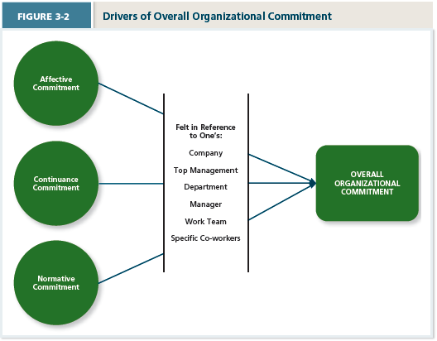

Overall Organizational Commitment:

Three forms of organizational commitment:

Affective Commitment: An employee’s desire to remain a member of an organization due to a feeling of emotional attachment.
- Staying because you want to
- Friends in my office
- Like atmosphere, it’s fun and relaxing
- Job duties are rewarding
Continuance Commitment: An employee’s desire to remain a member of an organization due to an awareness of the cost of leaving.
- Staying because you have to
- Due for a promotion
- Good benefits and salary, good for family
- Good area, school system put down roots where we are
Normative commitment: An employee’s desire to remain a member of an organization due to a feeling of obligation.
- Stay because you ought to.
- Boss has invested do much in me
- They took a chance in me
- Helped me out of a jam on a number of occasions

Embeddedness and Continuance Commitment:

Embeddedness: An employee’s connection to and sense of fit in the organization and community.
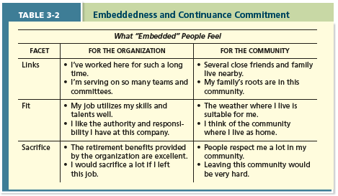
Withdrawal Behaviour:

Psychological Withdrawal:
Mentally escaping the work environment.
- Daydreaming
- Looking busy
- Cyber loafing
- Moonlighting
- Socializing
NEGLECT
A passive destructive response to a negative work event in which one’s interest and effort in work decline.

Physical Withdrawal:
A physical escape from the work environment.
- Tardiness
- Missing meetings
- Quitting
- Long Breaks
- Absenteeism
EXIT
A response to a negative work event in which one becomes often absent from work or voluntarily leaves the organization.

Exit – Active, destructive response- ends or restricts organizational membership.

Voice –Active, constructive response- attempts to improve the situation.

Loyalty –Passive, constructive response- “grin and bear it”

Neglect –Passive destructive response- interest and effort in the job declines.

EXIT  ACTIVE  DESTRUCTIVE | NEGLECT  PASSIVE  DESTRUCTIVE
VOICE  ACTIVE  CONSTRUCTIVE | LOYALTY  PASSIVE  CONSTRUCTIVE

CHAPTER 4:
Job Satisfaction

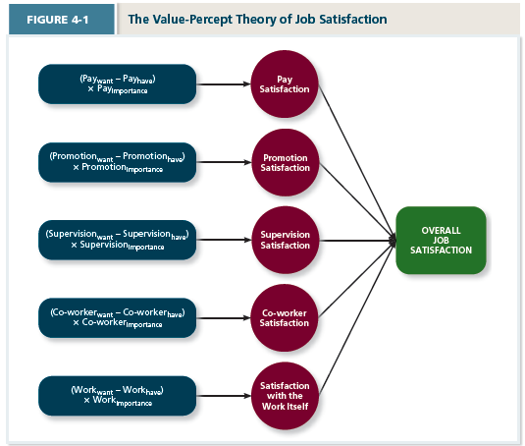
Value-Percept Theory
A theory that argues that job satisfaction depends on whether the employee perceives that his or her job supplies those things that he or she values.

Pay satisfaction: Employees’ feeling about the compensation for their jobs
- How our pay compares to others?

Promotion satisfaction: Employees’ feeling about how the company handles promotions.
- Are frequent, fair, and based on ability.

Supervision Satisfaction: Employees’ feeling about their boss, including his or her competency, communication, an personality.

Co-worker satisfaction: Employees’ feeling about their co-workers, including their abilities and personalities.
- Are co-workers smart, responsible, helpful, fun, and interesting

Satisfaction with the work itself: Employees’ feeling about their actual work tasks.
- Tasks are challenging, interesting, respected, and make use of key skills rather than being dull, repetitive, and uncomfortable.

Job characteristics Theory:

Meaningfulness of work:
A psychological state indicating the degree to which work tasks are viewed ad something that counts in the employee’s system of philosophies and beliefs.
- Variety: The degree to which a job requires different activities and skills.
- Identity: The degree to which a job offers completion of a whole identifiable piece of work.
- Significance: the degree to which a job really matters and impacts society as a whole.

Responsibility for Outcomes:
A psychological state indicating the degree to which employees feel they are key drivers of the quality of work doing.
- Autonomy: The degree to which a job allows individual freedom and discretion regarding how the work is to be done.

Knowledge of Results: A psychological state indicating the extent to which employees are aware of how or how poorly they are doing.
- Feedback: in job characteristics theory, the degree to which the job itself provides information about how well the job holder is doing.

Knowledge and skill: The degree to which employees have the aptitude and competence needed to succeed on their job.
Growth need strength: The degree to which employees desire to develop themselves further.
CHAPTER 5
STRESS

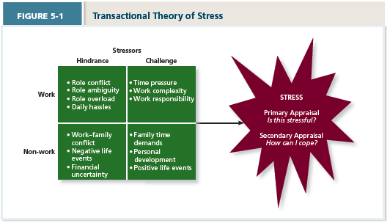

Transactional Theory of Stress

A theory that explains how stressful demands are perceived and appraised, as well as how people respond to the perceptions of appraisals.

WORK Stressors:

Hindrance: Stressors that tend to be appraised as thwarting progress towards growth and achievement.

- Role conflict: Others’ having differing expectations of what an individual needs to do in a role.
- Role ambiguity: A lack of direction and information about what needs to be done in a role.
- Role overload: An excess of demands on an employee preventing him or her from working effectively.
- Daily Hassles: Minor day-to-day demands that interfere with work accomplishment.

Challenge Stressors: Stressors that tend to be appraised as opportunities for growth and achievement.

- Time pressure: the sense that the amount of time allotted to do a job is not quite enough.
- Work Complexity: The degree to which job requirements tax or just exceed employee capabilities.
- Work responsibility: The number and importance of the obligations that an employee has to others.

NON- WORK Stressors:

Hindrance:

- Work-family conflict: A form of role conflict in which the demands of a work role hinder the fulfillment of the demands in a family role (or vice versa)
- Negative life events: Events such as a divorce or death of a family member that tend to be appraised as hindrance.
- Financial Uncertainty: Uncertainties with regard to potential for loss of livelihood, savings, or the ability to pay expenses.

Challenges:

- Family time demands: The amount of time committed to fulfilling family responsibilities.
- Personal development: Participation in activities outside of work that foster growth and learning.
- Positive Life Events: Events such as marriage or the birth of a child that tend to be appraised as a challenge.

COPING Strategies:

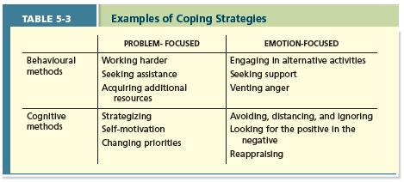

Behavioural Coping: physical activities used to deal with a stressful situation.

Cognitive Coping: Thoughts used to deal with a stressful situation.

Problem-focused coping: Behaviours and cognitions of an individual intended to manage the stressful situation itself.

Emotion-focused coping: Behaviours and cognitions of an individual intended to help manage emotional reactions to the stressful demands.

Examples of strain:

Physiological strain: Reactions from stressors that harm the human body.

Psychological Strain: negative psychological reactions from stressors such as depression, anxiety, and anger.
- Burnout: the emotional. Mental and physical exhaustion from copping with stressful demands on a continuing basis.

Behavioural Strains: patterns of negative behaviours that are associated with other strains.

CHAPTER 6: Motivation

A set of energetic forces that determine that direction, intensity, and persistence of an employee’s work effort.

Expectancy: the belief that exerting a high level of effort will result in successful performance on some task.

Instrumentality: The belief that successful performance will result on some outcome or outcomes.

Valence: The anticipated value of the outcomes associated with successful performance.

Goal setting theory: A theory that views goals as the primary drivers of the intensity and persistence of effort.
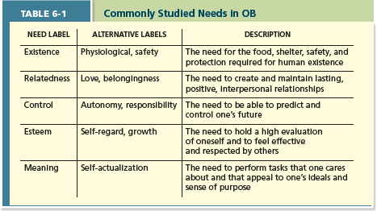

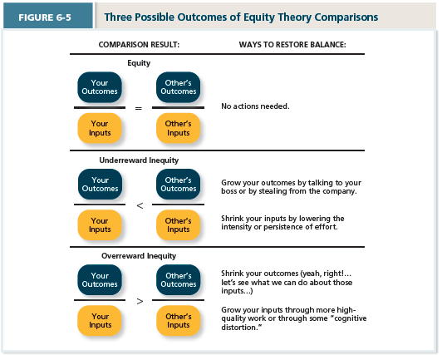

CHAPTER 7: Trust, Justice, and Ethics

Trust: the willingness to be vulnerable to an authority based on positive expectations about the authority’s actions and intentions.

Justice: The perceived fairness of an authority’s decision making.

Ethics: The degree to which the behaviours of an authority are on accordance with generally accepted moral norms.

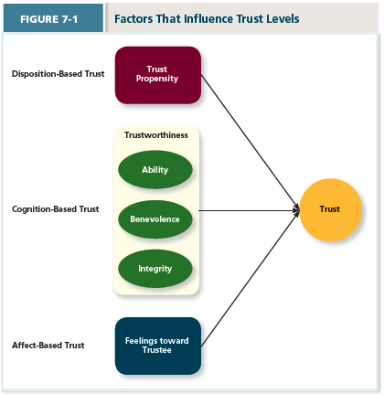

Factors that influence trust levels

- Disposition-Based Trust:
Trust that is rooted in one’s own personality, as opposed to a careful assessment of the trustee’s trustworthiness. When we don’t have data about a particular authority.

Trust propensity: A general expectation that the words, promises, and statements of individuals can be relied upon. Product of both nature and nurture. Are you a trusting person or not?

- Cognition-Based Trust:
Trust that is rooted in a rational assessment of the authority’s trustworthiness.
Is driven by the authority’s “track record”.

Trustworthiness: Characteristics or attributes of a person that inspire trust, including competence, character, and development.

We gauge the track record of an authority along three dimensions:

Ability: The skills. Competencies, and areas of expertise that enable an authority ro be successful in some specific area.

Benevolence: The belief that an authority wants to do good for a trustor, apart from any selfish or profit-centred motives.

Integrity: The perception that an authority adheres to a set of values and principles that the trustor finds acceptable.

- Affect Based trust:
Trust that depends on feelings towards the authority that go beyond any rational assessment of trustworthiness. More emotional then rational, feelings for the person in question. We trust them because we like them.

Four Dimensions of Justice:
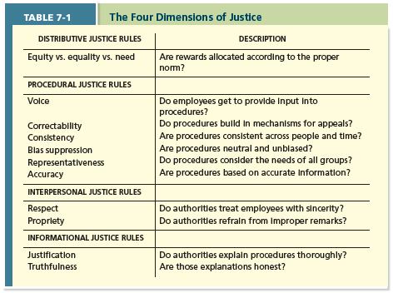
Distributive Justice:
The perceived fairness of decision-making outcomes.

Procedural Justice:
The perceived fairness of decision-making processes.

Interpersonal Justice:
The perceived fairness of the interpersonal treatment received by employees from authorities.

Informational Justice:
The perceived fairness of the communications provided to employees from authorities.

Post mid term

Chap 8:
methods of learning (p 202-208) Schedules of reinforcement (paycheck = fixed interval method)

Reinforcement: used to increase desired behaviours
Contingencies of reinforcement: four specific consequences used by organizations to modify employee behaviour
- Positive reinforcement: a positive outcome follows a desired behaviour
- Negative reinforcement: an unwanted outcome is removed following desired behaviour
- Punishment: an unwanted outcome follows and unwanted behaviour
- Extinction: the removal of a positive consequence following an unwanted behaviour

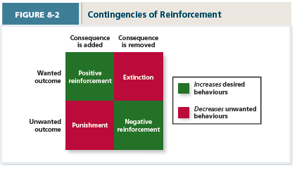

Schedules of reinforcement: The timing of when contingencies are applied or removed
- Continuous reinforcement: A schedule of reinforcement in which a specific consequence follows each and every occurrence of a certain behaviour.
- Fixed-interval Schedule: A schedule whereby reinforcement occurs at fixed time periods.
- Variable-interval schedule: A schedule whereby reinforcement occurs at random periods of time.
- Fixed-ratio schedule: A schedule whereby reinforcement occurs following a fixed number of desired behaviours.
- Variable- ratio schedule: A schedule whereby behaviours are reinforced after a varying number of them have been exhibited.

Continuous = praise
Fixed Interval = Paycheque
Variable Interval = Supervisor Walk-by
Fixed Ratio = Piece-Rate Pay
Variable Ratio = Commission Pay

Observation
- Social learning theory: Theory that argues that people in organizations learn by observing others.
- Behaviour modelling: when employees observe the actions of others, learn from what they observe, and then repeat the observed behaviour.
Goal orientation:
- Learning orientation: A predisposition or attitude according to which building competence is deemed more important by an employee than demonstrating competence.
- Performance-prove orientation: A predisposition or attitude by which employees focus on demonstrating their competence so that others think favourably of them
- Performance-avoid orientation: A predisposition or attitude by which employees focus on demonstrating their competence so that others will not think poorly of them.

Decision making problems (p211-216)

Limited information
- Bounded rationality: the notion that people do not have the ability or resources to process all available information and alternatives when making decisions.

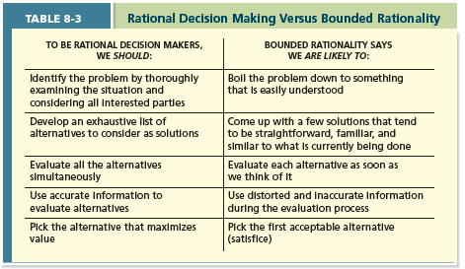

Other decision making errors (slides)

Chap 9:
Big 5 (p229-236) canoe

- Conscientiousness: dimension of personality-reflecting traits like being dependable, organized, reliable, ambitious, hard-working and persevering.
- Agreeableness: dimension of personality-reflecting traits like being kind, cooperative, sympathetic, helpful, courteous and warm.
- Neuroticism: Dimension of personality-reflecting traits like being nervous, moody, emotional, insecure, jealous, and unstable.
- Openness to experience: dimension of personality-reflecting traits like being curious, imaginative, creative, complex, refined, and sophisticated.
- Extraversion: Dimension of personality-reflecting traits of being talkative, sociable, bold, and dominant.

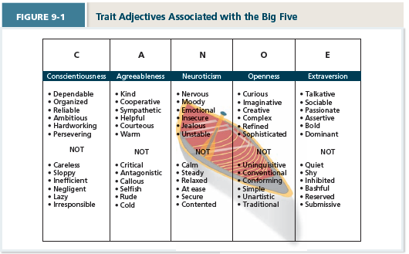

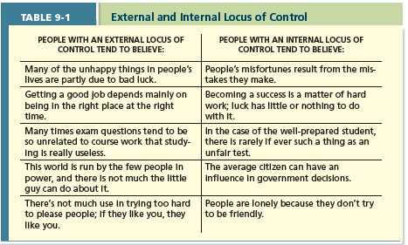

Cultural values (p237-240) what dimensions mean
Culture: the shared values, beliefs, motives, identities, and interpretations that result from common experiences of members of a society and are transmitted across generations.

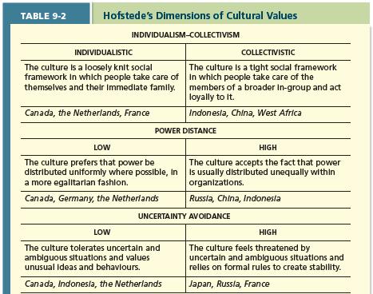
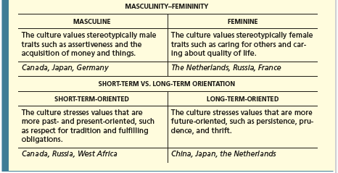

Emotional ability (p246-249)
Emotional intelligence: A set of abilities related to the understanding and use of emotions that affect social functioning.
Self-awareness: the ability to recognize and understand the emotions in oneself.
Other awareness: the ability to recognize and understand the emotions that other people are feeling.
Emotion regulation: the ability to recover quickly from emotional experiences.
Use of emotions: the degree to which people can harness emotions and employ then to improve their chances of being successful in whatever they are seeking to do.

Chap 10:
models of team development (p269-…)
- Forming: try to understand what id expected
- Storming: conflict arises that affect some relationships and harms the team’s progress.
- Norming: need to work together to accomplish team goals.
- Performing: makes progress towards goals.
- Adjourning: members separate from the team.
Punctuated Equilibrium
Midpoint: aha moment, we have to start working and get it done
Big mistake managers can male is giving more time to work on it.
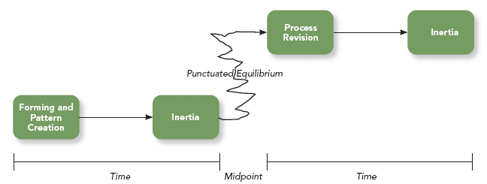

Team composition (p273-277)
- The mix of the various characteristics that describe the individuals who work in the team.
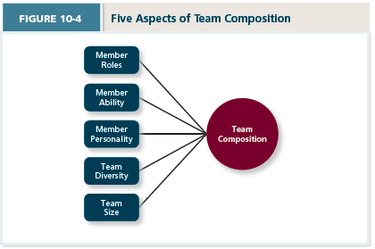
Member role: A pattern of behaviours a person is generally expected to display in a given context.
Team task roles: refers to behaviours that directly facilitate the accomplishment of team tasks.
- Orienteer: Establishes the direction for the team. (important in teams that have autonomy over how to accomplish their work)
- The devil’s advocate: offers constructive challenges to the team’s status quo. (important in team contexts in which decisions are “high stakes: in nature)
- Energizer: motivates team members to work harder towards team goals. (important in team contexts in which that work is important, but not intrinsically motivating)
Team building roles: behaviours that influence that quality of the team’s social climate.
- Harmonizer: steps in to resolve differences among teammates.
- Encourager: praises the work of teammates.
- Compromiser: helps the team see alternative solutions that teammates can accept.
Individualistic roles: reflect behaviours that benefit the individual as the expense of the team. (fosters negative feelings among team members, hinder a team’s ability to function effectively)
- Aggressors: “puts down” or deflates fellow teammates.
- Recognition seeker: takes credit for the team successes.
- Dominator: manipulates teammates to acquire control and power.
Member ability:
- Relevant physical abilities: involved in physical work
- Cognitive abilities: when designing teams
- Disjunctive tasks: ?
Member personality:
- Agreeableness of team members has an important influence on team effectiveness. Agreeable people tend to be more cooperative and trusting which promote positive attitudes about the team. More concerned about interest of team then own interests. Less likely to speak up.
Team diversity: the degree to which team members are different from one another.
- Value in diversity problem-solving approach: a theory that supports team diversity because it provides a large pool of knowledge and perspectives.
- Similarity-attraction approach: a theory explaining that team diversity can be counterproductive because people tent to avoid interacting with others who are unlike them.
- Surface-level diversity: diversity of observable attributes such as race. Gender, ethnicity, and age.
- Deep-level diversity: diversity of attributes that are inferred through observation or experience, such as one’s values or personality.

Communication (p287-291)
The process by which information and meaning is transferred from a sender to a receiver.
- People spend nearly 70 % of their waking hours communicating- writing, reading, speaking, listening.
- Interpersonal Communication: one-on-one exchanges between two people.
Communication competence:
Gender differences: men –maintain power, status. Woman –build and strengthens their relationships
Noise:
Information Richness: body language, facial expressions, tone…
Network Structure:

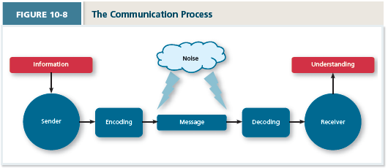

Chap 11:
Power, 5 types (p303-312)
Power: the ability to influence the behaviour of others and resist unwanted influence in return.
Organizational Power
- Legitimate power: “formal authority”
- Reward power: control over the resources
- Coercive power: control over punishments
Personal Power
- Expert power: knowledge on which others demands
- Reference: desired to identify with a person

Contingencies of power

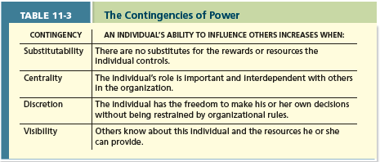

Influence tactics (p313-315)
Influence: is the use of an actual behaviour that causes behavioural and/or attitudinal changes in others.
Most effective tactics
- Rational persuasion – use of logical arguments and hard facts to show that a request if worthwhile.
- Inspirational appeal – designed to appeal to one’s values and ideals, thereby creating an emotional or attitudinal reaction
- Consultation – whereby the target is allowed to participate in deciding how to carry out or implement a request.
- Collaboration – whereby the leader makes it easier for the target to offering to work with and help the target.
Moderately effective tactics
- Ingratiation – use of favors, compliments, etc, so target feels better about the influencer
- Personal appeal –asks for something based on personal friendship or loyalty
- Exchange –offers a reward in return for performing a request
- Apprising –clearly explained why performing the request will benefit the target personally.
Least effective tactics
- Pressure –attempts to use coercive power through threats and demands
- Coalitions –Influencer enlists other people to help influence the target

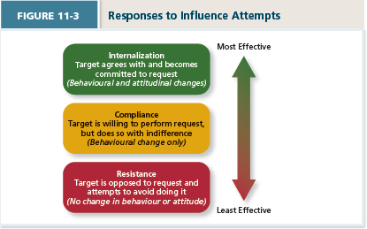

Conflict resolution (p317-320) labels of axes
5 styles can be viewed as combinations of two separate factors:
- How assertive individual want to be in pursuing their goals and,
- How cooperative they are with regard to the concerns of others
Competing – a conflict resolution style by which one party attempts to get his or her own goals met without concern for the other party’s results.
- When quick decisive action id vital (emergencies)
- On important issues for which unpopular actions need implementing
- On issues vital to company welfare when you know your right
- Against people who take advantage of non-competitive people
Avoiding –A conflict resolution style by which one party wants to remain neutral, stay away from conflict, or postpone the conflict to gather information or let things cool down.
- When an issues is trivial or more important issues are pressing
- When you perceive no chance of satisfying your concerns
- When potential disruption outweighs the benefits of resolution
- To let people cool down and regain perspective.
…
Accommodating –A conflict resolution style by which one party gives in to the other and acts
In a completely unselfish way.
- when you find you are wrong, to allow a better position to be heard, to learn, and to show reasonableness.
- When issues are more important to others than yourself, to satisfy others and maintain cooperation.
- To build social credits for later issues
Collaborating –a conflict resolution style whereby both parties work together to maximize outcomes.
- To find an integrative solution when both sets of concerns are too important to be compromised.
- When your objective is to learn
- To merge insights from people with different perspectives
Compromise –A resolution style by which conflict is resolved through give and take concessions.
- When goals are important but not worth the effort of potential disruption of more assertive modes
- To achieve temporary settlements to complex issues
- When opponents with equal power are commitment to mutually exclusive goals.

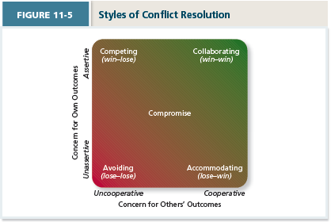

Negotiation (p320-323)
A process in which two or more interdependent individuals discuss and attempt to reach agreement about their differences.
Distributive bargaining –involves win-lose negotiating over a ‘fixed-pie” of resources.
- Objective – maximize your outcome
- Strategy –
  - set a target, resistance point and opening offer
  - Minimize disclosure of your target and resistance points
  - Convince the other party that you have a good alternative
- Tactics –bluff, low/high ball, delay, Snow job – looks like you are well prepared
- Factors influencing the distributive bargaining process –
  - Tangible (e.g., price, terms, wages)
  - Intangible (wanting to win, beating the other guy)
  - Intangibles just as important as tangibles
  - A distributive strategy ignores relationships
Integrative bargaining –is aimed at accomplishing a win-win scenario.
- Objective: to indentify a common goal and to develop a solution that achieves that goal
- Difficult to achieve because
  - Past history
  - Bias towards viewing issues as win/lose
  - Intertwined nature of distributive and integrative issues
- Strategies
  - Problem solving techniques
  - Depersonalize the problem
  - Active listening
  - Share power
  - Encourage brainstorming
- Tactics
  - Expanding the pie
  - Nonspecific compensation logrolling
  - Cost cutting
  - Bridging
Stages
- Preparation
- Exchanging information
- Bargaining
- Closing and commitment

Chap 12:
leadership styles and behaviors (LMX) (p334-336)

leadership – is the use of power and influence to direct the activities of followers towards goal achievement.

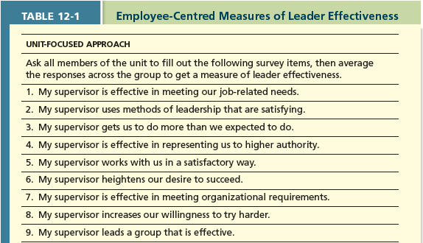

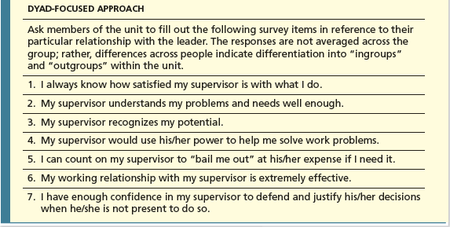

Leader-member exchange theory
Describes how leader-member relationships develop over time
- Role taking phase –A manager describes role expectations and the employee attempts to fulfill those expectations
- Role making phase –The employee’s own expectations for the dyad get mixed in with those of the leader.
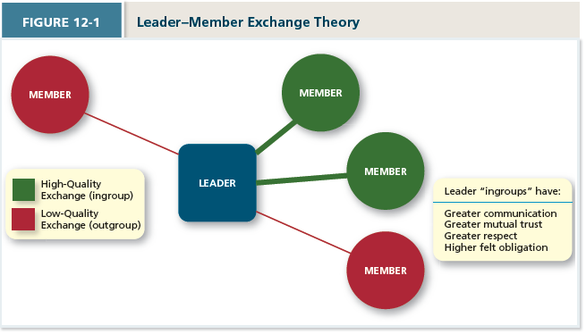

Leader decision making styles (p338-340) types of criteria top and bottom of figure

Autocratic Style – makes the decision alone (judge, prod, military)
Consultative style –asks for opinions and suggestions before ultimately making the decision, (stoke trader)
Facilitative style –seeks consensus on a solution
Delegative style –gives away the responsibility for making the decision
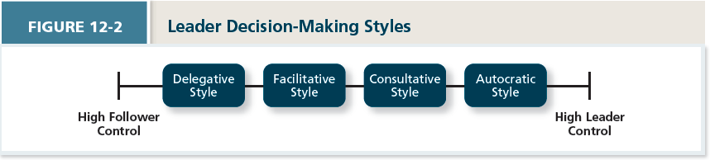

Time-driven model of leadership
- Focus should shift away from the type of leader to the type of situation.
- Seven factors combine to make some decision-making styles more effective in a given situation
- Decision significance: Is the decision significant to the success of the project or the organization?
- Importance of commitment: Is it important that employees “buy in” to the decision?
- Leader expertise: Does the leader have significant knowledge or expertise regarding the problem?
- Likelihood of commitment: How likely is it that employees will trust the leader’s decision and commit to it?
- Shared objectives: Do employees share and support the same objectives, or do they have an agenda of their own?
- Employee expertise: Do the employees have significant knowledge or expertise regarding the problem?
- Teamwork skills: Do the employees have the ability to work together to solve the problem, or will they struggle with conflicts or inefficiencies?
- NOTE: Treat each of the seven factors as questions that can be answered as High=H or Low=L. Then follow the chart on Figure 12-3 to determine the appropriate style

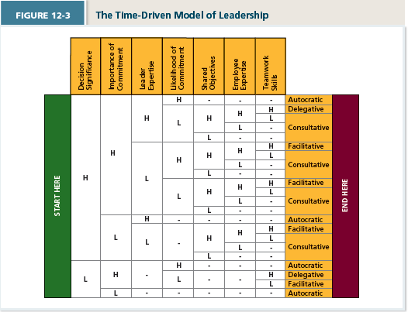

Day-to-day leadership behaviours (341-344)
Initiating structure
- A pattern of behaviour where the leader defines and structures the roles of employees in pursuit of goal attainment. (strong task-orientation)
Consideration
- A pattern of behaviour where the leader creates job relationships characterized nu mutual trust, respect for employee ideals, and consideration of employee feelings (strong relationship-orientation)
Life cycle theory of leadership
- Optimal combination of initiating structure and consideration depends on “employee readiness” i.e. the ability and willingness to accomplish tasks.
  - Telling style –when the leader provides specific instructions and closely supervises performance
  - Selling –when the leader explains key issues and provides opportunities for clarification
  - Participating –Leader behaviour in which the leader shares ideas and tries to help the group conduct its affairs
  - Delegating –leader behaviours in which the leader turns responsibility for key behaviours over to employees
- 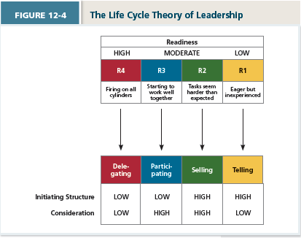
R1 –Unable and Unwilling = lakes motivation, ability and commitment
R2 –Unable and Willing = lacks ability but is motivated
R3 –Able and Unwilling = has ability, not motivated
R4 –Able and Willing = has ability and is motivated
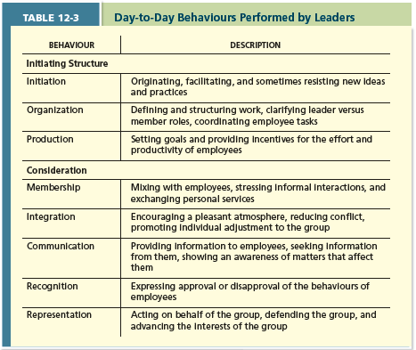
Transformational leadership (p345-350)
A pattern of behaviour in which the leader inspires followers to commit to share vision that provides meaning to their work while also serving as a role model who helps followers develop their own potential and view problems from new perspectives.
- Laissez-faire leadership: when the leader avoids leadership duties all together
- Transactional leadership: a pattern of behaviour in which the leader rewards or disciplines the follower on the basis of performance
- Passive management by-exception: a type of transactional leadership on which the leader arranges to monitor mistakes and errors actively, ad takes corrective action when required.
- Contingent reward: A more active and effective type of leadership, in which the leader attains follower agreement on that needs to be done using rewards in exchange for adequate performance.

Idealized influence: Power held by leader who behaves in ways the earn the admiration, trust, and respect of followers, causing followers to want to identify with and emulate the leader.
“leader instills pride in me for being associated with him/her”.

Inspirational motivation: type of influence in which the leader behaves in ways that foster an enthusiasm for and commitment to a shared vision of the future.
“The leader articulates a compelling vision of the future”

Intellectual stimulation: type of influence in which the leader behaves in ways that challenge followers to be innovative and creative by questioning assumptions and reframing old situations in new ways. “leader gets others to look at problems from many different angles”

Individualized consideration: Type of influence in which the leader behavers in ways that help followers achieve their potential through coaching, development and mentoring. “The leader spends time teaching and coaching”.

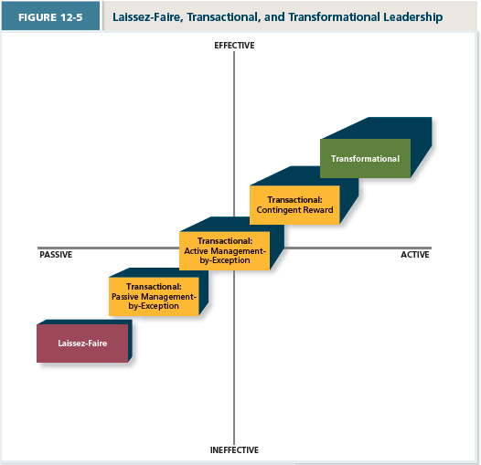
Chap 13:
elements of organizational structure (p364-370) SLIDES** Mechanistic and organic structures
Formally dictates how jobs and tasks are divided and coordinated between individuals and groups within the company
An organizational chart is a drawing that represents every job in the organization and the formal reporting relationships between those jobs.

Elements in combination
- Mechanistic organizations
  - Are efficient, rigid, predictable, and standardized organizations that thrive on stable environments.
- Organic Organizations
  - Are flexible, adaptive, outward focused organizations that drive in dynamic environments.
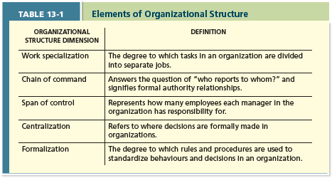
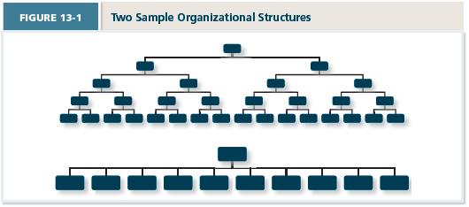
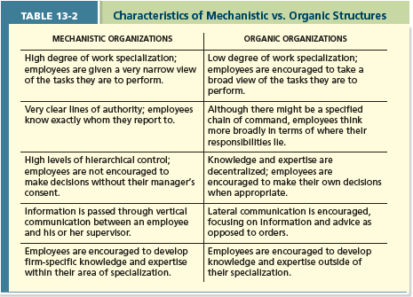
Common organizational forms (p372-378)
Simple structures- most common form of organization design because there are more small organizations that large ones.
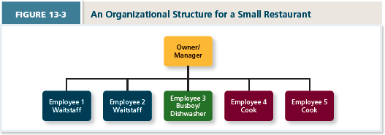
Bureaucratic Structures
- Functional structures: employees are grouped by the function they perform for the organization.
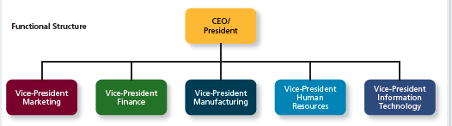

- Product structures: group business units around different products that the company produces
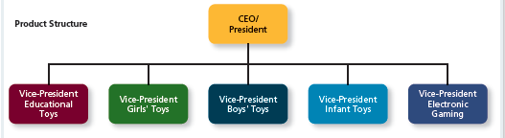

- Geographic structures: based around the different locations where the company does business.
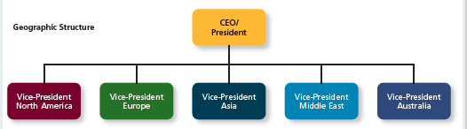
- Client structures: employees are organized around serving customers
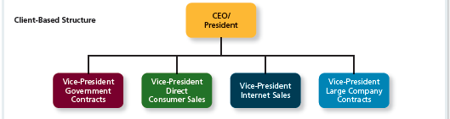

Matrix structures: a more complex form of organizational design that tries to take advantage of functional and product structured at the same time.
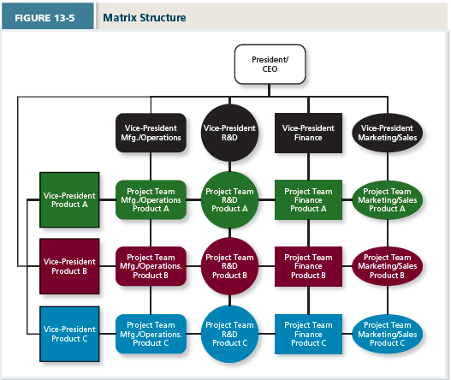
Chap 14:
Cultural components (p390-393) onion
Observable artifacts: aspects of an organizations culture that employees and outsides can easily see or talk about.
  - Symbols: image
  - Physical structures: building and internal office designs
  - Language: jargon, slang, and slogans used within an organization
  - Stories: anecdotes, accounts, legends and myths passed down from cohort to cohort within an organization
  - Rituals: daily or weekly planned routines that occur in an organization
  - Ceremonies: formal events, generally performed in from of an audience of organizational members
Espoused Values –The beliefs, philosophies and norms that a company explicitly stated
Basic underlying assumptions –Taken for granted beliefs and philosophies that are so ingrained that employees simply act on them rather than questioning the validity of their behaviour in a given situation.
General cultural types (p393-395)
- Fragmented –Employees are distant and disconnected
- Mercenary – “what in it for me?” employees think alike but are not friendly to one another
- Networked –Friendly but everyone does their own thing
- Communal –Friendly and all thing alike
Specific culture types
- Customer service culture – focused on service quality
- Safety culture – focused on the safety of employees
- Diversity culture – Focused on the fostering or taking advantage of a diverse group of employees
- Creativity culture- Focused on the fostering a creative atmosphere.

Maintaining an organizational culture
- Attraction-Selection-Attrition (ASA) framework – Potential employees will be attracted to organizations whose cultures match their own personality.

- Attraction selection attrition framework
- Realistic job previews

