CHEM 271 Fall 2016 Learning outcomes 17

Gluconeogenesis

You should know:
Which precursors are utilized in gluconeogenesis?
Gluconeogenesis (in liver but can also occur in kidney) generates glucose from non-carbohydrate precursors – important in fasting because it supplies glucose to the tissues that most need it. Gluconeogenesis maintains the glucose levels in the blood so that the brain and muscles can extract sufficient amounts of glucose to meet their metabolic needs
- Lactic acid and alanine (they will lead to pyruvate) – pyruvate can come from lactic acid which accumulates in tired/exerting muscles under anaerobic conditions. Lactate dehydrogenase in the liver catalyzes the conversion. Pyruvate can also come from the breakdown of alanine
- Selected amino acids (they will lead to oxaloacetate) – oxaloacetate can be formed from amino acids upon breakdown of proteins in the diet or skeletal muscle upon starvation
- Glycerol (it will lead to dihydroxyacetone) – Dihydroxyacetone phosphate (DHAP) comes from the hydrolysis of triacylglycerols (triglycerides, in fat cells). The hydrolysis yields fatty acids and glycerol. Glycerol can be converted into dihydroxyacetone phosphate which can be processed by gluconeogenesis or glycolysis

Which steps in gluconeogenesis are different from glycolysis?
Gluconeogenesis occurs mainly in the liver (small amount in the kidney). There are three irreversible steps in glycolysis catalyzed by hexokinase, phosphofructokinase and pyruvate kinase → not available in gluconeogenesis and new enzymes are used.
- Formation of Phosphoenolpyruvate in a two-step reaction
- Pyruvate carboxylase-catalyzed generation of oxaloacetate from pyruvate
- Phosphoenolpyruvate carboxykinase-catalyzed generation of Phosphoenolpyruvate from oxaloacetate
- This process is energetically favorable because it is coupled to the hydrolysis of high-energy phosphate bonds in ATP and GTP. CO2 is required in step A1 is released in step A2

- Fructose 1,6-bisphosphatase-catalyzed formation of fructose 6-phosphat from fructose 1,6-bisphosphate via hydrolysis of the phosphate ester at carbon 1
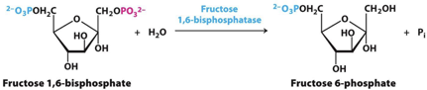

- Glucose-6-phosphatase-catalyzed hydrolysis of glucose-6-phosphate generating glucose. Since glucose-6-phosphatase is a liver enzyme, gluconeogenesis does not occur in muscles or in the brain
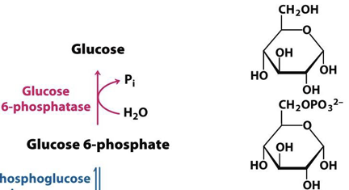

What are the substrates and products and which enzymes are involved?

Step 1:
Substrate: Pyruvate
Product: Oxaloacetate
Cofactor: ATP, HCO3
Enzyme: Pyruvate Carboxylate
Description: Occurs in the mitochondria
1. Bicarbonate is activated to carboxyphosphate. 2. The carboxyphosphate becomes bonded to biotin generating the CO2-biotin-enzyme intermediate. 3. The activated CO2 group is then transferred from carboxybiotin to pyruvate to form oxaloacetate. Biotin is not carboxylated unless acetyl CoA is bound to the enzyme (allosteric activation)

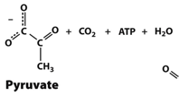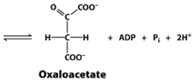

Step 2:
Substrate: Oxaloacetate
Product: Phosphoenolpyruvate
Cofactor: GTP
Enzyme: PEP (Phosphoenolpyruvate) carboxykinase
Description: Formation of oxaloacetate by pyruvate carboxylase occurs in the mitochondria. But Phosphoenolpyruvate carboxykinase works in the cytosol → oxaloacetate get transported as malate in the Malate Shuffle using malate dehydrogenase. Oxaloacetate is reduced to malate by an NADH-linked malate dehydrogenase and once reduced, it gets transported into the cytoplasm where its is reoxidized to oxaloacetate by a NAD+ liked malate dehydrogenase with the generation of cytoplasmic NADH.
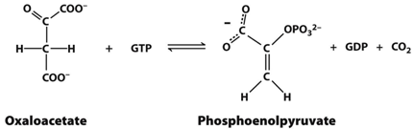

Step 9:
Substrate: Fructose 1,6-bisphosphate
Product: Fructose 6-phosphate
Cofactor: H2O
Enzyme: Fructose 1,6-bisphosphatase
Description: Fructose 1,6-bisphosphatase catalyzes an irreversible reaction, the hydrolysis of the phosphate group at C1 → since it is irreversible it is regulated (under allosteric control). Fructose 1,6-biphosphatase is an allosteric enzyme

Step 11:
Substrate: Fructose 6-phosphate, Glucose 6-phosphate
Product: Glucose 6-phosphate, Glucose
Cofactor: H2O
Enzyme: Phosphoglucose isomerase, glucose 6-phosphatase
Description: Fructose 6-phosphate is readily converted to glucose-6-phosphate by an isomerization reaction. In most tissues, gluconeogenesis ends at this point. Glucose-phosphate is used to synthesize glycogen. Being phosphorylated, it cannot be transported out of the cell.
Conversion of glucose 6-phosphate to glucose: occurs in tissues responsible for maintaining proper blood-glucose levels. Glucose-6-phosphatase (membrane protein) catalyzes this reaction in the lumen of the ER. Sine it is a membrane protein, it is bound to the membrane, stabilized by Ca2+ binding stabilizing protein (SP), a protein essential for its activity. Transport protein 1 (T1) transports glucose 6-phosphate from the cytoplasm into the lumen of the ER. Transporter protein 2 (T2) and transporter protein 3 (T3) take Pi and glucose into the cytoplasm → 5 proteins are needed to transform glucose-6-phosphate to glucose
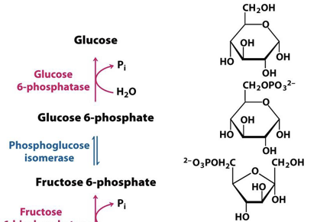

How does oxaloacetate get out of the mitochondrion?
The formation of oxaloacetate by pyruvate carboxylase occurs in the mitochondria. But Phosphoenolpyruvate carboxykinase works in the cytosol → oxaloacetate must be transported to the cytoplasm as malate in the Malate Shuffle, Oxaloacetate is reduced to malate by an NADH-linked malate dehydrogenase and once reduced, it gets transported into the cytoplasm where it is reoxidized to oxaloacetate by a NAD+ liked malate dehydrogenase with the generation of cytoplasmic NADH.

Oxaloacetate → (malate dehydrogenase) forming malate

How is gluconeogenesis regulated, especially in relation to regulation of glycolysis?
Glycolysis and Gluconeogenesis are pathways that operate in opposite directions - if one is up regulated, the other one is down regulated - Reciprocal regulation

Interconversion of fructose-6-phosphate and fructose 1,6-bisphosphate:
- [AMP] is high, AMP stimulates phosphofructokinase but inhibits fructose 1,6-bisphosphatase (glycolysis on, gluconeogensis off)
- High [ATP] and citrate indicate that biosynthetic intermediates are abundant. ATP and citrate inhibit phosphofructokinase, whereas citrate activates fructose 1,6-bisphophatase (glycolysis off, gluconeogenesis on). Citrate takes part in the citric cycle - high levels of citrate indicate an energy-rich situation and the presence of precursors for biosynthesis.

Interconversion of phosphoenolpyruvate and pyruvate in liver:
- The glycolytic enzyme pyruvate kinase is inhibited by allosteric effectors ATP and alanine - signal that the energy charge is high and that building blocks are abundant (glycolysis off, gluconeogensis on)
- Pyruvate carboxylase is inhibited by ADP (gluconeogensis off)
- Phosphoenolpyruvate carboxykinase is also inhibited by ADP, but is activated by acetyl CoA - like citrate indicating that the citric acid cycle is producing energy and biosynthetic intermediates (gluconeogenesis on)

High energy charge inhibits pyruvate carboxylase and phosphoenolpyruvate carboxylase
High concentrations of metabolic intermediates activate pyruvate carboxyl's while they inhibit pyruvate kinase
Gluconeogenesis is favoured when the cell is rich in biosynthetic precursors and ATP

Balance between Glycolysis and Gluconeogenesis in the liver is sensitive to blood glucose concentration
- in liver, the rates of glycolysis and gluconeogenesis are glutted to maintain balanced blood glucose level
- Fructose 2,6-bisphosphate stimulates phsophofructokinase and inhibits fructose 1,6-bisphosphatase
- if [blood-glucose] is high - F-6P (doesn’t bind to PFK) gets covered to F-2,6-BP (binds to PFK and stimulates it, inhibit fructose 1,6-bisphosphatase)
- if [blood-glucose] is low - F-2,6-BP gets converted to F-6B

Bifunctional enzyme controls fructose 2,6-bisphosphate
- enzyme displays two enzymatic activities- contains a kinase (phosphofructokinase 2, PFK2) that phosphorylates fructose 6-bisphosphate and phosphatase (fructose bisphosphatase 2) - removes the phosphoryl group on carbon 2 on fructose 2,6-bisphosphate
Bifunctional enzyme has:
- N-terminal regulatory domain which can be phosphorylated. the activities of PFK2 and FBPase2 are controlled by the phosphorylation of a single serine residue
- Kinase domain
- C-terminal phosphatase domain

Hormone control: synthesis and degradation of Fructose 2,6-bisphosphate in the liver
- blood glucose levels determine which activity on the bifunctional enzyme is performed
- [blood-glucose] is lower - glucagon is secreted leads to phosphorylation of the bifunctional enzyme by protein kinase A, which inhibits the kinase (PFK2) and stimulates the phosphatase (FBPase2) - lower [fructose 2,6-bisphosphate] — PFK is not stimulated and glucose will not be metabolized and go back to the tissue that need it
- [blood-glucose] is high - insulin is secreted and activates a phosphoprotein phosphatase removing the phosphoryl group from PFK2, which activates PFK2 and inhibits FBPase2 — increase in [fructose 2,6-bisphosphate] and glycolysis is activated, gluconeogenesis is inhibited

What are substrate cycles?
ATP-driven cycle operates at tow different rates. A small change int he rates of the two opposing reactions results in a large change in the net flux of product B.
Substrate cycles amplify metabolic signals: supposed the rate of conversion of A into B is 100 and B to A = 90, giving an initial net flux of 10. Assume that an allosteric effector increases A to B rate by 20% to 120 and reciprocally decreases B to A by 20% to 72 = the new net flux is 48 and so a 20% change in the rates of the opposing reactions has led to 380% increase in the net flux.
This amplification is made possible by the rapid hydrolysis of ATP, the flux down the glycolytic pathway has been suggested to increase as much as 1000-fold at the initiation of intense exercise — the existence of the substrate cycles may partly account for the rapid rise in the rate of glycolysis.

What is the Cori cycle?
In contracting skeletal muscle, the formation and release of lactate lets the muscle generate ATP in the absence of oxygen and shift the burden of metabolizing lactate from muscle to other organs
Contracting skeletal muscle supplies lactate to the liver, which uses it to synthesize and release glucose - the liver restores the level of glucose necessary for active muscle cells, which derive ATP from the glycolytic conversion of glucose into lactate.

Pyruvate is converted to lactate in order to restore the redox balance in the cell. Lactate can be taken up by some cells in which it is converted to pyruvate where it can be metabolized aerobically by the citric acid cycle. Or it can be taken up by the liver via the blood, where it is converted back to pyruvate and then to glucose by gluconeogenesis where it is released into the blood. The liver restores the glucose necessary for the active muscles. Glucose is then able to drive ATP production from the glycolytic pathway.

Lactate dehydrogenase catalyzes the converse of pyruvate to lactate. LDH is a tetramer with two different types of subunits (H and M). M4 predominates in the muscles and liver and H4 predominates in the heart. H4 isozyme oxidizes lactate to pyruvate which is used to fuel the heart through aerobic metabolism. M4 reduces pyruvate to lactate to allow glycolysis to process under anaerobic conditions.

