Table of Contents

Introduction..................................................................................................................................................3
Main Findings...............................................................................................................................................4
Financial Barriers...........................................................................................................................4
Geography and Climate.................................................................................................................5
Employment and Economics..........................................................................................................8
Political Climate..............................................................................................................................9
Attracting Foreign Investment......................................................................................................9
Conclusion...................................................................................................................................................10
References...................................................................................................................................................11

Introduction

Germany is an international expansion option in which is examined throughout this business report. Germany is home to Europe’s largest economy, and most populous country after Russian Federation. Germany is vital towards the EU’s economic, political, and defence organizations. The nation’s capital is Berlin consists of an area at 356,854km². Germany’s population is at 82 million and the currency currently used is the EURO adopted by the German government in 2002. The EURO is more dominant than the Canadian dollar (CAD) and is shared throughout the EU which allows for a larger market. (EUBUSINESS). Germany and Canada have a very strong economic relationship. The two countries both benefit from foreign investment and their trade relationship. Canadian businesses benefit by German expansion because they are offered minimal export customs and duty fees when investing within Germany. The main goods Germany exports to Canada are machinery, vehicles, chemicals, and electronic products. While the primary goods Canada exports to Germany are copper ores, turbo jets, coin, and coal.

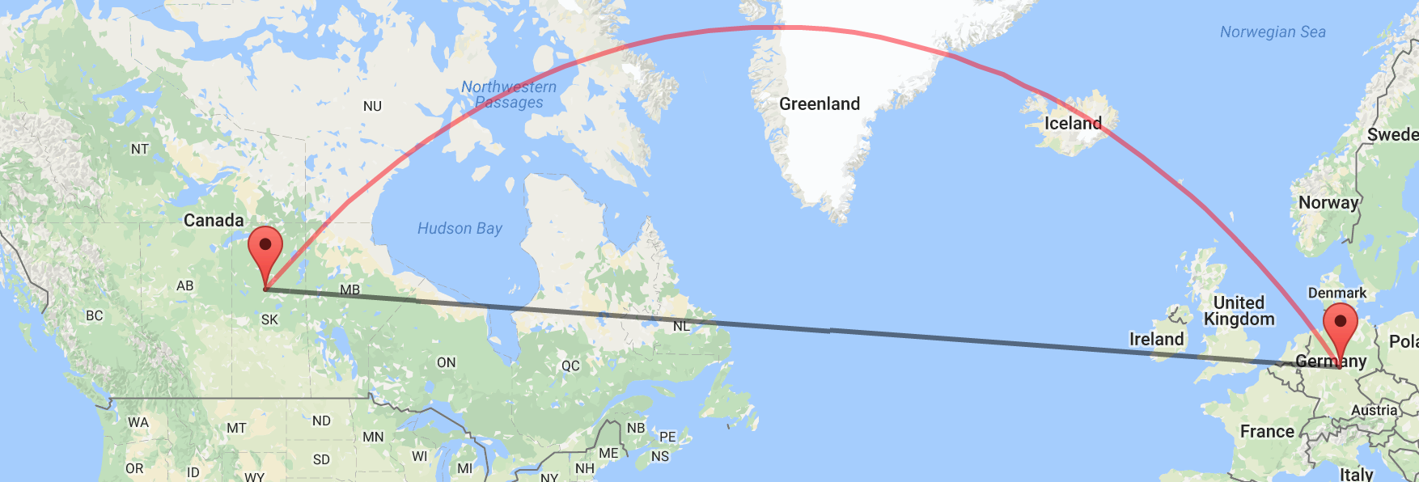
Figure 1 Map of Germany relative to Canada (GOOGLE)

Main Findings
Financial Barriers
The country has no barriers within the Eurozone because it is part of the European Union, this allows for potential further expansion in the future of Blue Line Hockey Sticks. The EU shares all economic policies, regulations, and sanctions. All imports entering into the EU are subject to the Notably Agricultural Tariffs. Germany imposes high tariffs on rice, sugar and beef and low tariffs on agricultural products including wheat, dairy, some meats, textiles, and apparel. (CGDEV). All agriculture imports are charged with a 7% tax depending on the quantity of the import. Germany has a feed-in tariff on electricity; it’s purpose is to encourage the incorporation of renewable energy and green technologies such as solar, hydro, wind, and geothermal generated power. (E-PARL). The German government encourages any foreign investment which provides new employment. There are no significant limitations on foreign investments other than the Turnover Tax which applies to all foreign entrepreneurs in Germany. (DELOITTE). The 19% Import Turnover Tax is placed on all industrial imports in Germany since January 1 2007. Most goods and services are categorized and taxed under the 19% Turnover Tax. (CFE-EUTAX). Countries within the EU have a list of embargoes on arms and military related trade to many nations as a protest/boycott against particular government practices. (EEAS). Germany has had many revisions in its currency, Germany’s previous government’s monetary policies damaged the preceding currencies. Hyperinflation occurred between June 1921 and January 1924, this was due to the government’s uncontrolled money printing. In consequence, a currency devaluation of the Mark which led to worthless banknotes throughout Germany. Eventually the nation’s currency became stable with the Reichsmark in subsequent to the Mark. (FRASER). Germany switched to the EURO in January 2002. (BBC). The EURO is regarded as one of the most stable currencies due to its wide market. The EURO is almost never affected because it is shared throughout 18 other sovereign states excluding Germany. While the Canadian currency (CAD) may be on the lower end of the conversion to the German Dollar (EURO), the EURO offers a wide market for investors to expand into.
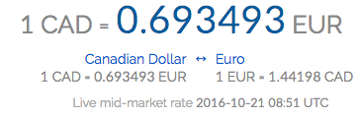
Figure 2. Current Canadian (CAD) and Germany Currency Conversion Rate (XE)
Physical Geography and Climate
Germany is located in Europe in between the Baltic and North Seas. Both the Baltic and North Seas are considered arms to the North Atlantic Ocean. The nation borders with nine other countries: France, Luxembourg, Belgium, Netherlands, Denmark, Poland, Czech Republic, Austria, and Switzerland. Due to the location of both Canada and Germany, imports and business travel must be done through plane and/or cargo ships. Ships are a longer yet cheaper form of transportation, whereas travel through plane is faster and more expensive method of importing and business travel. According to World Bank Data (2015), Germany has a total land mass of 357,168 km² with a population density of 234 people per km² . The largest city and the country’s capital, Berlin, is located in the northeastern region of Germany. Other major cities within Germany are Hamburg, Munich, Cologne, and Frankfurt am Main.
Border with Belgium: 167 km
Border with Denmark: 68 km
Border with Czech Republic: 646 km
Border with Luxembourg: 138 km
Border with Netherlands: 577 km
Border with France: 451 km
Border with Poland: 456 km
Border with Switzerland: 334 km
Border with Austria: 784 km
Coastline: 2389 km
Terrain: Lowlands in north, highlands in the centre, and Bavarian Alpines in the South.
Elevation extremes:
Lowest point: Neuendorf bei Willster (-3.54m)
Highest point: Zugspitze (2962m)
Land Use:
Arable land: 48%
Permanent Crops: 0.6%
Other: 20.2%
Irrigated land: 5157km²
Natural Hazards: Flooding
Environmental Issues: (party to) Climate change, Forest damages, Air pollution caused by emissions from coal burning industries. Pollution in the Baltic sea due to hazardous waste disposal. (CIA).
Issues related to Geography: 9 different country borders Germany which provokes for a high unregistered migrant rate.
The climate in Germany is characterised to be moderate and marine. Similar to Canada, the country has cold winters and mild to hot summers. The average temperature is approximately 18c and the coldest average temperature being -1 in January and February. Prolonged periods of frost or snow are rare in Germany. Germany receives on average 700mm of precipitation annually and 58mm per month. The driest month is October and the wettest is June. Hours of sunshine range from 1.1 per day in December to 8.8 in June. Germany is known for having unpredictable weather. Germany is found in the world’s temperate zone, within this zone, temperatures change dramatically from season to season. The weather in the west coast of Germany is affected by the Atlantic Ocean.

Figure 3. Climate Graph of Germany’s capital Berlin. (CLIMATEMPS).
The geography of Germany supports international trade through accessible travel infrastructure, environmental stability, and a hospitable climate.
Employment and Economics
The unemployment rate in Germany is currently at 4.6%. The working sector is composed of three strands:
- 1.6% agriculture
- 24.6% industry
- 73% services & government

Gross Domestic Product: Approximately $62599.07 per capita. (CIA.,2015)

Average household income: $33,333(USD). (GALLUP).

Germany has a mixed economic system. Germany’s economy largest economy in Europe and is the fourth largest economy in the world. (INVESTOPEDIA). The main factor for Germany’s successful economy is their skilled labour market. the government’s investment in education provokes a skilled labour force. Despite a strong economy, 15.5% of Germany’s population lives below the poverty line. (CIA). In an effort to defeat poverty, the country is recognized to have a high minimum wage. Germany has a very strong competitive advantage in the production of high tech goods, i.e chemicals, vehicles, and engineering. This is due to investments in new technology, high labour productivity and highly skilled workers. (WORLDECONOMICFORUM). The government went into a recession during 2008-2009, recovered through using fiscal policies; cutting taxes.

Political Climate
Although Germany acts as an individual country, Germany itself is a state within the European Union. The European Union runs as a council type system; the current President of the European Commission is Jean-Claude Juncker. As for Germany, the political party currently in power is the Christian Democratic Union (CDU) of Germany, led by Chancellor Angela Merkel. Germany’s current political system is a democracy type government with 6 major political parties. Before having a federal republic democratic government, Germany had a Nazism type government led by the infamous Adolf Hitler. For the past 60 years, Germany has had a very stable and successful democratic system. For example, Germany has governed a low corruption level to be sought as one of the lowest in the world. This being the result of the unification of government and citizens. The nation’s political stability is also due to their investments in infrastructure that will provoke a low unemployment rate and higher education. Germany’s government is similar to Canada’s in which the country is split up to 16 federated states likewise to Canada’s provincial and territorial system. Germany’s democratic system allows for foreign investment and also is strongly active in global trade with minimal restrictions.

Attracting Foreign Investment
The government attracts foreign investment through their favourable foreign investment tax rates, highly skilled workers, currency, travel infrastructure, and minimal foreign investment restrictions. Germany’s tax rates are extremely satisfying for international businesses which makes Germany a plausible expansion destination. There is no specific foreign tax rate, all tax rates are subjected to the same tax rates imposed on domestic businesses. Germany has many skilled workers in their labour force which is a n international asset that foreign investors seek. Skilled workers is a competitive advantage in which efficiency is increased in businesses/foreign investments. Another competitive advantage Germany has to offer is their internationally respected advanced technology. Foreign investors are able to take advantage of their technology in order to better their businesses. Foreign investors often move to countries that use the EURO currency system. They are able to invest dollars profited from their businesses in the vast market of the European Union. Also investors do not have to pay customs/duty fees when importing goods in-between European Union Member states. This offers a possibility for easy transitions in future business expansions in the European market. Germany is renowned for its impressive transportation systems, the country has great travel infrastructure making foreign investors to easily import their goods and services to Germany. The travel infrastructure is an absolute advantage in which it allows for a simple international transition.

Conclusion
Blue Line Hockey Sticks should expand into Germany because of the numerous advantages outlined in this business report. Germany is an investment destination to foreign investors, when evaluating through opportunity cost; the advantages most definitively outweigh the disadvantages. There are very minimal financial barriers that Blue Line Hockey Sticks will encounter as the German Government does not tariff goods that the company offers. The political climate has been safe and should be stable for a very long time period. When expanding internationally, Germany should be Blue Line Hockey Sticks first international venture.

References
Banking and Monetary Statistics, 1914-1941 - FRASER - St ... (n.d.). Retrieved October 20, 2016, from https://fraser.stlouisfed.org/title/38
BBC NEWS | Business | Call of duty for Germany's mark. (n.d.). Retrieved October 20, 2016, from http://news.bbc.co.uk/2/hi/business/4602717.stm
Climatemps. (n.d.). In Http://www.berlin.climatemps.com/index.php. Retrieved October 20, 2016.
Currency Conversion [Photograph]. (n.d.). In Http://www.xe.com/currencyconverter/.
European Union Restrictive measures (sanctions) in force. (n.d.). Retrieved October 20, 2016, from http://eeas.europa.eu/sites/eeas/files/restrictive_measures-2016-10-11-clean.pdf
Germany | Center For Global Development. (n.d.). Retrieved October 20, 2016, from http://www.cgdev.org/page/germany-1
Germany: Country overview — EUbusiness.com | EU news ... (n.d.). Retrieved October 20, 2016, from http://www.eubusiness.com/europe/germany
Google Maps. (n.d.). Retrieved October 25, 2016, from http://maps.google.com/
Population density (people per sq. km of land area) | Data. (n.d.). Retrieved October 20, 2016, from http://data.worldbank.org/indicator/EN.POP.DNST
Success story: Feed-In Tariffs Support renewable energy in ... (n.d.). Retrieved October 20, 2016, from http://e-parl.net/eparliament/pdf/080603 FIT toolkit.pdf
Taxation and Investment in Germany 2016. (n.d.). Retrieved October 20, 2016, from https://www2.deloitte.com/content/dam/Deloitte/global/Documents/Tax/dttl-tax-germanyguide-2016.pdf
The World Factbook — Central Intelligence Agency. (n.d.). Retrieved October 20, 2016, from https://www.cia.gov/library/publications/the-world-factbook/geos/gm.html
The World's Top 10 Economies | Investopedia. (n.d.). Retrieved October 20, 2016, from http://www.investopedia.com/articles/investing/022415/worlds-top-10-economies.asp
Value added tax/Turnover tax in Germany | CFE portal. (n.d.). Retrieved October 20, 2016, from http://www.cfe-eutax.org/taxation/VAT-taxation/germany
Worldwide, Median Household Income About $10,000. (n.d.). Retrieved October 20, 2016, from http://www.gallup.com/poll/166211/worldwide-median-household-income-000.aspx

